Supporting information
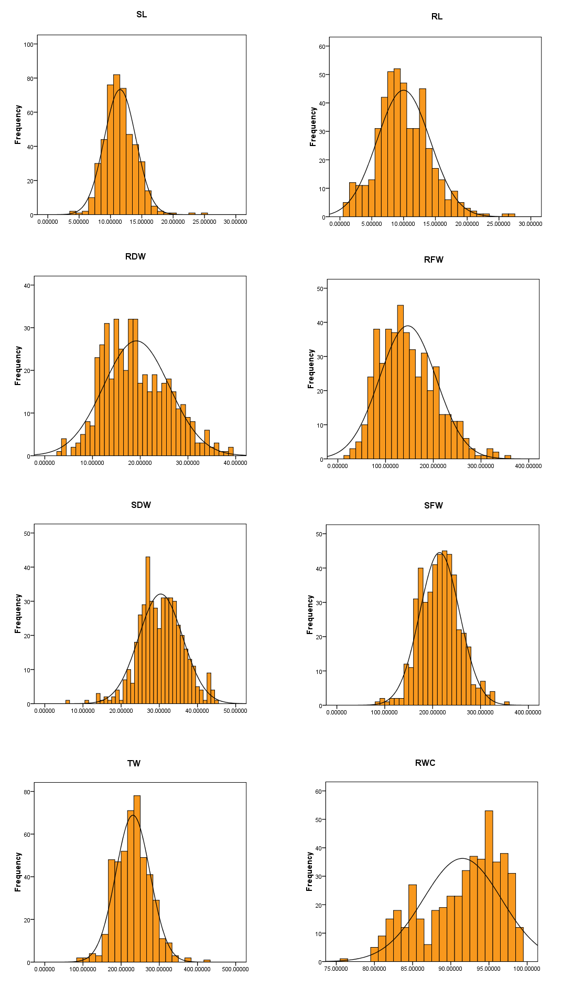
Figure S1a. A histogram showing the frequency distribution of 8 traits phenotyped for germplasm set used in the study under control condition.
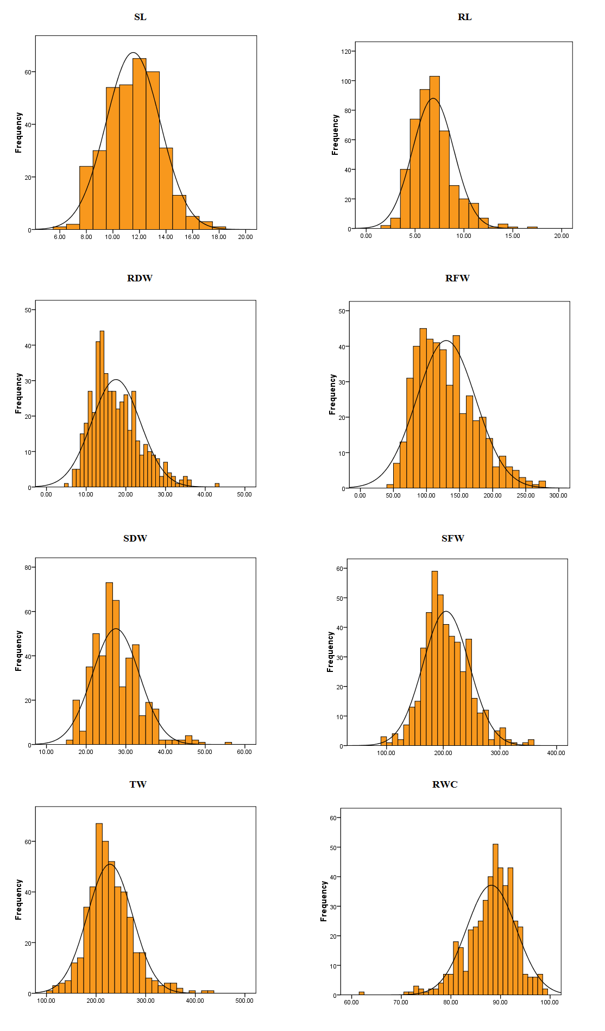
Figure S1b. A histogram showing the frequency distribution of 8 traits phenotyped for germplasm set used in the study under salinity condition.

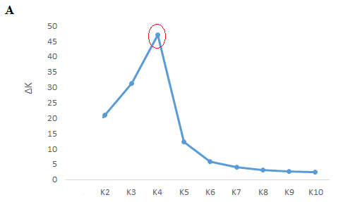
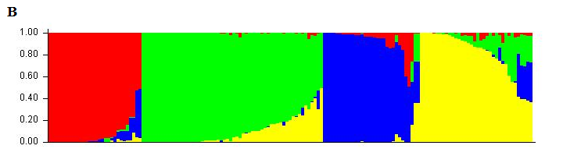
Figure S2 Results of clustering the entire population. (A) Determining the optimized number of K clusters based on Evanno et al (2005) method. (B) Bar plot of the clustering result showing the population structure derived from the STRUCTURE software.

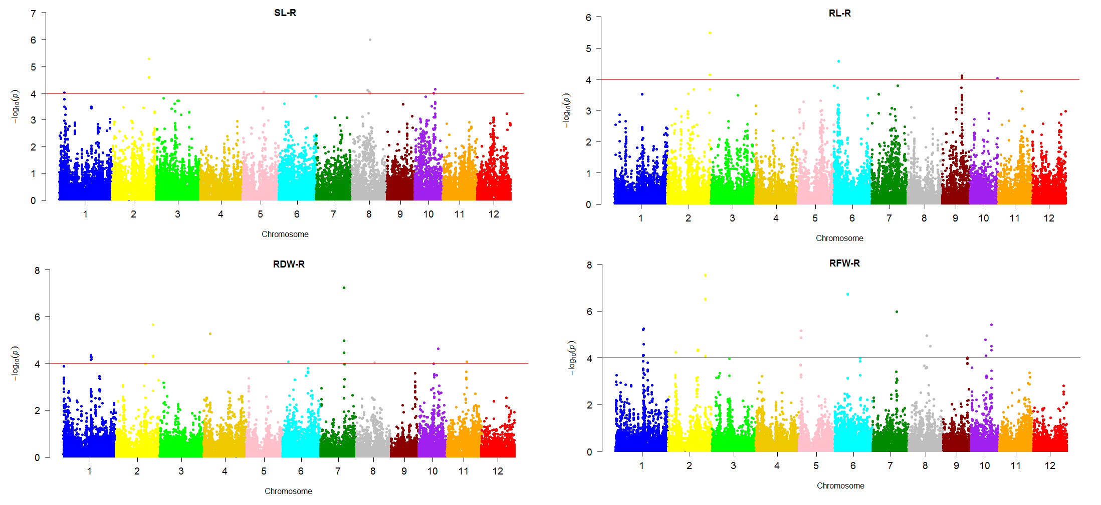
Figure S3. Manhattan plots of p-values analyzed using mixed linear model (MLM) controlled for population structure and kinship of rice genotypes for derived traits under salinity condition.

