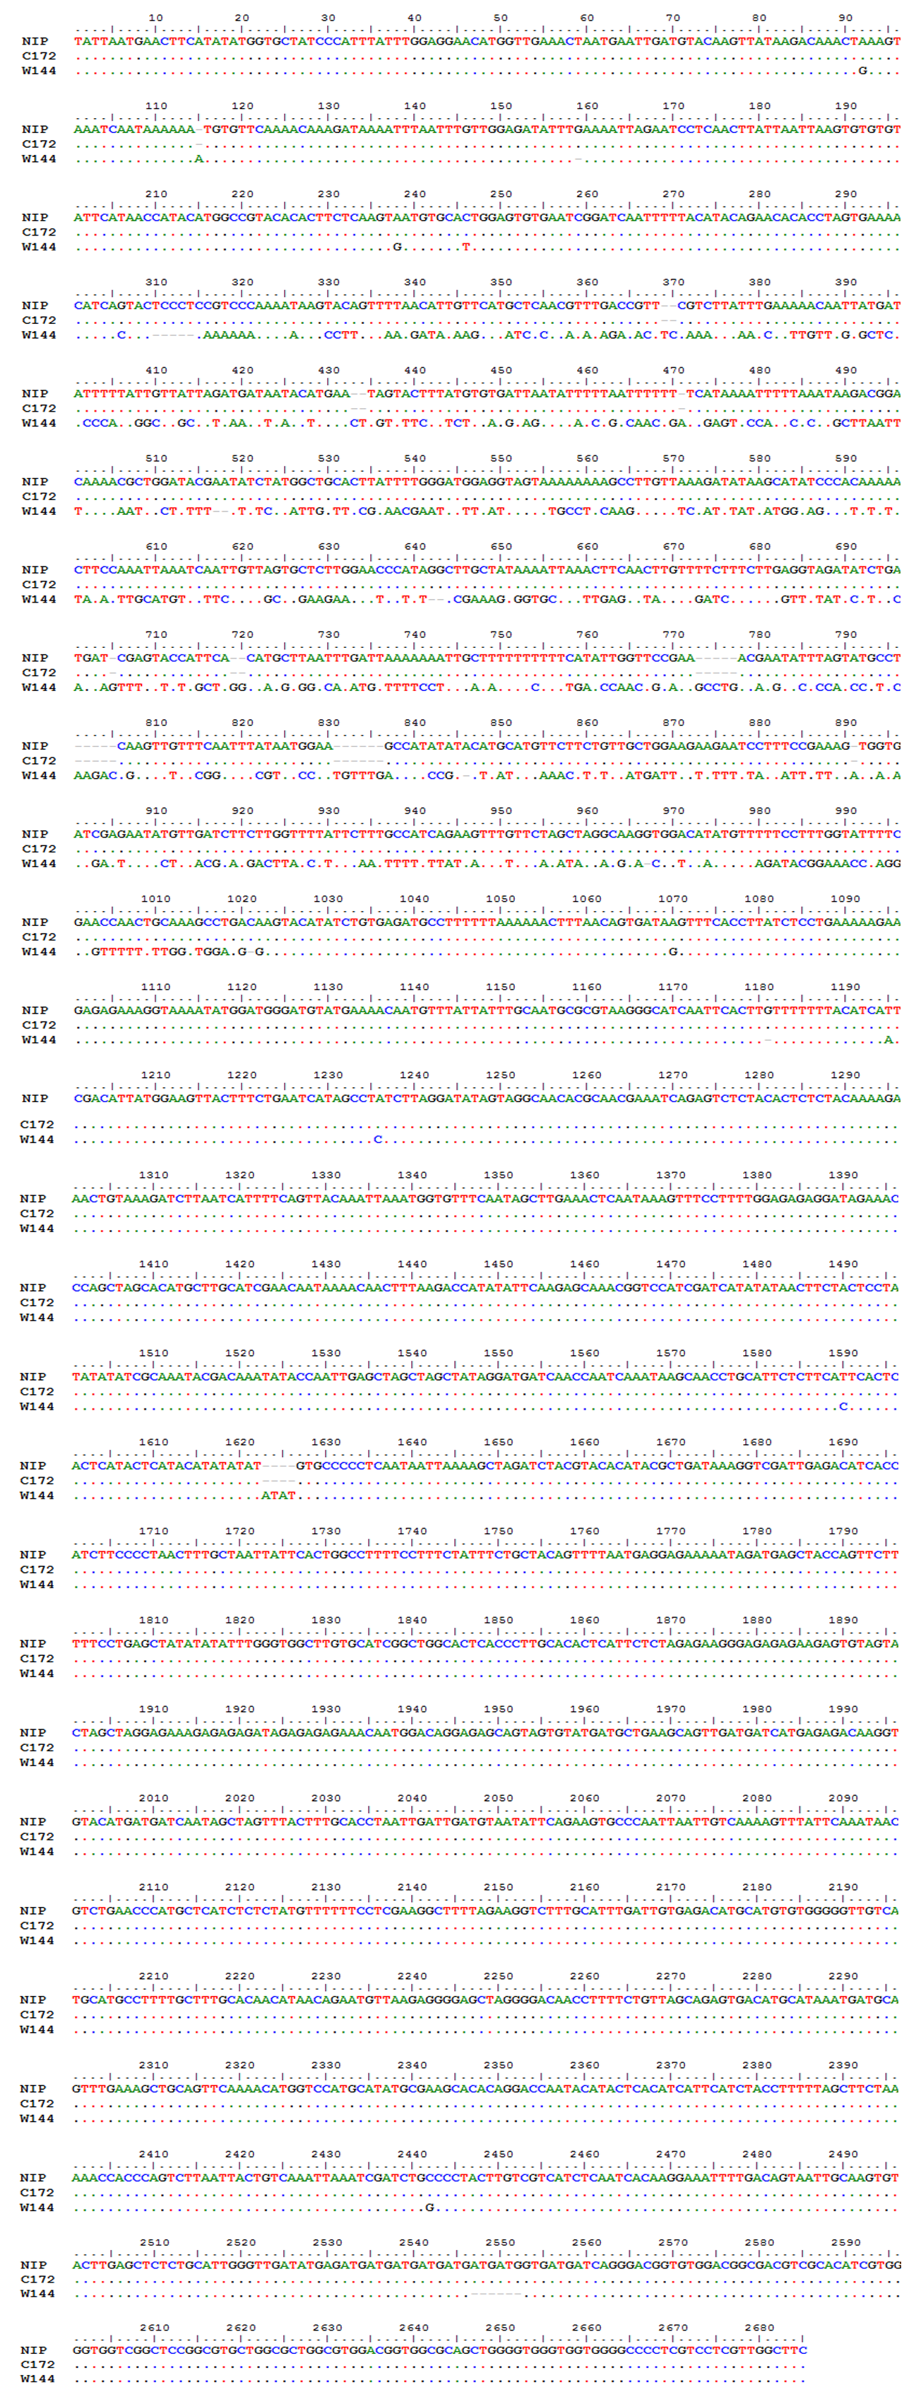

Supplementary file 2: Fig. S2 Sequencing of two different types of promoter sequences of OsAAP4. NIP indicates Nipponbare, C172 indicates the Hap5 type in Japonica. W144 indicates the Hap2 type in Indica.

