Supplementary Data

Running title: GA deactivation capabilities of rice GA 2-oxidase genes

Comparisons within the Rice GA 2-Oxidase Gene Family Revealed Three Dominant Paralogs and a Functional Attenuated Gene that Led to the Identification of Four Amino Acid Variants Associated with GA Deactivation Capability

*Corresponding author:
L-J Chen,
Institute of Molecular Biology, National Chung Hsing University, Taichung 40227, Taiwan
Tel: +886-4-22851885
E-mail address: ljchen@nchu.edu.tw

Subject areas:
1) growth and development,
3) regulation of gene expression,
10) genomics, evolution,

Number of color figures: 10
Number of tables: 2
Number of supplementary figures: 8
Number of supplementary tables: 3

Supplementary figures

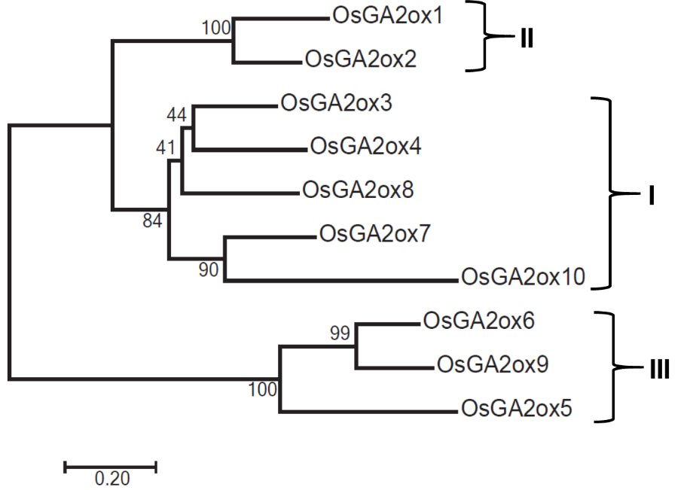
Figure S1. Phylogenetic tree based on comparisons of OsGA2ox amino acid sequences
The OsGA2ox protein sequences were aligned by MAFFT version 7, and the resulting alignment was used to generate a phylogenetic tree that was constructed by the neighbor-joining method using bootstrap analysis with 400 replicates.

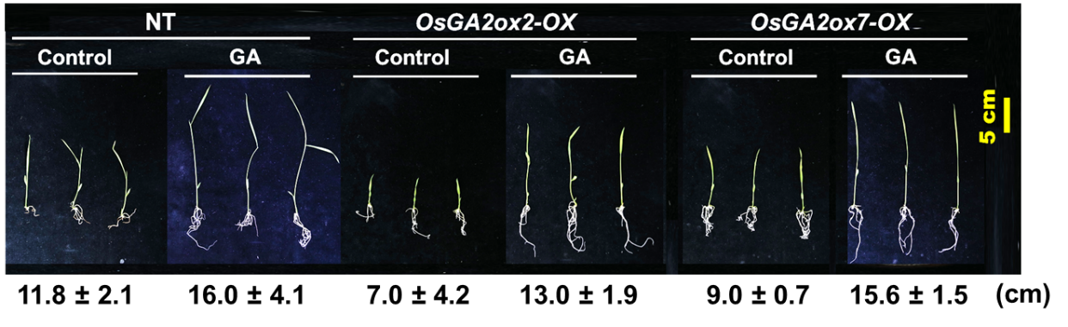
Figure S2. Effects of exogenous GA₃ treatment on seedling growth
Seeds from nontransgenic (NT), OsGA2ox2-OX and OsGA2ox7-OX rice plants were grown on MS media for 7 days and then transferred to MS media supplemented with 10 µM GA₃ (GA) or no GA (Control) for 3 days to measure their shoot length. The average shoot lengths are shown below the picture. OsGA2ox2-OX and OsGA2ox7-OX could be rescued by exogenous GA₃ treatment.

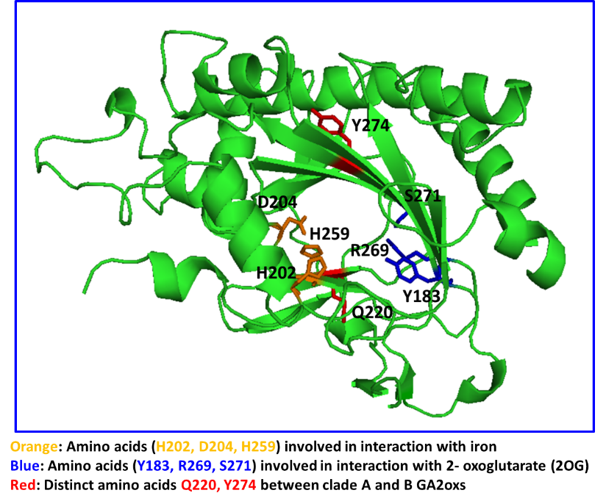
Figure S3. Relative positions of amino acids Q220 and Y274 in OsGA2ox3 according to the resolved 3-D protein structure
The protein structure was downloaded from the Protein Data Bank under accession number 6KU3, the amino acids involved in interaction with iron are shown in orange, the amino acids involved in interaction with 2-oxoglutarate (2OG) are shown in blue, and Q220 and Y274 are shown in red.

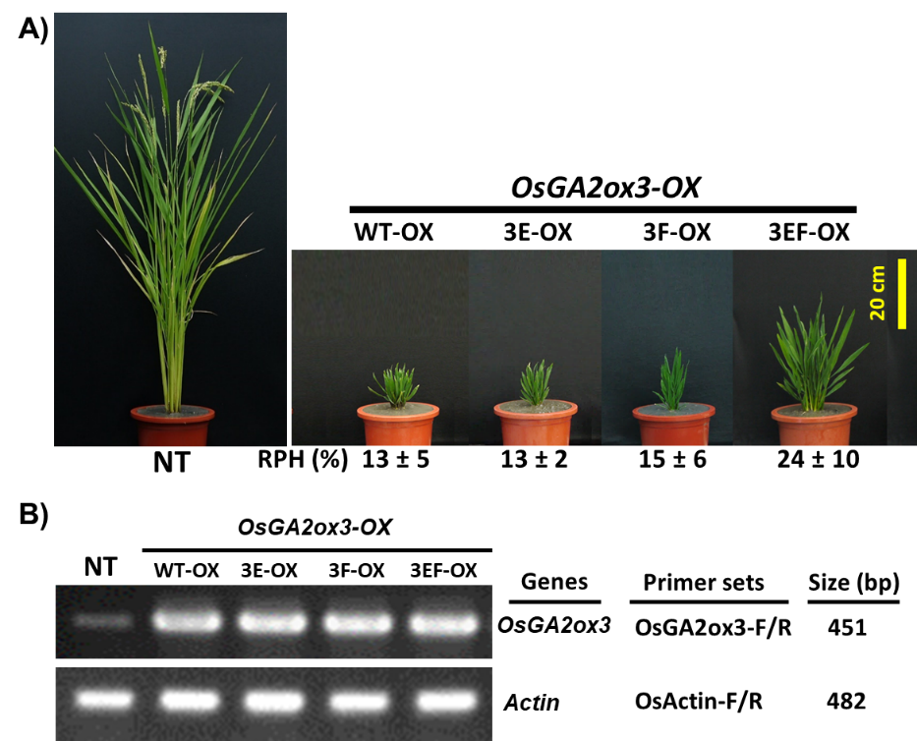
Figure S4. Phenotypic comparison of WT-OX, 3E-OX, 3F-OX and 3EF-OX transgenic rice plants and their RNA expression analysis
- Phenotypic comparison of WT-OX, 3E-OX, 3F-OX and 3EF-OX transgenic rice plants and their nontransgenic (NT) plants. A representative transgenic plant with the average RPH resulting from each overexpression line is shown. Values are means ± SE (n = 5).
- Results of RT-PCR analysis of OsGA2ox3 gene in WT-OX, 3E-OX, 3F-OX and 3EF-OX transgenic rice plants and NT plant. The Actin gene was used as control.

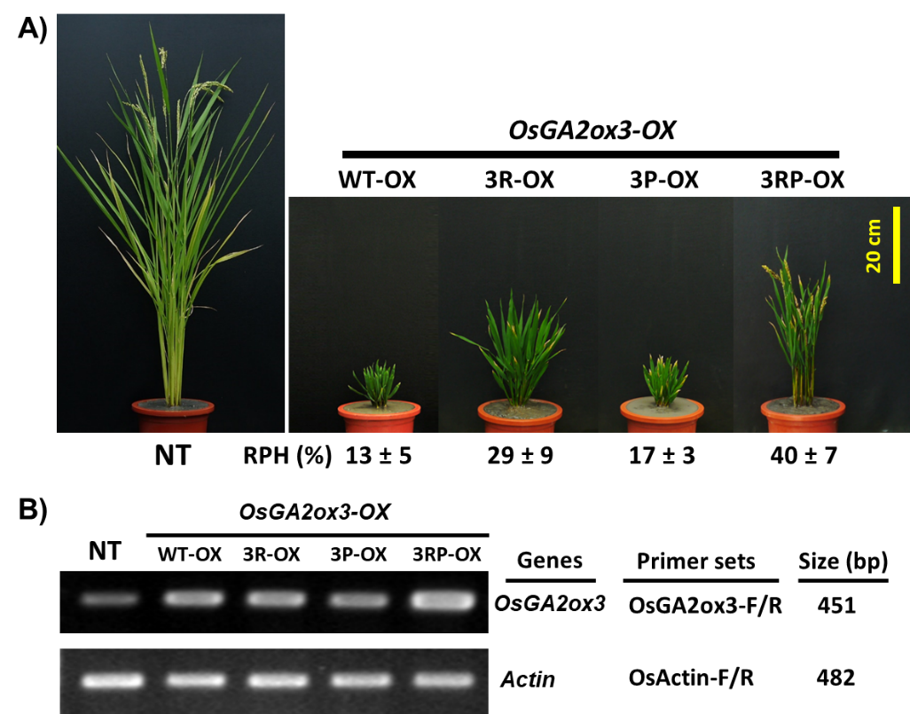

Figure S5. Phenotypic comparison of WT-OX, 3R-OX, 3P-OX and 3RP-OX transgenic rice plants and their RNA expression analysis
(A) Phenotypic comparison of WT-OX, 3R-OX, 3P-OX and 3RP-OX transgenic rice plants. A representative overexpression transgenic plant with the average RPH from each overexpression line is shown. Values are means ± SE (n = 5).
(B) Results of RT-PCR analysis of OsGA2ox3 gene in WT-OX, 3R-OX, 3P-OX and 3RP-OX transgenic rice plants and NT plant. The Actin gene was used as control.

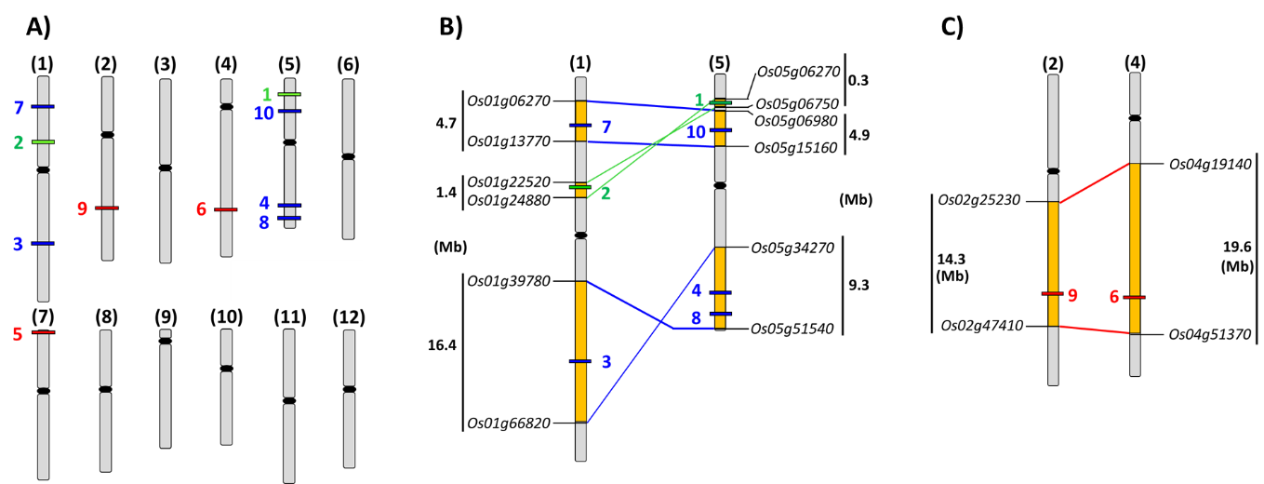
Figure S6. Locations of and evolutionary relationships among the OsGA2ox genes on rice chromosomes
- The relative locations of the 10 OsGA2ox family genes on rice chromosomes.
- Schematic representation of syntenic blocks between chromosomes #1 and #5 and the relative locations of each C₁₉-type OsGA2ox in the syntenic regions are indicated.
- Schematic representation of syntenic blocks between chromosomes #2 and #4 and the locations of OsGA2ox6 and OsGA2ox9 in the syntenic regions are indicated.
The locus IDs from the Rice Genome Annotation Project were used to define the boundary of the syntenic blocks. The syntenic blocks defined by Thiel’s study (Thiel et al. 2009) are shown as colored boxes. The chromosome locations of each OsGA2ox gene, boundary loci and syntenic blocks were visualized using the Oryzabase Map tool (Kurata and Yamazaki 2006) (http://viewer.shigen.info/oryzavw/maptool/MapTool.do).

Kurata N, Yamazaki Y (2006) Oryzabase. An integrated biological and genome information database for rice. Plant Physiol 140: 12-17
Thiel T, Graner A, Waugh R, Grosse I, Close TJ, Stein N (2009) Evidence and evolutionary analysis of ancient whole-genome duplication in barley predating the divergence from rice. BMC Evol Biol 9: 209
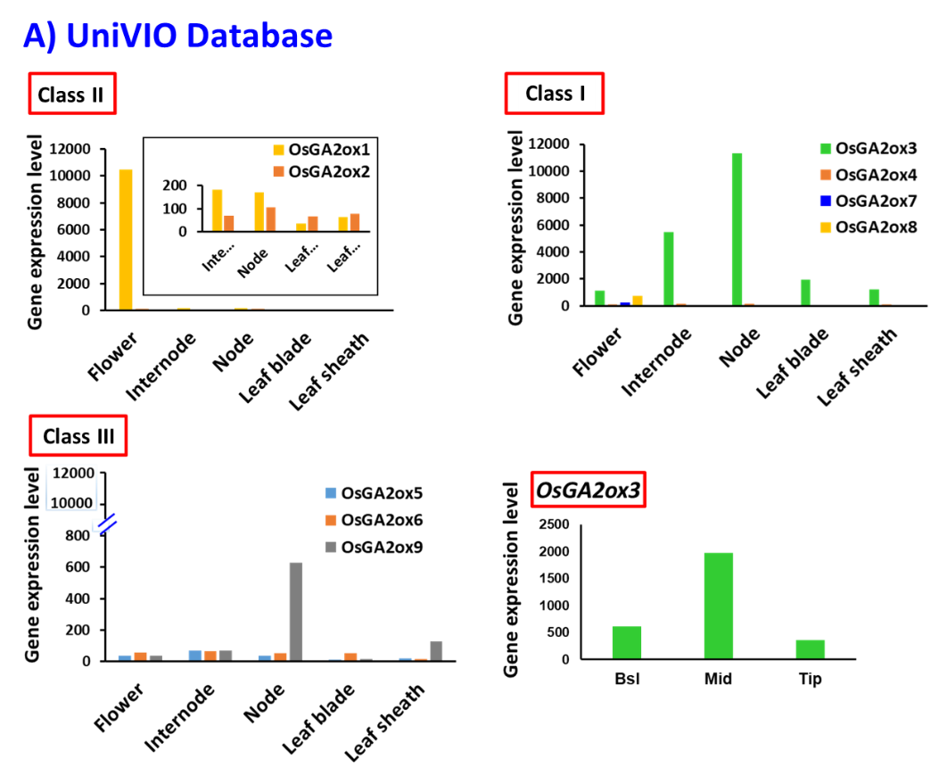
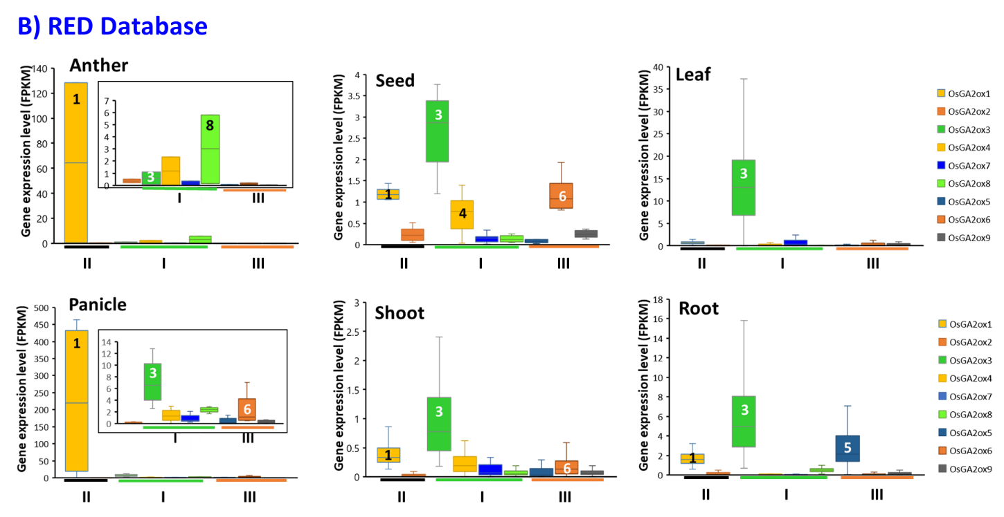

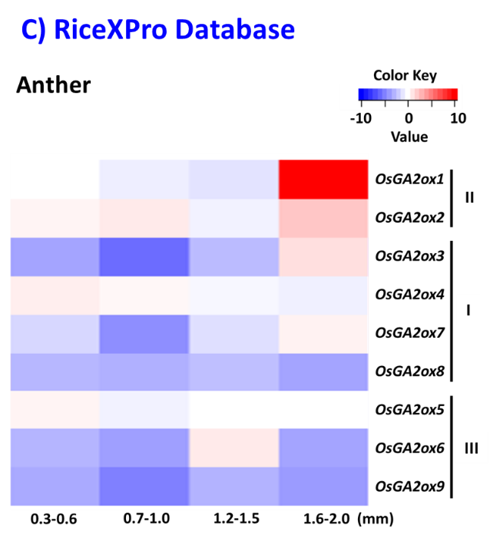
Figure S7. Expression analysis of OsGA2ox genes in various tissues according to data collected from different rice expression databases
- Expression profiles of OsGA2oxs in various rice tissues represented by different GA2ox classes; the data were obtained from the UniVIO (http://univio.psc.riken.jp/) database. The “Bsl”, “Mid” and “Tip” stand for the “basal”, “middle” and “tip” part of the flag leaf blade respectively.
- Expression profiles of OsGA2oxs in various tissues that classified by different tissues; the data were obtained from the RED database (http://expression.ic4r.org/).
- Expression heat map of OsGA2oxs in anthers at different developmental stages; the data were obtained from the RiceXPro database (https://ricexpro.dna.affrc.go.jp/).

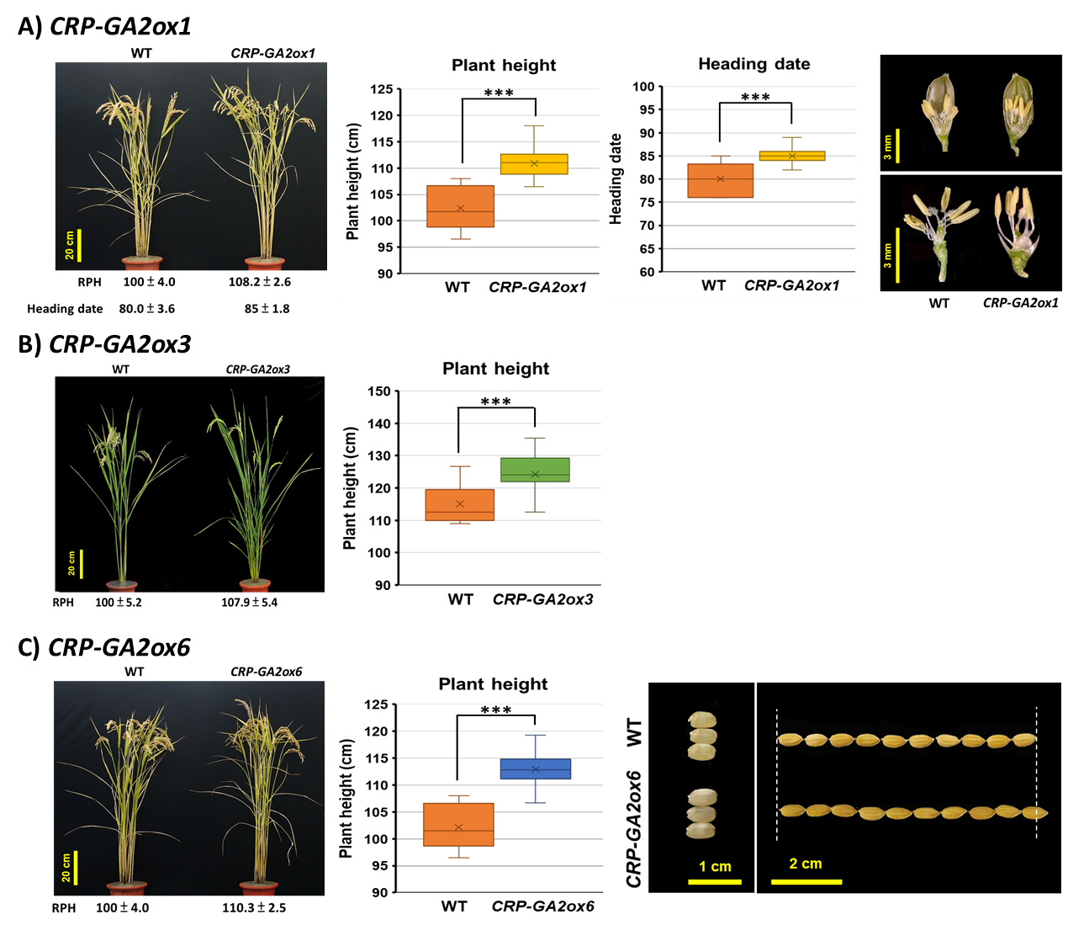
Figure S8. Phenotypic comparisons of CRISPR/Cas9 knockout OsGA2ox1, OsGA2ox3, and OsGA2ox6 mutants
Knockout mutants of OsGA2ox1, OsGA2ox3 and OsGA2ox6 were created via CRISPR/Cas9 editing technology. At least two independent transformation events and two or three editing patterns that resulted in knocking out the function of the genes were obtained. Quantitative data were obtained from edited plants that were determined to be T-DNA free and that remained homozygous-edited for at least two seasons. The relative plant height (RPH %) means ± SE were shown for each of the representative mutant plants and the absolute plant height (cm) from at least 10 samples were analyzed and presented by boxplots. The statistical comparisons using Student’s t-test was to show the differences between the mutants and the wild-type (WT) control and their significance levels were determined as *P < 0.05, **P < 0.01, ***P < 0.001. Representative knockout mutants of osga2ox1 (A, CRP-GA2ox1), osga2ox3 (B, CRP-GA2ox3), and osga2ox6 (C, CRP-GA2ox6), and statistical analysis of plant heights for CRP-GA2ox1, CRP-GA2ox3, CRP-GA2ox6 and heading date for CRP-GA2ox1 are shown. The phenotype comparisons of anthers for CRP-GA2ox1 and the bigger and chalky rice grains for CRP-GA2ox6 are shown.

Table S1A. The locations and aligned lengths of the two conserved regions in the first intron of OsGA2ox1 and its orthologs in Bd and Sb
Intron conserved region #1 |  |  |  |  |  | Intron conserved region #2
Gene | Location | Identity | Alignment length | E-value |  | Location | Identity | Alignment length | E-value
Bd2g34837 | 2632 to 3006 | 80.8 | 395 | 1E-91 |  | 3032 to 3183 | 73.9 | 157 | 1E-15
OsGA2ox1 | 3524 to 3907 | 80.8 | 395 | 1E-91 |  | 4009 to 4153 | 73.9 | 157 | 1E-15
OsGA2ox1 | 3599 to 3989 | 82.7 | 306 | 9E-80 |  | 4029 to 4160 | 74.3 | 140 | 2E-17
Sb9g053700 | 2507 to 2803 | 82.7 | 306 | 9E-80 |  | 2925 to 3061 | 74.3 | 140 | 2E-17
Table S1B. The locations and aligned lengths of the conserved regions in the 5’-regulatory region of OsGA2ox3 and its orthologs in Bd and Sb
5’-regulatory conserved region #1 |  |  |  |  |  | 5’-regulatory conserved region #2
Gene | Location | Identity | Alignment length | E-value |  | Location | Identity | Alignment length | E-value
Bd2g50280 | -472 to -411 | 85.5 | 62 | 3E-16 |  | -220 to -126 | 71.4 | 105 | 3E-9
OsGA2ox3 | -451 to -390 | 85.5 | 62 | 3E-16 |  | -206 to -110 | 71.4 | 105 | 3E-9
OsGA2ox3 | -467 to -391 | 79.5 | 78 | 1E-13 |  | -189 to -139 | 87.3 | 55 | 3E-15
Sb3g300800 | -419 to -343 | 79.5 | 78 | 1E-13 |  | -197 to -143 | 87.3 | 55 | 3E-15
Table S1C. The locations and aligned lengths of the conserved region in the first intron of OsGA2ox6 and its orthologs in Bd and Sb
Intron conserved region #1
Gene | Location | Identity | Alignment length | E-value
Bd5g16040 | 423 to 592 | 83.5 | 170 | 7E-47
OsGA2ox6 | 789 to 956 | 83.5 | 170 | 7E-47
OsGA2ox6 | 834 to 953 | 89.2 | 120 | 1E-40
Sb9g150800 | 1065 to 1183 | 89.2 | 120 | 1E-40

Table S2A. DNA-binding motifs in the first intron region of OsGA2ox1
TF/Motif Name | Location | Sequence | Matrix ID/Literature
OsGA2ox1 CR1 (3599~3898)
α-Amylase | 3606~3611 | AATAAA | TF_motif_seq_0282
RAmy3D TATCCAY motif | 3644~3650 | TATCCAT | TF_motif_seq_0387
RAmy3D TATCCAY motif | 3890~3896 | TATCCAT | TF_motif_seq_0387
ANAERO1 | 3659~3665 | AAACAAA | TF_motif_seq_0343
AT-Hook | 3603~3611 | GAGAATAAA | TFmatrixID_0131
AT-Hook | 3793~3801 | TGGAAAAAA | TFmatrixID_0133
AT-Hook | 3827~3836 | ATTTTTGCCC | TFmatrixID_0133
B3 | 3680~3684 | CATGC | TF_motif_seq_0256
B3 | 3863~3867 | GCATG | TF_motif_seq_0256
B3 | 3894~3898 | CATGC | TF_motif_seq_0256
GATA | 3611~3619 | AATGATCCA | TFmatrixID_0262
GATA | 3756~3764 | TGTGATCCA | TFmatrixID_0262
GT1 | 3706~3711 | GATAAA | TF_motif_seq_0321
GT1 | 3795~3800 | GAAAAA | TF_motif_seq_0321
GT1 | 3840~3846 | GGAAAAT | TF_motif_seq_0321
Homeodomain; TALE | 3812~3821 | TCCTGTCAAC | TFmatrixID_0293
Homeodomain; TALE | 3848~3852 | TGTCA | TF_motif_seq_0246
NF-YB | 3808~3812 | CCAAT | TF_motif_seq_0257
NF-YB | 3837~3841 | ATTGG | TF_motif_seq_0257
TBP | 3649~3655 | ATATAAA | TFmatrixID_0418
TCP | 3620~3624 | GGCCC | TF_motif_seq_0266
OsGA2ox1 CR2 (4029~4153)
AT-Hook | 4096~4104 | TTTTTACTT | TFmatrixID_0133
GT1 | 4149~4154 | GATAAA | TF_motif_seq_0321
Homeodomain; TALE | 4063~4067 | AGTCA | TF_motif_seq_0246
Homeodomain; TALE | 4104~4108 | TGTCA | TF_motif_seq_0246
Homeodomain; WOX | 4057~4064 | TCAATCAG | TFmatrixID_0299
Homeodomain; HD-ZIP | 4055~4066 | CATCAATCAGTC | TFmatrixID_0295
NAC; NAM | 4062~4070 | CAGTCAAAG | TFmatrixID_0382
WRKY | 4061~4071 | TCAGTCAAAGA | TFmatrixID_0451
KNOX | 4054~4069 | CCATCAATCAGTCAAA | Bolduc and Hake (2009)

Table S2B. DNA-binding motifs in promoter regions of OsGA2ox3
TF/Motif Name | Location | Sequence | Matrix ID/Literature
OsGA2ox3 CR1 (-451~-391)
RAmy3 CGACG element | -431~-427 | CGTCG | TF_motif_seq_0259
RAmy3 CGACG element | -415~-411 | CGACG | TF_motif_seq_0259
TCP | -425~-421 | GGCCC | TF_motif_seq_0266
ABRE | -433~-428 | CACGTC | Cantoro (2013)
CE1 | -394~-390 | CACCA | Cantoro (2013)
OsGA2ox3 CR2 (-189~-139)
B3 | -149~-145 | CATGC | TF_motif_seq_0256
Storekeeper | -174~-166 | CCCGACCTC | TFmatrixID_0417

Table S2C. DNA-binding motifs in the first intron region of OsGA2ox6
TF/Motif Name | Location | Sequence | Matrix ID/Literature
OsGA2ox6 CR1 (834~953)
ANAERO3 | 844~850 | GTGATGA | TF_motif_seq_0390
AP2 | 948~957 | AACGCCGTCC | TFmatrixID_0103
B3 | 885~889 | CATGC | TF_motif_seq_0256
C2H2 | 898~910 | TAGTACACTAACC | TFmatrixID_0214
Homeodomain; TALE | 835~839 | AGTCA | TF_motif_seq_0246
NAC; NAM | 834~842 | GAGTCAATG | TFmatrixID_0382
RAmy1A Pyrimidine box | 893~898 | CCTTTT | TF_motif_seq_0309
WRKY | 834~841 | GAGTCAAT | TFmatrixID_0445

Table S3. List of primers and their sequences used in this study
Name of primer sets | Sequence | Size of PCR product
For gene cloning
OsGA2ox1-SpeI-F | 5’-TTACTAGTATGGTGGTGCCTTCCGCGACGA-3’ | 1166 bp
OsGA2ox1-KpnI-R | 5’-AGAGGTACCCTATGCTTTTCCCTCACTGGCAT-3’
OsGA2ox2-SpeI-F | 5’-AAGACTAGTATGGTGGTGCCGGCTGCTG-3’ | 1195 bp
OsGA2ox2-KpnI-R (3'-UTR) | 5’-AGGGTACCCAACAAACTTCCAGCGAT-3’
OsGA2ox3-SpeI-F | 5’-AGAACTAGTATGGTGGTTCTCGCTGGC-3’ | 1002 bp
OsGA2ox3-KpnI-R | 5’-GATGGTACCCTACTTCTTCTCAAACTGGGC-3’
OsGA2ox4-SpeI-F | 5’-GAAACTAGTATGGTGGTGCTCGCGAA-3’ | 1083 bp
OsGA2ox4-KpnI-R | 5’-GCTGGTACCTTAGGCGAGTGGGTTAGCG-3’
OsGA2ox7-SpeI-F | 5’-GAAACTAGTATGGTGGTGCTTGCCAAGG-3’ | 1026 bp
OsGA2ox7-KpnI-R | 5’-CCTGGTACCCTAGTTCTCAAATCTGCAGAGCC-3’
OsGA2ox8-SpeI-F | 5’-GAAACTAGTATGGTGGCGATCACGGCG-3’ | 1080 bp
OsGA2ox8-KpnI-R | 5’-CCTGGTACCTTATTTCTTCGTCGCGGC-3’
Bd2g50280-SpeI-F | 5’-AGAACTAGTATGGTGGTTCTCGCCAGC-3’ | 999 bp
Bd2g50280-KpnI-R | 5’-GATGGTACCGGTACCCTACTTCTGAAACTGGGC-3’
Bd2g19900-SpeI-F | 5’-GAAACTAGTATGGTGGTCCTGGCGAAGC-3’ | 1083 bp
Bd2g19900-KpnI-R | 5’-GCTGGTACCTTAGGACCGGTGGTGGAGGC-3’
Bd2g06670-SpeI-F | 5’-GAAACTAGTATGGTGGTCCTTGCCAAGGG-3’ | 1095 bp
Bd2g06670-KpnI-R | 5’-CCTGGTACCCTAGTTCTCGAAGAGGCAGAGC-3’
Bd2g32577-SpeI-F | 5’-GAAACTAGTATGGTGGTTCTTGCCCAGGGCG-3’ | 1097 bp
Bd2g32577-KpnI-R | 5’-CCTGGTACCCAATGGCGTGCCTAGCTGGTGGTC-3’
For point mutations
OsGA2ox3-Q220E-F | 5’-GGCACGTCCGGCCTGGAGATCGCGCTCCGCGAC-3’ |  | 5960 bp
OsGA2ox3-Q220E-R | 5’-GTCGCGGAGCGCGATCTCCAGGCCGGACGTGCC-3’
OsGA2ox3-Y274F-F | 5’-CTAGGGTTTCCTTCATCTTCTTTGGAGGGCCACCG-3’
OsGA2ox3-Y274-R | 5’-CGGTGGCCCTCCAAAGAAGATGAAGGAAACCCTAG-3’
OsGA2ox3-C186R-F | 5’-GAACCACTACCCGCCGCGCCGCGCGCTGCAGG-3’
OsGA2ox3-C186R-R | 5’-CCTGCAGCGCGCGGCGCGGCGGGTAGTGGTTC-3’
OsGA2ox3-C194P-F | 5’-CTGCAGGGGCTCGGCCCGAGCGTCACCGGCTTC-3’
OsGA2ox3-C194P-R | 5’-GAAGCCGGTGACGCTCGGGCCGAGCCCCTGCAG-3’

Table S3. List of primers and their sequences used in this study (continued)
Name of primer sets | Sequence | Size of PCR product
For genotyping, inverse PCR and Southern blotting
M36548-F | 5’-TTGTGTGCTTAATAGGTTGATGC-3’ | 765 bp
M36548-R | 5’-CTCTTCATTTCATTCTATCTCCGT-3’ | 765 bp
M43852-F | 5’-GGCTTCTCCTACACCAACACATC-3’ | 1480 bp
M43852-R | 5’-CACACCTTCTTGACGCGCTC-3’ | 1480 bp
M96803-F | 5’-CCTGCTCTTGGTACAAGGGAC-3’ | 1287 bp
M96803-R | 5’-CATAGGCAGCAGAAATATGTGAC-3’ | 1287 bp
M66925-F | 5’-CCACCAACAGAGAAGCCAAGACG-3’ | 956 bp
M66925-R | 5’-GGACAAGCCGACGCGCATC-3’ | 956 bp
M61685-F | 5’-CTATTGGGCTGCTACCATGGC-3’ | 1902 bp
M61685-R | 5’-ACTCCCAGGCTACAGGCCAT-3’ | 1902 bp
2ox7_L1-F | 5’-CCAAGAAGTCCAAGCAAGCC-3’ | 758 bp
2ox7_L1-R | 5’-CATACCAAGCATCAGCATAGGAAA-3’ | 758 bp
2ox7_L3-F | 5’-CGGCGTGTATGTGTTTCCTT-3’ | 552 bp
2ox7-L3-R | 5’-GAGAGGAATGGCTGGCGAT-3’ | 552 bp
Hpt-F | 5’-GCTTCGATGTAGGAGGGCGTG-3’ | 542 bp
Hpt-R | 5’-GCTCCAGTCAATGACCGCTGTTAT-3’ | 542 bp
GUS-F | 5’-ACGTCCTGTAGAAACCCCA-3’ | 413 bp
GUS-R | 5’-AGTTCAGTTCGTTGTTCACACA-3’ | 413 bp
RB | 5’-AACTCATGGCGATCTCTTACC-3’
LB2-B | 5’-GTGAGCAGTTCCCAGATAAGG-3’
For OsGA2ox CRISPR knockout
OsGA2ox1_sgRNA-F | 5’-GGCAGGTGGCGAGGCAGGTGGCGA-3’
OsGA2ox1_sgRNA-R | 5’-AAACTCGCCACCTGCCTCGCCACC-3’
OsGA2ox3_sgRNA-F | 5’-GGCAGCGCGCTGGTGACGGCGGAA-3’
OsGA2ox3_sgRNA-R | 5’-AAACTTCCGCCGTCACCAGCGCGC-3’
OsGA2ox6_sgRNA-F | 5’-GGCAGTACCCGGCGTGCCCTTTCG-3’
OsGA2ox6_sgRNA-R | 5’-AAACCGAAAGGGCACGCCGGGTAC-3’

Table S3. List of primers and their sequences used in this study (continued)
Name of primer sets | Sequence | Size of PCR product
For RT-PCR
OsGA2ox1-F | 5’-CGAGCAAACGATGTGGAAGGGCTACAGG-3’ | 332 bp
OsGA2ox1-R | 5’-TGGCTCAGGCGGAGTGAGTACATTGTCG-3’ | 332 bp
OsGA2ox2-F (LOC_Os01g22910-F) | 5’-CCCCACATCCCTGACAAGGCTC-3’ | 592 bp
OsGA2ox2-R (LOC_Os01g22910-R) | 5’-CTATTCATGGTCGTCATCGTCC-3’ | 592 bp
LOC_Os01g22920-F | 5’-GGCGTTCTTCGTGCGGGC-3’ | 292 bp
LOC_Os01g22920-R | 5’-CGAGTTCATATCTTTGTCAAGTTGCTG-3’ | 292 bp
OsGA2ox3-F | 5’-TGAGCGCGCTGGTGACGGCGGA-3’ | 451 bp
OsGA2ox3-R | 5’-CTTGATTTGTAGGCAGCCTTC-3’ | 451 bp
OsGA2ox4-F | 5’-TCGGTGGAGGATAACTTCGGC-3’ | 999 bp
OsGA2ox4-R | 5’-TGGGTTAGCGACAGGTGGTGG-3’ | 999 bp
OsGA2ox7-F | 5’-ACGGGAGCTTCTACGCGAGT-3’ | 594 bp
OsGA2ox7-R | 5’-TCAAATCTGCAGAGCCTGTCGTC-3’ | 594 bp
OsGA2ox8-F | 5’-GTGCTGCGGCGGATGGTGGTGG-3’ | 555 bp
OsGA2ox8-R | 5’-CTTCGTCGCGGCCTCATCGTTGG-3’ | 555 bp
OsGA20ox2-F | 5’-TACTACAGGGAGTTCTTCGCGGACAGCA-3’ | 268 bp
OsGA20ox2-R | 5’-TGTGCAGGCAGCTCTTATACCTCCCGTT-3’ | 268 bp
OsGA3ox2-F | 5’-TCTCCAAGCTCATGTGGTCCGAGGGCTA-3’ | 346 bp
OsGA3ox2-R | 5’-TGGAGCACGAAGGTGAAGAAGCCCGAGT-3’ | 346 bp
OsActin-F | 5’-CTTGTATGTGACAATGGCACTG-3’ | 482 bp
OsActin-R | 5’-CCTTCATAGATTGGCACTG-3’ | 482 bp
Bd2g50280-F | 5’-TGCTCCGCTCCAACGGCACCTC-3’ | 161 bp
Bd2g50280-R | 5’-CACCACCCTATGCTTCACGCTCTT-3’ | 161 bp
Bd2g19900-F | 5’-CCGCAGCTCGTCTCCATCCTTCA-3’ | 337 bp
Bd2g19900-R | 5’-CCGCCTTCTTGTACTCGCCC-3’ | 337 bp
Bd2g06670-F | 5’-AGATCATCTCCGTGCTCCGCTC-3’ | 185 bp
Bd2g06670-R | 5’-CTCGCTGTTCACCACCACCCTGT-3’ | 185 bp
Bd2g32577-F | 5’-GCTGGAGCTGATGGCGGAAG-3’ | 481 bp
Bd2g32577-R | 5’-CGTGAACTCCCTGTAGCGGC-3’ | 481 bp

