Appendix A. Supplementary data
Supplementary Figures and Tables Captions
Supplementary Fig. S1. Shoots length of cv. 9311 and cv. NIP under CK (control) and Cd (cadmium)groups. (A) and (B) Comparison of root length, in 3-day-old seedlings of cv. 9311 and cv. NIP under under control condition and Cd stress conditions, respectively. Data are presented as means ± SE. n = 15. Statistical analysis was conducted using the Student’s t-test. *, P-value < 0.05; **, P-value < 0.01; ***, Pvalue < 0.001.

Supplementary Fig. S2. relative mRNA levels validated by qRT-PCR
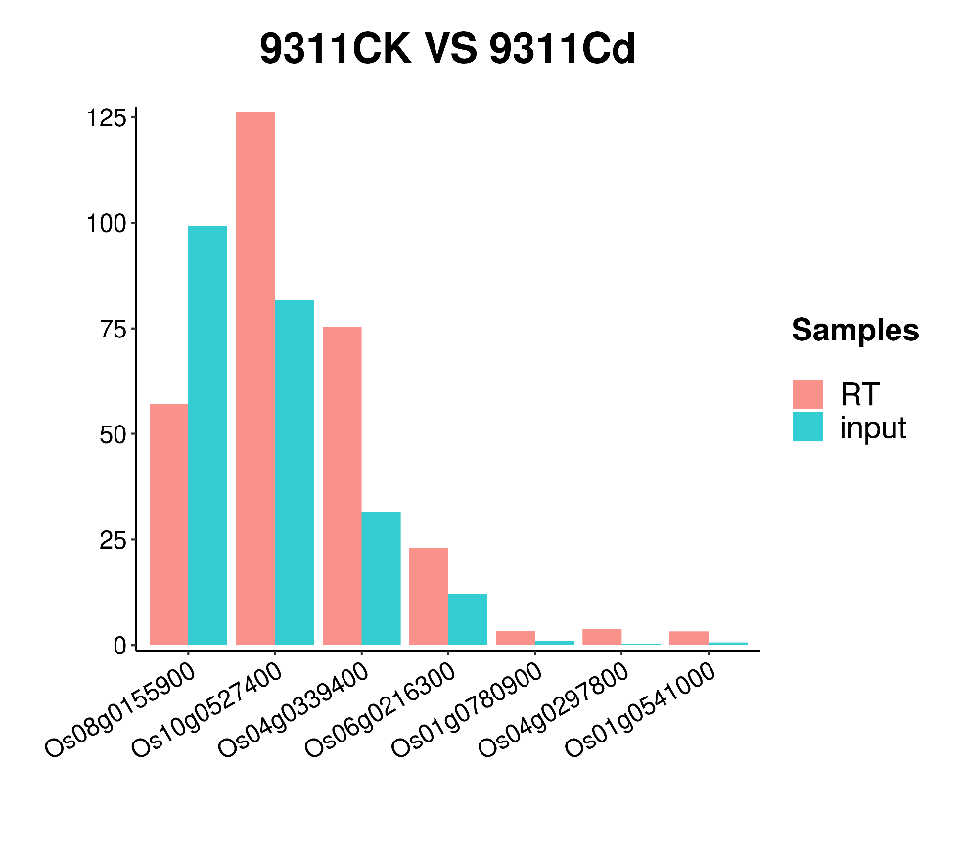
Supplementary Fig. S3. Distribution of m⁶A peaks in four experimental conditions. (A) Fractions, (B), (C)and (D) relative enrichment of m⁶A peaks in six nonoverlapping transcript segments: 5′ UTRs, start codons, CDS, stop codons, TSS and 3′ UTRs.
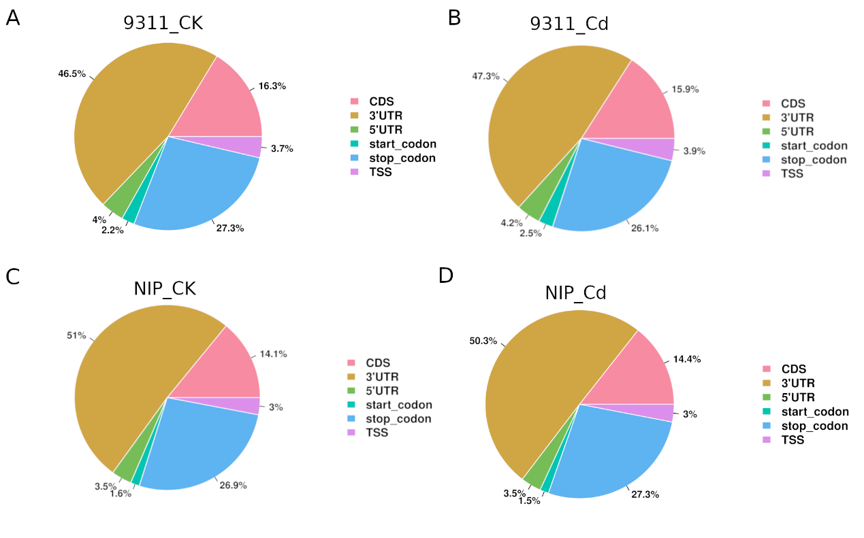
Supplementary Fig. S4 Compare the differential hcpeaks and DE genes.
(A) comparison of genes overlapping with differential hcpeaks and DE genes in cv. 9311_Cd vs cv. NIP_ Cd (B) comparison of genes overlapping with differential hcpeaks and DE genes in cv. 9311_ck vs cv. NIP_ ck.
Supplementary Table S1. Summary of reads quality control.
Sample_ID | Raw_Reads | Valid_Reads | Valid% | Q20% | Q30%
9311_Cd1_IP | 67259878 | 62242012 | 84.30 | 98.65 | 95.45
9311_Cd 2_IP | 64873816 | 59531924 | 83.49 | 98.69 | 95.51
9311_Cd 3_IP | 70384052 | 65917902 | 84.95 | 98.63 | 95.38
9311_CK1_IP | 69846630 | 63389786 | 82.76 | 98.71 | 95.56
9311_CK2_IP | 63965380 | 58954284 | 84.72 | 98.67 | 95.47
9311_CK3_IP | 57909012 | 55456780 | 87.74 | 98.59 | 95.30
NIP_Cd1_IP | 64771488 | 61246300 | 86.37 | 98.61 | 95.37
NIP_Cd2_IP | 72752356 | 59739746 | 75.07 | 98.62 | 95.40
NIP_Cd3_IP | 72721782 | 63112304 | 79.30 | 98.66 | 95.48
NIP_CK1_IP | 61690248 | 57677808 | 85.44 | 98.70 | 95.53
NIP_CK2_IP | 61453436 | 55806788 | 83.14 | 98.64 | 95.41
NIP_CK3_IP | 72714228 | 67849584 | 85.11 | 98.68 | 95.55
9311_Cd1_input | 75479226 | 73010726 | 88.88 | 97.24 | 92.01
9311_Cd2_input | 74172300 | 71837780 | 88.67 | 97.23 | 91.98
9311_Cd3_input | 72687242 | 70624020 | 89.16 | 97.10 | 91.76
9311_CK1_input | 74013554 | 71818434 | 88.74 | 97.36 | 92.25
9311_CK2_input | 76478032 | 74401868 | 89.39 | 97.26 | 92.08
9311_CK3_input | 74008778 | 71776102 | 88.69 | 97.26 | 92.04
NIP_Cd1_input | 72140082 | 70002664 | 88.72 | 97.16 | 91.88
NIP_Cd2_input | 76873534 | 74690828 | 88.50 | 97.20 | 91.96
NIP_Cd3_input | 63250858 | 60276994 | 86.94 | 98.50 | 95.28
NIP_CK1_input | 59283270 | 57255310 | 88.35 | 98.52 | 95.32
NIP_CK2_input | 60959830 | 58114726 | 86.88 | 98.49 | 95.26
NIP_CK3_input | 65929070 | 63917780 | 88.63 | 98.54 | 95.39
Supplementary Table S2. Summary of the presence of unipeaks in biological replictes of each group
Presence in replicates | 9311_Cd | 9311_CK | NIP_Cd | NIP_CK
0 | 2537 | 2890 | 2385 | 3638
1 | 1333 | 1713 | 1751 | 1391
2 | 1070 | 1304 | 1411 | 1182
3 | 7902 | 6935 | 7295 | 6631

Supplementary Table S3. Cadmlation related genes in rice. “UP” indicates that this gene is overlapping with significantly enriched m⁶A methylation peaks in the Cd treated group compared to the control group, and vice versa. “NDE” indicates that this gene is not overlapping with any significantly differential m⁶A peaks when comparing the Cd treated group with the control group.
gene | RAP_id | MSU | 9311_hcpeaks | 9311_DE_genes | NIP_hcpeaks | NIP_DE_genes
OsNAAT1 | Os02g0306401 | LOC_Os02g20360 | NDE | NDE | NDE | NDE
OsHMA4 | Os02g0196600 | LOC_Os02g10290 | NDE | UP | NDE | UP
PEZ1 | Os03g0571900 | LOC_Os03g37490 | NDE | UP | NDE | UP
OsZIP3 | Os04g0613000 | LOC_Os04g52310 | NDE | NDE | NDE | NDE
OsHsfA4a | Os01g0749300 | LOC_Os01g54550 | NDE | UP | NDE | UP
OsPDR8 | Os01g0609900 | LOC_Os01g42410 | NDE | UP | NDE | UP
OSMTI-1b | Os03g0288000 | LOC_Os03g17870 | NDE | UP | NDE | NDE
OsPCR1 | Os10g0112100 | LOC_Os10g02300 | NDE | NDE | NDE | NDE
rgMT | Os11g0704500 | LOC_Os11g47809 | NDE | NDE | NDE | NDE
RCS1 | Os12g0625000 | LOC_Os12g42980 | NDE | UP | NDE | UP
OsPCS2 | Os06g0102300 | LOC_Os06g01260 | DOWN | NDE | DOWN | NDE
OsLCD | Os01g0956700 | LOC_Os01g72670 | NDE | NDE | NDE | UP
OsCDT3 | Os01g0178300 | LOC_Os01g08300 | NDE | NDE | NDE | NDE
Ospdr9 | Os01g0609300 | LOC_Os01g42380 | NDE | UP | NDE | UP
OsWJUMK1 | Os01g0665200 | LOC_Os01g47530 | DOWN | UP | NDE | UP
OsZIP1 | Os01g0972200 | LOC_Os01g74110 | NDE | UP | NDE | NDE
OsAUX1 | Os01g0856500 | LOC_Os01g63770 | NDE | NDE | NDE | NDE
OsCDT4 | Os02g0208500 | LOC_Os02g11770 | NDE | DOWN | NDE | DOWN
OsYSL2 | Os02g0649900 | LOC_Os02g43370 | NDE | NDE | NDE | NDE
OsCDT1 | Os03g0656500 | LOC_Os03g45370 | NDE | NDE | NDE | UP
OsIRT1 | Os03g0667500 | LOC_Os03g46470 | NDE | NDE | NDE | NDE
OsIRT2 | Os03g0667300 | LOC_Os03g46454 | NDE | NDE | NDE | NDE
OsMSRMK2 | Os03g0285800 | LOC_Os03g17700 | NDE | UP | NDE | UP
OsCDT5 | Os05g0178300 | LOC_Os05g08554 | NDE | NDE | NDE | NDE
OsMTP1 | Os05g0128400 | LOC_Os05g03780 | NDE | NDE | NDE | NDE
OsHMA2 | Os06g0700700 | LOC_Os06g48720 | NDE | NDE | NDE | NDE
OsHMA9 | Os06g0665800 | LOC_Os06g45500 | NDE | UP | NDE | UP
OsLCT1 | None | LOC_Os06g38120 | NDE | NDE | NDE | NDE
OsMSRMK3 | Os06g0699400 | LOC_Os06g48590 | NDE | UP | NDE | NDE
OsABCG43 | Os07g0522500 | LOC_Os07g33780 | NDE | UP | NDE | UP
OsHMA3 | Os07g0232900 | LOC_Os07g12900 | DOWN | NDE | NDE | NDE
OsNramp1 | Os07g0258400 | LOC_Os07g15460 | NDE | NDE | NDE | NDE
OsNramp5 | Os07g0257200 | LOC_Os07g15370 | NDE | NDE | NDE | NDE
OsMAPK2 | Os08g0157000 | LOC_Os08g06060 | DOWN | UP | NDE | UP
OsHIR1 | Os08g0398400 | LOC_Os08g30790 | UP | UP | NDE | NDE
OsNramp6 | Os01g0503400 | LOC_Os01g31870 | UP | UP | NDE | NDE

Supplemental Table S4. Primers used in this study.
Primers used for qPCR
Name | Forward primer (5'-3') | Reverse primer (5'-3')
Os08g0155900 | TCTACAAGTACGGCTTCGCC | AGCTGTCGCCGTCGC
Os10g0527400 | AAGGGCCTGAGCTACGACTA | GGACCTTCTTGTGTACCGGG
Os04g0339400 | CATCGAATCGACTCCACGGT | CCACGTGAGCCCTCCTTATC
Os06g0216300 | TTCATGAAGGACAGCGCCAA | AAGTCGACGAACGGCGATAA
Os01g0780900 | GTGGGGATCCTTTGCTGAGT | AACCGTTAATCCCCATCGGC
Os04g0297800 | CCATCGTTGAAGGTTGGCTG | GTTCGAGCTCAACCCGAATG
Os01g0541000 | CGACCAGACAATCGTTTCGC | CATTTCGCTGATAGTGCGCC

Supplementary Table S5. Cd concentration for four samples(mg/kg).
9311_CK | 1.11
9311_Cd | 672.84
NIP_ CK | 0.94
NIP_ Cd | 1234.81

