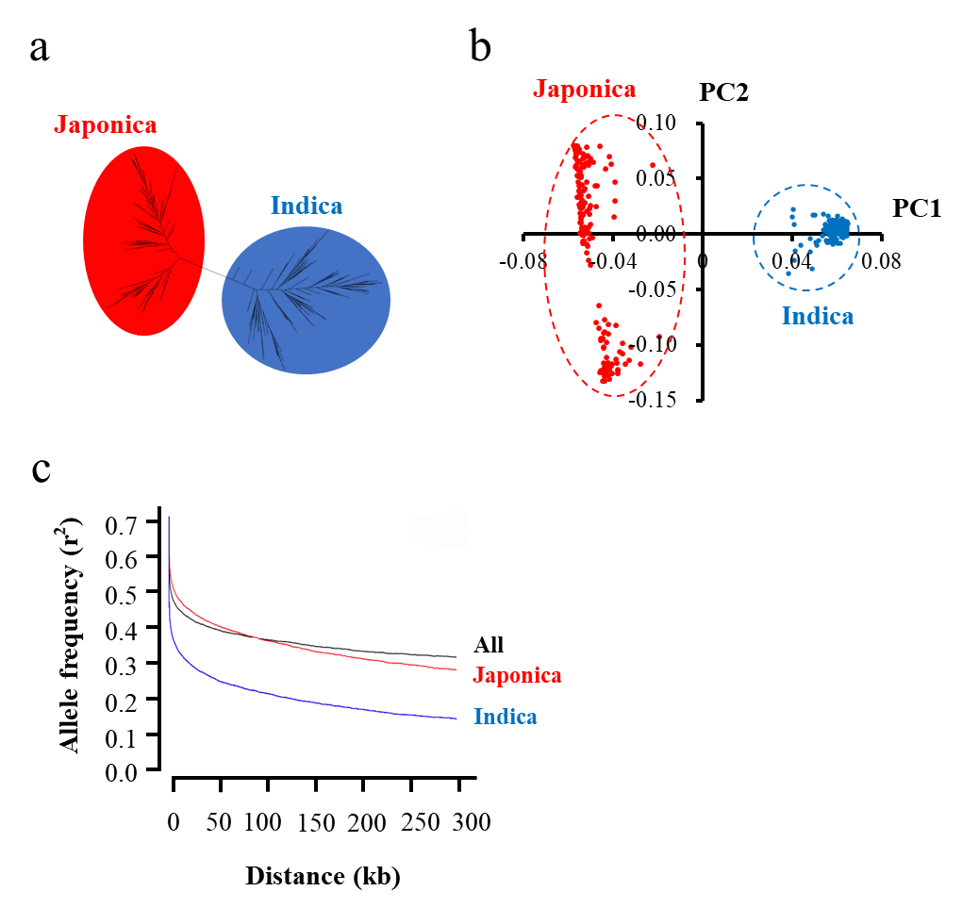
Figure S1 Population structure of 340 rice accessions, comprising 161 indica and 179 japonica varieties. a Neighbor-joining tree based on all the SNPs from 340 rice accessions. b Principal component analysis of the genotypic data. c Genome-wide average linkage disequilibrium decay for three populations using the SNP data. When allele frequency (r²) decays to half of its maximum value, the corresponding physical distance is recorded as the linkage disequilibrium (LD) attenuation distance of the whole genome.

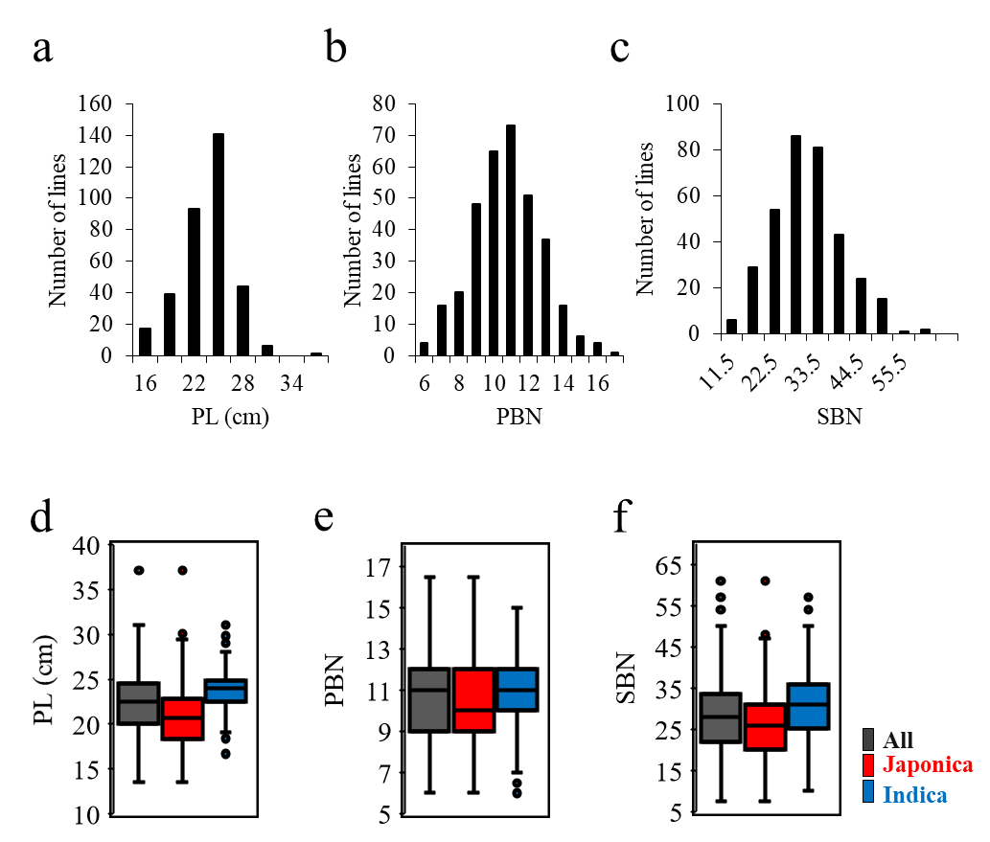
Figure S2 Panicle architecture traits of the three rice panels in 2015. a–c Distributions of a panicle length (PL), b primary branch number (PBN), and c secondary branch number (SBN) of the whole panel. d–f Box plot of the phenotypic variation of d PL, e PBN, and f SBN within the whole panel, and indica and japonica sub-panels. Boxes show median, and upper and lower quartiles. Whiskers extend to 1.5×the interquartile range, with any remaining points indicated with dots.
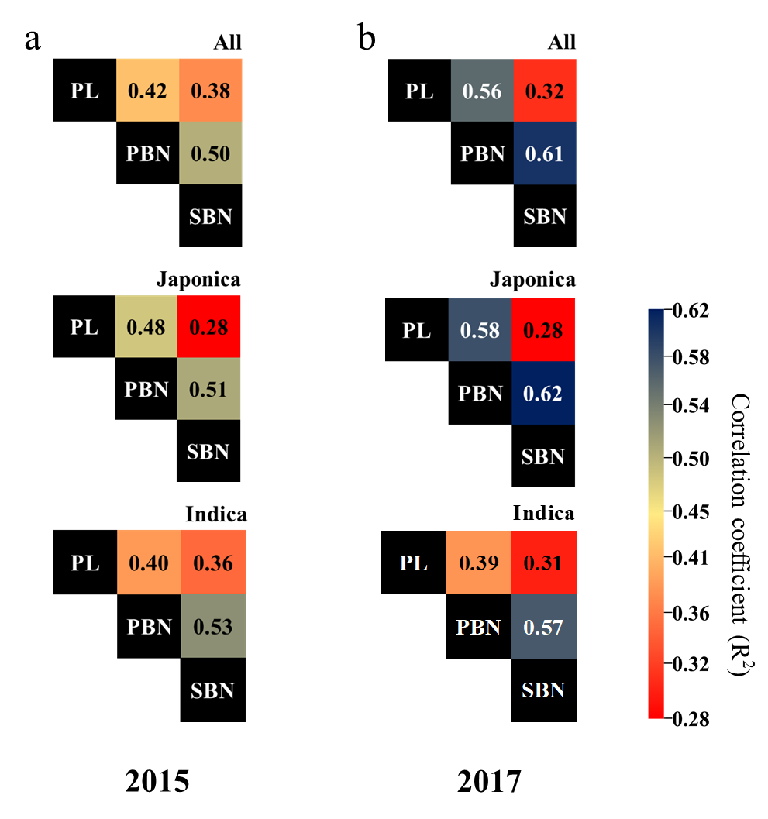
Figure S3 Correlations between PL, PBN, and SBN from each GWAS panel in a 2015 and b 2017
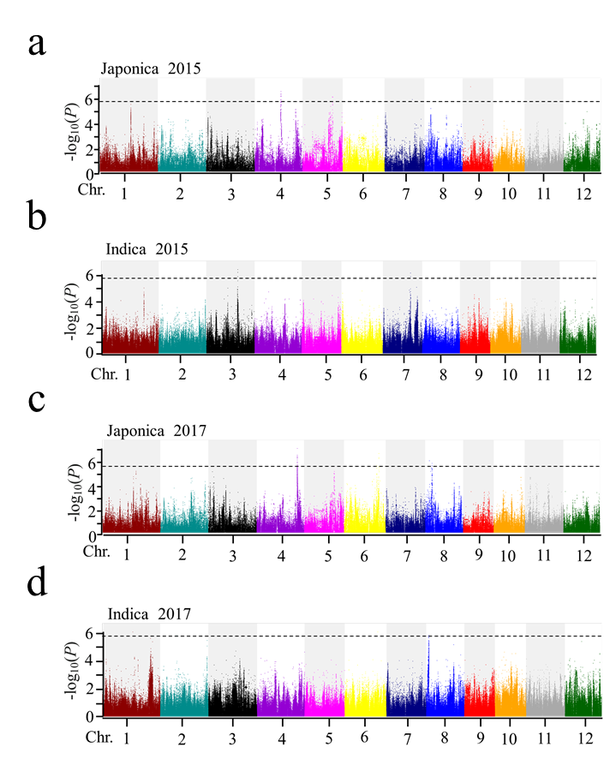
Figure S4 Manhattan plots of GWAS for panicle length in a–b 2015 and c–d 2017 for a, c japonica accessions; and b, d indica accessions. The black horizontal dashed line indicates the genome-wide significance threshold, -log₁₀(P) > 5.69.

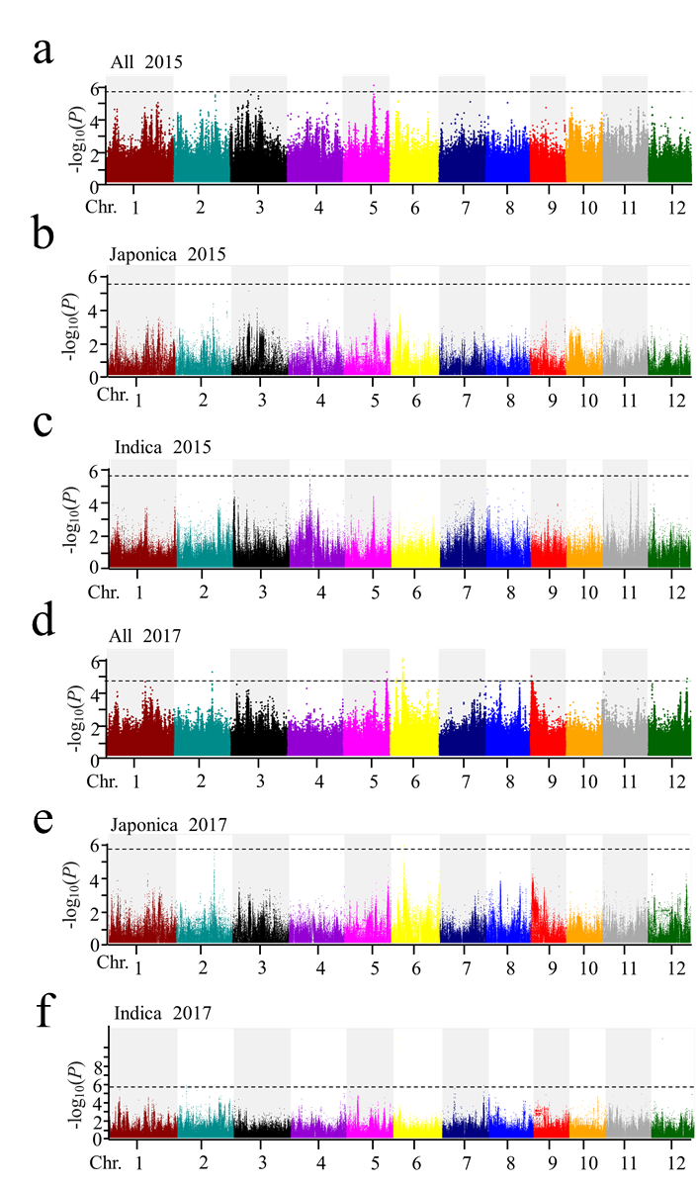
Figure S5 Manhattan plots of GWAS for primary branch number in a–c 2015 and d–f 2017 for a, d all accessions; b, e japonica accessions; and c, f indica accessions. The black horizontal dashed line indicates the genome-wide significance threshold, -log₁₀(P) > 5.69.
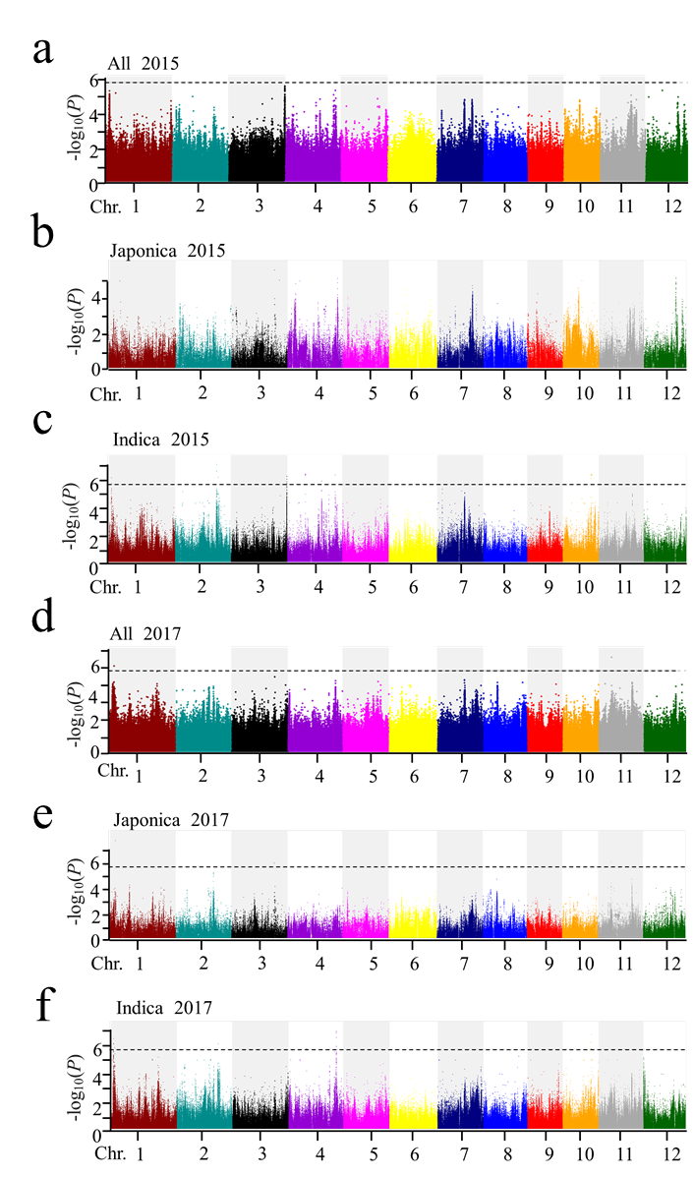
Figure S6 Manhattan plots of GWAS for secondary branch number in a–c 2015 and d–f 2017 for a, d all accessions; b, e japonica accessions; and c, f indica accessions. The black horizontal dashed line indicates the genome-wide significance threshold, -log₁₀(P) > 5.69.
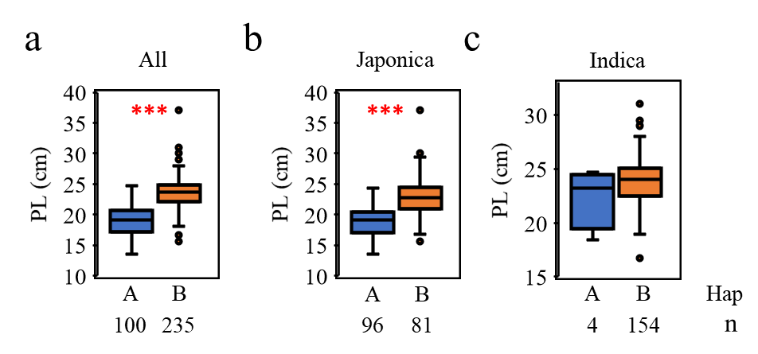
Figure S7 Panicle length (PL) in the two haplotypes of OsGRRP in a all accessions, b japonica accessions, and c indica accessions in 2015. Number of accessions (n) of each haplotype (Hap) in each panel given under the x-axis. Boxes show median, and upper and lower quartiles. Whiskers extend to 1.5× the interquartile range, with any remaining points indicated with dots. *** P<0.001 (Welch two sample t-test).

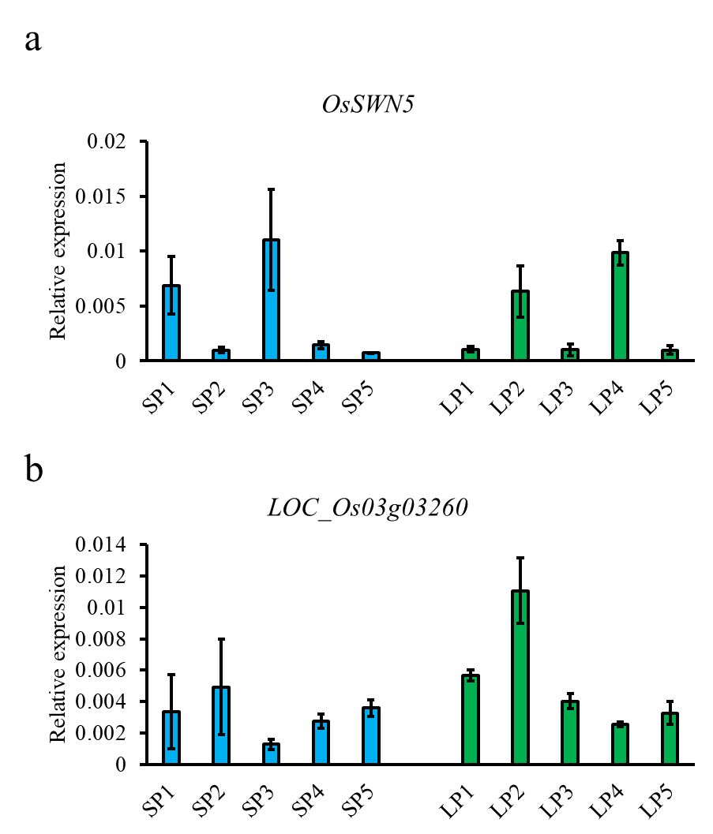
Figure S8 Relative expression of a OsSWN5 and b LOC_Os03g03260 in short panicle (SP) and long panicle (LP) accessions. SP1: IRIS_313-8085; SP2: IRIS_313-8096; SP3: IRIS_313-8099; SP4: IRIS_313-8195; SP5: IRIS_313-8048; LP1: IRIS_313-8903; LP2: B199; LP3: IRIS_313-9505; LP4: IRIS_313-7993; LP5: IRIS_313-799

