Supplementary Data

Lu et al., The PPR-domain protein SOAR1 regulates salt tolerance with potential value in crop improvement for salt tolerance in rice

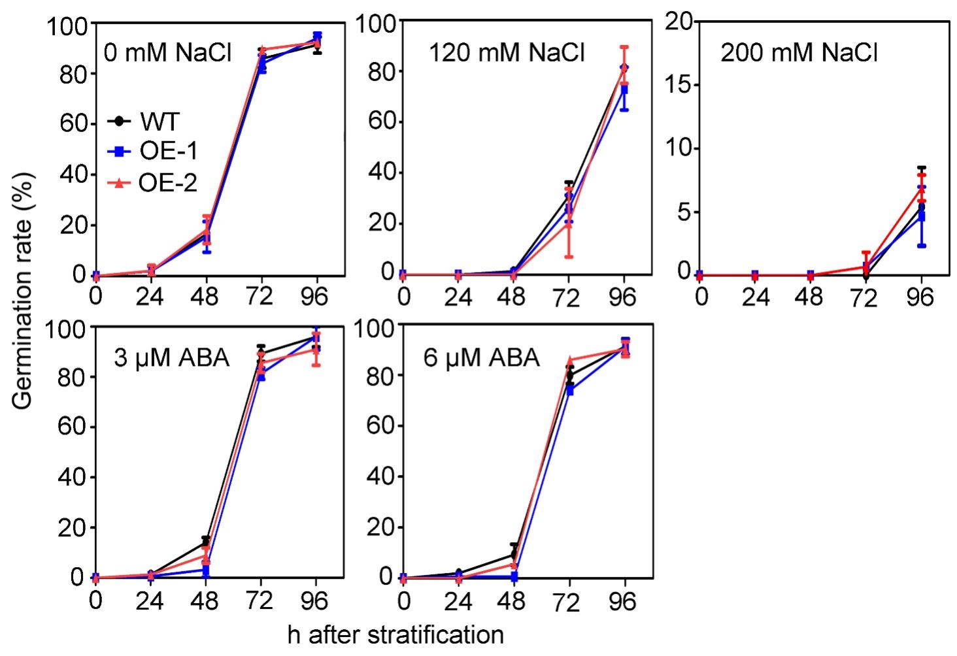

Supplementary Figure. S1. Phenotypic comparison of wild-type and AtSOAR1-transgenic plants OE-1 and OE-2 in NaCl- or ABA- induced inhibition of seed germination. Seeds of different genotypes were cultured in solutions supplemented with different concentrations of NaCl (0, 120, 200 mM NaCl) or (±) ABA (3, 6 μM). Numbers of germinated seeds were scored from 0-96 h and germination rates were calculated. All the values are means ± SE from three independent experiments.

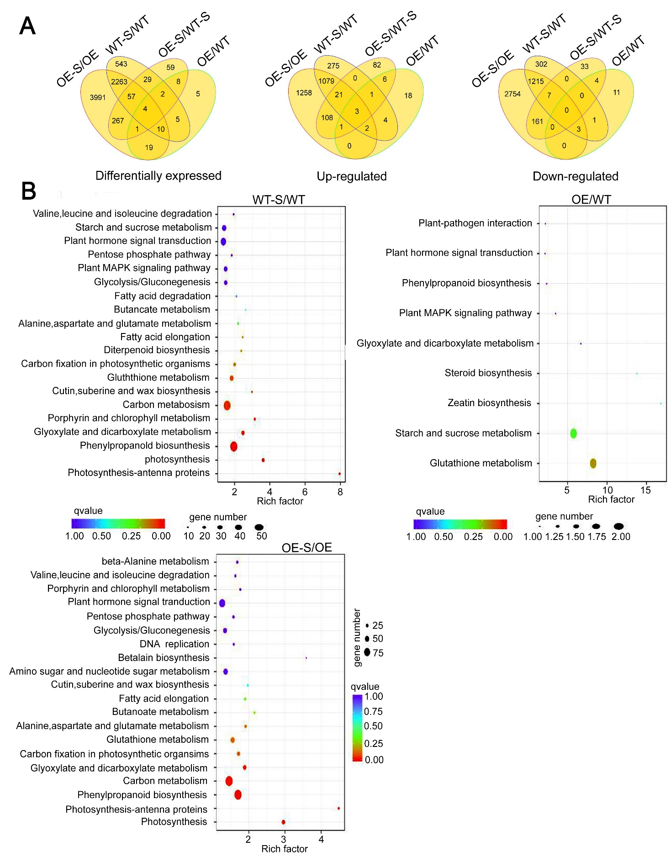

Supplementary Figure. S2. Statistics and analysis of differential expressed genes between different comparison groups. (A) Venn diagram showing the number of differential expressed-, up-regulated-, and down-regulated-genes, and the overlaps of genes between different comparison groups. (B) Statistics of pathway enrichment of differential expressed genes between different comparison groups. Upper left panel, salt-treated WT relative to WT without treatment; upper right panel, OE-1 relative to WT without treatment; lower left panel, salt-treated OE-1 relative to OE-1 without treatment.
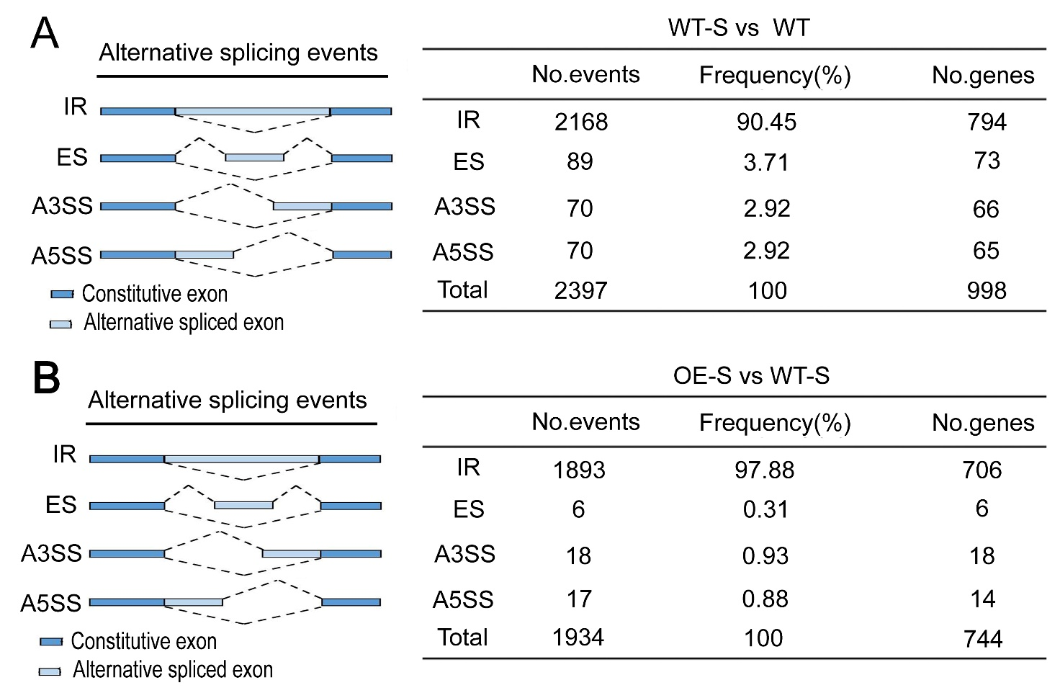

Supplementary Figure. S3. Salt-induced and AtSOAR1-mediated alternative splicing analysis. (A) Global analysis of salt-induced alternative splicing. WT, wild-type plants without NaCl treatment; WT-S, wild-type plants with NaCl treatment; OE, SOAR1-transgenic plants OE-1 without NaCl treatment; OE-S, AtSOAR1-transgenic plants OE-1 with NaCl treatment. (B) Global analysis of AtSOAR1-mediated alternative splicing.

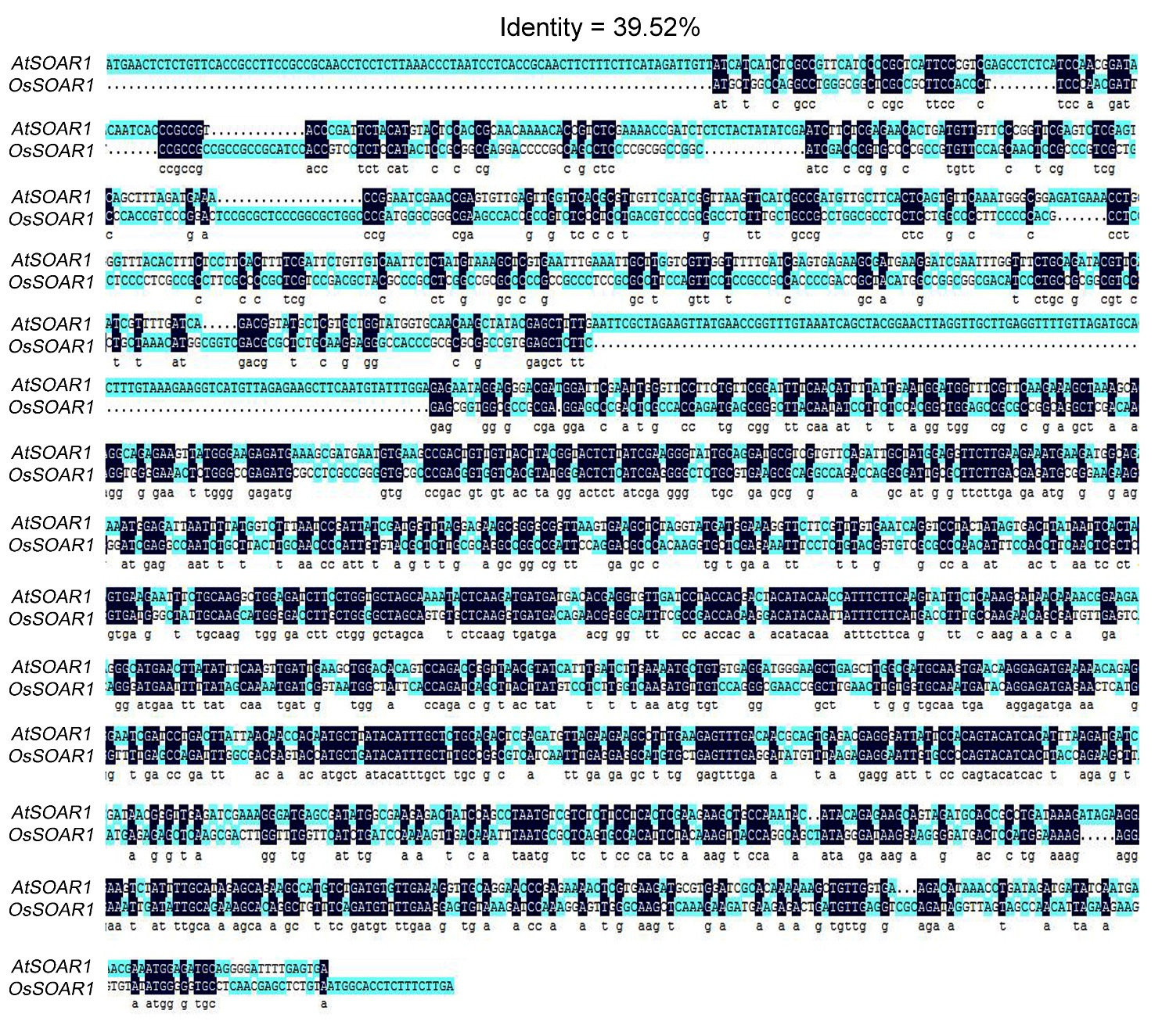

Supplementary Figure. S4. Alignment of coding sequence of AtSOAR1 and OsSOAR1. The sequences were compared using software DNAMAN4.0 version. The conserved sequences were marked by black color.

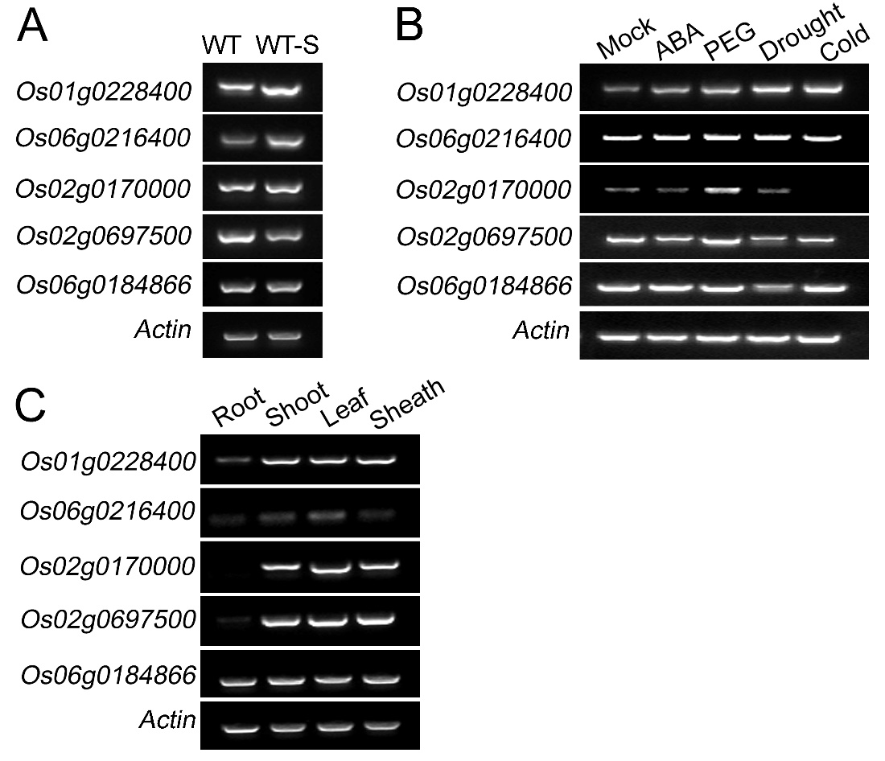

Supplementary Figure. S5. Confirmation of the expression pattern of the five salt-induced PPR genes by semi-quantitative RT-PCR. (A) Detection of the salt-induced PPR genes by semi-quantitative RT-PCR. Hydroponic cultured two-week-old seedlings were treated with 0 or 140 mM NaCl for 2d followed by RNA extraction and cDNA synthesis. WT-S, salt-treated wild-type. Actin1 was used for internal control. The experiments were repeated for three times and similar results were obtained. (B) Detection of the five salt-induced PPR genes in response to ABA, PEG, drought and cold treatment. Hydroponic cultured two-week-old seedlings were treated with 0 or 10 µM (±) ABA, 100 mM PEG and cold stress for 5 h or drought stress for 2 h. The material was collected at the indicated time and used for cDNA synthesis. Actin1 was used for internal control. (C) Detection of the expression level of the five PPR genes in different tissues by semi-quantitative RT-PCR. Actin1 was used for internal control.

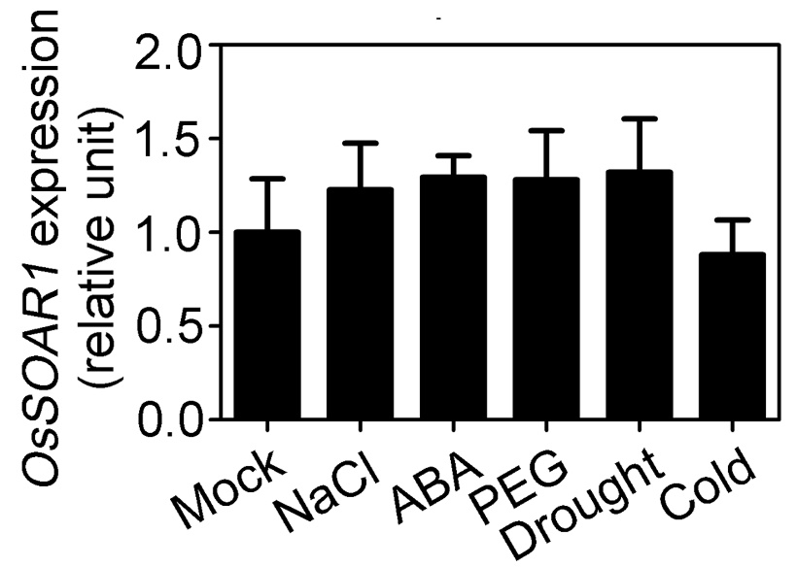

Supplementary Figure. S6. Expression pattern analysis of OsSOAR1 under abiotic stress treatments by qPCR. Hydroponic cultured two-week-old seedlings were treated with 0 or 10 µM (±) ABA, 100 mM PEG and cold stress for 5 h or drought stress for 2 h. The material was collected at the indicated time and used for total RNA extraction. Expression level of OsSOAR1 without stress treatment was taken as 1. Actin1 was used for internal control and all the values are means ± SE from three independent biological determinations.

Supplementary Table S1. Summary of the RNA-Seq data.

 | Reads | Mean Length | Clean Reads | Full-length Reads | Full-length Percentage (%)
WT-Rep.1 | 6,339,743 | 1,080 | 6,137,755 | 5,420,529 | 88.31
WT-Rep.2 | 6,742,849 | 1,038 | 6,513,108 | 5,764,424 | 88.50
WT-Rep.3 | 7,623,044 | 1,012 | 7,379,743 | 6,550,015 | 88.76
OE-Rep.1 | 7,662,826 | 945 | 7,430,128 | 6,627,106 | 89.19
OE-Rep.2 | 6,878,140 | 1,020 | 6,645,954 | 5,920,838 | 89.09
OE-Rep.3 | 7,376,458 | 1,019 | 7,152,951 | 6,377,889 | 89.16
WT-S-Rep.1 | 7,100,127 | 1,135 | 6,847,572 | 6,074,821 | 88.71
WT-S-Rep.2 | 7,450,057 | 1,014 | 7,202,940 | 6,422,619 | 89.17
WT-S-Rep.3 | 7,356,668 | 924 | 7,115,010 | 6,391,654 | 89.83
OE-S-Rep.1 | 7,377,367 | 941 | 7,131,639 | 6,456,436 | 90.53
OE-S-Rep.2 | 9,430,535 | 933 | 9,118,550 | 8,164,753 | 89.54
OE-S-Rep.3 | 9,939,527 | 882 | 9,628,084 | 8,705,262 | 90.42

Supplementary Table S2. List of differential expressed (≥ 2 fold) salt-responsive genes in AtSOAR1 expression plants compared with that of wild-type plants under NaCl treatment by GO analysis.

Gene ID |  | Gene name |  | Description | Change (log2 fold)
Os01g0184100 | HSP18.0-CII |  | Class II small heat shock protein |  | -1.82
Os01g0197700 | OsCKX2 |  | Cytokinin oxidase/dehydrogenase |  | 4.37
Os01g0225600 | LEA14 |  | late embryogenesis abundant protein, |  | -0.87
Os01g0654400 | Os01g0654400 |  | Similar to Salt tolerant correlative protein |  | -1.33
Os01g0699100 | MAPKKK63 |  | MAP kinase kinase kinase |  | -1.16
Os01g0705200 | WSI18/OsLEA14 |  | Late embryogenesis abundant protein repeat containing protein |  | -1.26
Os01g0733200 | HsfC1b |  | Heat shock factor, |  | -1.91
Os01g0839100 | OsZFP179 |  | Cys2/His2-type zinc finger protein |  | -1.64
Os01g0867300 | OsABF1 |  | bZIP transcription factor, |  | -1.03
Os01g0868000 | ERF99 |  | AP2/ERF transcription factor |  | 1.36
Os01g0884300 | OsNAC6 |  | NAC transcription factor |  | -1.01
Os02g0662000 | RCc3 |  | Root-specific RCc3 protein |  | -2.07
Os02g0669100 | OsLEA23 |  | SK3-type dehydrin |  | -0.82
Os03g0168100 | LEA16 |  | Late embryogenesis abundant protein repeat containing protein |  | -1.82
Os03g0179400 | RLCK103 |  | Drought-inducible receptor-like cytoplasmic kinase |  | -2.01
Os04g0534600 | PEX11-4 |  | Peroxisomal protein |  | -1.63
Os04g0554500 | HYPRP6 |  | Hybrid proline-rich protein |  | -2.39
Os04g0560600 | CDPK12 |  | Calcium-dependent protein kinase |  | 2.59
Os04g0648900 | ERF8 |  | Similar to Dehydration responsive element binding protein 2F (DREB2F protein) |  | -1.40
Os04g0659300 | OsRMC |  | Receptor-like protein |  | -1.77
Os05g0111300 | OsMT2b |  | Metallothionein, Reactive oxygen species (ROS) scavenger protein |  | 2.64
Os05g0381400 | AWPM-19 |  | AWPM-19-like protein |  | -1.98
Os05g0572700 | ABI1 |  | Similar to protein phosphatase 2C ABI1 |  | -1.15
Os07g0500300 | OsGAP |  | C2-domain abscisic acid-related protein, CAR protein |  | 1.01
Os08g0537900 | OsERF106 |  | ethylene-responsive factor |  | -1.41
Os08g0546800 | HSFB2B |  | Class B heat shock factor |  | -1.40
Os10g0419300 | HsfA6a |  | Heat stress transcription factor |  | -0.77
Os10g0529500 | OsGSTU30 |  | Tau class glutathione S-transferase |  | 0.85
Os11g0117600 | WRKY50 |  | WRKY transcription factor |  | 2.20
Os11g0211800 | OsDT11 |  | Cysteine-rich peptide |  | 2.40
Os11g0592200 | PR4 |  | Pathogenesis-related (PR) protein, |  | 0.92
Os12g0435200 | NCED2 |  | Carotenoid-cleavage dioxygenase |  | 1.08
Os12g0555000 | RSOSPR10 |  | Root-specific pathogenesis-related (PR) protein |  | 0.80

Supplementary Table S3. PCR primers used in this study.
- Primers for generating the transgenic lines
Primer Name | Sequence（5'-3'）
OE-AtSOAR1-F | CGGGATCCATGAACTCTCTGTTCACCGC
OE-AtSOAR1-R | GGGGTACCCTCAAAATCCCCTGCAT
OE-OsSOAR1-F | TTAATTAAATGCTGGCCAGGCCTGGGCG
OE-OsSOAR1-R | GGCGCGCCAAGAAAGAGGTGCCATTACAGAG
- Primers for RT-PCR
Primer Name | Sequence（5'-3'）
RT-Os01g0889200-F | ATGTGAATCTTCCATCCATCCAG
RT-Os01g0889200-R | CATTTTGCCCAAATATCCTTGTG
RT-Os12g0532500-F | ACTCTTGCAGGTGGATGCACAT
RT-Os12g0532500-R | GTCATCAATTGTGGTGTGGTCG
RT-Os08g0220600-F | CGAAACAAACAATAATCTGGAAGCG
RT-Os08g0220600-R | TGTGAACAGCCAAAAGGCAAAA
RT-Os07g0418000-F | CGAAACAAACAATAATCTGGAAGCG
RT-Os07g0418000-R | TGTGAACAGCCAAAAGGCAAAA
- Primers for qPCR
Primer Name | Sequence（5'-3'）
qPCR-Actin1-F | GATGACCCAGATCATGTTTG
qPCR-Actin1-R | GGGCGATGTAGGAAAGC
qPCR-AtSOAR1-F | TACGGAACTTAGGTTGCTTGAG
qPCR-AtSOAR1-R | AACAACAGTCGGCTTCACATTC
qPCR-OsSOAR1-F | GAGCGGGCTTACAATATCCTTCTC
qPCR-OsSOAR1-R | CAAGAGCGTACACAATGGGGTT
qPCR-ABI3-F | CCCAACAACAAAAGCAGGAT
qPCR-ABI3-R | CCTTTGTATTGGACGAGACG
qPCR-RAB16A-F | CAGCTCAAGCTCGTCTGA
qPCR-RAB16A-R | GCTTCTCCTTGATCTTCTCCTT
qPCR-RAB21-F | CACACCACAGCAAGAGCTAAGTG
qPCR-RAB21-R | TGGTGCTCCATCCTGCTTAAG
qPCR-OsWRKY50-F | GGGTATCAATGGAGGAAGTATGGTC
qPCR-OsWRKY50-R | GGTTGTTGGTAGTACGGACGGT
qPCR-OsNAC6-F | GAGATGAGGACTCGAGAAAGGC
qPCR-OsNAC6-R | GTAATAATTAACCAATGAAGAAACAGAAACAG
qPCR-ERF8-F | ATAAGAACAAGGGAAGGGCAGC
qPCR-ERF8-R | GGAGAAGAGAGAGAGGAAAAAAAAACA
qPCR-Os01g0228400-F | GTTAGAGGAGGCCATCTTGTGTTGT
qPCR-Os01g0228400-R | ACATAAACATATTTCCCAGTCTTCCTTC
qPCR-Os06g0216400-F | GGAGCTTTTCGATTGTATGGGC
qPCR-Os06g0216400-R | CGTCTGTTGCTGCACTGTCTGT
qPCR-Os02g0170000-F | TGAAAGGAAGAACAGGAAATACAACG
qPCR-Os02g0170000-R | CGACATTCACAAGATCATCAAAAAGA
qPCR-Os02g0697500-F | GCCGGCGACTACATAATCCTCT
qPCR-Os02g0697500-R | ACTCCATCTGGTGCAGCATCTC
qPCR-Os06g0184866-F | ATGCTTTTCTCTACTACTCCACTCTACTTGTC
qPCR-Os06g0184866-R | CACTCCTCCTGCTTCTTCTCCTC
- Primers for semi-quantitative qPCR
Primer Name | Sequence（5'-3'）
RT-Actin1-F | GATGACCCAGATCATGTTTG
RT-Actin1-R | GGGCGATGTAGGAAAGC
RT-OsSOAR1-F | CATCCACCGTCCTCTCCATACTC
RT-OsSOAR1-R | AATGCCCCGTTCTGTCATCAC
RT-ABI3-F | TCCAGAATCCCCTATCAAACAAGC
RT-ABI3-R | GAGTAGATCACAATGAAATCACCCTCCT
RT-RAB16A-F | CTCCAGCTCAAGCTCGTCTGA
RT-RAB16A-R | TTGTCCATGATGCCCTTCTTCT
RT-RAB21-F | CACCTTCACCTGCTTGCACA
RT-RAB21-R | GCCATCACACATTCACACTCATC
RT-OsWRKY50-F | TCAAGGCAGCCAAAGAGTAAAAGG
RT-OsWRKY50-R | GATGTGCATGGAGTAGGGAAGGTC
RT-OsNAC6-F | ACGAGGAGCTGGTGATGCACTAC
RT-OsNAC6-R | CTGAGGCTGTTCTTCTTGCGG
RT-ERF8-F | CTGCTTCTGCTGCTGCTGCT
RT-ERF8-R | CGACCTCGATGGCCTTCTTC
RT-Os01g0228400-F | GTTAGAGGAGGCCATCTTGTGTTGT
RT-Os01g0228400-R | ACATAAACATATTTCCCAGTCTTCCTTC
RT-Os06g0216400-F | GGCTGCTCTTTCTCCTCTTCCC
RT-Os06g0216400-R | CATCTCCACATGATCCCACCTCT
RT-Os02g0170000-F | CATTCCTTCCACACACAATCTTTT
RT-Os02g0170000-R | TTTTCGGTACATCTTGCCTTCA
RT-Os02g0697500-F | GCCGGCGACTACATAATCCTCT
RT-Os02g0697500-R | ACTCCATCTGGTGCAGCATCTC
RT-Os06g0184866-F | CTACTCCACTCTACTTGTCACGTGTTTTG
RT-Os06g0184866-R | CCTCCTGCTTCTTCTCCTCCAG

