Additional file 1: Supplemental Figures
Figure S1. Homology analysis of OsSAP proteins
The amino acid sequence homology of the 18 OsSAP proteins was aligned by BioEdit software.

Figure S2. Phylogenetic analysis of OsSAP proteins
The amino acid sequence homology of 18 OsSAP proteins was grouped by the neighbor-joining method phylogenetic analysis results, a bootstrap method with 1,000 replications was used for test of phylogeny. Scale bar indicates 0.2 amino acid substitution per site.

Figure S3. Subcellular localization of OsSAP6-GFP at other excitation wavelengths
OsSAP6-GFP were observed at blue excitation group (383nm), red excitation group (587nm) and merge of green and red excitation group. Bar, 50 μm.

Figure S4. Identification of OsSAP6 overexpression lines.
A. The integration of OsSAP6 into the genome of Lj11 in OsSAP6-overexpressing lines T0 was detected by PCR with specific primers. B. The relative expression of OsSAP6 in seedlings of T3 generation transformed lines was measured using qRT–PCR. The values of Lj11 are set as 1. Values are mean ± SD; n = 3. Statistical analyses were performed using Student’s t test: *p < 0.05, **p < 0.01.

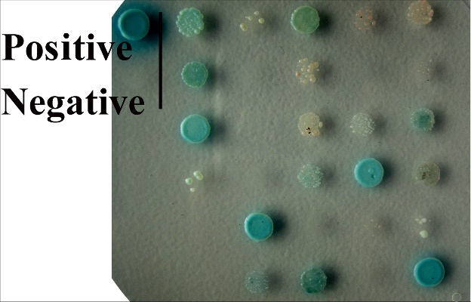
Figure S5. Colonies interacting with OsSAP6 protein in the rice cDNA library
To identify the interactors of the OsSAP6 protein, a yeast two-hybrid system was used to preliminarily screen out a total of 16 colonies that turned blue on SD/‐Trp‐Leu-His containing X‐α‐gal. Four genes were identified according to Y2H assay, namely 2-phospho-D-glycerate hydrolase (PGH2, AK099342), voltage-dependent anion channel (VDAC1, AK071833), pyruvate kinase 5 (PK5, EU267984) and probable plastid-lipid-associated protein 2 (PAP2, AK104742). These proteins include proteins responsible for regulating ion channels and enzymes, and may cooperate with OsSAP6 proteins to participate in abiotic stress response mechanisms.

Figure S6. Expression of OsPK5 in response to NaHCO₃ and H₂O₂ stress in rice
qRT–PCR detected OsPK5 expression in leaves and roots of Lj11 treated with 60 mM NaHCO₃ and 5 mM H₂O₂ stress. The values of 0 h (control) are set as 1. Values are mean ± SD; n = 3. Statistical analyses were performed using Student’s t test: *p < 0.05, **p < 0.01.

Figure S7. Expression of OsCu/Zn-SOD, OsAPX2 and OsCAT1 in OsPK5 overexpression rice under soda saline-alkaline stress.
7-day-old OsPK5 overexpression lines and Lj11 seedlings were treated with different ratios of SAE (H₂O:SAE=4:1, 3:1, and 2:1, water as a control) for 7 days. The expression levels of OsCu/Zn-SOD, OsAPX2 and OsCAT1 were detected by qRT–PCR. The expression level of Lj11 was set to 1, and the Os18sRNA gene was used as an internal reference control. Values are the mean ± standard deviation of three replicates. Statistical differences are labeled with different letters using Duncan test (p < 0.05, one-way ANOVA).

