Additional information
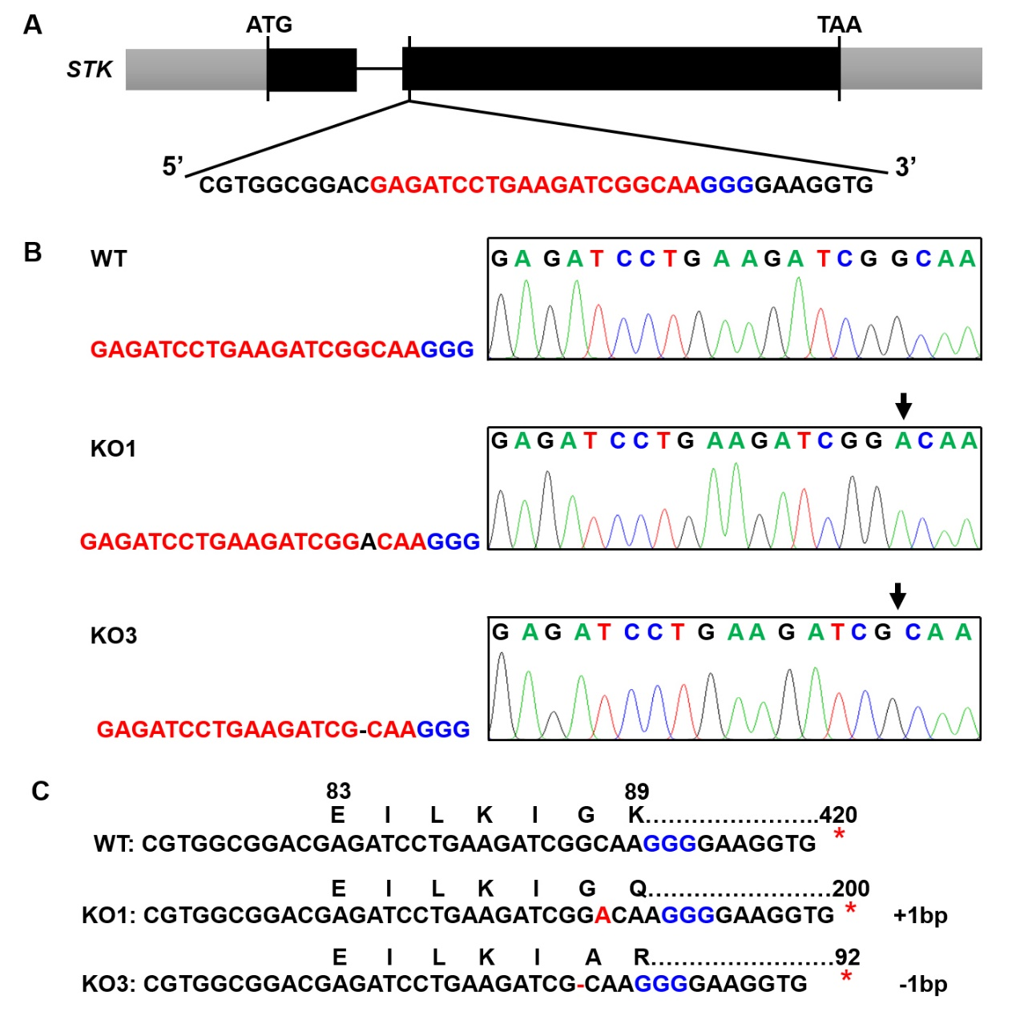
Fig. S1 Identification of CRISPR/Cas9-STK rice mutant plants. A: Schematic of the STK gene structure and target site. Exons and introns are indicated with black rectangles and black lines, respectively. The spacer and PAM sequences were marked in red and blue. B: Homozygous mutations identified at the target site of STK-KO plants in the T₁ generation. C: Amino acids of STK in STK-KO plants. Amino acids were marked above the relative nucleotide triplets, and the first altered ones from the frameshift were indicated in red, with the number representing the order in the proteins. The stars represent premature stop codons.

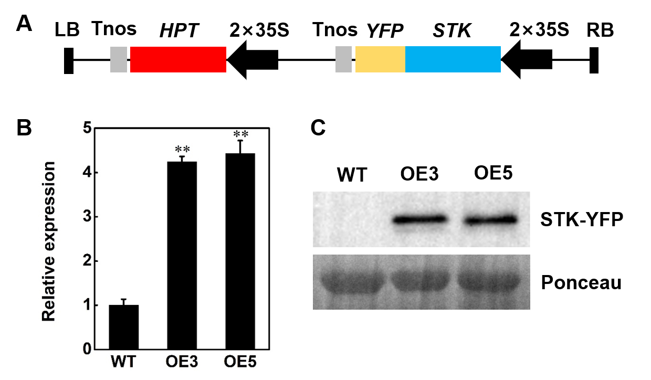
Fig. S2 Characterization of STK overexpression (STK-OE) plants. A: Schematic representation of the overexpression constructs used for STK-OE assay. B: RT-qPCR analysis of STK transcript levels in wild-type, OE3 and OE5 plants. The ACTIN gene was amplified as a control. Data are presented as mean ± SD (n = 3, **P ≤ 0.01, Tukey’s test). C: Western blot analysis of the STK-YFP protein in wild-type (WT), OE3 and OE5 plants using anti-GFP antibody.

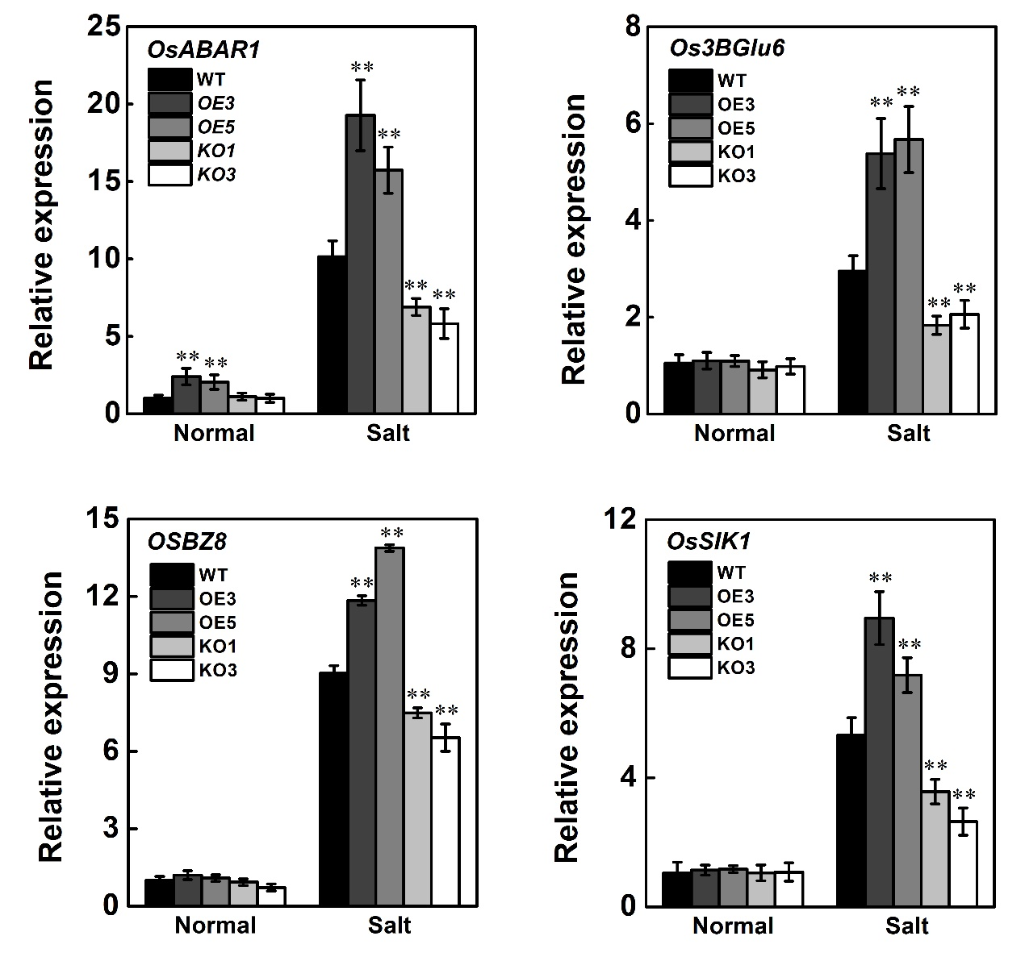
Fig. S3 Relative expression levels of four previously known stress-related genes up-regulated in STK-OE pants and down-regulated in STK-KO plants at 48 h under salt stress condition in rice seedlings. Values are means ± SD (n = 3, **P ≤ 0.01, Tukey’s test).

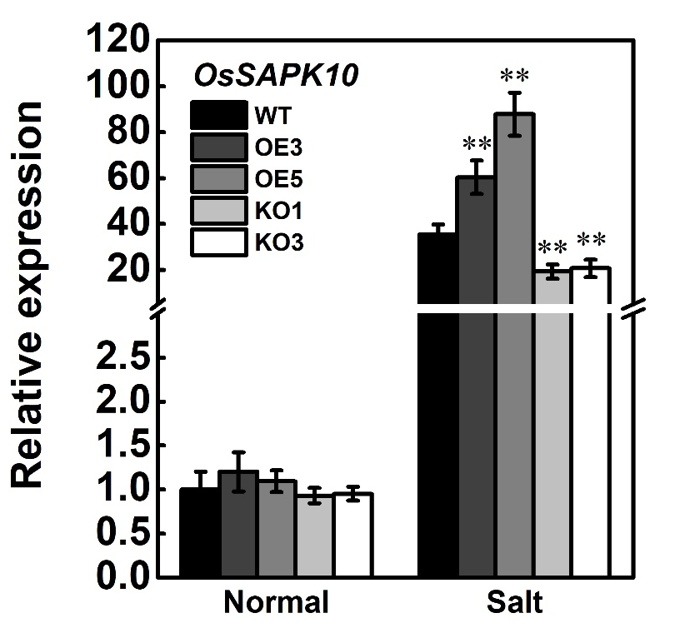
Fig. S4 Relative expression levels of OsSAPK10 in leaves of wild-type, STK-OE and STK-KO plants under salt stress condition. Values are means ± SD (n = 3, **P ≤ 0.01, Tukey’s test).

