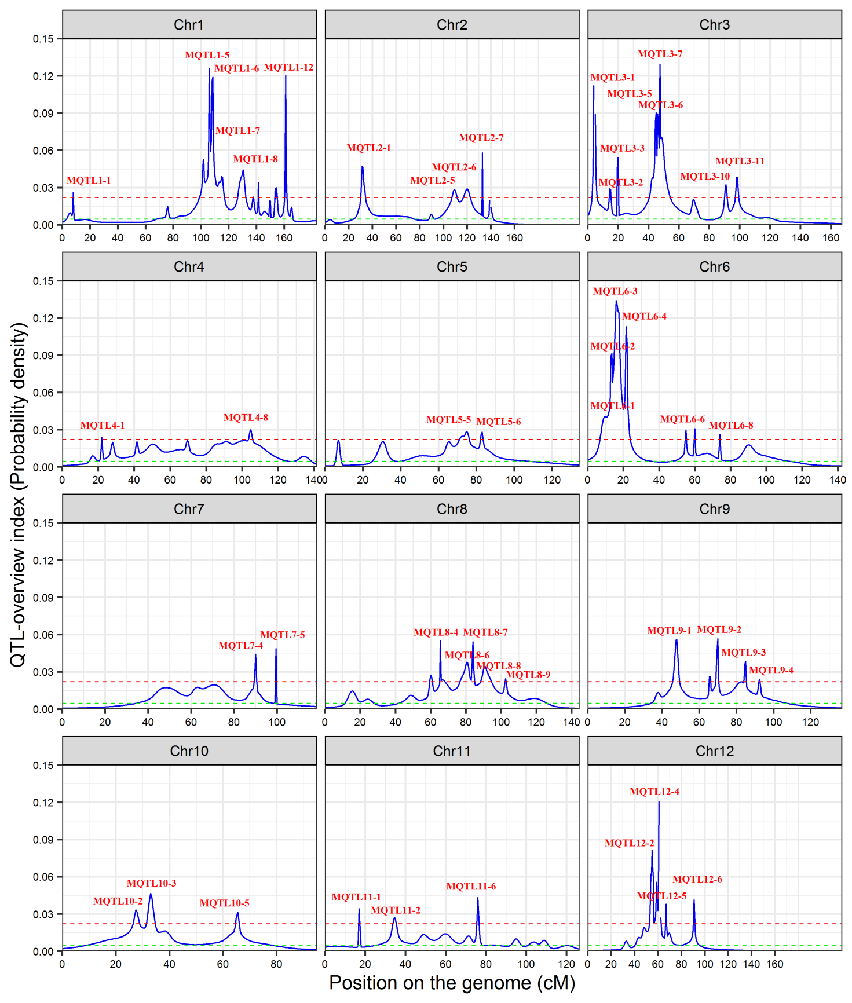
a

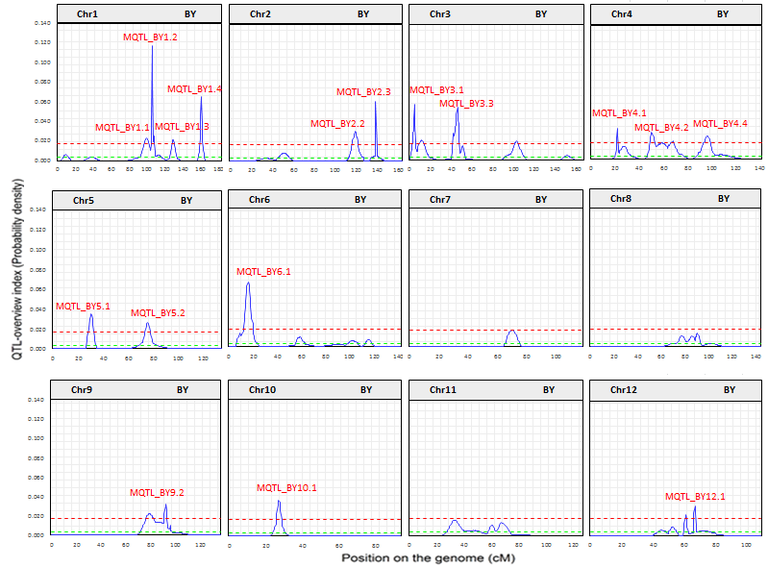
b

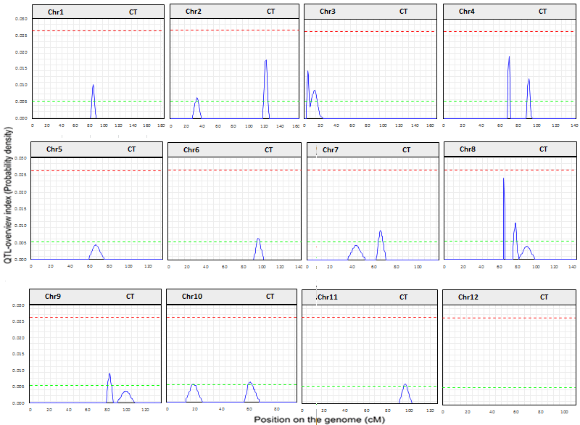
c
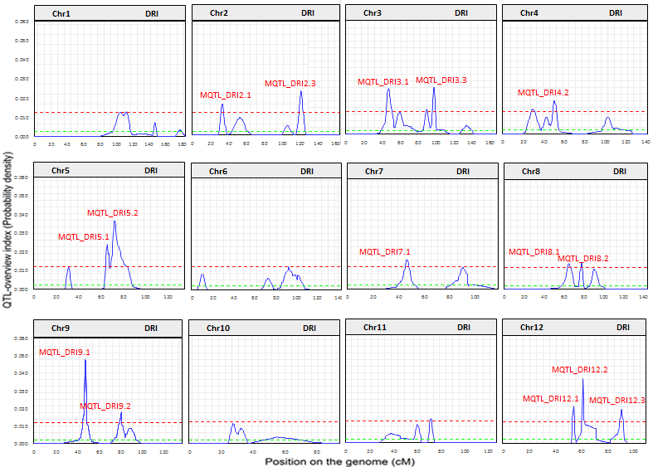
d

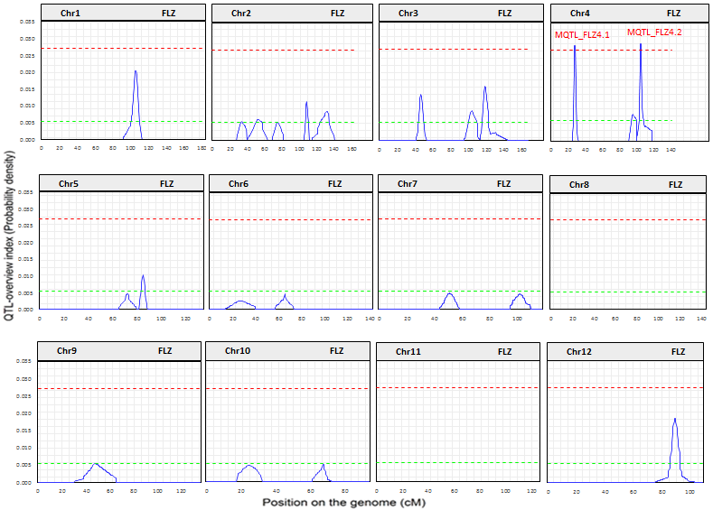
e
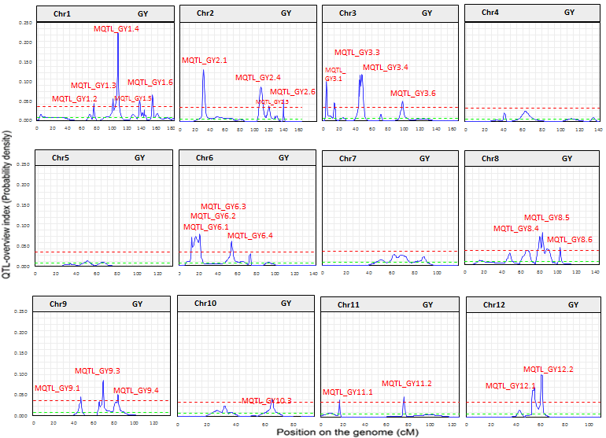
f

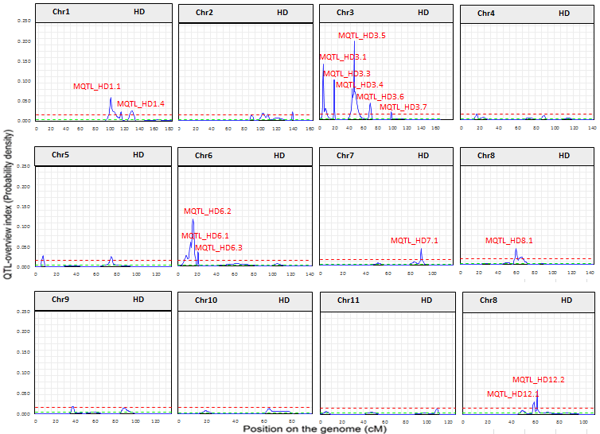
g

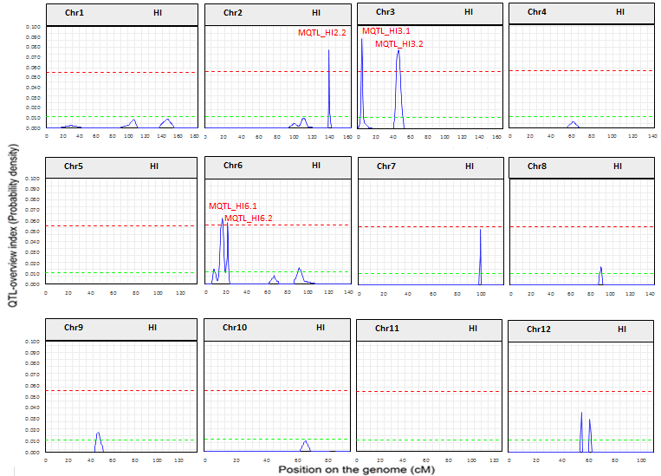
h

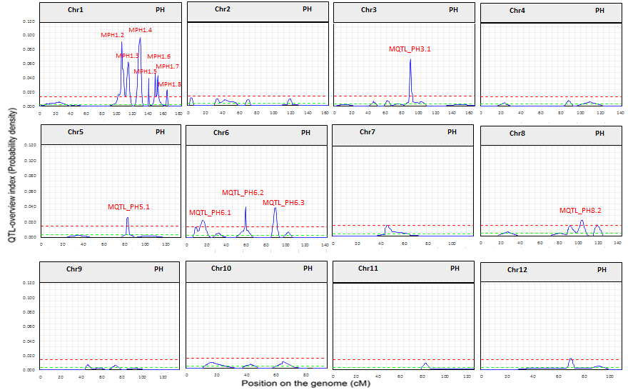
i

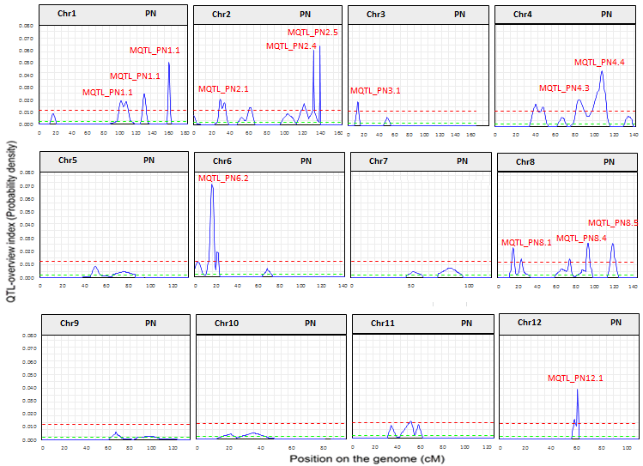
j

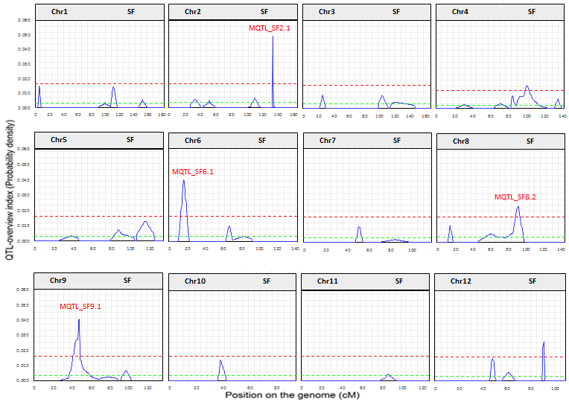
k
Supplementary Figure S2. QTL-overview index of yield and DT-associated traits on the consensus genetic map of rice. A total of 1087 initial QTLs from 76 independent studies were used for the analysis. Green and red horizontal lines show the average index (real QTLs) and high-value threshold (QTL hotspot), respectively. The position of the 49 "QTL hotspot" areas are indicated by upper labels. a; QTL-overview index for all the studied traits, b; QTL-overview index for BY, c; QTL-overview index for CP, d; QTL-overview index for DRI, e; QTL-overview index for FLZ, f; QTL-overview index for GY, g; QTL-overview index for HD, h; QTL-overview index for HI, i; QTL-overview index for PH, j; QTL-overview index for PN, k; QTL-overview index for SF.
b

