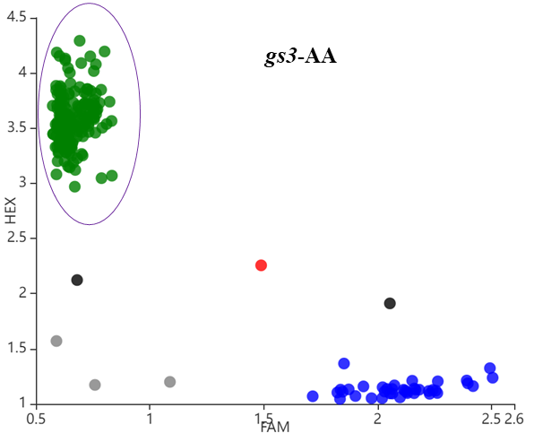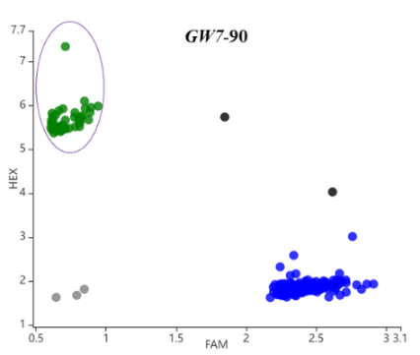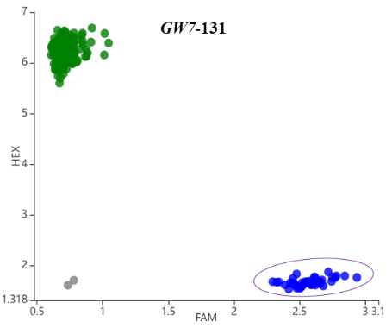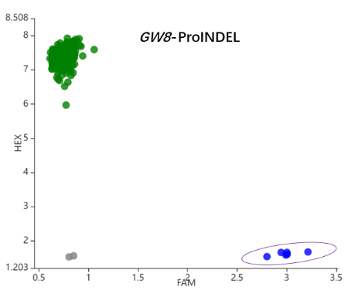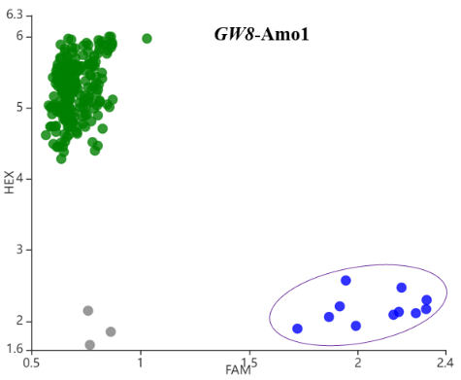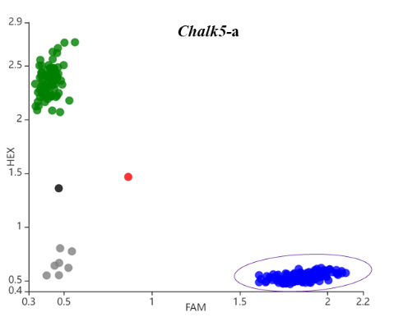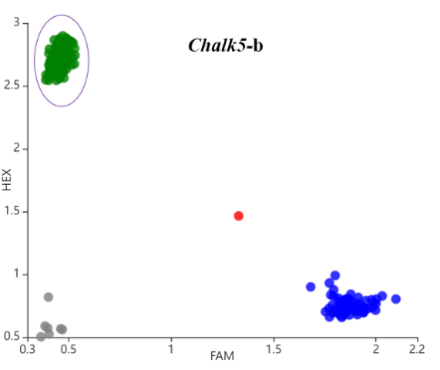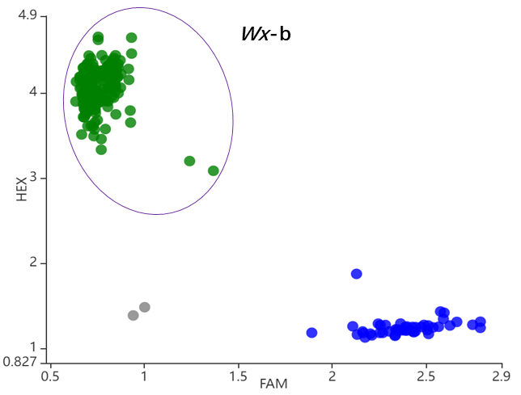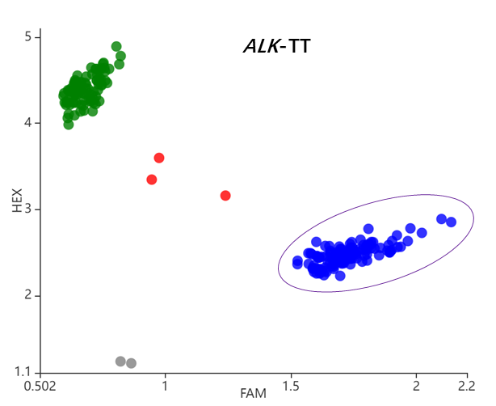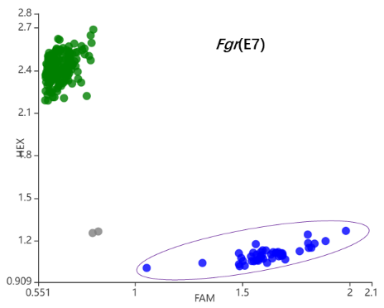
Supplementary Figure S1. Development of functional molecular markers of targeted genes. Excellent allele genotyping is shown in purple circles.

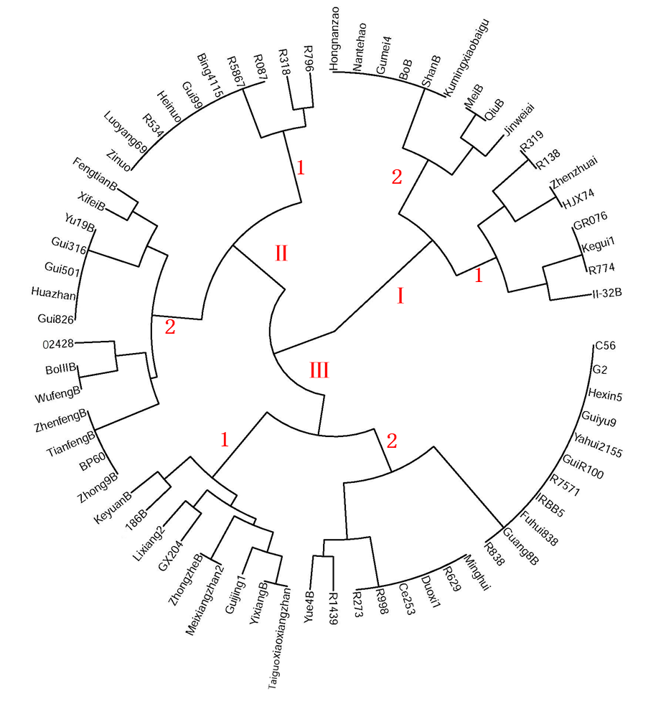
Supplementary Figure S2. Phylogenetic tree of these 69 parental lines. Symbols I, II, and III represent the three major branches of the phylogenetic tree, and numbers 1 and 2 represent the small branches on each major branch

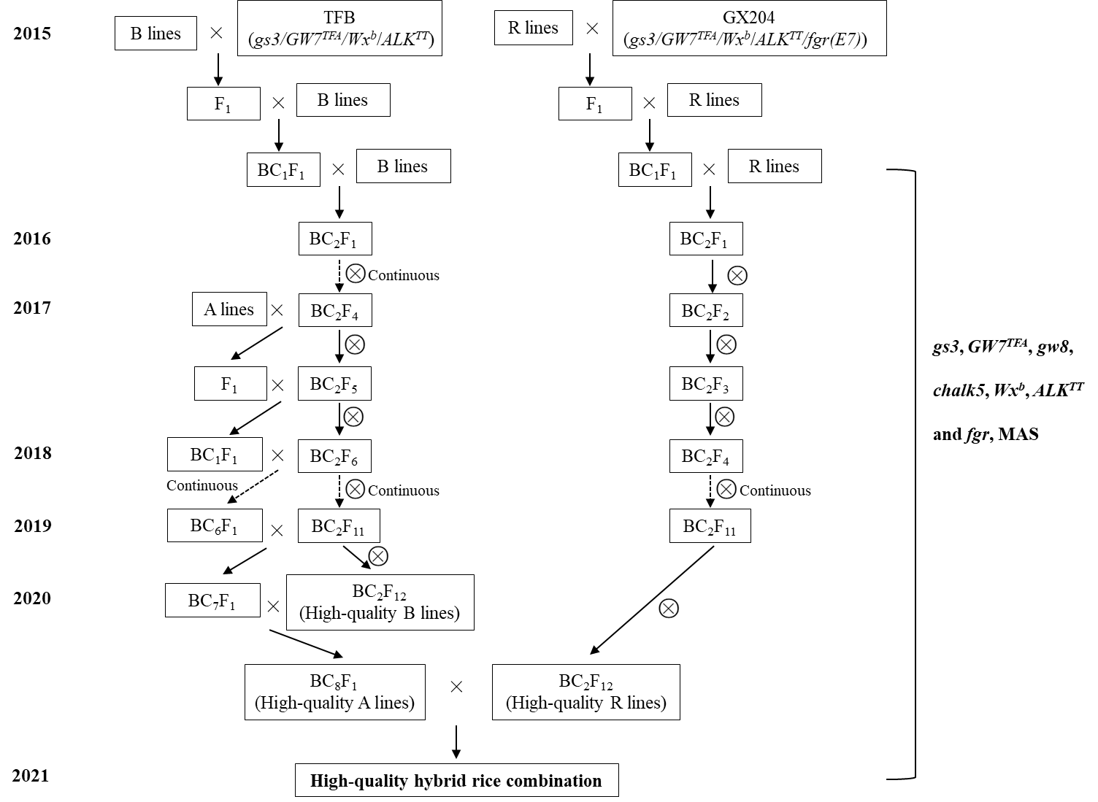
Supplementary Figure S3. Molecular design breeding schedule. The maintainer lines (B lines) and restorer lines (R lines) of CMS lines were selected as the recurrent parents, TFB and V204 were chosen as donor parents for B lines and R lines of CMS lines, respectively.

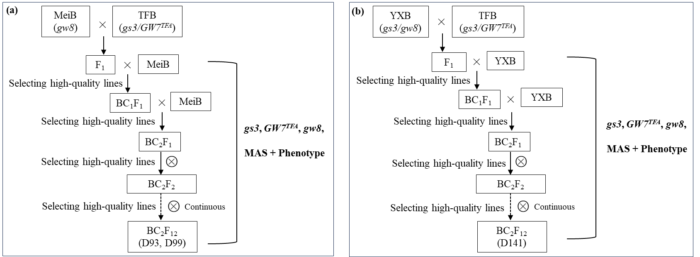
Supplementary Figure S4. The breeding flow chart for improving grain shape in MeiB and YXB. MeiB and YXB were selected as the recurrent parents, TFB was chosen as donor parents.

