Genomic regions and molecular markers associated with deeper rooting to improve grain yield in aerobic rice (Oryza sativa L.) production systems

Wenliu Gong^{1†}, Ricky Vinarao^{1†*}, Christopher Proud^{1, 2}, Shona Wood¹, Peter Snell³, Shu Fukai¹, and Jaquie Mitchell¹

¹ The University of Queensland, School of Agriculture and Food Sustainability, Brisbane, QLD 4072, Australia
² Rice Breeding Australia, Leeton, NSW 2705, Australia
³ Rice Research Australia Pty Ltd, Jerilderie, NSW 2716, Australia
* Corresponding author: Ricky Vinarao, r.vinarao@uq.edu.au

Supplementary Data

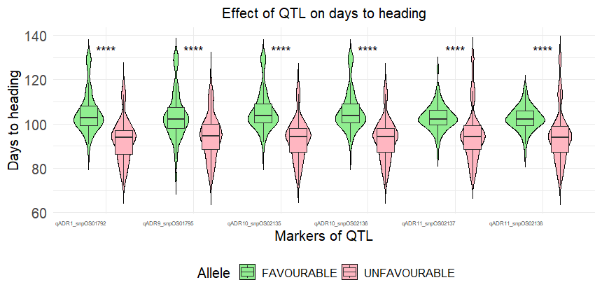
Fig. S1 Effect of identified deep rooting QTL on days to heading in the validation set between groups with favourable and unfavourable alleles. Validation set included Experiment 3 – 6 (n = 230); Significance levels between groups are displayed on the top of each figure: ****, p<0.001

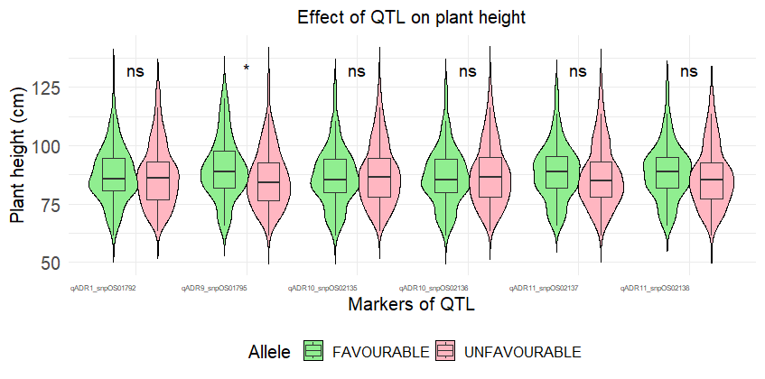
Fig. S2 Effect of identified deep rooting QTL on plant height in the validation set between groups with favourable and unfavourable alleles. Validation set included Experiment 3 – 6 (n = 230); Significance levels between groups are displayed on the top of each figure: *, p<0.05; ns – not significant

Supplementary Table S1 Summary statistics for whole genome resequencing analysis of 12 selected genotypes using Illumina
Genotype | Criteria
Genotype | QC Passed | Duplicates | Mapped | Properly Paired | Duplicates (%) | Mapped (%) | Properly Paired (%) | Depth of Coverage
Bluebelle | 32888862 | 1501482 | 31400678 | 30203779 | 4.6 | 100 | 91.8 | 6.7
IRAT109 | 109016734 | 7562638 | 104471105 | 99387811 | 6.9 | 100 | 91.2 | 22.1
Kyeema | 79687602 | 5517104 | 78024690 | 59795342 | 6.9 | 97.9 | 75 | 23.2
Kinandang Patong | 64277124 | 3754391 | 61942321 | 56714663 | 5.8 | 100 | 88.2 | 12.6
Labelle | 68682620 | 4521558 | 66701532 | 49235864 | 6.6 | 97.1 | 71.7 | 19.1
M205 | 63152748 | 3927742 | 61969671 | 50045736 | 6.2 | 98.1 | 79.2 | 19.4
Nipponbare | 88285064 | 6539882 | 87003853 | 84978902 | 7.4 | 100 | 96.3 | 18.9
Pelde | 63228908 | 4249529 | 61391391 | 59507306 | 6.7 | 100 | 94.1 | 13.2
Reiziq | 70212202 | 4576463 | 68776206 | 54122122 | 6.5 | 98 | 77.1 | 21
Rexmont | 59258332 | 3556187 | 56797637 | 54664014 | 6 | 100 | 92.2 | 12.2
Sherpa | 69192646 | 4401736 | 67951544 | 54326698 | 6.4 | 98.2 | 78.5 | 21.1
YRF210 | 83896056 | 6465749 | 82046523 | 62612584 | 7.7 | 97.8 | 74.6 | 24.3
Mean | 70981575 | 4714538 | 69039763 | 59632902 | 6.5 | 98.9 | 84.2 | 17.8

Supplementary Table S2 Variants identfied using IRAT109 and Sherpa resequencing data per chromosome
Chromosome | Length | Variants | Variant Rate
1 | 43,270,923 | 319,618 | 135
2 | 35,937,250 | 223,619 | 160
3 | 36,413,819 | 230,094 | 158
4 | 35,502,694 | 211,116 | 168
5 | 29,958,434 | 188,880 | 158
6 | 31,248,787 | 257,654 | 121
7 | 29,697,621 | 154,620 | 192
8 | 28,443,022 | 194,592 | 146
9 | 23,012,720 | 125,538 | 183
10 | 23,207,287 | 237,606 | 97
11 | 29,021,106 | 309,341 | 93
12 | 27,531,856 | 247,654 | 111
Total | 374,471,240 | 2,700,332 | 138ª
ª-Mean variant rate across chromosomes

Supplementary Table S3 Effect of deep rooting QTL on grain yield with days to heading (DTH) and plant height (PH) as covariates.

Covariate | Marker | Grain Yield (t/ha) |  | P value
Covariate | Marker | Favourable | Unfavourable | P value
DTH | qADR1_snpOS01792 | 9.98 | 8.33 | 7.26E-08
DTH | qADR9_snpOS01795 | 9.99 | 8.65 | 2.04E-05
PH | qADR9_snpOS01795 | 9.93 | 8.45 | 5.15E-07
DTH | qADR10_snpOS02135 | 9.82 | 8.64 | 0.000196
DTH | qADR10_snpOS02136 | 9.82 | 8.63 | 0.000164
DTH | qADR11_snpOS02137 | 10.15 | 8.46 | 6.46E-08
DTH | qADR11_snpOS02138 | 10.17 | 8.46 | 6.90E-08

