Supporting Information
Title: Endophytes enhance rice inorganic nitrogen use efficiency and mitigate nitrogen loss via dissimilatory nitrate reduction to ammonium in paddy soils
Type of contribution: Regular paper
Authors: Mengting Liuª, Ting Liu^{a,}*, Zixian Zhangª, Jinzhi Yao^{b}, Xiao Xiaoª, Huanhuan Anª, Pangzhi Weiª, Xubiao, Luo^{a, c}, Shuping Qin ^{b}
a Key Laboratory of Jiangxi Province for Persistent Pollutants Prevention Control and Resource Reuse, National-Local Joint Engineering Research Center of Heavy Metals Pollutants Control and Resource Utilization, Nanchang Hangkong University Nanchang 330063, PR China
b Key Laboratory of Soil Ecology, Key Laboratory of Agricultural Water Resources, Center for Agricultural Resources Research, Institute of Genetic and Developmental Biology, The Chinese Academy of Sciences, 286 Huaizhong Road, Shijiazhuang 050021, Hebei, PR China
c Key laboratory of Jiangxi province for agricultural environmental pollution prevention and control in red soil hilly region, School of life sciences, Jinggangshan University, Ji’an 343009, PR China
* Corresponding author.
E-mail address: tingliu@nchu.edu.cn (T. Liu).
ORCID: Ting Liu https://orcid.org/0000-0002-6302-6000; Xiao Xiao https://orcid. org/0000-0002-0510-244X; Shuping Qin https://orcid.org/0000-0001-7087-9709.

Text S1. Collection and isolation methods for strains A1501, B5 and B10
A1501 was provided by the Fujian Provincial Key Laboratory of Soil Environmental Health and Regulation. B5 and B10 were isolated from surface-sterilized rice leaves (Oryza sativa L.) following a protocol based on Qin et al. (2024). After rinsing to remove dust, the leaves were cut into small pieces (~2 × 2 mm), disinfected in 75% ethanol for 1 min and 2.5% NaOCl for 3 min, then rinsed five times with sterile water. The sterilized tissues were homogenized in 10 mL sterile buffer, and the homogenate was serially diluted (1:100, 1:1,000, 1:10,000). Each dilution (200 µL) was plated on LB agar and incubated at 30 °C for 3 days. Colonies were subsequently purified and stored. All steps were performed under aseptic conditions to prevent contamination.
Text S2. Evaluation of endophytes B5 and B10 performance
(1) Nitrate reduction: the strains were inoculated into nitrate medium and cultured in a shaker incubator at 30°C and 160 rpm for 1 day. Following incubation, p-aminobenzenesulfonic acid and α-naphthylamine reagents were added, and the appearance of a red color indicated the reduction of NO₃⁻ to NO₂⁻.
(2) Nitrogen-fixing capability: the bacterial suspension was spot-inoculated onto Ashby solid medium and incubated in an incubator at 30°C for 7 days. The growth of the strains on the medium indicates the presence of nitrogen fixation ability.
(3) Exogenous N₂O reduction capacity: the bacterial suspension was introduced into sterilized anaerobic bottles containing LB medium and N₂O standard gas, with the initial N₂O concentration in the headspace measured. After 5 days of shaking incubation, the headspace N₂O concentration was measured again to evaluate the ability of the strains to reduce exogenous N₂O.
(4) Anaerobic growth curves: LB medium was transferred into anaerobic bottles, vacuumed three times, flushed with pure helium gas (≥ 99.999%), and sterilized under high temperature and pressure. The bacterial suspension was inoculated into these bottles, and OD600 values were measured at regular intervals to plot the strain's anaerobic growth curve.
Text S3. Determination and calculation of N₂O
In the soil microcosms experiment, cumulative N₂O amount was measured using a gas displacement-gas chromatography method. The Robot System consisted of an autosampler (Gilson model 222, Gilson, France), a peristaltic pump (Gilson Miniplus 3, Gilson, France), and a gas chromatograph (Agilent Technologies 7890B, USA). The headspace gas from the anaerobic bottles was collected by the autosampler and transferred into the gas chromatograph via peristaltic pump for analysis. The N₂O concentrations were quantified using a gas chromatograph equipped with an electron capture detector (ECD), ensuring precise detection and minimizing air leakage during sampling. The soil microcosms were maintained at 25°C in an incubator between measurements.
The N₂O emission concentration was calculated using the following formula：
N₂O(μg N kg⁻¹ dry soil)=$\frac{C×V×M}{V_{m}×m}$
where C represents the N₂O emission concentration (ppm), V_{m} is the molar volume of gas (L mol⁻¹), and V denotes the headspace volume in anaerobic bottles (L). M and m refer to the molar mass of the gas (g mol⁻¹) and the dry weight of soil (kg), respectively.
Text S4. Determination of NH₄⁺-N and NO₃⁻-N in rice
At the end of the experiment, rice seedlings were removed from the bottle, and both shoots and roots were cut into 2 mm sections. These sections were transferred to a test tube, weighed, and treated with 10 ml of deionized water. The mixture was then heated in a water bath for 30 minutes, and the extract was filtered through a 0.45 μm membrane to obtain the filtrate. To determine the NO₃⁻-N content, 0.1 ml of the filtrate was mixed with 0.4 ml of 5% salicylic acid-H₂SO₄ solution. After shaking, the mixture was allowed to reach room temperature, followed by the addition of 9.5 ml of 8% NaOH solution. After shaking and cooling to room temperature, absorbance was measured at 410 nm, and the NO₃⁻-N concentration was determined using the standard curve. For NH₄⁺-N determination, 0.2 ml of the filtrate was mixed with 0.5 ml of phenol solution and 0.5 ml of alkaline NaClO solution, and the mixture was incubated for 1 hour at room temperature. Afterward, 1.2 ml of the reaction solution was combined with 3.8 ml of distilled water, and the absorbance was measured at 625 nm. The NH₄⁺-N concentration was then calculated using the standard curve.
Text S5. Soil physicochemical parameters measurements
Soil NO₃⁻-N concentration was determined using the dual-wavelength method, with absorbance measured at 220 nm and 275 nm using a UV spectrophotometer. NH₄⁺-N concentration was quantified using the indophenol blue colorimetric method, with absorbance read at 625 nm. Soil pH was measured using a PHS-3C mv/pH meter (Shanghai), with deionized water at a soil-to-water ratio of 1:2.5.
Text S6. Total DNA extraction and quantitative PCR (qPCR) of soil samples
Total genomic DNA was extracted from soil samples using a soil DNA extraction kit (TSP201-200, Meiji Biotech, Guangzhou). DNA concentration was assessed using 1.2% agarose gel electrophoresis, and quantification was performed with a Novogene ultramicro spectrophotometer (US850), where an A260/A280 ratio of approximately 1.8 indicated acceptable quality. The primers used for qPCR are detailed in Table S1. Extracted DNA samples were stored on dry ice and transported to Jiangxi Kangxu He Technology Co., Ltd. for further analysis.
Table S1. Identification of the endophytes isolated from rice (Qin et al., 2024)
Strain and accession numbers |  | Strain identification
B5 OP678163 | Fictibacillus rigui strain WPCB074（99.79%）  Fictibacillus solisalsi strain YC1（97.86%）  Bacillus tianmuensis strain B5（97.86%）
B10 OP678164 | Priestia aryabhattai B8W22（99.65%）  Bacillus zanthoxyli strain 1433（99.58%）  Priestia megaterium NBRC 15308 (99.51%)

Table S2. Primer design table for DNRA-related genes in soil experiments
Gene | Primer | sequence (5'-3')
hzsB | hzsB-396F | ARGGHTGGGGHAGYTGGAAG
hzsB | hzsB-742R | GTYCCHACRTCATGVGTCTG
nrfA | nrfA2aw | CARTGYCAYGTBGARTA
nrfA | nrfAR1 | TWNGGCATRTGRCARTC

Table S3. High-throughput sequencing PCR amplification primer sequence list
amplified region | primer sequence
16S V4-V5 | 515F(5’-GTGCCAGCMGCCGCGGTAA-3’)
16S V4-V5 | 907R (5’-CCGTCAATTCMTTTRAGTTT-3’)
All PCR mixes were added to 15 μL of Phusion⑥ High-Fidelity PCR Master Mix (New England Biolabs), 0.2 μM primers and 10 ng of genomic DNA template.

Table S4. Physicochemical properties of soil from the rice-soil experiments
 | NH₄⁺-N | Fe²⁺ | Fe | pH | Ec | DOC
 | (mg g⁻¹) | (mg g⁻¹) | (mg g⁻¹) | pH | (us cm⁻¹) | (mg g⁻¹)
CK | 70.83±7.51a | 0.14±0.014a | 0.16±0.082a | 7.28±0.082a | 57.47±0.98a | 436.55±5.15a
A1501 | 69.67±3.97a | 0.13±0.048a | 0.14±0.019a | 7.22±0.04a | 58.90±5.93a | 443.85±22.05a
B5 | 60.08±1.26a | 0.10±0.028a | 0.14±0.004a | 7.33±0.042a | 52.50±1.32a | 430.33±10.91a
B10 | 67.50±11.91a | 0.11±0.022a | 0.14±0.026a | 7.24±0.038a | 54.60±5.34a | 428.43±13.44a
The letter “a” denotes the absence of statistically significant differences between treatments.

Bacillus zanthoxyli strain 1433(NR164882.1)
Priestia aryabhattai B8W22(NR115953.1)
B10
Priestia megaterium NBRC 15308(NR112636.1)

Bacillus cereus strain IAM 12605(NR115526.1)
Bacillus cereus ATCC 14579 (NR074540.1)
Bacillus cereus strain CCM 2010(NR115714.1)
Fictibacillus solisalsi strain YC1(NR044387.1)
Bacillus tianmuensis strain B5(NR116701.1)
B5
Fictibacillus rigui strain WPCB074(NR116518.1)
100
100
57
100
100
49
91
0.0050

Fig. S1. Neighbour-joining tree based on 16S rRNA gene sequences showing the phylogenetic position of strains B5, B10 and representatives of some other related taxa. Bootstrap values (expressed as percentages of 1000 replications) ≥50% are shown at branch points. Bar, 0.0050 substitutions per nucleotide position.

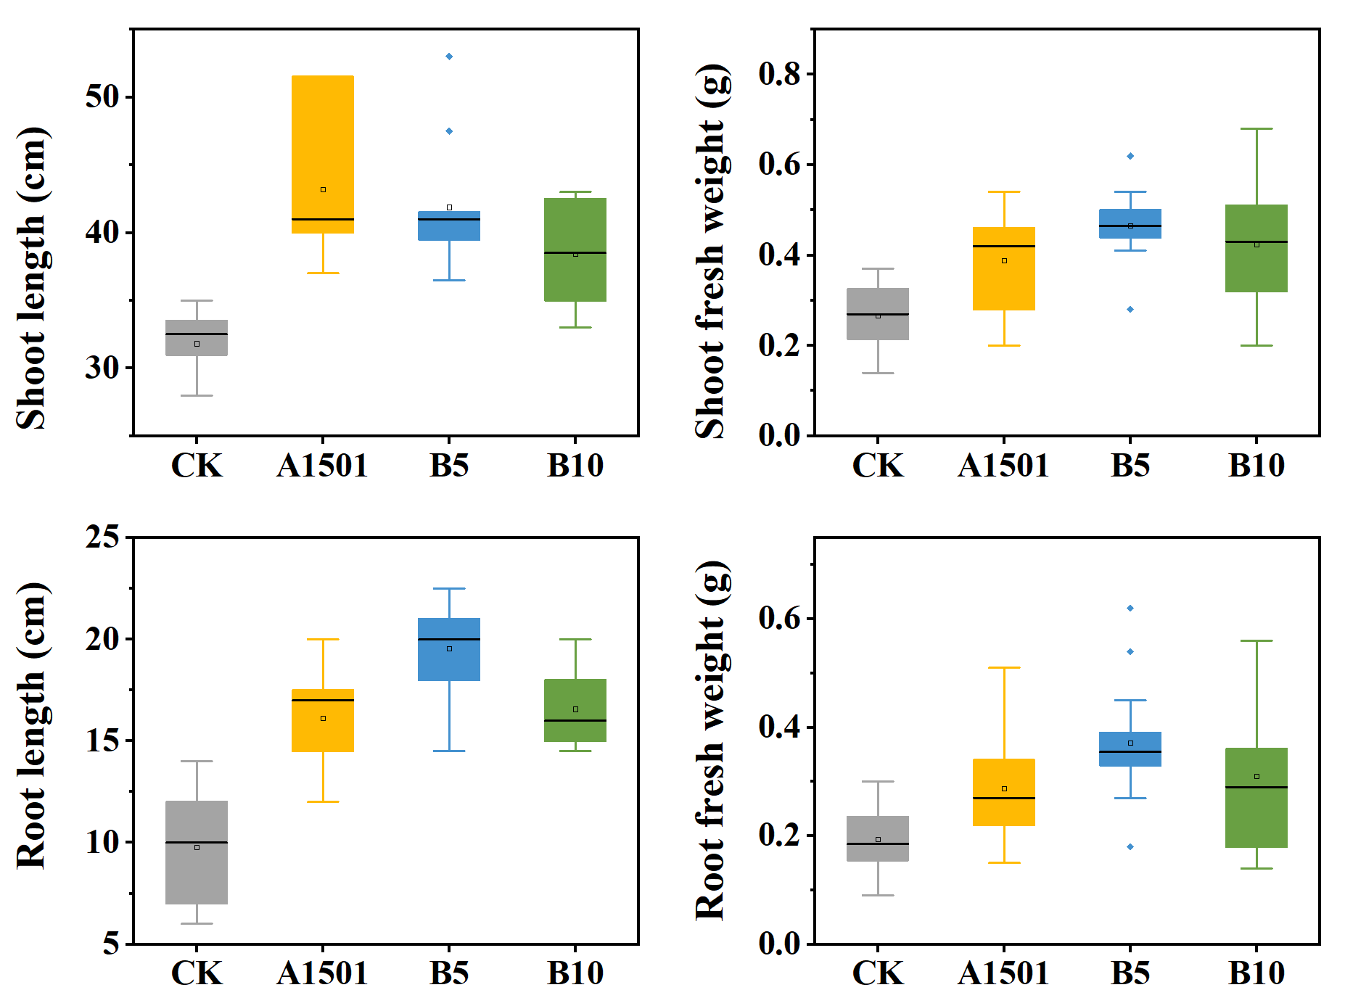
Fig. S2. The length and weight of shoots and roots of the rice plant.

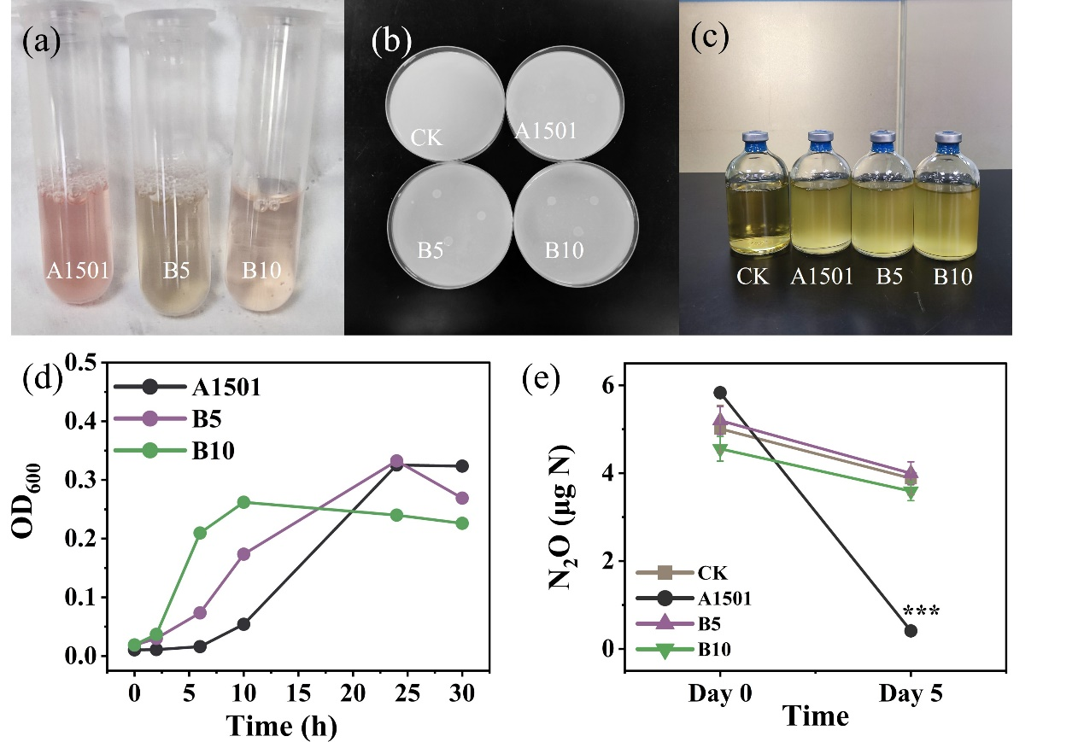
Fig. S3. Strain performance: nitrate reduction (a), nitrogen-fixing capacity (b), anaerobic growth of strains in serum bottles (c), anaerobic growth curve (d), and exogenous N₂O reduction capacity (e). Data are presented as mean ± standard deviations. Asterisks denote statistically significant differences: *** for P ≤ 0.001.

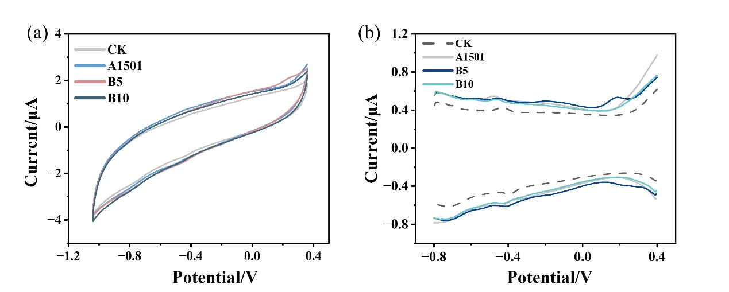
Fig. S4. The CV(a) and DPV(b) curves of the LB medium supernatant after 16 hours of bacterial strains cultivation.

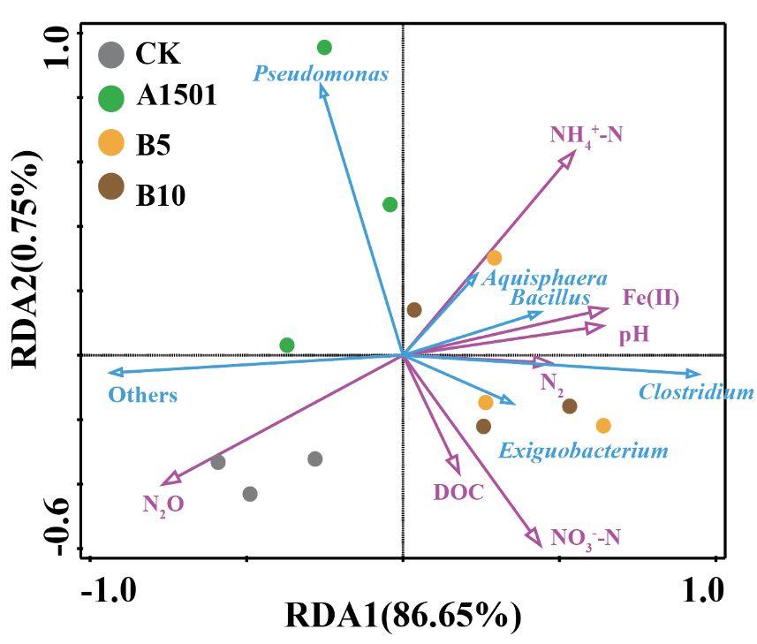
Fig. S5. Redundancy analysis (RDA) of soil bacteria and environmental factors in soil experiment.

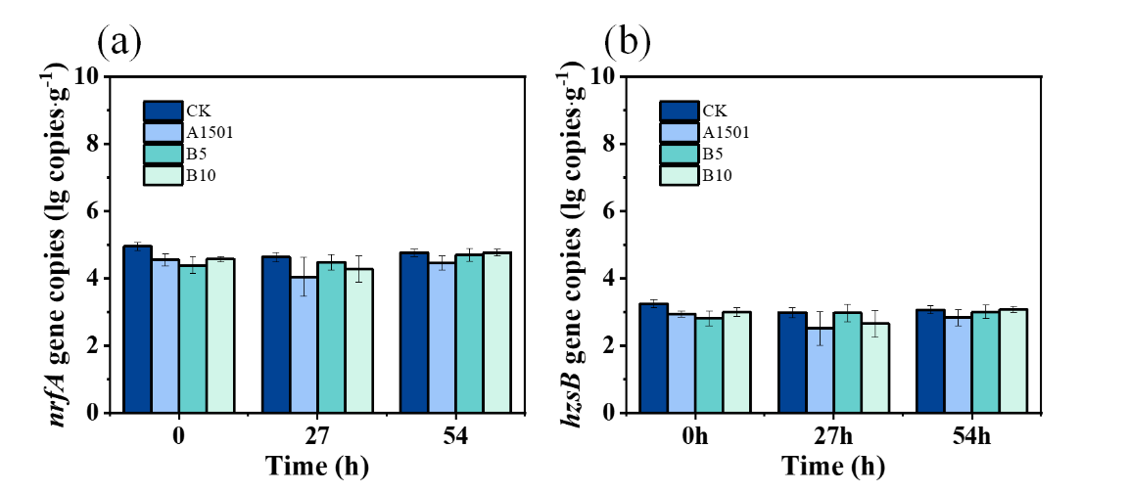
Fig. S6. Changes in the gene copy numbers of nrfA (a) and hzsB (b) genes in soil samples in Part III. Data are presented as mean ± standard deviations. Asterisks denote statistically significant differences: * for P ≤ 0.05, ** for P ≤ 0.01, and *** for P ≤ 0.001.

References
Qin, S., Pang, Y., Hu, H., Liu, T., Yuan, D., Clough, T., Oenema, O (2024) Foliar N₂O emissions constitute a significant source to atmosphere. Global Change Biology 30(2): e17181. https://doi.org/10.1111/gcb.17181

