Supporting Information
Supporting Figure 1
Supporting Figure 1 (A) A schematic diagram of two independent CRISPR-Cas9-knock out (cas9-3, cas9-8) lines. (B) Sequencing analysis in the oskea1 mutant. The G to A mutation changed glycine to arginine.

Supporting Figure 2
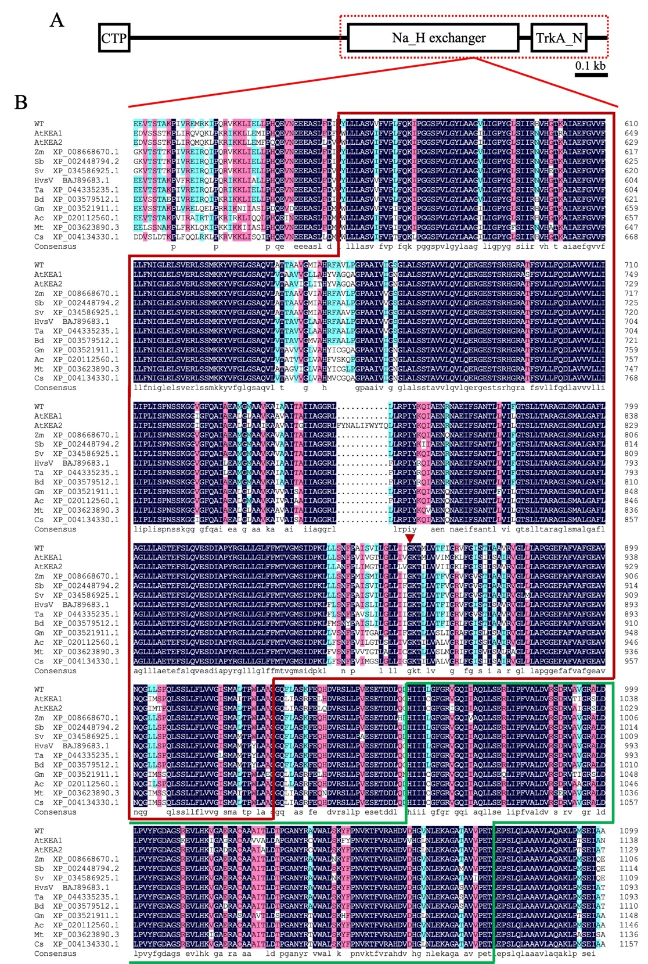
Supporting Figure 2 (A) Schematic diagram of OsKEA1 protein domains, including a N-terminal domain of chloroplast transit peptides (CTP), Na_H_Exchanger domain and a C-terminal TrkA_N domain. (B) Protein alignment of the Na_H_Exchanger domain and TrkA_N domain of OsKEA1 and its homologs with MegAlign software. The red and green boxes represented the predicted Na_H exchanger domain and a TrkA_N domain of OsKEA1 protein, respectively. The red triangle represented the mutation site of oskea1 protein.

Supporting Figure 3
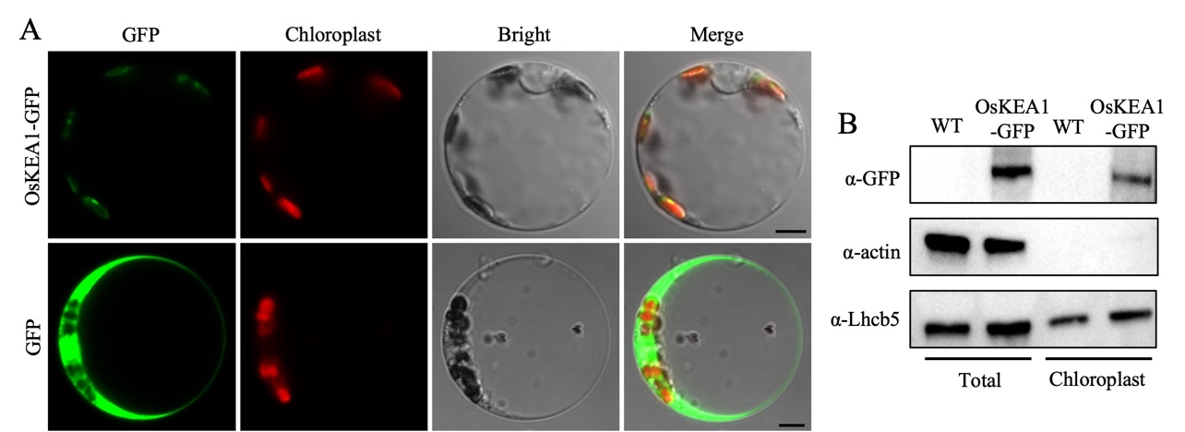
Supporting Figure 3 (A) Subcellular localization of OsKEA1 protein. The green fluorescent signals were OsKEA1-GFP and GFP protein signals. The red fluorescent signals were the chlorophyll autofluorescence signals. GFP protein was the control. Scale bars = 5 μm. (B) Analysis of subcellular localization of OsKEA1 by immunoblotting. Total and Chloroplast proteins were extracted separately from the cells expressing OsKEA1-GFP or not. Actin and Lhcb5 served as total and chloroplast fraction markers, respectively.
Supporting Figure 4
Supporting Figure 4 Determination of expression levels of salt stress-responsive genes of different plants under normal and 180 mM NaCl treated conditions. Data are means ± SD (n = 3). Asterisks show statistical significances at **p ≤ 0.01 according to Student’s t-test.

Supporting Figure 5
Supporting Figure 5 Determination of expression levels of proline biosynthesis genes of different plants under normal and 180 mM NaCl treated conditions. Data are means ± SD (n = 3). Asterisks show statistical significances at **p ≤ 0.01 according to Student’s t-test.
Supporting Figure 6
Supporting Figure 6 Determination of expression levels of ROS scavenger enzymes genes of different plants under normal and 180 mM NaCl treated conditions. Data are means ± SD (n = 3). Asterisks show statistical significances at *p ≤ 0.05, **p ≤ 0.01 according to Student’s t-test.

Supplemental Table 1. Primers used in this study.
Purpose | Primer name | Primer sequence
Gene editing | OsKEA1-cas9-1F | ggcAGCCAAGTAGAAGAGGCTAC
 | OsKEA1-cas9-1R | aaacGTAGCCTCTTCTACTTGGC
 | OsKEA1-cas9-2F | gccGGCCCTTGCGTCCGCGCAAG
 | OsKEA1-cas9-2R | aaacCTTGCGCGGACGCAAGGGC
qRT-PCR | OsKEA1-F | GTTGCCTTCGGAGAAGCTGT
 | OsKEA1-R | ACTTCTCACATCATGCTGCTC
 | CHL1-F | AGTAACCTTGGTGCTGTG
 | CHL1-R | AATCCATCAACATTCAACTCTG
 | PORB-F | CCGATCACGATCAGTGAGTGAGAG
 | PORB-R | GGAGAAGAAGAAGAAGAGCACAGC
 | Lhcb1-F | CCATGTTCTCCATGTTCGGCTTCT
 | Lhcb1-R | TAGGCCCAGGCGTTGTTGTTGA
 | PsbA-F | ACTAGCACCGAAAACCGTCTTT
 | PsbA-R | CAGCGATGAAGGCGATAATAAA
 | CAB1R-F | AGATGGGTTTAGTGCGACGAG
 | CAB1R-R | TTTGGGATCGAGGGAGTATTT
 | CAB2R-F | TAGCTAGGTTGACGACGATGCG
 | CAB2R-R | TCTCACCCTCTCTCCAATACTCG
 | ATR-F | TCCGAAACCCACATGCACAGAG
 | ATR-R | TGCTTGGCCTTCCACAGAAAGTG
 | PARP-F | GCGGCATCTATTAGACCGTTGTGC
 | PARP-R | ACTGGGCAAGTACCCAATGCTC
 | RAD51A1-F | TGCTCCAGATAGCTGACAGGTTCG
 | RAD51A1-R | TGCCTCCAGCAGAAGTCTTGATTG
 | OsNHX2-F | TGGAGGTGTGATTCTGCTCG
 | OsNHX2-R | ATCAATGTCCCCACAGCACC
 | OsSOS2-F | GAAAGTTCACGGCAACGCTT
 | OsSOS2-R | ACTGGAGGCGAATTGTTCGAT
 | OsHKT4-F | TCGCAAAACCAGGTACAGCA
 | OsHKT4-R | AGTTTGCGAACGAGGACACT
 | SIT1-F | TGGTCAACTTCGACACCGGAAC
 | SIT1-R | GCTCACCCTTCTGCCGACAATATC
 | SIT2-F | TGTCCTACCCGATGACATCCAC
 | SIT2-R | TGGGAACGGGTCATCATCTACC
 | DST-F | GCACTTGCAACCAACCGCATTG
 | DST-R | TGGCGATTCGAGCATGAGATGAAC
 | OsP5CS1-F | AGAATGCGAATTTGTGGGAATC
 | OsP5CS1-R | GCTTCTCATATC CAGCAACTTG
 | OsP5CR-F | AAATTGTCGTCTGAGGAGCGT
 | OsP5CR-R | GGTCATCCGAGCAACCAATGA
 | APX1-F | AGGTGCCACAAGGAAAGATCTGG
 | APX1-R | TCAGCAGGGCTTTGTCACTAGGAA
 | APX2-F | TGGGAAGATGCCACAAGGAGAGA
 | APX2-R | TCCGCAGCATATTTCTCCACCAGT
 | AOX1b-F | CCTGCTCAGTTCATCACCATCA
 | AOX1b-R | GCATAAAACGGAGGACAATAGC
 | AOX1c-F | GCGTCGGATGTTCATTTTCA
 | AOX1c-R | CCGCCGTAAGATTTCTTCAGT
 | SODA-F | ATCTGGATGGGTGTGGCTAGCTTT
 | SODA-R | AGTACGCATGCTCCCAGACATCAA
 | SODB-F | TCCGCCGTATAAACTTGATGCCCT
 | SODB-R | TGGGTTGCCGTTGTTGTATGCTTC

