Supplementary Information file

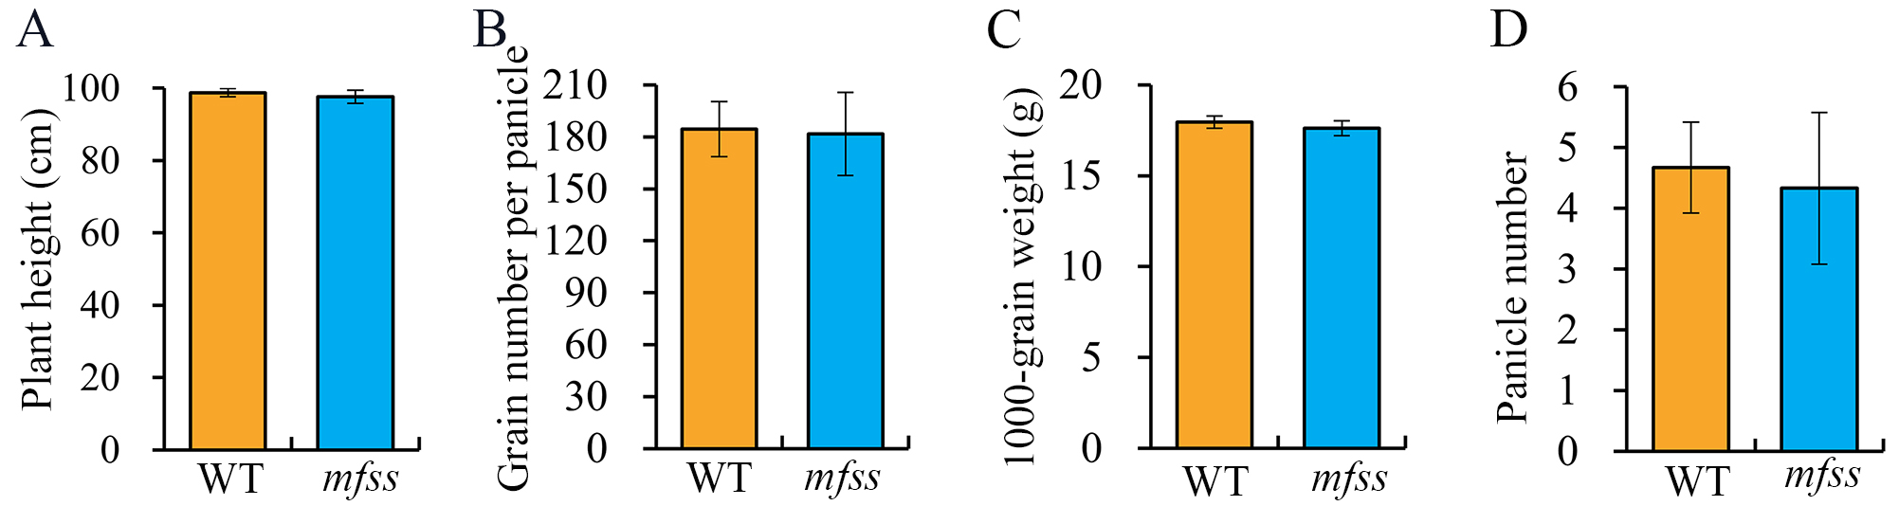 Fig. S1 Phenotypic analysis of the WT plants and mfss.
Comparison of WT plants and mfss with respect to (A) plant height, (B) grain number per panicle, (C) 1000-grain weight, (D) panicle number. Data are shown as means ± SD (n ≥ 3; two-tailed Student’s t-test).

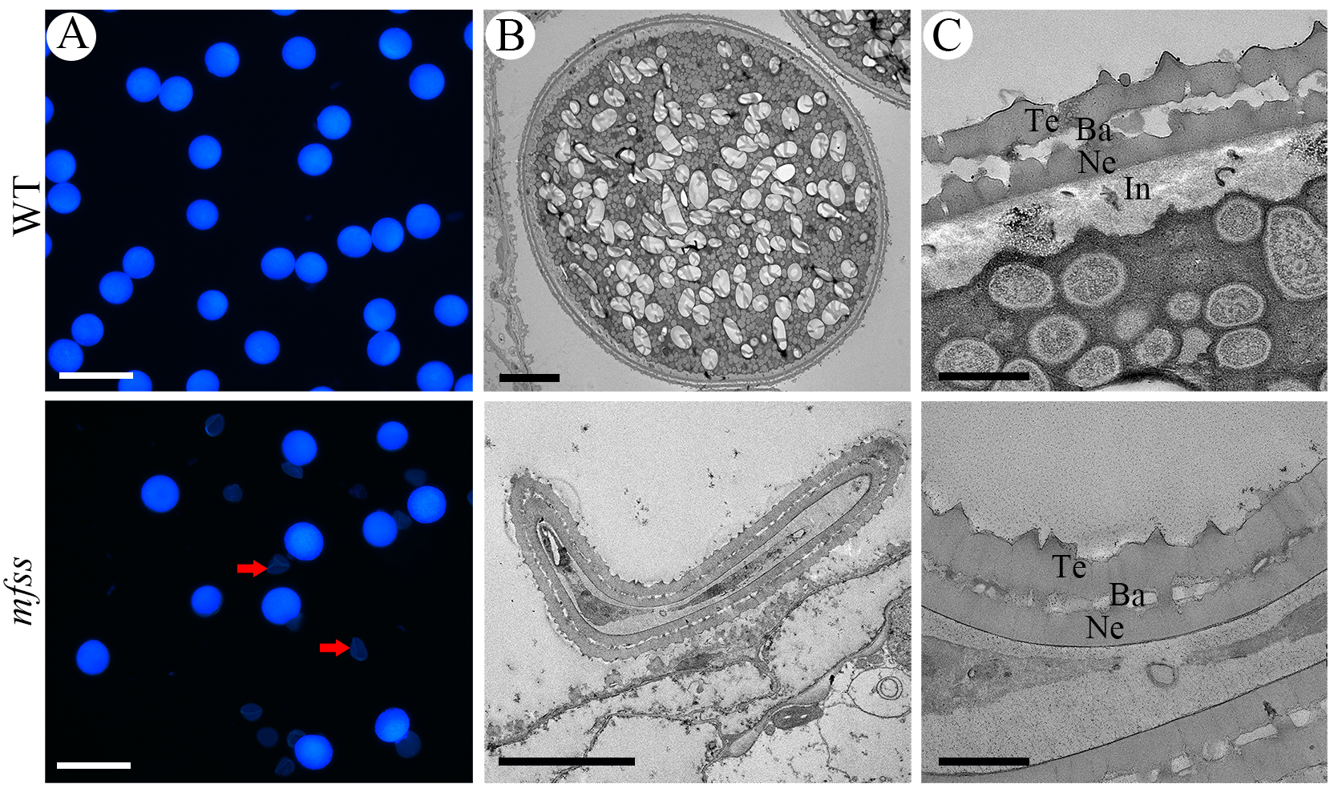
Fig. S2 Observation of mature pollen grains in the WT plants and mfss.
(A) Calcofluor white staining of mature pollen grains in WT plants and mfss observed under fluorescence microscopy. Scale bars, 40 μm. (B and C) Transmission electron micrographs of pollen grains and pollen wall in WT plants and mfss at stage 12. Scale bars, 5 μm and 500 nm, respectively. Te, tectum; Ba, bacula; Ne, nexin; In, intine.

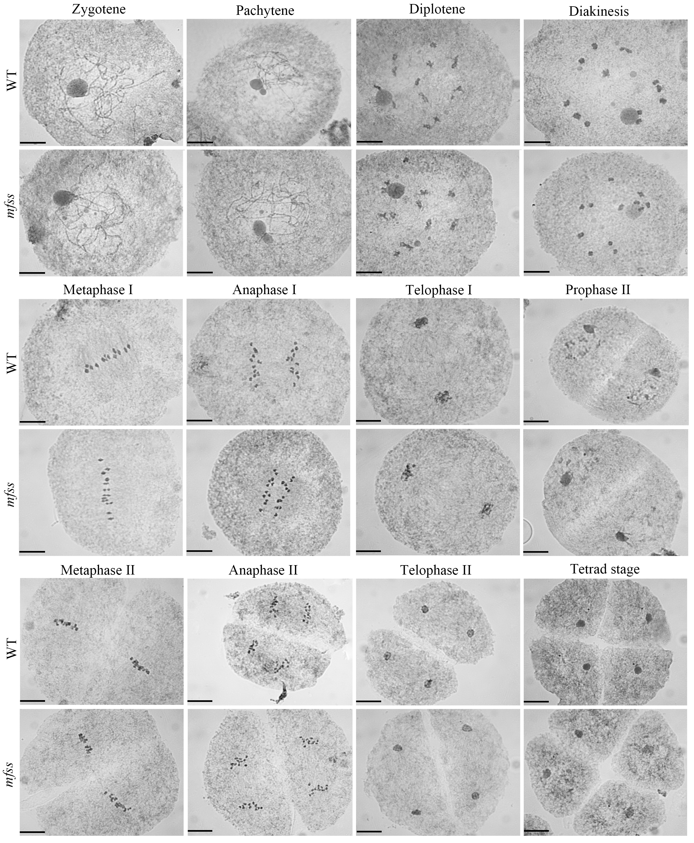 Fig. S3 Meiosis of pollen mother cells in the WT plants and mfss.
Scale bars: 10 μm.

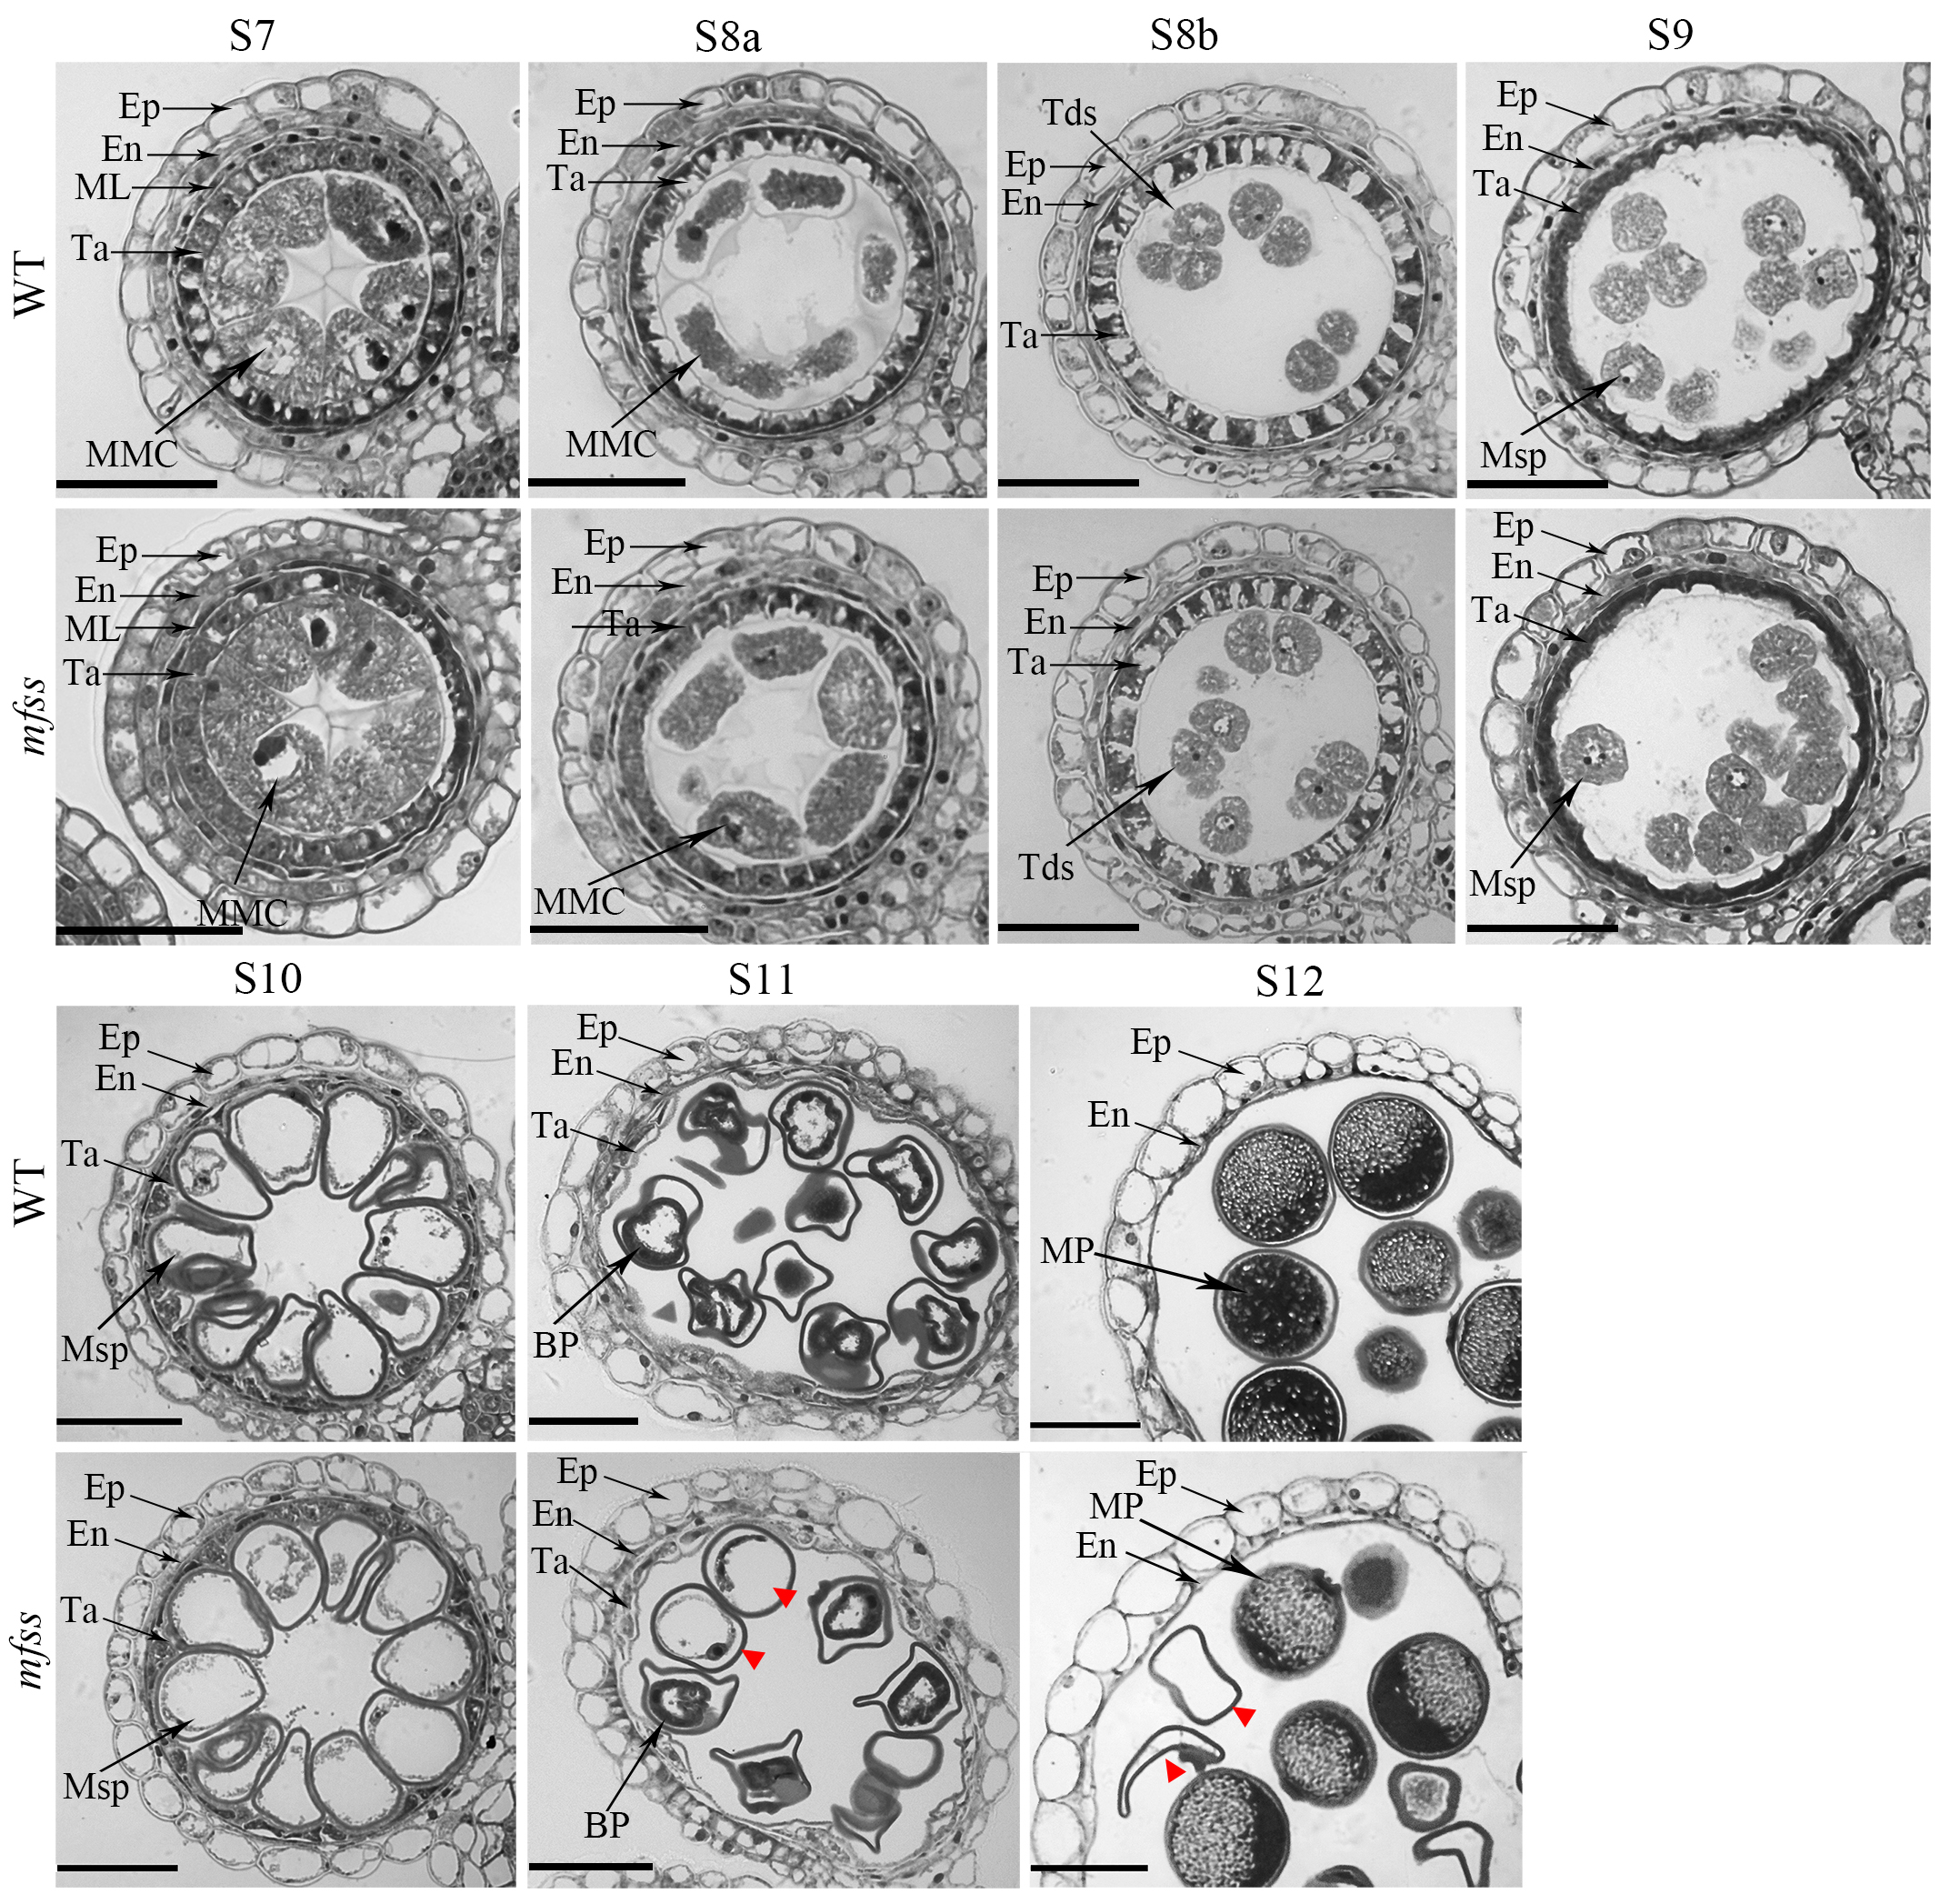
Fig. S4 Anther semi-thin sections analysis of the WT plants and mfss.
MMC, microspore mother cell; Tds, tetrads; Msp, microspore parietal cell; BP, bicellular pollen; MP, mature pollen; Ep, epidermis; En, endothecium; ML, middle layer; Ta, tapetum; Arrows indicate abnormal pollen grains. Scale bars: 40 μm.

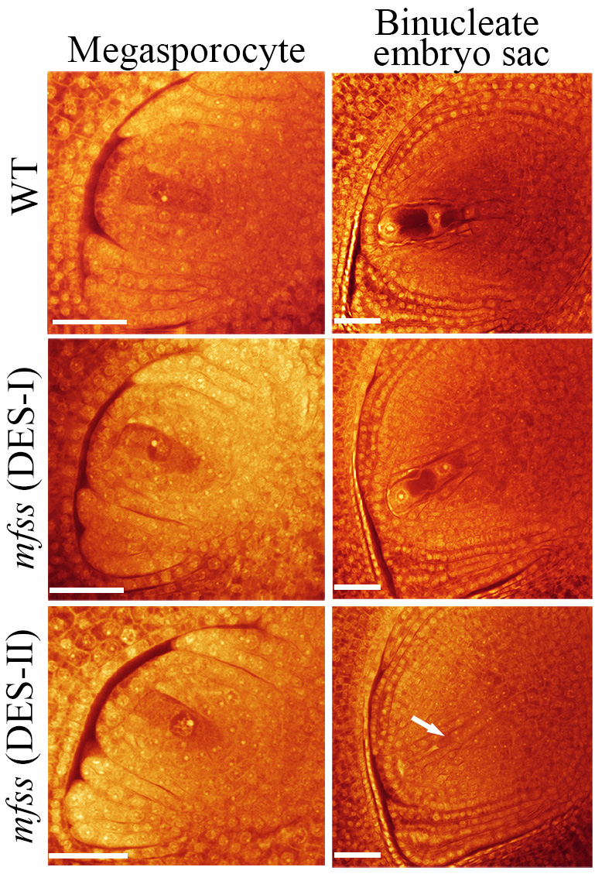
Fig. S5 Supplemental embryo sac development in the WT plants and mfss.
Arrows indicate abnormal embryo sacs. Scale bars, 30 μm.

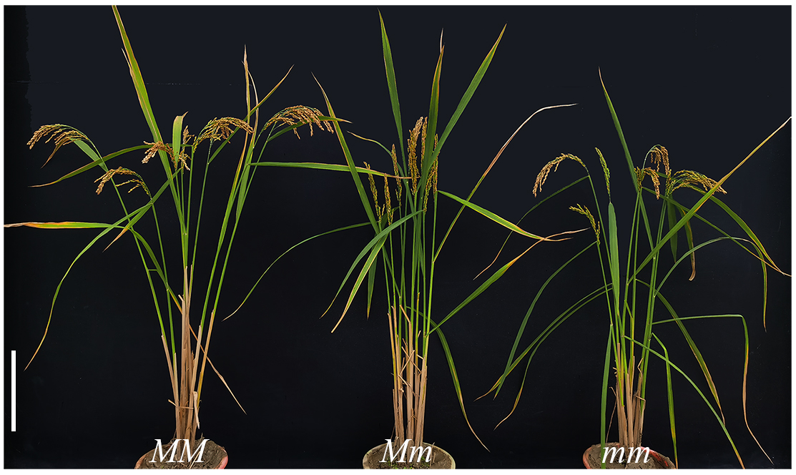
Fig. S6 Morphology of MM, Mm, and mm plants.
Scale bars, 20 cm.

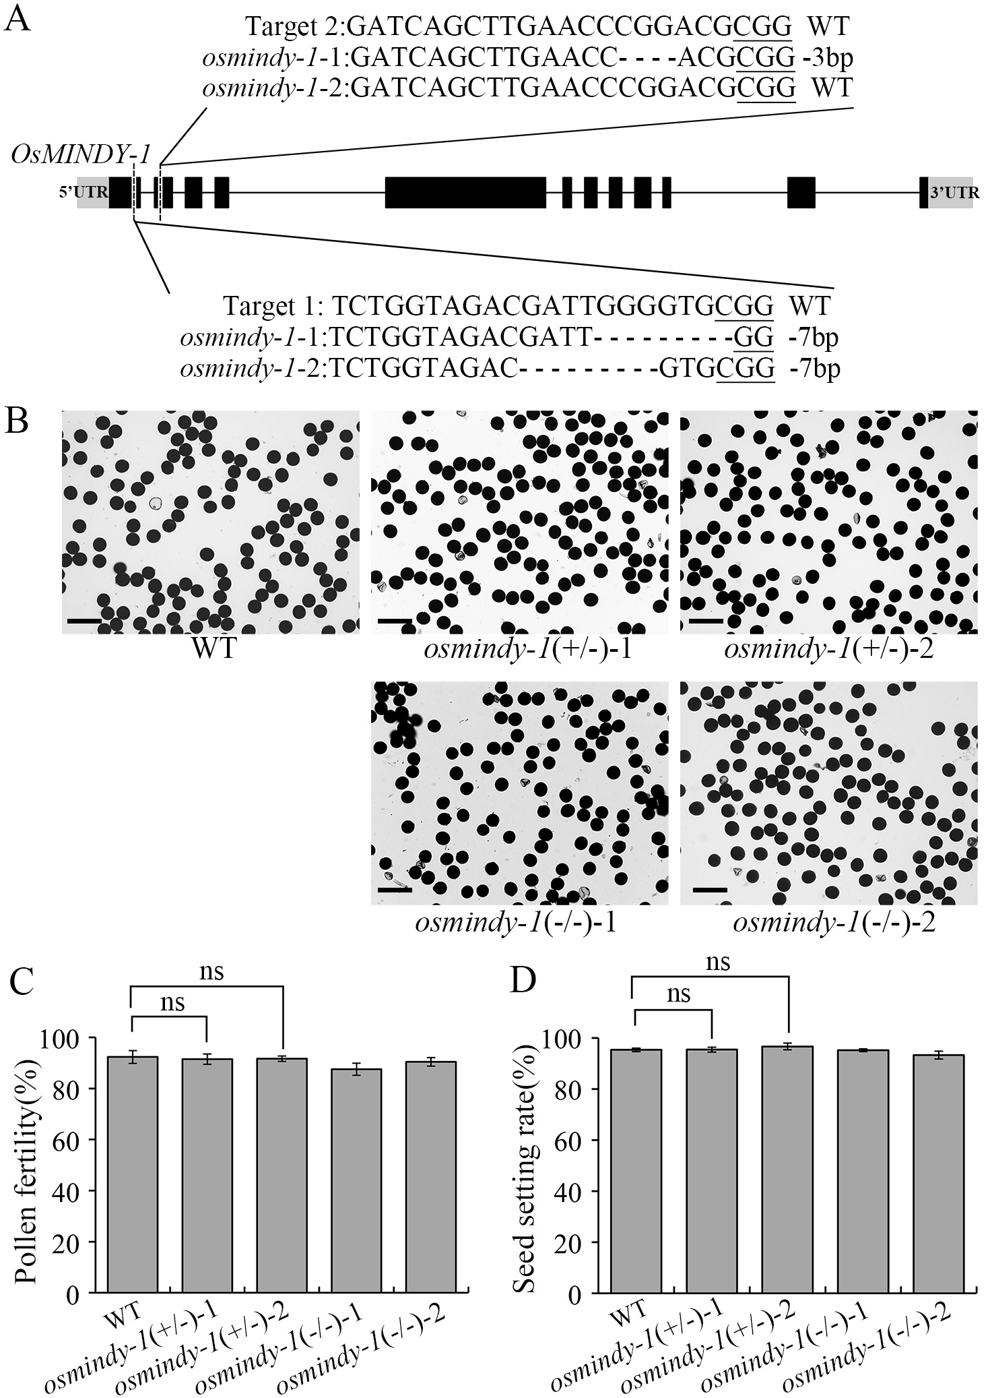
Fig. S7 Phenotypic analysis of osmindy-1(+/-) and osmindy-1(-/-).
(A) CRISPR/Cas9-induced mutations in OsMINDY-1 in T₁ plants. (B) Pollen stained with I₂-KI in osmindy-1(+/-) and osmindy-1(-/-). Scale bars=100 μm. (C) Pollen fertility of osmindy-1(+/-) and osmindy-1(-/-). (D) Seed setting rate of osmindy-1(+/-) and osmindy-1(-/-). Data are shown as means ± SD (n ≥ 3). ( Dunnett; ns: not significant ( P > 0.05)).

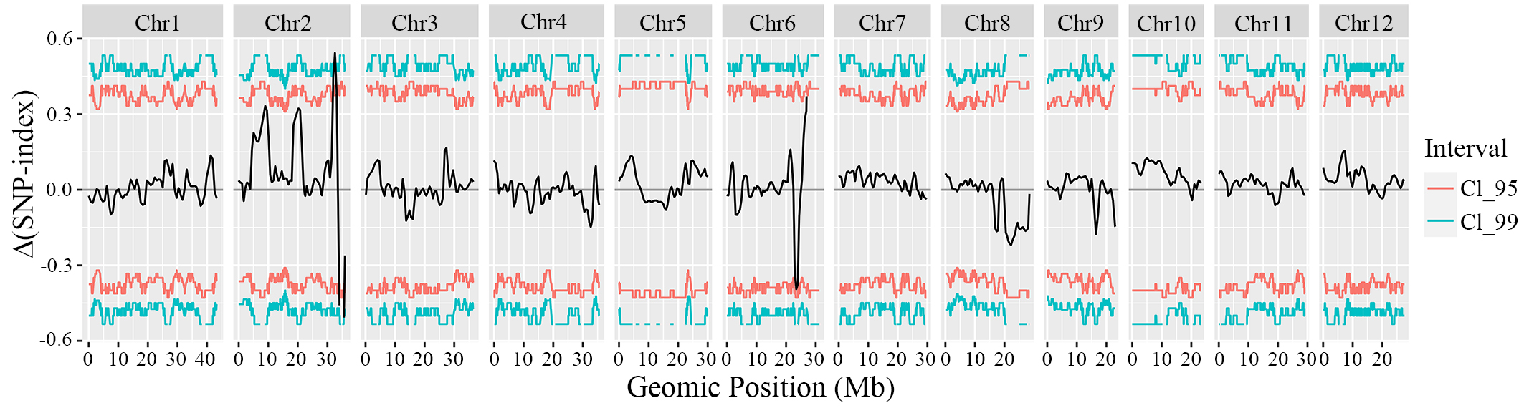
Fig. S8 Δ(SNP-index) analysis result

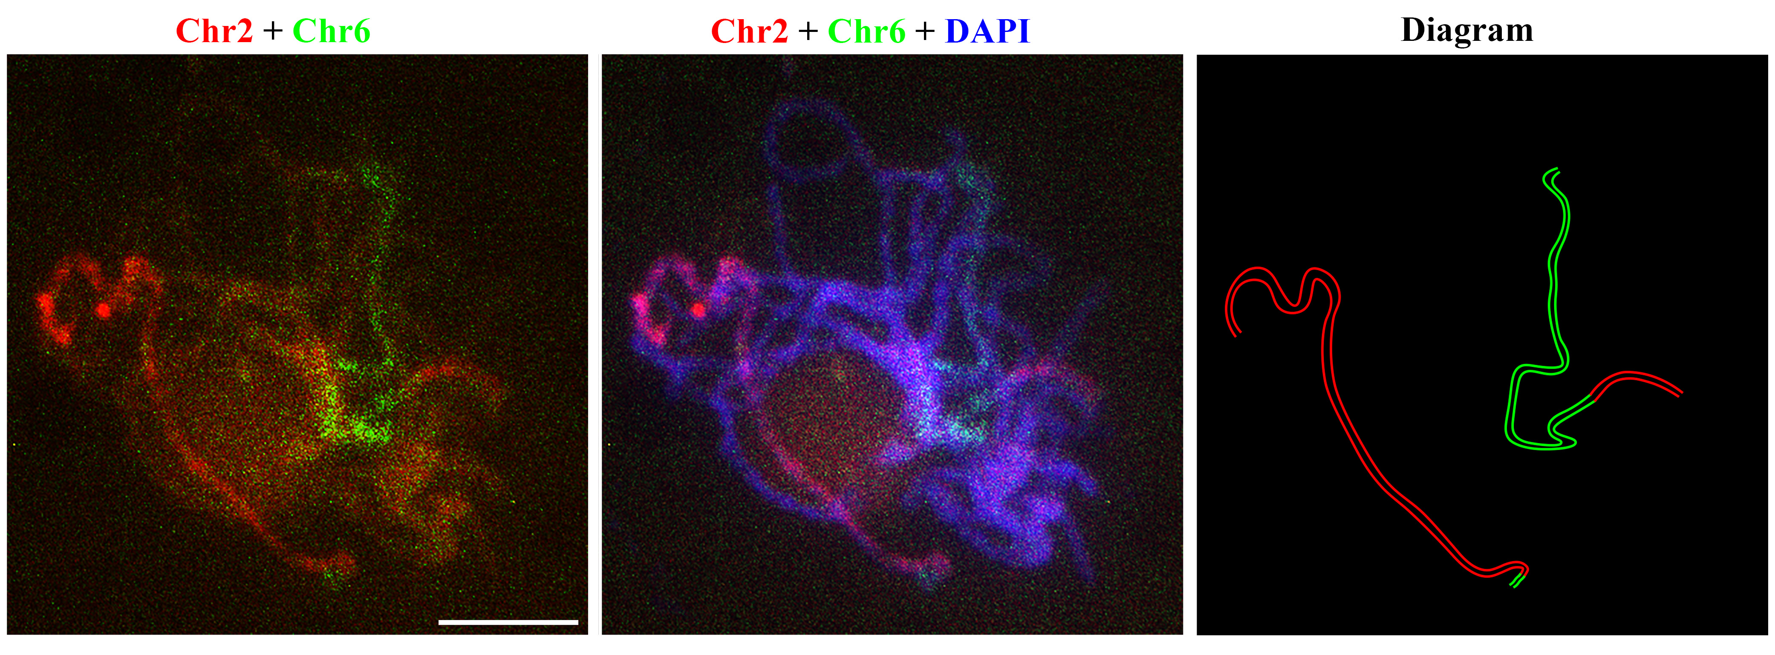
Fig. S9 FISH analysis using pooled oligo probes specific to the entire chromosome 2 (Chr2, red) and chromosome 6 (Chr6, green)
Scale bars, 5 μm.
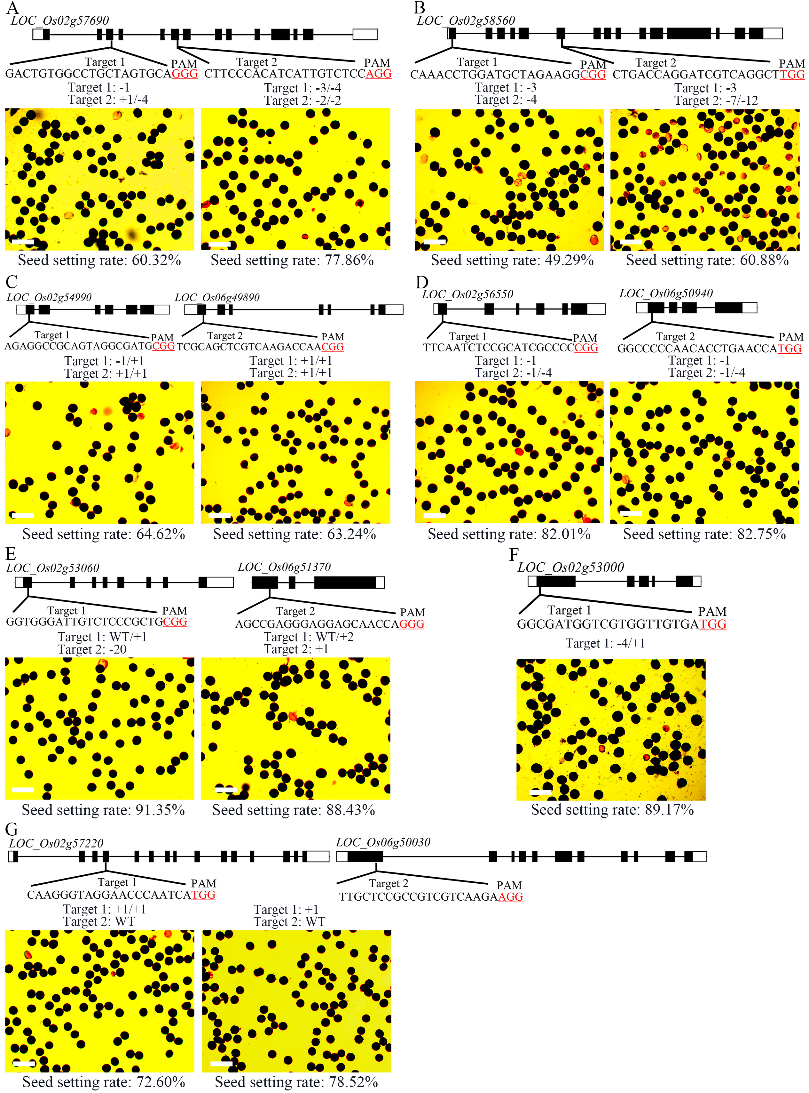
Fig. S10 CRISPR/Cas9 based single gene or multiplex genes editing of candidate genes.
The white box represents UTR, and the black box represents CDS. “-” represent deletion bases and “+” represent insertion bases. Scale bars: 100 μm.
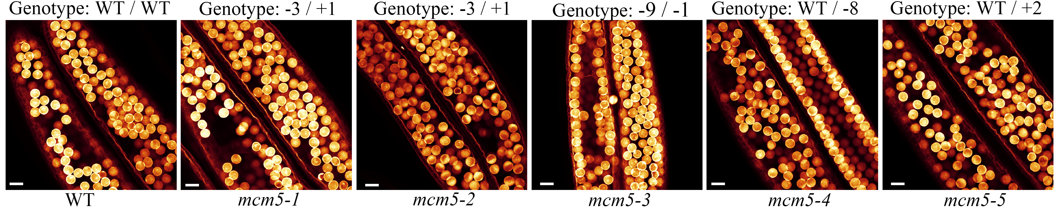
Fig. S11 WE-CLSM observation of the mature pollen in WT and heterozygous mcm5.
WT represent wild type, “-” represent deletion bases and “+” represent insertion bases. Scale bars, 30 μm.

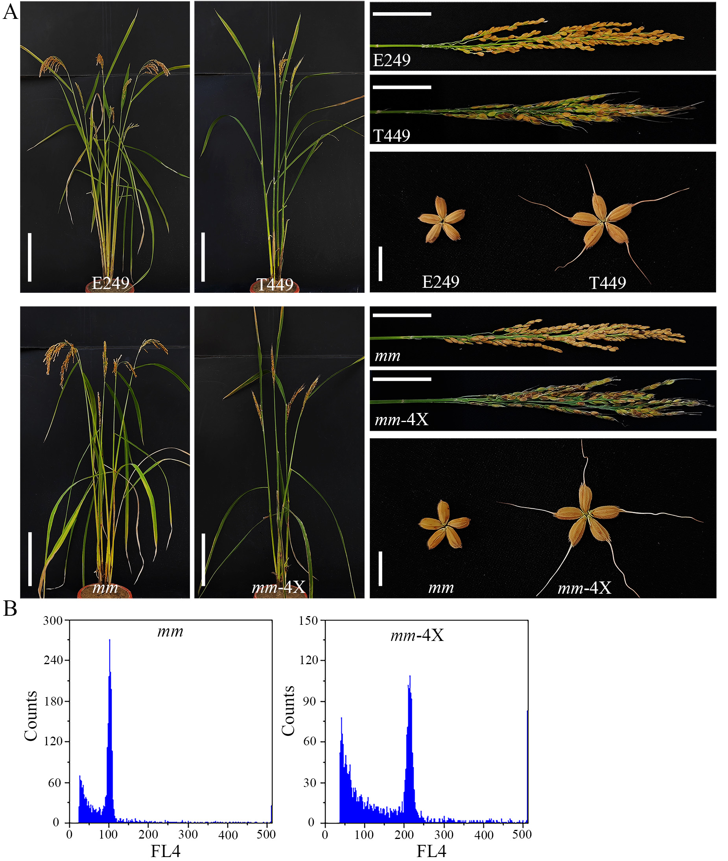
Fig. S12 Phenotypes comparison of autotetraploid and corresponding diploid.
(A) Plant morphology, panicle morphology, and spikelets phenotype of autotetraploid (T449 and mm-4X) and diploid rice (E249 and mm). Scale bars, 20 cm, 5 cm, and 1 cm, respectively. (B) Verification of the ploidy of diploid and tetraploid with flow cytometry. The x-axis represents the signal peak for the nucleus, and the y-axis represents the number of nuclei.

Fig. S13 Distribution of reproductive development genes on chromosomes.

