1. Starch granule size distribution by volume
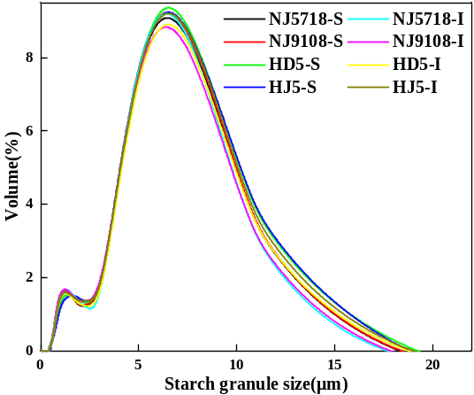
Fig.1 Differences in starch granule size distribution by volume between superior and inferior grains of soft and non-soft rice
S: superior grain, I: inferior grain.
2. Branched starch chain length area distribution
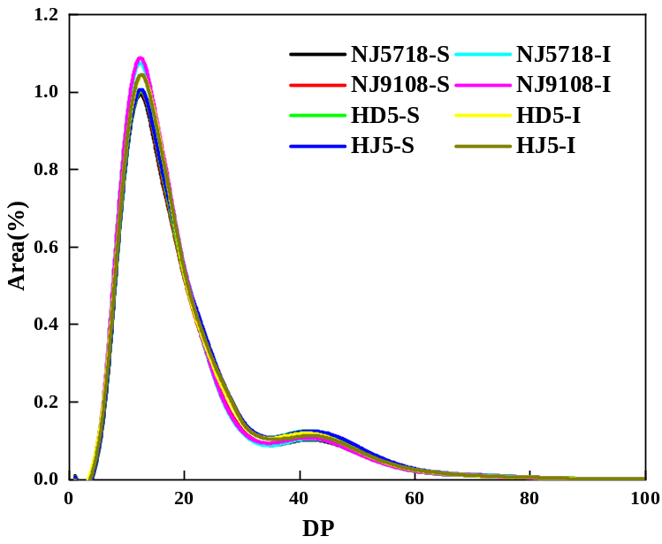
Fig. 2 Differences in amylopectin chain length distribution between superior and inferior grains of soft and non-soft rice
S: superior grain, I: inferior grain.
3. FTIR and deconvoluted spectra
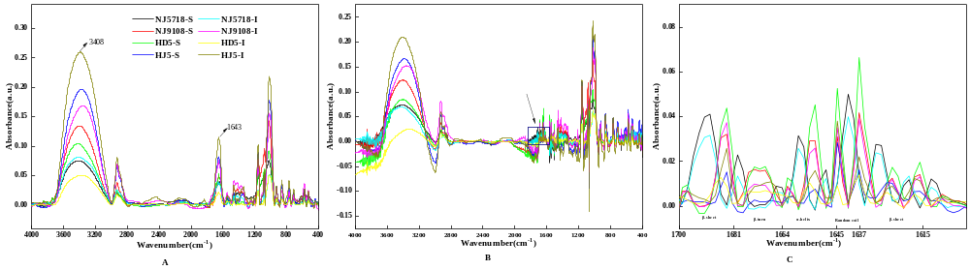
Fig. 3 Differences in FTIR and deconvoluted spectra between superior and inferior grains of soft and non-soft rice
A presents the original FTIR spectra across the full wavenumber range (400-4000 cm⁻¹). B shows the spectrum from Fig.7-A after deconvolution. C provides an expanded view of the 1600-1700 cm⁻¹ region from B. S: superior grain, I: inferior grain.
Dear Editor,

Thank you and the reviewers for your meticulous review of our manuscript titled “Interrelationships between appearance quality and starch and protein structures in superior and inferior grains of soft and non-soft rice” and for providing us with the valuable opportunity to revise it.
We have carefully studied all comments and believe these suggestions are highly insightful, which will greatly help us improve the paper's quality. In response, we fully commit to the following:
Strictly verifying all data to ensure the results are presented with absolute accuracy.
Carefully revising all conclusive statements to eliminate any potential exaggeration.
Comprehensively discussing and clearly stating the limitations of this study.
We have now completed the revisions accordingly. We will submit the revised manuscript along with a detailed point-by-point response letter through the submission system.
We sincerely hope the revised version meets the journal's standards. Thank you again for your and the reviewers' hard work and invaluable guidance.

Sincerely,
Xi Chen

