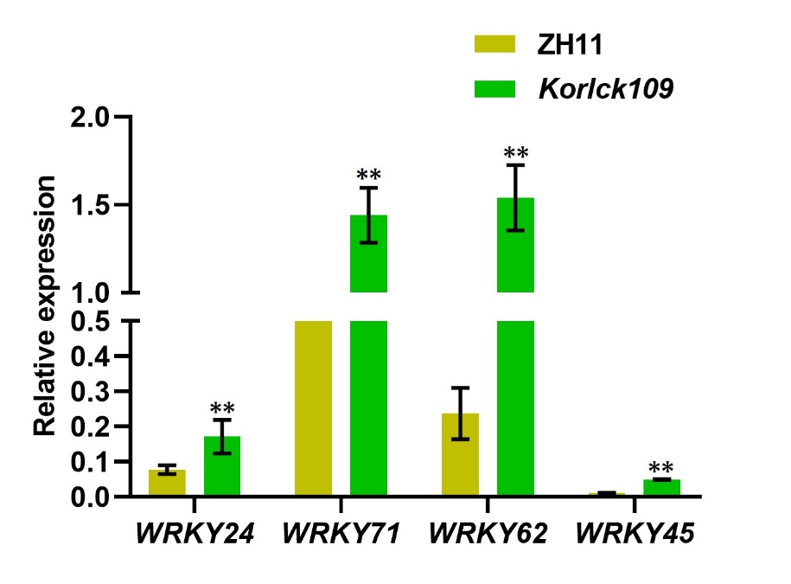
Figure S1: Analysis of the expression levels of some WRKY transcription factors in ZH11 and Korlck109.Data shown as mean±SD, n=3, **p < 0.01, Student's t-test.

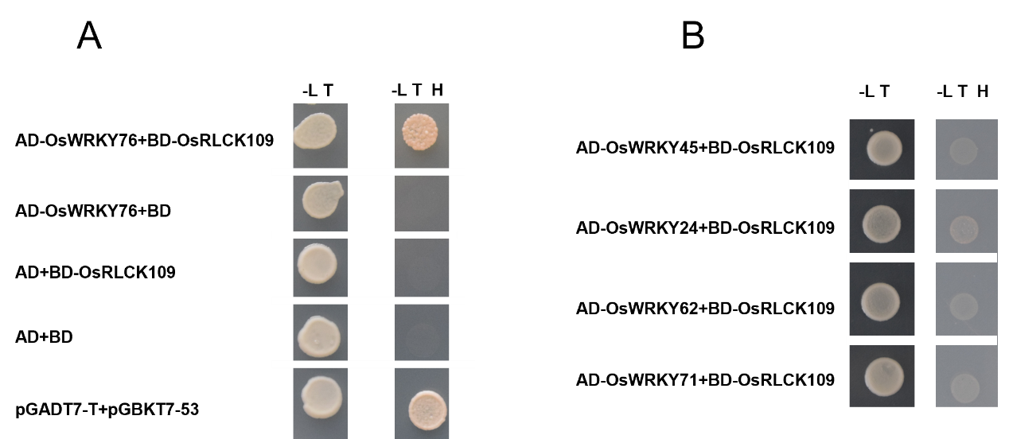

Figure S2: The interaction scenario between OsRLCK109 and various transcription factors within the yeast two-hybrid system. (A) OsRLCK109 and OsWRKY76 interact in yeast. (B) OsRLCK109 does not interact with specific transcription factors in the yeast system. Yeast cells were cultured on SD/-Leu/-Trp (-L T) and SD/-Leu/-Trp/‐His (-L T H) media. pgadt7-T+pgbkt7-53 as a positive control.

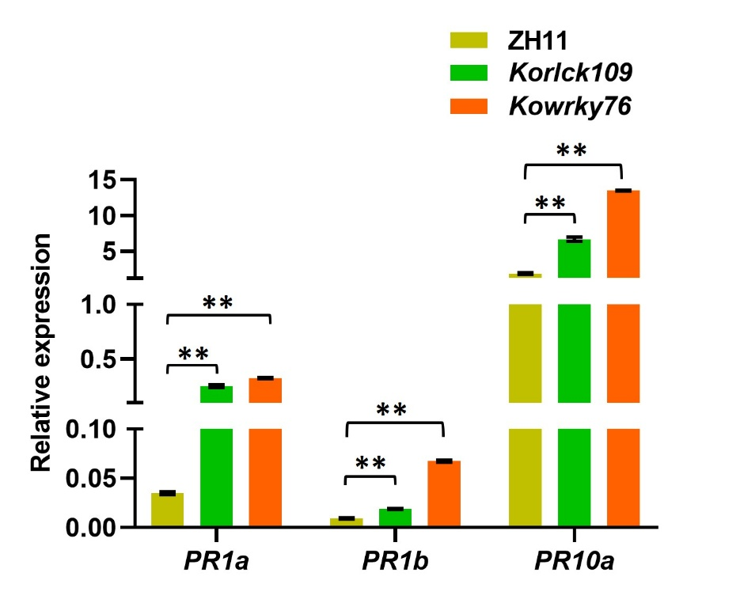
Figure S3: The expression levels of pathogenesis-related genes in Korlck109 and Kowrky76. Wild-type ZH11 served as the control. Data shown as mean±SD, n=3, **p < 0.01, Student's t-test.

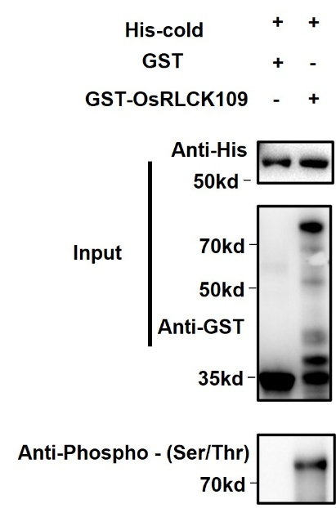
Figure S4: OsRLCK109 is capable of auto-phosphorylation.

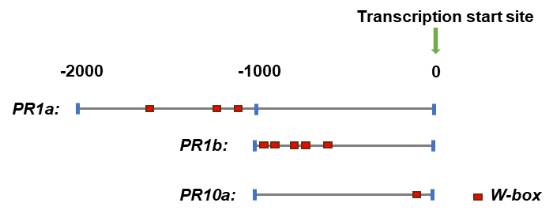
Figure S5: Analysis of the promoter region of the PR gene, the red rectangle indicates the W-box.

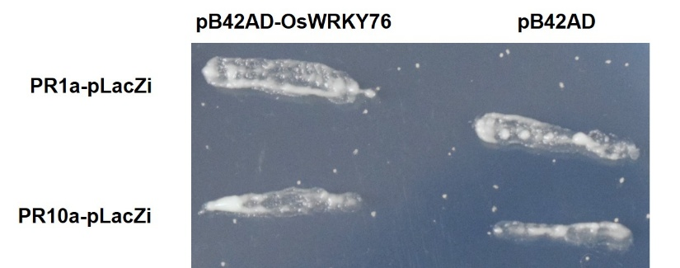
Figure S6: OsWRKY76 did not bind to the promoters of PR1a and PR10a in the yeast one-hybrid system.

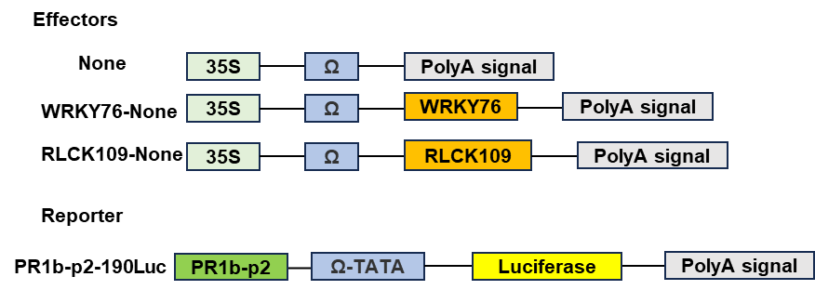
Figure S7: Diagram of the various constructs used in the Luc assay.

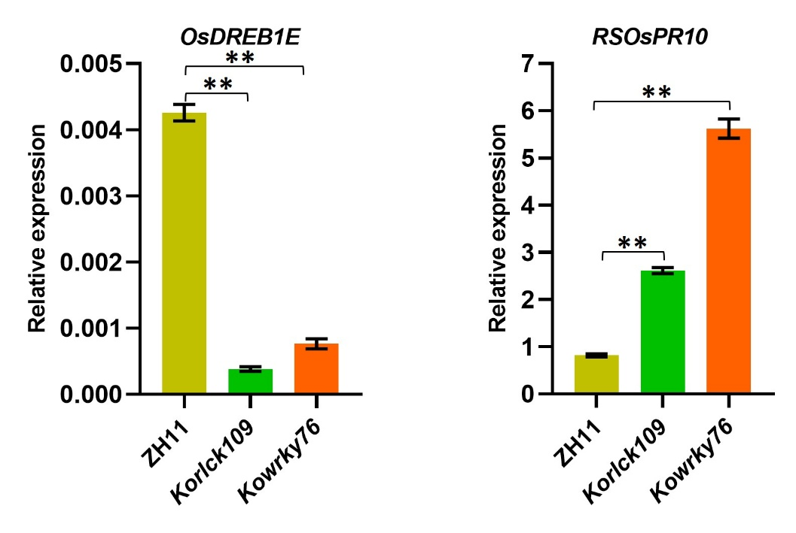
Figure S8: The expression levels of OsDREB1E and RSOsPR10 in Korlck109 and Kowrky76. Wild-type ZH11 was employed as the control. Data shown as mean±SD, n=3, **p < 0.01, Student's t-test.

Table S1: The primers used in this study
Primers for prokaryotic expression
HIS-WRKY76-F | CAAATGGGTCGCGGATCCATGGACGCGGCGTGGCGCGG
HIS-WRKY76-R | TCGACGGAGCTCGAATTCGAATTCGGGCAGCTTCTGGA
HIScold+WRKY76-F | CTCGAGGGATCCGAATTCATGGACGCGGCGTGGCGCGG
HIScold+WRKY76-R | GTCGACAAGCTTGAATTCCTAGAATTCGGGCAGCTTCT
GST+RLCK109-F | TGGATCCCCGGAATTCATGCCGCCGAGGCAGTGGAG
GST+RLCK109-R | GTCGACCCGGGAATTCTCAGGGCAGCTTGGCGGAGG
For yeast two-hybrid primers
BD+RLCK109-F | GGAGGCCAGTGAATTCATGCCGCCGAGGCAGTGGAG
BD+RLCK109-R | CACCCGGGTGGAATTCTCAGGGCAGCTTGGCGGAGG
AD+WRKY76-F | GGAGGCCAGTGAATTCATGGACGCGGCGTGGCGCGG
AD+WRKY76-R | CACCCGGGTGGAATTCCTAGAATTCGGGCAGCTTCT
For co-immunoprecipitation primers
1132GFP+WRKY76-F | TAGAACTAGTGGATCCATGGACGCGGCGTGGCGCGG
1132GFP+WRKY76-R | GCAGCCCGGGGGATCCGAATTCGGGCAGCTTCTGGA
RLCK109-MYC-F | CGGAGCTAGCTCTAGAATGCCGCCGAGGCAGTGGAG
RLCK109-MYC-R | TCGAGACGTCTCTAGAGGGCAGCTTGGCGGAGGCGC
For the transcriptional activity experiment, primers
none+RLCK109-F | TCTAGAACTAGTGGATCCATGCCGCCGAGGCAGTGGAG
none+RLCK109-R | CTGCAGCCCGGGGGATCCGGGCAGCTTGGCGGAGGCGC
none+WRKY76-F | TCTAGAACTAGTGGATCCATGGACGCGGCGTGGCGCGG
none+WRKY76-R | CTGCAGCCCGGGGGATCCGAATTCGGGCAGCTTCTGGA
190LUC+PR1b-p2-F | gagaggacacgctggatccAGGAAAATAATTGGAAAGTT
190LUC+PR1b-p2-R | ttgttggtaattgtggatcctttaggtcatatcatttgat
For q-RTPCR primers
Q-RSOsPR10-F | ATGAAGCTCAACCCTGCTGT
Q-RSOsPR10-R | TGAGCTTGCCCACCTTACTT
Q-DREB1E-F | ACTTCCCTTGCTACCCGATG
Q-DREB1E-R | GGCTCGATGAGCATTCCCTG
Q-RLCK109-F | CTGGTGAAGCTGCTGGGCTA
Q-RLCK109-R | CACCGTCGCCGATATCCTCTT
Q-WRKY76-F | TTCCGAATGCTTTTCTGCTG
Q-WRKY76-R | ATCGTGAGGCCCGATAGAAG
Q-Actin1-F | CAGCCACACTGTCCCCATCTA
Q-Actin1-R | AGCAAGGTCGAGACGAAGGA
Q-WRKY45-F | GACACGGGCCGGGTAAA
Q-WRKY45-R | TTTCTGTACACACGCGTGGAA
Q-WRKY24-F | GACTTTGACTGGAGGCCGGA
Q-WRKY24-R | GCGCCGTCTGAAACGAGAAG
Q-WRKY71-F | AGAAGGTCACCAAGGACAACC
Q-WRKY71-R | AACCTTCTTCTTGACAGGGCA
Q-WRKY62-F | ACCCCTACCCTAGAGCTTACTTCC
Q-WRKY62-R | GACCTATCCTCCGCACATCTTT
Q-PR1b-F | TACGCCAGCCAGAGGAGC
Q-PR1b-R | GCCGAACCCCAGAAGAGG
Q-PR1a-F | TGTACTGTCAGCCGTATTTGCT
Q-PR1a-R | ATGACCATCAGACCATGCATGT
Q-PR10a-F | TGGCATGCTCAAGATGATCGAGGA
Q-PR10a-R | TTACTCTCACGGACTCAAACGCCA
For EMSA
Probe-PR1b-1F | tttgacaccgttgactttttagcacgtgtt
Probe-PR1b-1R | aacacgtgctaaaaagtcaacggtgtcaaa
Probe-PR1b-2F | tttagcacgtgtttgaccgttcaccttatt
Probe-PR1b-2R | aataaggtgaacggtcaaacacgtgctaaa
Mutation probe-PR1b-1F | tttgacaccgtCgactttttagcacgtgtt
Mutation probe-PR1b-1R | aacacgtgctaaaaagtcGacggtgtcaaa
Mutation probe-PR1b-2F | tttagcacgtgttCgaccgttcaccttatt
Mutation probe-PR1b-2F | aataaggtgaacggtcGaacacgtgctaaa
For Y1H primers
PR1b-p1-pLacZi-F | ATCTGTCGACCTCGAGCATGGTATTAAAGTAATTTG
PR1b-p1-pLacZi-R | GAGCACATGCCTCGAGTTTCCTGATCGATCTTTACT
PR1b-p2-pLacZi-F | ATCTGTCGACCTCGAGAGGAAAATAATTGGAAAGTT
PR1b-p2-pLacZi-R | GAGCACATGCCTCGAGtttaggtcatatcatttgat
PR1b-p3-pLacZi-F | ATCTGTCGACCTCGAGataagacgaattgtcaaaca
PR1b-p3-pLacZi-R | GAGCACATGCCTCGAGCCAGCAGCACGAGGGCAAAG
PB42AD-WRKY76-F | TGCCTCTCCCGAATTCATGGACGCGGCGTGGCGCGG
PB42ADWRKY76-R | CGAGTCGGCCGAATTCCTAGAATTCGGGCAGCTTCT

Materials and methods
Plant materials and growth conditions
Korlck109 and Kowrky76 rice plants were created using the CRISPR/Cas9 technique in the ZH11 background. Plants designated for rice blast disease resistance assay and catalase activity tests were grown in sterilized soil inside an incubator under a 14-hour light/10-hour dark cycle at 30°C. All other plant materials were cultivated under natural conditions in the experimental fields of the China National Rice Research Institute located in Hangzhou or Lingshui.
Yeast two-hybrid system
The coding sequences (CDS) of OsRLCK109 and OsWRKY76 (LOC_Os09g25060) were, respectively, fused to the pGBKT7 and pGADT7 vectors. The vectors were then introduced into the Y2HGold strain. The selective culture medium for yeast was prepared using products from Takara Company (Cat. Nos. 630417 and 630419). Yeast monoclonal cells exhibiting uniform growth after cultivation at 28°C were subsequently employed for spotting.
Co-immunoprecipitation assay
The OsRLCK109-Myc vector is regulated by the ubiquitin promoter, with OsRLCK109 fused to the N-terminal of 4*Myc. The OsWRKY76-GFP vector is driven by the 35S promoter, with OsWRKY76 linked to the N-terminal of EGFP. After a 20-hour transformation of the vector into rice protoplasts, total proteins were extracted for subsequent analyses. Immunoprecipitation was performed using Anti-Myc magnetic beads (Cat.No. B26301) obtained from Bimake Company.
Pull-down assay
The His-tagged antibody is produced using the pCold™ TF DNA vector, while the GST-tagged vector utilizes pGEX-4T-1. Upon introduction of the fusion vector into the BL21 strain, induction was performed at 16°C with agitation at 120 rpm for 16 hours. The protein was subsequently purified and employed in subsequent experiments. The mixture of protein and Glutathione High-Capacity Magnetic Agarose Beads (Sigma G0924) was incubated at room temperature for 30 minutes, followed by Western blot analysis.
Extracellular phosphorylation experiment
The expression vector OsRLCK109-GST employs pGEX-4T-1, while the vector OsWRKY76-His utilizes pET-28a (+). The purified protein was incubated in a reaction mixture containing 50 mM Tris-HCl (pH 7.5), 1 mM DTT, 1 mM ATP, and 10 mM MgCl2 at 30°C for 1 hour. Detection of input proteins was performed using Anti-His Mouse Monoclonal Antibody and Anti-GST Mouse Monoclonal Antibody (TransGen HT601-01, HT501-01). In contrast, the Anti-Phospho-(Ser/Thr) Phe antibody (Abcam ab17464) was used to identify phosphorylated proteins.
Yeast one-hybrid assay
The EGY48-LacZ Yeast One-Hybrid interaction-proving kit is used to conduct Y1H experiments (Coolaber YH3010-10T). The CDS of OsWRKY76 was cloned into the pB42AD vector, and the promoter sequence of the PR gene was cloned into the pLACZi plasmid. Two fusion plasmids were introduced into EGY48 yeast-competent cells and cultured on SD/-Trp/-Ura medium at 28-30°C for 3-5 days. Subsequently, the cells were selected on SD/-Ura/-Trp plates containing 2% galactose, 1% raffinose, 1× BU salts, and 80 mg/L X-Gal. Upon interaction, the LacZ reporter gene is expressed, resulting in the production of β-galactosidase. This enzyme cleaves X-gal into galactose and the dark-blue substrate 5-bromo-4-chloroindigo. The interaction was validated by the appearance of blue colonies on the medium, indicating successful interaction.
Quantitative RT-PCR analysis
The rice leaves, which had grown for 30 days, were used to extract total RNA. Quantitative analysis of cDNA was performed using TB Green Premix Ex Taq II (Takara RR820A) on the CFX96 Touch real-time fluorescence quantitative PCR system (Bio-Rad).
Dual-Luciferase Reporter assay
The CDSs of OsRLCK109 and OsWRKY76 were respectively cloned into the "None" vector as effectors, and the promoter region of the PR1b-p2 was cloned into the 190LUC vector as a reporter gene. Following the introduction of the fusion vector into rice protoplasts for a period of 20 hours, total protein extraction was performed to determine enzyme activity. Initially, the luciferase activity of firefly luciferase (Luc) was measured, followed by the measurement of Renilla luciferase (Ren). For each sample, three independent replicates were conducted, and the relative luciferase activity was calculated as the ratio of Luc to Ren (Luc/Ren).
Electrophoretic Mobility Shift Assay
The probe was synthesized by BeijingTsinke Biotechnology Company and labeled with an EMSA Probe Biotin Labeling Kit (Beyotime, Cat No. GS008). Protein binds to DNA using the Chemiluminescent EMSA Kit (Beyotime, Cat No. GS009). The reaction conditions are 23°C for 20 minutes, and electrophoresis is performed on a 6% polyacrylamide gel. Subsequent experiments were conducted in accordance with the kit's instructions.
Pathogen inoculation and quantification
The Magnaporthe oryzae strain RB22 was cultivated on oat tomato medium in darkness for 5 days at 25 °C, then exposed to light for 7 days. Spores were washed with sterile water and adjusted to a final concentration of 5 × 10⁵ spores per mL. For inoculation, a 2 mm diameter hole was punched in the leaf, and 10 μL of spore suspension was applied. The wound was sealed with tape to maintain humidity. Post-inoculation, plants remained in darkness for 24 hours, then were transferred to a 12-hour light/12-hour dark cycle at 25 °C for 14 days. Lesion areas were measured using ImageJ. Total DNA from the inoculation site was extracted via the CTAB method and used to estimate fungal biomass through DNA-based qRT-PCR.
Gene ID
OsRLCK109 (LOC_Os03g24930), OsWRKY76 (LOC_Os09g25060), WRKY24 (LOC_Os01g61080), WRKY45 (LOC_Os05g25770), WRKY71 (LOC_Os02g08440), WRKY62 (LOC_Os09g25070), PR1b(LOC_Os07g03600), PR1a( LOC_Os07g03710), PR10a(LOC_Os12g36880), RSOsPR10(LOC_Os12g36830), DREB1E(LOC_Os04g48350),

