Supplementary File:

Index:
- Search strategy
- Supplementary table 1
- Forest plot showing sensitivity analysis of change in urinary calcium
- Risk of Bias Assessment Plots

- Search Strategy:

Pubmed:
((kidney calculi) OR (renal calculi) OR urolithiasis OR nephrolithiasis OR (calcium oxalate) OR oxalate OR (calcium phosphate) OR struvite OR (uric acid) OR cystine OR (ureteric calculi) OR (renal stones) OR (kidney stones) OR (hypercalciuria) OR (hyperoxaluria)) AND ("Fruit and Vegetable Juices"[Mesh] OR juice OR "Citrus"[Mesh] OR lemon OR tomato OR orange OR apple OR cranberry) AND ("Randomized Controlled Trial" [Publication Type] OR (randomized trial) OR (randomised clinical trials) OR (randomized clinical trial) OR (double blind studies) OR (placebo-controlled clinical trials) OR (well-controlled studies) OR "Clinical Trial" [Publication Type])

- Supplementary Table 1:

Supplementary Table 1: Studies Included in Meta-analysis
 |  |  | Trinchieri, 2002 | Aras, 2008 | Ruggenenti, 2021
No. Of Patients (Intervention/Control) |  |  | 7/7 | 10/10 | 74/84
URINARY CITRATE |  |  | 112.8(161.935) | 180.1(55.006) | -22.19 (288.165)
Intervention |  | Mean change (SD) (mg/dL) | 112.8(161.935) | 180.1(55.006) | -22.19 (288.165)
Control |  | Mean change (SD) (mg/dL) | -31(108.25) | 83.8 (55.489) | -11.7 (233.310)
URINARY OXALATE |  |  | 11.76 (13.281) | 1.65 (20.503) | 0.35 (14.48)
Intervention | Mean change (SD) (mg/dL) |  | 11.76 (13.281) | 1.65 (20.503) | 0.35 (14.48)
Control | Mean change (SD) (mg/dL) |  | 13.44 (12.572) | 0.9 (9.031) | 1.70 (16.799)
URINARY CALCIUM
Intervention | Mean change (SD) (mg/dL) |  | 16.8(80.898) | -68.30(67.915) | 2.93(87.436)
Control | Mean change (SD) (mg/dL) |  | -28.8(54.865) | -9.5 (59.987) | -9.25(88.670)
URINARY pH
Intervention | Mean Change (SD) |  | -0.3 (0.445) | 0.2 (0.286) | -0.1 (0.412)
Control | Mean Change (SD) |  | 0 (0.429) | 0.1 (0.214) | -0.08(0.438)

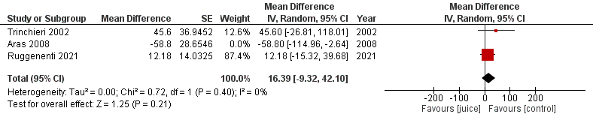
- Forest Plot showing sensitivity analysis of urinary calcium

Supplementary Figure 1: Results of Sensitivity Analysis of Change in Urinary Calcium Levels

- Risk of Bias Assessment Plots:
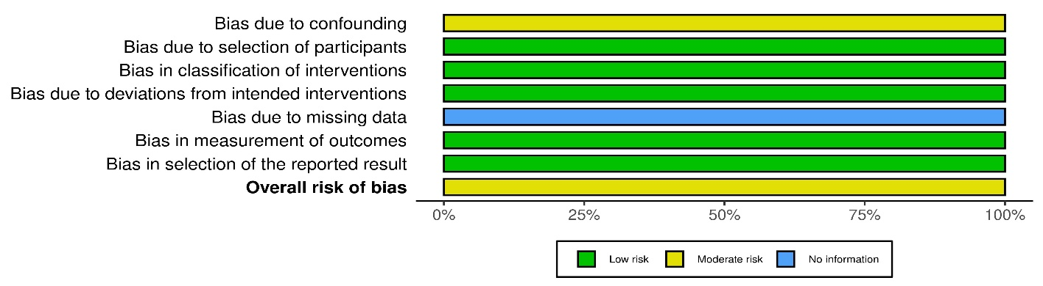

Supplementary Figure 2: Summary of Results of Quality Assessment of Non-randomized Studies using ROBINS-I Tool

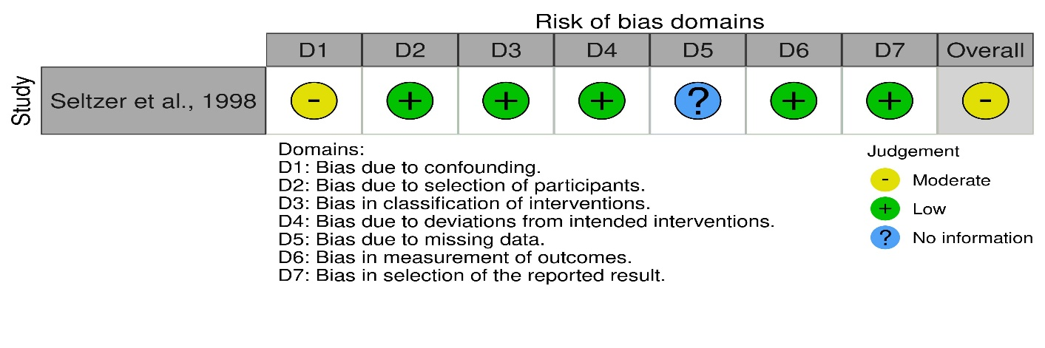

Supplementary Figure 3: Traffic Light Plot of Quality Assessment of Non-randomized Studies using ROBINS-I Tool
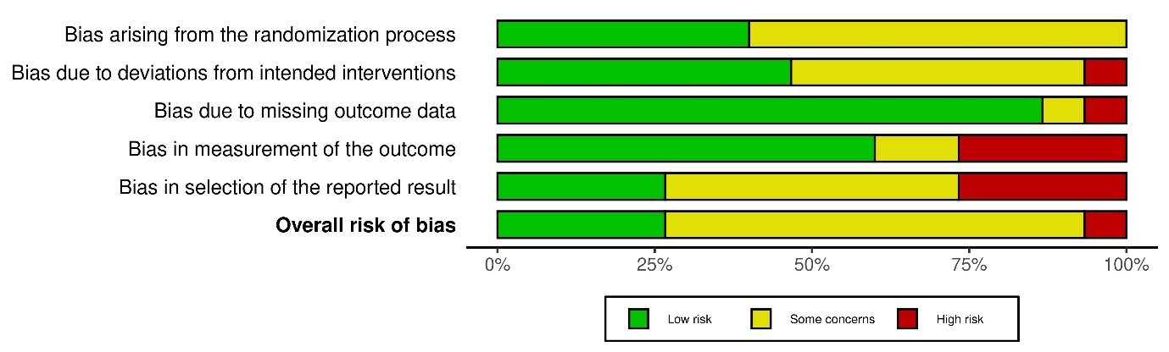

Supplementary Figure 6: Summary of Results of Quality Assessment of Randomized Studies using RoB-2 Tool

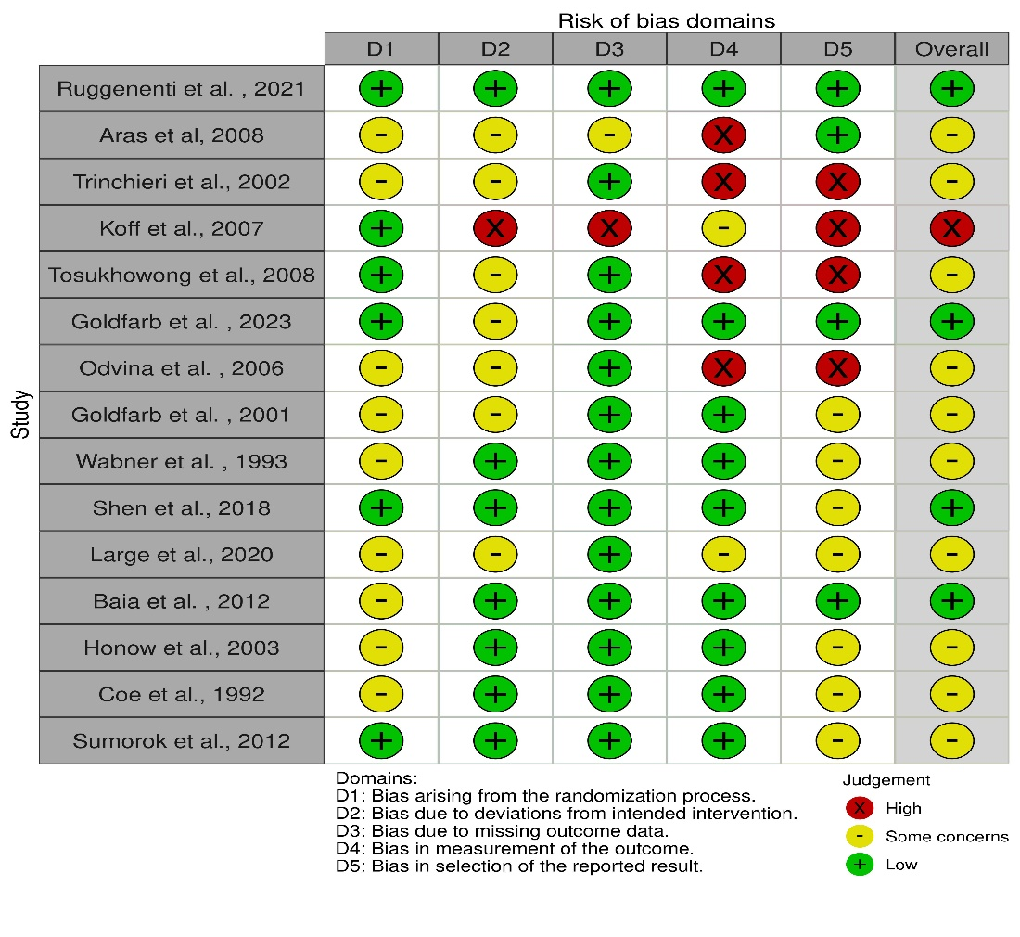

Supplementary Figure 5: Traffic Light Plot of Quality Assessment of Randomized Studies using RoB-2 Tool

