Supplementary Materials

A Comparison of Prostate Cancer Detection Rates Between TRUS-GB and MRI-GB: A Systematic Review and Meta-Analysis

Summary of Contents

SUPPLEMENTARY TABLES
Online Resource 1. Detailed baseline data of the included studies..................................................................2

SUPPLEMENTARY FIGURES
Online Resource 2. Diagram of Risk of Bias assessment in non-randomised trials using the ROBINS-I tool………………………………………………………………………………………………….………….4
Online Resource 3. Subgroup analysis of randomized controlled trials (RCTs) only, assessing the outcomes of overall prostate cancer (PCa) detection rates (1.1), clinically significant prostate cancer (csPCa) detection rates (1.2), and clinically insignificant prostate cancer detection rates (1.3). 5
Online Resource 4. Subgroup analysis of studies with no contamination of systematic biopsies in the intervention group, assessing the outcomes of overall prostate cancer (PCa) detection rates (1.1), clinically significant prostate cancer (csPCa) detection rates (1.2), and clinically insignificant prostate cancer detection rates (1.3)............................................................................................................................................................6
Online Resource 5. Subgroup analysis of overall prostate cancer (PCa) detection rates stratified by biopsy technique subtypes, including (1.1) mpMRI-guided biopsy (mpMRI-GB) subtypes (cognitive, fusion, and in-bore) and (1.2) US-guided biopsy (US-GB) approaches (transrectal and transperineal)..............................7
Online Resource 6. Subgroup analysis of clinically significant prostate cancer (csPCa) detection rates stratified by biopsy technique subtypes, including (1.3) mpMRI-guided biopsy (mpMRI-GB) subtypes (cognitive, fusion, and in-bore) and (1.4) US-guided biopsy (US-GB) approaches (transrectal and transperineal)......................................................................................................................................................8
Online Resource 7. Subgroup analysis of clinically insignificant prostate cancer detection rates stratified by biopsy technique subtypes, including (1.5) mpMRI-guided biopsy (mpMRI-GB) subtypes (cognitive, fusion, and in-bore) and (1.6) US-guided biopsy (US-GB) approaches (transrectal and transperineal)......................................................................................................................................................9
Online Resource 8. Subgroup analysis of missed diagnostic rates stratified by biopsy technique subtypes, including (1.7) mpMRI-guided biopsy (mpMRI-GB) subtypes (cognitive, fusion, and in-bore) and (1.8) US-guided biopsy (US-GB) approaches (transrectal and transperineal)....................................................................................................................................................10

SUPPLEMENTARY TABLES
Online Resource 1. Detailed baseline data of the included studies
Study ID | Study Design | MRI Used | Coil Used | Target Approach | Final Baseline Population Size, No. | Age, years (mean ± SD) | Prostate Volume, mL (mean ± SD) | Prebiopsy PSA levels ng/mL (mean ± SD)
Wang X et al., 2022 [9] | RCT | Signa HDX 3T | PAC | MpMRI Cognitive | Overall: 267, MpMRI: 134, TRUS: 133 | Overall: NA, MpMRI: 64.9 ± 6.6, TRUS: 64.2 ± 6.6 | Overall: NA, MpMRI: 45.5 ± 24.4, TRUS: 44.9 ± 27.9 | Overall: NA, MpMRI: 9.5 ± 4.3, TRUS: 9.6 ± 4.2
Zhang F et al., 2022 [10] | Non-RCT | Philips Achieva 3T | NA | MpMRI/TRUS Fusion | Overall: 738, MpMRI: 738, TRUS: 738 | Overall: 70.04 ± 7.96, MpMRI: 70.04 ± 7.96, TRUS: 70.04 ± 7.96 | Overall: 58.06 ± 35.26, MpMRI: 58.06 ± 35.26, TRUS: 58.06 ± 35.26 | Overall: 32.26 ± 128.02, MpMRI: 32.26 ± 128.02, TRUS: 32.26 ± 128.02
Alkema NG et al., 2022 [11] | Non-RCT | Unknown 3T | PAC | MpMRI/TRUS Fusion | Overall: 353, MpMRI: 263, TRUS: 353 | Overall: 66.9 ± 6.39, MpMRI: NA, TRUS: NA | Overall: 83.25 ± 35.88*, MpMRI: NA, TRUS: NA | Overall: 8.35 ± 3.26*, MpMRI: NA, TRUS: NA
Wagensveld IM et al., 2022 [12] | Non-RCT | NA | NA | MpMRI In-bore, MpMRI/TRUS Fusion, MpMRI Cognitive | Overall: 1965, MpMRI: 1015, TRUS: 950 | Overall: NA, MpMRI: 66.75 ± 1.39*, TRUS: 68.50 ± 1.24* | Overall: NA, MpMRI: 47.2 ± 11.4, TRUS: 46.8 ± 12.3 | Overall: NA, MpMRI: 7.28 ± 0.66*, TRUS: 6.88 ± 0.67*
Thangarasu M et al., 2021 [13] | Non-RCT | Philips Ingenia 3T | Non-ERC | MpMRI Cognitive | Overall: 75, MpMRI: 75, TRUS: 75 | Overall: 66.31 ± 7.9, MpMRI: 66.31 ± 7.9, TRUS: 66.31 ± 7.9 | Overall: 45.67 ± 18.9, MpMRI: 45.67 ± 18.9, TRUS: 45.67 ± 18.9 | Overall: 11.43 ± 3.23*, MpMRI: 11.43 ± 3.23*, TRUS: 11.43 ± 3.23*
Klotz L et al., 2021 [14] | RCT | Unknown 3T | PAC | MpMRI/TRUS fusion | Overall: 453, MpMRI: 227, TRUS: 226 | Overall: NA, MpMRI: 65.3 ± 7.6, TRUS: 64.5 ± 8.8 | Overall: NA, MpMRI: 60 ± 45, TRUS: 48 ± 25 | Overall: NA, MpMRI: 7.5 ± 3.6, TRUS: 6.8 ± 3.0
Bae JH et al., 2020 [15] | Non-RCT | Skyra, Achieva and Ingenia CX (Philips), 750W Architect (GE) | PAC | MpMRI/TRUS Fusion | Overall: 1442, MpMRI: 632, TRUS: 810 | Overall: NA, MpMRI: NA, TRUS: NA | Overall: NA, MpMRI: NA, TRUS: NA | Overall: NA, MpMRI: NA, TRUS: NA
Yalcin S et al., 2019 [16] | Non-RCT | Siemens 3T | NA | MpMRI/TRUS Fusion | Overall: 344, MpMRI: 206, TRUS: 138 | Overall: 66.45 ± 8.71, MpMRI: NA, TRUS: NA | Overall: NA, MpMRI: NA, TRUS: NA | Overall: NA, MpMRI: 7.13 (median), TRUS: 8.01 (median)
van der Leest M et al., 2019 [17] | Non-RCT | Siemens Magnetom Skyra 3T | NA | MpMRI In-bore; | Overall: 626, MpMRI: 317, TRUS: 626 | Overall: 64.25 ± 1.45*, MpMRI: NA, TRUS: 64.25 ± 1.45* | Overall: 57.00 ± 5.83*, MpMRI: NA, TRUS: 57.00 ± 5.83* | Overall: 6.40 ± 0.58*, MpMRI: NA, TRUS: 6.40 ± 0.58*
Kaushal R et al., 2019 [18] | Non-RCT | Philips Ingenia 3T | NA | MpMRI/TRUS Fusion; | Overall: 114, MpMRI: 114, TRUS: 114 | Overall: NA, MpMRI: NA, TRUS: NA | Overall: NA, MpMRI: NA, TRUS: NA | Overall: NA, MpMRI: NA, TRUS: NA
Wang L et al., 2019 [19] | Non-RCT | GE Signa HDxt 3T | PAC | MpMRI Cognitive; | Overall: 126, MpMRI: 79, TRUS: 47 | Overall: 68.7 ± 9.2, MpMRI: 69.7 ± 9.3, TRUS: 66.9 ± 8.7 | Overall: 60.5 ± 50.0, MpMRI: 53.6 ± 38.2, TRUS: 72.1 ± 64.1 | Overall: 13.82 ± 3.62*, MpMRI: 16.58 ± 5.57*, TRUS: 11.13 ± 2.50*
Choi YH et al., 2019 [20] | Non-RCT | Philips Intera Achieva TX 3T | PAC | MpMRI/TRUS Fusion, MpMRI Cognitive | Overall: 2009, MpMRI: 223, TRUS: 1786 | Overall: NA, MpMRI: 65.72 ± 0.41*, TRUS: 64.00 ± 0.11* | Overall: NA, MpMRI: 34.48 ± 0.70*, TRUS: 41.23 ± 0.28* | Overall: NA, MpMRI: 5.09 ± 0.17*, TRUS: 5.21 ± 0.04*
Alberts AR et al., 2018 [21] | Non-RCT | Discovery MR750 3T | PAC | MpMRI/TRUS fusion | Overall: 153, MpMRI: 74, TRUS: 79 | Overall: NA, MpMRI: NA, TRUS: NA | Overall: NA, MpMRI: NA, TRUS: NA | Overall: NA, MpMRI: NA, TRUS: NA
Kasivisvanathan V et al., 2018 [22] | RCT | Unknown 1.5T; Unknown 3T | PAC AND ERC | MpMRI/TRUS fusion | Overall: 500, MpMRI: 252, TRUS: 248 | Overall: 64.4 ± 7.8, MpMRI: 64.4 ± 7.5, TRUS: 64.5 ± 8 | Overall: NA, MpMRI: NA, TRUS: NA | Overall: NA, MpMRI: 7.00 ± 0.74*, TRUS: 6.70 ± 0.62*

ERC = endorectal coil; Mp = multiparametric; MRI = magnetic resonance imaging; NA = not available; PAC = phased array coil; PSA = prostate-specific antigen; RCT = randomized controlled trial; T = tesla; TRUS = transrectal ultrasound.
* Mean and standard deviation (SD) estimated from median and interquartile range.

SUPPLEMENTARY FIGURES
Online Resource 2. Diagram of Risk of Bias assessment in non-randomised trials using the ROBINS-I tool.
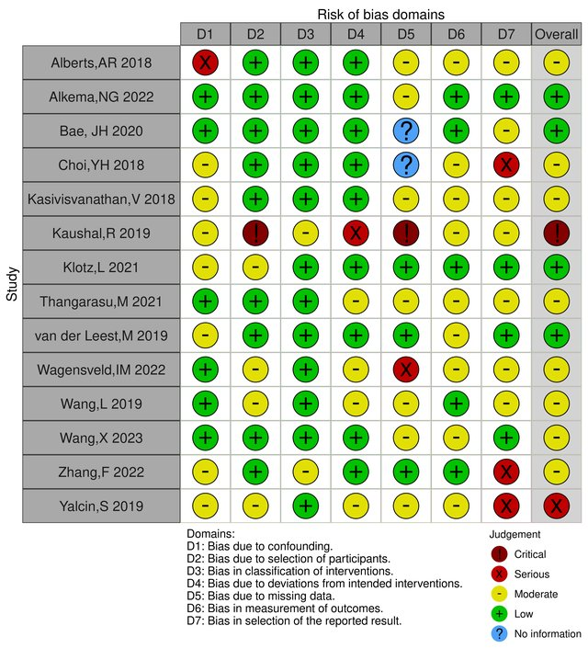

Online Resource 3. Subgroup analysis of randomized controlled trials (RCTs) only, assessing the outcomes of overall prostate cancer (PCa) detection rates (1.1), clinically significant prostate cancer (csPCa) detection rates (1.2), and clinically insignificant prostate cancer detection rates (1.3).

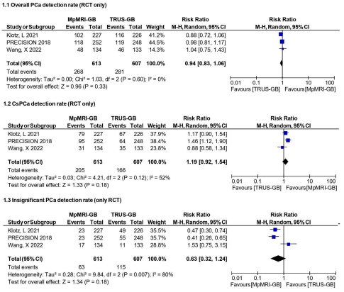

Online Resource 4. Subgroup analysis of studies with no contamination of systematic biopsies in the intervention group, assessing the outcomes of overall prostate cancer (PCa) detection rates (1.1), clinically significant prostate cancer (csPCa) detection rates (1.2), and clinically insignificant prostate cancer detection rates (1.3).
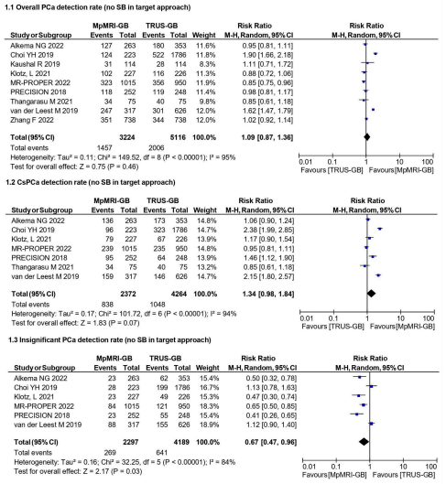

Online Resource 5. Subgroup analysis of overall prostate cancer (PCa) detection rates stratified by biopsy technique subtypes, including (1.1) mpMRI-guided biopsy (mpMRI-GB) subtypes (cognitive, fusion, and in-bore) and (1.2) US-guided biopsy (US-GB) approaches (transrectal and transperineal).
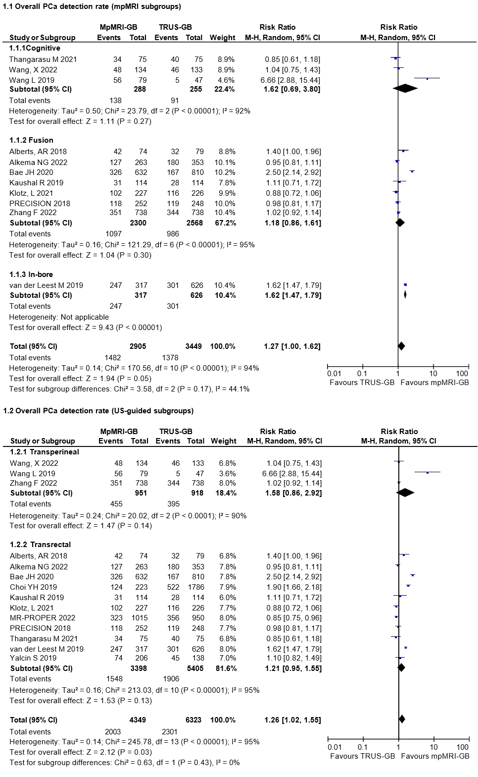
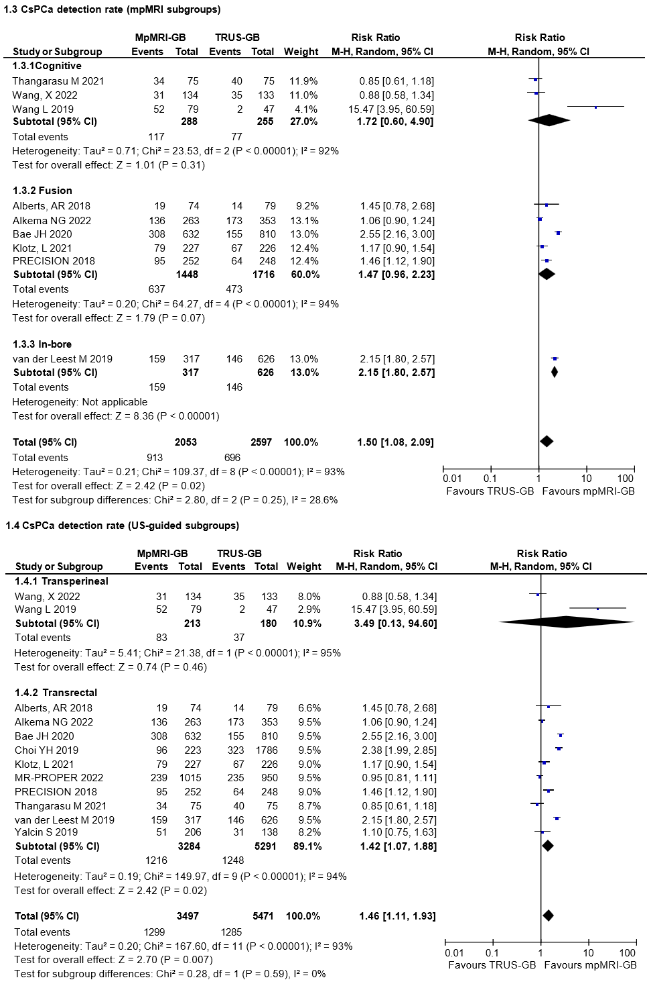
Online Resource 6. Subgroup analysis of clinically significant prostate cancer (csPCa) detection rates stratified by biopsy technique subtypes, including (1.3) mpMRI-guided biopsy (mpMRI-GB) subtypes (cognitive, fusion, and in-bore) and (1.4) US-guided biopsy (US-GB) approaches (transrectal and transperineal).

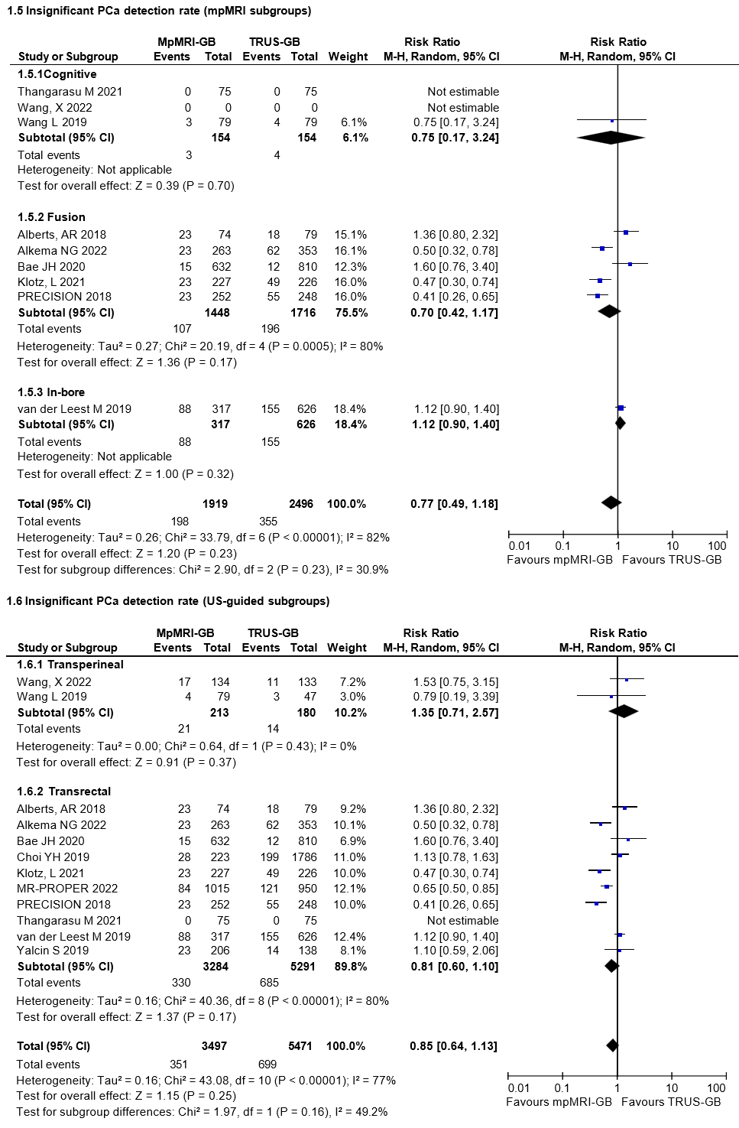
Online Resource 7. Subgroup analysis of clinically insignificant prostate cancer detection rates stratified by biopsy technique subtypes, including (1.5) mpMRI-guided biopsy (mpMRI-GB) subtypes (cognitive, fusion, and in-bore) and (1.6) US-guided biopsy (US-GB) approaches (transrectal and transperineal).

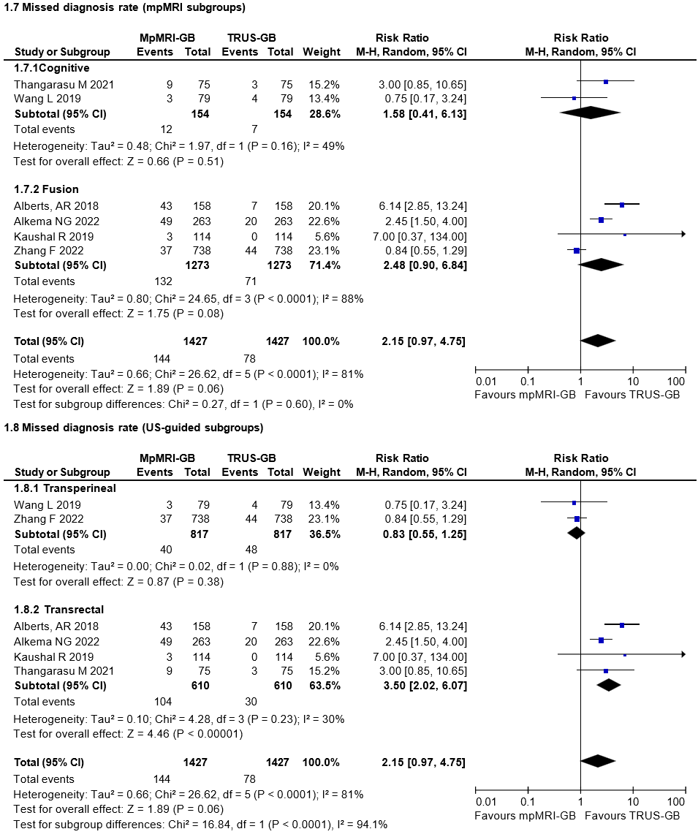
Online Resource 8. Subgroup analysis of missed diagnostic rates stratified by biopsy technique subtypes, including (1.7) mpMRI-guided biopsy (mpMRI-GB) subtypes (cognitive, fusion, and in-bore) and (1.8) US-guided biopsy (US-GB) approaches (transrectal and transperineal).

