Supplements

S1: Exponential model of EU risk assessment compared with power model described in Hofmann et al.2014 (Figure 5)
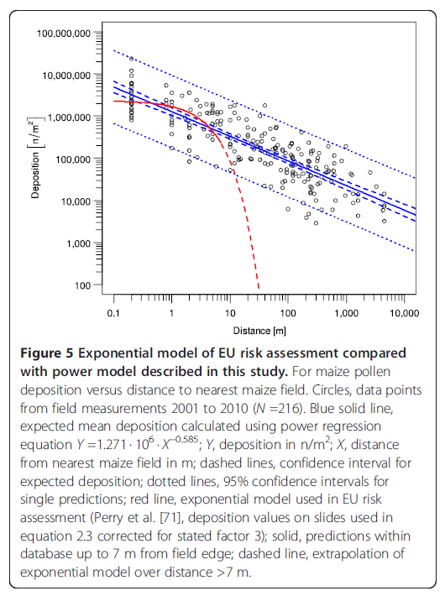

S2: The 8 uncertainty factors of EFSA 2015 (Table 2)

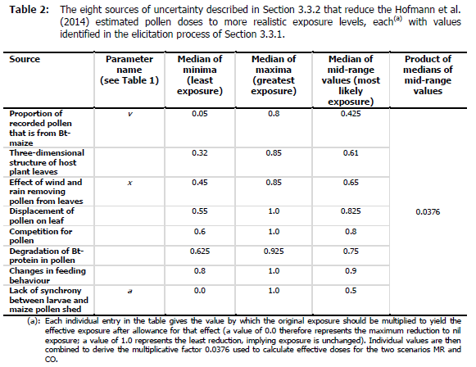

S3: Maize pollen deposition versus distance to the next maize field in Hofmann et al. 2014

S4: Standardized residuals for the regression in Hofmann et al. 2014

S5: Structured design: The structured design (last column) reflects best mean, variability and maximum peaks of the true leaf density distribution (column “Total”)

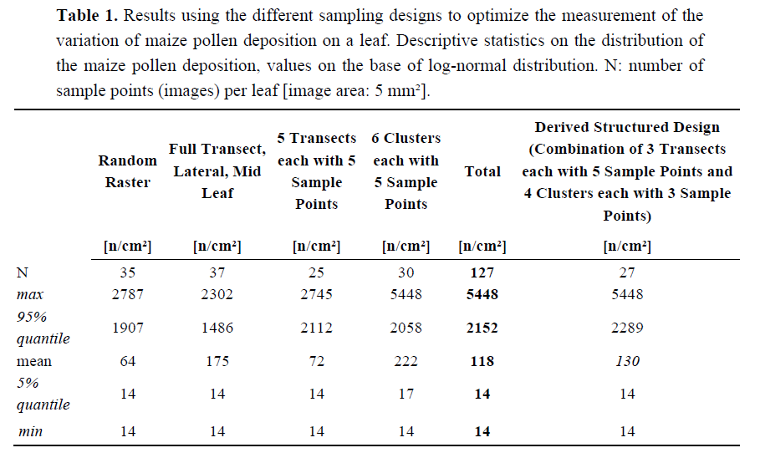

S6: Fig. 4, Hofmann et al. 2016

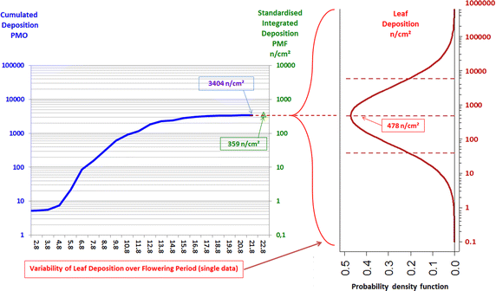

Fig. 4
Combining plant-specific leaf deposition and its variability with standardised measurements of pollen deposition. The blue line indicates cumulative maize pollen deposition, D _{total} (=cumulative daily deposition rate), measured with a PMO pollen monitor. The green values show standardised integrated deposition, D _{S}, measured with a PMF passive sampler. The red curve shows the variability of plant-specific leaf deposition on maize leaves over the flowering period (log-normal distribution) with mean and 90 % confidence intervals.

S7: Variability of leaf density over the flowering period and standardized deposition
(Fig. 3 Hofmann et al. 2016)
