Additional file

1) DLS measurements
The system used a backscattering angle of 173° at a wavelength of 632.8 nm.
For batch-DLS measurements, the temperature of the measurement cell was set to 25 °C. All measurements were performed in automatic mode, which optimizes attenuation and cell position automatically. The directly obtained intensity-weighted size distribution is converted to a number-weighted distribution by the MALVERN Zetasizer software (version 7.11) according to a refractive index of 1.59.
For the flow-DLS measurements (AF4-UV-MALS-DLS) the cell position was set to 4.2 and the attenuation to 11, which means no attenuation. The measurement time was 3 seconds.
2) Sample preparation
Dilution with ultrapure water, no sonication, thorough mixing for 30 seconds.
3) AF4-UV-MALS-DLS Fractionation System (Postnova Analytics GmbH, Landsberg, Germany) consisting of:
AF2000 MT
PN7520 Solvent Degasser
PN1130 isocratic pump
PN 5300 Autosampler
PN4020 Channel oven
PN3211 UV Detector at a wavelength of 254 nm, R=0.0005
PN3621 MALS
DLS Zetasizer Nano S MALVERN
Injection volume 125 µL at a concentration of 20 mg/L.
4) AF4 separation method and fractogram
The measurements were carried out in triplicate. Further fractionation conditions were as follows: injection volume was adjusted to 125 µl, detector flow with 0.5 mL min⁻¹, cross flow 1 mL min⁻¹ with a power gradient of 0.2, injection flow 0.2 mL min⁻¹ with an injection time of 7 min and a fractionation time of 50 min (see figure 1). A rinse step of 10 min at the end of the fractionation process was used between injections.
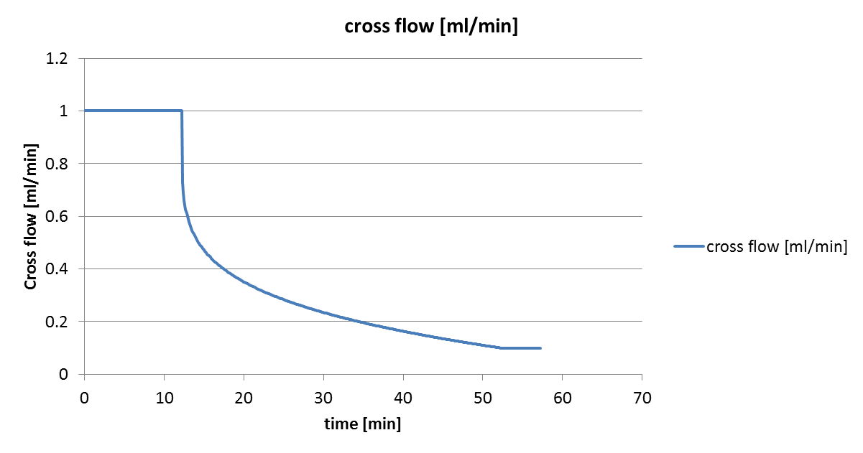
Figure S1: Separation program for AF4-measurements.

5) Data evaluation by AF4-MALS
Gyration diameters were calculated with the sphere model based on the Rayleigh-Debye-Gans Theory within the Postnova AF2000 control software. Detection angles from 12° till 156° (19 of 21 angles applied).$$\frac{R(ϑ)}{c K}=MP(ϑ)$$
with K: contrast factor; ϑ: Scattering angle; R_{ϑ}: Rayleigh ratio; c: Concentration of the analyte; λ₀ the wavelength; M: Molar mass.
$$K=\frac{4π^{2}}{λ_{0}^{4}N_{A}}{(n_{0}\frac{dn}{dc})}^{2}$$
with: n₀: refractive index of the solvent; dn/dc: refractive index increment of the analyte in solvent: λ₀: wavelength of the light; N_{A}: Avogadro’s number; r: radius of gyration.
$$q=\sin{\frac{ϑ}{2}}$$
$$h=rq=r\frac{4πn_{0}}{λ_{0}}\sin{\frac{ϑ}{2}}$$
Sphere model: $P\left(ϑ\right)={\left[\frac{3}{h^{3}}\left(sinh-hcosh\right)\right]}^{2}$

$$\frac{1}{P(ϑ)}=1+\frac{16π^{2}n_{0}^{2}r^{2}}{3λ_{0}^{2}}\sin^{2}(\frac{ϑ}{2})$$

5) Obtained results
- Batch-DLS
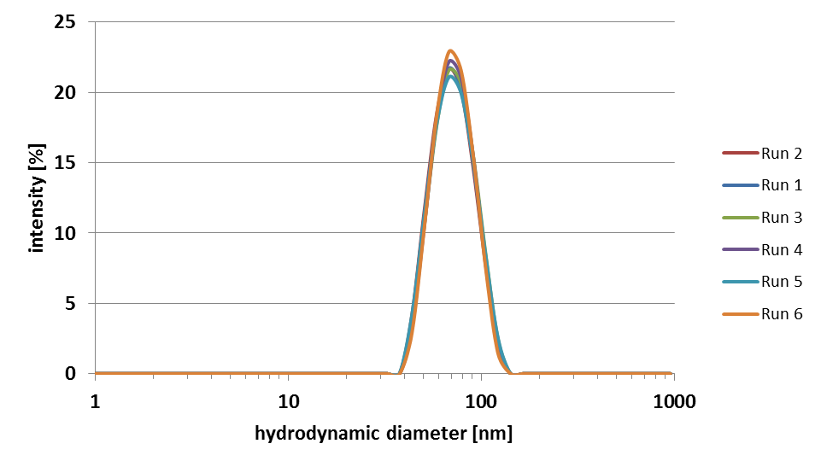
Figure S2: Intensity-weighted size distribution by batch-DLS.

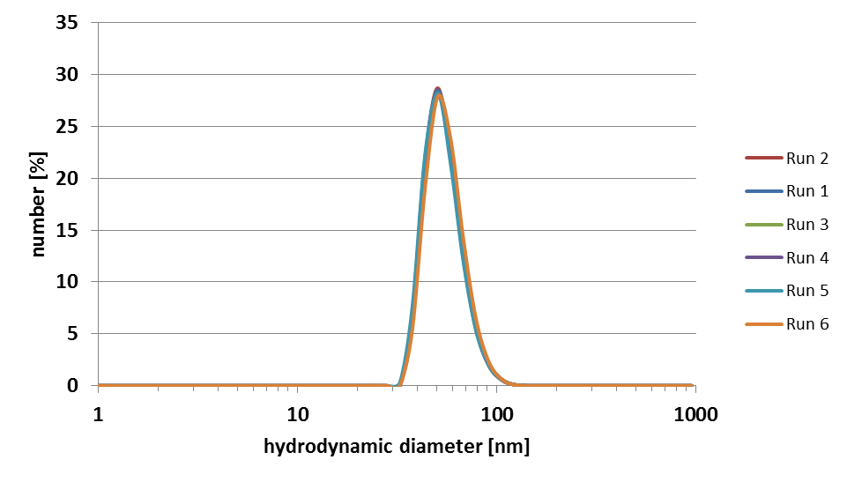
Figure S3: Number-weighted size distribution by batch-DLS.

- AF4-UV-MALS-DLS
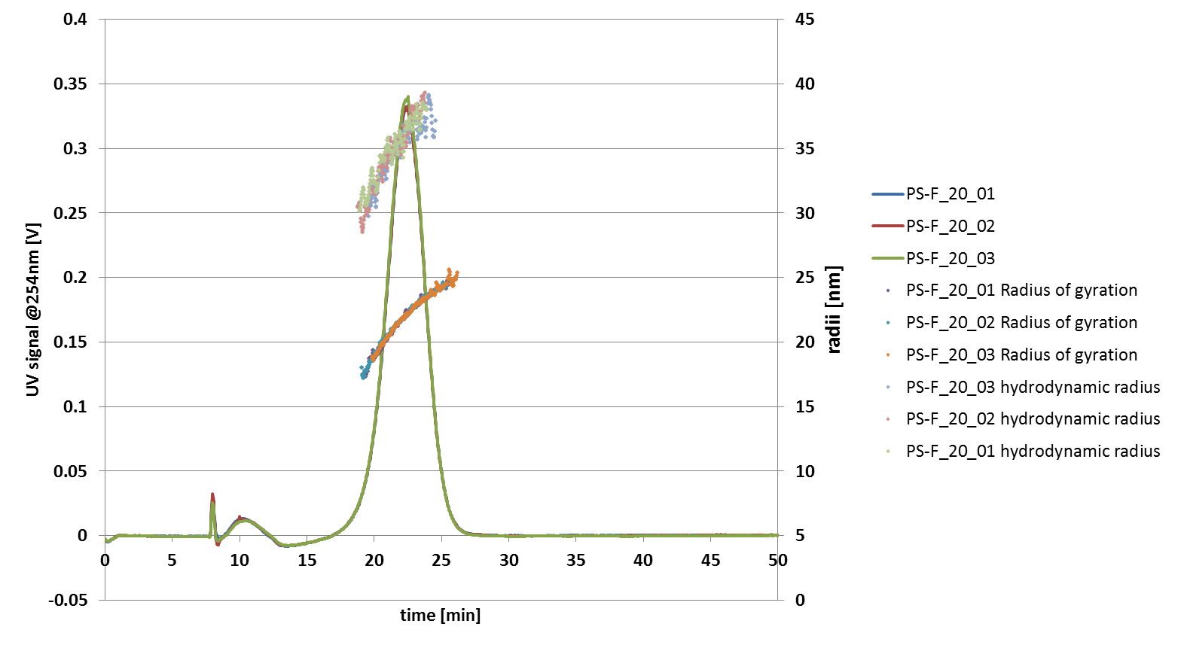
Figure S4: AF4-UV-MALS-DLS measurements corrected by a blank run with radius of gyration and hydrodynamic radius.

Table 1: Results of AF4-UV-MALS-DLS measurements of PS-F Nanoparticles.
 | Peak maximum (22.8 min)
 | Gyration diameter [nm] | Hydrodynamic diameter [nm]
run 1 | 46.2 | 73.4
run 2 | 46.5 | 71.2
run 3 | 46.7 | 72.4
average | 46.4 | 72.3
 | 0.3 | 1.2
Gyration diameter [nm] | 46.4 ± 0.3
Hydrodynamic diameter [nm] | 72.3 ± 1.2

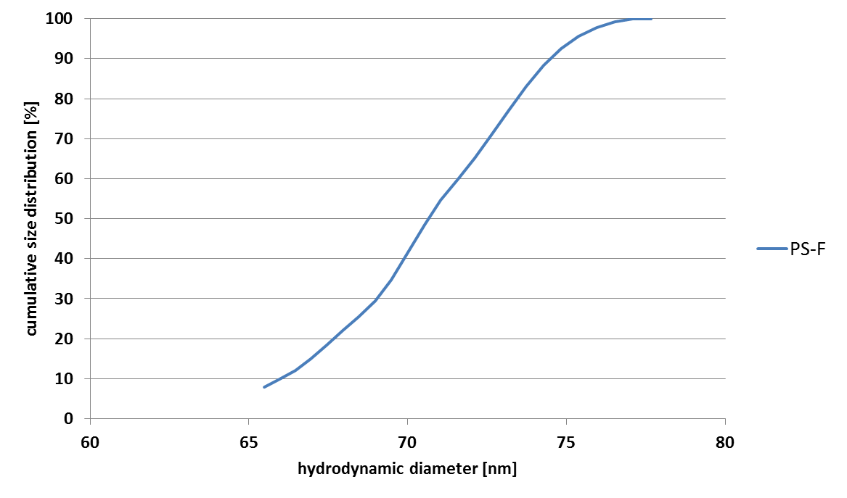
Figure S5: Number-weighted size distribution obtained from AF4-DLS (n=3).
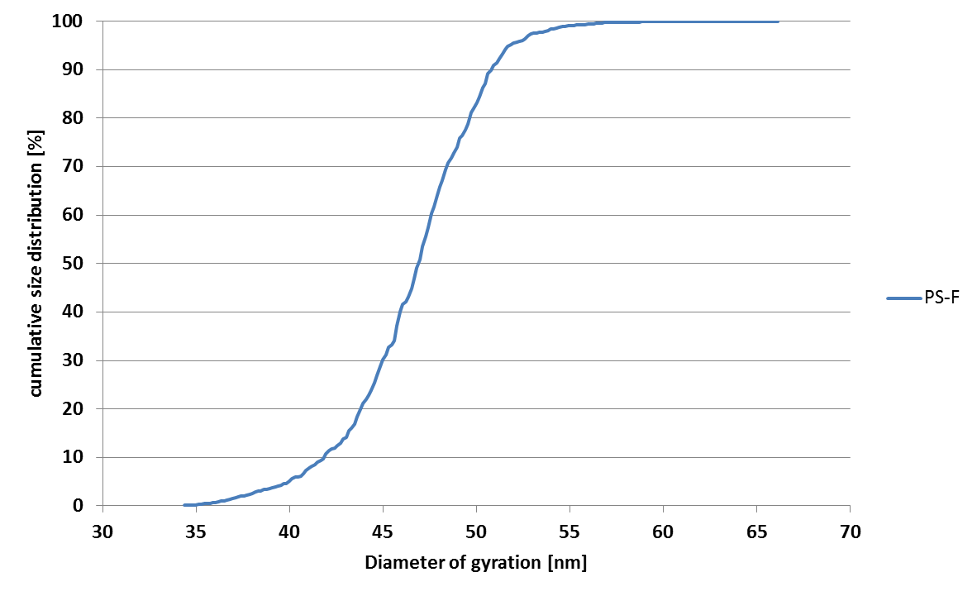
Figure S6: Mass-weighted size distribution obtained from AF4-UV-MALS (n=3).

