Factors Associated with Blooms of Cyanobacteria in a large shallow lake, China

Di Li E-mails: ld@jshb.gov.cn; Naicheng Wu E-mails: nwu@hydrology.uni-kiel.de; Song Tang E-mails: tangsong@nieh.chinacdc.cn; Guanyong Su E-mails: sugy@njust.edu.cn; Xuwen Li E-mails: lxw241@163.com; Yong Zhang E-mails: zhangyong@jshb.gov.cn; Guoxiang Wang E-mails: 442371719@qq.com; Junyi Zhang E-mails: blocksharon@163.com; Hongling Liu E-mails: hlliu@nju.edu.cn; Markus Hecker E-mails: markus.hecker@usask.ca; John P. Giesy E-mails: JGiesy@aol.com; Hongxia Yu E-mails: yuhx@nju.edu.cn
¹ State Key Laboratory of Pollution Control and Resource Reuse, School of the Environment, Nanjing University, Nanjing, Jiangsu 210046, China

² Jiangsu Environmental Monitoring Center, Nanjing, Jiangsu 210036, China
³ Department of Hydrology and Water Resources Management, Kiel University, Kiel 24118, Germany
⁴ National Institute of Environmental Health, Chinese Center for Disease Control and Prevention, Beijing 100021, China
⁵ Jiangsu Key Laboratory of Chemical Pollution Control and Resources Reuse, School of Environmental and Biological Engineering, Nanjing University of Science and Technology, Nanjing 210094, China
⁶ School of the Environment, Nanjing Normal University, Nanjing, Jiangsu 210023, China

⁷ Wuxi Environmental Monitoring Center, Wuxi, Jiangsu 214000, China
⁸ Toxicology Centre, University of Saskatchewan, Saskatoon, SK S7N 5B3, Canada.
⁹ School of Environment and Sustainability, University of Saskatchewan, Saskatoon, SK S7N 5C3, Canada.
¹⁰ Department of Veterinary Biomedical Sciences and Toxicology Centre, University of Saskatchewan, Saskatoon, Saskatchewan S7N5B3, Canada
¹¹ Department of Zoology and Center for Integrative Toxicology, Michigan State University, East Lansing, Michigan 48824, United States
¹² School of Biological Sciences, University of Hong Kong, Hong Kong, SAR China
*Corresponding author: Dr. Hongxia Yu, State Key Laboratory of Pollution Control and Resource Reuse, School of the Environment, Nanjing University, Nanjing, Jiangsu 210046, China
Tel: +86-25-89680356; Fax: +86-25-89680356; E-mails: yuhx@nju.edu.cn
Figure S1. Profiles of diversity represented by one-parametric Renyi diversity index for two hypothetical assemblages, denoted by A and B. Vertical dotted lines denote values of the scale parameter (measured along the x-axis), which provides classical diversity index statistics, such as number of species, Shannon, Simpson, and Berger-Parker index of diversity.
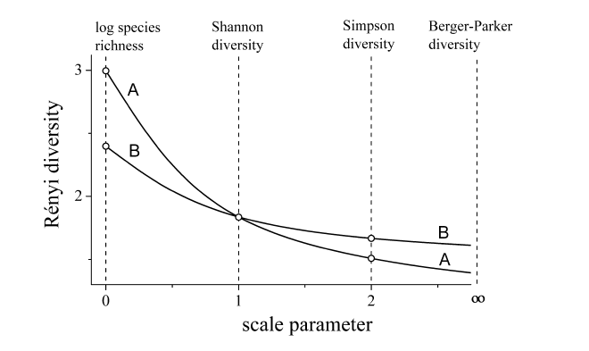

Figure S2. Densities of phytoplankton taxa of seven sampling sites in Tai Lake.
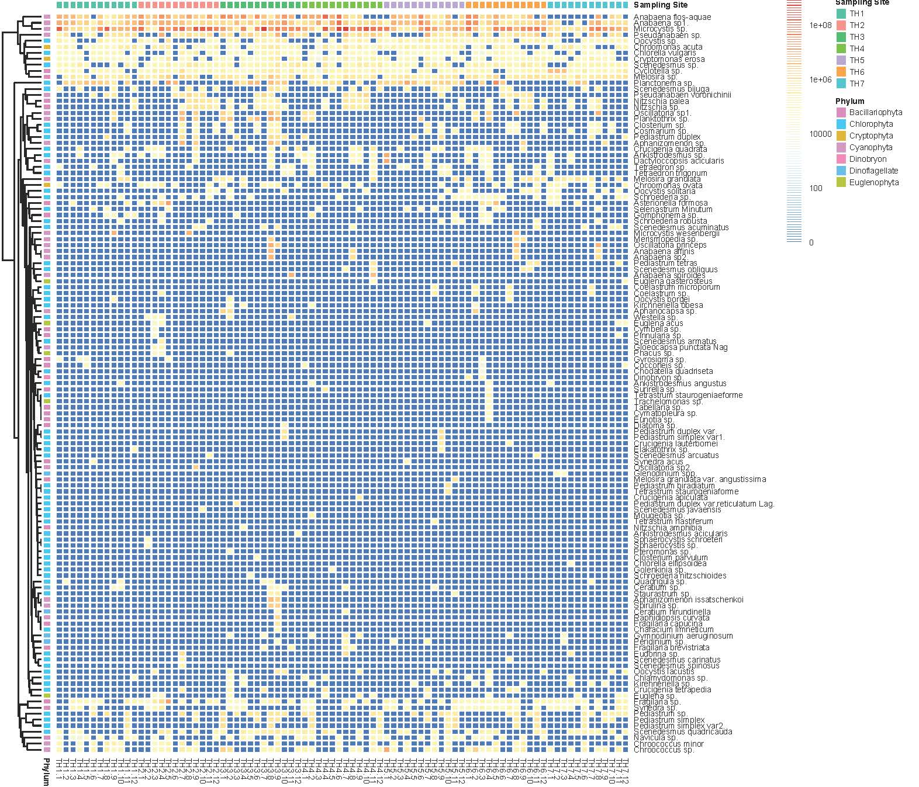

Figure S3. Diversities of phytoplankton communities at four different seasons in Tai Lake.

Table S1. Synthesized index of trophic state (STSI), trophic state, and qualitative descriptor of water quality.
Synthesized trophic state index (STSI) | Trophic state | Water quality
0＜STSI≤30 | Oligotrophication | Excellent
30＜STSI≤50 | Mesotrophication | Good
50＜STSI≤60 | Eutrophication | Polluted
60＜STSI≤70 | Supereutrophication | Superpolluted
70＜STSI≤100 | Hypereutrophication | Hyperpolluted

Table S2. Pairwise Spearman’s correlations coefficients (ρ) among environmental variables.
 | WT | pH | SD | DO | Conductivity | CODMn | BOD5 | TN | NH4N | TP | CODCr | F | As | Cu | Pb | MCLR | NPR | STSI
WT | 1.000 | 0.693 | 0.103 | -0.803 | 0.017 | -0.072 | 0.065 | -0.017 | 0.083 | 0.072 | -0.070 | -0.474 | 0.475 | 0.219 | 0.578 | 0.012 | -0.037 | 0.073
pH | 0.693 | 1.000 | 0.238 | -0.449 | 0.266 | -0.061 | 0.019 | 0.002 | -0.117 | -0.039 | 0.042 | -0.236 | 0.306 | 0.152 | 0.459 | 0.191 | 0.094 | 0.021
SD | 0.103 | 0.238 | 1.000 | -0.105 | 0.318 | 0.163 | 0.321 | 0.052 | 0.077 | -0.176 | 0.258 | -0.090 | 0.139 | -0.022 | 0.151 | 0.174 | 0.216 | -0.181
DO | -0.803 | -0.449 | -0.105 | 1.000 | -0.093 | 0.277 | 0.030 | -0.036 | -0.179 | 0.015 | 0.115 | 0.432 | -0.343 | -0.336 | -0.512 | 0.174 | -0.043 | 0.100
Conductivity | 0.017 | 0.266 | 0.318 | -0.093 | 1.000 | 0.081 | 0.238 | 0.360 | -0.061 | -0.041 | 0.506 | 0.215 | -0.273 | 0.022 | 0.169 | 0.016 | 0.329 | -0.013
CODMn | -0.072 | -0.061 | 0.163 | 0.277 | 0.081 | 1.000 | 0.565 | 0.031 | 0.224 | 0.423 | 0.248 | 0.300 | 0.144 | -0.055 | 0.111 | 0.531 | -0.336 | 0.558
BOD5 | 0.065 | 0.019 | 0.321 | 0.030 | 0.238 | 0.565 | 1.000 | 0.490 | 0.324 | 0.377 | 0.447 | 0.078 | 0.137 | 0.023 | 0.163 | 0.321 | 0.020 | 0.613
TN | -0.017 | 0.002 | 0.052 | -0.036 | 0.360 | 0.031 | 0.490 | 1.000 | 0.200 | 0.237 | 0.464 | 0.080 | -0.199 | 0.057 | -0.079 | 0.064 | 0.551 | 0.415
NH4N | 0.083 | -0.117 | 0.077 | -0.179 | -0.061 | 0.224 | 0.324 | 0.200 | 1.000 | 0.174 | -0.138 | -0.043 | 0.093 | 0.069 | 0.224 | -0.017 | -0.049 | 0.265
TP | 0.072 | -0.039 | -0.176 | 0.015 | -0.041 | 0.423 | 0.377 | 0.237 | 0.174 | 1.000 | 0.040 | -0.133 | 0.278 | 0.047 | -0.079 | 0.398 | -0.653 | 0.818
CODCr | -0.070 | 0.042 | 0.258 | 0.115 | 0.506 | 0.248 | 0.447 | 0.464 | -0.138 | 0.040 | 1.000 | 0.333 | -0.076 | -0.002 | -0.027 | 0.022 | 0.312 | 0.173
F | -0.474 | -0.236 | -0.090 | 0.432 | 0.215 | 0.300 | 0.078 | 0.080 | -0.043 | -0.133 | 0.333 | 1.000 | -0.232 | -0.142 | -0.058 | 0.058 | 0.144 | -0.017
As | 0.475 | 0.306 | 0.139 | -0.343 | -0.273 | 0.144 | 0.137 | -0.199 | 0.093 | 0.278 | -0.076 | -0.232 | 1.000 | -0.065 | 0.240 | 0.183 | -0.398 | 0.163
Cu | 0.219 | 0.152 | -0.022 | -0.336 | 0.022 | -0.055 | 0.023 | 0.057 | 0.069 | 0.047 | -0.002 | -0.142 | -0.065 | 1.000 | 0.499 | -0.065 | 0.002 | 0.025
Pb | 0.578 | 0.459 | 0.151 | -0.512 | 0.169 | 0.111 | 0.163 | -0.079 | 0.224 | -0.079 | -0.027 | -0.058 | 0.240 | 0.499 | 1.000 | 0.144 | 0.027 | -0.039
MCLR | 0.012 | 0.191 | 0.174 | 0.174 | 0.016 | 0.531 | 0.321 | 0.064 | -0.017 | 0.398 | 0.022 | 0.058 | 0.183 | -0.065 | 0.144 | 1.000 | -0.284 | 0.391
NPR | -0.037 | 0.094 | 0.216 | -0.043 | 0.329 | -0.336 | 0.020 | 0.551 | -0.049 | -0.653 | 0.312 | 0.144 | -0.398 | 0.002 | 0.027 | -0.284 | 1.000 | -0.372
STSI | 0.073 | 0.021 | -0.181 | 0.100 | -0.013 | 0.558 | 0.613 | 0.415 | 0.265 | 0.818 | 0.173 | -0.017 | 0.163 | 0.025 | -0.039 | 0.391 | -0.372 | 1.000
Note: STSI was excluded due to its higher correlations with TP (bold numbers).

