Additional material – Additional Figure S1

Prioritization of hazards of novel flame retardants using the mechanistic toxicology information from ToxCast and Adverse Outcome Pathways

by Lola Bajard, Lisa Melymuk, Ludek Blaha

Masaryk University, Faculty of Science, RECETOX, Kamenice 5, CZ62500 Brno, * blaha@recetox.muni.cz

Additional Figure S1: Criteria for “invalidating” a hit from ToxCast after examination of the dose-response curve, examples.
We considered as invalid the assays for which: 1. The dose-response curve did not display a sigmoidal shape (see examples in B,C), or 2. Only one isolated data point was above cut off (see examples in A,B) or 3. The data points for low concentrations were absent and the AC50 extrapolated (see examples in C,D).

A B
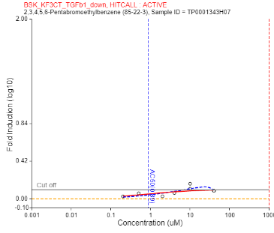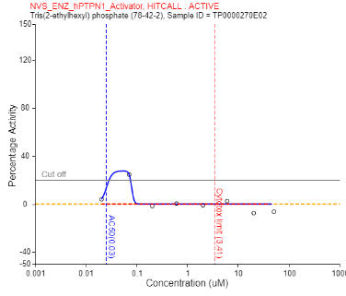
C D
