Supplementary Material
Table S1 Mass confirmation and purity determination of each dye used in this study
Ref number | MWDL index | Molecular formula | Ion Polarity | Theoretical exact mass | Ion species | Experimental exact mass | ppm error | λ max (nm) | Purity | RT (min)
5 | 27237-115 | C17H12NO4Cl | Pos | 330.0528 | [M+H]⁺ | 330.0526 | -0.61 | 485 | 79% | 1.87
9 | 27237-061 | C14H12O2S | Neg | 243.0485 | [M-H]⁻ | 243.0488 | 1.23 | 317 | 100% | 1.40
21 | 25380-49 | C20H14N2O5 | Pos | 363.0976 | [M+H]⁺ | 363.0979 | 0.83 | 271 | 100% | 0.89
25 | 25380-174 | C16H9N3S2 | Pos | 308.0311 | [M+H]⁺ | 308.0311 | 0.00 | 386 | 100% | 2.00
41 | 25377-031 | C10H8N4O2 | Neg | 215.0574 | [M-H]⁻ | 215.0576 | 0.93 | 371 | 100% | 0.73
42 | 25377-013 | C28H18N2O8S2 | Neg | 573.0432 | [M-H]⁻ | 573.0423 | -1.57 | 655 | 100% | 2.21
72 | 5417-15 | C16H18N3O5Cl | Pos | 267.1492 | [M]⁺ | 267.1498 | 2.25 | 547 | 87% | 3.41
83 | 6012-90F | C22H18N10O3 | Pos | 471.1636 | [M+H]⁺ | 471.1639 | 0.64 | 431 | 100% | 1.87
136 | 5380-112A | C16H4N5S2 | Pos | 340.0685 | [M]⁺ | 340.0685 | 0.00 | 484 | 100% | 3.20
145 | 5210-71 | C14H3O4BrCl4 | Neg | 452.7896 | [M-H]⁻ | 452.7892 | -0.88 | 480 | 86% | 3.95
160 | 11769-62A | C27H26N4Cl | Pos | 441.1841 | [M]⁺ | 441.1835 | -1.36 | 626 | 96% | 3.00
183 | 17994-277-1 | C23H18N3O6S | Neg | 464.0922 | [M-H]⁻ | 464.0921 | -0.22 | 620 | 100% | 0.69
70 | 5158-83C | C12H12N4O2S | Pos | 277.0754 | [M+H]⁺ | 291.0548 | -0.06 | 451 | 100% | 1.38
117 | 5432-22D | C17H12N4O | Pos | 289.1084 | [M+H]⁺ | 223.0978 | 0.72 | 360, 410 | 94% | 3.06*
118 | 5432-33C | C14H10N2OClF3 | Pos | 315.0507 | [M+H]⁺ | 315.0501 | -1.90 | 340 | 96% | 3.40*
*: data were obtained from Agilent instrument

Table S2 Results from testing the 15 dyes to Daphnia similis performed in single concentrations at maximum of limit of solubility
Dye | Concentration  mg L⁻¹ | Number of Immobilized Organisms |  |  |  | Total | % |  | pH
Dye | Concentration  mg L⁻¹ | 1 | 2 | 3 | 4
Control | 0 | 0/5 | 0/5 | 0/5 | 0/5 | 0/20 | 0 |  | 6.6
5 | 3.1 | 5/5 | 5/5 | 5/5 | 5/5 | 20/20 | 100* |  | 6.6
9 | 6.25 | 5/5 | 5/5 | 5/5 | 5/5 | 20/20 | 100 |  | 6.5
21 | 1.3 | 0/5 | 0/5 | 0/5 | 0/5 | 0/20 | 0 |  | 6.7
25 | 15.7 | 0/5 | 1/5 | 1/5 | 0/5 | 2/20 | 10 |  | 6.7
41 | 12.6 | 0/5 | 0/5 | 0/5 | 0/5 | 0/20 | 0 |  | 6.5
42 | 6.4 | 1/5 | 1/5 | 0/5 | 0/5 | 2/20 | 10 |  | 6.5
70 | 8.4 | 5/5 | 5/5 | 5/5 | 5/5 | 20/20 | 100 |  | 6.6
72 | 8.4 | 5/5 | 5/5 | 5/5 | 5/5 | 20/20 | 100 |  | 6.6
83 | 3.1 | 5/5 | 5/5 | 5/5 | 5/5 | 20/20 | 100 |  | 6.6
117 | 8.3 | 5/5 | 5/5 | 5/5 | 5/5 | 20/20 | 100 |  | 6.6
118 | 62.5 | 5/5 | 5/5 | 5/5 | 5/5 | 20/20 | 100 |  | 6.7
136 | 3.8 | 5/5 | 5/5 | 5/5 | 5/5 | 20/20 | 100 |  | 6.6
145 | 3.2 | 0/5 | 2/5 | 2/5 | 2/5 | 6/20 | 30 |  | 6.6
160 | 8.2 | 5/5 | 5/5 | 5/5 | 5/5 | 20/20 | 100 |  | 6.5
183 | 8.3 | 0/5 | 0/5 | 0/5 | 0/5 | 0/20 | 0 |  | 6.7
* Values in bold indicate toxicity because the % of immobilized organisms were greater than 10.
Table S3 Raw data for acute test of Dye 5 to Daphnia similis
Concentration  (mg L⁻¹) | Number of immobilized organisms |  |  |  | Total | %
Concentration  (mg L⁻¹) | 1 | 2 | 3 | 4 | Total | %
Control | 0/5 | 0/5 | 0/5 | 0/5 | 0/20 | 0
DMSO 0.1% (v/v) | 0/5 | 0/5 | 0/5 | 0/5 | 0/20 | 0
0.03 | 0/5 | 0/5 | 0/5 | 0/5 | 0/20 | 0
0.1 | 0/5 | 0/5 | 0/5 | 0/5 | 0/20 | 0
0.3 | 0/5 | 0/5 | 0/5 | 0/5 | 0/20 | 0
1 | 3/5 | 3/5 | 3/5 | 5/5 | 14/20 | 70
3.1 | 5/5 | 5/5 | 5/5 | 5/5 | 20/20 | 100

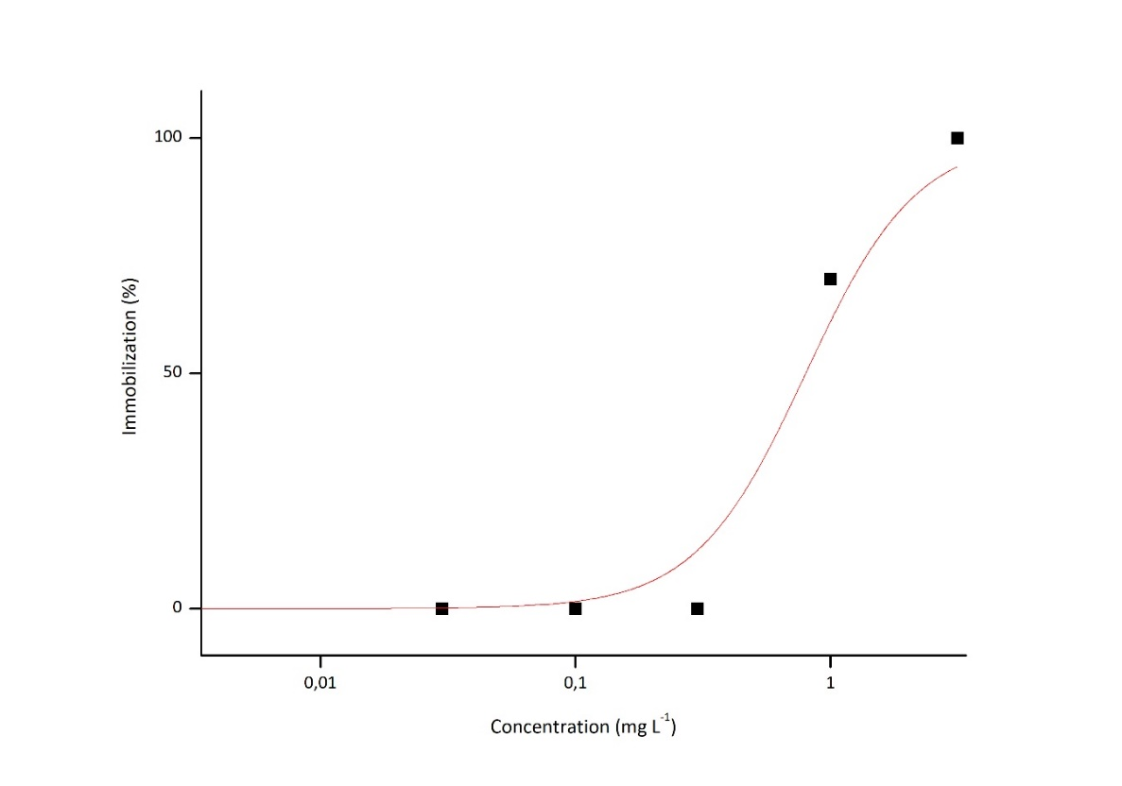
Fig. S1 Concentration-response curve for dye 5 to Daphnia similis, EC₅₀ = 0.94 mg L⁻¹ (0.63 – 0.99 mg L⁻¹)
Table S4 Raw data for acute test of Dye 9 to Daphnia similis
Concentration  (mg L⁻¹) | Number of immobilized organisms |  |  |  | Total | %
Concentration  (mg L⁻¹) | 1 | 2 | 3 | 4 | Total | %
Control | 0/5 | 0/5 | 0/5 | 0/5 | 0/20 | 0
DMSO 0.0025% (v/v) | 0/5 | 0/5 | 0/5 | 0/5 | 0/20 | 0
0.0625 | 0/5 | 0/5 | 0/5 | 0/5 | 0/20 | 0
0.2 | 0/5 | 0/5 | 0/5 | 0/5 | 0/20 | 0
0.625 | 0/5 | 0/5 | 0/5 | 0/5 | 0/20 | 0
2 | 4/5 | 4/5 | 4/5 | 3/5 | 15/20 | 75
6.25 | 5/5 | 5/5 | 5/5 | 5/5 | 20/20 | 100

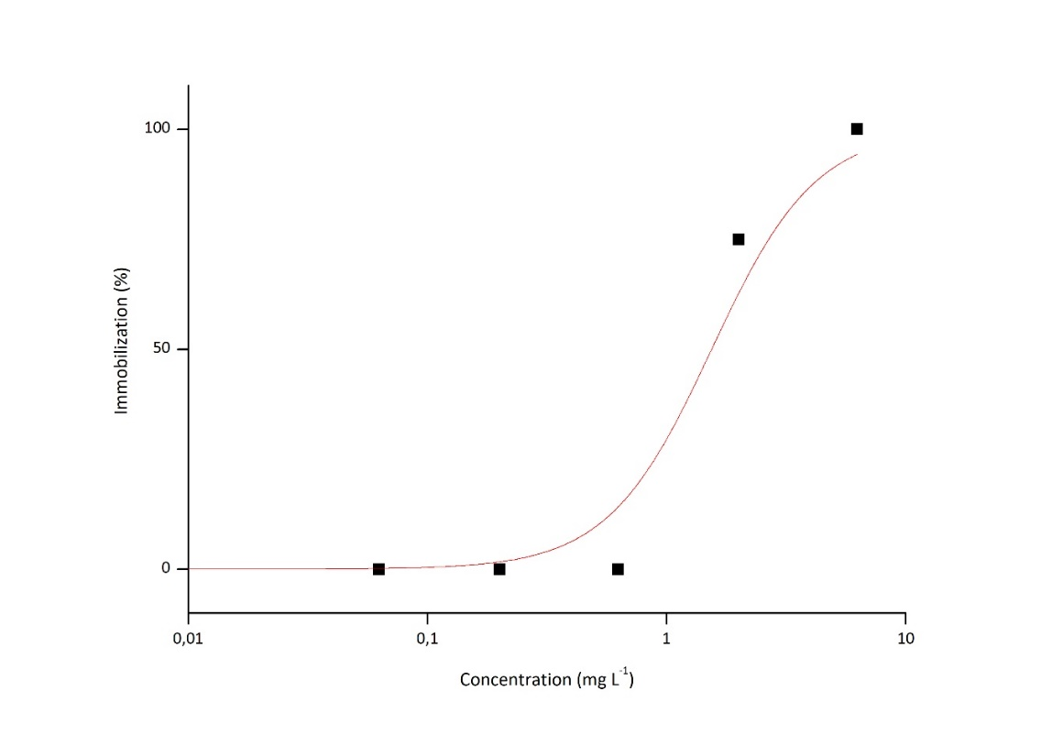
Fig. S2 Dye 9 concentration-response curve to Daphnia similis, EC₅₀ = 1.86 mg L⁻¹ (1.28 – 1.99 mg L⁻¹)
Table S5 Raw data for acute test of Dye 70 to Daphnia similis
Concentration  (mg L⁻¹) | Number of immobilized organisms |  |  |  | Total | %
Concentration  (mg L⁻¹) | 1 | 2 | 3 | 4 | Total | %
Control | 0/5 | 0/5 | 0/5 | 0/5 | 0/20 | 0
DMSO 0.1% (v/v) | 0/5 | 0/5 | 0/5 | 0/5 | 0/20 | 0
0.084 | 0/5 | 0/5 | 0/5 | 0/5 | 0/20 | 0
0.42 | 0/5 | 0/5 | 0/5 | 0/5 | 0/20 | 0
0.84 | 0/5 | 0/5 | 2/5 | 0/5 | 2/20 | 10
4.2 | 4/5 | 3/5 | 3/5 | 3/5 | 13/20 | 65
8.4 | 4/5 | 4/5 | 4/5 | 4/5 | 16/20 | 80
8.4 | 5/5 | 5/5 | 5/5 | 5/5 | 20/20 | 100

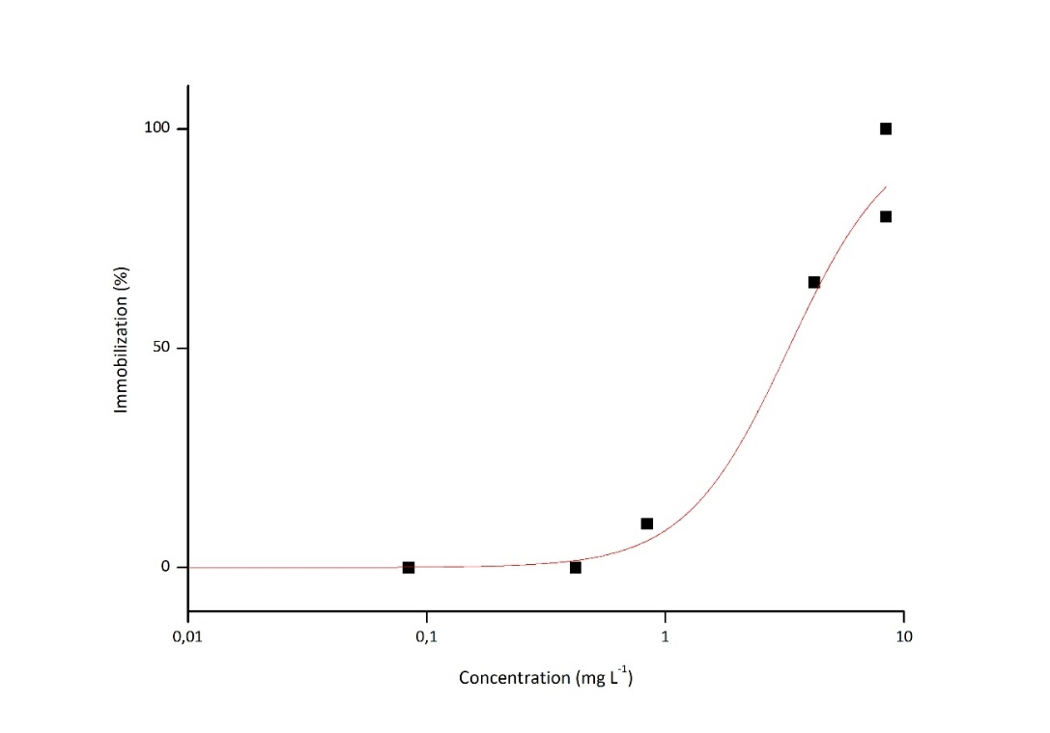
Fig. S3 Dye 70 concentration-response curve to Daphnia similis, EC₅₀= 2.95 mg L⁻¹ (1.79 – 3.99 mg L⁻¹)
Table S6 Raw data for acute test of Dye 72 to Daphnia similis
Concentration  (mg L⁻¹) | Number of immobilized organisms |  |  |  | Total | %
Concentration  (mg L⁻¹) | 1 | 2 | 3 | 4 | Total | %
Control | 0/5 | 0/5 | 0/5 | 0/5 | 0/20 | 0
DMSO 0.1% (v/v) | 0/5 | 0/5 | 0/5 | 0/5 | 0/20 | 0
0.1 | 0/5 | 0/5 | 0/5 | 0/5 | 0/20 | 0
0.18 | 0/5 | 0/5 | 0/5 | 0/5 | 0/20 | 0
0.26 | 0/5 | 0/5 | 0/5 | 0/5 | 0/20 | 0
0.32 | 0/5 | 1/5 | 0/5 | 2/5 | 3/20 | 15
0.53 | 3/5 | 5/5 | 5/5 | 5/5 | 18/20 | 90
0.58 | 4/5 | 5/5 | 4/5 | 5/5 | 18/20 | 90
1.0 | 5/5 | 5/5 | 5/5 | 5/5 | 20/20 | 100
1.04 | 5/5 | 5/5 | 5/5 | 5/5 | 20/20 | 100
2.0 | 5/5 | 5/5 | 5/5 | 5/5 | 20/20 | 100
4.2 | 5/5 | 5/5 | 5/5 | 5/5 | 20/20 | 100
8.4 | 5/5 | 5/5 | 5/5 | 5/5 | 20/20 | 100

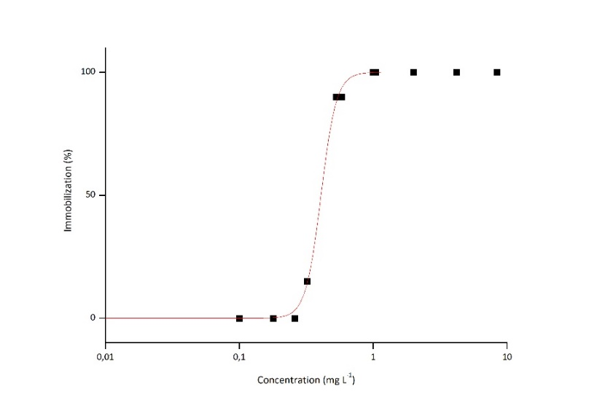
Fig. S4 Dye 72 concentration-response curve to Daphnia similis, EC₅₀ = 0.40 mg L⁻¹ (0.40 – 0.41 mg L⁻¹)

Table S7 Raw data for acute test of Dye 83 to Daphnia similis
Concentration  (mg L⁻¹) | Number of immobilized organisms |  |  |  | Total | %
Concentration  (mg L⁻¹) | 1 | 2 | 3 | 4 | Total | %
Control | 0/5 | 0/5 | 0/5 | 0/5 | 0/20 | 0
DMSO 0.1% (v/v) | 0/5 | 0/5 | 0/5 | 0/5 | 0/20 | 0
0.031 | 0/5 | 0/5 | 0/5 | 0/5 | 0/20 | 0
0.1 | 0/5 | 0/5 | 0/5 | 0/5 | 0/20 | 0
0.31 | 0/5 | 0/5 | 0/5 | 0/5 | 0/20 | 0
1 | 3/5 | 3/5 | 2/5 | 2/5 | 10/20 | 50
3.1 | 3/5 | 5/5 | 4/5 | 4/5 | 16/20 | 80
3.1 | 5/5 | 5/5 | 5/5 | 5/5 | 20/20 | 100
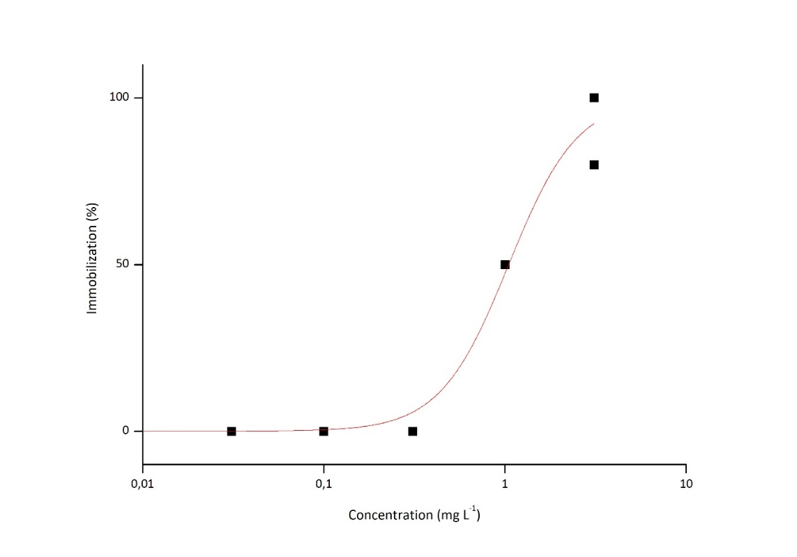
Fig. S5 Dye 83 concentration-response curve to Daphnia similis, EC₅₀ = 1.04 mg L⁻¹ (0.74 – 1.41 mg L⁻¹)

Table S8 Raw data for acute test of Dye 117 to Daphnia similis
Concentration  (mg L⁻¹) | Number of immobilized organisms |  |  |  | Total | %
Concentration  (mg L⁻¹) | 1 | 2 | 3 | 4 | Total | %
Control | 0/5 | 0/5 | 0/5 | 0/5 | 0/20 | 0
DMSO 0.1% (v/v) | 0/5 | 0/5 | 0/5 | 0/5 | 0/20 | 0
0.083 | 0/5 | 0/5 | 0/5 | 0/5 | 0/20 | 0
0.3 | 0/5 | 0/5 | 0/5 | 0/5 | 0/20 | 0
0.83 | 3/5 | 1/5 | 1/5 | 2/5 | 7/20 | 35
3.0 | 5/5 | 5/5 | 5/5 | 5/5 | 20/20 | 100
8.3 | 5/5 | 5/5 | 5/5 | 5/5 | 20/20 | 100
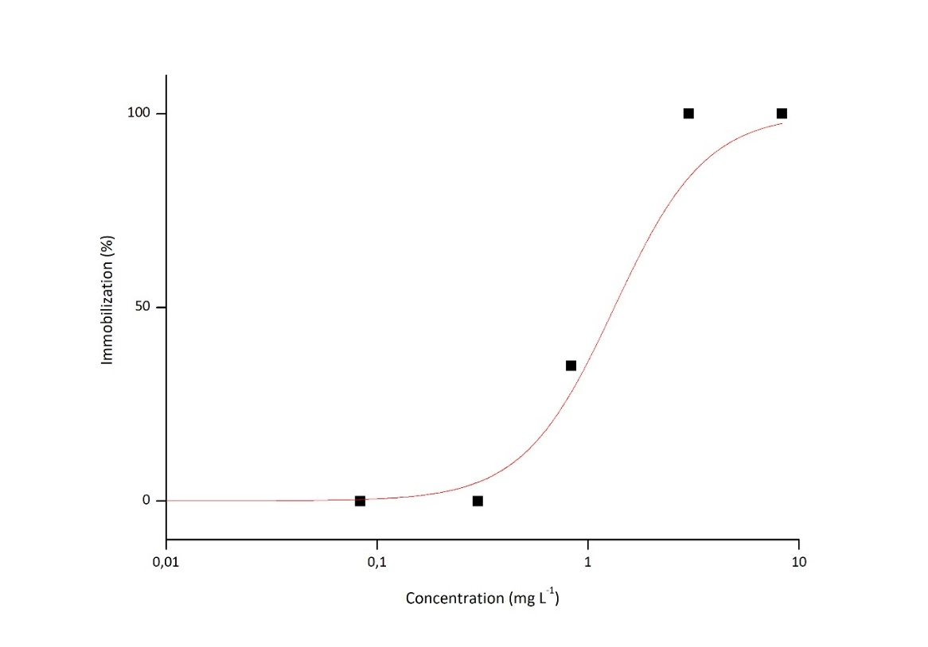
Fig. S6 Dye 117 concentration-response curve to Daphnia similis, EC₅₀ = 0.86 mg L⁻¹ (0.59 – 1.26 mg L⁻¹)

Table S9 Raw data for acute test of Dye 118 to Daphnia similis
Concentration  (mg L⁻¹) | Number of immobilized organisms |  |  |  | Total | %
Concentration  (mg L⁻¹) | 1 | 2 | 3 | 4 | Total | %
Control | 0/5 | 0/5 | 1/5 | 0/5 | 1/20 | 5
DMSO 0.05% (v/v) | 0/5 | 0/5 | 0/5 | 0/5 | 0/20 | 0
0.31 | 3/5 | 1/5 | 2/5 | 0/5 | 6/20 | 30
1.0 | 4/5 | 1/5 | 3/5 | 2/5 | 10/20 | 50
3.1 | 5/5 | 5/5 | 5/5 | 5/5 | 20/20 | 100
0.1 | 5/5 | 5/5 | 5/5 | 5/5 | 20/20 | 100
31 | 5/5 | 5/5 | 5/5 | 5/5 | 20/20 | 100

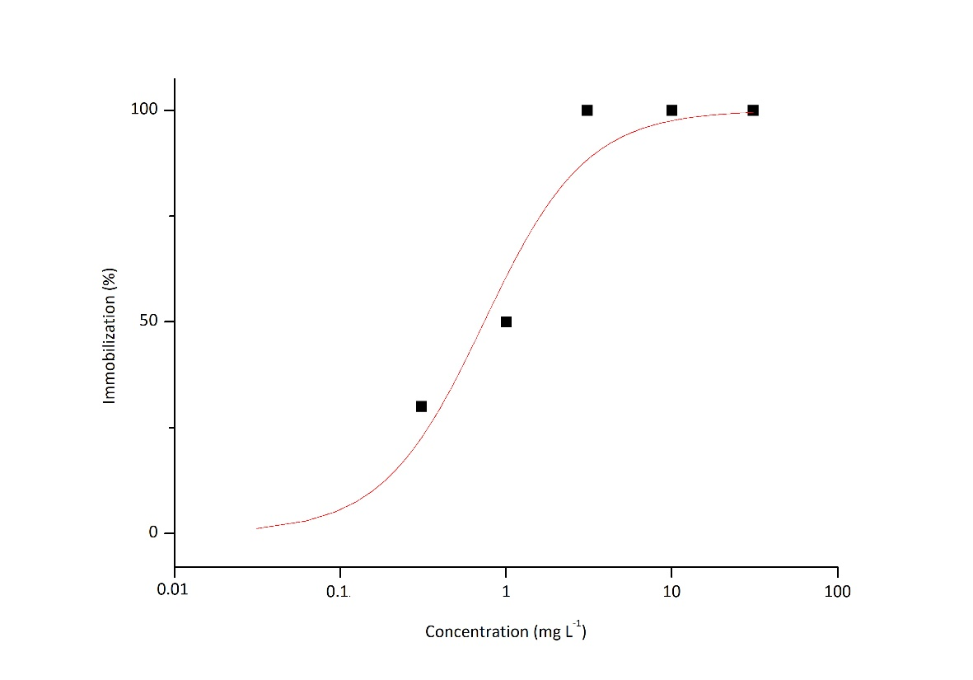
Fig. S7 Dye 118 concentration-response curve to Daphnia similis, EC₅₀ = 0.73 mg L⁻¹ (0.40 – 1.33 mg L⁻¹)

Table S10 Raw data for acute test of Dye 136 to Daphnia similis
Concentration  (mg L⁻¹) | Number of immobilized organisms |  |  |  | Total | %
Concentration  (mg L⁻¹) | 1 | 2 | 3 | 4 | Total | %
Control | 0/5 | 0/5 | 0/5 | 0/5 | 0/20 | 0
DMSO 0.05% (v/v) | 0/5 | 0/5 | 0/5 | 0/5 | 0/20 | 0
0.0625 | 0/5 | 0/5 | 0/5 | 0/5 | 0/20 | 0
0.125 | 0/5 | 0/5 | 0/5 | 1/5 | 1/20 | 5
0.25 | 1/5 | 0/5 | 1/5 | 2/5 | 4/20 | 20
0.5 | 4/5 | 5/5 | 4/5 | 3/5 | 16/20 | 80
1.0 | 5/5 | 5/5 | 5/5 | 5/5 | 20/20 | 100
2.0 | 5/5 | 5/5 | 5/5 | 5/5 | 20/20 | 100

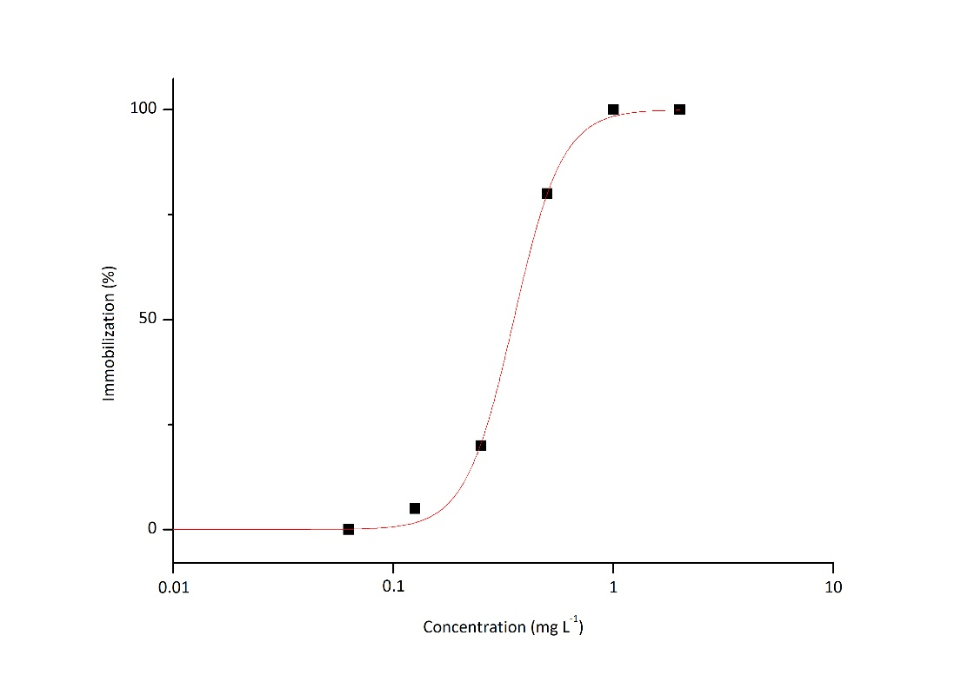
Fig. S8 Dye 136 concentration-response curve to Daphnia similis, EC₅₀ = 0.35 mg L⁻¹ (0.33 – 0.36 mg L⁻¹)

Table S11 Raw data for acute test of Dye 145 to Daphnia similis
Concentration  (mg L⁻¹) | Number of immobilized organisms |  |  |  | Total | %
Concentration  (mg L⁻¹) | 1 | 2 | 3 | 4 | Total | %
Control | 0/5 | 0/5 | 0/5 | 0/5 | 0/20 | 0
DMSO 0.1% (v/v) | 0/5 | 0/5 | 0/5 | 1/5 | 1/20 | 5
0.032 | 0/5 | 0/5 | 3/5 | 0/5 | 3/20 | 15
0.1 | 1/5 | 0/5 | 1/5 | 1/5 | 3/20 | 15
0.32 | 1/5 | 2/5 | 1/5 | 2/5 | 6/20 | 30
1 | 4/5 | 3/5 | 3/5 | 2/5 | 12/20 | 60
3.2 | 4/5 | 5/5 | 5/5 | 4/5 | 18/20 | 90
3.2 | 5/5 | 5/5 | 5/5 | 5/5 | 20/20 | 100

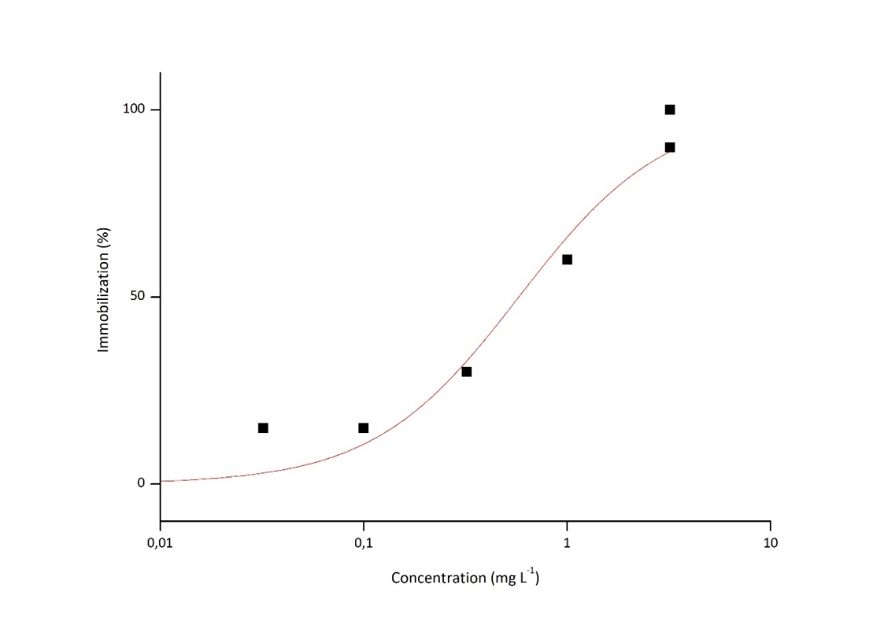
Fig. S9 Dye 145 concentration-response curve to Daphnia similis, EC₅₀ = 0.58 mg L⁻¹ (0.33 – 0.94 mg L⁻¹)

Table S12 Raw data for acute test of Dye 160 to Daphnia similis
Concentration  (mg L⁻¹) | Number of immobilized organisms |  |  |  | Total | %
Concentration  (mg L⁻¹) | 1 | 2 | 3 | 4 | Total | %
Control | 0/5 | 0/5 | 0/5 | 0/5 | 0/20 | 0
DMSO 0.1% (v/v) | 0/5 | 0/5 | 0/5 | 0/5 | 0/20 | 0
0.082 | 0/5 | 0/5 | 0/5 | 0/5 | 0/20 | 0
0.3 | 0/5 | 0/5 | 0/5 | 0/5 | 0/20 | 0
0.82 | 3/5 | 4/5 | 3/5 | 3/5 | 13/20 | 65
3 | 5/5 | 5/5 | 5/5 | 5/5 | 20/20 | 100
8.2 | 5/5 | 5/5 | 5/5 | 5/5 | 20/20 | 100

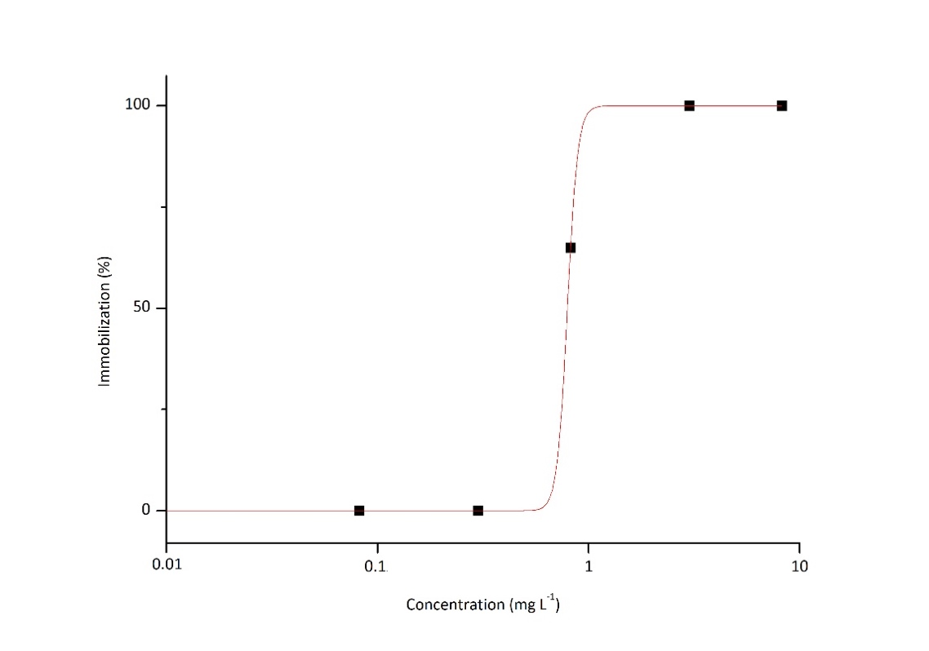
Fig. S10 Dye 160 concentration-response curve to Daphnia similis, EC₅₀= 0.79 mg L⁻¹ (0.55 – 0.81 mg L⁻¹)
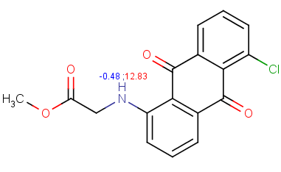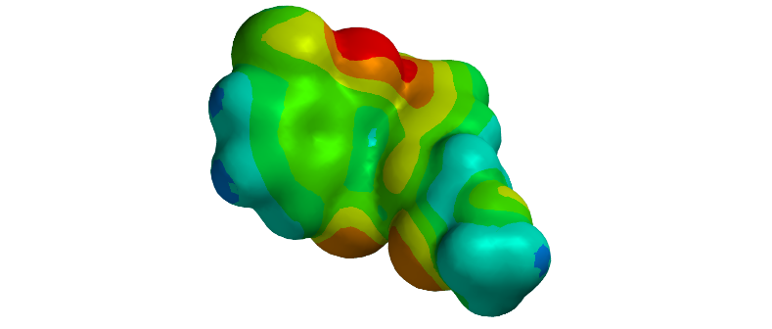  Ionization surface:  Moeity that affects aqueous solubility  pka map: | Dye 5: Solubility in Water  Intrinsic solubility: 10 mg L⁻¹  Solubility category: Low
Fig. S11 The ionization potency of dye 5 and its effects on aqueous solubility in different pHs

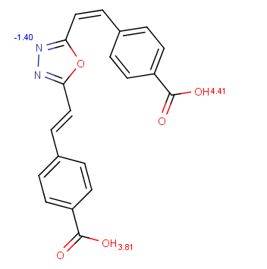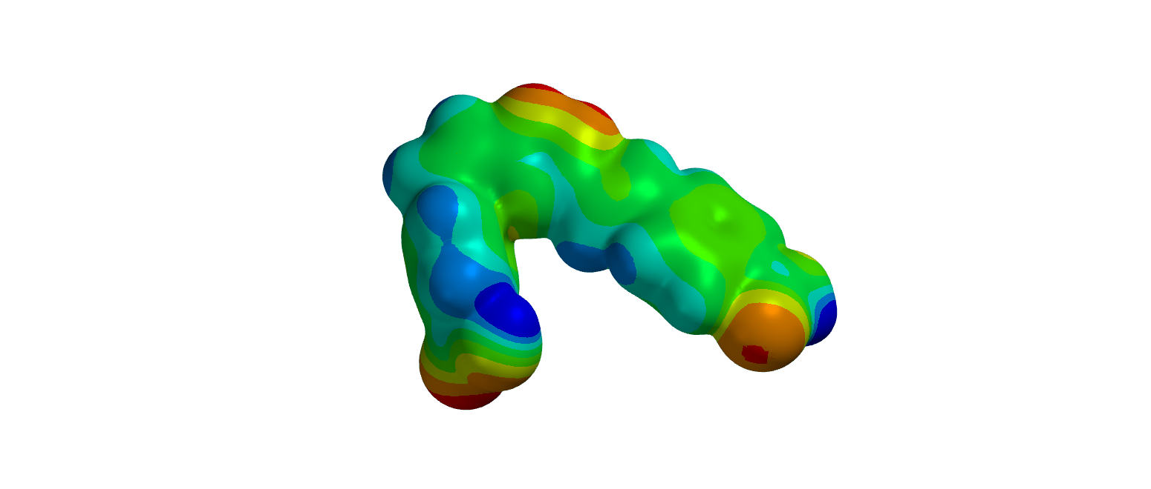  Ionization surface:  Moiety that affects aqueous solubility  pka map: | Dye 21: Solubility in Water  Intrinsic solubility: 20 mg L⁻¹  Solubility category: Moderate
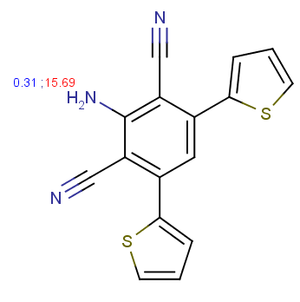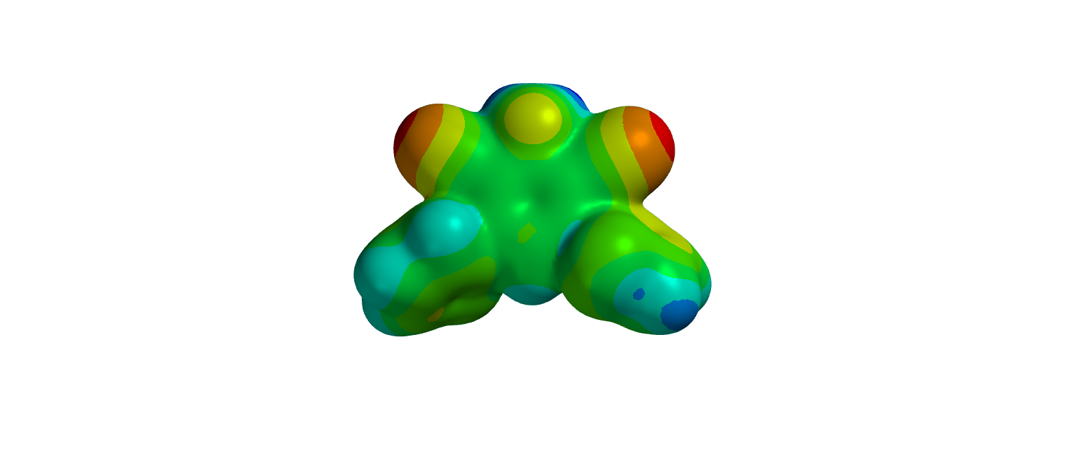  Ionization surface:  pka map:  Moiety that affects aqueous solubility | Dye 25: Solubility in Water  Intrinsic solubility: 1 mg L⁻¹  Solubility category: Low
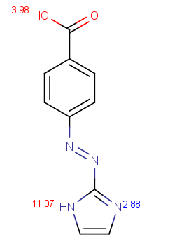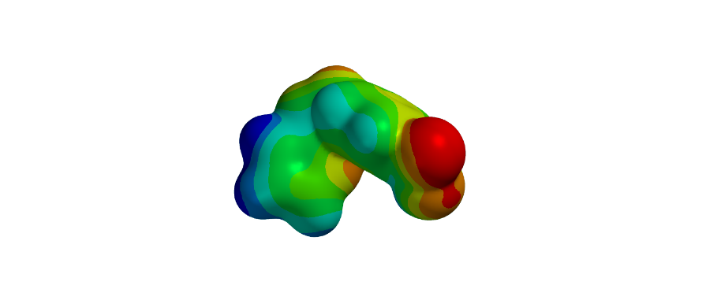  Ionization surface:  pka map:  Moiety that affects aqueous solubility | Dye 41: Solubility in Water  Intrinsic solubility: 440 mg L⁻¹  Solubility category: High
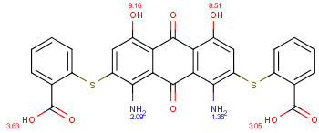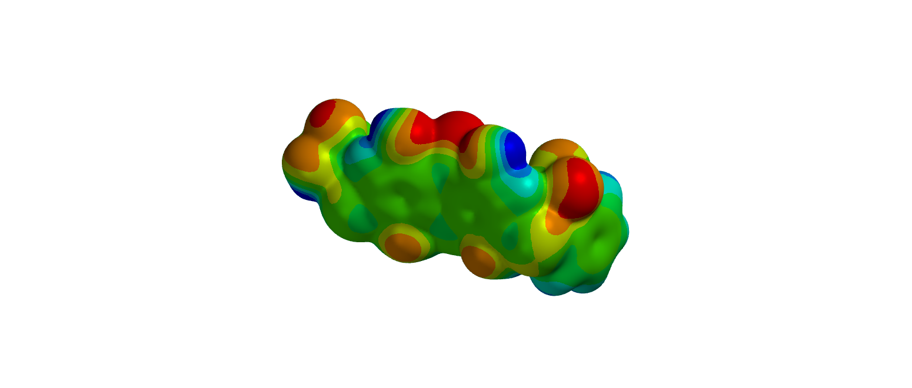  Ionization surface:  pka map:  Moiety that affects aqueous solubility | Dye 42: Solubility in Water  Intrinsic solubility: 1 mg L⁻¹  Solubility category: Low
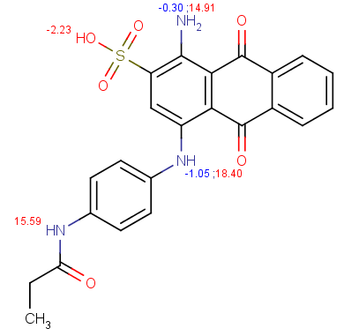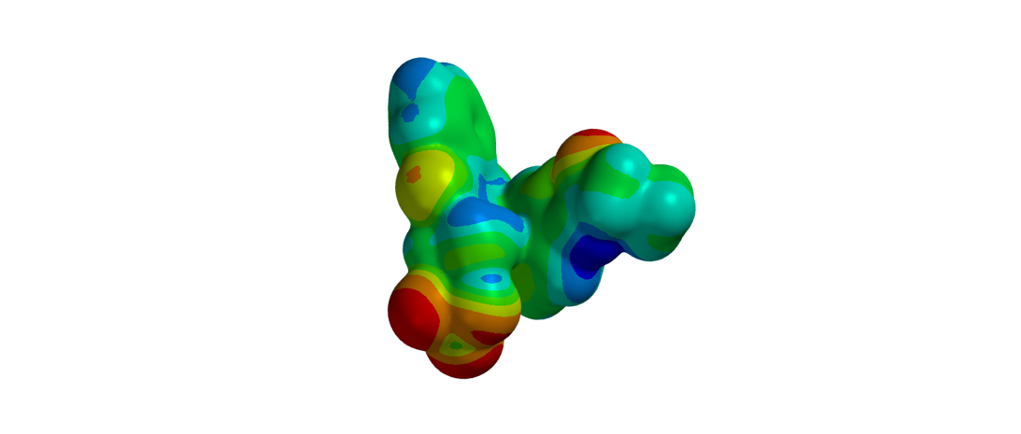  Ionization surface:  pka map:  Moeity that affects aqueous solubility | Dye 183: Solubility in Water  Intrinsic solubility: 1 mg L⁻¹  Solubility category: Low
Fig. S12 The ionization potency of dyes 21, 25, 41, 42 and 183 as well as its effects on aqueous solubility in different pHs

