Additional file for
Pyrolysis kinetic modelling of abundant plastic waste (PET) and in-situ emissions monitoring
Ahmed I. Osman ^{a,b*}, Charlie Farrell ^{c,d}, Ala'a H. Al-Muhtaseb^{e}, Ahmed S. Al-Fatesh^{f}, John Harrison ^{c}, David W. Rooney ª
ª School of Chemistry and Chemical Engineering, Queen’s University Belfast, Belfast BT9 5AG, Northern Ireland, UK.
^{b} Chemistry Department, Faculty of Science - Qena, South Valley University, Qena 83523 – Egypt.
^{c} South West College, Cookstown, Co. Tyrone, BT80 8DN, Northern Ireland, UK.
^{d} School of Mechanical and Aerospace Engineering, Queen’s University Belfast, Belfast BT9 5AH, Northern Ireland, UK.
^{e} Department of Petroleum and Chemical Engineering, College of Engineering, Sultan Qaboos University, Muscat, Oman.
^{f} Chemical Engineering Department, College of Engineering, King Saud University, P.O. Box 800, Riyadh 11421, Saudi Arabia.
Corresponding Author: Ahmed Osman
Email: aosmanahmed01@qub.ac.uk
Address: School of Chemistry and Chemical Engineering, Queen's University Belfast, David Keir Building, Stranmillis Road, Belfast BT9 5AG, Northern Ireland, United Kingdom

Fax: +44 2890 97 4687
Tel.: +44 2890 97 4412

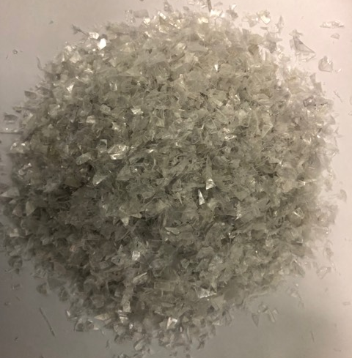
Figure S1: The PET sample used herein.
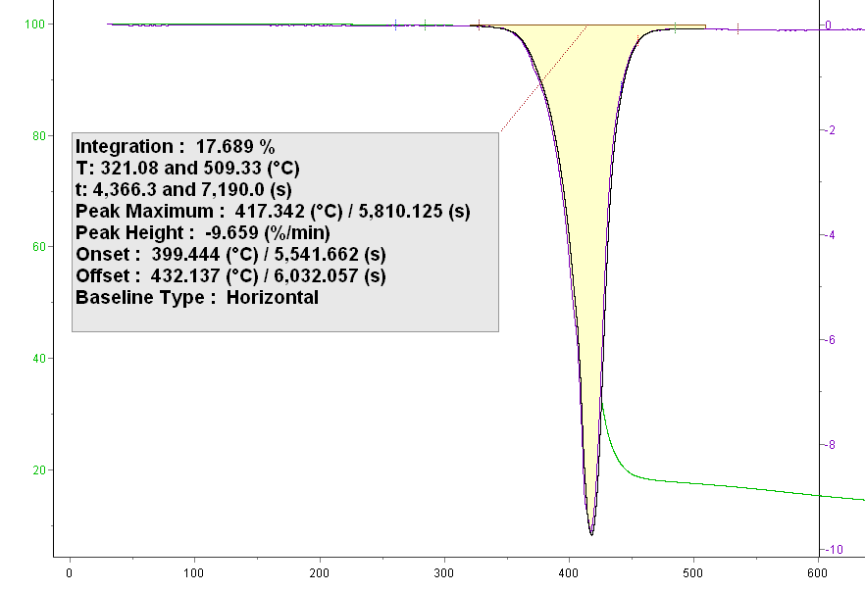
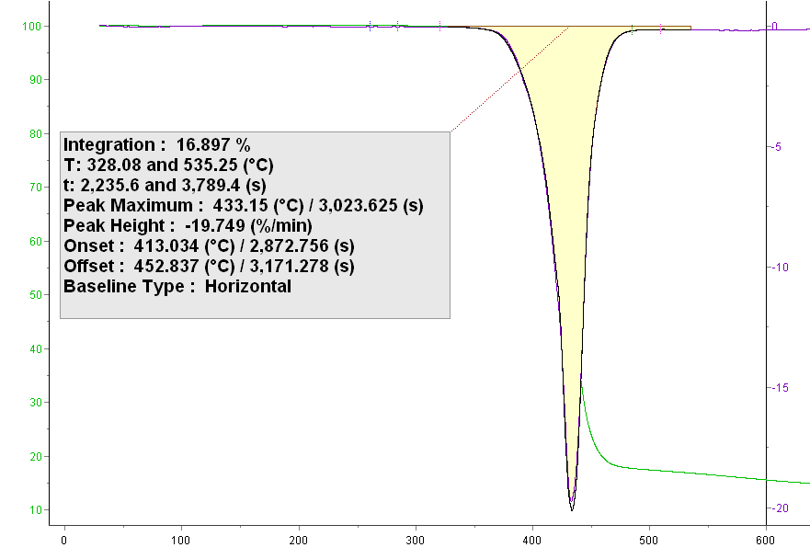
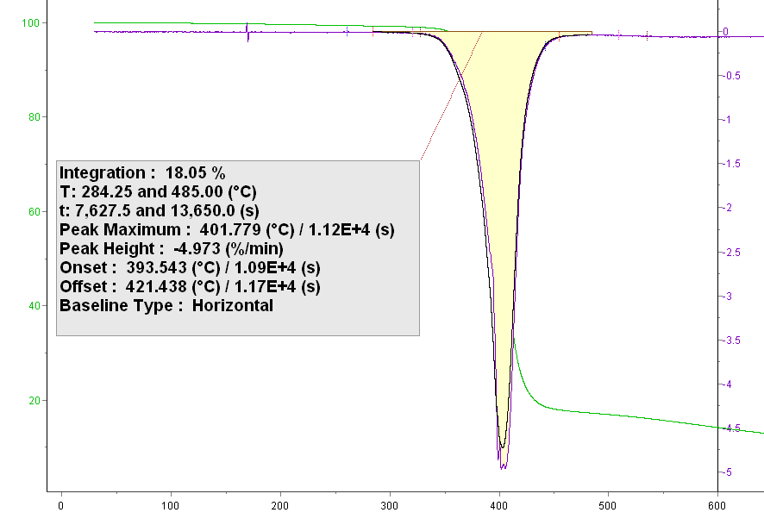
Temperature (°C)
Temperature (°C)
Temperature (°C)
(8 °C.min⁻¹)

(4 °C.min⁻¹)

(2 °C.min⁻¹)

Temperature (°C)
dm/dt(%/min)
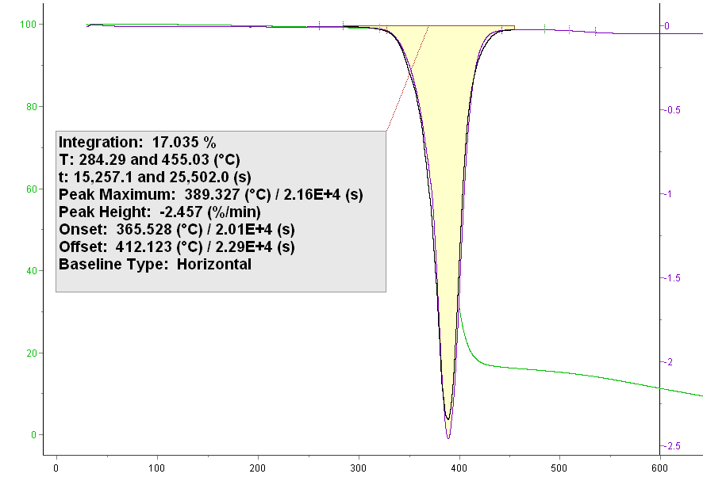
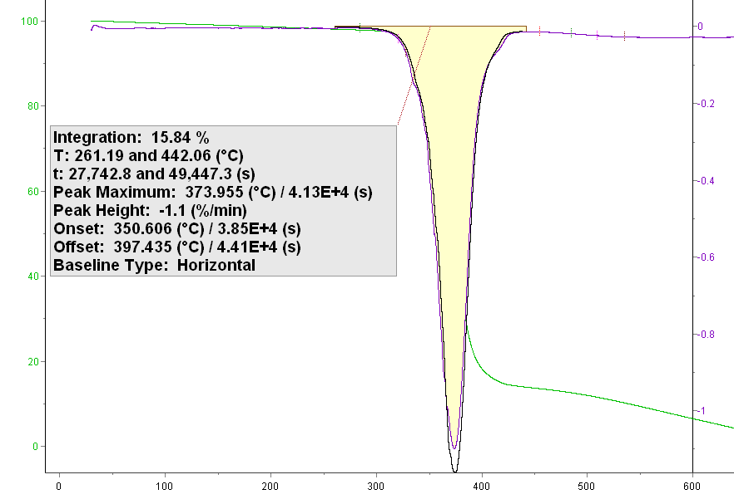
Figure S2: The % integrated mass derived from TGA results of PET pyrolysis at heating rates of 0.5, 1, 2, 4 and 8 °C.min⁻¹. The integration of the DTG curve is shown in yellow and simulation results are shown by black lines.

Temperature (°C)
(1 °C.min⁻¹)

(0.5 °C.min⁻¹)
TG (%)
dm/dt(%/min)
dm/dt(%/min)
dm/dt(%/min)
TG (%)
TG (%)
dm/dt(%/min)
TG (%)
TG (%)

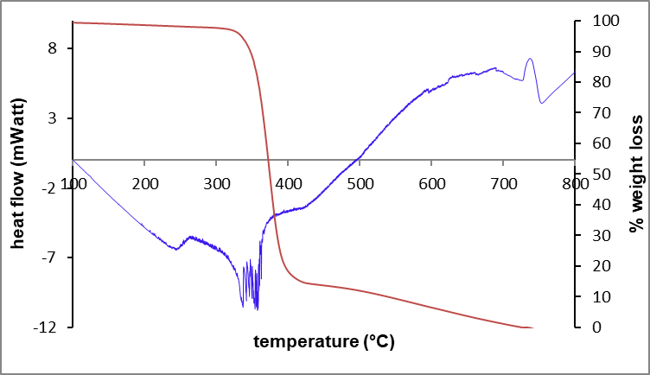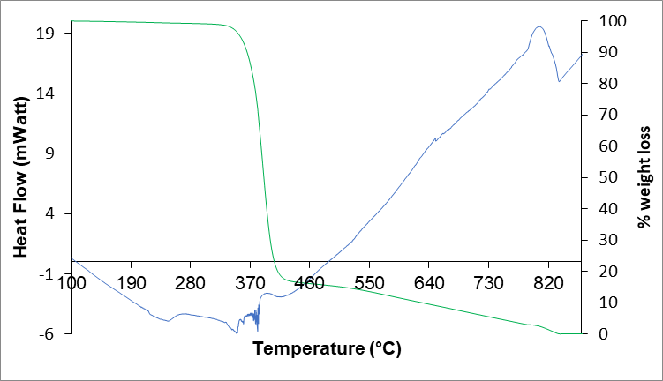
b)

Carbon graphitization
PET pyrolysis


a)
Carbon graphitization
PET pyrolysis
PET melting

Figure S3: The DSC-TGA thermogram of the PET pyrolysis at heating rate of 0.5 °C.min⁻¹ (a) and 1°C.min⁻¹ (b) under nitrogen atmosphere.

Figure S4: Benzene evolution during the PET pyrolysis.

