Assessing the relevance of atmospheric heavy metal deposition with regard to ecosystem integrity and human health in Germany

Angela Schlutow, Winfried Schröder*, Thomas Scheuschner

*Corresponding author: winfried.schroeder@uni-vechta.de

Supplementary Material 1: Tables, Figures

Table S1. Compilation of categories of effect values for heavy metal fluxes for the protection of ecosystems, protected goods, levels and objectives, and impact indicators.
Sources for appraisal values | Designation/category of appraisal values | Binding force | Objects of protection | Level of protection | Application for the as-sessment | Impact indicator
Requirements of assessment values from legal, sublegal regulations and recommendations for air pollution control
39th BImSchV (2010, 2019) | Immission limit value (Pb) | legally binding | Man + Environment | Precaution + danger prevention | general strain | human toxicological impact thresholds
39th BImSchV (2010, 2019) | Target values (As, Cd, Ni) | referral | Man + Environment | Precaution + danger prevention | general strain | human toxicological impact thresholds
TA Luft (2002) | Immission values for pollutant deposition | binding on administrative action | Environment | Hazard prevention (immission values) | plants requiring approval | human toxicological impact thresholds
EU-Directive 2004/107/EG | immission target values | EU recommen-dation | Man and environment (via soil, plants) | Precaution + danger prevention | general strain | human toxicological impact thresholds
EU-Directive  2008/50/EG | Immission limit value (Pb) | legally binding | Man + Environment | Precaution + danger prevention | general strain | human toxicological impact thresholds
CLRTAP 2014, 2016) | Critical Loads (CL(M)_{eco}) | Recommendation/Orientation | Terr. ecosystems, soil organisms and plants, | precaution | general strain | ecotoxicological thresholds NOEC, LOEC microorganisms, invertebrates and plants
CLRTAP 2014, 2016) | Critical Loads (CL(M)_{drink}),  (CL(Cd)_{food}) | Recommendation/Orientation | human | precaution | general strain | Limit values of drinking water VO and critical limit for Cd in wheat
Requirements of assessment values from legal, sublegal regulations and recommendations of other areas of law
BBodSchV (2012, 2017) | precautionary values | legally binding | Ecosystems, soil organisms and plants | precaution | General validity (cross-use) | Ecotoxicological thresholds NOEC, LOEC, (in future: HC5, EC10) of soil organisms and plants (all pathways) + background values
BBodSchV (2012, 2017) | permissible annual additional load | legally binding | Ecosystems, soil organisms and plants (all paths of action) | Pension entitlement and limited in the long run | General validity (cross-use) | Information on the amount of ubiquitous deposition
AG of LAWA/ LABO/ LAGA | Minority thresholds | Recommendation, orientation | Humans, Ecosystems | precaution | General validity (cross-use) | human and ecotoxicological thresholds (soil-groundwater), comparison with background values
Branden-burg enforce-ment aid (2008, 2019) | Assessment values for testing the relevance of heavy metal deposition | state recommendation | terrestrial communities (FFH-LRT) | Prevention, partly hazard prevention | Plant-related, influence on FFH areas | ecotoxicological thresholds of soil microorganisms, invertebrates and plants
 | target | state recommendation | aquatic communities (FFH-LRT) | danger prevention | plant-related | ecotoxicological thresholds of bacteria, green algae, small crustaceans and fish
AG of LaWa/LaBo/LaGa = Federal/State Working Group on Water (LAWA) - Federal/State Working Group on Soil Protection (LABO), Federal/State Working Group on Waste (LAGA); BBodSchV = Federal Soil Protection Ordinance; BImSchV = Federal Immission Control Ordinance; Brandenburische Vollzugshilfe = Brandenburg enforcement aid; CLRTAP = Convention on Long-range Transboundary Air Pollution; EC10 = ECx is the effect concentration at which x% effect (mortality, inhibition of growth, reproduction, etc) is observed compared to the control group; EU Pos. Paper = EU Position Paper ; FFH LRT = Flora Fauna Habitats; HC5 = Hazardous concentration for 5 % of the species; LOEC = Lowest Obseved Effect Level; NOEC = No Observed Effect Concentration; PNEC = Predicted No Effect Concentration; TA Luft = Technical Instructions Air.

Table S2. Estimation of area distribution of the crops in rotation units according to good practice on the soil units of the German BÜK1000
Soil form | Area distribution of the crops in rotation units
Soil form | Wheat | Rye | Barley | Rough-age | Beta beet | Potatoes | Rape-seed | Silage maize
Dystric regosols from sand dunes | 0,125 | 0,25 | 0,125 | 0,5
Salo-thionic Gleysols in tital areas
Calcaric and eutric gleysols (tidal marsh) | 0,25 |  | 0,125 | 0,5 | 0,0625 |  |  | 0,0625
Gleyo-eutric fluvisols from brackish sediments | 0,25 |  | 0,125 | 0,5 | 0,0625 |  |  | 0,0625
Eutric fluvisols from tidal sediments | 0,25 |  | 0,125 | 0,5 | 0,0625 |  |  | 0,0625
Eutric histosols |  |  |  | 1
Dystric histosols |  |  |  | 1
Gleysols from loamy to clayey fluviatile sediments | 0,25 |  | 0,125 | 0,5 | 0,0625 |  |  | 0,0625
Calcareous gleyic chernosems | 0,25 |  | 0,125 | 0,5 | 0,0625 |  |  | 0,0625
Sandy to loamy fluvisols | 0,125 |  | 0,125 | 0,5 |  |  | 0,25
Sandy to clayey fluvisols | 0,25 |  | 0,125 | 0,5 | 0,0625 |  |  | 0,0625
Sandy gleysols | 0,125 |  | 0,125 | 0,5 |  |  | 0,25
Calcaric regosols | 0,125 | 0,125 | 0,125 | 0,375 | 0,0625 | 0,0625 | 0,0625 | 0,0625
Haplic silty to loamy luvisols | 0,125 | 0,125 | 0,125 | 0,375 | 0,0625 | 0,0625 | 0,0625 | 0,0625
Haplic loess covered loamy luvisols | 0,25 |  | 0,125 | 0,5 | 0,0625 |  |  | 0,0625
Dystric sandy cambisols | 0,125 |  | 0,125 | 0,5 |  |  | 0,25
Sandy gley-podsol | 0,125 |  | 0,125 | 0,5 |  |  | 0,25
Haplic loes-bearing luvisol | 0,125 | 0,125 | 0,125 | 0,375 | 0,0625 | 0,0625 | 0,0625 | 0,0625
Haplic luvisol from boulder clay | 0,125 | 0,125 | 0,125 | 0,375 | 0,0625 | 0,0625 | 0,0625 | 0,0625
Luvic chernosem from boulder clay | 0,125 | 0,125 | 0,125 | 0,375 | 0,0625 | 0,0625 | 0,0625 | 0,0625
Eutric cambisol from calcareous loamy to sandy till | 0,125 | 0,125 | 0,125 | 0,375 | 0,0625 | 0,0625 | 0,0625 | 0,0625
Stagnic gleysol from loamy boulder clay with sandy cover | 0,125 |  | 0,125 | 0,5 |  |  | 0,25
Stagnic gleysol from loamy boulder clay | 0,125 |  | 0,125 | 0,5 |  |  | 0,25
Stagnic chernosem from loamy boulder clay with sandy cover | 0,125 |  | 0,125 | 0,5 |  |  | 0,25
Spodic sandy podzoluvisol over boulder clay | 0,125 | 0,25 | 0,125 | 0,5
Luvic sandy arenosol over boulder clay | 0,125 | 0,25 | 0,125 | 0,5
Umbric sandy-loamy regosol | 0,125 | 0,25 | 0,125 | 0,5
Spodo-stagnic loamy cambisol | 0,125 |  | 0,125 | 0,5 |  |  | 0,25
Sandy stagnic gleysol | 0,125 |  | 0,125 | 0,5 |  |  | 0,25
Calcareous loamy stagnic gleysol | 0,125 | 0,25 | 0,125 | 0,5
Spodic areanosol from dry distrophic sand | 0,125 | 0,25 | 0,125 | 0,5
Eutrophic sandy camisol | 0,125 | 0,125 | 0,125 | 0,375 | 0,0625 | 0,0625 | 0,0625 | 0,0625
Haplic podzol from dry distrophic sand | 0,125 | 0,25 | 0,125 | 0,5
Dystric regosol from dry distrophic sand | 0,125 | 0,25 | 0,125 | 0,5
Calcareous regosol from loess | 0,125 | 0,125 | 0,125 | 0,375 | 0,0625 | 0,0625 | 0,0625 | 0,0625
Haplic chernosem from loess | 0,125 | 0,125 | 0,125 | 0,375 | 0,0625 | 0,0625 | 0,0625 | 0,0625
Haplic chernosem from loess and marlstone | 0,125 | 0,125 | 0,125 | 0,375 | 0,0625 | 0,0625 | 0,0625 | 0,0625
Haplic chernosem from loess over claystone | 0,25 |  | 0,125 | 0,5 | 0,0625 |  |  | 0,0625
Chernosem of the upper Rhine
Phaeozemic luvisol from loess | 0,125 | 0,125 | 0,125 | 0,375 | 0,0625 | 0,0625 | 0,0625 | 0,0625
Phaeozemic luvisol from sandy loess | 0,125 | 0,125 | 0,125 | 0,375 | 0,0625 | 0,0625 | 0,0625 | 0,0625
Eutric podzoluvisol from loess | 0,125 | 0,125 | 0,125 | 0,375 | 0,0625 | 0,0625 | 0,0625 | 0,0625
Stagnic gleysol from loess | 0,25 |  | 0,125 | 0,5 | 0,0625 |  |  | 0,0625
Haplic luvisol from siliceous material | 0,125 | 0,125 | 0,125 | 0,375 | 0,0625 | 0,0625 | 0,0625 | 0,0625
Eutric cambisol from sandy loess | 0,125 | 0,125 | 0,125 | 0,375 | 0,0625 | 0,0625 | 0,0625 | 0,0625
Haplic podzoluvisol from sandy loess | 0,125 | 0,125 | 0,125 | 0,375 | 0,0625 | 0,0625 | 0,0625 | 0,0625
Eutric cambisol from loessic loam | 0,125 | 0,125 | 0,125 | 0,375 | 0,0625 | 0,0625 | 0,0625 | 0,0625
Stagnic gleysol from loess | 0,25 |  | 0,125 | 0,5 | 0,0625 |  |  | 0,0625
Rendzic leptosol from limestone | 0,125 |  | 0,125 | 0,5 |  |  | 0,25
Chromic cambisol from limestone | 0,125 | 0,125 | 0,125 | 0,375 | 0,0625 | 0,0625 | 0,0625 | 0,0625
Vertic cambisol from marlstone | 0,125 | 0,125 | 0,125 | 0,375 | 0,0625 | 0,0625 | 0,0625 | 0,0625
Eutric cambisol from marlstone | 0,125 | 0,125 | 0,125 | 0,375 | 0,0625 | 0,0625 | 0,0625 | 0,0625
Eutric cambisol from basic rocks | 0,125 | 0,125 | 0,125 | 0,375 | 0,0625 | 0,0625 | 0,0625 | 0,0625
Andic cambisol from basic tuffs | 0,125 | 0,125 | 0,125 | 0,375 | 0,0625 | 0,0625 | 0,0625 | 0,0625
Dystric cambisols from acid rocks | 0,125 |  | 0,125 | 0,5 |  |  | 0,25
Dystric cambisol from intermediate rocks | 0,125 | 0,125 | 0,125 | 0,375 | 0,0625 | 0,0625 | 0,0625 | 0,0625
Spodic cambisols from acid rocks | 0,125 | 0,125 | 0,125 | 0,375 | 0,0625 | 0,0625 | 0,0625 | 0,0625
Stagnic gleysol from siltstone, sandstone or claystone | 0,25 |  | 0,125 | 0,5 | 0,0625 |  |  | 0,0625
Spodic cambisol from hard argillaceous and silty slates | 0,125 |  | 0,125 | 0,5 |  |  | 0,25
Spodic cambisol from greywacke and phyllite | 0,125 |  | 0,125 | 0,5 |  |  | 0,25
Dystric low-basic cambisol from quarzitic sandstone | 0,125 | 0,125 | 0,125 | 0,375 | 0,0625 | 0,0625 | 0,0625 | 0,0625
Dystric cambisols from loess over sandstone | 0,125 |  | 0,125 | 0,5 |  |  | 0,25
Haplic podzol from low-basic sandstone | 0,125 |  | 0,125 | 0,5 |  |  | 0,25
Stagnic and spodic loamy gleysol | 0,25 |  | 0,125 | 0,5 | 0,0625 |  |  | 0,0625
Base-rich rendzic leptosol | 0,125 | 0,125 | 0,125 | 0,375 | 0,0625 | 0,0625 | 0,0625 | 0,0625
Stagnic gleysol from limestone | 0,125 |  | 0,125 | 0,5 |  |  | 0,25
Ferralsol | 0,125 |  | 0,125 | 0,5 |  |  | 0,25
Umbric leptosol from limestone and dolomite |  |  |  | 1
Lithric leptosol |  |  |  | 1
Urbic anthrosol | 0,125 | 0,25 | 0,125 | 0,5
Cumulic anthrosol |  |  |  | 1

Table S3. Classification and scoring of soils according to pedogenesis and texture with regard to the influence on potential arable. wood and grassland yields
Soil texture  according to pedological mapping instructions 5th edition | Genesis | Soil water balance |  |  |  |  |  |  |  |  |  | Relative yield potential  EP_{(geo-hoz)}
 | Genesis |  |  |  | Nutrient balance |  |  |  | Soil structure |  |  | Relative yield potential  EP_{(geo-hoz)}
 | Genesis | PPorosity <0.2 µm with dead water (pF>4.2)/ formation of stagnant moisture | Risk of dehydration | Groundwater or backwater influence | Usable field capacity (pore content 0.2-50 µm with plant-available adhesive water pF4.2-1.8) | Humus levels as a function ofSsoil texture | Ccation exchange capacity |  | Thoroughness | Root penetration (poreCcontent >50 µm with air. pF<1.8) | Slope of solidification in the B-horizon | Relative yield potential  EP_{(geo-hoz)}
Ss | D | 5 | 1 | 1 | 1 | 1 | 1 |  | 3 | 5 | 1 | 2.00
Ss | Al | 5 | 1 | 4 | 1 | 1 | 1 |  | 4 | 5 | 1 | 2.36
Ss | K | 5 | 1 | 1 | 1 | 1 | 1 |  | 2 | 5 | 1 | 1.89
Ss | V | 5 | 1 | 1 | 1 | 1 | 1 |  | 2 | 5 | 1 | 1.89
Su2. Sl2. Sl3.  St2 | D | 4 | 2 | 1 | 3 | 1 | 2 |  | 3 | 5 | 1 | 2.50
Su2. Sl2. Sl3.  St2 | Al | 4 | 2 | 5 | 3 | 1 | 2 |  | 4 | 5 | 1 | 2.94
Su2. Sl2. Sl3.  St2 | K | 4 | 2 | 4 | 3 | 1 | 2 |  | 3 | 5 | 1 | 2.75
Su2. Sl2. Sl3.  St2 | V | 4 | 2 | 3 | 3 | 1 | 2 |  | 2 | 5 | 1 | 2.56
Su3. Su4 | D | 3 | 3 | 2 | 4 | 2 | 2 |  | 3 | 5 | 2 | 3.00
Su3. Su4 | lo | 3 | 3 | 2 | 4 | 2 | 2 |  | 5 | 5 | 2 | 3.22
Su3. Su4 | Al.K | 3 | 3 | 5 | 4 | 2 | 2 |  | 4 | 5 | 2 | 3.36
Su3. Su4 | V | 3 | 3 | 3 | 4 | 2 | 2 |  | 2 | 5 | 2 | 2.97
Su3. Su4 | Vg | 3 | 3 | 1 | 4 | 2 | 2 |  | 1 | 5 | 2 | 2.69
Slu. Sl4. St3 | D | 3 | 4 | 2 | 5 | 2 | 3 |  | 3 | 4 | 3 | 3.39
Slu. Sl4. St3 | lo | 3 | 4 | 2 | 5 | 2 | 3 |  | 5 | 4 | 3 | 3.61
Slu. Sl4. St3 | Al.K | 3 | 4 | 5 | 5 | 2 | 3 |  | 5 | 4 | 3 | 3.86
Slu. Sl4. St3 | V | 3 | 4 | 3 | 5 | 2 | 3 |  | 2 | 4 | 3 | 3.36
Slu. Sl4. St3 | Vg | 3 | 4 | 1 | 5 | 2 | 3 |  | 1 | 4 | 3 | 3.08
Ls2-4. Lt2.  Lts. Ts4. Ts3 | D | 3 | 4 | 3 | 5 | 3 | 4 |  | 3 | 3 | 4 | 3.69
Ls2-4. Lt2.  Lts. Ts4. Ts3 | lo | 3 | 4 | 2 | 5 | 3 | 4 |  | 5 | 3 | 4 | 3.83
Ls2-4. Lt2.  Lts. Ts4. Ts3 | Al | 3 | 4 | 5 | 5 | 3 | 4 |  | 5 | 3 | 4 | 4.08
Ls2-4. Lt2.  Lts. Ts4. Ts3 | K | 3 | 4 | 4 | 5 | 3 | 4 |  | 3 | 3 | 4 | 3.78
Ls2-4. Lt2.  Lts. Ts4. Ts3 | V | 3 | 4 | 3 | 5 | 3 | 4 |  | 2 | 3 | 4 | 3.58
Ls2-4. Lt2.  Lts. Ts4. Ts3 | Vg | 3 | 4 | 1 | 5 | 3 | 4 |  | 1 | 3 | 4 | 3.31
Uu. Us. Ut2-4.  Uls. Lu | D | 2 | 3 | 3 | 4 | 4 | 3 |  | 3 | 2 | 5 | 3.33
Uu. Us. Ut2-4.  Uls. Lu | Al | 2 | 5 | 5 | 4 | 4 | 4 |  | 5 | 2 | 5 | 4.00
Uu. Us. Ut2-4.  Uls. Lu | lo | 2 | 3 | 2 | 4 | 4 | 4 |  | 5 | 2 | 5 | 3.58
Uu. Us. Ut2-4.  Uls. Lu | K | 2 | 3 | 4 | 4 | 4 | 3 |  | 4 | 2 | 5 | 3.53
Uu. Us. Ut2-4.  Uls. Lu | V | 2 | 3 | 3 | 4 | 4 | 3 |  | 2 | 2 | 5 | 3.22
Uu. Us. Ut2-4.  Uls. Lu | Vg | 2 | 3 | 1 | 4 | 4 | 3 |  | 1 | 2 | 5 | 2.94
Lt3. Tu2-4.  Ts2. Tl. Tt | D | 1 | 1 | 2 | 3 | 5 | 5 |  | 3 | 1 | 5 | 3.03
Lt3. Tu2-4.  Ts2. Tl. Tt | Al | 1 | 1 | 5 | 3 | 5 | 5 |  | 4 | 1 | 5 | 3.39
Lt3. Tu2-4.  Ts2. Tl. Tt | lo | 1 | 1 | 2 | 3 | 5 | 5 |  | 5 | 2 | 5 | 3.36
Lt3. Tu2-4.  Ts2. Tl. Tt | K | 1 | 1 | 4 | 3 | 5 | 5 |  | 1 | 1 | 5 | 2.97
Lt3. Tu2-4.  Ts2. Tl. Tt | V | 1 | 1 | 3 | 3 | 5 | 5 |  | 2 | 1 | 5 | 3.00
Lt3. Tu2-4.  Ts2. Tl. Tt | Vg | 1 | 1 | 2 | 3 | 5 | 5 |  | 1 | 1 | 5 | 2.81
Hh |  | 1 | 1 | 1 | 1 | 5 | 1 |  | 1 | 1 | 1 | 1.44
Hn |  | 1 | 1 | 1 | 2 | 5 | 3 |  | 4 | 3 | 1 | 2.42
EP_{(geo-hor)} = Relative yield potential determined by the soil
Yield scores: 1 = Very unfavourable. 2 = Unfavourable. 3 = Moderately favourable. 4 = Favourable. 5 = Very favourable
Soil genesis: D = Diluvial soils of the undulating lowlands and hilly areas; Lö = Soils of the loess areas; Al = Alluvial soils of broad river valleys. including terraces and lowlands; K = Soils of coastal regions; V = Weathered soils of solid rock and their surrounding rock masses in mountainous and hilly areas; Vg = Rock-rich weathered soils of the high mountains

Soil texture classes: Hh = Raised bog; Hn = Fen; Ls2-4 = Weak to strong sandy loam; Lt2 = Weak clayey loam; Lt3 = Medium clayey loam; Lts = Sandy-clayey loam; Lu = Silty loam; Sl2 = Light loamy sand; Sl3 = Medium clayey sand; Sl4 = Very loamy sand; Slu = Silty-clayey sand; Ss = Pure sand; St2 = Light clayey sand; St3 = Medium clayey sand; Su2 = Light silty sand; Su3 = Medium silty sand; Su4 = Strongly silty sand; Tl = Clayey clay; Ts2 = Slightly sandy clay; Ts3 = Medium sandy clay; Ts4 = Very sandy clay; Tt = Pure clay; Tu2-4 = Weak to strong silty clay; Uls = Sandy-clayey silt; Us = Sandy silt; Ut2-4 = Weak to strong clayey silt; Uu = Pure silt.

Figure S1.1. Critical load for lead with the protection objective of drinking water quality.
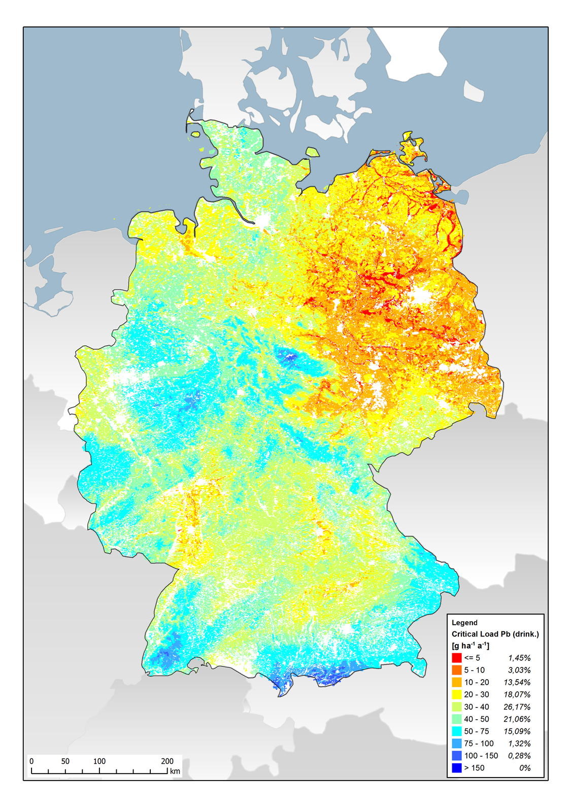
Figure S1.2. Critical load for lead with the aim of protecting the ecosystem function.
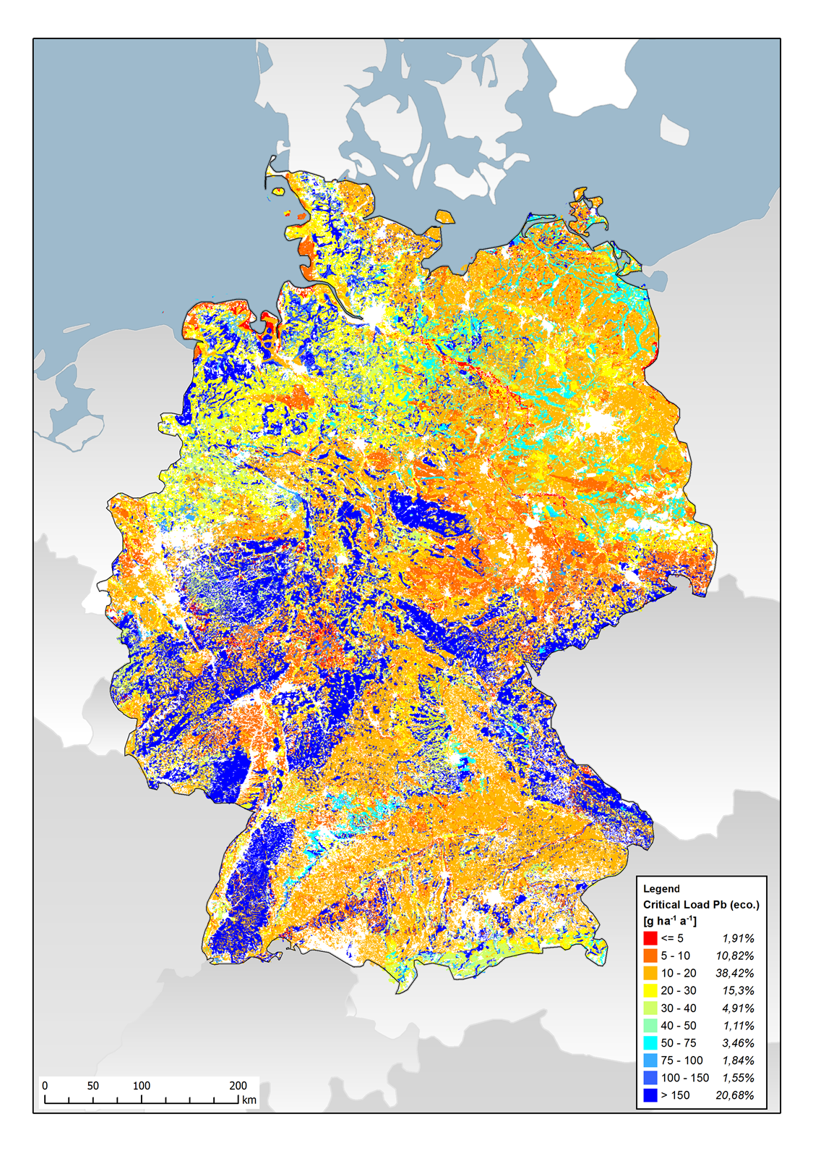

Figure S1.3. Critical load for cadmium with the protection objective drinking water quality.
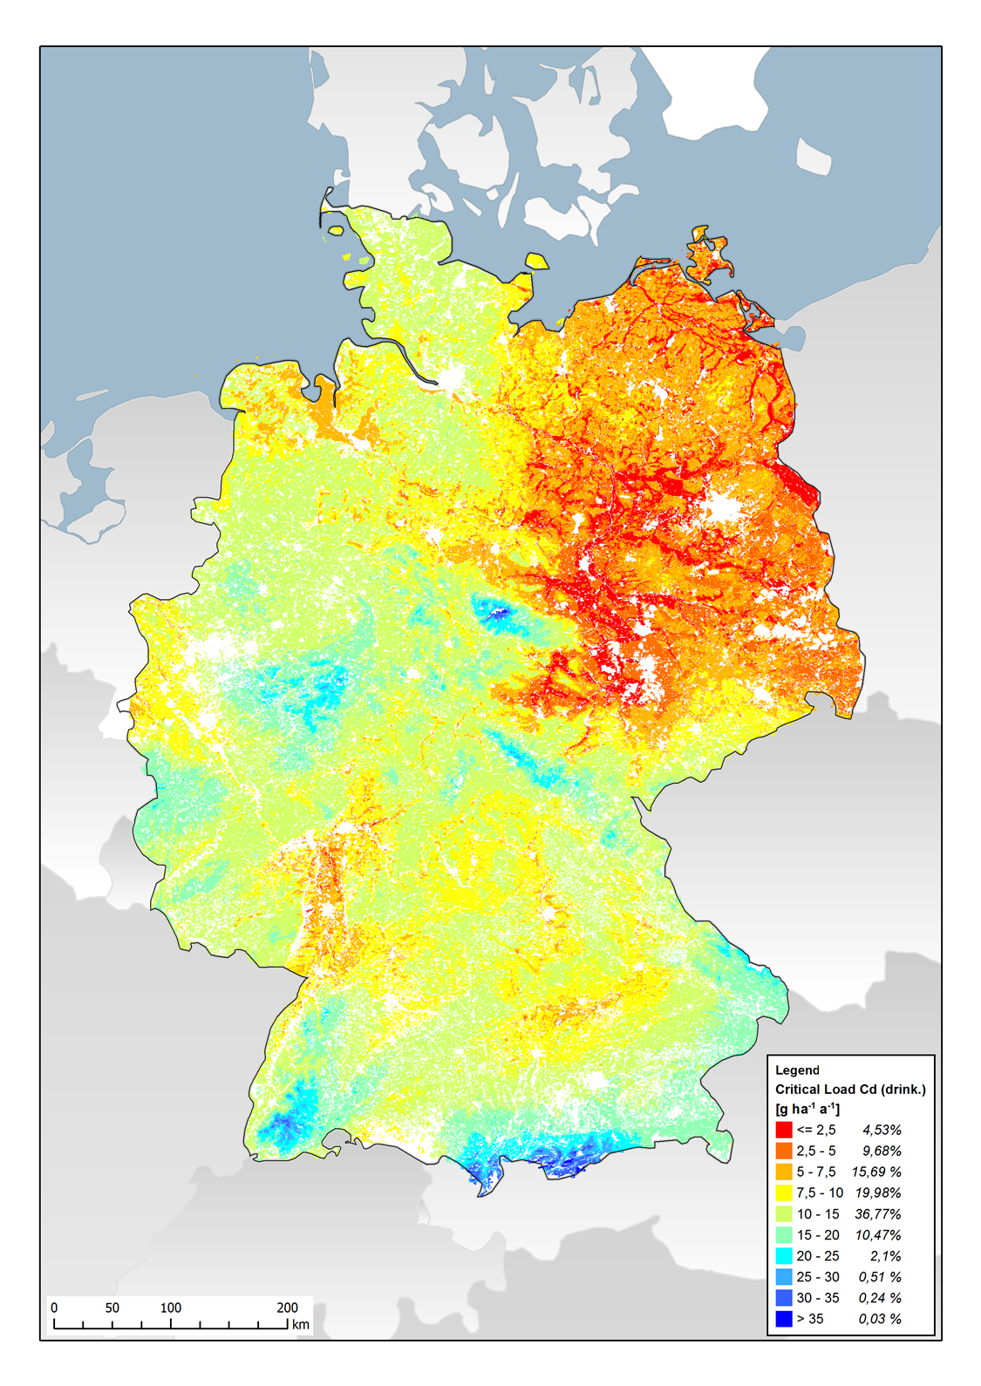
Figure S1.4. Critical load for cadmium with the protection objective ecosystem function.
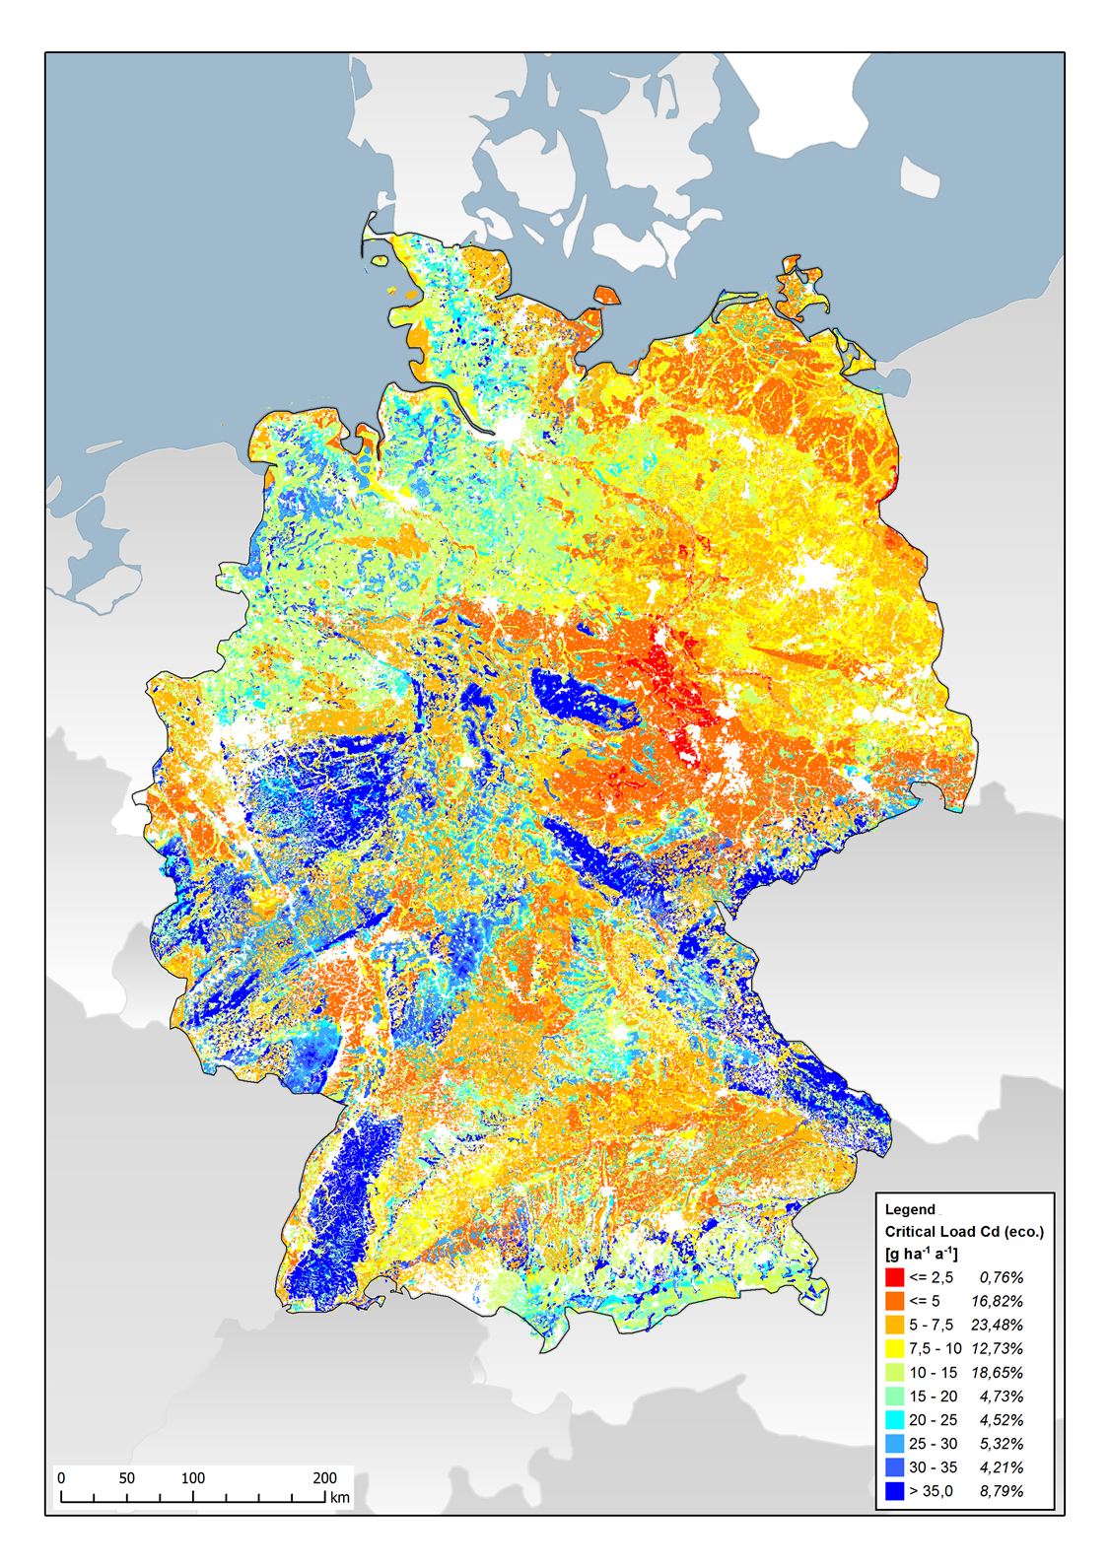

Figure S1.5. Critical load for cadmium with the protective objective of food quality.
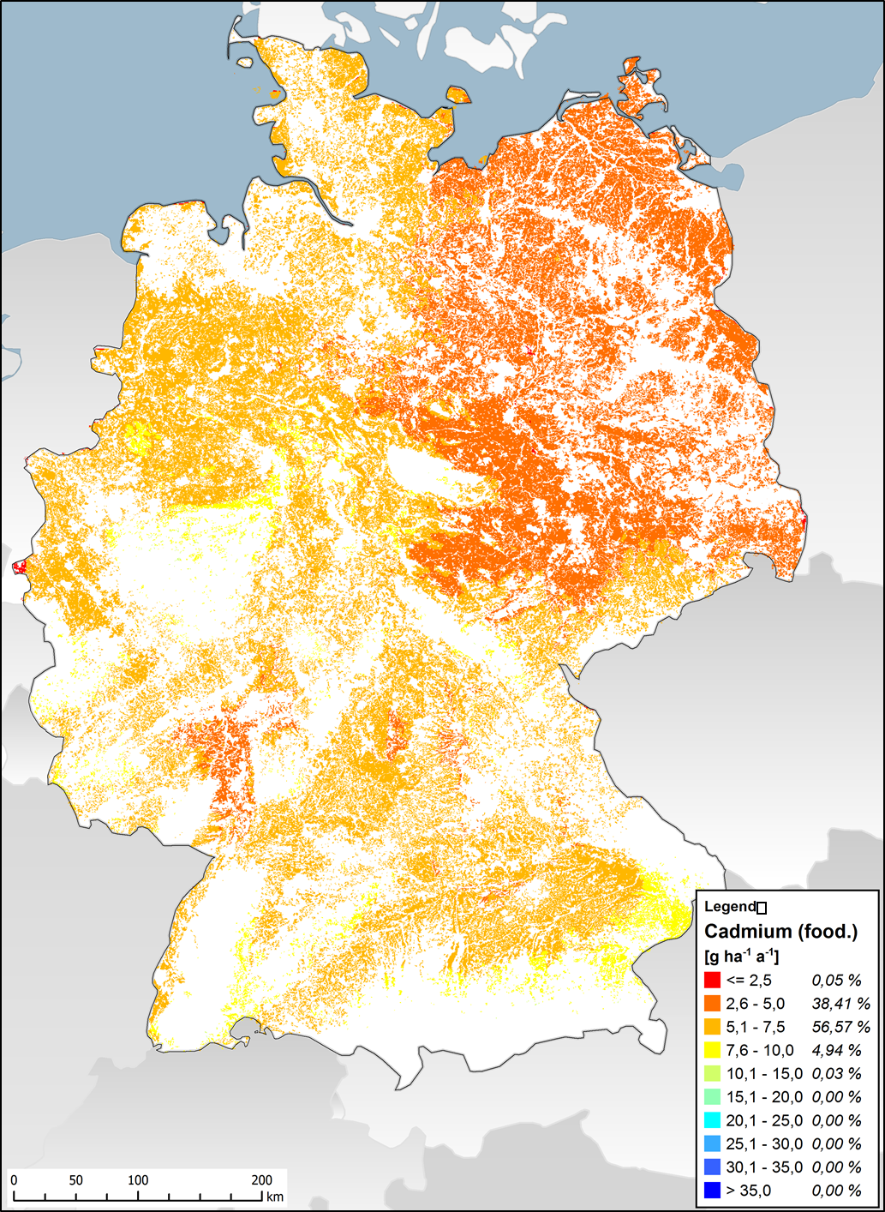

Figure S1.6. Critical load for mercury with the protection objective of drinking water quality.
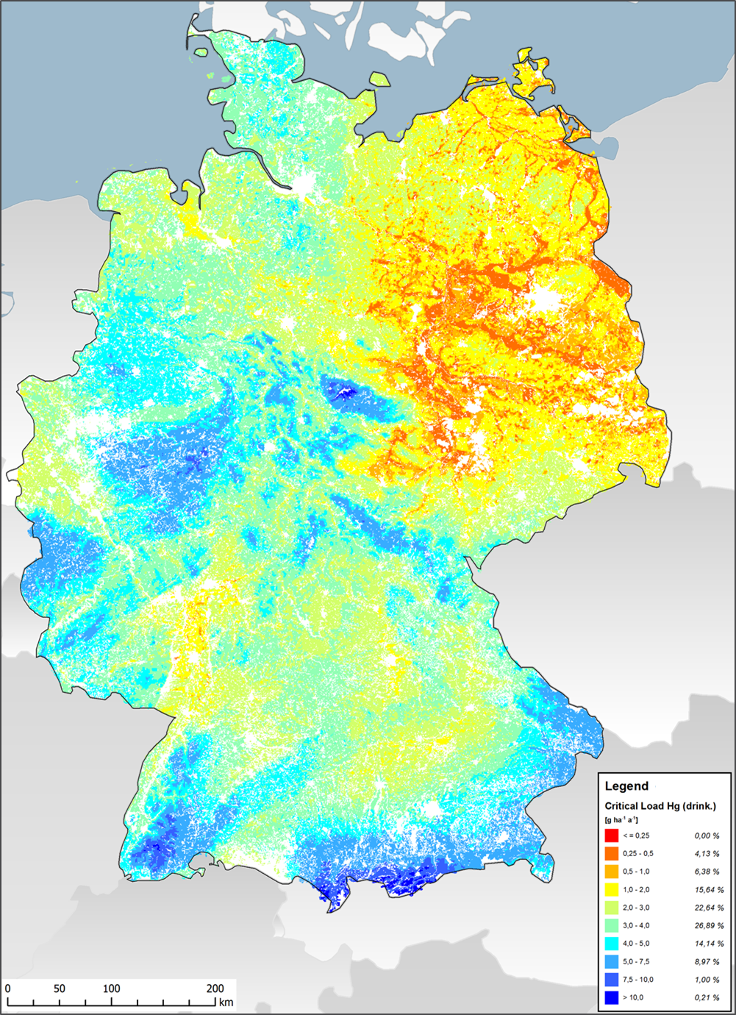
Figure S1.7. Critical load for mercury with the protection objective of ecosystem function.
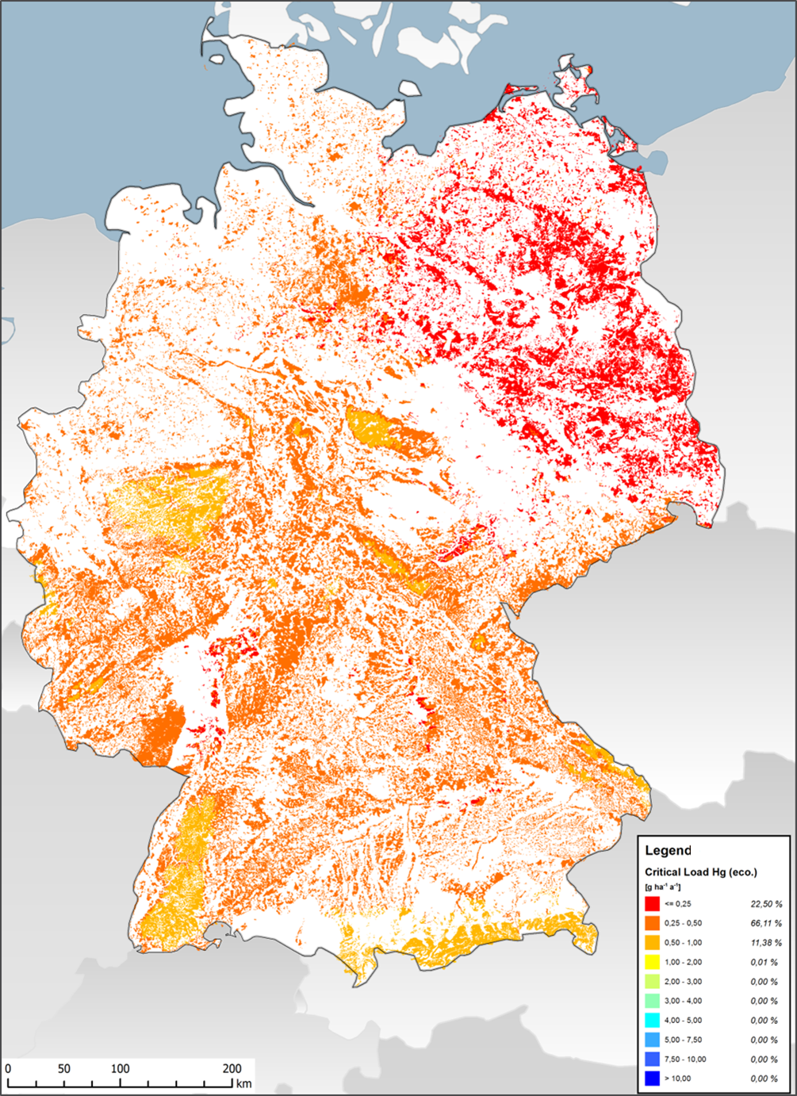

Figure S1.8. Critical load for arsenic with the protection objective of drinking water quality.
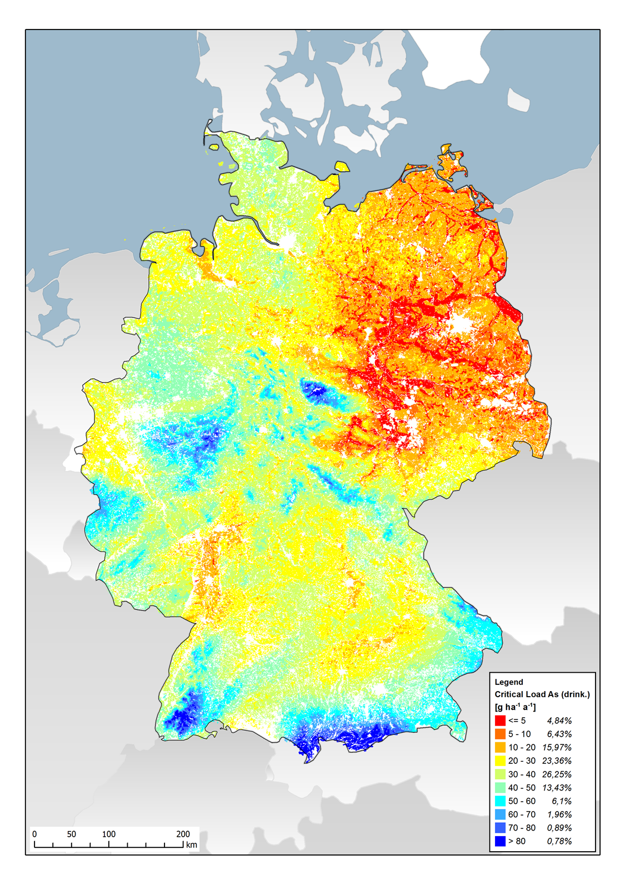

Figure S1.9. Critical load for arsenic with the protection objective of ecosystem function.
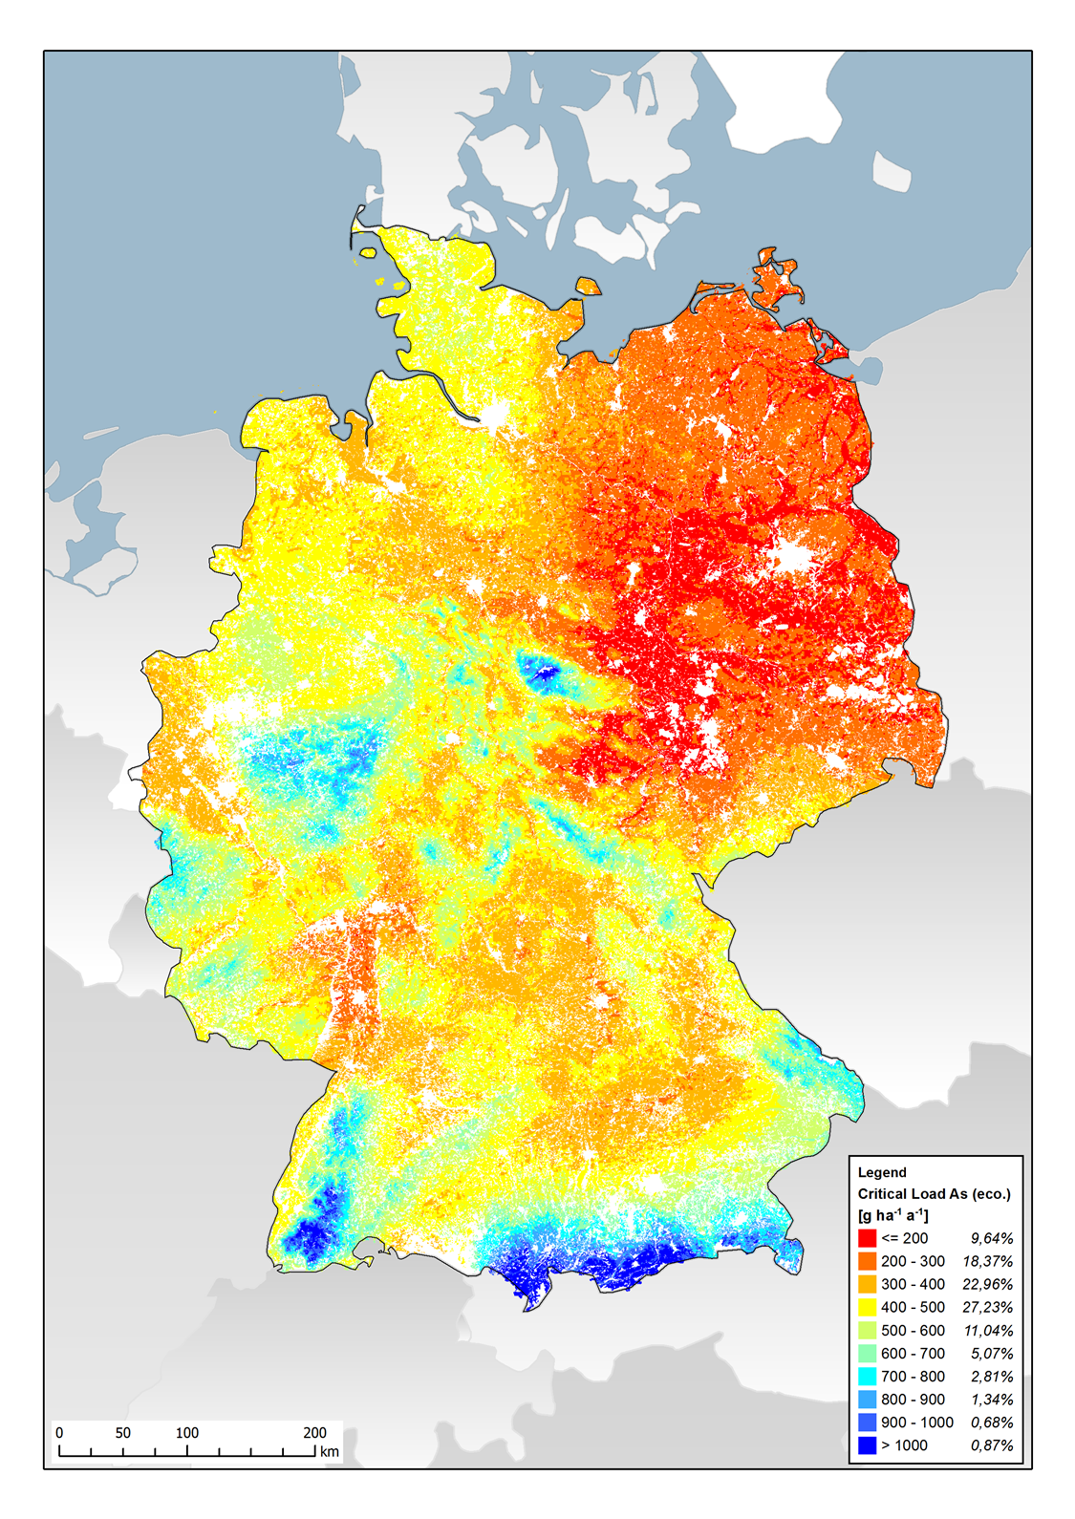

Figure S1.10. Critical load for copper with the protection objective of drinking water quality.
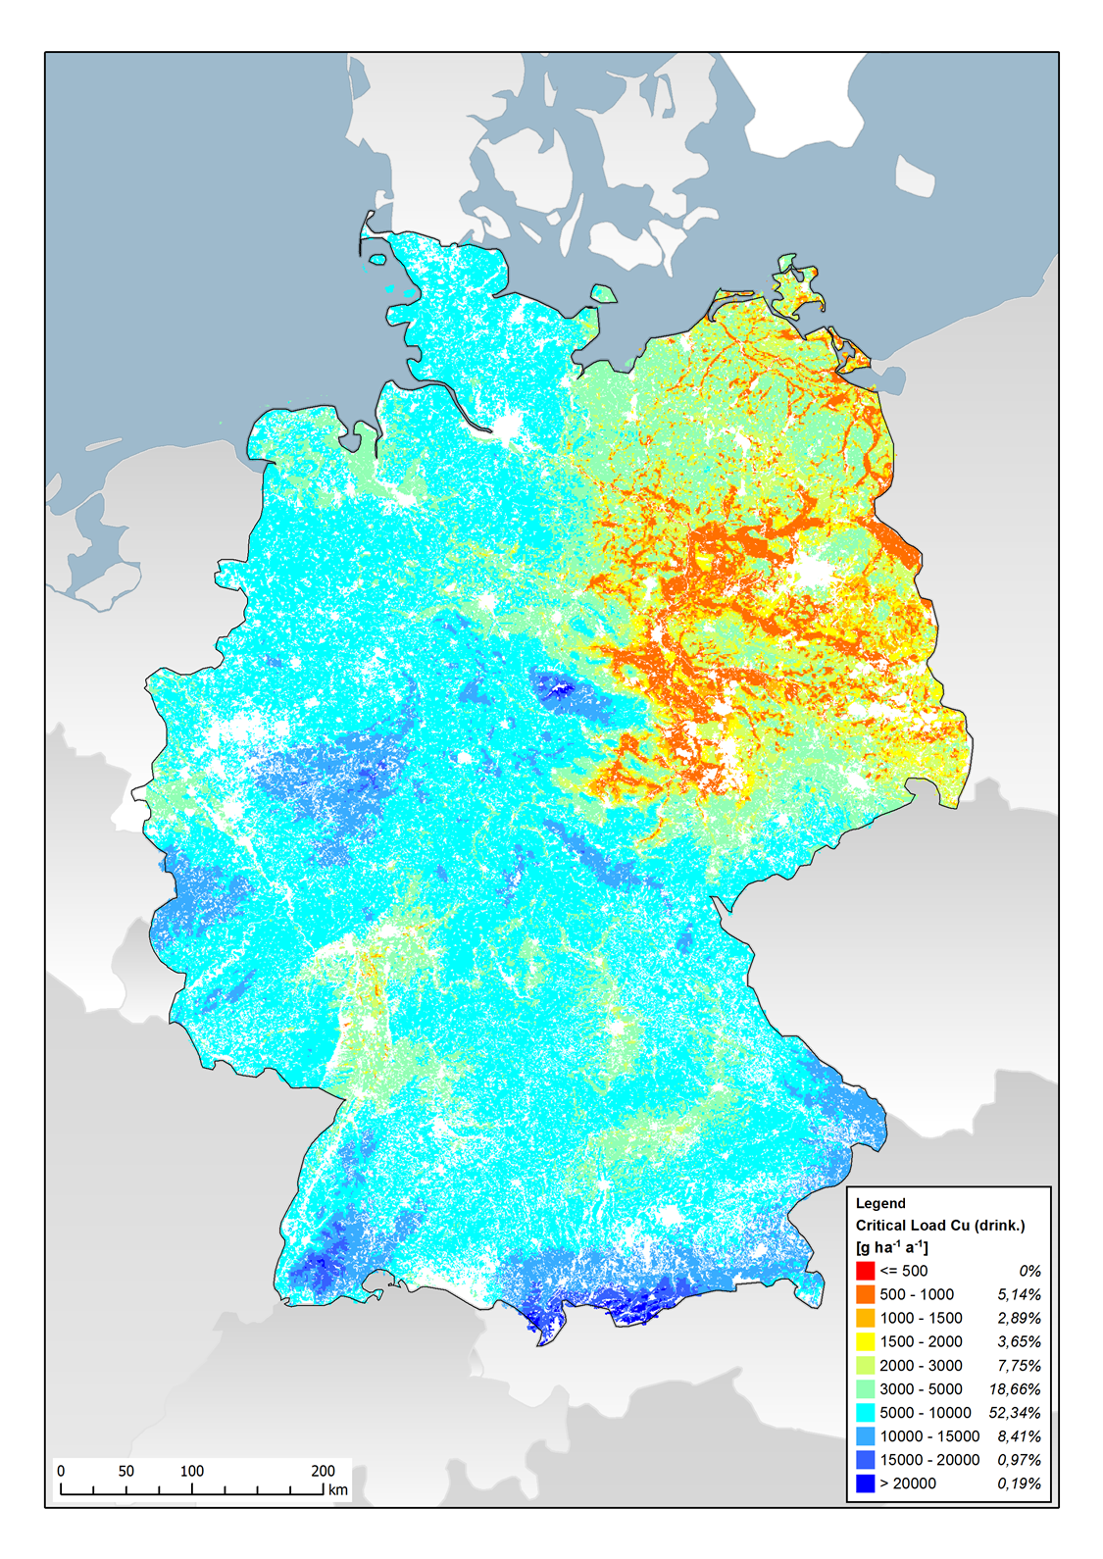

Figure S1.11. Critical load for copper with the protection objective of ecosystem function.
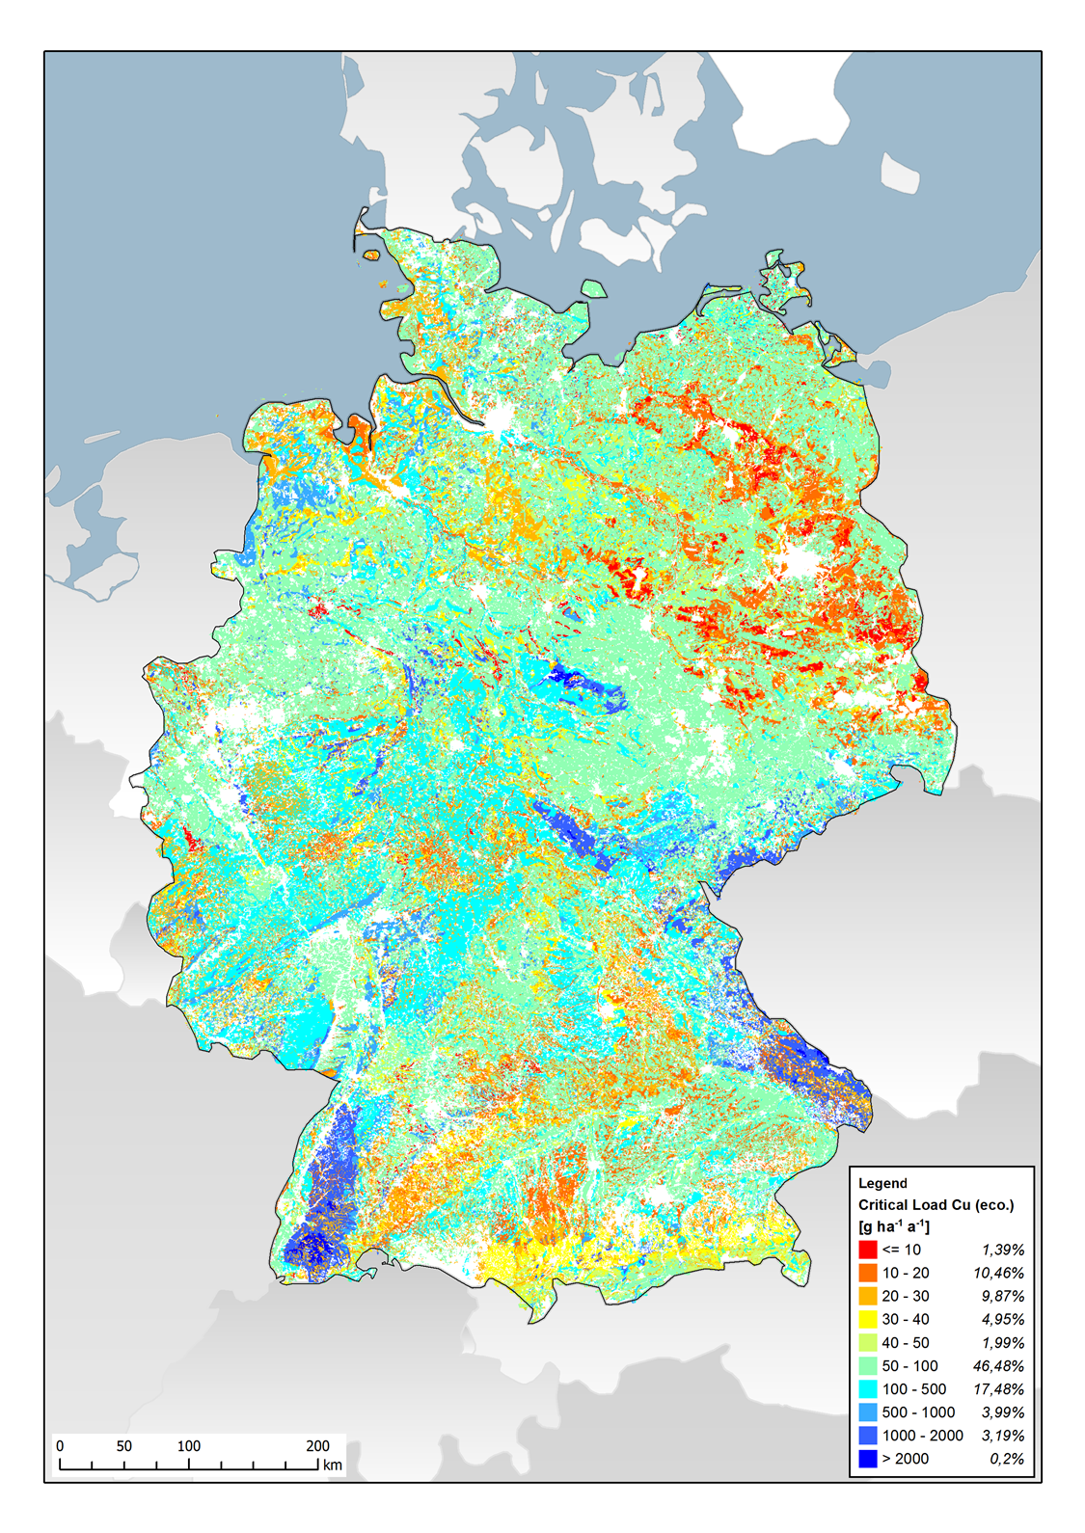
Figure S1.12. Critical load for nickel with the protection objective of ecosystem function.
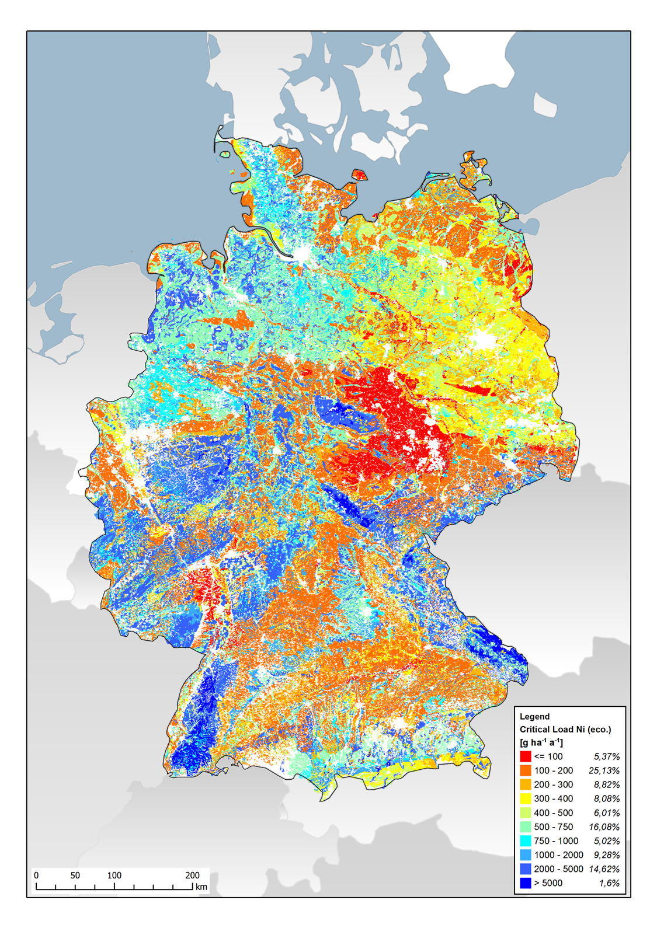

Figure S1.13. Critical load for zinc with the protection objective of ecosystem function.
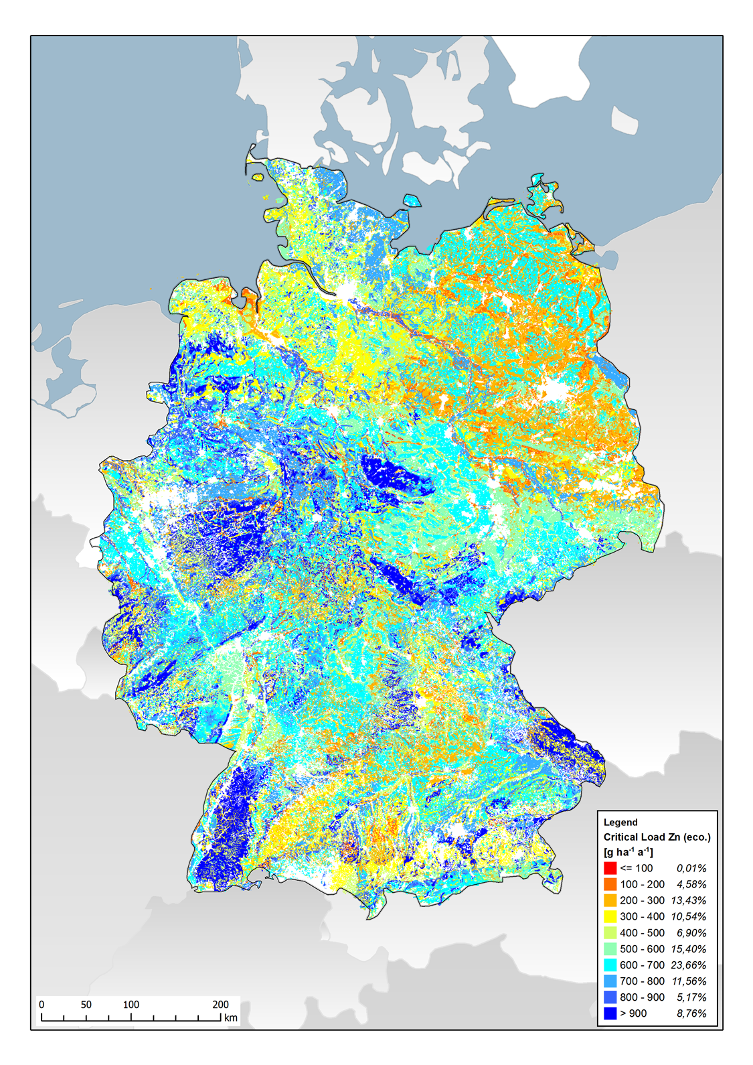

Figure S1.14. Critical load for chromium with the protection objective of drinking water quality.
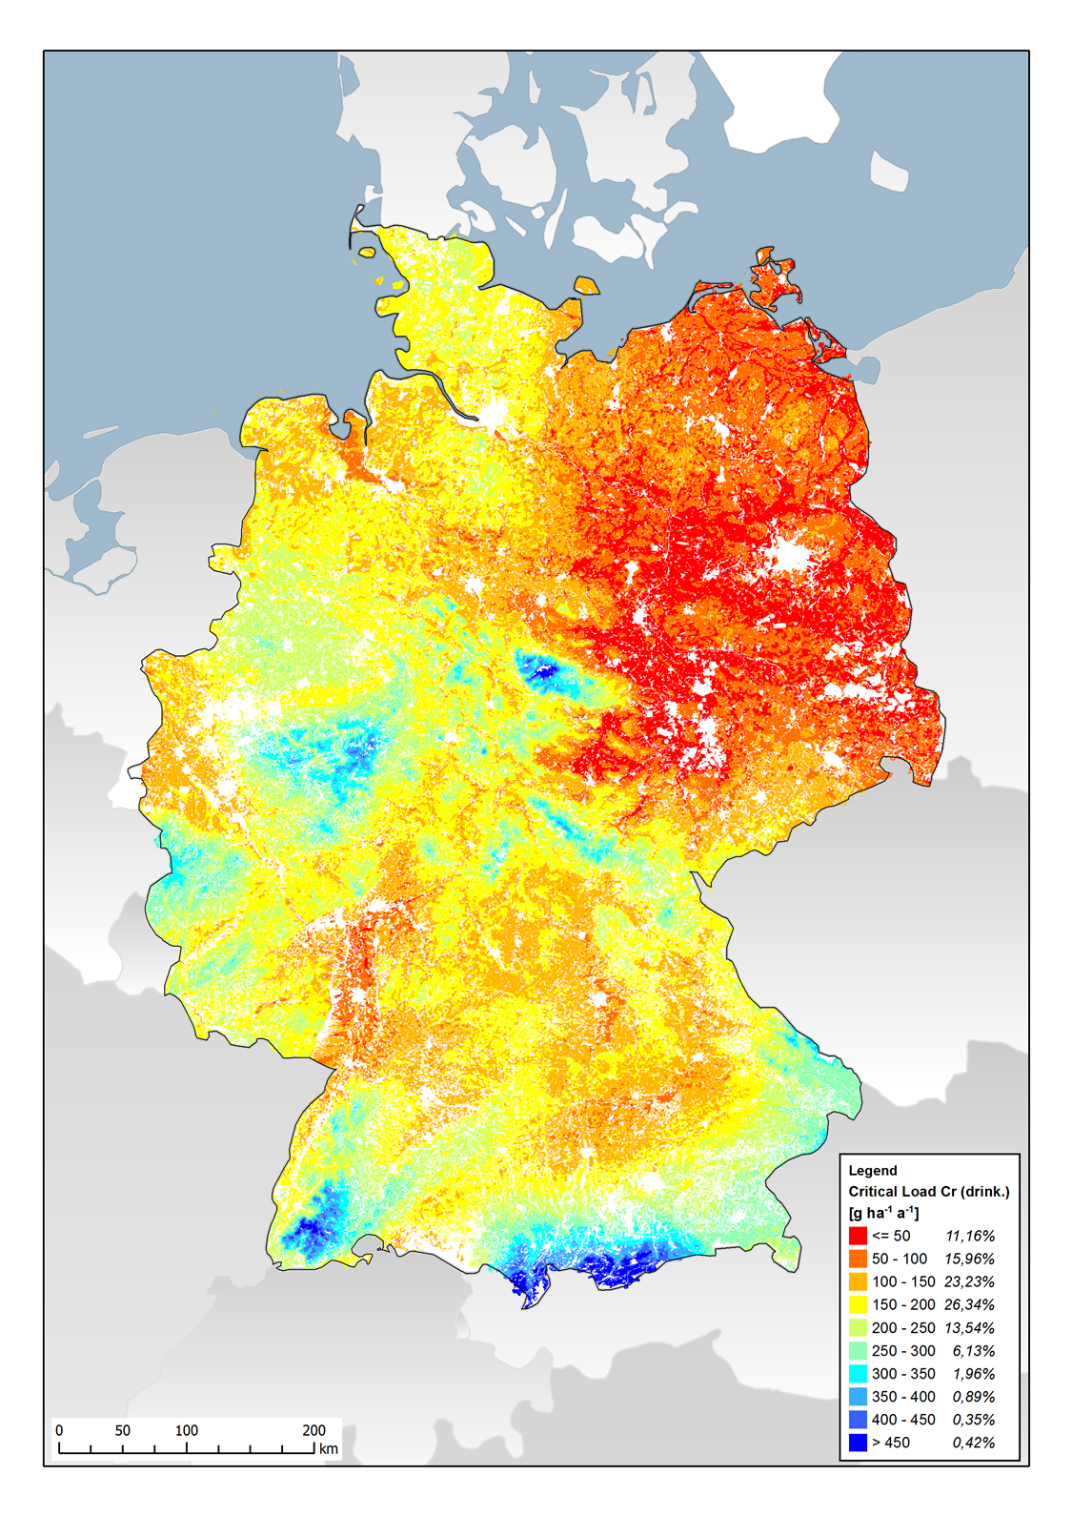

Figure S1.15. Critical load for chromium with the protection objective of ecosystem function.
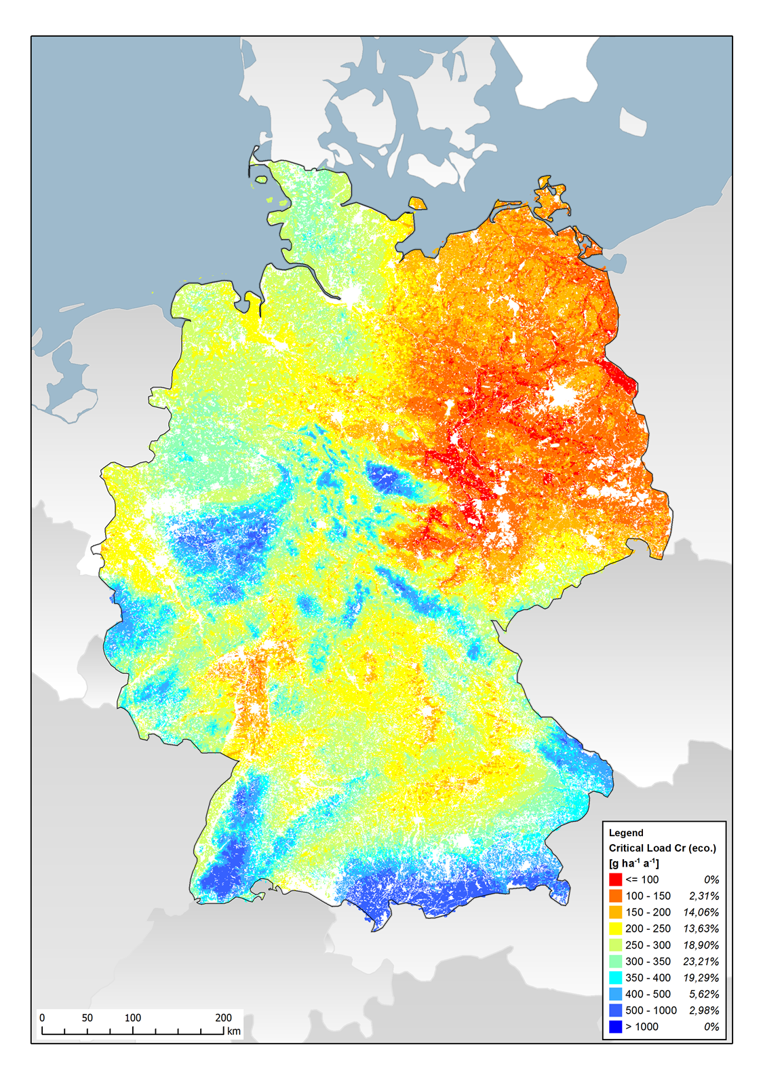

It is legally binding that values for the permissible additional load are derived. The values themselves are rather indicative, as there are no concrete prescribed applications. Installations or input values due to management are subject to other technical laws.

