Assessing the relevance of atmospheric heavy metal deposition with regard to ecosystem integrity and human health in Germany

Angela Schlutow, Winfried Schröder*, Thomas Scheuschner

*Corresponding author: winfried.schroeder@uni-vechta.de

Supplementary Material 2: Exceeding Critical Loads (Section 5)

5 Exceeding Critical Loads

5.1 Deposition of heavy metals from atmospheric deposition

The deposition data set (Schaap et al. 2018) contains information on the concentrations and deposition fluxes of various heavy metals (Cd, Pb, Ni, As, Zn, Cu, V and Cr) for the years 2009, 2010 and 2011. The data delivery included text files with information on the centroid coordinates of the degree cells with the deposition data. The modelled data for cadmium and lead were provided in the 0.125° x 0.0625° degree network of the Long/Lat system and the data for the other heavy metals in the 0.5° x 0.25°. The methodology of the deposition calculation is explained by Schaap et al. (2018), where also the different scales of the deposition data were justified. The available point data (centroids of the grid cells and intersection points of the grid cells) were assigned to the planar degree grid, which has the corresponding mesh size of the respective resolution. This step was necessary to compare the deposition data with the critical load data set.

The originally divided deposition data sets (dry and wet) were combined to the total deposition, converted into the unit of measure of the critical load [g ha⁻¹ a⁻¹] and blended with the critical load receptor areas. After a detailed examination of all years (2009, 2010 and 2011) for all heavy metals, the data for 2010 turned out to be the highest. For this reason, the full-year presentation is limited to 2010.

The visual evaluation of the deposition data showed that the metropolitan regions (Ruhr area, Berlin, Hamburg and Frankfurt/Main) and the Alpine foothills are focal points for the atmospheric inputs of most heavy metals (Figure S2.1, left). In addition, the border regions with Poland and the Czech Republic are more heavily contaminated with As, Cd, Ni and Zn from the air, while the border region with France and the Benelux countries is a hotspot for atmogenic chromium deposition. Vanadium from the air is particularly strongly present in coastal regions (North Sea and Baltic Sea) (Figure S2.1, right). This is in line with a study carried out in 2013 (Visschedijk et al. 2013) which identified emissions from shipping as a major source of vanadium in air freight.

Figure S2.1. Total atmospheric deposition of cadmium (left) and vanadium (right) in 2010 on the receptor surfaces used.
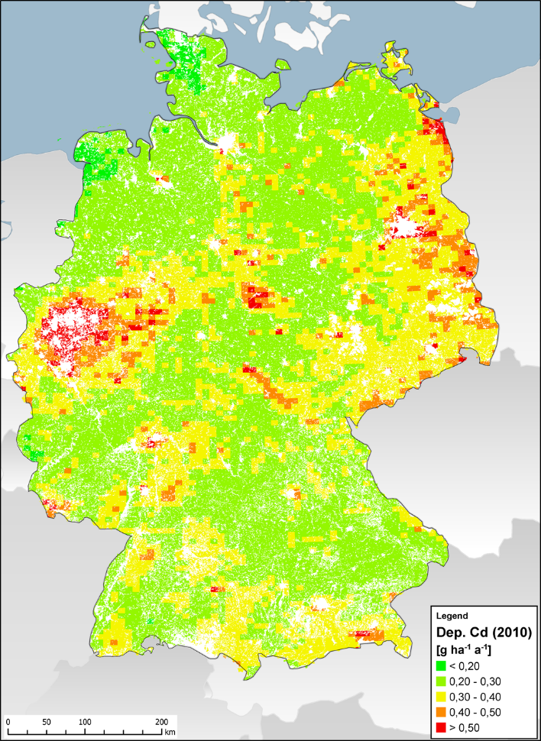 | 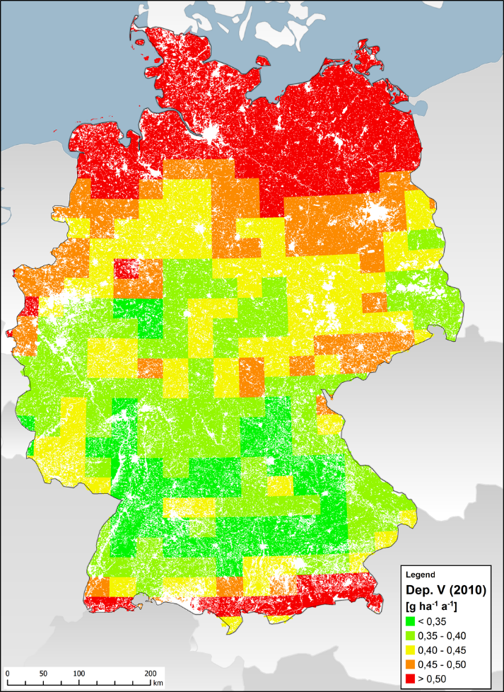

Deposition data for cadmium and lead for the year 2010 were not only modeled in Schaap et al. (2018) with LOTOS-EUROS model, EMEP/MSC-E also published data on this topic (Ilyin et al. 2012; EMEP 2015). It becomes clear that the two data sets are of the same order of magnitude (Figure S2.2 and S2.3), whereby the values modelled with LOTOS-EUROS for Cd are slightly, for Pb significantly lower than in the EMEP data set.
Figure S2.2. Total atmospheric deposition for cadmium (left) and lead (right) for the year 2010 (Schaap et al. 2018).
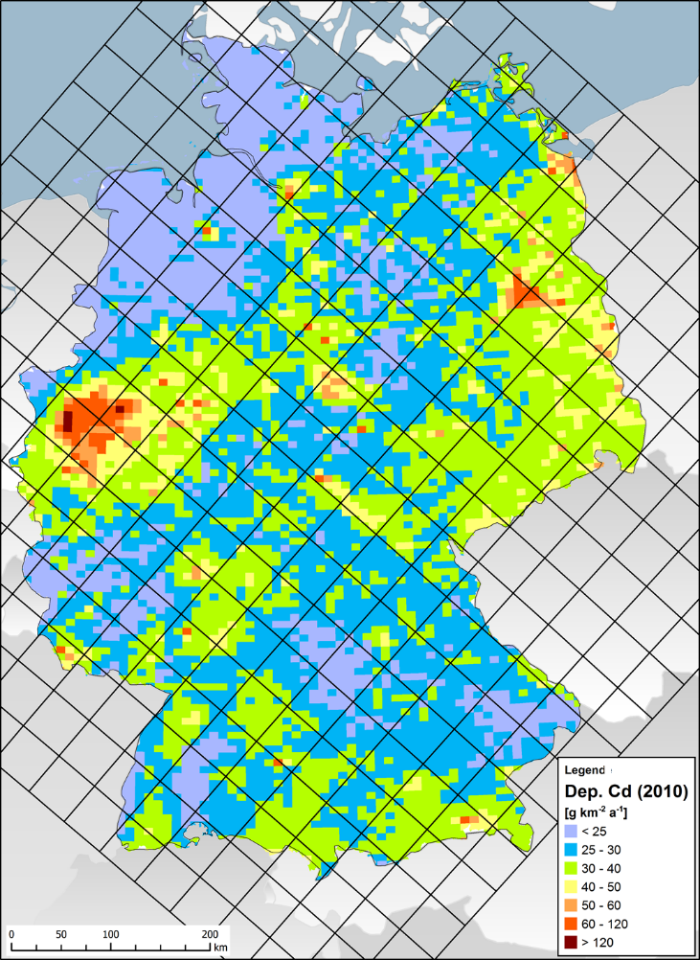 | 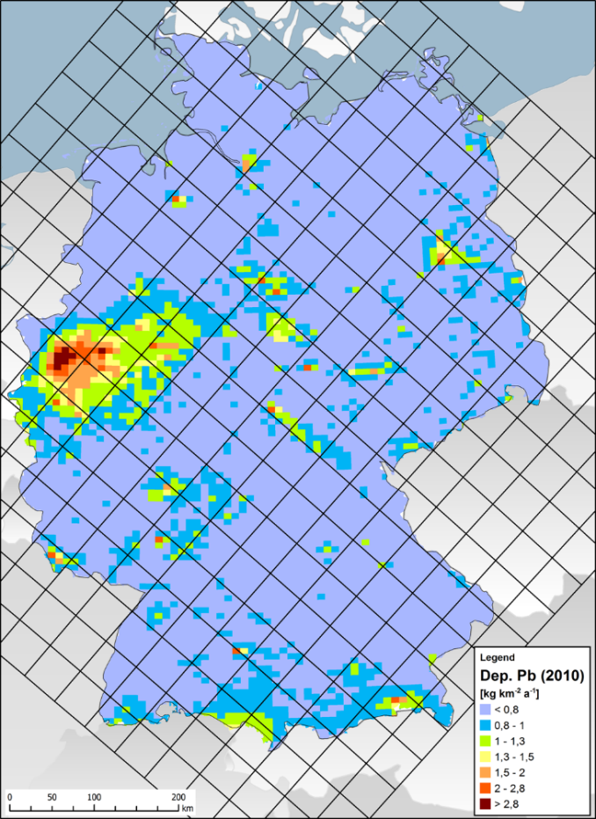

Figure S2.3. Total atmospheric deposition for cadmium (left) and lead (right) for 2010 from Ilyin et al (2012).
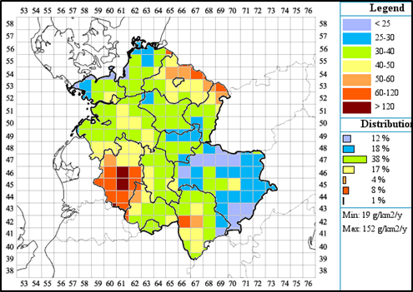 | 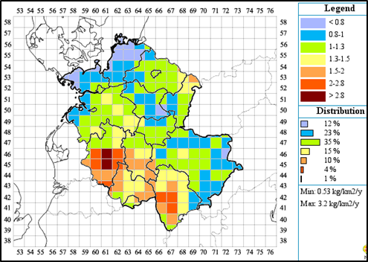

The ranges of depositions for the year 2010 (Schaap et al. 2018) are shown in Table S2.1. By comparison, the table shows the EMEP values for 2013 (EMEP 2015).

Table S2.1. Background deposits (total) of heavy metals (EMEP 2015; Schaap et al. 2018).
Source |  | Pb | Cd | As | Ni | Hg | Tl | Cu | Zn | Cr | V
Source |  | [g ha⁻¹ a⁻¹]
Spreads of depositions in Germany 2010 (Schaap et al 2018) | 5 Perc. | 4.96 | 0.21 | 0.282 | 1.98 |  | Not specified | 3.07 | 11.89 | 0.84 | 0.33
Spreads of depositions in Germany 2010 (Schaap et al 2018) | 25 Perc. | 5.90 | 0.26 | 0.333 | 2.35 |  | Not specified | 4.81 | 16.07 | 1.03 | 0.39
Spreads of depositions in Germany 2010 (Schaap et al 2018) | 50 Perc. | 6.71 | 0.29 | 0.380 | 2.69 |  | Not specified | 5.89 | 19.08 | 1.22 | 0.44
Spreads of depositions in Germany 2010 (Schaap et al 2018) | 75 Perc. | 7.81 | 0.33 | 0.437 | 3.10 |  | Not specified | 7.17 | 22.24 | 1.45 | 0.52
Spreads of depositions in Germany 2010 (Schaap et al 2018) | 95 Perc. | 11.00 | 0.45 | 0.603 | 3.92 |  | Not specified | 10.67 | 33.38 | 2.08 | 0.85
Spreads of depositions in Germany 2010 (Schaap et al 2018) | Min | 3.59 | 0.17 | 0.208 | 1.42 |  | Not specified | 1.98 | 8.24 | 0.66 | 0.30
Spreads of depositions in Germany 2010 (Schaap et al 2018) | Max | 87.25 | 2.33 | 1.026 | 7.11 |  | Not specified | 29.42 | 76.63 | 3.97 | 1.90
Spreads of depositions in Germany 2010 (Schaap et al 2018) | mean | 7.24 | 0.31 | 0.401 | 2.80 |  | Not specified | 6.42 | 20.25 | 1.31 | 0.49
Depositions 2013 in 50 x 50 km² grid. (EMEP 2015) 5-95 Perc. | Deciduous forest |  |  |  |  | 0-0.76 | Not specified
Depositions 2013 in 50 x 50 km² grid. (EMEP 2015) 5-95 Perc. | Coniferous forest |  |  |  |  | 0.16-0.87 | Not specified
Depositions 2013 in 50 x 50 km² grid. (EMEP 2015) 5-95 Perc. | Acre |  |  |  |  | 0.8-0.35 | Not specified
Depositions 2013 in 50 x 50 km² grid. (EMEP 2015) 5-95 Perc. | Marshes |  |  |  |  | 0-0.31 | Not specified
Depositions 2013 in 50 x 50 km² grid. (EMEP 2015) 5-95 Perc. | Grassland |  |  |  |  | 0.08-0.34 | Not specified
Depositions 2013 in 50 x 50 km² grid. (EMEP 2015) 5-95 Perc. | Semi natural vegetation |  |  |  |  | 0-0.34 | Not specified

5.2 Heavy metal inputs from other sources

In addition to the atmospheric inputs of heavy metals discussed in Section 5.1, the following other input pathways play an important role in soil pollution:
- Application of mineral and organic ("farm") fertilisers containing heavy metals on agricultural land (arable land and intensive grassland);
- Application of pesticides containing heavy metals on agricultural land;
- Application of lime fertilizers containing heavy metals in forests.

Findings by Knappe et al. (2008) on nationwide surveys of these inputs are available (Table S2.2).

Table S2.2. Inputs from fertilisation in agriculture and forestry (in g ha⁻¹ a⁻¹) in Germany (Knappe et al. 2008).
Heavy metal |  |  | Acre |  |  |  |  |  |  |  |  | Grassland |  |  |  |  | Organic agriculture |  | Forest
 |  |  | Mineral fertilizer |  | Compost |  | Sewage sludge |  | Farm fertilizer |  | Mineral fertilizer |  |  | Farm fertilizer |  |  |  |  | Liming
 |  |  | g ha⁻¹ a⁻¹
As | min | 0.99 |  | 8.91 |  | 4.4 |  | 0.76 |  | 1.07 |  |  | 2.61 |  | 0.527 |  |  | 0.4
As | max | 1.69 |  | 31.28 |  | 7.97 |  | 3.9 |  | 1.28 |  |  | 4.98 |  | 0.72
Pb | min | 4.19 |  | 82.82 |  | 47.98 |  | 1.81 |  | 8.11 |  |  | 8.65 |  | 0.859 |  |  | 0.7
Pb | max | 8.76 |  | 315.89 |  | 87.28 |  | 10.39 |  | 9.31 |  |  | 10.94 |  | 1.245
Cd | min | 1.33 |  | 1.61 |  | 1.14 |  | 0.4 |  | 2.05 |  |  | 0.66 |  | 0.619 |  |  | 0.2
Cd | max | 3.3 |  | 4.57 |  | 2.61 |  | 1.43 |  | 2.61 |  |  | 0.86 |  | 0.82
Cr | min | 46.61 |  | 73.42 |  | 55.45 |  | 40.65 |  | 24.42 |  |  | 21.51 |  | 8.82 |  |  | 8.2
Cr | max | 57.23 |  | 163.8 |  | 70.14 |  | 59.32 |  | 29.2 |  |  | 27.32 |  | 10.38
Cu | min | 11.27 |  | 98.61 |  | 282.21 |  | 8.8 |  | 20.27 |  |  | 81.43 |  | 0.78 |  |  | 0.8
Cu | max | 34.61 |  | 397.79 |  | 514.49 |  | 220.17 |  | 27.13 |  |  | 174.27 |  | 3.53
Ni | min | 6.64 |  | 31.83 |  | 26.76 |  | 5.15 |  | 5.4 |  |  | 8.32 |  | 1.75 |  |  | 1.6
Ni | max | 9.16 |  | 109.76 |  | 45.77 |  | 16.75 |  | 5.8 |  |  | 14.82 |  | 2.03
Hg | min | 0.01 |  | 0.27 |  | 0.64 |  | 0.01 |  | 0.03 |  |  | 0.06 |  | 0.037 |  |  | 0.06
Hg | max | 0.05 |  | 1.06 |  | 1.19 |  | 0.09 |  | 0.03 |  |  | 0.12 |  | 0.046
Tl | min | 0.08 |  | 0.26 |  | 0.33 |  | 0.04 |  | 0.11 |  |  | 0.13 |  | 0.08 |  |  | 0.09
Tl | max | 0.18 |  | 0.85 |  | 0.64 |  | 0.23 |  | 0.14 |  |  | 0.24 |  | 0.09
Zn | min | 66.76 |  | 376.05 |  | 694.12 |  | 31.09 |  | 99.35 |  |  | 331.6 |  | 9.73 |  |  | 4.2
Zn | max | 250.2 |  | 1445.75 |  | 1272.09 |  | 911.77 |  | 129.54 |  |  | 706.5 |  | 27.48

Critical loads, as defined in the Manual of ICP Modelling and Mapping (CLRTAP 2004-2017), denote tolerable total inputs into ecosystems, whereby negative values mean that the inputs fall short of the critical loads. If the fertiliser inputs were taken into account accordingly when determining the exceedances, the following view of the actual soil contamination in Germany emerged (Table S2.3).

Table S2.3. Exceedance of the CL(M)_{eco} (medians) taking into account both the atmospheric input loads in Germany and the fertilisation loads in agriculture and forestry according to Knappe et al. (2008).
Heavy metal |  | Atmospheric deposition  MinM_{dep}  MaxM_{dep} |  |  | Entry from fertilisation  Min_{Fertilizer}  Max _{fertiliser} |  |  | Exceeding the CL(M)_{eco} MinExcCL(M)_{eco} ; MaxExcCL(M)_{eco}
 |  | 2009 | 2010 | 2011 | acre | meadow | wood | acre | meadow | wood
 |  | g ha⁻¹ a⁻¹
As | min | 0.22 | 0.21 | 0.17 | 15.1 | 3.68 | 0.4 | -425 | -436 | -439
As | max | 0.93 | 1.03 | 0.81 | 44.8 | 6.26 |  | -394 | -433
Pb | min | 3.81 | 3.59 | 3.36 | 137 | 16.8 | 0.7 | 120 | -0.43 | -16.5
Pb | max | 71.1 | 87.3 | 59.8 | 422 | 20.3 |  | 472 | 70.3
Cd | min | 0.17 | 0.17 | 0.14 | 4.48 | 2.71 | 0.2 | -5.85 | -7.62 | -10.1
Cd | max | 1.91 | 2.33 | 1.6 | 11.9 | 3.47 |  | 3.74 | -4.7
Cr | min | 0.63 | 0.66 | 0.66 | 216 | 45.9 | 8.2 | -84 | -254 | -292
Cr | max | 3.59 | 3.97 | 3.05 | 350 | 56.5 |  | 53 | -241
Cu | min | 2.47 | 1.98 | 2.41 | 401 | 102 | 0.8 | 359 | 60 | -40.7
Cu | max | 22.5 | 29.4 | 18.9 | 1167 | 201 |  | 1152 | 187
Ni | min | 1.45 | 1.42 | 1.25 | 70.4 | 13.7 | 1.6 | -496 | -553 | -565
Ni | max | 6.6 | 7.11 | 5.83 | 181 | 20.6 |  | -379 | -540
Hg | min | n.a. | n.a. | n.a. | 0.93 | 0.09 | 0.06 | >0.53 | >-0.31 | >-0.34
Hg | max | n.a. | n.a. | n.a. | 2.39 | 0.15 |  | >1.99 | >-0.25
Zn | min | 9.24 | 8.24 | 8.66 | 1168 | 431 | 4.2 | 831 | 94 | -333
Zn | max | 66.3 | 76.6 | 57.5 | 3880 | 836 |  | 3610 | 567

The exceedance rates were calculated as follows:
MinExcCL(M)_{eco} = (MinM_{dep}+MinM_{fertilizer})-CL(M)_{eco}
and
MaxExcCL(M)_{eco} = (MaxM_{dep}+MaxM_{fertilizer})-CL(M)_{eco}
with:
MinExcCL(M)_{eco} = Minimum ecosystem critical loads exceedance in the German receptor areas due to total deposition from the air and fertiliser inputs
MaxExcCL(M)_{eco} = Maximum ecosystem critical loads exceedance in the German receptor areas due to total depositions from the air and fertiliser inputs
MinM_{dep} = Minimum of the total depositions from the air in the German receptor surfaces, corresponds to the highest minimum of the three years 2009-2011
MaxM_{dep} = Maximum of total depositions from the air in the German receptor surfaces corresponds to the highest maximum of the three years 2009-2011
MinM_{fertilizer} = Minimum of the metal inputs with the fertilization in the German receptor surfaces
MaxM_{fertilizer} = Maximum of the metal inputs with the fertilization in the German receptor areas
CL(M)_{eco} = Median of the Ecosystem Critical Loads for the metal in the German receptor surfaces

It can be seen that only a fraction of the heavy metal load on agricultural soils results from the atmosphere. The input with fertilizers outweighs the atmogenic input with all considered heavy metals mostly by several hundred percent. However, even with an integrative determination of the inputs of arsenic and nickel, there is no risk for arable land, grassland or forest. If one compares the maximum inputs from fertilisation and from the air with the lowest critical loads in Germany for arsenic CL(As)_{eco} (128.5 g ha⁻¹ a⁻¹), there is still no exceedance. For nickel (CL(Ni)_{eco} -Minimum = 42 g ha⁻¹ a⁻¹), in the worst case an exceedance on arable land is to be expected. There is a risk for arable soils if cadmium or chromium meet average sensitive soils with the maximum deposition rate. There is a high risk for arable and grassland soils from lead, copper and zinc even with minimal inputs from the air plus minimal inputs from fertilizers. The forest of medium sensitivity is not endangered by heavy metal inputs from the air and by fertilization. The comparison of cadmium inputs by fertilisation with CL(M)_{food} (3-9 g ha⁻¹ a⁻¹) shows a potential risk to human health from the consumption of wheat products of German origin. How to interpret statements that potential risks exist is discussed in Section 5.4.

5.3 Critical load exceedances due to atmospheric deposition

After comparing the deposition data available from this study for 2009-2011 (Schaap et al. 2018) with the respective critical loads, three exceedances occurred: Lead (drinking water and ecosystem protection) and copper (ecosystem protection) (Figures S2.4-S2.6). The critical load exceedance for lead depositions from air with the protection target drinking water quality can only be expected on a relatively small receptor surface. Between 1.32 % (2011) and 2.44 % (2010) of the receptor surface have an increased risk for drinking water quality due to airborne pollutant deposition of Pb. Critical load exceedance with airborne copper deposition with ecosystem integrity as a protection target is also relatively low. The values vary between 0.35% (2011) and 1.16% (2010) of the receptor areas. A significantly higher proportion of land is affected by a critical load exceedance in airborne lead depositions with the protection objective of ecosystem integrity. Here, space shares between 5.18% (2011) and 14.36% (2010) are achieved. In absolute terms this corresponds to 14,494 km² (2011) and 40,181 km² (2010). The focus is on the Leipzig and Thuringian basins, the loess areas (including the northern Harz foothills and the Lower Saxony area), the Erzgebirgs foothills, the Lower Saxony highlands, parts of the Mecklenburg Lake District backcountry and parts of the Ruhr area (Lower Rhine lowlands and Cologne Bay). These areas are already identified as particularly sensitive to lead deposition (Figure S1.2). Maps of the exceedance rates of the critical loads for lead (drinking water and ecosystem protection) and copper (ecosystem protection) are shown in Figures S2.4-S2.6. There is no need to map exceedances of other critical loads as there are no exceedances of these CLs in 2010.
Figure S2.4. Exceedance of critical loads with the protection objective of drinking water quality by atmospheric lead deposition.
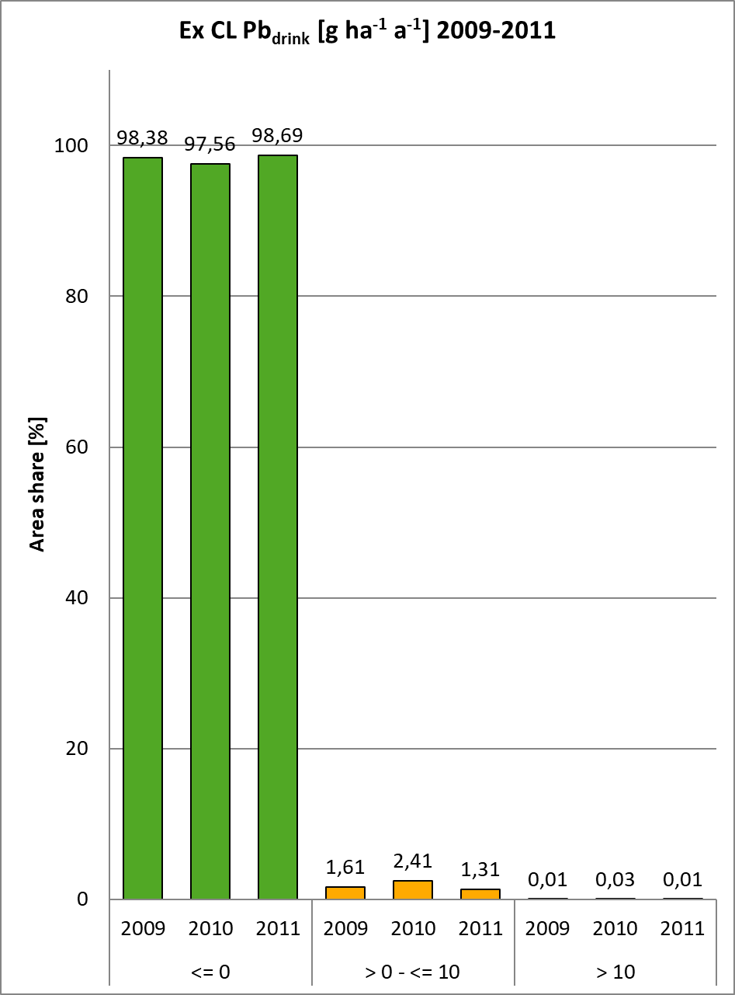 | 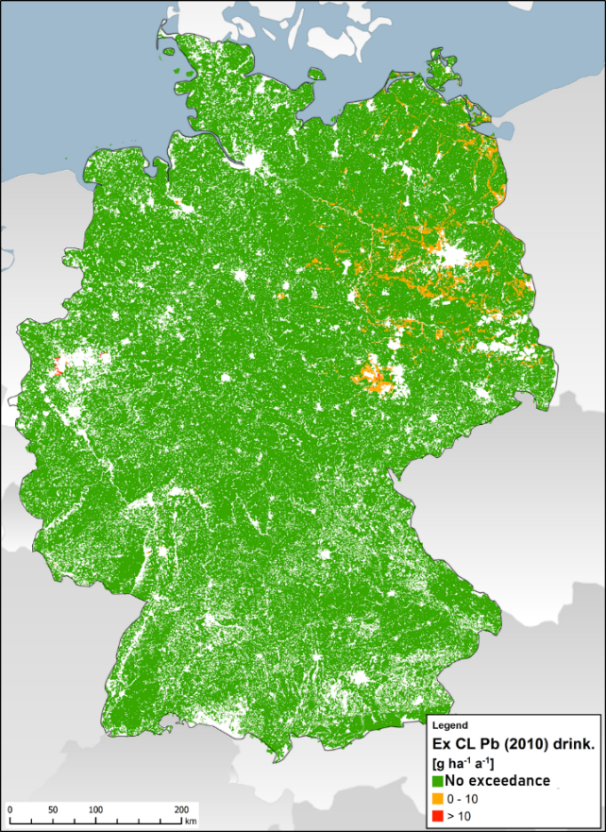

Figure S2.5. Exceedance of critical loads with the aim of protecting ecosystem integrity by atmospheric lead deposition.
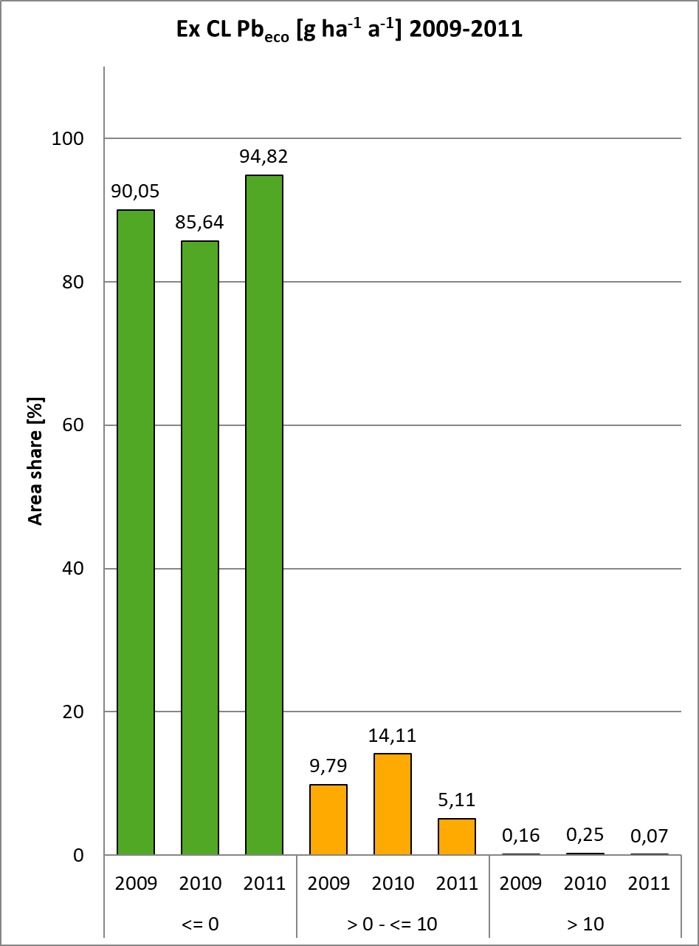 | 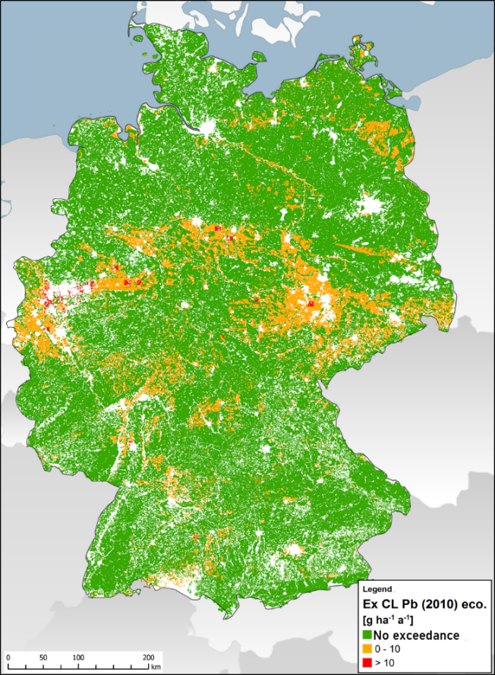
Figure S2.6. Exceedance of Critical Loads with the protection objective ecosystem integrity by atmospheric copper deposition.
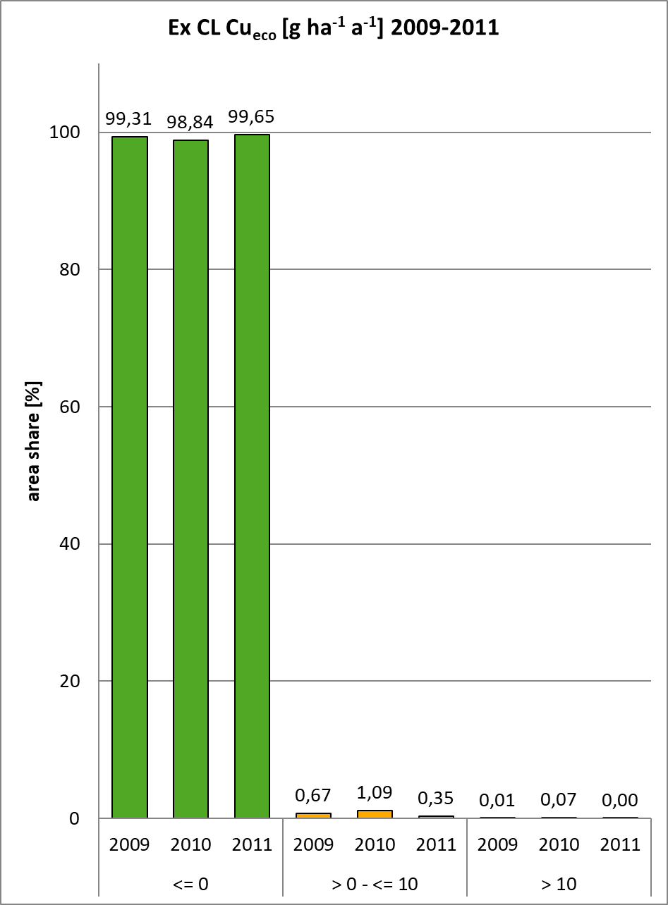 | 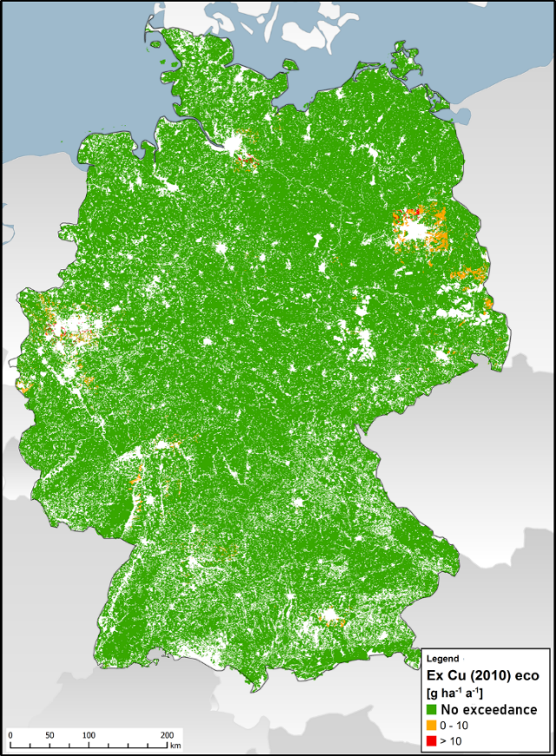

These results based on the deposition calculations with the LOTOS-EUROS model differ significantly from the deposition calculations with the EMEP model (see Schaap et al. 2018). The LOTOS-EUROS model consistently results in lower medians and maxima than EMEP. The EMEP/ LOTOS-EUROS ratios correlate very strongly with the deposition height, i.e. where EMEP calculates particularly high depositions (e.g. Pb in the Ruhr area or Cd in North Rhine-Westphalia), the differences between the two models are also highest. Conversely, the low deposition calculated with LOTOS-EUROS, e.g. at altitudes in southern Bavaria, is higher than with EMEP (Cd: 45 % higher, Pb: 12 % higher).

The integrative analysis of the LOTOS-EUROS models (2005, 2007-2011, Germany) with the geostatistical area estimates of the heavy metal contents in moss (EMS, 2005, Germany) showed stronger statistical correlations than the correlation with measured concentrations in moss (Schröder et al. 2019 b). For Cu, the correlation is weak. At Pb, the mean correlations to LOTOS-EUROS were stronger than to EMEP, but strongest to the arithmetic mean of LOTOS-EUROS and EMEP. It follows from this that if EMEP background depositions were applied, the proportion of areas with critical load exceedances would be higher. But the comparison of the geostatistical area estimates of the heavy metal contents in moss with the EMEP results also leads to the conclusion that the LOTOS-EUROS results for the Pb depositions are closer to reality than the EMEP data and thus at least for Pb the exceedance rates shown above have lower uncertainties than when using EMEP depositions. The uncertainties of the LOTOS-EUROS results cannot be measured quantitatively, because there are not enough measurement data containing wet and dry deposition at the same time.

5.4 Statistical Evaluation of Critical Load Exceedances

In the following, the values for the total deposition for 2010 by Schaap et al. (2018) and for Hg from the EMEP dataset for Germany 2013 are compared with the critical loads for 2016 (minimum, 5-percentile, 95-percentile and median). This comparison shows possible risks for ecosystems and human health for the areas that cannot be represented in the German data set due to its small scale. Since the 2010 deposition data set shows higher average depositions than the 2009 and 2011 data sets for Germany, this comparison also tends to show more unfavourable conditions, so that the risk assessment is conservative.

The German data sets for critical loads and depositions were calculated on the basis of input data collected on a scale of 1:1 million. The mapping units of BÜK1000N, CORINE 2006 (CLC 2006) and the site types classified by climate zones are not homogeneous in reality. They may contain sprays that are more sensitive to heavy metal ingress. The German dataset of Critical Loads 2016 and the exceedances of Critical Loads in 2010 is therefore not applicable for large-scale area-based evaluations or even for site-specific statements. A rough orientation for individual sites can only be derived from the German dataset if it can be demonstrated that the same site conditions prevail for specific areas or sites as were used as a basis in the German CL(M) and deposition datasets. In order to nevertheless be able to derive a statement on the risks also for areas that cannot be represented at a scale of 1 : 1 million, the respective worst case values are compared with each other, i.e. the lower range limit of the critical loads with the upper range limits of the depositions. It is assumed that the parameter values of the site types that are not representative in terms of area on a scale of 1:1 million and are not represented in the German data sets would not lie outside the ranges of the critical loads and atmospheric deposition in Germany.

The comparison of the ranges of critical loads and deposition shows the risk of whether and to what extent, in the worst case, further accumulation of heavy metals in ecosystems or in groundwater or in the soil of wheat fields above the critical concentrations could take place if the annual deposition rates were to remain constant at the 2010 level in the future. However, it should be pointed out here that the deposition data used for comparison, which were determined on the basis of models throughout Germany (Schaap et al. 2018), could be significantly higher locally, e.g. on areas with industrial and/or traffic concentrations or in the vicinity of a particularly high-emission plant.

Mercury

Since no Germany-wide deposition calculations including dry deposition for Hg are available (Schaap et al. 2018), the assessment of the total atmogenic load situation can only be made on the basis of the EMEP deposition mapping (Ilyin 2015) (Table S2.4).

Table S2.4. Comparison of the mercury deposition in the year 2013 (EMEP 2015) with the critical loads of the receptor surfaces in Germany.
Mercury
Deposition: | 2013 EMEP (5 Perc.) |  | [g ha⁻¹ a⁻¹] | 0.00
Deposition: | 2013 EMEP (95 Perc.) |  | [g ha⁻¹ a⁻¹] | 0.87
Critical loads:
CL(Hg)_{eco} | min | [g ha⁻¹ a⁻¹] |  | 0
CL(Hg)_{eco} | 5-95 Perc. (median) | [g ha⁻¹ a⁻¹] |  | 0.2 – 0.6 (0.4)
CL(Hg)_{drink} | min | [g ha⁻¹ a⁻¹] |  | 0.26
CL(Hg)_{drink} | 5-95 Perc. (median) | [g ha⁻¹ a⁻¹] |  | 0.6-5.7 (3.2)

Based on the evaluation of the EMEP total deposition values in a 50 km x 50 km grid, it can be assumed that a proportion of Germany's ecosystem receptor areas, i.e. those with high to medium sensitivity, are contaminated by mercury inputs above the critical load. Sensitive ecosystem types include in particular the unused deciduous forests of dry, nutrient-poor sites such as dry oak forests in the arid regions of Brandenburg and Saxony-Anhalt or beech forests along the coasts. The critical loads for drinking water protection in Germany are also clearly exceeded in the worst case. This means that in the worst case, Hg can accumulate in the soil or groundwater as soon as the critical limits in soil and soil water have been reached. However, the buffer capacity of the humus-rich forest soils in particular is very high for Hg, so that actual damage to ecosystem compartments, even if critical loads are exceeded, may only be expected after decades or centuries.

Cadmium

The comparison of the Germany-wide raster maps of the total deposition of cadmium in 2010 determined by Schaap et al. (2018) with the critical loads determined in this study shows Table S2.5.

Table S2.5. Comparison of the cadmium deposition with the assessment values and statistical evaluation of the area share of protected receptor areas in Germany, 2010, against limit values exceeded.
Cadmium
Deposition | 5-95 Perc. (Median) from Schaap et al. (2018) | [g ha⁻¹ a⁻¹] | 0.21-0.45 (0.29)
Deposition | max | [g ha⁻¹ a⁻¹] | 2.33
Critical loads:
CL(Cd)_{eco} | min | [g ha⁻¹ a⁻¹] | 1.53
CL(Cd)_{eco} | 5-95 Perc. (median) | [g ha⁻¹ a⁻¹] | 4.1 – 42.4 (10.5)
CL(Cd)_{drink} | min | [g ha⁻¹ a⁻¹] | 0.65
CL(Cd)_{drink} | 5-95 Perc. (median) | [g ha⁻¹ a⁻¹] | 2.5-18 (10.2)
CL(Cd)_{food} | min | [g ha⁻¹ a⁻¹] | 2.31
CL(Cd)_{food} | 5-95 Perc. (median) | [g ha⁻¹ a⁻¹] | 3-9.3 (6)

The maximum atmospheric deposition in 2010 may have exceeded the critical loads for the protection of ecosystems, drinking water and food in a few areas if maximum deposition rates hit areas with very low critical loads (< 2.3 g ha⁻¹ a⁻¹). This means that in the worst case an unacceptable accumulation of Cd in soil and drinking water could occur as long as the deposition is above the respective critical load and the critical limits have already been reached. However, when the inputs from atmospheric deposition and fertilisers are determined summarily, there is a risk that arable land will be exceeded if maximum total inputs are applied to high to average sensitive soils.

The comparison of the maximum inputs of cadmium by fertilisation with CL(Cd)_{food} shows that risks to human health from the consumption of wheat products of German origin cannot be excluded, since an intolerable increase in the Cd content in the soil can at the same time lead to an intolerable increase in the Cd content in the wheat grain (Knappe et al. 2008).

Lead
The comparison of the Germany-wide raster maps of the total deposition of lead in 2010 calculated by Schaap et al. (2018) with the critical loads determined in this paper is shown in the Table S2.6.

Table S2.6. Comparison of lead deposition 2010 with the critical loads of receptor surfaces in Germany.
lead
Deposition: | 5-95 Perc. (Median) from Schaap et al. (2018) | [g ha⁻¹ a⁻¹] | 4.43-11 (6.71)
Deposition: | max | [g ha⁻¹ a⁻¹] | 87.25
Critical loads:
CL(Pb)_{eco} | min | [g ha⁻¹ a⁻¹] | 1.97
CL(Pb)_{eco} | 5-95 Perc. (median) | [g ha⁻¹ a⁻¹] | 6 - 601 (21)
CL(Pb)_{drink} | min | [g ha⁻¹ a⁻¹] | 2.8
CL(Pb)_{drink} | 5-95 Perc. (median) | [g ha⁻¹ a⁻¹] | 9-61 (35)

The maximum atmospheric deposition in 2010 has exceeded the critical loads for the protection of ecosystems and drinking water in a large part of the areas. This means that an unacceptable accumulation of Pb in soil and especially in drinking water occurs as soon as the critical limits in soil and soil water are reached. When the inputs from atmospheric deposition and fertilisation are determined summarily, there is an excess risk for all arable land and grassland if maximum total inputs are applied to high to medium sensitive soils.

Arsenic

Table S2.7 compares the grid maps of the total deposition of arsenic in 2010 calculated throughout Germany by Schaap et al. (2018) with the critical loads determined in this study.

Table S.2.7. Comparison of arsenic depositions in 2010 with the critical loads of receptor surfaces in Germany.
Arsenic
Deposition: | 5-95 Perc. (Median) from Schaap et al. (2018) | [g ha⁻¹ a⁻¹] | 0.28-0.6 (0.38)
Deposition: | max | [g ha⁻¹ a⁻¹] | 1.03
Critical loads:
CL(As)_{eco} | min | [g ha⁻¹ a⁻¹] | 115
CL(As)_{eco} | 5-95 Perc. (median) | [g ha⁻¹ a⁻¹] | 181-711 (414)
CL(As)_{drink} | min | [g ha⁻¹ a⁻¹] | 2
CL(As)_{drink} | 5-95 Perc. (median) | [g ha⁻¹ a⁻¹] | 6-56 (31)

Even in the worst case (maximum deposition meets minimum critical loads), the critical loads for the protection of ecosystems and drinking water are clearly undercut. Even if the fertiliser inputs in the maximum are added to the total atmogenic inputs in the maximum, the critical loads for ecosystem or drinking water protection are not exceeded. If, in the critical load calculation for ecosystem protection, the minimum threshold (Zeddel et al. 2016 used instead of the critical concentration in the leachate according to Doyle et al. (2003, in Reinds et al. 2006), a minimum critical load of 2.9 g ha⁻¹ a⁻¹ would be obtained. In the worst case scenario, this minimum would also not be exceeded by the maximum deposition. The same applies to the alternatively calculated minimum critical load for drinking water protection.

Copper

The comparison of the grid maps of the total deposition of copper in 2010 calculated by Schaap et al. (2018) throughout Germany with the critical loads determined in this paper is shown in Table S2.8.

Table S2.8. Comparison of the 2010 copper deposition with the critical loads of the receptor surfaces in Germany.
Copper
Deposition: | 5-95 Perc. (Median) from Schaap et al. (2018) | [g ha⁻¹ a⁻¹] | 3.1-10.67 (5.89)
Deposition: | max | [g ha⁻¹ a⁻¹] | 29.42
Critical loads:
CL(Cu)_{eco} | min | [g ha⁻¹ a⁻¹] | 7
CL(Cu)_{eco} | 5-95 Perc. (median) | [g ha⁻¹ a⁻¹] | 13 - 710 (74)
CL(Cu)_{drink} | min | [g ha⁻¹ a⁻¹] | 484
CL(Cu)_{drink} | 5-95 Perc. (median) | [g ha⁻¹ a⁻¹] | 1070-11268 (6172)

The maximum atmospheric deposition in 2010 (Schaap et al. 2018) has exceeded the critical loads for ecosystem protection on part of the areas. This means that there will be an unacceptable accumulation of Cu in soil and/or groundwater as soon as the critical limits in soil are exceeded. When the inputs from atmospheric deposition and fertilisation are determined summarily, there is an exceedance risk for all arable land and grassland when maximum total inputs meet high to average sensitive soils.

Zinc

The comparison of the Germany-wide grid maps of the total deposition of zinc 2010 calculated by Schaap et al. (2018) with the critical loads determined in this study shows Table S2.9.

Table S2.9. Comparison of the zinc deposition 2010 with the critical loads of the receptor surfaces in Germany.
Zinc
Deposition: | 5-95 Perc. (Median) from Schaap et al. (2018) | [g ha⁻¹ a⁻¹] | 11.89-33.38 (19.08)
Deposition: | max | [g ha⁻¹ a⁻¹] | 76.63
Critical loads:
CL(Zn)_{eco} | min | [g ha⁻¹ a⁻¹] | 81
CL(Zn)_{eco} | 5-95 Perc. (median) | [g ha⁻¹ a⁻¹] | 189 - 1032 (565)
CL(Zn)_{drink} | min | [g ha⁻¹ a⁻¹] | 1234
CL(Zn)_{drink} | 5-95 Perc. (median) | [g ha⁻¹ a⁻¹] | 2848 – 28316 (15628)

Even in the worst case (maximum deposition meets minimum critical loads), the critical loads for the protection of ecosystems and drinking water are barely undershot. The minimum inputs of Zn with fertilisers are already so high that there is a high risk of the critical loads for ecosystem protection being exceeded for all arable land and grassland. Since limit concentrations for zinc in drinking water are not specified, a critical load for drinking water protection cannot be determined.

Chrome

The comparison of the Germany-wide raster maps of the total deposition of chromium 2010 determined by Schaap et al. (2018) with the critical loads determined in this study is shown in the Table S2.10.

Table S2.10. Comparison of chromium deposition 2010 and critical loads of receptor areas in Germany.
Chrome
Deposition: | 5-95 Perc. (Median) from Schaap et al. (2018) | [g ha⁻¹ a⁻¹] | 0.84-2.08 (1.22)
Deposition: | max | [g ha⁻¹ a⁻¹] | 3.97
Critical loads:
CL(Cr)_{eco} | min | [g ha⁻¹ a⁻¹] | 78
CL(Cr)_{eco} | 5-95 Perc. (median) | [g ha⁻¹ a⁻¹] | 115 - 448 (263)
CL(Cr)_{drink} | min | [g ha⁻¹ a⁻¹] | 12
CL(Cr)_{drink} | 5-95 Perc. (median) | [g ha⁻¹ a⁻¹] | 28-282 (156)

The maximum atmospheric deposition in 2010 may not have exceeded the critical loads for the protection of ecosystems and drinking water in any area. This means that in the worst case there is no unacceptable accumulation of Cr in soil and drinking water. If, in the critical load calculation for ecosystem protection, instead of the critical concentration in the leachate according to Crommentuijn et al. (1997, in Reinds et al. 2006), the minimum threshold (Zeddel et al. 2016) were used as an alternative, a minimum critical load of 2.1 g ha⁻¹ a⁻¹ would be obtained. In the worst case, however, this minimum would be exceeded by the maximum deposition. The same applies to the alternatively calculated minimum critical load for drinking water protection. There is also an exceedance risk for a part of the arable land in Germany when the entries from atmospheric deposition and fertilisation are determined summarily, if maximum total entries hit soils with high to average sensitivity.

Nickel

Table S2.11 compares the grid maps of the total deposition of nickel in 2010 calculated by Schaap et al. (2018) throughout Germany with the critical loads determined in this study.

Table S2.11. Comparison of nickel deposition in 2010 with the critical loads of receptor areas in Germany.
Nickel
Deposition: | 5-95 Perc. (Median) from Schaap et al. (2018) | [g ha⁻¹ a⁻¹] | 1.98-3.92 (2.69)
Deposition: | Max | [g ha⁻¹ a⁻¹] | 7.11
Critical loads:
CL(Ni)_{eco} | Min | [g ha⁻¹ a⁻¹] | 37
CL(Ni)_{eco} | 5-95 Perc. (median) | [g ha⁻¹ a⁻¹] | 109 - 3338 (518)

The maximum atmospheric deposition in 2010 may not have exceeded the critical loads for ecosystem protection in any area. This means that in the worst case there is no unacceptable accumulation of Ni in the soil. Since limit concentrations for nickel in drinking water are not specified, a critical load for drinking water protection cannot be determined. There is no risk that the critical loads for the protection of forest, arable and grassland ecosystems will be exceeded when the inputs from atmospheric deposition and fertilisation are summarily determined, even if maximum total inputs would occur on high to average sensitive soils. If instead of the WHAM modelling results (Tipping 2014) for the critical concentration in leachate, the critical load calculation for ecosystem protection were to alternatively use the minimum threshold (Zeddel et al. 2016), a minimum critical load of 7.9 g ha⁻¹ a⁻¹ would be obtained. In the worst case, this minimum would also not be exceeded by the maximum deposition. The same applies to the alternatively calculated minimum critical load for drinking water protection.

Thallium

Critical loads for thallium for the protection of ecosystems cannot yet be determined, because there is no valid database for the derivation of impact-based ecosystem critical limits. A provisional rough estimate of the risk of thallium inputs into Germany's receptor ecosystems can be based on a calculated balance of inputs and outputs in the ranges typical for Germany (Table S2.12).

Table S2.12. Calculation of the acceptable thallium discharge in the typical German range (minimum. maximum).
 | Acre | Grassland | Forest
Yield Minimum [t dry mass ha ⁻¹ a⁻¹] | 2.199 | 0.1 | 0.65
Yield Maximum [t dry mass ha ⁻¹ a⁻¹] | 14.088 | 6.5 | 7.4
Tl withdrawal by biomass harvest Minimum [g ha ⁻¹ a⁻¹] | 0.11 | 0.005 | 0.033
Tl removal by biomass harvest Maximum [g ha ⁻¹ a⁻¹] | 0.704 | 0.325 | 0.37
Leakage water rate Minimum [m³ ha ⁻¹ a⁻¹] | 175 | 125 | 70
Seepage water rate Maximum [m³ ha ⁻¹ a⁻¹] | 949 | 678 | 380
Acceptable Tl- washing rate Minimum [g ha ⁻¹ a⁻¹] | 0.035 | 0.025 | 0.014
Acceptable Tl- washout rate Maximum [g ha ⁻¹ a-1] | 0.19 | 0.136 | 0.076
Acceptable total Tl discharge Minimum [g ha ⁻¹ a⁻¹] | 0.145 | 0.03 | 0.046
Acceptable total Tl discharge Maximum [g ha ⁻¹ a⁻¹] | 0.894 | 0.46 | 0.446

The average Tl content in vegetable biomass on unpolluted soils is 0.05 g t⁻¹ dry matter (Markert 1992). Thus, the range of Tl outputs with the biomass harvest is obtained by multiplying this typical concentration in plant stands of unpolluted soils by the minimum and maximum yields in Germany. In leachate, the minimum threshold of 0,0002 g m⁻³ (Zeddel et al. 2016) may be used as a critical limit. This threshold value is an ecotoxicologically determined threshold value for a Tl limit concentration.

Since no nationwide deposition surveys are available, no assessment of the pollution situation can be made. But a measuring station in Dortmund, for example, recorded an annual average concentration in 2013, which converted into a deposition rate of 0.15 g ha⁻¹ a⁻¹ (LANUV NRW 2015). This value is within the range for the acceptable discharge rate. Thus, a risk cannot be excluded that sensitive ecosystems could be overburdened in the long term.

Vanadium

Critical loads for vanadium for the protection of ecosystems cannot yet be determined because there is no valid database for the derivation of impact-based ecosystem-critical limits. A provisional rough estimate of the risk of vanadium inputs into Germany's receptor ecosystems can be based on a calculated balance of inputs and outputs in the ranges typical for Germany (Table S2.13).

Table S2.13. Calculation of the acceptable vanadium discharge in the typical German range (minimum. maximum).
 | acre | grassland | wood
Yield Minimum [t dry mass ha ⁻¹ a⁻¹] | 2.199 | 0.1 | 0.65
Yield Maximum [t dry mass ha ⁻¹ a⁻¹] | 14.088 | 6.5 | 7.4
V extraction by biomass harvest Minimum [g ha ⁻¹ a⁻¹] | 1.54 | 0.07 | 0.455
V extraction by biomass harvest Maximum [g ha ⁻¹ a⁻¹] | 9.86 | 4.55 | 5.18
Leakage water rate Minimum [m³ ha ⁻¹ a⁻¹] | 175 | 125 | 70
Seepage water rate Maximum [m³ ha ⁻¹ a⁻¹] | 949 | 678 | 380
Acceptable V-washing rate Minimum [g ha ⁻¹ a⁻¹] | 0.7 | 0.5 | 0.28
Acceptable V-washing rate Minimum [g ha ⁻¹ a⁻¹] | 3.8 | 2.71 | 1.52
Acceptable total V discharge Minimum [g ha ⁻¹ a⁻¹] | 2.24 | 0.57 | 0.735
Acceptable total V discharge Minimum [g ha ⁻¹ a⁻¹] | 13.66 | 7.62 | 6.697

Biomass harvesting is one of acceptable cutting methods. The average V content in vegetable biomass can be assumed to be 0.7 g t⁻¹ dry matter (Schroeder et al. 1963). The ranges of the V outputs with the biomass harvest then result from multiplying this typical concentration in plant stands of unpolluted soils with the minimum and maximum yields in Germany. Furthermore, leaching with the seepage can be taken into account as an acceptable discharge, whereby the critical concentration of the metal in the leachate can be assumed to be the negligibility threshold of 0.004 g m⁻³ (Zeddel et al. 2016). This human-toxic threshold value is lower than the ecotoxicological threshold value for a V limit concentration.

The maximum deposition 2010 (Schaap et al. 2018) for forest and grassland is slightly above the minimum acceptable deposition. In the worst case (maximum deposition meets areas with minimal cut-offs), a risk of impairment of ecosystem functions cannot be ruled out.

5.5 Comparison and discussion of assessment values, risk assessment of heavy metal inputs

When comparing the deposition calculated by Schaap et al (2018) as an area-wide data set for Germany with the assessment values (Section 4), the differences between the calculation results of the deposition (with EMEP model, LOTO-EUROS model, derived from mosses) and between assessment values are of great importance. The data set for heavy metal deposition calculated for Germany corresponds methodically roughly to the German data set for the total deposition of nitrogen, which is used for the assessment of environmental impacts of projects and plants as the data basis for determining the background deposition. However, such an application is not recommended for the data sets of the total heavy metal deposition due to the high uncertainties (Schaap et al. 2018). However, it is in line with expectations that this background deposition will not exceed assessment values for the assessment of the environmental impacts of plants or projects.

5.5.1 Protection of human health

Comparing the assessment values based on human toxicological thresholds and relating to the total general exposure with the corresponding airborne input rates (for Hg: EMEP deposition grid data for 2013; for all other metals deposition grid data for 2010 from Schaap et al. 2018), then the following picture of the under- and over-exceedances emerges in the overview (Figure S2.7); A comparison of the plant-related assessment values for deposition according to TA Luft (2002) with the background loads does not provide any information on the currently existing risks and is therefore not made in the following section. Alternatively, it is indicated to what extent the background deposition already exhausts the values according to Table 6 or 8 of the TA Luft (2002) or comparable assessment values.

Figure S2.7. Assessment values for heavy metal fluxes for the protection of human health and the presentation of their under- or over-flow by airborne inputs (for Hg: EMEP in 2013; for all others German dataset in 2010 from Schaap et al. 2018).
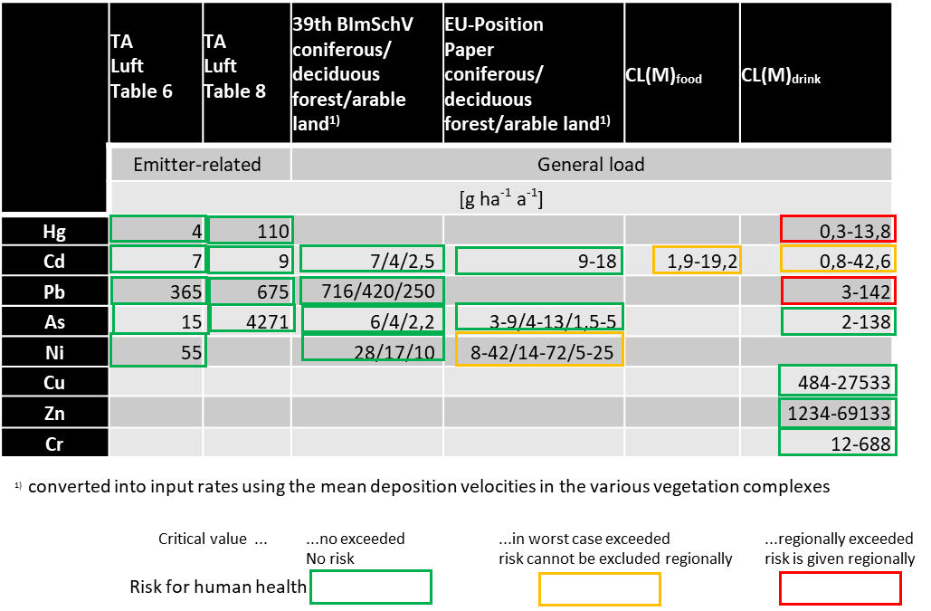

Although the immission limit values and target values of the 39th Federal Immission Control Ordinance (39th BImSchV) are in principle suitable as assessment values for endangering human health, the concentrations stated are not directly comparable with the depositions of the German data set. If the concentrations are converted into input rates using the mean deposition velocities in the various vegetation complexes, taking into account the proportions of coarse and fine fractions in the dust, different permissible input rates are obtained for coniferous and deciduous forest and for arable land.

The EU Position Paper specifies immission target values (concentrations in the particulate matter fraction PM10) for arsenic, cadmium and nickel. For cadmium, a deposition threshold derived from concentration values is also proposed. These are proposals derived from human toxicological data. These assessment values are therefore suitable for the risk assessment of total entries for human health. The assessment concentrations for arsenic and nickel were converted into allowable input rates as indicated above. For the protection of drinking water, the critical loads (CL(M)_{drink}) for the atmogenic total heavy metal inputs for the German receptor surfaces on a scale of 1:1 million were determined as assessment values for the assessment of the critical loads (CL(M)_{drink)}, in which the limit concentrations from the German Drinking Water Ordinance (BTrinkwV 2001) were included as critical threshold values. These are identical with the corresponding limit concentrations of the WHO guideline (WHO 2011). The critical loads for drinking water protection were determined taking into account the different leachate rates and vegetation types. In this respect, they show a higher degree of differentiation than the absolute assessment values of the 39th BImSchV and the TA Luft (2002). Entries at the critical load level lead to an equilibrium between total input and unpolluted output and thus guarantee the precautionary avoidance of an accumulation of heavy metals in drinking water above the limit values. Thus, the following differentiated picture emerges with regard to the risk to human health from inputs of the individual heavy metals under consideration.

Mercury

The 39th BImSchV and the EU Position Paper do not contain assessment values for mercury. Based on the EMEP deposition grid map of Germany for the year 2013, the critical loads for drinking water protection CL(Hg)_{drink were} exceeded in the German dataset 2016 with a focus on southeast Brandenburg, northeast Saxony and southwest Saxony-Anhalt. The maximum deposition exhausts the assessment value of TA Luft (2002, Tab. 6) to 22% and the assessment value of TA Luft (2002, Tab. 8) to 0.8%.

Cadmium

For the protection of plant food (wheat grain), a critical load for cadmium inputs on wheat fields (CL(Cd)_{food}) was determined as the assessment value, in which the cadmium limit concentration for wheat was included in accordance with the recommendation of the manual (CLRTAP 2004, 2017). This is half of the limit value set in the EU regulation (EC No. 1881/2006). The CL(Cd)_{food} was not exceeded in 2010 by the atmospheric Cd depositions in the receptor surfaces of the German CL data set 2016. However, it should be noted that only a fraction of the heavy metal load on agricultural soils results from the atmosphere. In particular, the comparison of cadmium inputs by fertilisation with CL(M)_{food} shows the risk of harmful accumulation in wheat fields. Since the current content of cadmium in wheat correlates with the content in soil (Knappe et al. 2008), there is currently a risk potential for human health from the consumption of wheat products of German origin. The critical loads for drinking water protection in the receptor areas of the German data set 2016 are not exceeded by the atmogenic depositions in 2010 (Table S2.1). In the German dataset 2016, it may be possible that areas where maximum deposition rates meet a very low critical load (< 2.3 g ha⁻¹ a⁻¹) (worst case) may not be mapped due to scale conditions. In these cases, the maximum atmospheric deposition in 2010 (Table S2.1) may have exceeded the critical loads for the protection of drinking water and food. This means that in the worst case, Cd may accumulate in drinking water and wheat products as long as the deposition is above the respective critical load and the critical limits are exceeded.

The CL(Cd)_{drink} and CL(Cd)_{food} are predominantly in the range of the range from the EU position paper, but also go deeper than this. The target value for the cadmium entry from the EU position paper is far below the atmospheric depositions 2010 (Schaap et al. 2018). The maximum deposition exhausts the assessment value of TA Luft (2002, Tab. 6) at 27% and the assessment value of TA Luft (2002, Tab. 8) at 21%. If the assessment value for the concentration from the 39th BImSchV were alternatively converted into a deposition, this would result in assessment values of 2.5-7 g ha⁻¹ a⁻¹, which would not be exceeded by the depositions in the German data set or in the worst case. However, this is only an auxiliary calculation for a rough comparison of the exceedance rates of CL(M)_{drink} and CL(M)_{food}.

Lead

The critical loads for the protection of drinking water will be exceeded by atmospheric lead depositions in 2010 on 2.41 % of the receptor areas in Germany, predominantly in the state of Brandenburg, in Leipzig and in the Ruhr area. This area proportion may be higher, since the German dataset 2016 may not include areas where maximum deposition rates meet a very low critical load (worst case) (Table S2.6). The maximum deposition exhausts 19% of the assessment value of the TA Luft (2002, Tab. 6) and 11% of the assessment value of the TA Luft (2002, Tab. 8). If the assessment value for the concentration from the 39th BImSchV were alternatively converted into a deposition rate, this would result in assessment values of 250 -716 g ha⁻¹ a⁻¹, which are not exceeded by the depositions of the German data set and also in the worst case.

Arsenic

The critical loads for drinking water protection are not exceeded in the receptor areas of the German data set 2016 by the atmogenic depositions in 2010. Even in the worst case (maximum deposition rates meet the lowest critical load), which does not occur in the German data set 2016 but could occur on a larger scale, exceeding the critical loads for drinking water protection is ruled out. Even if a critical load calculation for drinking water protection is carried out alternatively on the basis of the minimum threshold value (Zeddel et al. 2016), the resulting minimum critical load in the worst case would not be exceeded by the maximum deposition. The Minority threshold (Zeddel et al. 2016) corresponds to the base value.
The maximum deposition exhausts 6% of the assessment value of the TA Luft (2002, Tab. 6) and 0.02% of the assessment value of the TA Luft (2002, Tab. 8). If the assessment value for the concentration from the 39th BImSchV were alternatively converted into a deposition, this would result in assessment values of 2.5-6 g ha⁻¹ a⁻¹, which are not exceeded by the depositions of the German data set and also in the worst case.

Copper

The critical loads for drinking water protection in the receptor areas of the German data set 2016 are not exceeded by the atmogenic depositions in 2010. Even in the worst case (maximum deposition rates meet the lowest critical load), which does not occur in the German data set 2016 but could occur on a larger scale, exceeding the critical loads for drinking water protection is ruled out.

Zinc

The critical loads for drinking water protection in the receptor areas of the German data set 2016 are not exceeded by the atmogenic depositions in 2010. Even in the worst case (maximum deposition rates meet the lowest critical load), which does not occur in the German data set 2016 but could occur on a larger scale, exceeding the critical loads for drinking water protection is ruled out.

Chrome

The critical loads for drinking water protection in the receptor areas of the German data set 2016 are not exceeded by the atmogenic depositions in 2010. Even in the worst case (maximum deposition rates meet the lowest critical load), which does not occur in the German data set 2016 but could occur on a larger scale, exceeding the critical loads for drinking water protection is ruled out. However, if a critical load calculation for drinking water protection was carried out alternatively on the basis of the minimum threshold value (Zeddel et al. 2016), the resulting minimum critical load would be exceeded by the maximum deposition in the worst case.

Nickel

The BTrinkwV does not specify a limit concentration for nickel, therefore no critical load for drinking water protection is calculated in this study. If a critical load calculation for drinking water protection is carried out alternatively on the basis of the minimum threshold value (Zeddel et al. 2016), the resulting minimum critical load in the worst case would not be exceeded by the maximum deposition. The maximum deposition exhausts 12% of the TA Luft (2002, Tab. 6) assessment value.

If the assessment value for the concentration from the 39th BImSchV were alternatively converted into a deposition, this would result in assessment values of 10-28 g ha⁻¹ a⁻¹, which would not be exceeded by the depositions of the German data set and also in the worst case. If the target values of the EU position paper are converted into deposition rates (5-72 g ha⁻¹ a⁻¹), in the worst case (maximum deposition meets minimum permissible input) there is an exceedance risk on arable land and grassland.

Thallium

No limit concentration for thallium is specified in the BTrinkwV. Therefore no critical load for the drinking water protection CL(Ni)_{drink} is calculated in this study. A human toxicological minimum threshold is also not available (Zeddel et al. 2016). An exceedance of the immission values for heavy metal depositions according to TA Luft (2002, Tables 6 and 8) by the diffuse total pollution from the long-distance transport of the metal in the atmosphere cannot be determined nationwide. However, the assessment values are far above, for example, the annual average concentration measurement values 2013 of the LANUV NRW (2015) in Dortmund converted into deposition rates.

Vanadium

The BTrinkwV does not specify a limit concentration for vanadium. Therefore no critical load for the drinking water protection CL(Ni)_{drink} is calculated in this study. A risk assessment using an input/output balance based on a human toxicological minimum threshold (Zeddel et al. 2016) shows that a health risk cannot be safely excluded by the inputs in 2010.

5.5.2 Protection of terrestrial ecosystems (in particular soils) from harmful changes

If one compares the assessment values with the corresponding aerial input rates (for Hg: EMEP deposition grid data for 2013; for all other metals deposition grid data for 2010 according to Schaap et al. 2018), the following under- and overruns result (Figure S2.8). However, the assessment of risks from airborne inputs on the basis of the assessment values from the various statutory regulations and recommendations must be considered taking into account different levels of protection, protection objectives and impact thresholds. The assessment values of the TA Luft (2002), the 39th BImSchV and the EU Position Paper (2000) are based on human toxicological threshold values, but are also intended for the protection of plants and the environment in general, whereby it is assumed that the ecosystem compartments are not more sensitive than humans. After conversion of the permissible concentrations from the 39th BImSchV into permissible annual input rates, there are no exceedances in 2010 due to the atmospheric background deposition. The assessment values from the EU position paper (2000) for cadmium will not be exceeded in 2010, as will the assessment values for arsenic after conversion. The converted lowest assessment values for nickel are exceeded in the worst case on fields and grassland.

Figure S2.8. Assessment values for heavy metal fluxes to protect ecosystems and their under- or exceedance by airborne inputs (for Hg: EMEP in 2013; for all others German dataset in 2010 from Schaap et al. 2018).
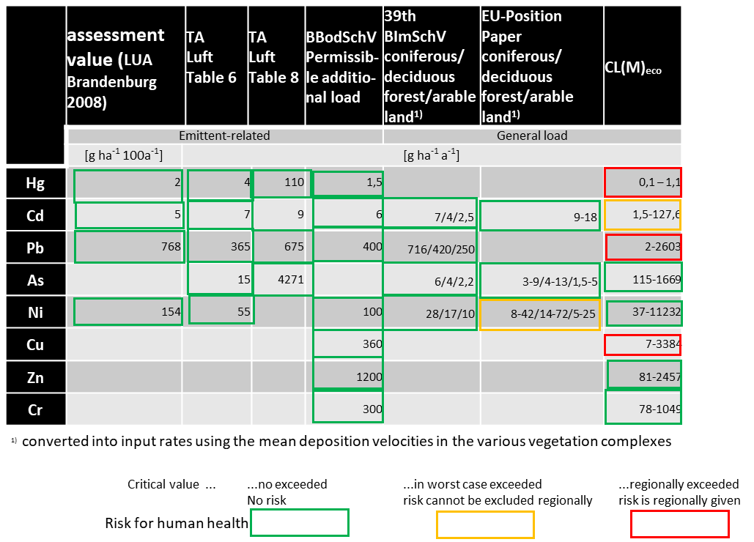

At the same time, a comparison of the plant-related assessment values for metal inputs (assessment value according to LUA Brandenburg 2008, TA Luft 2002, permissible additional load according to BBodSchV 1999/2015) with the background loads does not provide any information on the currently existing spatially widespread risks for ecosystems. The comparison can only serve to roughly estimate to what extent the permissible total load has already been exhausted by the background load. The uncertainties of the deposition mapping and its small scale do not permit concrete spatial statements for individual sites. It was therefore to be expected that the atmogenic entries for 2010 would not exceed the plant-related assessment values.

In the following, only the risks of terrestrial ecosystems, including soil, are discussed on the basis of assessment values based on ecotoxicological thresholds, i.e. from the BBodSchV 2015, the Brandenburg enforcement aid for the FFH-habitats impact assessment (LUA Bbg 2008) and the critical loads for ecosystem protection identified in this study. As the pathways of action of heavy metals to all compartments of a terrestrial ecosystem usually run across the soil, the assessment values for the protection of soil functions can at the same time be regarded as relevant assessment values for the protection of ecosystems.

The critical loads for ecosystem protection determined in this study for the heavy metal inputs of mercury, cadmium, lead, arsenic, copper, zinc, chromium and nickel (CL(M)_{eco}) are differentiated by ecosystem type. The input values are determined soil- and vegetation-specifically. The critical threshold values (critical concentration in the soil for the maintenance of microbial functions, for the protection of plants, invertebrates and soil microorganisms) are comparable with the criteria for determining the precautionary values in the Federal Soil Protection Ordinance (BBodSchV). However, the precautionary values of the BBodSchV are stated as concentrations and are therefore not directly comparable with the flow rates of the critical loads.

According to current knowledge, compliance with CL(M)_{eco} with the inclusion of all input paths permanently (for all time) excludes the possibility of risks arising, provided that the critical limits (critical concentrations in the indicators considered) have not yet been exceeded. If they have already been exceeded, compliance with the critical load leads to a long-term, gradual reduction up to the critical limits.

The assessment values of the ´Brandenburgische FFH-Vollzugshilfe´ (LUA Bbg 2008) are given as maximum permissible concentrations in the soil. In addition, plant-related irrelevance thresholds can be calculated. A comparison of the permissible enrichment rate in 100 years with background depositions therefore also does not lead to a real risk assessment. In the following, therefore, only the extent to which the total permissible positions calculated in this way are already exhausted by the entries at background level is given.

In the following, an assessment of the risk of harmful changes in terrestrial ecosystems based on the current 2010 and 2013 depositions of the heavy metals under consideration is nevertheless to be carried out, taking into account the limited comparability of the assessment values.

Mercury

On the basis of the EMEP deposition grid map of Germany for 2013, the critical loads for ecosystem protection in the German dataset 2016 are exceeded, with a focus on North Rhine-Westphalia, southeast Brandenburg, north-east Saxony and southwest Saxony-Anhalt.
In addition, further diffuse Hg entries may have to be taken into account, which aggravates the situation. However, due to the high buffering capacity of the soils for Hg, it cannot be concluded from a CL(Hg)_{eco} exceedance that there is an immediate risk.

The permissible annual additional load of Hg according to BBodSchV in the amount of 1.5 g ha⁻¹ a⁻¹, if the precautionary value of the Hg concentration in the soil according to BBodSchV has already been reached or exceeded, is far above the maximum of the EMEP deposition in 2013. 58 % of the maximum atmospheric background deposition uses this value, but the permissible additional load also applies to all other input paths in total. The irrelevant plant-related additional load extrapolated from the irrelevance threshold according to LUA Bbg (2008) using the example of a cambisol to 100 years is already 44% exhausted by the maximum atmogenic background deposition in 2013.

Cadmium

The critical loads for ecosystem protection in the receptor areas of the German data set 2016 are not exceeded by the atmogenic depositions 2010 (Schaap et al. 2018). In the German dataset 2016, it may be possible that areas where maximum deposition rates meet a very low critical load (<2.3 g ha⁻¹ a⁻¹) (worst case) may not be depicted due to scale. In these cases, the maximum atmospheric deposition in 2010 may have exceeded the critical loads for ecosystem protection. The permissible annual Cd input rate according to BBodSchV of 6 g ha⁻¹ a⁻¹), if the precautionary value (Cd concentration in soil) according to BBodSchV has already been reached or exceeded, is far above the maximum of the EMEP deposition in 2013. 39 % of the maximum atmospheric background deposition uses this value, but the permissible additional load applies to all input paths.

The irrelevant plant-related additional load extrapolated from the irrelevance threshold according to LUA Bbg (2008) using the example of a cambisol to 100 years is already 47% exhausted by the maximum atmogenic background deposition in 2010.

Lead

The critical loads for lead inputs for the protection of ecosystems are exceeded by the atmospheric depositions in 2010 on 14.11% of the receptor areas in Germany, predominantly in the Leipzig and Thuringian bight, in the Harz foreland and in the Ruhr area. This area share may be higher, since the German dataset 2016 may not include areas where maximum deposition rates meet a very low critical load (worst case). The permissible annual Pb input rate under the BBodSchV of 400 g ha⁻¹ a⁻¹, if the precautionary value has already been reached or exceeded, is well above the maximum of the 2010 deposition (Schaap et al. 2018). The maximum atmogenic background deposition exhausts 22% of this value, but the permissible additional load applies to all entry paths. The irrelevant plant-related additional load extrapolated from the irrelevance threshold according to LUA Bbg (2008) using the example of a cambisol to 100 years is used up by 11% by the maximum atmospheric background deposition in 2010.

Arsenic

The critical loads for ecosystem protection in the receptor areas of the German data set 2016 are not exceeded by the atmogenic depositions 2010 (Schaap et al. 2018). Even in the worst case (maximum deposition rates meet the lowest critical load), which does not occur in the German data set 2016 but could occur on a larger scale, exceeding the critical loads for ecosystem protection is ruled out. Even if a critical load calculation for ecosystem protection was carried out alternatively on the basis of the minimum threshold value (Zeddel et al. 2016), the resulting minimum critical load in the worst case would not be exceeded by the maximum deposition. A permissible additional annual input rate of As according to BBodSchV is not specified.

Copper

In 2010 (Schaap et al. 2018), the copper deposits exceeded the CL(Cu)_{eco} on 1.16 % of the receptor areas in Germany, predominantly in the Berlin environs and the Ruhr area. This area proportion may be higher, since the German CL dataset 2016 may not reflect areas where maximum deposition rates meet a very low critical load (worst case). The permissible annual input rate of Cu according to BBodSchV of 360 g ha⁻¹ a⁻¹, if the permissible Cu concentration in the soil according to BBodSchV has already been reached or exceeded, is far above the maximum of the deposition 2010. The maximum background deposition exhausts this value to 8 %, but the permissible additional load applies to all input paths.

Zinc

The critical loads for ecosystem protection in the receptor areas of the German data set 2016 are not exceeded by the atmogenic depositions 2010 (Schaap et al. 2018). Even in the worst case (maximum deposition rates meet the lowest critical load), which does not occur in the German data set 2016 but could occur on a larger scale, exceeding the critical loads for ecosystem protection is ruled out. The permissible annual input rate of Zn according to BBodSchV of 1200 g ha⁻¹ a⁻¹, if the permissible Zn concentration in the soil according to BBodSchV has already been reached or exceeded, is far above the maximum of the deposition in 2010. The maximum background deposition exhausts this value by 6 %, but the permissible additional load applies to all input paths.

Chrome

The critical loads for ecosystem protection in the receptor areas of the German data set 2016 are not exceeded by the atmogenic depositions 2010 (Schaap et al. 2018). Even in the worst case (maximum deposition rates meet the lowest critical load), which does not occur in the German CL dataset 2016 but could occur on a larger scale, exceeding the critical loads for ecosystem protection is ruled out. However, if a critical load calculation for ecosystem protection was carried out alternatively on the basis of the minimum threshold value (Zeddel et al. 2016), the resulting minimum critical load would be exceeded by the maximum deposition in the worst case. The permissible annual input rate of Cr according to BBodSchV of 300 g ha⁻¹ a⁻¹, if the permissible Cr concentration in the soil according to BBodSchV has already been reached or exceeded, is far above the maximum of the deposition in 2010. The maximum background deposition exhausts this value by 1.3 %, but the permissible additional load applies to all input paths.

Nickel

The critical loads for ecosystem protection in the receptor areas of the German CL dataset 2016 are not exceeded by the atmogenic depositions 2010 (Schaap et al. 2018). Even in the worst case (maximum deposition rates meet the lowest critical load), which does not occur in the German CL dataset 2016, but could occur on a larger scale, exceeding the critical loads for ecosystem protection is ruled out. even if a critical load calculation for ecosystem protection was carried out alternatively on the basis of the minimum threshold value (Zeddel et al. 2016), the resulting minimum critical load would not be exceeded by the maximum deposition in the worst case. The permissible annual Ni input rate according to BBodSchV of 100 g ha⁻¹ a⁻¹, if the permissible Ni concentration in the soil according to BBodSchV has already been reached or exceeded, is far above the maximum of the deposition in 2010. The maximum background deposition exhausts this value by 7 %, but the permissible additional load applies to all input paths.
The maximum atmogenic background deposition in 2010 exploits 4.6% of the irrelevance threshold according to LUA Bbg (2008) extrapolated from the example of a cambisol to 100 years of irrelevant plant-related additional pollution.

Thallium

Since no nationwide deposition surveys are available, no assessment of the pollution situation can be made. But a measuring station in Dortmund, for example, recorded an annual average concentration in 2013, which converted to a deposition rate of 0.15 g ha⁻¹ a⁻¹ (LANUV NRW 2015). A risk assessment by means of an input/output balance based on an ecotoxicological minimum threshold (Zeddel et al. 2016) shows that a risk cannot be safely excluded, at least in the Ruhr region. Thallium is a highly toxic element for living organisms, comparable to the effect of mercury (Madejón 2013). Tl is hardly transported in the soil and is thus strongly enriched in the rooted topsoil during prolonged immissions (Scholl and Metzger 1981). Madejón (2013) states that 80% of anthropogenic thallium is stored in humus-rich topsoil. This results in an obviously neglected need for research. The impact-based derivation of assessment values and at the same time the inventory of the current deposition in Germany are urgently required.

Vanadium

A risk assessment by means of an input/output balance based on a human toxicological minimum threshold (Zeddel et al. 2016), which is lower than the ecotoxicological threshold determined, results in a health risk from the inputs in 2010 in the worst case. For example, the maximum deposition in 2010 (Table S2.1) for forest and grassland is slightly above the minimum acceptable deposition. In the worst case (maximum deposition meets areas with minimal outcropping), a long-term risk of impairment of ecosystem functions cannot be ruled out. Assessment values for vanadium are not given in the BBodSchV.

References:
39th BImSchV (2010): Neununddreißigste Verordnung zur Durchführung des Bundes-Immissionsschutzgesetzes Verordnung über Luftqualitätsstandards und Emissionshöchstmengen [Thirty-ninth Ordinance for the Implementation of the Federal Immission Control Act Ordinance on Air Quality Standards and Emission Ceilings]. 2. August 2010. BGBl. I S. 1065.
BBodSchV (1999/2015) Bundes-Bodenschutz- und Altlastenverordnung (BBodSchV) (GBBl. I S. 1554 vom 12. Juli 1999, zuletzt geändert durch Art. 102 der Verordnung vom 31. August 2015 (GBl. I S. 1474) [Federal Soil Protection and Contaminated Sites Ordinance (BBodSchV) (GBBl. I p. 1554 of 12 July 1999, last amended by Article 102 of the Ordinance of 31 August 2015 (GBl. I p. 1474)].
BTrinkwV (2001) (Bundes-Trinkwasserverordnung): BGBl. I S. 2977: Verordnung über die Qualität von Wasser für den menschlichen Gebrauch [Regulation on the quality of water intended for human consumption], zuletzt geändert durch Artikel 4 Absatz 22 des Gesetzes vom 7. August 2013 (BGBl. I S. 3154).
CLC (2006): Karte der Bodenbedeckung [Land cover map]. CORINE Land Cover 2006 (), URL: http://sia.eionet.europa.eu/CLC2006 Assessed 28 March 2017
CLRTAP (2004): Manual on Methodologies and Criteria for Modelling and Mapping Critical Loads and Levels and Air Pollution Effects, Risks and Trends. UBA-Texte 52/2004.
CLRTAP (2014): Guidance on mapping concentrations levels and deposition levels, Manual on methodologies and criteria for modelling and mapping critical loads and levels and air pollution effects, risks and trends. UNECE Convention on Long-range Transboundary Air Pollution. Online-Version unter www.icpmapping.org. Assessed 20 July March 2015
CLRTAP (2017): Revision of guidance on mapping concentrations levels and deposition levels, Manual on methodologies and criteria for modelling and mapping critical loads and levels and air pollution effects, risks and trends. UNECE Convention on Long-range Transboundary Air Pollution. Online-Version unter www.icpmapping.org. Assessed 28 March 2017
Crommentuijn T, Polder MD, van de Plassche EJ (1997) Maximum Permissible Concentrations and Neglectible Concentrations for metals, taking Background concentrations into account. National Institut of Public Health and Environment, Bilthoven, Netherlands, J Report Nr. 601501 001.
Doyle PJ, Gutzman DW, Sheppard MI, Sheppard SC, Bird GA, Hrebenyk D (2003) An ecolocical risk assessment of air emissions of trace metals from copper and zinc production facilities. J Human and Ecological Risk Assessment 9: pp. 607-636.
EMEP (2015): EMEP Status Reports: Heavy Metals: Analysis of long-term trends, country-specific research and progress in mercury regional and global modelling (No 2/2015). Online im Internet: URL: http://www.msceast.org/index.php/reports]. Country specific information, complementary to the EMEP Status Reports: URL: http://www.msceast.org/index.php/emep-countries. Assessed 20 July 2015
EU (2000) Position Paper: AMBIENT AIR POLLUTION BY AS, CD AND NI COMPOUNDS. Working Group On Arsenic, Cadmium And Nickel Compounds. URL: http://ec.europa.eu/environment/air/pdf/pp_as_cd_ni.pdf. Assessed 28 March 2017
Ilyin I, Gusev A,Rozovskaya O, Strijkina I (2012) Transboundary Pollution of Germany by Heavy Metals and Persistent Organic Pollutants in 2010. EMEP/MSC-E J Technical Report 5/2012.
Ilyin I, Rozovskaya O, Travnikov O, Varygina M, Aas W, Uggerud HT (2011) Heavy Metals: Transboundary Pollution of the Environment. J EMEP Status Report 2/2011. Meteorological Synthesizing Centre - East, Moscow, Russian Federation. URL: http://www.msceast.org. Assessed 28 March 2017
Ilyin I, Rozovskaya O, Travnikov O, Varygina M, Aas W, Uggerud HT (2013) Heavy Metals: Transboundary Pollution of the Environment. J EMEP Status Report 2/2013. Meteorological Synthesizing Centre - East, Moscow, Russian Federation. URL: http://www.msceast.org. Assessed 28 March 2017
Knappe F, Möhler S, Ostermayer A, Lazar S, Kaufmann C (2008) Vergleichende Auswertung von Stoffeinträgen in Böden über verschiedene Eintragspfade [Comparative evaluation of substance inputs into soils via different input paths]. UBA-Texte 36/08:1-410.
LANUV NRW(Landesamt für Natur, Umwelt und Verbraucherschutz NRW) (2015): Jahreskenngrößen der LUQS-Messstetionen des LANUV NRW für die Jahre 2003-2013 [Annual characteristics of the LUQS measuring stations of LANUV NRW for the years 2003-2013]. URL: http://www.lanuv.nrw.de. Assessed 28 March 2017
LUA Bbg– Landesumweltamt Brandenburg (2008): Vollzugshilfe zur Ermittlung erheblicher und irrelevanter Stoffeinträge in Natura 2000-Gebiete [Implementation aid for the identification of significant and irrelevant substance inputs into Natura 2000 areas]. J Studien und Tagungsberichte des Landesumweltamtes, Band 58, - Stand November 2008.
Madejón P (2013) Tallium. In: Alloway B J (Ed.) (2013) Heavy Metals in Soils. Trace Metals and Metalloids in Soils and their Bioavailability. Springer Dordrecht, Heidelberg, New York, London. S. 543-547.
Markert B (1992) Multi-element analysis in plant material-analytical tools and biological questions. In: Adriano DC (Ed.) Biochemistry of trace elements. Boca Raton: Lewis publishers. pp. 401-428.
NaSE (2017): Nationale Trendtabellen für die deutsche Berichterstattung atmosphärischer Emissionen (Schwermetalle) 1990-2015 [National trend tables for German reporting of atmospheric emissions (heavy metals) 1990-2015]. Stand Januar 2017. Umweltbundesamt, Dessau Roßlau
Reinds GJ, Groenenberg JE, De Vries WD (2006) Critical Loads of Copper, Nickel, Zinc, Arsenic, Chromium and Selenium for Terrestrial Ecosystems at a European Scale. A Preliminary Assessment. J Alterra-rapport, Alterra, Wageningen, 46 pp.
Schaap M, Hendriks C, Jonkers S, Builtjes P (2018) Assessment of the atmospheric heavy metal deposition to terrestrial ecosystems in Germany. Part 1 of: Schröder W, Nickel S, Schlutow A, Nagel H-D, Scheuschner T (2018) Auswirkungen der Schwermetall - Emissionen auf Luftqualität und Ökosysteme in Deutschland - Quellen, Transport, Eintrag, Gefährdungspotenzial [Impacts of heavy metal emission on air quality and ecosystems across Germany - Sources, transport, deposition and potential hazards]. UBA-TEXTE 107/2018:1-81.
Schaap M, Roemer M, Sauter F, Boersen G, Timmermans R, Builjes PJH, Vermeulen AT (2005) LOTOS-EUROS: Documentation, J TNO report B&O-A R 2005/297.
Schaap M, Timmermans RMA, Roemer M, Boersen GAC, Builtjes PJH, Sauter FJ, Velders GJM, Beck JP (2008) The LOTOS–EUROS model: description, validation and latest developments, J International Journal of Environment and Pollution 32(2), pp.270–290.
Scholl G, Metzger F (1981) Erhebungen über die Ti-Belastung von Nutzpflanzen auf kontaminierten Böden im Raum Lengerich [Surveys on the Ti contamination of crops on contaminated soil in the Lengerich area]. J Landwirtschaftliche Forschung, Sonderheft 38, Kongreßband, Trier:216-223.
Schröder W, Nickel S, Völksen B, Dreyer A, Wosniok W (2019b) Nutzung von Bioindikationsmethoden zur Bestimmung und Regionalisierung von Schadstoffeinträgen für eine Abschätzung des atmosphärischen Beitrags zu aktuellen Belastungen von Ökosystemen [Use of bioindication methods for the determination and regionalisation of pollutant inputs to estimate the atmospheric contribution to current ecosystem pressures]. Bd. 1 pp. 1-189, Bd. 2 pp. 1-296, UBA-Texte 91/2019.
Schroeder HA, Balassa JJ, Tipton HJ (1963) Vanadium in plants. J Journal of Chronic Diseases 16, pp. 1047-1071.
TA Luft (Bundesministerium für Umwelt, Naturschutz und Reaktorsicherheit) (2002): Erste Allgemeine Verwaltungsvorschrift zum Bundes–Immissionsschutzgesetz (Technische Anleitung zur Reinhaltung der Luft – TA Luft) vom 24. Juli 2002 [First General Administrative Regulation on the Federal Immission Control Act (Technical Instructions on Air Quality Control - TA Luft) of 24 July 2002].
Tipping E (2014) Ergebnisse der mit dem WHAM-Modell berechneten Critical Limits für die in Deutschland vorkommenden Rezeptortypen [Results of the critical limits calculated with the WHAM model for the receptor types occurring in Germany]. Excel-Table per Email.
Visschedijk AHJ, Denier van der Gon HAC, Hulskotte JHJ, Quass U (2013) Anthropogenic Vanadium emissions to air and ambient air concentrations in North-West Europe. E3S Web of Conferences, Proceedings of the 16th International Conference on Heavy Metals in the Environment, Vol 1. URL: http://dx.doi.org/10.1051/e3sconf/20130103004. Assessed 28 March 2017
WHO (2011) Guidelines for drinking-water quality. 4th edn. World Health Organization, Geneva 632 pp.
Zeddel A, Quadflieg A, Utermann J (2016): Grundsätze für die Anwendung der Geringfügigkeitsschwellen an der Schnittstelle Wasserrecht – Abfallrecht – Bodenschutzrecht [Principles for the application of minimum thresholds at the interface of water law - waste law - soil protection law]. Recht/Strategie/Wirtschaft . URL: http://vivis.de/phocadownload/2016_mna/2016_MNA_051-64_Zeddel.pdf. Assessed 28 March 2017

