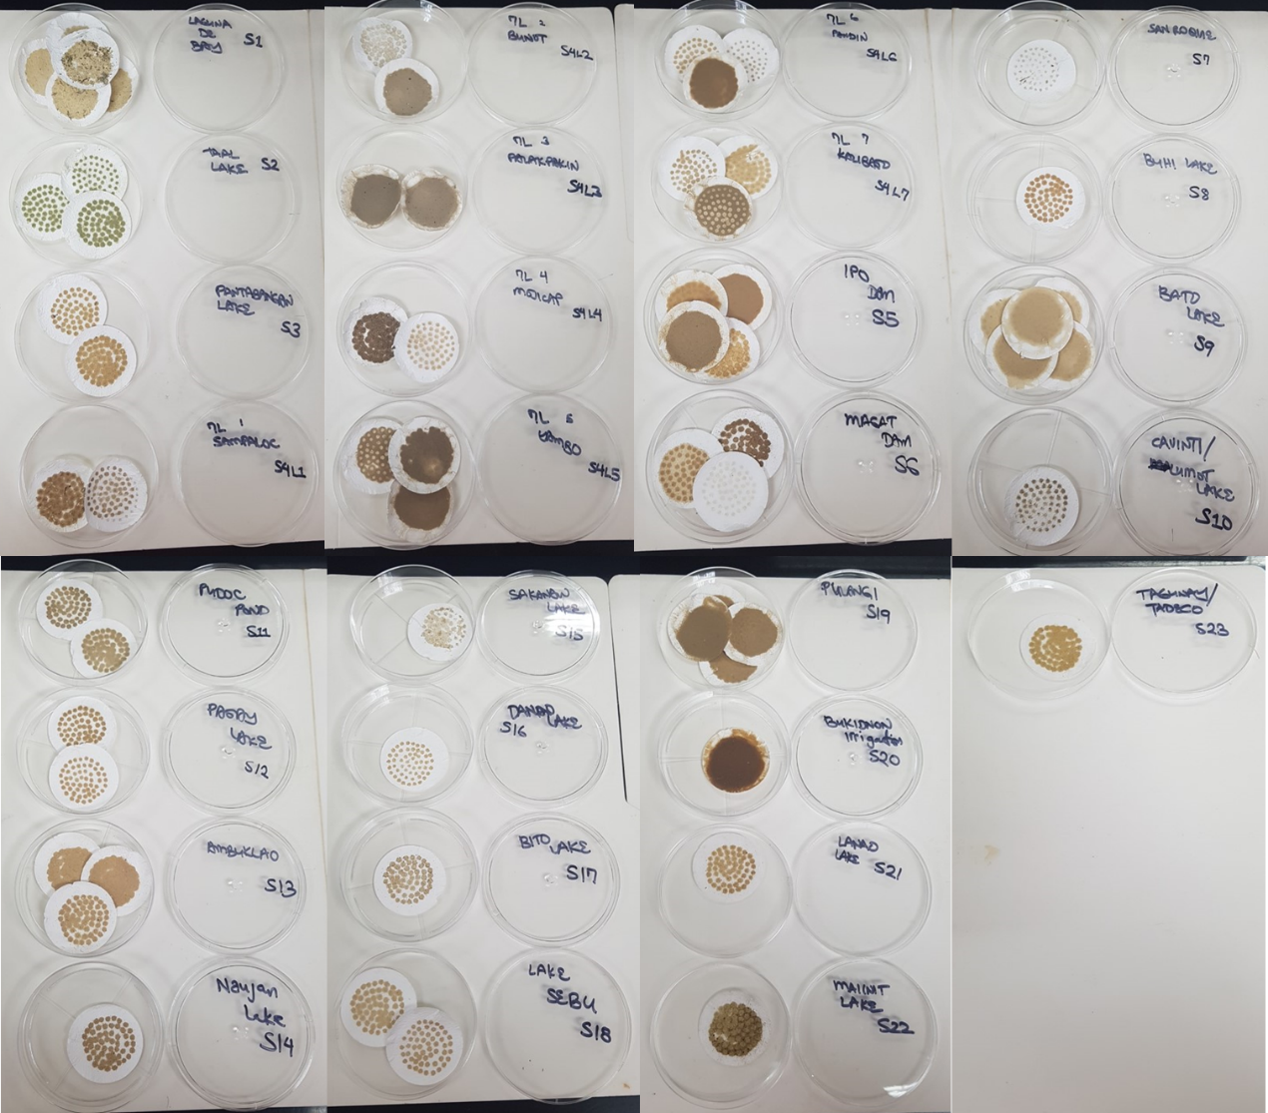
Additional file 4 Filtered sediments of 1 L bulk water samples from sampling sites. Filtration of low-volume (1 L) bulk water with 1.2 µm pore size glass microfiber filter is efficient in recovering dispersed sediments from surface water samples and can be used for high turbidity aquatic matrices by simply changing the filter once full. Different sampling sites show different density and physical characteristics of suspended solids.

