Additional file
Seasonal variability in metal and metalloid burdens of mussels: using data from the German Environmental Specimen Bank to evaluate implications for long-term mussel monitoring programs
Burkhard Knopf^{1*}, Annette Fliedner¹, Georg Radermacher¹, Heinz Rüdel¹, Martin Paulus², Ulrike Pirntke³, Jan Koschorreck³
¹ Fraunhofer Institute for Molecular Biology and Applied Ecology (Fraunhofer IME), Department Environmental Specimen Bank and Elemental Analysis, 57392 Schmallenberg, Germany.
² Biogeography, University of Trier; 54286 Trier, Germany.
³ German Environment Agency (Umweltbundesamt), 06813 Dessau-Rosslau, Germany
*: Corresponding author. Tel: +49-2972-302-208, E-mail: Burkhard.knopf@ime.fraunhofer.de

Captions:
Table S1: ICP-MS parameters for metal and metalloid measurements.
Table S2: GC parameters, GC temperature program and ICP-MS parameters for organotin measurements.
Table S3: Correlation (p ≤ 0.05, non-directional) between the shell length of mussels and concentrations of analyses elements/compounds.
Table S4: Correlation (p ≤ 0.05, non-directional) between the condition index of mussels and concentrations of elements/compounds. NS: North Sea, BS: Baltic Sea.
Table S5: Correlation (p ≤ 0.05, non-directional) between the condition index of mussels and wet weight-based concentrations of elements/compounds - comparison between annual and monthly samples. NS: North Sea, BS: Baltic Sea.
Table S6: Cd-concentrations (ng g⁻¹ dry weight dw and wet weight ww) of monthly samples and annual composite samples of blue mussels (Mytilus edulis Complex) from North Sea and Baltic Sea sites.
For comparison: BAC and EC maximum food level used by HELCOM and OSPAR (wet weight based data without respiratory water).
Table S7: Pb-concentrations (ng g⁻¹ dry weight dw and wet weight ww) of monthly samples and annual composite samples of blue mussels (Mytilus edulis Complex) from North Sea and Baltic Sea sites. For comparison: BAC and EC maximum food level used by HELCOM and OSPAR (wet weight based data without respiratory water).
Table S8: Hg concentrations (ng g⁻¹ wet weight) of monthly samples and annual composite samples of blue mussels (Mytilus edulis Complex) from North Sea and Baltic Sea site.
For comparison: BAC and EC maximum food level used by HELCOM and OSPAR and the Water Framework Directive (Directive 2013/39/EU) (wet weight based data without respiratory water).
Table S9: Comparison of Cd-thresholds used by HELCOM and OSPAR with Cd-concentrations in seasonal and annual composite samples of blue mussels (Mytilus edulis Complex) from North Sea and Baltic Sea sites (wet weight based data without respiratory water).
Table S10: Comparison of Pb-threshold values used by HELCOM and OSPAR with Pb-concentrations in monthly samples and annual composite samples of blue mussels (Mytilus edulis Complex) from sampling sites North Sea and Baltic Sea sites (wet weight based data without respiratory water).
Table S11: Comparison of Hg-thresholds used by HELCOM, OSPAR and the WFD with THg-concentrations in monthly and annual composite samples of blue mussels (Mytilus edulis Complex) from North Sea and Baltic Sea sites (wet weight based data without respiratory water).

Figure S1: Biometrical parameters of blue mussels (Mytilus edulis Complex) from the sampling sites of the German environmental specimen bank in the North Sea (Eckwarderhoerne, Koenigshafen) and the Baltic Sea (Darsser Ort). Shown are data of monthly samples and of annual composite samples of the respective year (dark columns).
Figure S2: Long-term trends and seasonal variations in concentrations of metals in blue mussel (Mytilus edulis Complex) sampled at the North Sea site Eckwarderhoerne. Upper row: long-term trends based on annual composite samples (continuous line = significant linear or non-linear trend; dashed line = trend not significant; p = 0.05); lower row: seasonal variation based on bi-monthly samples from 2013, 2015, and 2017.
Figure S3: Long-term trends and seasonal variations in concentrations of metals in blue mussel (Mytilus edulis Complex) sampled at the North Sea site Koenigshafen. Upper row: long-term trends based on annual composite samples (continuous line = significant linear or non-linear trend; dashed line = trend not significant; p = 0.05); lower row: seasonal variation based on bi-monthly samples from 2013, 2015, and 2017.
Figure S4: Long-term trends and seasonal variations in concentrations of metals in blue mussel (Mytilus edulis Complex) sampled at the Baltic Sea site Darsser Ort. Upper row: long-term trends based on annual composite samples (continuous line = significant linear or non-linear trend; dashed line = trend not significant; p = 0.05); lower row: seasonal variation based on six-month samples from 2013, 2015, and 2017.

Table S1: ICP-MS parameters for metal and metalloid measurements.
Rf power | 1450
Carrier gas flow rate | 0.85 L/min
Makeup gas flow rate | 0.25 L/min
Nebulizer | Micro Mist
Spray chamber | Double pass quartz Scott type
Monitoring mass | ⁵⁹Co, ⁶⁰Ni, ⁶¹Ni, ⁶³Cu, ⁶⁵Cu, ⁷⁵As, ⁷⁸Se, ⁸²Se, ¹¹¹Cd, ¹¹⁴Cd,²⁰⁶Pb, ²⁰⁷Pb and ²⁰⁸Pb
Integration time | Depending on element and gas mode used
Collision/Reaction gas mode | noGas, Helium and Hydrogen mode (Hydrogen only for Se)

Table S2: GC parameters, GC temperature program and ICP-MS parameters for organotin measurements.
GC-parameters
Injector |  | Splitless
Injector temperature |  | 200 °C
Injection volume |  | 2 µL
Carrier flow |  | He 2.00 mL/min
Additional flow |  | Ar 70.01%
Column |  | RTX-5 (fused silica), 5% polydiphenyl-/95% polydimethylsiloxane, length 30 m,  ID 0.32 mm, d_{f} 0.25 µm
Transfer line |  | Silcosteel, Temperature 300 °C
GC temperature program
Rate [°C/min] |  | End temperature [°C] | Dwell time [min]
0.0 |  | 60.0 | 1.20
80.0 |  | 100.0 | 0.00
20.0 |  | 160.0 | 0.00
80.0 |  | 300.0 | 0.00
90.0 |  | 310.0 | 1.00
ICP-MS parameters
Dwell time |  | 70 ms
Plasma power |  | 1550 W
Additional gas flow |  | 0.8 L/min
Measured Isotopes |  | ¹¹⁸Sn, ¹¹⁹Sn, ¹²⁰Sn

Table S3: Correlation (p ≤ 0.05, non-directional) between the shell length of mussels and concentrations of analyses elements/compounds.
 | NS - Eckwarderhoerne |  | NS - Koenigshafen |  | BS – Darsser Ort
 | wet weight | dry weight | wet weight | dry weight | wet weight | dry weight
Cobalt | - | - | +* | - | +* | +*
Nickel | - | - | - | + | +* | +*
Copper | - | - | +* | - | - | +*
Cadmium | + | - | +* | - | - | -
Mercury | - | - | - | + | +* | +*
Lead | - | - | - | - | +* | +*
Arsenic | - | - | +* | - | - | +
Selenium | - | - | +* | - | - | +*
MeHg | - | - | +* | - | + | -
Tributyl tin | - |  | +* |  | -
*negative correlation

Table S4: Correlation (p ≤ 0.05, non-directional) between the condition index of mussels and concentrations of elements/compounds. NS: North Sea, BS: Baltic Sea.
 | NS - Eckwarderhoerne |  | NS - Koenigshafen |  | BS – Darsser Ort
 | wet weight | dry weight | wet weight | dry weight | wet weight | dry weight
Cobalt | - | - | - | +* | + | -
Nickel | - | - | - | +* | - | +*
Copper | - | - | + | - | + | +*
Cadmium | + | - | - | +* | - | -
Mercury | - | - | - | - | - | -
Lead | - | - | - | +* | - | -
Arsenic | - | - | - | - | - | -
Selenium | - | +* | - | - | + | -
MeHg | - | - | + | - | - | -
Tributyl tin | - |  | - |  | +*
*negative correlation

Table S5: Correlation (p ≤ 0.05, non-directional) between the condition index of mussels and wet weight-based concentrations of elements/compounds - comparison between annual and monthly samples. NS: North Sea, BS: Baltic Sea.
 | NS - Eckwarderhoerne |  | NS - Koenigshafen |  | BS – Darsser Ort
 | annual pool sample | monthly sample | annual pool sample | monthly sample | annual pool sample | monthly sample
Cobalt | - | - | - | - | + | -
Nickel | - | - | - | - | - | -
Copper | - | + | + | + | + | -
Cadmium | + | - | - | - | - | -
Mercury | - | - | - | + | - | -
Lead | - | - | - | - | - | -
Arsenic | - | - | - | + | - | -
Selenium | - | - | - | + | + | +
Methyl-Hg | - | - | + | + | - | -
Tributyl tin | - | - | - | + | +* | +
*negative correlation

Table S6: Cd-concentrations (ng g⁻¹ dry weight and wet weight ww) of monthly samples and annual composite samples of blue mussels (Mytilus edulis Complex) from North Sea and Baltic Sea sites.
For comparison: BAC and EC maximum food level used by HELCOM and OSPAR (wet weight based data without respiratory water).
sampling site | Monthly sample or annual pool sample | Cd - HELCOM: 960 ng g-1 dry weight; BAC based |  |  | Cd - OSPAR: 1000 ng g-1 wet weight; EC maximum food level based
sampling site | Monthly sample or annual pool sample | Year 2013 | Year 2015 | Year 2017 | Year 2013 | Year 2015 | Year 2017
North Sea Koenigshafen | February | 1235 | 1049 | 1137 | 90.6 | 68.4 | 67.4
North Sea Koenigshafen | April | 1169 | 1112 | 1231 | 101 | 77.4 | 75.4
North Sea Koenigshafen | June | 1291 | 1021 | 1336 | 101 | 50.5 | 63.0
North Sea Koenigshafen | August | 1094 | 1052 | 1480 | 68.6 | 61.9 | 57.9
North Sea Koenigshafen | October | 872 | 1311 | 1479 | 68.0 | 56.8 | 61.2
North Sea Koenigshafen | December | 993 | 1320 | 1483 | 70.8 | 62.3 | 68.1
North Sea Koenigshafen | annual composite sample | 1099 | 1192 | 1406 | 73.7 | 63.7 | 66.7
North Sea Eckwarderhoerne | February | 1762 | 1946 | 1824 | 118 | 70.9 | 71.7
North Sea Eckwarderhoerne | April | 1574 | 2056 | 2026 | 119 | 76.6 | 81.3
North Sea Eckwarderhoerne | June | 1562 | 1769 | 1834 | 126 | 79.8 | 92.8
North Sea Eckwarderhoerne | August | 1223 | 1346 | 1500 | 121 | 82.9 | 90.8
North Sea Eckwarderhoerne | October | 1487 | 1688 | 1706 | 95.4 | 80.3 | 77.9
North Sea Eckwarderhoerne | December | 1569 | 1636 | 1626 | 85.6 | 74.8 | 73.9
North Sea Eckwarderhoerne | annual composite sample | 1541 | 1620 | 1688 | 96.5 | 82.3 | 80.3
Baltic Sea  Darsser Ort | June | 1326 | 1004 | 2230 | 81.3 | 42.3 | 33.7
Baltic Sea  Darsser Ort | November/December | 1572 | 1061 | 1201 | 42.9 | 68.5 | 56.0
Baltic Sea  Darsser Ort | annual composite sample | 1432 | 1014 | 1515 | 64.2 | 53.4 | 42.3

Table S7: Pb-concentrations (ng g⁻¹ dry weight dw and wet weight ww) of monthly samples and annual composite samples of blue mussels (Mytilus edulis Complex) from North Sea and Baltic Sea sites. For comparison: BAC and EC maximum food level used by HELCOM and OSPAR (wet weight based data without respiratory water).
sampling site | Monthly sample or annual pool sample | Pb - HELCOM: 1300 ng g-1 dry weight; BAC based |  |  | Pb - OSPAR: 1500 ng g-1 wet weight; EC maximum food level based
sampling site | Monthly sample or annual pool sample | Year 2013 | Year 2015 | Year 2017 | Year 2013 | Year 2015 | Year 2017
North Sea Koenigshafen | February | 1115 | 1230 | 1359 | 81.8 | 80.3 | 80.5
North Sea Koenigshafen | April | 1074 | 1298 | 1313 | 92.7 | 90.4 | 80.4
North Sea Koenigshafen | June | 905 | 1334 | 1443 | 70.6 | 66.0 | 68.0
North Sea Koenigshafen | August | 818 | 1348 | 1683 | 51.3 | 79.3 | 65.9
North Sea Koenigshafen | October | 687 | 1195 | 1498 | 53.5 | 51.8 | 62.0
North Sea Koenigshafen | December | 869 | 1373 | 1645 | 61.9 | 64.8 | 75.5
North Sea Koenigshafen | annual composite sample | 851 | 1291 | 1501 | 57.1 | 69.0 | 71.2
North Sea Eckwarderhoerne | February | 2264 | 3137 | 1978 | 152 | 114 | 77.8
North Sea Eckwarderhoerne | April | 2831 | 3564 | 2997 | 213 | 133 | 120
North Sea Eckwarderhoerne | June | 2140 | 3354 | 2300 | 172 | 151 | 116
North Sea Eckwarderhoerne | August | 1263 | 2507 | 1750 | 125 | 154 | 106
North Sea Eckwarderhoerne | October | 2187 | 2323 | 2119 | 140 | 111 | 96.8
North Sea Eckwarderhoerne | December | 1965 | 2705 | 2855 | 107 | 124 | 130
North Sea Eckwarderhoerne | annual composite sample | 1919 | 2412 | 2305 | 120 | 123 | 110
Baltic Sea  Darsser Ort | June | 1005 | 753 | 1695 | 61.6 | 31.7 | 25.6
Baltic Sea  Darsser Ort | November/December | 1103 | 631 | 1334 | 30.1 | 40.7 | 62.2
Baltic Sea  Darsser Ort | annual composite sample | 875 | 655 | 1424 | 39.2 | 34.5 | 39.8

Table S8: Hg concentrations (ng g⁻¹ wet weight) of monthly samples and annual composite samples of blue mussels (Mytilus edulis Complex) from North Sea and Baltic Sea site.
For comparison: BAC and EC maximum food level used by HELCOM and OSPAR and the Water Framework Directive (Directive 2013/39/EU) (wet weight based data without respiratory water).
sampling site | Monthly sample or annual pool sample | Hg - HELCOM: 20 ng g-1 wet weight; EQS based (WFD); Hg - OSPAR: 20 ng g-1 wet weight; EQS based (WFD) and 500 ng g-1 wet weight EC maximum food level based
sampling site | Monthly sample or annual pool sample | Year 2013 | Year 2015 | Year 2017
North Sea Koenigshafen | February | 18.9 | 13.5 | 14.3
North Sea Koenigshafen | April | 19.7 | 15.4 | 15.8
North Sea Koenigshafen | June | 17.8 | 10.8 | 11.3
North Sea Koenigshafen | August | 13.3 | 8.90 | 10.9
North Sea Koenigshafen | October | 13.3 | 7.68 | 9.60
North Sea Koenigshafen | December | 15.6 | 9.08 | 10.3
North Sea Koenigshafen | annual composite sample | 15.5 | 10.7 | 11.0
North Sea Eckwarderhoerne | February | 17.3 | 10.9 | 11.5
North Sea Eckwarderhoerne | April | 20.1 | 11.6 | 13.0
North Sea Eckwarderhoerne | June | 16.3 | 12.1 | 15.3
North Sea Eckwarderhoerne | August | 14.7 | 12.3 | 14.3
North Sea Eckwarderhoerne | October | 14.0 | 9.79 | 11.6
North Sea Eckwarderhoerne | December | 11.9 | 10.4 | 12.1
North Sea Eckwarderhoerne | annual composite sample | 14.9 | 11.6 | 12.3
Baltic Sea  Darsser Ort | June | 3.17 | 1.62 | 1.06
Baltic Sea  Darsser Ort | November/December | 1.18 | 1.55 | 1.87
Baltic Sea  Darsser Ort | annual composite sample | 2.23 | 1.89 | 1.39

Table S9: Comparison of Cd-thresholds used by HELCOM and OSPAR with Cd-concentrations in seasonal and annual composite samples of blue mussels (Mytilus edulis Complex) from North Sea and Baltic Sea sites (wet weight based data without respiratory water).
sampling site | seasonal or annual composite samples | Comparison with | Year 2013 | Year 2015 | Year 2017
North Sea Koenigshafen | seasonal samples | Cd - HELCOM: 960 ng g-1 dry weight; BAC based | all > BAC (except Oct.) | all > BAC | all > BAC
North Sea Koenigshafen | annual composite sample | Cd - HELCOM: 960 ng g-1 dry weight; BAC based | > BAC | > BAC | > BAC
North Sea Eckwarderhoerne | seasonal samples | Cd - HELCOM: 960 ng g-1 dry weight; BAC based | all > BAC | all > BAC | all > BAC
North Sea Eckwarderhoerne | annual composite sample | Cd - HELCOM: 960 ng g-1 dry weight; BAC based | > BAC | > BAC | > BAC
Baltic Sea Darsser Ort | seasonal samples | Cd - HELCOM: 960 ng g-1 dry weight; BAC based | all > BAC | all > BAC | all > BAC
Baltic Sea Darsser Ort | annual composite sample | Cd - HELCOM: 960 ng g-1 dry weight; BAC based | > BAC | > BAC | > BAC
North Sea Koenigshafen | seasonal samples | Cd - OSPAR: 1000 ng g-1 wet weight; EC maximum food level based | all < EC | all < EC | all < EC
North Sea Koenigshafen | annual composite sample |  | < EC | < EC | < EC
North Sea Eckwarderhoerne | seasonal samples |  | all < EC | all < EC | all < EC
North Sea Eckwarderhoerne | annual composite sample |  | < EC | < EC | < EC
Baltic Sea Darsser Ort | seasonal samples |  | all < EC | all < EC | all < EC
Baltic Sea Darsser Ort | annual composite sample |  | < EC | < EC | < EC

Table S10: Comparison of Pb-threshold values used by HELCOM and OSPAR with Pb-concentrations in monthly samples and annual composite samples of blue mussels (Mytilus edulis Complex) from sampling sites North Sea and Baltic Sea sites (wet weight based data without respiratory water).
sampling site | seasonal or annual composite samples | Comparison with | Year 2013 | Year 2015 | Year 2017
North Sea Koenigshafen | seasonal samples | Pb - HELCOM: 1300 ng g-1 dry weight; BAC based | all < BAC | Feb., April and Oct. <BAC; June, Aug. and Dec. > BAC | all > BAC
North Sea Koenigshafen | annual composite sample | Pb - HELCOM: 1300 ng g-1 dry weight; BAC based | < BAC | < BAC | > BAC
North Sea Eckwarderhoerne | seasonal samples | Pb - HELCOM: 1300 ng g-1 dry weight; BAC based | all > BAC | all > BAC | all > BAC
North Sea Eckwarderhoerne | annual composite sample | Pb - HELCOM: 1300 ng g-1 dry weight; BAC based | > BAC | > BAC | > BAC
Baltic Sea Darsser Ort | seasonal samples | Pb - HELCOM: 1300 ng g-1 dry weight; BAC based | all < BAC | all < BAC | all > BAC
Baltic Sea Darsser Ort | annual composite sample | Pb - HELCOM: 1300 ng g-1 dry weight; BAC based | < BAC | < BAC | > BAC
North Sea Koenigshafen | seasonal samples | Pb - OSPAR: 1500 ng g-1 wet weight; EC maximum food level based | all < EC | all < EC | all < EC
North Sea Koenigshafen | annual composite sample |  | < EC | < EC | < EC
North Sea Eckwarderhoerne | seasonal samples |  | all < EC | all < EC | all < EC
North Sea Eckwarderhoerne | annual composite sample |  | < EC | < EC | < EC
Baltic Sea Darsser Ort | seasonal samples |  | all < EC | all < EC | all < EC
Baltic Sea Darsser Ort | annual composite sample |  | < EC | < EC | < EC

Table S11: Comparison of Hg-thresholds used by HELCOM, OSPAR and the WFD with THg-concentrations in monthly and annual composite samples of blue mussels (Mytilus edulis Complex) from North Sea and Baltic Sea sites (wet weight based data without respiratory water).
sampling site | seasonal or annual composite samples | Comparison with | Year 2013 | Year 2015 | Year 2017
North Sea Koenigshafen | seasonal samples | Hg - HELCOM: 20 ng g-1 wet weight; EQS based (WFD) | all < EQS (except April) | all < EQS | all < EQS
North Sea Koenigshafen | annual composite sample | Hg - HELCOM: 20 ng g-1 wet weight; EQS based (WFD) | < EQS | < EQS | < EQS
North Sea Eckwarderhoerne | seasonal samples | Hg - HELCOM: 20 ng g-1 wet weight; EQS based (WFD) | all < EQS | all < EQS | all < EQS
North Sea Eckwarderhoerne | annual composite sample | Hg - HELCOM: 20 ng g-1 wet weight; EQS based (WFD) | < EQS | < EQS | < EQS
Baltic Sea Darsser Ort | seasonal samples | Hg - HELCOM: 20 ng g-1 wet weight; EQS based (WFD) | all < EQS | all < EQS | all < EQS
Baltic Sea Darsser Ort | annual composite sample | Hg - HELCOM: 20 ng g-1 wet weight; EQS based (WFD) | < EQS | < EQS | < EQS
North Sea Koenigshafen | seasonal samples | Hg - OSPAR: 20 ng g-1 wet weight; EQS based (WFD) and 500 ng g-1 wet weight EC maximum food level based | all < EC and EQS (except April) | all < EC and EQS | all < EC and EQS
North Sea Koenigshafen | annual composite sample |  | < EC and EQS | < EC and EQS | < EC and EQS
North Sea Eckwarderhoerne | seasonal samples |  | all < EC and EQS | all < EC and EQS | all < EC and EQS
North Sea Eckwarderhoerne | annual composite sample |  | < EC and EQS | < EC and EQS | < EC and EQS
Baltic Sea Darsser Ort | seasonal samples |  | all < EC and EQS | all < EC and EQS | all < EC and EQS
Baltic Sea Darsser Ort | annual composite sample |  | < EC and EQS | < EC and EQS | < EC and EQS

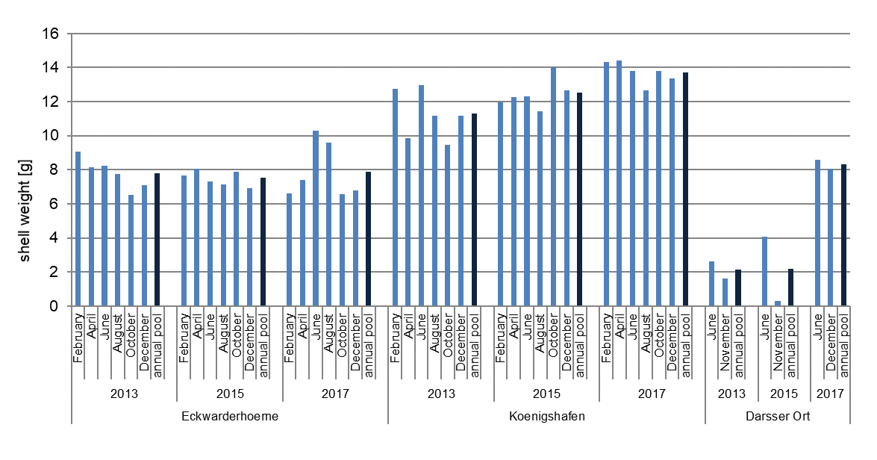 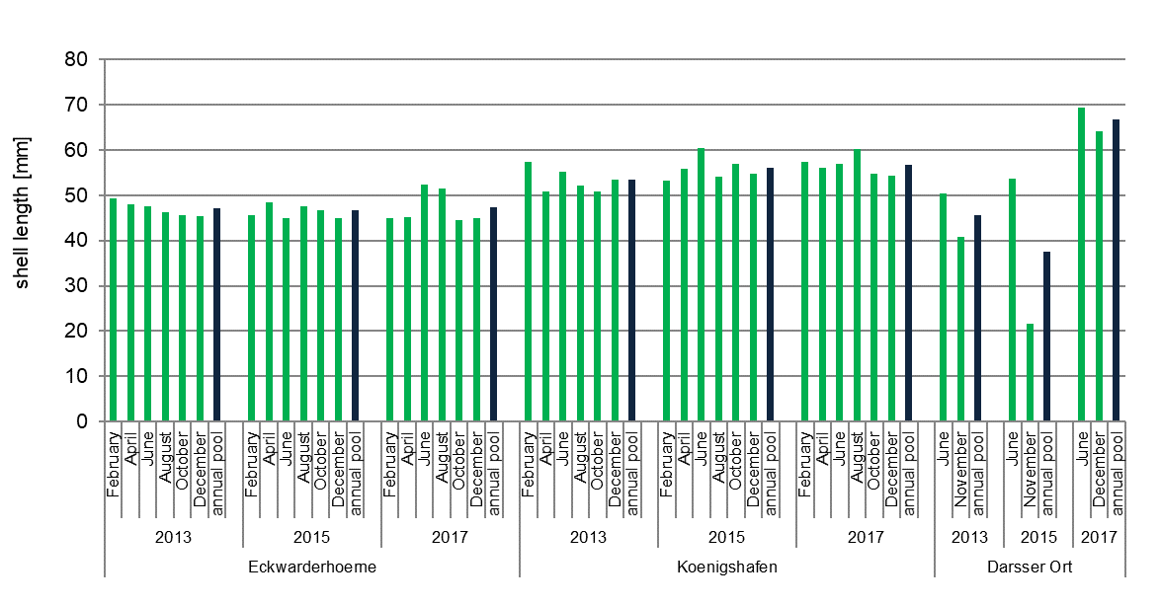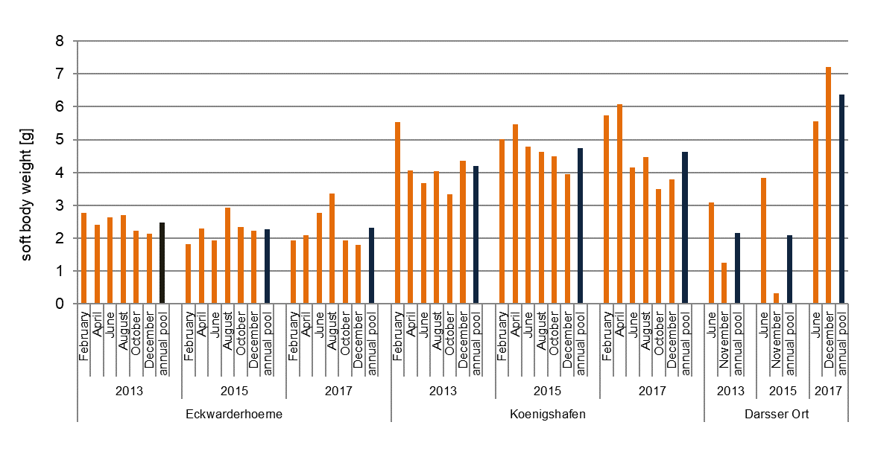
Figure S1: Biometrical parameters of blue mussels (Mytilus edulis Complex) from the sampling sites of the German environmental specimen bank in the North Sea (Eckwarderhoerne, Koenigshafen) and the Baltic Sea (Darsser Ort). Shown are data of monthly samples and of annual composite samples of the respective year (dark columns).

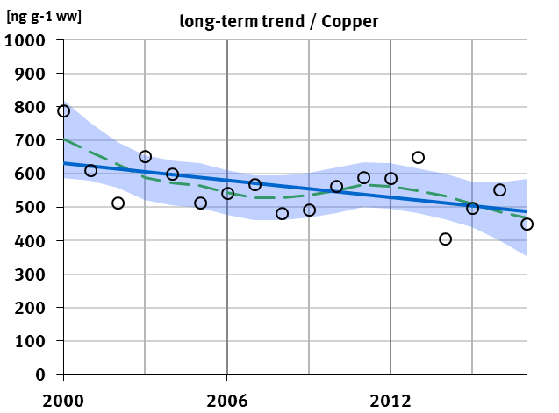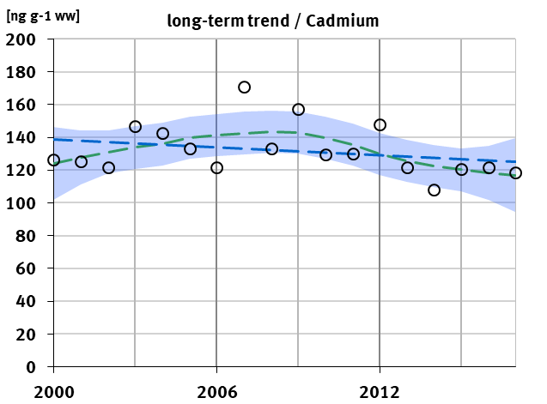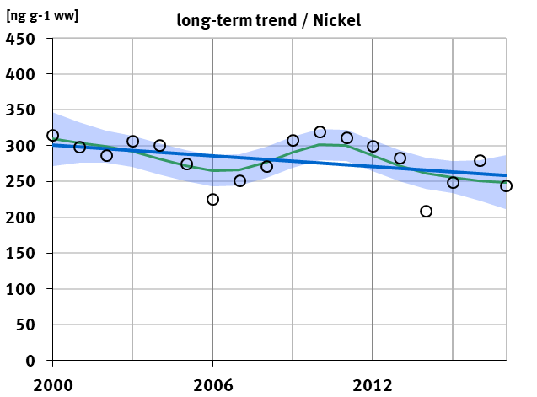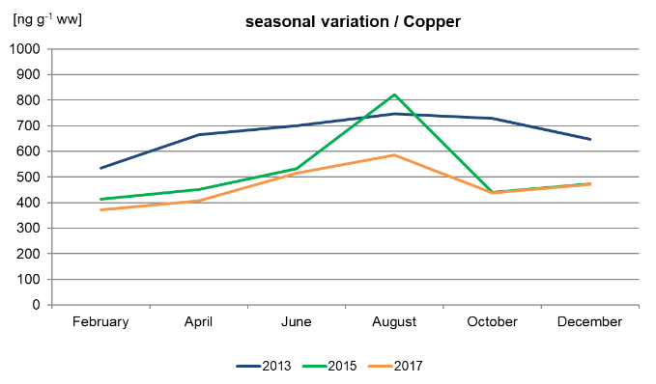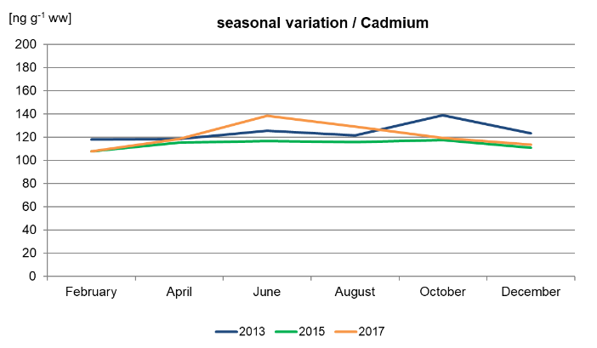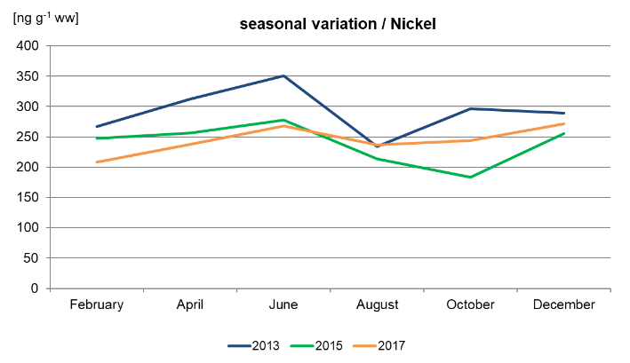
Figure S2: Long-term trends and seasonal variations in concentrations of metals in blue mussel (Mytilus edulis Complex) sampled at the North Sea site Eckwarderhoerne. Upper row: long-term trends based on annual pool samples (continuous line = significant linear or non-linear trend; dashed line = trend not significant; p = 0.05); lower row: seasonal variation based on bi-monthly samples from 2013, 2015, and 2017.
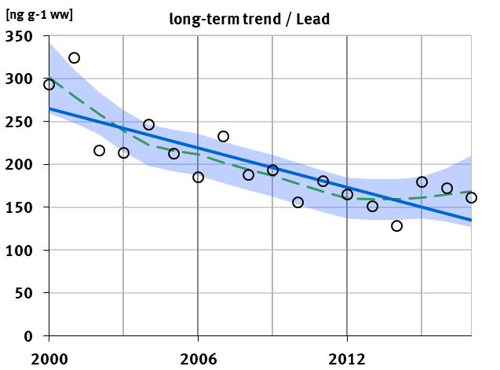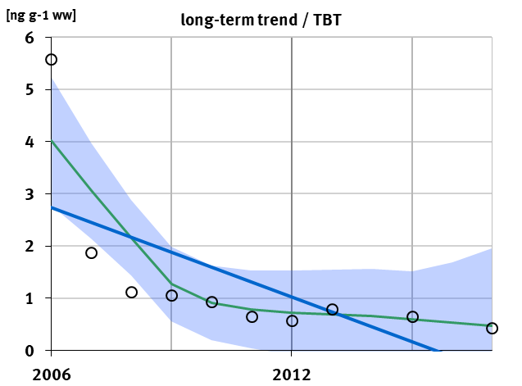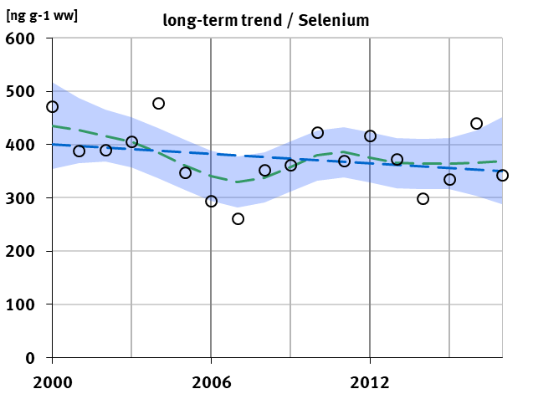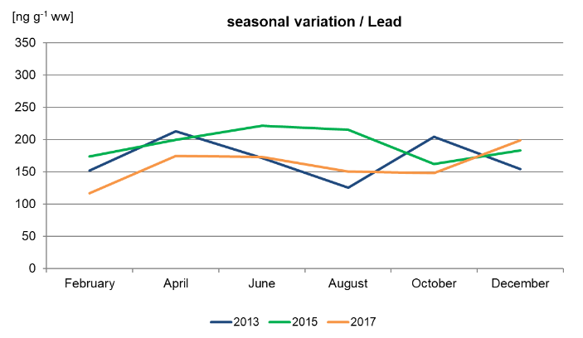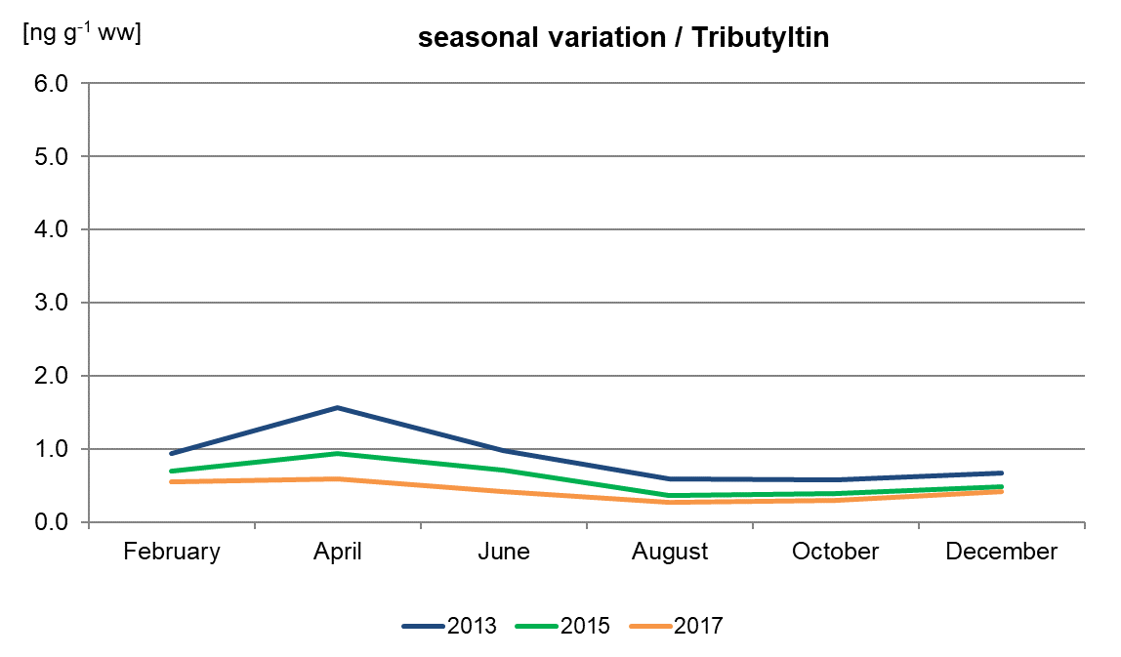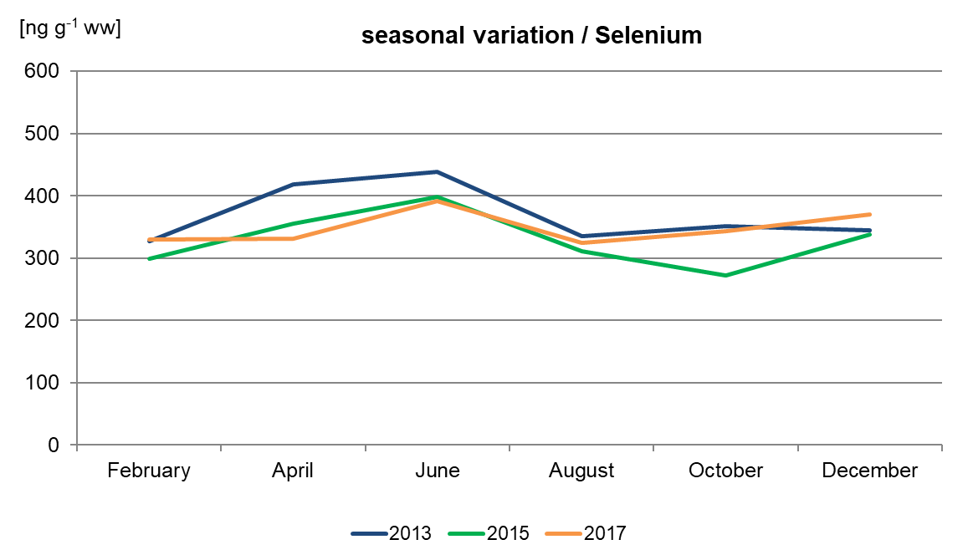
Figure S2 (cont.): Long-term trends and seasonal variations in concentrations of metals, metalloids, and TBT in blue mussel (Mytilus edulis Complex) sampled at the North Sea site Eckwarderhoerne. Upper row: long-term trends based on annual pool samples (continuous line = significant linear or non-linear trend; dashed line = trend not significant; p = 0.05); lower row: seasonal variation based on bi-monthly samples from 2013, 2015, and 2017.

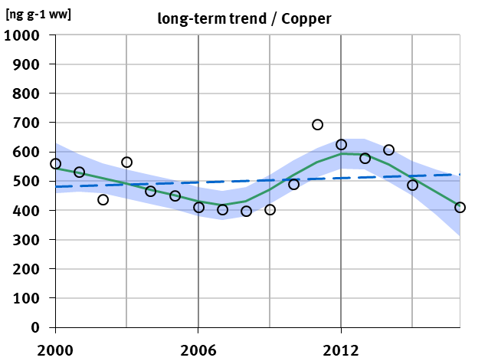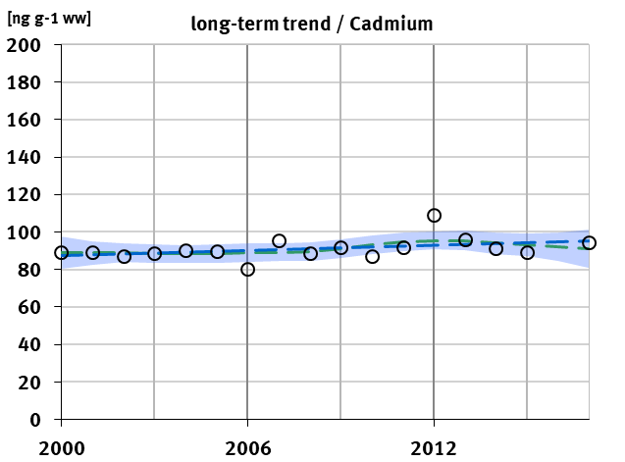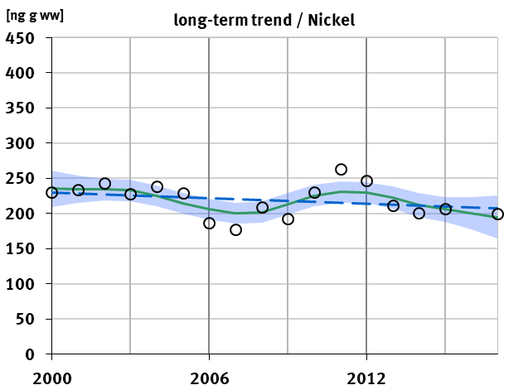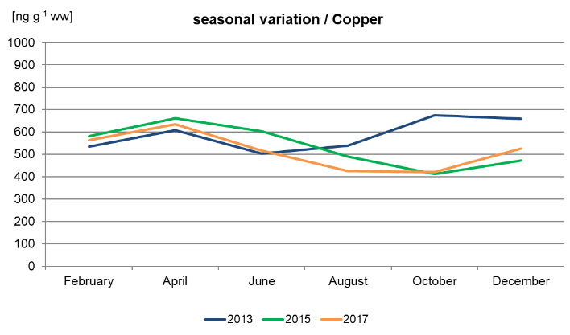 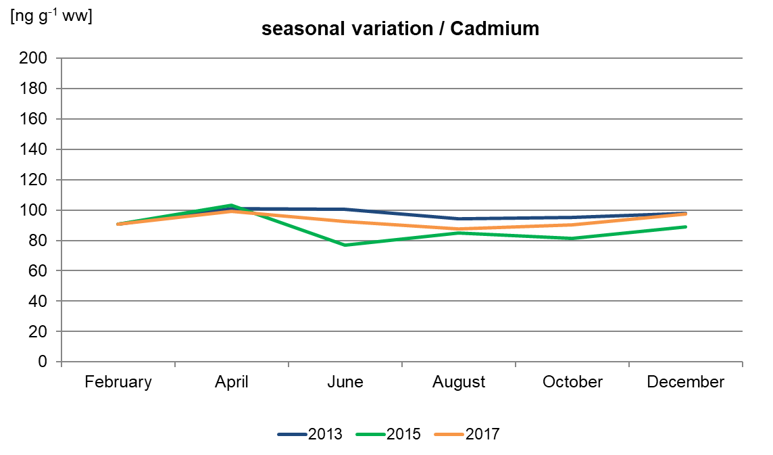 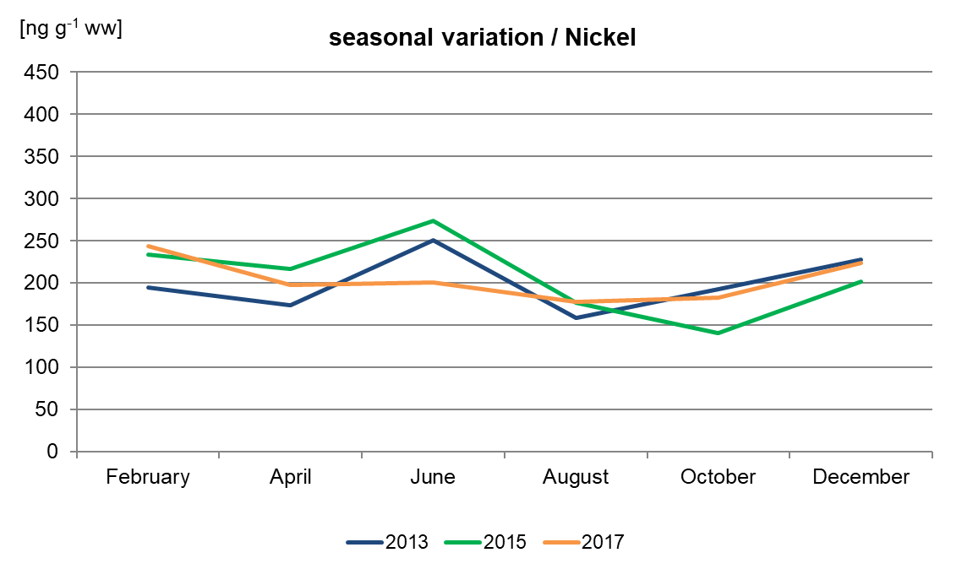
Figure S3: Long-term trends and seasonal variations in concentrations of metals in blue mussel (Mytilus edulis Complex) sampled at the North Sea site Koenigshafen. Upper row: long-term trends based on annual pool samples (continuous line = significant linear or non-linear trend; dashed line = trend not significant; p = 0.05); lower row: seasonal variation based on bi-monthly samples from 2013, 2015, and 2017.
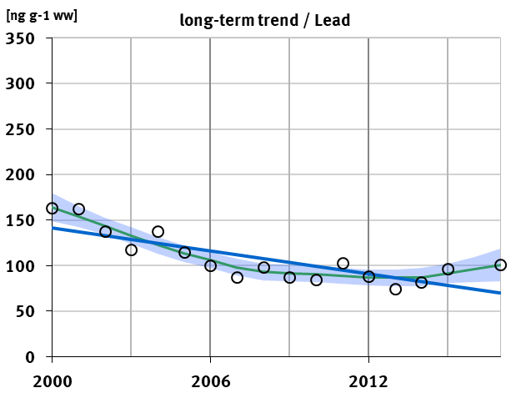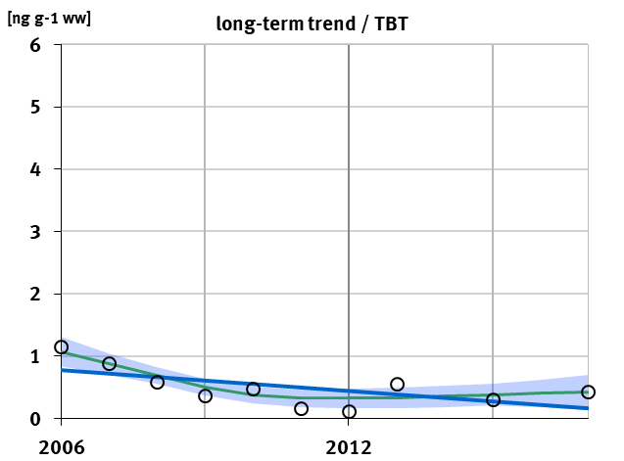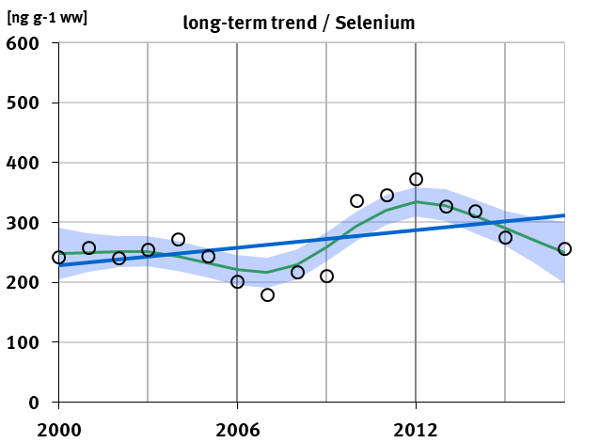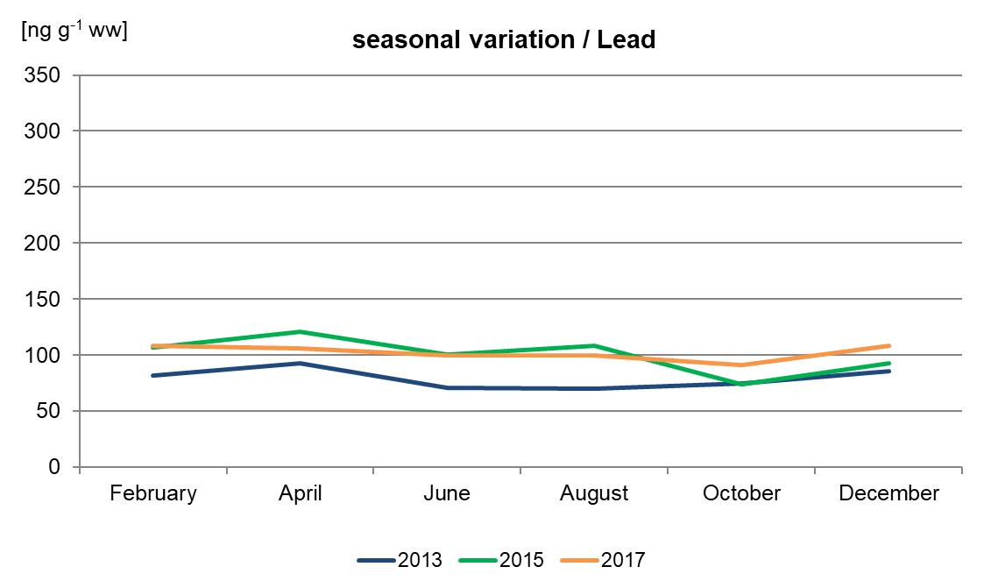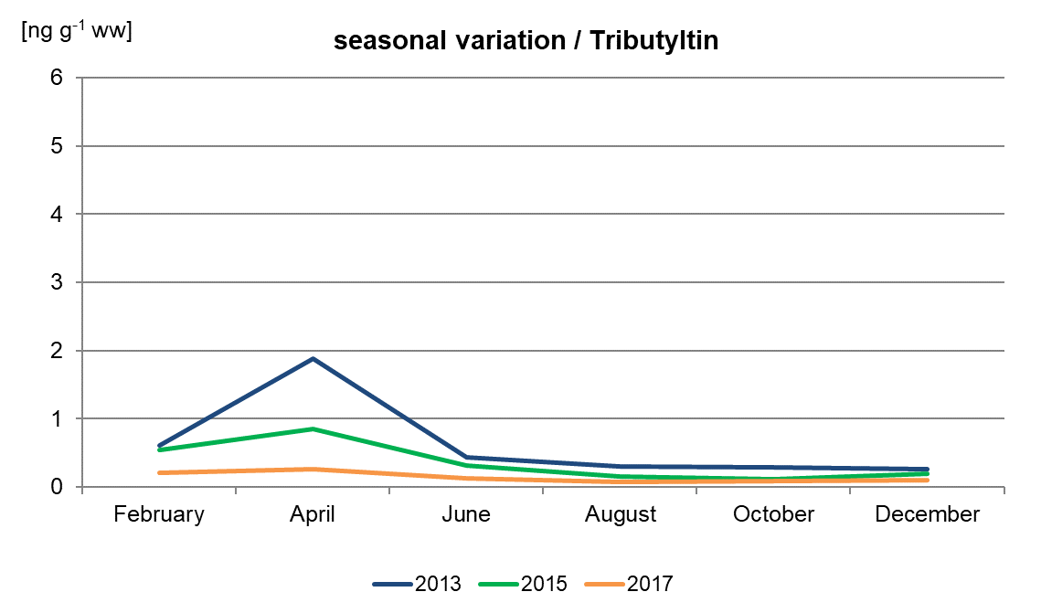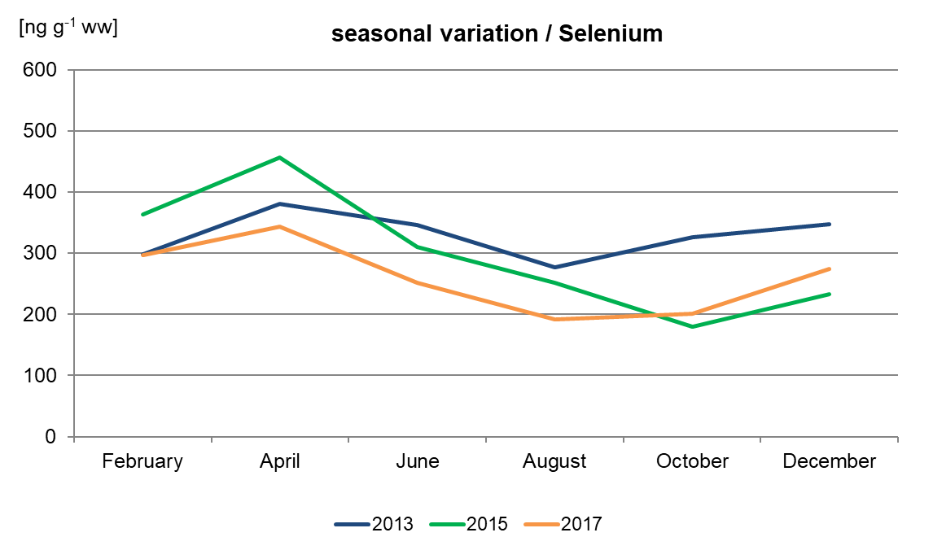
Figure S3 (cont.): Long-term trends and seasonal variations in concentrations of metals, metalloids, and TBT in blue mussel (Mytilus edulis Complex) sampled at the North Sea site Koenigshafen. Upper row: long-term trends based on annual pool samples (continuous line = significant linear or non-linear trend; dashed line = trend not significant; p = 0.05); lower row: seasonal variation based on bi-monthly samples from 2013, 2015, and 2017.

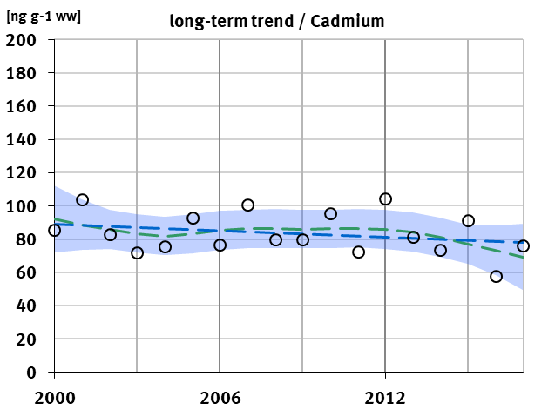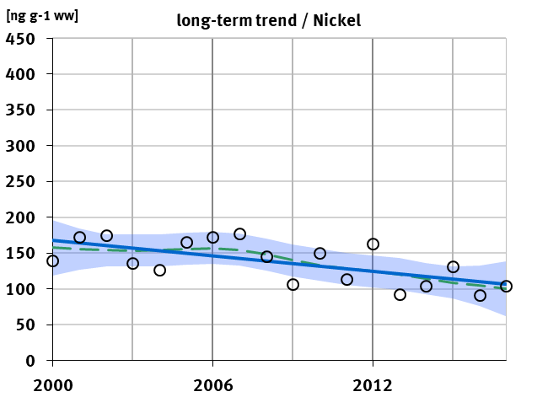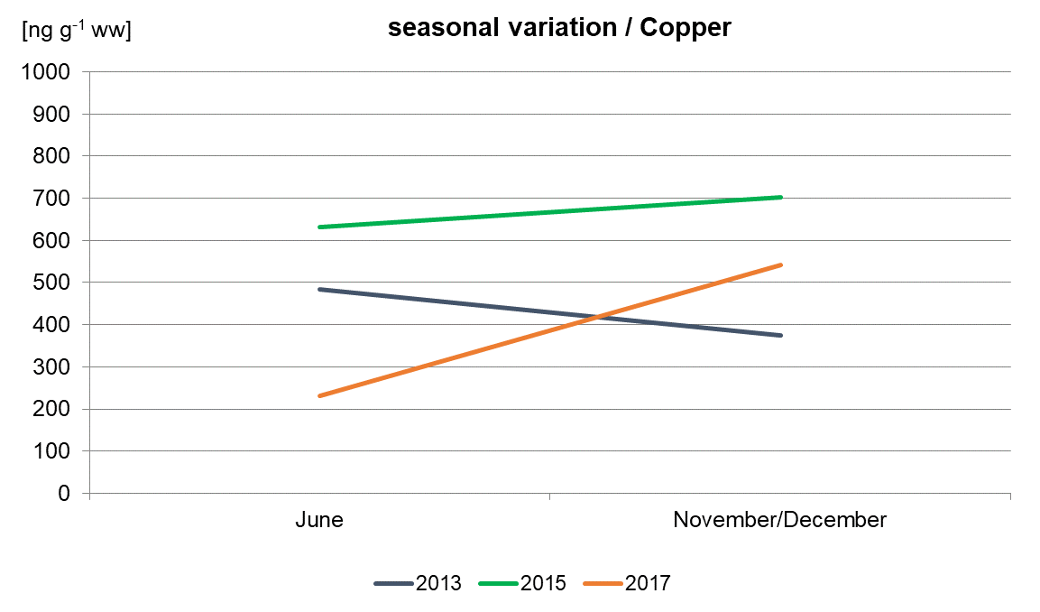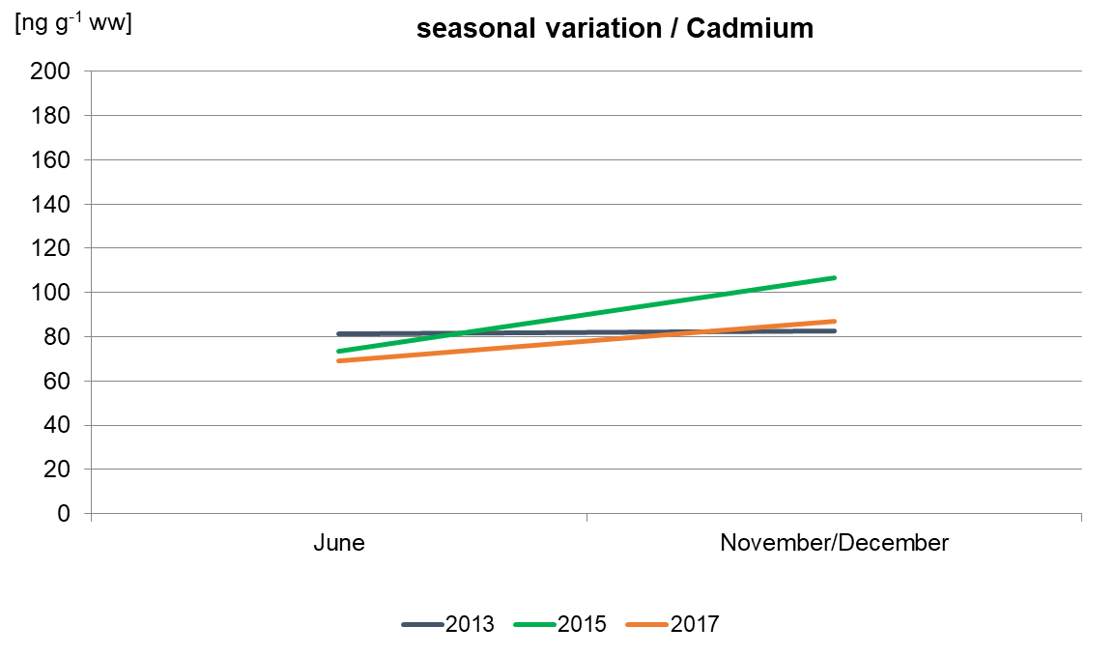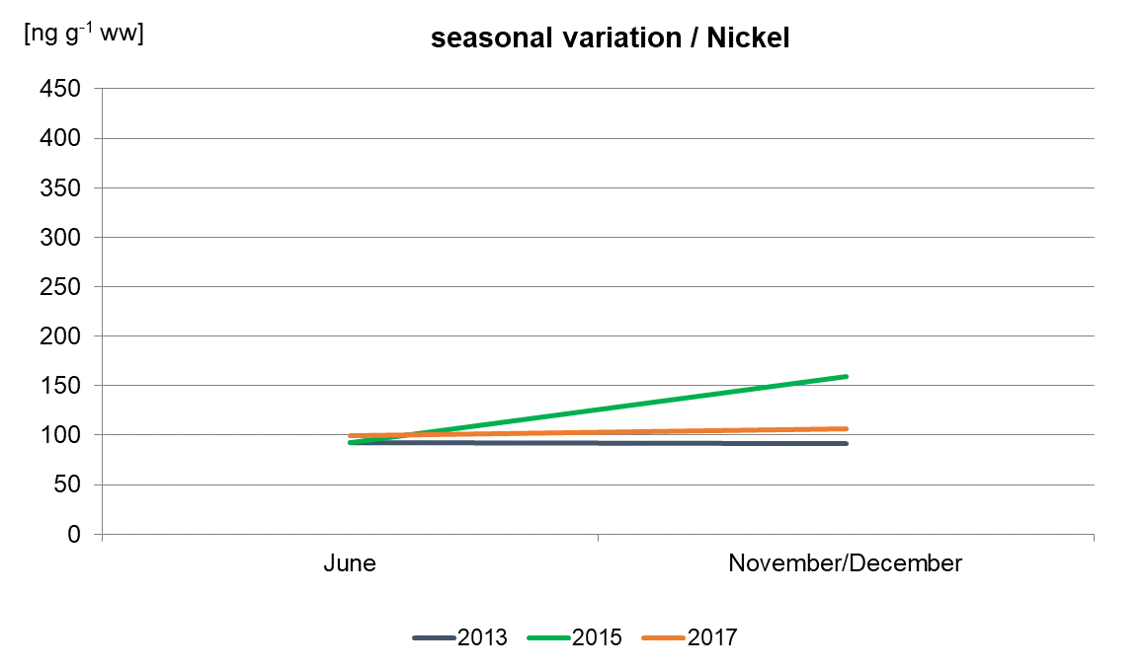
Figure S4: Long-term trends and seasonal variations in concentrations of metals in blue mussel (Mytilus edulis Complex) sampled at the Baltic Sea site Darsser Ort. Upper row: long-term trends based on annual pool samples (continuous line = significant linear or non-linear trend; dashed line = trend not significant; p = 0.05); lower row: seasonal variation based on six-month samples from 2013, 2015, and 2017.

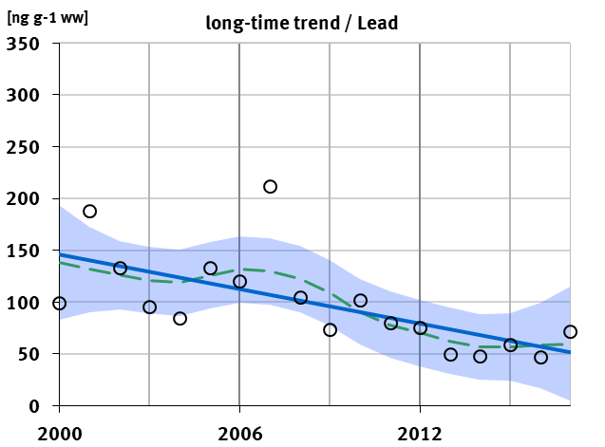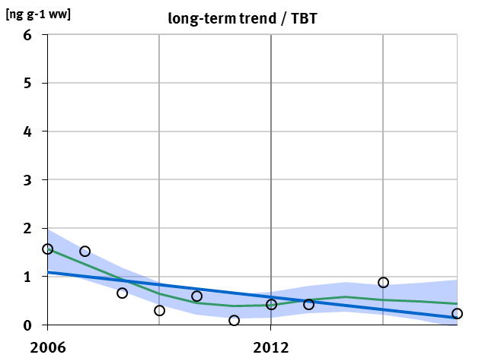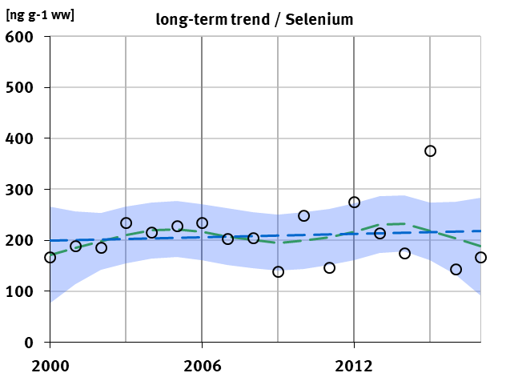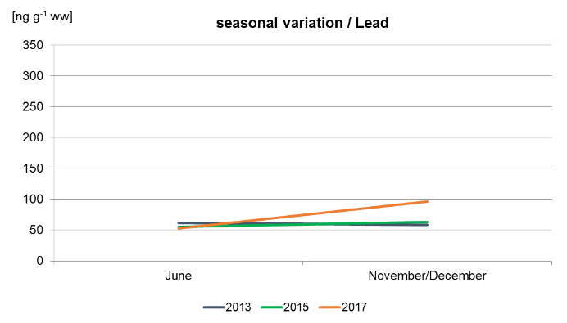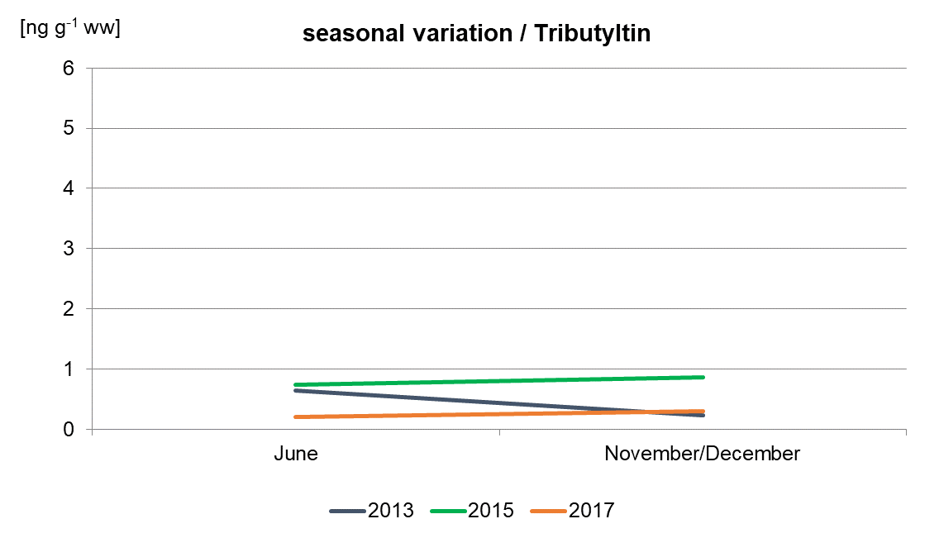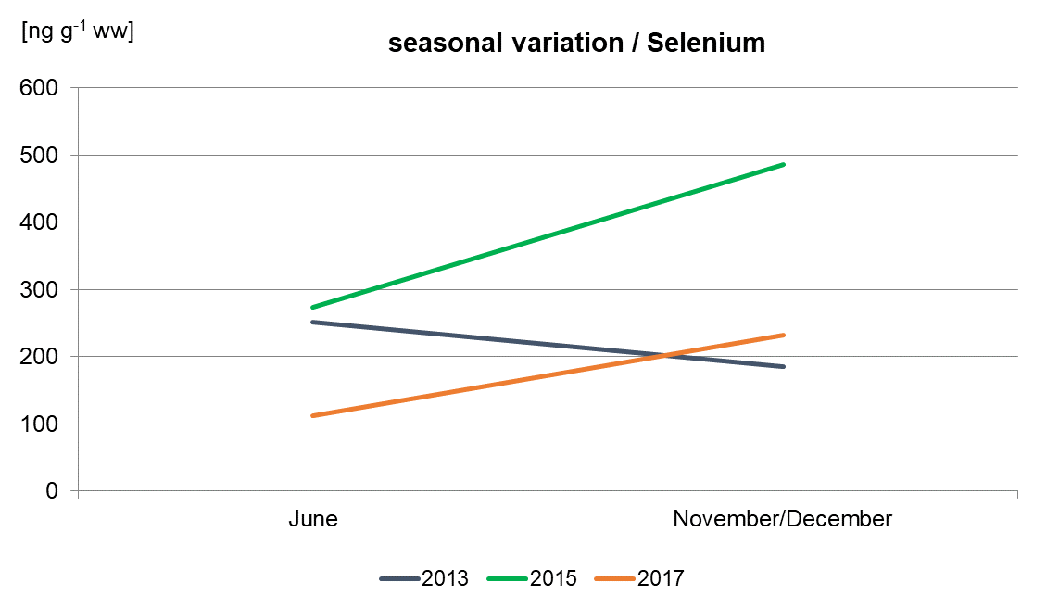
Figure S4 (cont.): Long-term trends and seasonal variations in concentrations of metals, metalloids, and TBT in blue mussel (Mytilus edulis Complex) sampled at the Baltic Sea site Darsser Ort. Upper row: long-term trends based on annual pool samples (continuous line = significant linear or non-linear trend; dashed line = trend not significant; p = 0.05); lower row: seasonal variation based on six-month samples from 2013, 2015, and 2017.

