Microplastics in Surface Water and Sediments of the Yangtze Estuary, China

Yubo Li^{1, 2}, Zhibo Lu^{1, 2*}, Hongyuan Zheng^{1, 2}, and Cheng chen³

¹ College of Environmental Science and Engineering, Tongji University, Shanghai 200092, China
² State Key Laboratory of Pollution Control and Resources Reuse, Tongji University, Shanghai 200092, China
³ State Key Laboratory of Pollution Control and Resource Reuse, School of the Environment, Nanjing University, Nanjing 210023, China

* Corresponding author
Email: luzhibo@tongji.edu.cn

Table S1 Sampling information and analysis results of all sampling sites in the Yangtze Estuary.
Sites | Sampling date | Longitude | Latitude | Sampling time (min) | Sampling Volume (L) | Abundance  (items m⁻³) | Abundance  (items kg⁻¹)
Y6 | 2019.6.21 | 121°50'23.44" | 31°26'31.74" | 11 | 105.7 | 28.4 | 40.0
Y5 | 2019.6.21 | 121°56'28.09" | 31°34'24.99" | 8 | 100.4 | 258.9 | 30.0
C6 | 2019.6.21 | 121°49'11.13" | 31°33'41.24" | 10 | 102.8 | 9.7 | 40.0
C5 | 2019.6.21 | 121°41'26.87" | 31°32'1.20" | 8 | 100.3 | 39.9 | 60.0
Y4 | 2019.6.22 | 121°29'29.59" | 31°35'10.51" | 13 | 118.0 | 16.9 | 15.0
M1 | 2019.6.22 | 121°30'52.77" | 31°36'32.72" | 10 | 101.0 | 9.9 | 50.0
C3 | 2019.6.22 | 121°32'53.33" | 31°37'48.44" | 8 | 101.6 | ND | 35.0
M2 | 2019.6.22 | 121°37'6.86" | 31°39'32.99" | 11 | 107.7 | 9.3 | 10.0
Y3 | 2019.6.22 | 121°38'3.39" | 31°42'21.29" | 8 | 101.4 | 39.4 | 15.0
C2 | 2019.6.22 | 121°27'3.55" | 31°41'53.02" | 9 | 100.8 | ND | 55.0
C1 | 2019.6.22 | 121°22'24.20" | 31°44'47.75" | 8 | 101.1 | 9.9 | 30.0
M3 | 2019.6.23 | 121°25'35.07" | 31°46'46.33" | 8 | 105.4 | 9.5 | 50.0
Y1 | 2019.6.23 | 121°14'33.03" | 31°50'53.66" | 11 | 112.0 | 17.9 | 50.0
Y2 | 2019.6.23 | 121°12'19.85" | 31°45'50.41" | 15 | 115.0 | 43.4 | 20.0
C4 | 2019.6.23 | 121°39'5.00" | 31°34'53.75" | 8 | 101.0 | ND | 25.0
Sampling volume is the amount of surface water was taken, and sampling time is also for taking water. Abundance (items m⁻³) is used for recording microplastics in surface water, while is used for recording microplastics in sediment (items kg⁻¹).

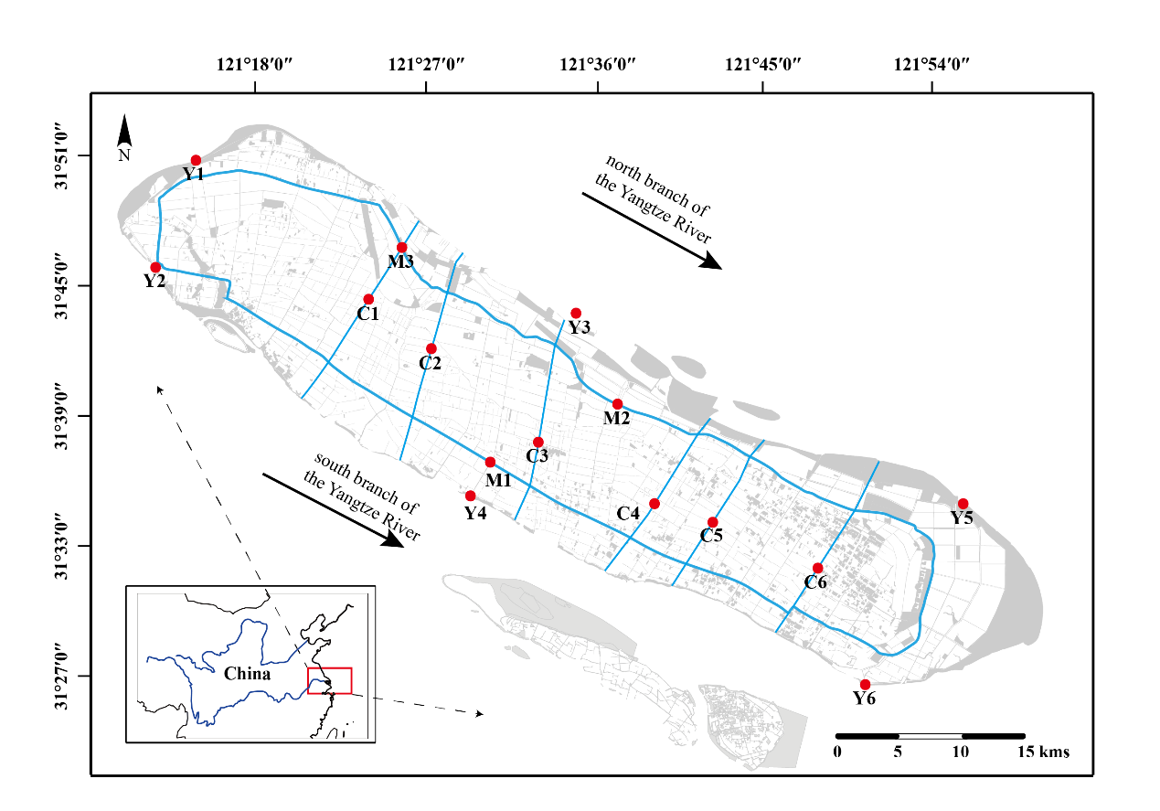
Fig. S1 Map of sampling sites.

Contamination prevention during transportation of the samples
After sampling, filters were taken out from the sampler and placed in a sealed metal container, which has multi-layer structure for storage. Each layer is slightly higher and larger than the filter to fix it inside. The container remained vertical in transit, then it was put in a refrigerator at 4 ℃ pending analysis. The transportation process of the samples is shown below.
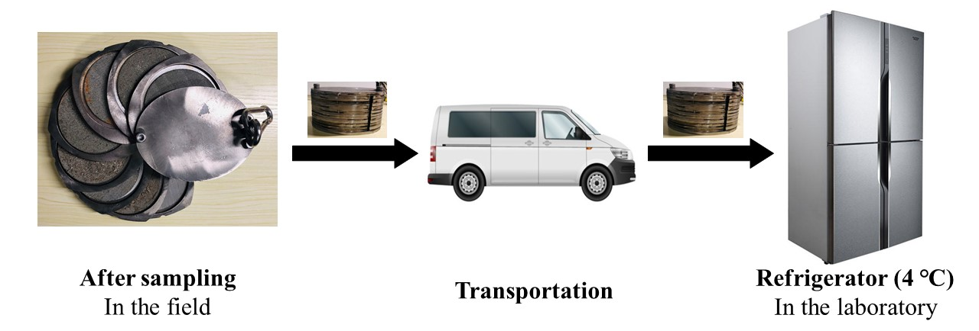
Fig. S2 Flow diagram of sample’s transportation.

Table S2 Detailed information of non-plastic particles found on the filter.
NO. | Shape | Color | Size | Composition
1 | fiber | white | 350 μm | Natural cellulose
2 | fiber | white | 1200 μm | Natural cellulose

Table S3 Comparison of different sized MPs.
 | MP counts (n) and percentage (%)
Size categories (μm) | YRS |  | ILR
Size categories (μm) | Surface water | Sediment | Surface water | Sediment
75 ≤ s ≤ 300 | 0 (0.0%) | 13 (38.2%) | 0 (0.0%) | 18 (25.4%)
300 < s ≤ 1000 | 17 (40.5%) | 19 (55.9%) | 5 (55.6%) | 41 (57.7%)
1000 < s ≤ 2000 | 12 (28.6%) | 2 (5.9%) | 4 (44.4%) | 10 (14.1%)
2000 < s≤ 5000 | 13(30.9%) | 0 (0.0%) | 0 (0.0%) | 2 (2.8%)

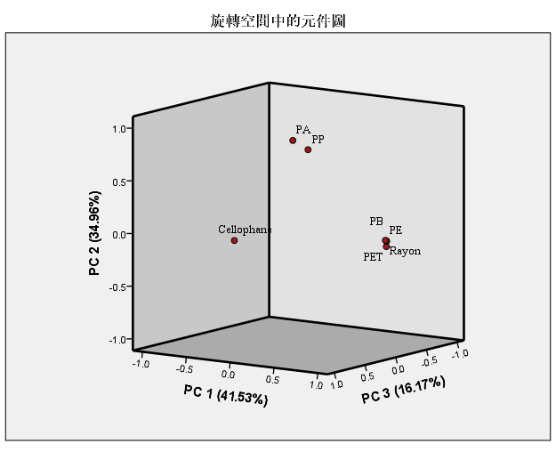Fig. S3 Component plot of surface water data.

Table S4 Component matrix of surface water data.
 | Component
 | 1 | 2 | 3
PE | .986 | .044 | .034
PET | -.217 | .775 | -.042
PA | .995 | .041 | .024
PP | .986 | -.001 | -.017
α-Cellulose | .004 | .669 | .589
Cellophane | -.095 | -.448 | .815
PB | .995. | 041 | .024

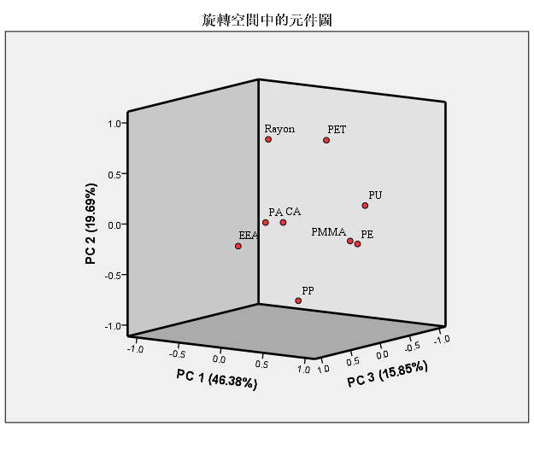Fig. S4 Component plot of sediment data.

Table S5 Component matrix of sediment data.
 | Component
 | 1 | 2 | 3
PE | .861 | -.155 | .024
PP | .024 | -.828 | -.166
α-Cellulose | -.290 | .745 | -.105
PET | .252 | .761 | -.316
PA | .186 | .076 | .623
PU | .906 | .221 | -.038
PMMA | .931 | -.086 | .250
EEA | .032 | -.138 | .866
CA | -.092 | -.052 | -.073

Table S6 Density information of identified polymers in this study.
NO. | Polymer type | Density/g cm⁻³
1 | PP | 0.9
2 | LDPE | 0.92
2 | HDPE | 0.94 – 0.97
3 | α-cellulose | 1.5
4 | PMMA | 1.18
5 | PA | 1.02 – 1.08
6 | PET | 1.4
7 | PU | 1.2
8 | PB | 0.92
9 | Cellophane | 1.42
10 | EEA | 0.93
11 | CA | 1.26

