Electronic Supporting Information
Phytotoxin Sorption to Clay Minerals
Carina D. Schönsee^{1,2}, Felix E. Wettstein¹, Thomas D. Bucheli^{1*}
¹Environmental Analytics, Agroscope, Reckenholzstrasse 191, 8046 Zürich, Switzerland
²Institute of Biogeochemistry and Pollutant Dynamics, ETH Zürich, Universitätsstrasse 16, 8092 Zürich, Switzerland

* Corresponding author
Telephone number: +41 58 468 73 42
E-mail address: thomas.bucheli@agroscope.admin.ch

List of Tables
Table S1: Investigated phytotoxins and their experimental and predicted properties. 3
Table S2: Molecular structures of all analyzed phytotoxins according to the main compound class. Structural features identified to majorly affect the compounds’ sorption behavior are shaded in grey. 4
Table S3: Measurement wavelength, recovery and pK_{a} values of all analyzed phytotoxins. 10
Table S4: Maximum sorbed concentrations and the percentage of occupied cation exchange sites on both montmorillonite and kaolinite. 13

List of Figures
Figure S1: Flow rate effects on retention factor (k) observed for the phytotoxins CAFfeine, CYTisine, GALanthamine, LYcOrine and STRophanthidin on a 1% montmorillonite column. 6
Figure S2: Retention time (t_{R}) comparison of the non-retained tracers nitrate and thiourea (THI) on a 1% montmorillonite column. 7
Figure S3: Amaryllidaceae alkaloid (GALanthamine, LYcOrine) sorption isotherms on kaolinite and montmorillonite. 9
Figure S4: Amine (HORdenine) sorption isotherms on kaolinite and montmorillonite. 9
Figure S5: Cardenolide and bufadienolide (CINobufagin, OLEandrin) sorption isotherms on kaolinite and montmorillonite. 10
Figure S6: Imidazole alkaloid (PILocarpine) sorption isotherms on kaolinite and montmorillonite. 10
Figure S7: Indole alkaloid (BRUcine, GELsemine, GRAmine, STrYchnine, VINcamine, YOHimbine) sorption isotherms on kaolinite and montmorillonite. 11
Figure S8: Isoquinoline alkaloid (BICuculine, ISoCorydine, NUCiferine, PROtopine) sorption isotherms on kaolinite and montmorillonite. 11
Figure S9: Pyrrolizidine alkaloid (ECHimidine, ERUcifoline, JACobine, LASiocarpine, MONocrotaline, RETrorsine, SEnKirkine, SENecionine) sorption isotherms on kaolinite and montmorillonite. 12
Figure S10: Pyridine alkaloid (NICotine) sorption isotherms on kaolinite and montmorillonite. 12
Figure S11: Quinoline alkaloid (QUInine) sorption isotherms on kaolinite and montmorillonite. 13
Figure S12: Quinolizidine alkaloid (CYTisine, MATrine, SOPhocarpine) sorption isotherms on kaolinite and montmorillonite. 13
Figure S13: Steroid alkaloid (CEVadine) sorption isotherms on kaolinite and montmorillonite. 14
Figure S14: Tropolone alkaloid (COLchicine) sorption isotherms on montmorillonite. 14

Table S1: Investigated phytotoxins and their experimental and predicted properties.
ID | toxin name | log D_{oc,CEC} [L mol⁻¹]¹ | log K_{ow}² | log P³ | MW [g mol⁻¹]
AIL | Ailanthone | 0.75 ± 0.02 | -0.34 ± 0.23 | -0.25 | 376.15
ANI | Anisatin |  |  | -1.90 | 328.12
BAC | Baccatin III | 0.54 ± 0.01 |  | 1.04 | 586.24
BIC | (+)-Bicuculline | NA |  | 2.68 | 367.11
BRU | Brucine | 3.04 ± 0.01 |  | 0.61 | 394.19
CAF | Caffeine | 1.78 ± 0.01 | -0.17 ± 0.13 | -0.55 | 194.08
CEV | Cevadine | 1.88 ± 0.03 |  | 0.86 | 591.34
CIN | Cinobufagin | 1.92 ± 0.01 |  | 2.81 | 442.24
COL | Colchicine | 1.39 ± 0.03 | 1.16 ± 0.06 | 1.46 | 399.17
CON | Convallatoxin | 0.82 ± 0.01 |  | 0.14 | 550.28
COS | (+)-Costunolide | 2.29 ± 0.02 |  | 3.82 | 232.15
CUE | Cucurbitacin E | 1.59 ± 0.01 |  | 3.48 | 556.30
CYT | (-)-Cytisine | 1.90 ± 0.05 |  | -0.28 | 190.11
DAB | 10-Deacetylbaccatin III | 0.48 ± 0.01 | 0.36 ± 0.31 | 0.60 | 544.23
DIG | Digitoxigenin | 1.54 ± 0.04 |  | 3.07 | 374.25
ECH | Echimidine | 1.55 ± 0.01 | 1.26 ± 0.14 | 0.68 | 397.21
ERU | Erucifoline | 1.47 ± 0.04 | 0.44 ± 0.21 | 0.60 | 349.15
ERUNO | Erucifoline N-oxide |  |  |  | 365.15
GAL | Galanthamine | 2.21 ± 0.03 | 0.88 ± 0.04 | 1.16 | 287.15
GEL | Gelsemine | 2.25 ± 0.01 |  | 1.42 | 322.17
GRA | Gramine | 2.85 ± 0.02 |  | 2.01 | 174.12
HEL | Heliotrine | 1.16 ± 0.02 |  | 0.35 | 313.19
HOR | Hordenine | 2.27 ± 0.01 |  | 1.63 | 165.12
ISC | (+)-Isocorydine | 2.88 ± 0.02 | 2.68 ± 0.06 | 2.92 | 341.16
JAC | Jacobine | 1.32 ± 0.02 | 0.83 ± 0.24 | 0.67 | 351.17
LAS | Lasiocarpine | 1.64 ± 0.09 | 1.84 ± 0.11 | 1.33 | 411.23
LASNO | Lasiocarpine N-oxide |  | -0.21 ± 0.24 | N/A | 427.22
LAT | Lathyrol | 1.54 ± 0.04 |  | 2.33 | 299.17
LYC | Lycopsamine | 1.15 ± 0.03 | 0.71 ± 0.05 | -0.29 | 287.12
LYO | Lycorine | 2.61 ± 0.08 |  | 0.16 | 248.19
MAT | Matrine | 1.68 ± 0.06 | 0.27 ± 0.33 | 1.08 | 325.15
MON | Monocrotaline | 1.25 ± 0.04 |  | -0.33 | 162.12
NIC | Nicotine | 1.82 ± 0.01 |  | 1.16 | 295.16
NUC | (-)-Nuciferine | 3.16 ± 0.01 |  | 3.39 | 576.33
OLE | Oleandrin | 0.83 ± 0.03 |  | 2.95 | 576.33
PAR | Parthenolide | 1.62 ± 0.04 |  | 3.07 | 248.14
PIC | Picrotoxinin | 0.59 ± 0.01 |  | 0.00 | 292.09
PIL | Pilocarpine | 2.01 ± 0.01 |  | 0.95 | 208.12
PRO | Protopine | 2.95 ± 0.01 |  | 2.59 | 353.13
PTB | Pterosin B | 2.23 ± 0.01 |  | 2.93 | 218.13
QUI | (-)-Quinine | 3.01 ± 0.01 |  | 2.51 | 324.18
REC | Retronecine | 0.93 ± 0.02 | 1.03 ± 0.08 | -1.17 | 155.09
RET | Retrorsine | 1.59 ± 0.03 |  | 0.60 | 351.17
SAT | alpha-Santonin | 1.52 ± 0.04 | 0.61 ± 0.11 | 2.60 | 246.13
SEK | Senkirkine | 1.44 ± 0.04 | 1.90 ± 0.10 | 1.89 | 365.18
SEN | Senecionine | 1.65 ± 0.05 |  | 1.64 | 335.17
SENNO | Senecionine N-oxide |  |  | N/A | 351.17
SOP | Sophocarpine | 2.05 ± 0.01 | 0.73 ± 0.06 | 1.07 | 246.17
STR | Strophanthidin | 1.15 ± 0.03 |  | 0.87 | 404.22
STY | (-)-Strychnine | 3.05 ± 0.01 |  | 0.93 | 334.17
VIN | (+)-Vincamine | 2.35 ± 0.07 |  | 3.39 | 354.19
YOH | Yohimbine | 2.89 ± 0.01 |  | 2.10 | 354.19
log D_{oc,CEC}¹ = cation exchange capacity normalized organic carbon-water distribution coefficient at pH 6; log K_{ow}² = experimental octanol-water partition coefficient for the neutral species; log P³ = predicted octanol-water partition coefficient; MW = molecular weight.

Table S2: Molecular structures of all analyzed phytotoxins according to the main compound class. Structural features identified to majorly affect the compounds’ sorption behavior are shaded in grey.
Alkaloids
GAL | 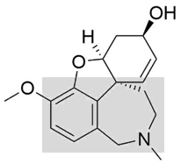 | LYO | 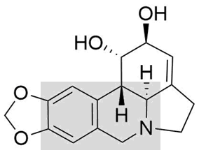
HOR | 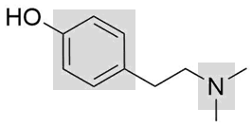 | PIL | 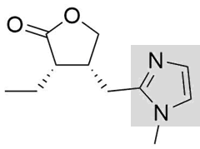
BRU | 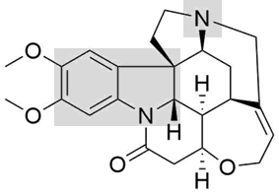 | GEL | 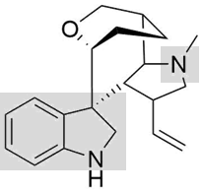
GRA | 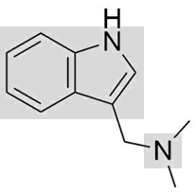 | STY | 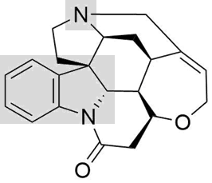
VIN | 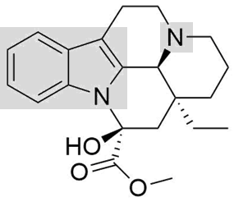 | YOH | 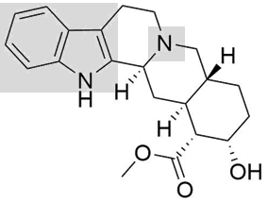
BIC | 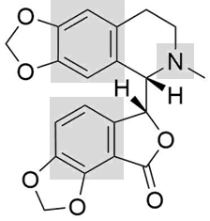 | ISC | 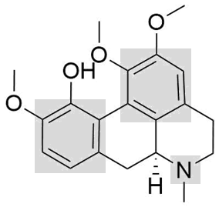
NUC | 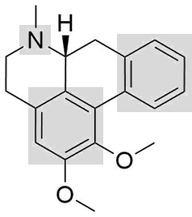 | PRO | 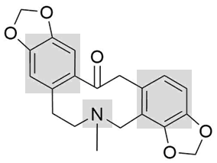
ECH | 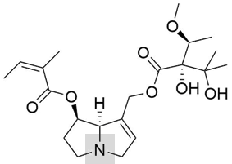 | HEL | 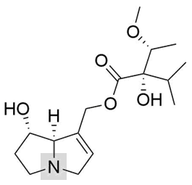
ERU | 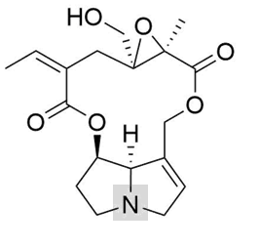 | ERUNO
JAC | 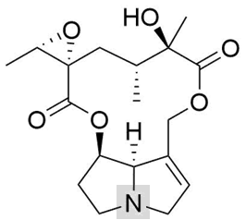 | LYC | 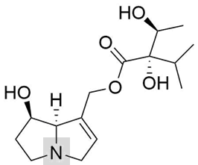
LAS | 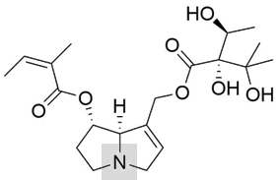 | LASNO | 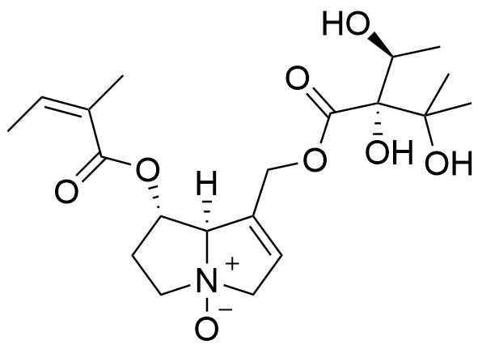
MON | 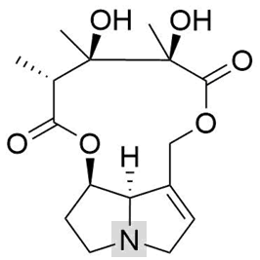 | RET | 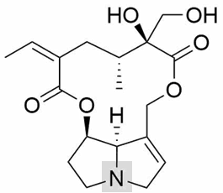
SEK | 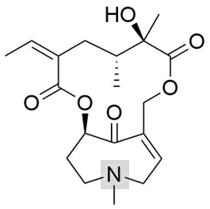 | REC | 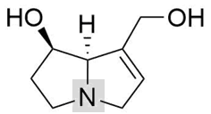
SEN | 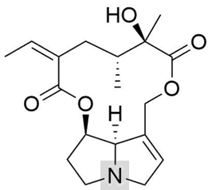 | SENNO | 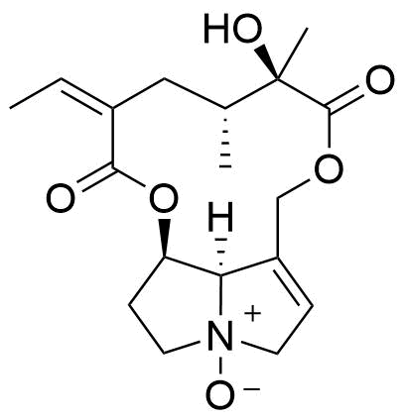
NIC | 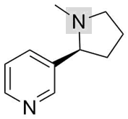 | CAF | 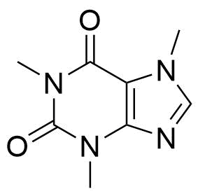
QUI | 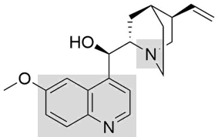 | CYT | 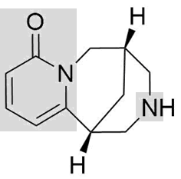
MAT | 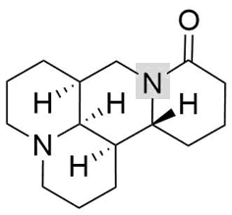 | SOP | 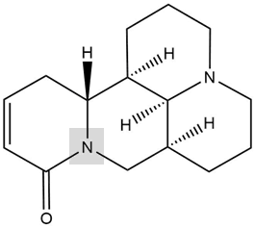
COL | 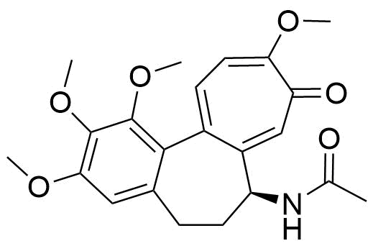
Terpenoids
AIL | 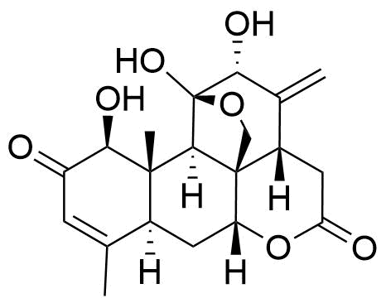 | ANI | 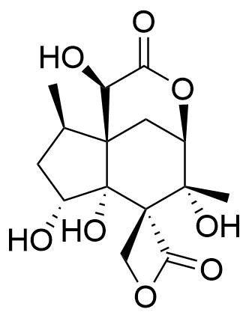
BAC | 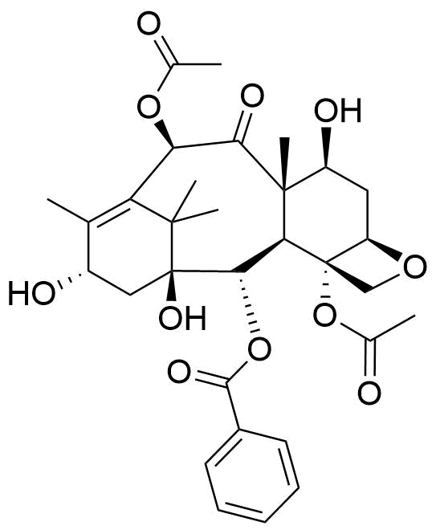 | DAB | 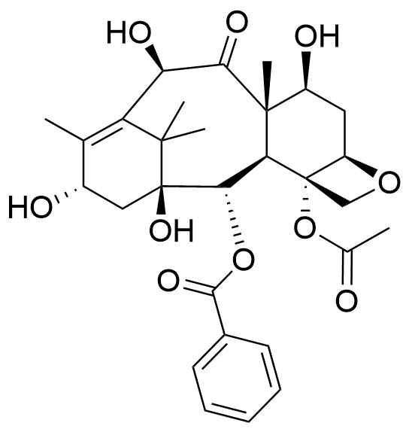
COS | 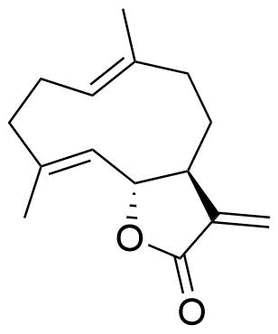 | LAT | 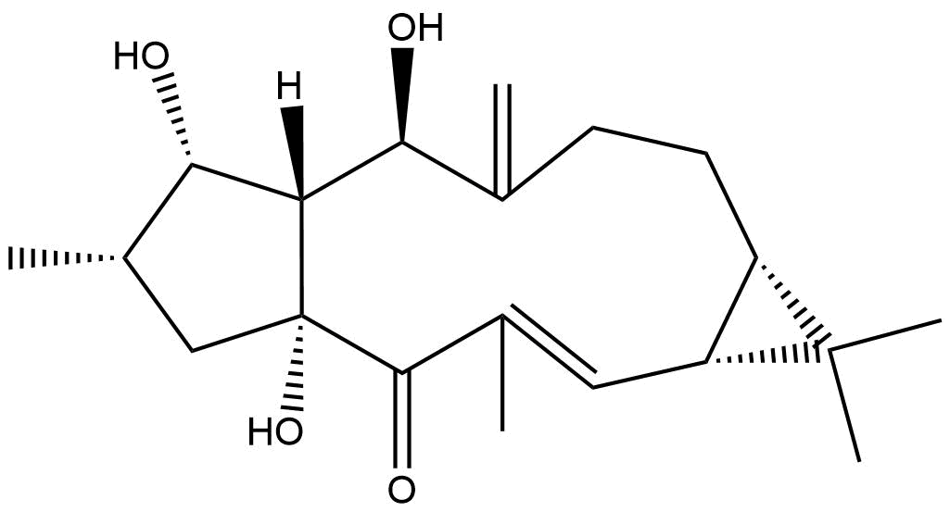
PAR | 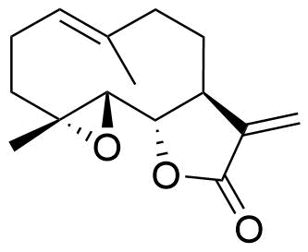 | PIC | 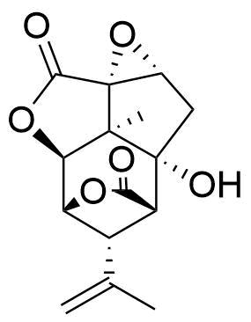
PTB | 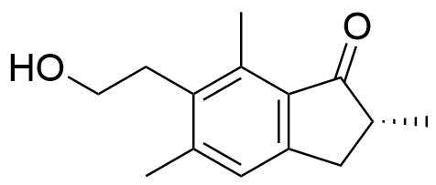 | SAT | 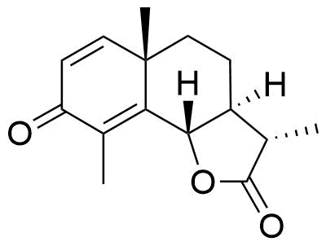
Steroids
CIN | 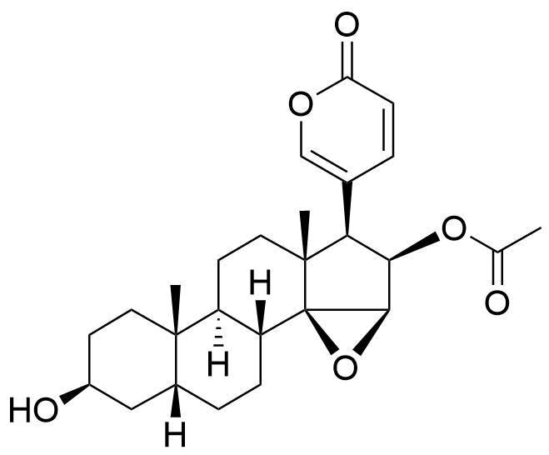 | OLE | 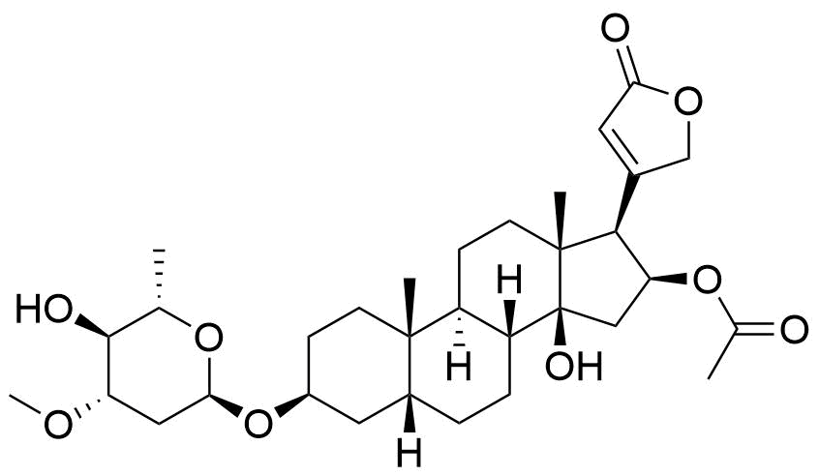
CON | 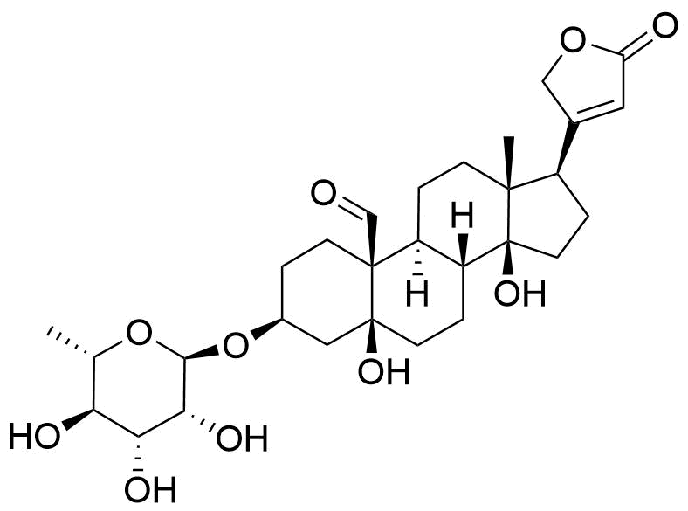 | DIG | 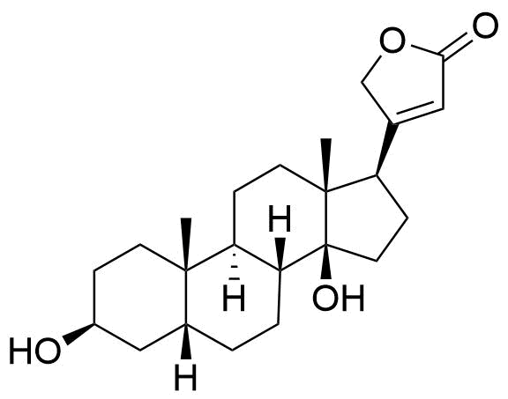
STR | 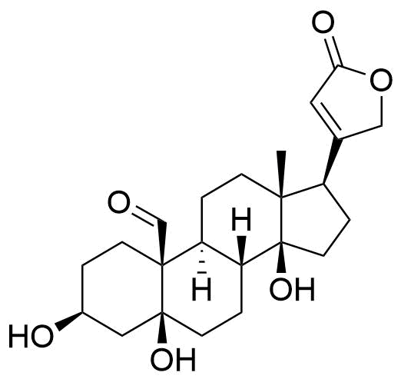
Streoidal Alkaloid |  | Steroidal Terpenoid
CEV | 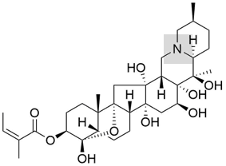 | CUE | 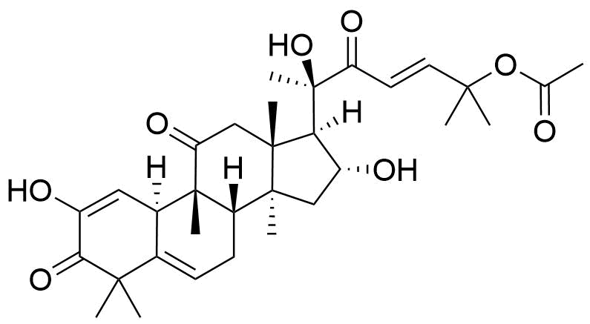
italic compound ID = retention on clay columns below the quantification threshold of log D = 0.1 for kaolinite or log D = 0.5 for montmorillonite.

Table S3: Measurement wavelength, recovery and pK_{a} values of all analyzed phytotoxins.
ID | λ [nm] | recovery [%] | pK_{a} base⁴ | pK_{a} acid⁴
AIL | 245 | 90 |  | 11.85
ANI | 200 | 77
BAC | 232 | 87 |  | 12.76
BIC | 225 | 72 | 6.71
BRU | 299 | 66 | 8.31
CAF | 205 | 93
CEV | 220 | 56 | 7.10 | 11.56
CIN | 296 | 120 |  | 15.10
COL | 350 | 97 | -0.91 | 14.75
CON | 220 | 83 |  | 13.04
COS | 225 | 103
CUE | 238 | 83 |  | 8.51
CYT | 309 | 96 | 10.50
DAB | 233 | 91 |  | 11.50
DIG | 220 | 97 |  | 14.93
ECH | 200 | 87 | 7.36 | 12.45
ERU | 200 | 87 | 5.92 | 14.58
ERUNO | 200 | NA | NA | NA
GAL | 289 | 80 | 7.92 | 13.93
GEL | 253 | 94 | 8.92 | 13.10
GRA | 248 | 92 | 9.67 | 17.00
HEL | 200 | 114 | 8.49 | 12.12
HOR | 224 | 106 | 9.51 | 10.05
ISC | 268 | 74 | 6.50 | 9.41
JAC | 200 | 75 | 5.86 | 12.89
LAS | 200 | 74 | 7.35 | 11.99
LASNO | 200 | 86 | NA | NA
LAT | 283 | 83 |  | 12.17
LYC | 200 | 104 | 8.50 | 12.59
LYO | 205 | 96 | 6.34 | 13.55
MAT | 200 | 96 | 9.47
MON | 200 | 112 | 5.90 | 12.21
NIC | 203 | 83 | 8.00
NUC | 270 | 63 | 7.87
OLE | 220 | 77 |  | 13.55
PAR | 220 | 98
PIC | 200 | 92 |  | 13.18
PIL | 215 | 70 | 7.02
PRO | 289 | 80 | 7.86
PTB | 220 | 100 |  | 14.85
QUI | 249 | 92 | 8.57 | 12.80
REC | 200 | 95 | 8.87 | 14.48
RET | 200 | NA | 5.79 | 12.00
SAT | 243 | 95
SEK | 200 | 70 | 6.51 | 12.66
SEN | 200 | 65 | 5.86 | 12.81
SENNO | 200 | NA | NA | NA
SOP | 206 | 93 | 9.59
STR | 220 | 95 |  | 13.92
STY | 209 | 72 | 8.37
VIN | 248 | 98 | 8.02 | 12.13
YOH | 229 | 86 | 8.44 | 14.39
pK_{a} base = pK_{a} valid for the protonated form of the base

Figure S1: Flow rate effects on retention factor (k) observed for the phytotoxins CAFfeine, CYTisine, GALanthamine, LYcOrine and STRophanthidin on a 1% montmorillonite column.
$$k [-] = \frac{(t_{R}- t_{0})}{t_{0}}$$

Figure S2: Retention time (t_{R}) comparison of the non-retained tracers nitrate and thiourea (THI) on a 1% montmorillonite column.

Table S4: Maximum sorbed concentrations and the percentage of occupied cation exchange sites on both montmorillonite and kaolinite.
 | montmorillonite |  | kaolinite
ID | max. c_{s} [mmol kg⁻¹] | %CES occupied | max. c_{s} [mmol kg⁻¹] | %CES occupied
BIC | 0.15 | 0.02 | 0.01 | 0.05
BRU | 0.33 | 0.04 | 0.06 | 0.32
CEV | 0.03 | <0.01 | 0.01 | 0.05
CIN |  |  | 0.01 | 0.03
COL | 0.21 | 0.02
CYT | 0.60 | 0.07 | 0.06 | 0.28
ECH | 0.08 | 0.01 | 0.01 | 0.05
ERU | 0.14 | 0.02 | 0.01 | 0.06
GAL | 1.90 | 0.23 | 0.66 | 3.31
GEL | 0.51 | 0.06
GRA | 0.50 | 0.06 | 0.03 | 0.16
HOR | 0.69 | 0.08 | 0.10 | 0.50
ISC | 0.34 | 0.04 | 0.06 | 0.28
JAC |  |  | <0.01 | 0.02
LAS | 0.11 | 0.01 | 0.02 | 0.09
LYO | 0.31 | 0.04
MAT | 0.28 | 0.03 | 0.02 | 0.08
MON | 0.25 | 0.03 | 0.03 | 0.15
NIC | 1.07 | 0.13 | 0.06 | 0.31
NUC | 0.51 | 0.06 | 0.10 | 0.48
OLE | 0.03 | <0.01
PIL | 0.41 | 0.05 | 0.03 | 0.13
PRO | 0.16 | 0.02 | 0.14 | 0.71
QUI | 0.32 | 0.04 | 0.13 | 0.64
RET | 0.07 | 0.01 | 0.01 | 0.05
SEK | 0.11 | 0.01 | 0.01 | 0.03
SEN | 0.10 | 0.01 | 0.01 | 0.05
SOP | 0.50 | 0.06 | 0.03 | 0.13
STY | 0.45 | 0.05 | 0.05 | 0.25
VIN | 0.08 | 0.01
YOH |  |  | 0.04 | 0.18
max. c_{s} = maximum sorbed concentration investigated; if no values are displayed, it was either not possible to quantify sorption for the sorbate to the respective sorbent or it was not possible to quantitatively evaluate minimum three replicates; %CES = percentage of cation exchange sites occupied by each respective sorbate, calculated with max. c_{s} and the cation exchange capacity of the sorbent; sorbed concentrations were estimated based on external calibrations with an average R² > 0.98 and calibration curve slopes between 2 (for the low absorbing molecules) and 40.

Figure S3: Amaryllidaceae alkaloid (GALanthamine, LYcOrine) sorption isotherms on kaolinite and montmorillonite.

Figure S4: Amine (HORdenine) sorption isotherms on kaolinite and montmorillonite.

Figure S5: Cardenolide and bufadienolide (CINobufagin, OLEandrin) sorption isotherms on kaolinite and montmorillonite.

Figure S6: Imidazole alkaloid (PILocarpine) sorption isotherms on kaolinite and montmorillonite.

Figure S7: Indole alkaloid (BRUcine, GELsemine, GRAmine, STrYchnine, VINcamine, YOHimbine) sorption isotherms on kaolinite and montmorillonite.

Figure S8: Isoquinoline alkaloid (BICuculine, ISoCorydine, NUCiferine, PROtopine) sorption isotherms on kaolinite and montmorillonite.

Figure S9: Pyrrolizidine alkaloid (ECHimidine, ERUcifoline, JACobine, LASiocarpine, MONocrotaline, RETrorsine, SEnKirkine, SENecionine) sorption isotherms on kaolinite and montmorillonite.

Figure S10: Pyridine alkaloid (NICotine) sorption isotherms on kaolinite and montmorillonite.

Figure S11: Quinoline alkaloid (QUInine) sorption isotherms on kaolinite and montmorillonite.

Figure S12: Quinolizidine alkaloid (CYTisine, MATrine, SOPhocarpine) sorption isotherms on kaolinite and montmorillonite.

Figure S13: Steroid alkaloid (CEVadine) sorption isotherms on kaolinite and montmorillonite.

Figure S14: Tropolone alkaloid (COLchicine) sorption isotherm on montmorillonite.

References

1) Schönsee, C. D., Wettstein, F. E., and Bucheli, T. D.; Disentangling Mechanisms in Natural Toxin Sorption to Soil Organic Carbon. submitted to Environ. Sci. Technol.
2) Schönsee, C. D. and Bucheli, T. D. (2020) Experimental Determination of Octanol–Water Partition Coefficients of Selected Natural Toxins. J. Chem. Eng. Data 65:1946-1953.
3) ChemAxon, Chemicalize (available via https://chemicalize.com/), ChemAxon Ltd., Budapest, Hungary, 2019.
4) ACD/Labs, Percepta Platform (release 2016.2), Advanced Chemistry Development, Inc., Toronto, Canada, 2016.

