Long-term trends of black carbon and particle number concentration in the lower free troposphere in Central Europe

Jia Sun¹, Markus Hermann¹, Ye Yuan², Wolfram Birmili^{1,3}, Martine Collaud Coen⁴, Kay Weinhold¹, Leizel Madueño¹, Laurent Poulain¹, Thomas Tuch¹, Ludwig Ries⁵, Ralf Sohmer⁵, Cedric Couret⁵, Gabriele Frank⁶, Benjamin Tobias Brem⁷, Martin Gysel-Beer⁷, Nan Ma^{8,1}∗, Alfred Wiedensohler¹∗∗

¹Leibniz Institute for Tropospheric Research (TROPOS), Leipzig, Germany
²Department of Ecology and Ecosystem Management, Technical University of Munich (TUM), Freising, Germany
³German Environment Agency (UBA), Dessau-Roßlau, Germany
⁴Federal Office of Meteorology and Climatology, MeteoSwiss, 1530 Payerne, Switzerland
⁵German Environment Agency (UBA), GAW Global Observatory Zugspitze-Hohenpeissenberg, Platform Zugspitze, 82475 Zugspitze, Germany
⁶Deutscher Wetterdienst, Monitoring NetworkRadioactivity, Offenbach, Germany
⁷Laboratory of Atmospheric Chemistry, Paul Scherrer Institute, CH-5232 Villigen PSI, Switzerland
⁸Institute for Environmental and Climate Research, Jinan University, Guangzhou, 511443, China

Additional information

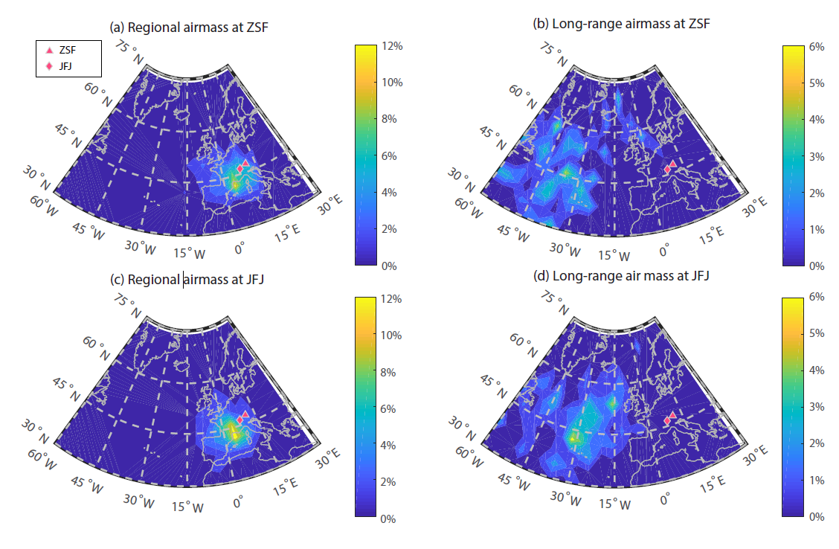
Figure S1. The frequency distribution of starting point for the two airmass clusters: (a) Regional airmass at ZSF; (b) Long-range airmass at ZSF; (c) Regional airmass at JFJ; (d) Long-range airmass at JFJ.
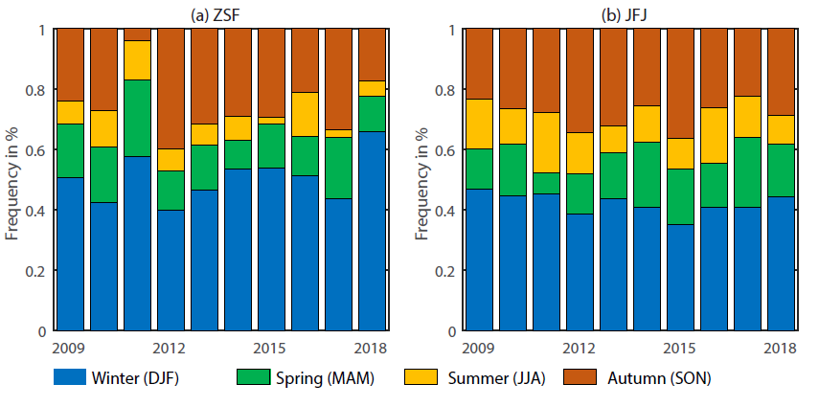
Figure S2. The annual relative FT frequency for different seasons at ZSF (a) and JFJ (b).

∗ Corresponding author. E-mail address: nan.ma@jnu.edu.cn
∗∗ Corresponding author. E-mail address: ali@tropos.de

