Table S1. Representative Examples of Key Mast Cell Mediators

Pro-inflammatory cytokines
IL-1α, IL-1β, IL-2, IL-4, IL-5, IL-6, IL-7, IL-9, IL-10, IL-12, IL-13, IL-15, IL-16, IL-18, IL-21, IL-23, IL-25, IL-31, IL-33, IFN-γ, TNF-α
Chemokines
MCP-1, IL-8, RANTES, eotaxin, leukotrienes B₄, C₄, D₄, E₄ (SRS-A), CCL2, CCL3, CCL4, CCL5, CCL11, CCL19, CCL20, CCL21, CXCL8, CXCL10, XCL-1
Proteases
Tryptase, chymase, angiotensin converting enzyme (ACE), ACE2, carboxypeptidase, cathepsin G, cysteinyl cathepsins, metalloproteinases
Growth factors
IL-3, GM-CSF, bFGF, VEGF, TGF-β, PDGF, EGF, NGF, SCF, angiopoietin
Vascular permeability, vasodilatation
Histamine, 5-hydroxytryptamine, tryptase, NO, VLA4
Platelet aggregation and thrombosis:
PAF, thromboxane
Neurohormones
Adrenocorticotrophin (ACTH), CRH, endorphins, HKA, leptin, melatonin, NT, SP, VIP
Heparin proteoglycan
Chondroitin sulfate proteoglycan
Superoxide dismutase
Acid hydrolases
Glucuronidase, galactosidase, hexosaminidase, peroxidase
Arylsulphatase A
Prostaglandin D₂, thromboxane
Serotonin, dopamine
Antimicrobial agents
IFN-α, IFN-β, IFN-γ, human cathelicidin (LL-37)
TSLP

Used with permission from Theoharides TC et al., Immunol Rev 2007, Theoharides TC, Exp Dermatol 2017, Theoharides TC, Biofactors 2020. Abbreviations: bFGF: basic fibroblast growth factor; CCL: chemokine (C-C motif) ligand; CRH: corticotropin releasing hormone; CXCL: chemokine (C-X-C motif) ligand; EGF: epidermal growth factor; GM-CSF: granulocyte-macrophage colony stimulating factor; HKA: hemokinin-A; IFN: interferon; IL: interleukin; MCP: mast cell protease; NGF: nerve growth factor; NO: nitrogen oxide; NT: neurotensin; PAF: platelet activating factor; PDGF: platelet-derived growth factor; RANTES: Regulated upon Activation, Normal T Cell Expressed and Presumably Secreted; SCF: stem cell factor; SP: Substance P; SRS-A: slow releasing substance of anaphylaxis; TGF: transforming growth factor; TNF: tumor necrosis factor; TSLP: thymic stromal lymphopoietin; VEGF: vascular endothelial growth factor; VIP: vasoactive intestinal peptide; VLA: very late antigen.

S2. QEESI Symptom Star. Source: Miller and Prihoda (1999) [38]

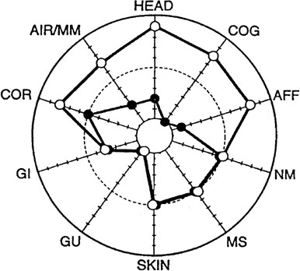
Symptom severity in an individual before (•) and after (○) an exposure event (e.g., pesticide application, indoor air contaminants, chemical spills). Two good examples of how the Symptom Star has been used in patient care are demonstrated in case reports by Yun et al., (2013) [72] and Imai and Imai (2011) [73].
Terms: HEAD = head-related symptoms; COG = cognitive symptoms; AFF = affective symptoms; NM = neuromuscular symptoms; MS = musculoskeletal symptoms; SKIN = skin-related symptoms; GU = genitourinary symptoms; GI = gastrointestinal symptoms; COR = heart/chest-related symptoms; AIR/MM = airway or mucous membrane symptoms.
Yun MJ, Kang DM, Lee K-H, Kim YK, Kim JE. 2013. Multiple chemical sensitivity caused by exposure to ignition coal fumes: a case report. Annals of Occupational and Environmental Medicine. 25:32.

Imai N and Imai Y. Necessity of counseling institutions for sick building syndrome patients. In Sabah A. Abdul-Wahab Eds, Sick Building Syndrome: in Public Buildings and Workplaces, p365. Springer Science & Business Media, 2011 - Technology & Engineering - 591 pages

