Supporting information for:

A tool (SPOLERC) to guide the evaluation of phosphorus leaching for agricultural soil by using the change point value in the Xingkai Lake Basin, China
Zijian Xie^{a,b,1}, Fan Zhang^{a,b,1}, Chun Ye^{a,b,*}, Hao Wang^{a,b}, Weiwei Wei^{a,b}, Chunhua Li^{a,b,*}, Xiaogang Shi^{c}
ª National Engineering Laboratory for Lake Pollution Control and Ecological Restoration, Chinese Research Academy of Environmental Sciences, Beijing 100012, China
^{b} State Environmental Protection Key Laboratory for Lake Pollution Control, Chinese Research Academy of Environmental Sciences, Beijing 100012, China
^{c} School of Interdisciplinary Studies, University of Glasgow, Dumfries, Scotland, DG1 4ZL, United Kingdom

¹ These authors contributed equally.

Corresponding author:
Chun Ye (E-mail: yechbj@163.com)
Chunhua Li (E-mail: 297535203@qq.com)
Chinese Research Academy of Environmental Sciences, National Engineering Laboratory for Lake Pollution Control and Ecological Restoration, State Environmental Protection Key Laboratory for Lake Pollution Control, Beijing 100012, China
Captions
Fig. S1. Figure sample that can be used for soil P leaching change point calculation in Model 1 (Xie et al., 2019)
Fig. S2. Figure sample that can be used for soil P leaching change point calculation in Model 2 (Xie et al., 2021)
Fig. S3. Scatter distribution of the soil Olsen-P and leachable P fitted by SPOLERC
Attachment 1. Instruction books for SPOLERC

Fig. S1. Figure sample that can be used for soil P leaching change point calculation in Model 1 (Xie et al., 2019)

Fig. S2. Figure sample that can be used for soil P leaching change point calculation in Model 2 (Xie et al., 2021)

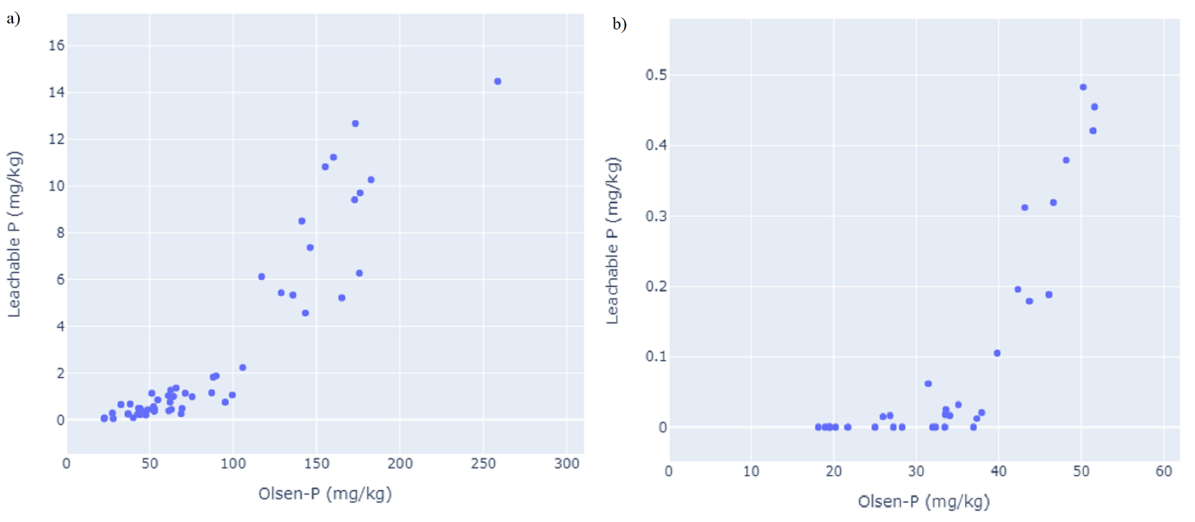
Fig. S3. Scatter distribution of the soil Olsen-P and leachable P fitted by SPOLERC

References:
Xie, Z., Li, S., Tang, S., Huang, L., Wang, G., Sun, X., & Hu, Z. (2019). Phosphorus Leaching from Soil Profiles in Agricultural and Forest Lands Measured by a Cascade Extraction Method. Journal of Environmental Quality, 48(3), 568–578. https://doi.org/10.2134/jeq2018.07.0285
Xie, Z., Yang, X., Sun, X., Huang, L., Li, S., & Hu, Z. (2021). Effects of biochar application and irrigation rate on the soil phosphorus leaching risk of fluvisol profiles in open vegetable fields. Science of The Total Environment, 147973. https://doi.org/10.1016/j.scitotenv.2021.147973

Attachment 1. Instruction books for SPOLERC
Step1: software installation
The software has been compiled for the small program, directly double-click “DblclickMe”(C:\Application\DblclickMe) or the “spolerc.exe”(C:\Application\dist\spolerc) can run, do not need to install.
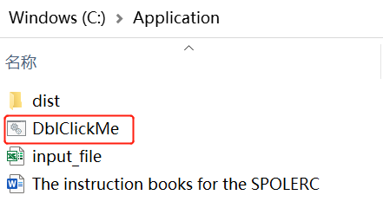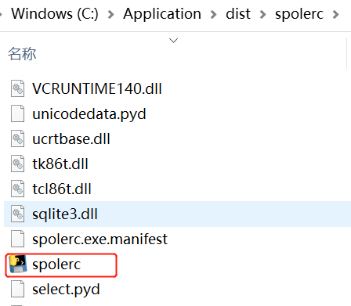
Step 2: document preparation
First of all, it is recommended to put the relevant files of SPOLERC into the same folder. The Spaces and Chinese characters should not occur in file names to avoid the possibility of running errors.
Secondly, prepare the “input_file.xls” (note that it is a file with an extension of xls, not xlsx) in the same format as the example file. It is worth mentioning that the first column of the file is the ordinal number, the second column is named “OP”, and the third column is named “LP”. The “input_file.xls” should be placed in the same directory as the batch file (with the extension "bat").
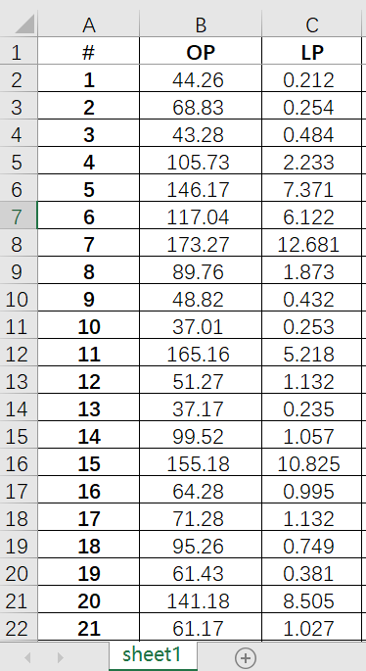
Step 3: software runs
First of all, enter the file location after the input file path: such as "C:\Application\input_file.xls". Be careful to ensure that the entire path has no space and no Chinese as far as possible to ensure that the following run will report fewer errors.
Secondly, enter the form name, such as “Sheet1” or a user-named form Name in the right column of the “Input Sheet Name” on the main SPOLERC screen, and make sure that the case is the same as the “input_file.xls”.
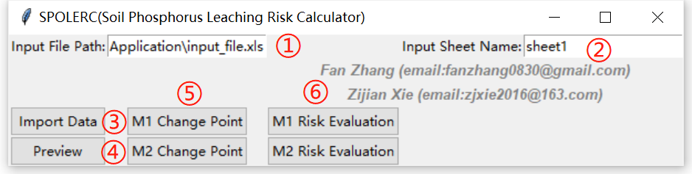
Thirdly, click the “Import Data” button on the left to import the Data. The program will automatically pop up the interface as shown in the following picture to prove that the data entry is complete. Click OK to continue.
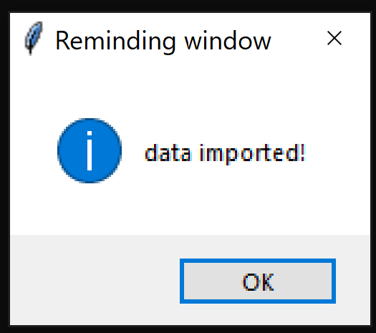
Fourthly, click the "Preview" button to preview the data points and determine the data processing mode. The SPOLERC software automatically calls the system's default browser to display the results. Then, the calculated mode was selected based on the preview figure.
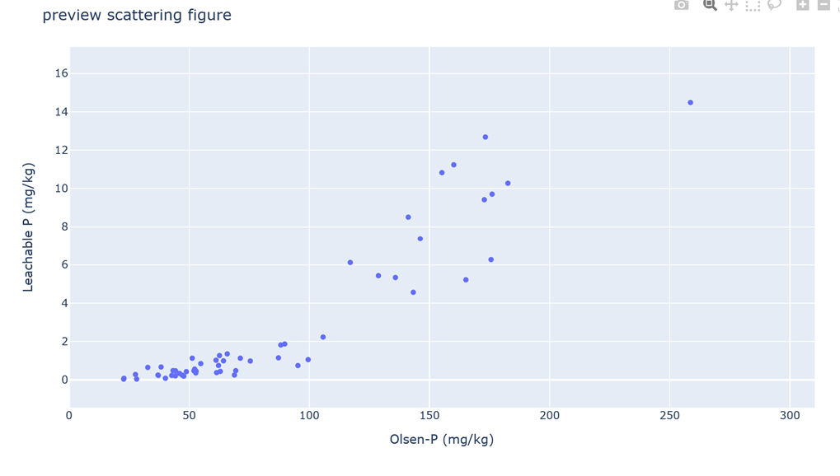
Fifthly, it assumes that the data structure conforms to Model 1, click on "M1 Change Point" and calculate the soil P leaching change point according to the “Mode 1”.
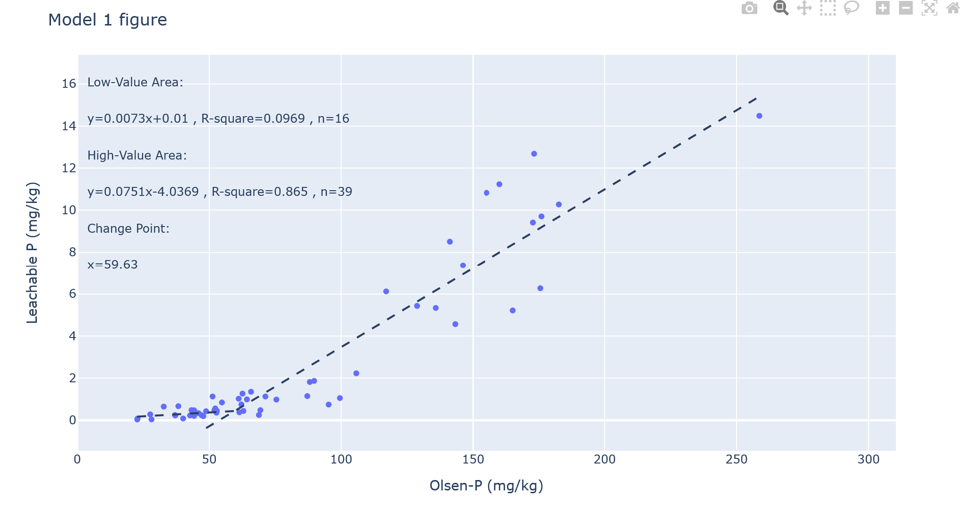
Then, click on "M1 Risk Evaluation" to carry out the risk assessment according to the “Mode 1”.
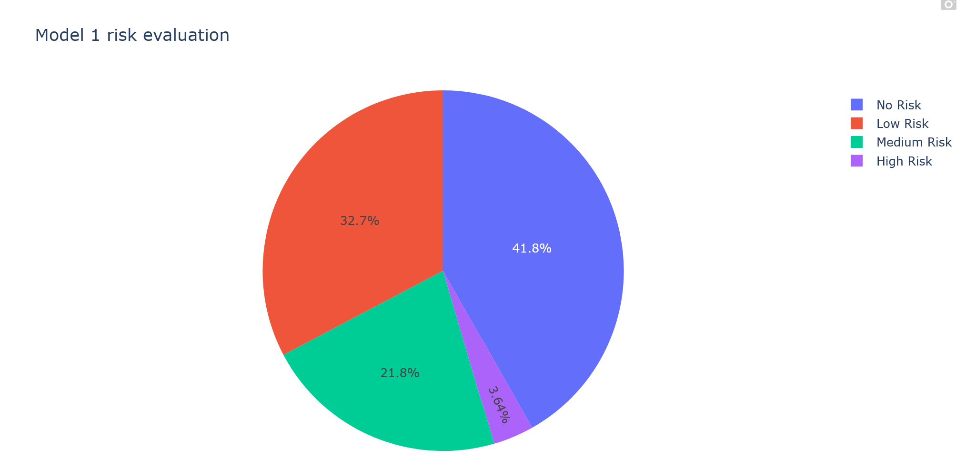
Similarly, click on "M2 Change Point" and calculate the soil P leaching change point according to the “Mode 2”, and, then, click on "M2 Risk Evaluation" to carry out the Risk assessment according to the “Mode 2”.

