Support information (SI):
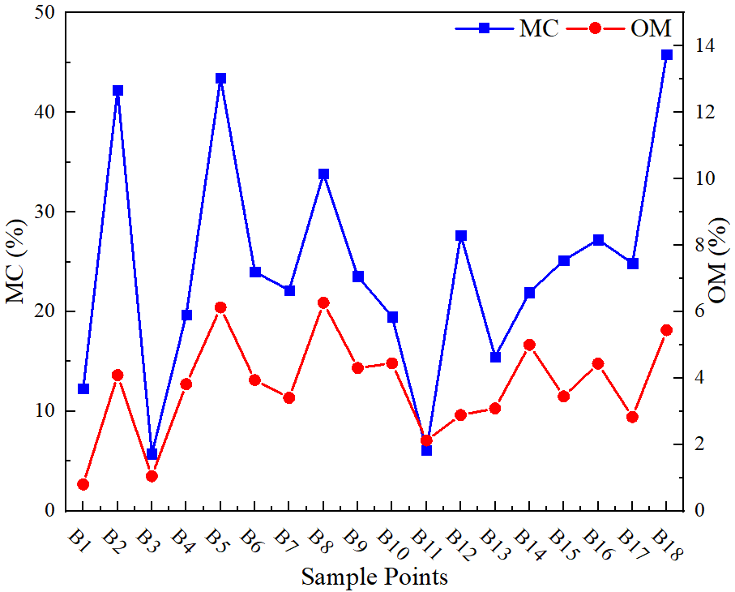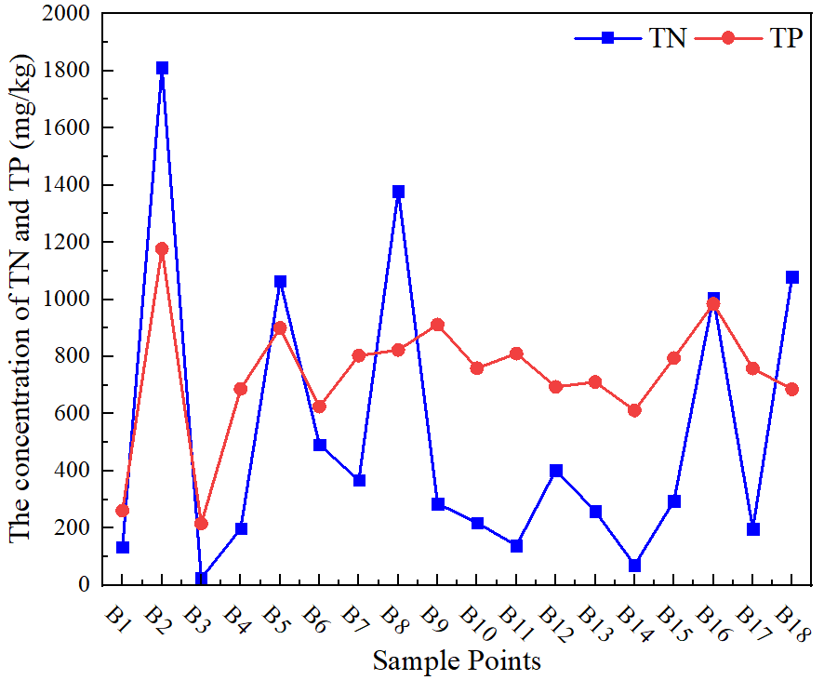

SI Fig. 1 physicochemical parameters of sediments in the Bahe River Basin
(MC: moisture content, OM: organic matter, TN: total nitrogen, TP: total phosphorus)

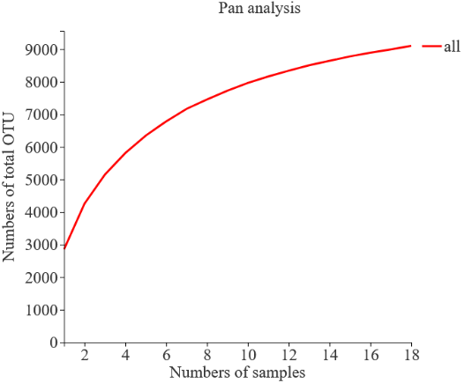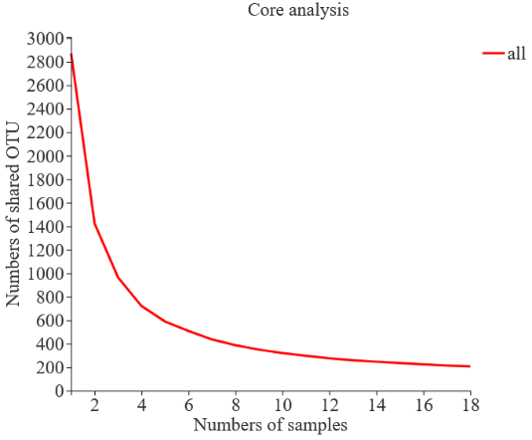

SI Fig.2 Pan and core species analysis curves

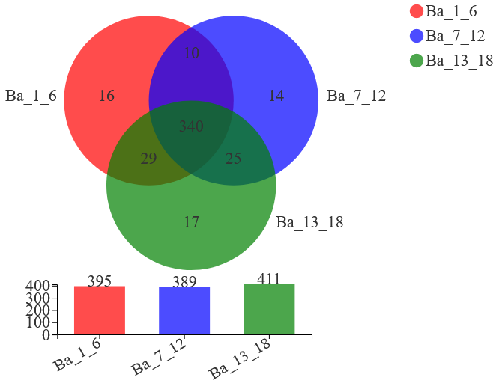

SI Fig. 3 Venn diagram of microbial community species in the sediments of Bahe River Basin

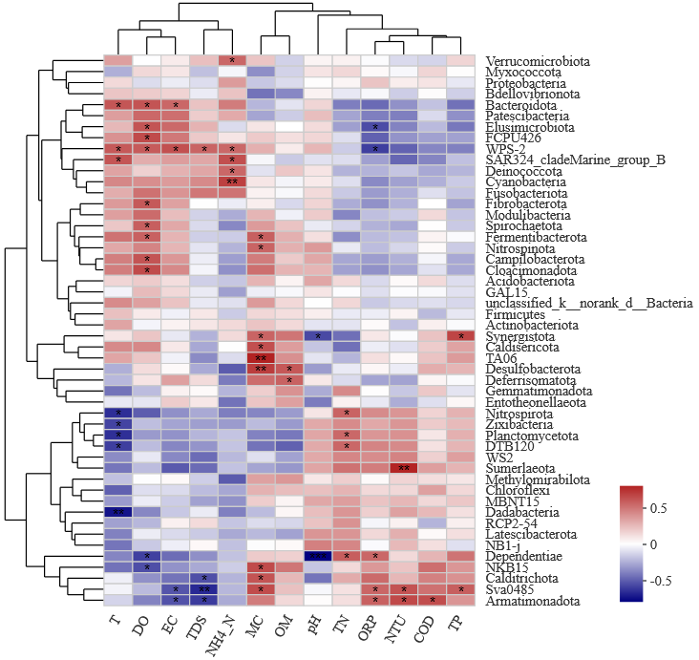

SI Fig.4 Pearson correlation heatmap between environmental factors and the abundance of microbial community at the phylum level in the Bahe River Basin.

