Life Cycle Assessment of MycoWorks’ Reishi™: the first low-carbon and biodegradable alternative leather

Ellie Williams¹, Katarzyna Cenian¹, Laura Golsteijn¹, Bill Morris^{2*}, Matthew L. Scullin².
Author details
¹PRé Sustainability, Stationsplein 121, 3818 LE Amersfoort, The Netherlands
²Mycoworks Inc., 1300 64th Street, Emeryville, California, USA
*Correspondence: info@mycoworks.com

Supporting Information 1
This document provides additional information to supplement the main article. When supporting information (SI) has been referred to in the main text, the content can be found in this document under the same heading.
Contents
Background 3
Methodology 5
Impact assessment method 5
Life Cycle Inventory (LCI) 5
Benchmark: Bovine Leather 7
Results 8
Comparison to the benchmark product 9
Discussion 11
References 13

Background
A comparison of carbon footprint impact between Reishi™, bovine leather, plus other mycelium leathers, and other alternative leathers is useful in determining the overall real-world impact that these materials can have as they see further adoption or decline in the marketplace. In this Supporting Information section we offer these comparisons.
Mycelium is grown via different processes depending on the company and their underlying technology used. MycoWorks utilizes a passive growth system that achieves the customarily high CO₂ levels required to grow mycelium without the need for externally-sourced CO₂, i.e., the process captures and utilizes only the organism’s naturally respirated CO₂ in a carbon-negative process. Conversely, other mycelium-based leather alternatives, such as those from Ecovative, Inc., and Bolt Threads, Inc. (via their partner mycelium supplier known to be utilizing the Ecovative process in the Netherlands in 2021) employ an active process that requires externally-sourced CO₂ as an input gas during mycelium growth which ultimately gets expelled into the atmosphere, resulting in a carbon-positive (i.e., carbon-consuming) process.
So as to clarify that different mycelium-based leathers are grown via different processes and therefore may have very different carbon footprints, in this section we calculated an estimated carbon footprint for the Ecovative “mushroom leather” process using their published patents (Bayer & Mclntyre, 2020). This calculation is presented below.

Table 1. Estimated CO2-eq. emissions from mycelium grown via the Ecovative process for Ecovative’s Forager™ “mushroom leather” and as an input for Bolt Threads’ Mylo™ material
Process Basics
8 | day growth period
Enclosed incubation chamber
11.5" x 18.5" tray size, 10 x 3 x 6 array
180 | trays in chamber
Mycelium characteristics
0.032 | g/cc Mycelium density (1.98 pcf)
Each tray produces 13" x 20" x 5" of mycelium foam
1300 | cu. in. of mycelial foam
0.75 | cu. ft. of mycelial foam
1.5 | lbs of mycelial foam
680 | g of mycelial foam produced per tray
Active process CO₂ (process input gas)
150 | cfm CO₂ flow rate
1728000 | cf CO₂ consumed per 8 day run
197689 | lbs CO₂ consumed per run
89752 | kg CO₂ consumed per run
98.8 | tons CO₂ consumed per run
3497 | sq ft leather resulting from per incubator run
325 | sq. m.
276 | kg CO₂ consumed per m²

Unlike ReishiTM, an active growth mycelium process consumes extremely large amounts of CO₂ relative to bovine leather. This CO₂ is used as a process gas to create a high-CO₂ environment to induce mycelium growth and is then exhausted to the atmosphere. It should be noted that this calculation is merely an estimation, but that even with an order-of-magnitude (10x) reduction in carbon use in the production of this product, carbon emissions would still be approximately equal to that of bovine leather (which is 32.97 kg CO2 eq. based on the benchmark product we modelled). It should also be noted that this calculation accounts solely for the carbon consumed and emitted during the growth process; raw materials inputs, power, water, shipping, tanning, etc., are not accounted for in this calculation and so would contribute an additional amount of CO₂ emissions.

Methodology
This section provides supplementary information for methodological aspects of the study.

Impact assessment method
The EF3.0 impact assessment method was used to generate the LCIA results. The full list of characterization factors is available at https://eplca.jrc.ec.europa.eu/permalink/EF-LCIAMethod_CF(EF-v3.0).xlsx. A key focus of the interpretation is on the midpoint indicator global warming potential (GWP) which is assessed in the EF IA method by Radiative Forcing as Global Warming Potential with the baseline model of 100 years of the IPCC (Huang et al., 2013).

Life Cycle Inventory (LCI)
Supporting Information 2 provides a complete LCI file of the foreground system for each of the four scenarios modelled. In Supporting Information 2, dataset names have been anonymized where proprietary information is involved. The corresponding author may provide the full confidential LCI files upon reasonable request. This section of Supporting Information 1 provides additional information on the proxies taken and datasets used.

Proxies used
In instances where an exact material was not found in secondary datasets, proxies were taken. Table 2 shows an overview of the main proxies taken for the respective materials.
Table 2. Overview of main proxies taken for raw materials
Material used for Reishi ™ production | Process(es) in which the material is used | Proxy dataset used  (Ruiz, 2013)
Softener | Post-processing in the pilot-scale day one results. | Fatty alcohol {GLO}| market for | Cut-off, S
Dye | Post-processing in the pilot-scale day one results. | Nitrous materials {GLO}| market for | Cut-off, S
Dye | Post-processing in the pilot-scale day one results. | Fatty acids {GLO}| market for | Cut-off, S  Proxies taken based on relative weight
Fatty alcohol | Post-processing in the pilot-scale day one results | Fatty alcohol {GLO}| market for | Cut-off, S
Organic solvent | Post-processing and coating in all scenarios. | Ethylene glycol monoethyl ether {RER}| market for ethylene glycol monoethyl ether | Cut-off, S
Fatliquor | ‘Plasticizing’ in all scenarios | Fatty alcohol {RER}| production, petrochemical | Cut-off, S

Technologies for heat usage
In the “pilot-scale day one” scenario, heat from natural gas uses the ecoinvent dataset Heat, district or industrial, natural gas {Europe without Switzerland}| heat production, natural gas, at industrial furnace >100kW (Ruiz, 2013).
For the “pilot-scale current scenario,” the dataset Heat, future {CH}| natural gas, burned in solid oxide fuel cell, with micro gas turbine, 180kWe, future was selected (Ruiz, 2013). This technology is based on a hybrid system which combines a 125kWe solid oxide fuel cell and a 55kWe micro gas turbine, has an electrical efficiency of 58% and a total efficiency of 80%. The description of this dataset can be found here.
For the two full-scale scenarios, MycoWorks has successfully sourced gas from methane recapture. Consequently, the dataset Heat, future {GLO}| market for heat, future was selected (Ruiz, 2013). This technology uses methane from biogas in a combination of different power generation equipment. The description of this dataset can be found here.

Benchmark: Bovine Leather
We modelled the environmental impact of Reishi™ against a known benchmark. This benchmark product was traditional bovine leather based on data from a screening study for the PEFCR on leather (De Rosa-Giglio et al., 2018). The benchmark uses the same functional unit, system boundaries and methodological choices as described for Reishi™. For allocation of co-products within the benchmark product model, the approaches defined in the PEFCR were followed (i.e. bovine farming allocation to meat uses biophysical allocation, bovine slaughtering allocation to hides uses economic allocation).
To represent an average material, the benchmark was modelled by including five main geographical suppliers. Their actual share in the global leather market was extrapolated to 100%, resulting in the following production mix: China (31.7%), Brazil (25.7%), Russia (17.2%), Italy (12.8%) and South Korea (12.6%). It was assumed that all the upstream processes—farming, slaughtering and preservation—take place in the country of tanning. To make the processes more representative for each of modelled countries, water flows and electricity mixes were made country-specific.
Farming activities are based on a process from Agri-footprint database. Slaughtering is modelled using the inventory from the PEFCR for leather (De Rosa-Giglio et al., 2018). The amount of hides obtained from the live animal is derived from Agri-footprint, which assumes 7.41 kg of raw cattle hide per m2 of tanned leather (Durlinger et al., 2017). The mass of shavings generated from the hides in the tannery is assumed to be 46.6kg of shavings per 1000kg of hides (final PEFCR for leather - table 44). Preservation consists only of salt input, derived from a publication on leather production in India (Joseph & Nithya, 2009). Tanning was modelled using the inventory from the PEFCR screening study which includes a list of ecoinvent secondary datasets to be used for chemicals that was followed when modeling tanning.

Results
Table 3 shows the characterized results for Reishi™ produced in each of the scenarios and for the benchmark product.
Table 3. Characterised LCIA results for 1m² of ReishiTM produced in the four scenarios, and for 1m² of the benchmark product (using mycelium-only)
Impact Category | Unit | pilot-scale day one | pilot-scale current | full-scale day one | full-scale with planned improvements | pilot-scale day one
Climate change | kg CO2 eq | 1.45E+01 | 6.20E+00 | 1.39E+01 | 2.76E+00 | 1.45E+01
Ozone depletion | kg CFC11 eq | 1.52E-06 | 5.71E-07 | 6.79E-07 | 1.63E-07 | 1.52E-06
Ionising radiation, HH | kBq U-235 eq | 8.48E-01 | 2.92E-01 | 7.32E-01 | 1.23E-01 | 8.48E-01
Photochemical ozone formation, HH | kg NMVOC eq | 3.47E-02 | 1.83E-02 | 2.57E-02 | 8.32E-03 | 3.47E-02
Respiratory inorganics | disease inc. | 6.00E-07 | 4.18E-07 | 9.18E-07 | 2.17E-07 | 6.00E-07
Non-cancer human health effects | CTUh | 4.24E-06 | 3.48E-06 | 3.79E-06 | 1.15E-06 | 4.24E-06
Cancer human health effects | CTUh | 6.20E-07 | 5.06E-07 | 4.28E-07 | 3.53E-07 | 6.20E-07
Acidification terrestrial and freshwater | mol H+ eq | 8.02E-02 | 5.50E-02 | 1.14E-01 | 2.42E-02 | 8.02E-02
Eutrophication freshwater | kg P eq | 3.42E-03 | 2.41E-03 | 3.36E-03 | 1.62E-03 | 3.42E-03
Eutrophication marine | kg N eq | 4.00E-02 | 3.12E-02 | 3.47E-02 | 3.25E-03 | 4.00E-02
Eutrophication terrestrial | mol N eq | 2.26E-01 | 1.68E-01 | 3.86E-01 | 5.64E-02 | 2.26E-01
Ecotoxicity freshwater | CTUe | 2.97E+01 | 2.03E+01 | 2.10E+01 | 7.93E+00 | 2.97E+01
Land use | Pt | 9.73E+02 | 8.52E+02 | 1.35E+03 | 5.01E+01 | 9.73E+02
Water scarcity | m3 depriv. | 5.35E+00 | 2.70E+00 | 4.98E+00 | 1.44E+00 | 5.35E+00
Resource use, energy carriers | MJ | 2.02E+02 | 6.68E+01 | 8.31E+01 | 2.15E+01 | 2.02E+02
Resource use, mineral and metals | kg Sb eq | 3.63E-04 | 2.82E-04 | 3.61E-04 | 2.13E-04 | 3.63E-04

Comparison to the benchmark product
In the discussion of the main report, Reishi™ is compared to a benchmark bovine leather product using the functional unit of 1 m² of post-processed, finished, and packaged leather-like material with natural haptics, satisfying the same performance, quality and hand-feel as animal leather. This section shows further detail on this analysis.
Figure 1 shows the potential differences between the environmental impacts of 1 m² of Reishi™ compared to 1 m² of traditional bovine leather. Looking at the characterized results of all impact categories, there is a clear general trend that Reishi™ has a lower impact across different impact categories. However, when produced at very small scales, Reishi™ may have a higher impact on “resource use (energy carriers),” “resource use (minerals and metals)” and “ozone depletion.” Importantly, the only impact category in which ReishiTM has a higher impact in the “full-scale with planned improvements” scenario is “resource use (minerals and metals).” It is not uncommon in LCA to see trade-offs when comparing materials, and it is important to note the level of data quality and sources between these two comparisons differs and so the results should be treated with caution.
When interpreting characterized results, the relative magnitude or perceived importance of an environmental issue is not accounted for; this can be addressed through normalisation and weighting. Figure 2 shows the normalized and weighted results showing the total environmental footprint (i.e., the “single score”) of Reishi™ (using mycelium-only) produced in the different scenarios compared to benchmark leather. This shows that for benchmark bovine leather, the impact categories of “cancer human health effects” and “non-cancer human health effects” have the greatest contribution to both the normalized and weighted results. These results also show benchmark bovine leather to have a considerably higher impact than Reishi™ produced in all scenarios (10.65 μPt compared to 2.13 μPt, 1.38 μPt, 1.94 μPt and 0.75 μPt for the pilot-scale day-one, pilot-scale current, full-scale day-one and full-scale with planned improvements respectively). As noted in the methods section, interpretation of normalized and weighted results should be treated with caution due to the subjectivity in the weighting factors used.
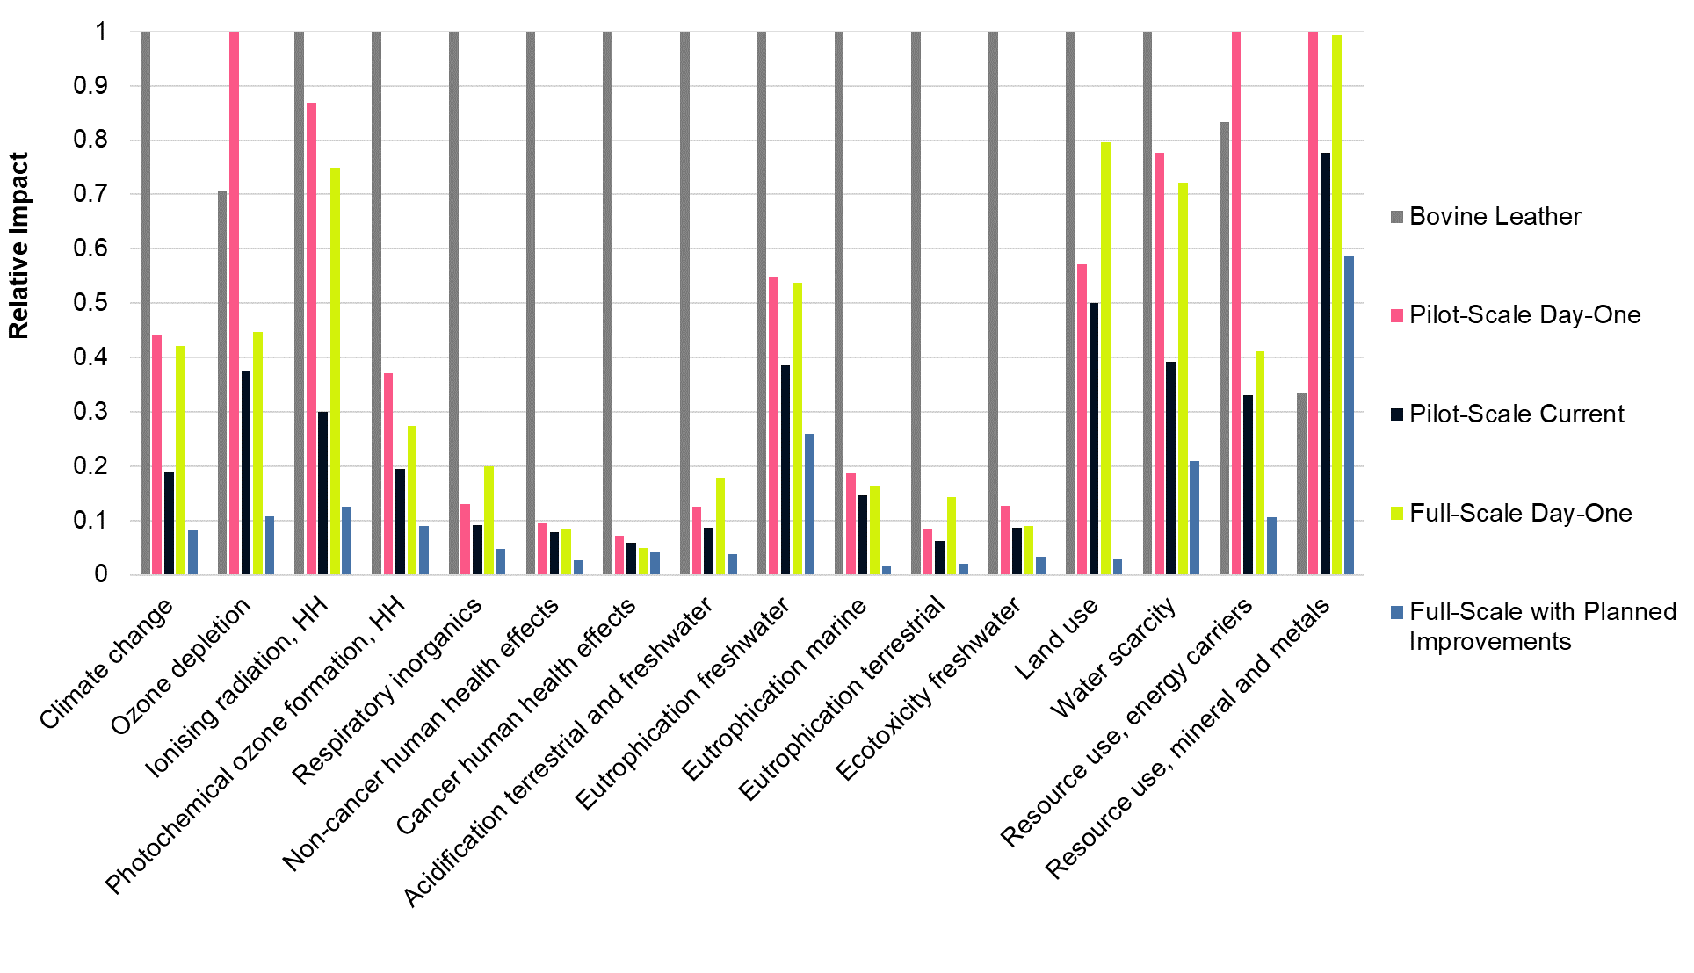
Figure 1. Characterized midpoint LCIA results of 1m² of Reishi in the four scenarios compared to 1m² of benchmark bovine leather, where the highest score is scaled to 100%.

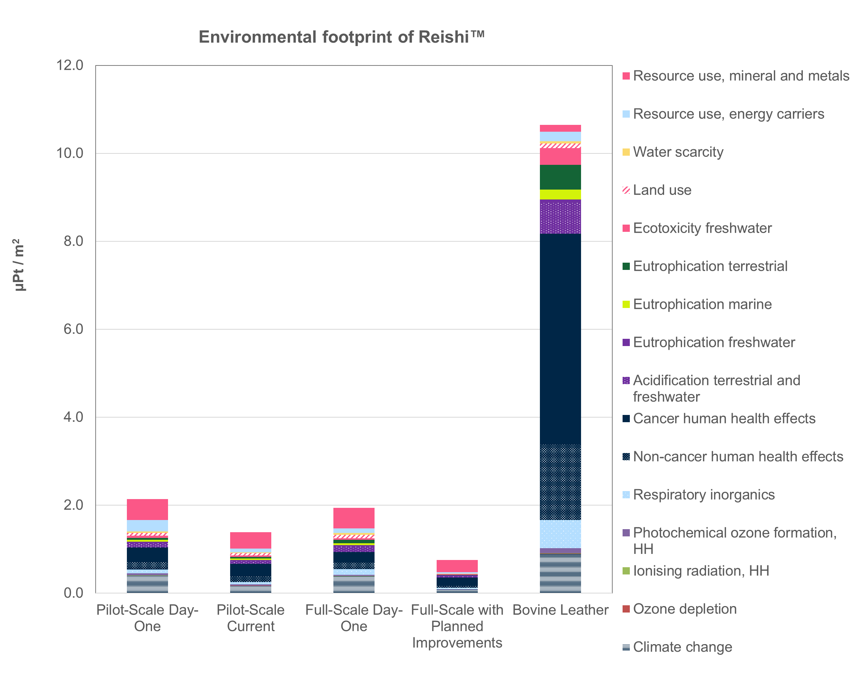
Figure 2. Environmental footprint (normalized and weighted results using the EF method 3.0 (Zampori & Pant, 2019)) for 1 m² of Reishi™ in the four scenarios compared to 1 m² of the benchmark bovine leather.

Discussion
Table 4 shows a comparison of all available published data for leather alternatives including the estimated calculation for “mushroom leather.”
In estimating the carbon footprint for Bolt Threads’ Mylo material, commercially available material was purchased and examined. Approximately 30% of the material by weight was found to be a polyurethane via FTIR analysis, with the remaining 70% comprising an unknown fraction of a combination of Viscose fibers, mycelium, and other polymers. For the purposes of this carbon emissions calculation, a weight fraction of 33% mycelium was used and applied to the Ecovative value calculated above to yield 92 kg CO₂-eq per m². Per the calculation above, this value also solely accounts for carbon consumed and emitted during the mycelium growth process and so is discounted to the actual value.
Table 4 Comparison of all available published data for leather alternatives *calculated value as explained in Table 1 and above
Company Name | Product Name | Product Structural Material | Material Description | Haptic | Best Carbon Emissions (kg CO₂₋eq. per m²) | Carbon Emissions Relative to Benchmark Bovine Leather Used
Natural haptics
Various | Leather | Animal hide | Animal hide | Natural | (Study-dependent) | 100%
MycoWorks | Reishi™ | Mycelium | Mycelium-only | Natural | 2.76 | 8%
Mogu | Ephea™ | Fabric backer | Mycelium mat (Mogu, 2022) | Natural | Unknown | Unknown
Ecovative | Forager™ | TBD | Compressed mycelium foam (“mushroom leather”) (ecovative, 2022) | Natural | 276* | 837%
Plastic haptics
Various | Vegan Leather (aka PU or PVC Leather) | Plastic (Polyurethane or PVC) | Polyurethane or Polyvinylchloride, can include a fabric backing | Plastic | 15.80  (Circumfauna, n.d.) | 48%
Various | Bicast Leather | Animal leather plus plastic (Polyurethane) | Animal hide coated with Polyurethane | Plastic | Unknown | Unknown
Bolt Threads | Mylo™ | Viscose fabric with thick plastic (polyurethane) | Viscose embedded with mycelium fibers and coated with Polyurethane | Plastic | 92* | 279%
Desserto | Desserto™ | Fabric with thick plastic (Polyurethane) | Polyurethane mixed with cactus fibers, applied as coating to a fabric | Plastic | 1.39  (DESSERTO®, 2022) | 5%
Vegea | V-Textile™ | Fabric with thick plastic (Polyurethane) | Polyurethane mixed with grape fibers, applied as coating to a fabric | Plastic | 3.80  (Vegea, 2022) | 6%
Modern Meadow | Bioleather1™ | Fabric with thick plastic (Polyurethane) | Fermented protein mixed with plastic, applied as coating to a fabric | Plastic | 8.22  (Locker et al., 2022) | 20%
Natural Fiber Welding | Mirum™ | Rubber (likely biodegradable) | Rubber cured with plant-based chemistry | Plastic-like (rubber) | 0.84  (Natural Fiber Welding, 2021) | 3%

References
Bayer, E., & Mclntyre, G. (2020). Method for Producing Grown Materials and Products Made Thereby. https://patents.google.com/patent/US20170049059A1/en
Circumfauna. (n.d.). LEATHER INDUSTRY DATA SHOWS US IT IS FAR MORE IMPACTFUL THAN EVEN SYNTHETIC ALTERNATIVES. Retrieved July 28, 2022, from https://circumfauna.org/leather-carbon-footprint#:~:text=In this case%2C CO2e emissions,of CO2e per square meter.
De Rosa-Giglio, P., Fontanella, A., Gonzalez-Quijano, G., Ioannidis, I., Nucci, B., & Brugnoli, F. (2018). Leather product environmental footprint category rules (Leather PEFCR). 25 April 2018, 1–160. https://ec.europa.eu/environment/eussd/smgp/pdf/PEFCR_leather.pdf
DESSERTO®. (2022). DESSERTO®. https://desserto.com.mx/home
Durlinger, B., Koukouna, E., Broekema, R., Van Paassen, M., & Scholten, J. (2017). Agri-footprint 4.0-Part 2: Description of data. Gouda, the Netherlands.
ecovative. (2022). Leather. https://www.ecovative.com/pages/leather
Huang, J., Mendoza, B., Daniel, J. S., Nielsen, C. J., Rotstayn, L., & Wild, O. (2013). Anthropogenic and natural radiative forcing. Climate Change 2013 the Physical Science Basis: Working Group I Contribution to the Fifth Assessment Report of the Intergovernmental Panel on Climate Change, 9781107057, 659–740. https://doi.org/10.1017/CBO9781107415324.018
Joseph, K., & Nithya, N. (2009). Material flows in the life cycle of leather. Journal of Cleaner Production, 17(7), 676–682.
Mogu. (2022). Mogu demonstration at “Biofabricate” conference.
MyloTM. (2022). Meet MyloTM. https://www.mylo-unleather.com/#meet-mylo
Natural Fiber Welding. (2021). How MIRUM® is made. https://blog.naturalfiberwelding.com/how-mirum-is-made
Ruiz, M. (2013). Documentation of changes implemented in ecoinvent. 0(5).
Vegea. (2022). Fashion. https://www.vegeacompany.com/v-textile/

