Supporting Information
Supporting Methods

Database Pre-Processing
Parameter harmonization
The three databases (NORMAN, EU-WB, WFD-DE) complement each other through different temporal-geographical scopes and cover a broad spectrum of pesticides (n = 535). The precise geo-referencing and day-accurate listing of the data, as well as overlapping substance spectra, facilitated the combination of individual data sets into a comprehensive, European-scale database. Challenges arise, however, from the use of multi-source data (Sprague et al., 2017), requiring the harmonization of incongruities within e.g., parameter names and formats. Differing spatial and temporal formats were normalized to a uniform decimal coordinate system (CRS WSG 84) and a uniform date and time format (DD-MM-YYYY).
Parameter and Data Filtering and Data Aggregation
The combined dataset was filtered for content, henceforth excluding substances not relevant for the research question at hand (e.g., industrial chemicals, pharmaceuticals, inorganic analytes) and waterbodies not unequivocally assignable to agricultural influence (e.g., estuaries, transitional waterbodies). Observations with missing values or presumable low-quality values according to the originator’s annotation, were excluded from further analysis. Respective metadata statements were available for all databases used, however not unequivocally expressive or extensive. Moreover, observations otherwise marked as not to be used or published were excluded from further utilization.
Potentially duplicate entries and blank samples were accounted for by aggregating the data to a daily maximum concentration on the basis of duplicates in specifications about measured substance, sampling date and geographic coordinates.
Data Quality Assessment
Harmonization of Quality Parameters
Analytical quality parameters, which are indispensable measures for analyzing and interpreting chemical monitoring data, were provided by the database originator in form of either limits of quantification or detection (LOQ or LOD respectively), binary vectors specifying a substance’s status of detection (“0” – non-detect or below LOD, “1” – detect or above LOD) and quantification (“0” – not quantified or below LOQ; “1” – quantified or above LOQ) or both. If the binary classification was not available a priori, categories were derived analogously through comparison of concentration and LOD and LOQ respectively. WB database provided neither classified nor extensive information on a substances detection status; in order to allow for comparison and combination with and among the databases, which provided both information criteria, quality and reliability of observations in all databases were henceforth assessed using only the LOQ information criterion, as it can be assumed that an observation categorized as quantified can comprehensibly be deemed as detected. Across database standardization of quality parameters was achieved by normalizing the binary quantification classifiers as per: 1 = quantified (measured value ≥ LOQ); 0 = not quantified (measured value < LOQ and/or measured value = 0). In cases where information was not provided by the database originator either to whether an observation was to be treated as quantified or serious doubt emerged from the comparison of an observations quality criteria, measured concentration and meta-data statements, LOQ were derived based on yearly, substance- and country-specific median LOQ values to fill the gaps.
Outlier detection and treatment
Exploratory data analysis was performed to determine the distributions of the data and to detect possible outliers and conspicuous values. However, since the databases chosen are environmental monitoring data, statistical detection and removal of outliers was (1) assumed to have taken place before publication of the data, yielding the quality criteria available in the data and (2) could post-hoc not be easily performed by the author, employing commonly used statistical tests (e.g., z-scores, see further explanation below) to avoid bias and possible exclusion of effective values actually measured in the environment. Instead, the detection and removal of outliers was performed under two assumptions, one taking into account properties of the pesticide and the other involving assumptions about the statistical distribution.
In a first step, outlier definitions provided within the databases were considered and accounted for when present, however, not all of the three databases included pre-defined, reliable outlier measures. Information of this type, nevertheless, indicates and highlights, that statistical quality assurance has already been performed prior to publishing the data. Data were then assessed based on common assumptions, e.g., a measured pesticide concentration of 10¹² µg/L in water was deemed improbable and removed from further analysis. Furthermore, intra-database (EU-WB) incongruencies struck attention when investigating different substances’ concentration distributions (i.e., patterns of unusually high concentrations a multiple, e.g., 1000-fold a substance’s LOQ value, potentially hinting at input errors and ambiguity errors concerning an observations unit) and were investigated and removed as thoroughly and comprehensible as possible by searching the respective database for multi-fold concentration-LOQ-combinations and removing them.
Secondly, the assumption was made that no substance can realistically be detected in water above its solubility level (according to the definition of aqueous solubility) at ecosystem level. After filtering out potential outliers according to this assumption, the third assumption takes into account how the remaining data are distributed per substance, and a "cut-off" for potential outliers is created according to gaps in each substance’s distribution, assuming that environmental concentration values are found on a continuous spectrum and gaps of - in some cases several orders of magnitude as found in the data - could not be plausibly explained.
For this purpose, a plausibility analysis of the substances concerned was carried out before the outlier analysis described in the following to ensure that no special events are responsible for certain noticeable concentrations. Since these plausibility analyses did not yield explanatory results and most of the unusual values were beyond reasonable assumptions of extraordinary exposure events, distance measures (as absolute differences to the next higher value) were calculated for each substance’s distribution above the 75th percentile. These differences were compared to standard deviations of different calculation bases (standard deviation of the total data set, per pesticide type and per substance). Finally, concentration values with differences of more than one standard deviation’s distance from the preceding value (in terms of quantity), including all subsequent (higher) concentration values, were classified as potential outliers. Due to the nature of the data, this method was chosen following the state of the art of statistical outlier tests, wherein outliers are detected, for example, by distances from the median or quartiles of a distribution (e.g., z-scores, Mishra et al., 2019). The chosen approach is roughly based on a distance-based approach introduced by Angiulli et al. (2006) and described in Smiti (2020), where a "solution set", a clustered subset of the data, is defined and differences of potential outliers to the nearest neighbors in this solution set are compared.
Finally, assuming the implementation of quality assurance measures related to measurement and analysis procedures either in the pre-processing of data prior to publication by the originators or appropriately available information on potential outlier classifications considered by users of these databases, the nature of environmental data can only be assumed to a certain extent. For example, assumptions about the nature of a distribution of a data set compiled of environmental data could be made (Blackwood, 1992), but not about the about the measured amount of an analyte (at least to a certain, "realistic" degree; e.g., a definite “error” of a concentration of 10¹² µg/L was identified and removed manually during the pre-analysis). It is therefore more evident to apply the dynamic difference measure approach outlined here, taking into account the respective substance distribution and physico-chemical behavior, rather than using a standard statistical measure (e.g., IQR = inter quartile range) that classifies outliers based on the distance of a value from, e.g., the median of a distribution, since by applying such an approach on a presumably (to some extent) preprocessed data set, one could be at higher risk of excluding relevant, valid values from the analysis.
Additional Parameter Attribution
The preprocessed data were assigned spatio-temporal climatic information (e.g., precipitation per day, wind speed; Agri4Cast, 2022), agricultural land use (Heymann, 1993), hydrological properties (e.g., Strahler number of a river, size of a water body; European Environment Agency, 2012), substance-specific physico-chemical data (University of Hertfordshire, 2022), information about current approval statuses (Waterbase - Water Quality ICM, European Environment Agency, 2021) and application regimens (Bundesamt für Verbraucherschutz und Lebensmittelsicherheit, 2021). Application schemes were represented by maximum number of applications per year/culture and minimum intervals between applications. Data were gathered from the German Federal Office for Consumer Protection and Food Safety’s directory of approved plant protection products (Bundesamt für Verbraucherschutz und Lebensmittelsicherheit, 2021). Since no data on European-scale application regimens or recommendations are available on a substance basis, German data were used and counter-checked with recommended application schemes mentioned in EFSA conclusion documents (European Food Safety Authority).
A hierarchical spatial index was used as an additional geographic reference. The Uber hexagonal hierarchical spatial index H3 (Brodsky, 2018, Uber Technologies, Inc., 2021) was chosen as a reference for the data by assigning unique indices for the entire data domain corresponding to a coordinate intersection with an H3 hexagon. Different zoom-levels have been tried; to assure the highest possible accuracy, H3 zoom level 10 (corresponding to 0.015 km²) was chosen to facilitate the joint consideration of sections of the same water body that are located close to each other and have been specified with different coordinates without, however, considering different water bodies.

Supporting Results

Data Quality Limitations and Considerations
During the process of preliminary data analysis, one of the monitoring data sets used (EU-WB) was found to indicate overall high environmental concentrations of pesticides throughout all pesticide types (insecticides, herbicides, fungicides). Rectification and adjustment based on meta-data available through the database originator was incongruent on an intra- and inter-database level (e.g., meta-data statements not unambiguously indicating a data points reliability) while assumptions on a data points nature (e.g., quantification amount) was attempted to be kept minimal to avoid arbitrary alterations to the data. Observations reported as quantified at the same amount as the specific LOQ reflect, in the worst-case scenario, minima, namely the lowest quantifiable concentration at the respective sampling site and date. A substance was hence observed with sufficient analytical accuracy, making its presence interpretable taking into account the distinctiveness called to attention in the previous remarks.
Analysis of chemical monitoring datasets can be challenging due to the integration of data from multiple sources, often requiring addressing issues related to data quality control, data synchronization, and data format compatibility (Hutton et al., 2016, Sprague et al., 2017, Stagge et al., 2019). The combination of the three databases used in this work (EU-WB, NORMAN & WFD-DE) revealed incongruencies on an intra- and inter-database level (e.g., availability and coverage of LOD and LOQ across the substance spectra), which were addressed taking into account the specific challenge at hand (e.g., detecting and removing potential outliers while incorporating the nature of the underlying observations).
High-quality meta-data could anticipate challenges regarding uniformly available data quality in the future, especially taking into account annotation of suspect or potentially incomplete data (Gudivada et al., 2017). International collaboration and extension of exchange and the establishment of cross-national and cross-source work-flows and standards in the implementation of large-scale hydrological monitoring data might facilitate future efforts of combining multiple source databases in the attempt to gain comprehensible data for exploration and modeling (Blöschl et al., 2019, Plana et al., 2019, Tang et al., 2019).

Data Significance
European-scale pesticide monitoring data are a crucial tool for the assessment of chemical pollution, especially taking into account the time series and geographical resolution of large-scale monitoring data sets in comparison to more particular data from peer-reviewed literature. The data compiled here provides a comprehensive view of the pesticide pollution levels in the aquatic environment across Europe. The data can be analyzed and compared to assess the distribution and trends of pesticide pollution and eventually to determine their impact on the environment. This information is essential for developing effective policies and strategies to reduce and manage chemical pollution in the aquatic environment. Moreover, these data are also critical for monitoring and evaluating the success of current and future efforts to control pesticide exposure of non-target ecosystems and to ensure the protection of the aquatic environment. With the growing concern about the impact of chemical pollutants on the environment, combined European-wide aquatic monitoring data will continue to play a critical role in the assessment and management of chemical pollution.
Environmental Behavior Driving POR Distribution
Physico-chemical properties of pesticides showed significant differences in distributions of solubility in water, DT_{soil}, vapor pressure and Henry coefficient (H) among the quadrants I, II and III (main text figure 2). Pesticides in figure 2 III were found to have a significantly lower vapor pressure than pesticides in I and II, wherein this pattern appears to be mainly influenced by insecticides and herbicides, with fungicides not exhibiting these significant differences (see figure SI-7). Similarly, the Henry coefficient in figure 2 II was significantly lower than in III, driven by insecticides. Both parameters (H and vapor pressure) are volatility measures, indicating lower tendency of pesticides (specifically insecticides) to volatilize when they also exhibit a high POR_{long-term}/POR_{short-term} ratio, hence permanently occurring behavior by remaining in the aquatic environment for longer timespans. Pesticide soil half-life (DT_{50, soil}) was similarly significantly lower in figure 2 II compared to III, however, only in case of insecticides (Insecticides_{II} < Insecticides_{III}), without an overall trend across pesticide types. Lower DT_{soil} indicate a faster dissolution from soil into water but also a higher speed of (a)biotic degradation, the former potentially causing a pesticide to be released from soil at rates sufficiently short to be available to be detected intermittently, over longer time periods (figure 2 II) given a large enough substance amount bound to soil, while longer DT_{soil} values indicate potential for permanent releases over longer time periods (figure 2 III; Redman et al., 2022). Substance solubility presented significantly lower in figure 2 I compared to III, influenced exclusively by herbicides, implying quicker dissolution and hence transport of an herbicide, especially taking into account, that only lotic water bodies are regarded here. Linear correlations between pesticide PORs and physico-chemical, hydrological or land-use specific parameters were not evident.
Physico-chemical properties of subset of pesticides (e.g., tebuconazole, cyprodinil, deltamethrin) suggest environmental behavior disaccording with relative POR categorizations. Tebuconazole, a fungicide currently approved for use in the EU, is considered persistent according to physico-chemical criteria (stable aquatic DT₅₀, hence candidate for substitution). However, based on its low POR_{medium-term} and high POR_{long-term}, in the present study, tebuconazole was assigned to figure 2 II. This implies intermittent occurrence rather than persistence, indicating intermittent decreases of its environmental exposure rather than permanent occurrence. Similarly, cyprodinil is generally considered moderately persistent with a potential to persist in the aquatic environment, depending on environmental conditions (it is volatile with a vapor pressure of 0.51 mPa, but stable in water; University of Hertfordshire, 2022). However, the present analysis rather suggests an ephemerally occurring pattern (located in figure 2 I, indicating low POR_{medium-term} and POR_{long-term}), potentially pointing to either monitoring strategies skewing observational accuracy, hence influencing the calculation of PORs, or the environmental behavior not aligning with laboratory-derived physico-chemical properties (e.g., DT₅₀; Beulke, Brown, 2001). Further, deltamethrin, a currently approved insecticide was located in figure 2 I (i.e., ephemerally occurring), although it is considered persistent according to its stable aqueous DT₅₀, semi-volatility (1.24×10⁻⁵ mPa) and low solubility in water (2×10⁻⁴ mg/L), making it potentially more transient in aqueous environments, but also less detectable during monitoring. Contrastingly, POR categorization of bentazone (figure 2 III: high POR_{medium-term} and POR_{long-term}), a currently approved herbicide aligns with persistence evaluations according to aqueous DT₅₀, considering it potentially persistent in water (University of Hertfordshire, 2022). Malathion, a currently approved insecticide, is not usually considered persistent (DT₅₀ = 6.2 days), it is also moderately volatile (3.1 mPa) and soluble (148 mg/L), which makes it categorization as intermittently occurring (i.e., figure 2 II) comprehensible as a substance rather readily dissolving and degrading but hardly volatilizing, it is also moderately mobile in soil (Freundlich coefficient = 1.58) and is readily released to water from sediments (DT_{50,sediment/water} 0.4 days), which in summary with its application for the protection of e.g., turnips, which are grown in the ground might lead to pulse-like, moderately long-term exposures of adjacent waterbodies following application.
Understanding the Impact of Application Schemes on Substance PORs
Apart from physico-chemical characteristics, a pesticide’s frequent application and repeated or prolonged presence in environmental compartments can be indicative of pseudo-persistent behavior (Primost et al., 2017). However, use of this term is not undisputed due to the importance persistence (physico-chemical and environmental) itself holds in the assessment and evaluation of chemicals and environmental implications (Cousins et al., 2019).
Comparison of maximum allowed uses per year or per use type (derived from German use data, BVL, 2021) did not yield significant differences between quadrants across pesticide types. However, fungicides exhibited higher mean allowed applications per year and use in figure 2 II and III (maximum per year: 3.4 & 3; maximum per use: 2 respectively) compared to figure 2 I (maximum per year: 2.1; maximum per use: 1.5), in line with previously observed patterns of fungicides tending towards longer-term reoccurrence. Insecticides, contrarily, applied at highest maximum rates per year and use are found in figure 2 I (2.3 and 1.8 respectively), followed by II (1.7 each) and III (1.8 and 1.4 respectively), highlighting the importance of peak exposure events in connection with insecticide application and monitoring. Herbicides most frequent maximum allowed applications per year and use are found in figure 2 III (1.5 and 1.3 respectively), followed by I and II (1.3, 1.2, 1.2 and 1.1 respectively), similarly to fungicides, highlighting the importance of long-term reoccurrence while also supporting the potential influence of repeated applications for high POR_{medium-term}. Limiting the evaluation to pesticides currently approved for use in the EU did not influence the overall trend among quadrants, however average allowed applications were shifted towards higher values, which could point towards adjusted application strategies for more recent pesticides or to an influence of the application data used for evaluation being unevenly distributed towards currently approved pesticides.
Among pesticides with relatively higher intermittent occurring behavior (figure 2 II) significant differences were revealed between substance solubilities with applications allowed less and more than twice per year, indicating higher (more than two times as high) solubility in substances applied less than two times per year. This study hereby unraveled how the interplay of physico-chemical properties and application regulations can induce pseudo-persistent behavior in contrast to per se non-persistent substance properties. Nevertheless, whether through frequent application or by physico-chemical environmental behavior, prolonged or repeated reoccurrence of pesticides in aquatic environments is problematic, due to continued or repeated stress exercised on the exposed ecosystems (Tennekes et al., 2011).
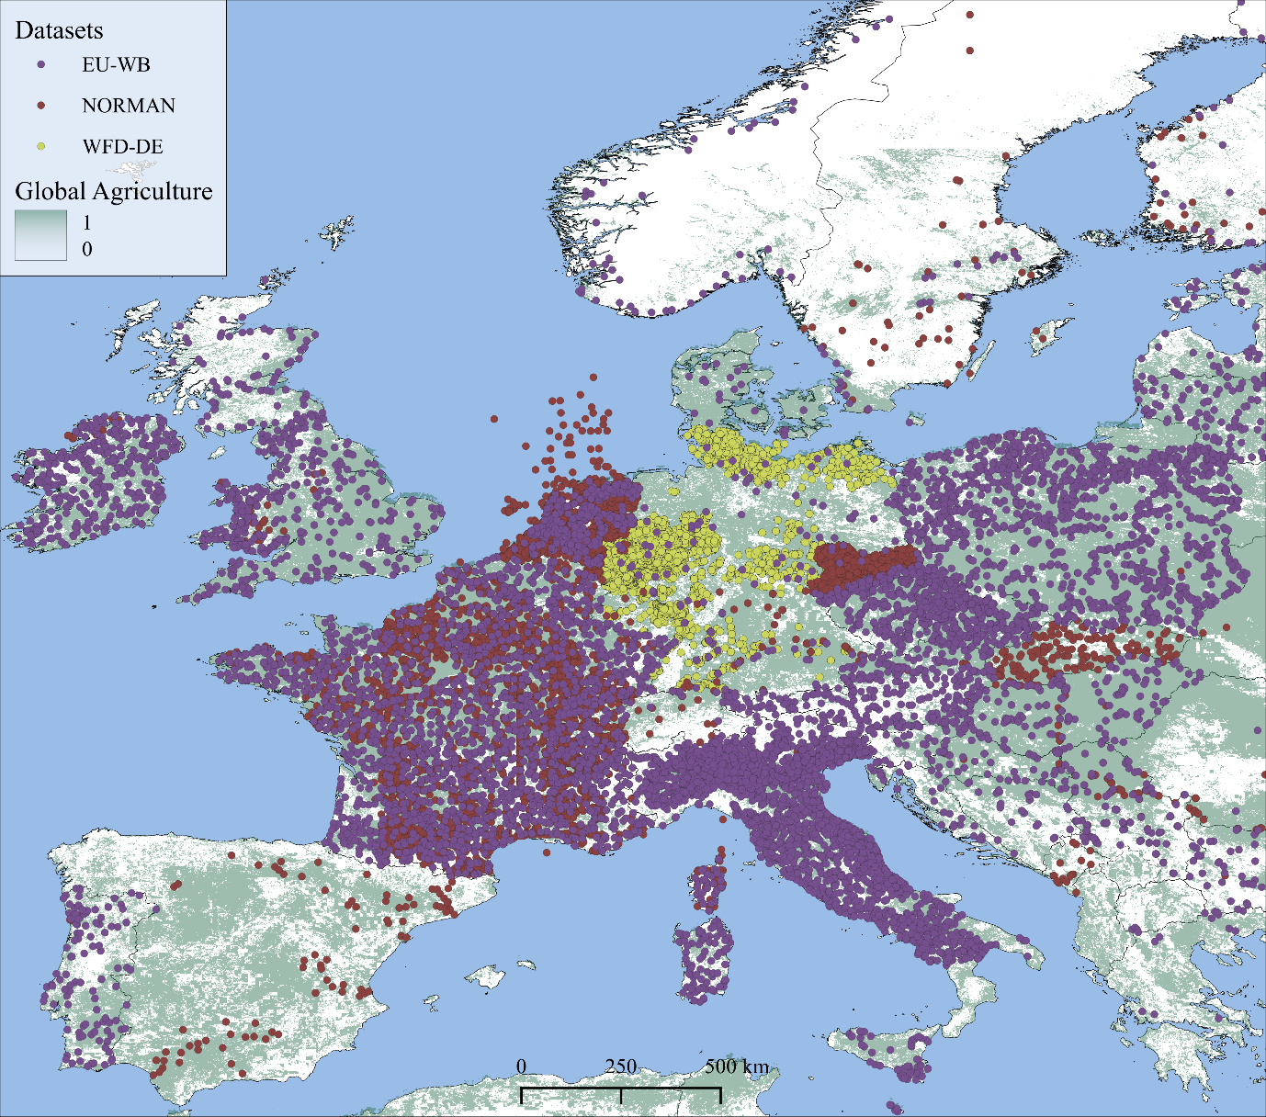
Supporting Figures
Figure SI-1 – Map displaying data coverage of the three opensource databases used in this study. CORINE Land Cover (Heymann 1993) data were used to display agriculturally used land-types across Europe.
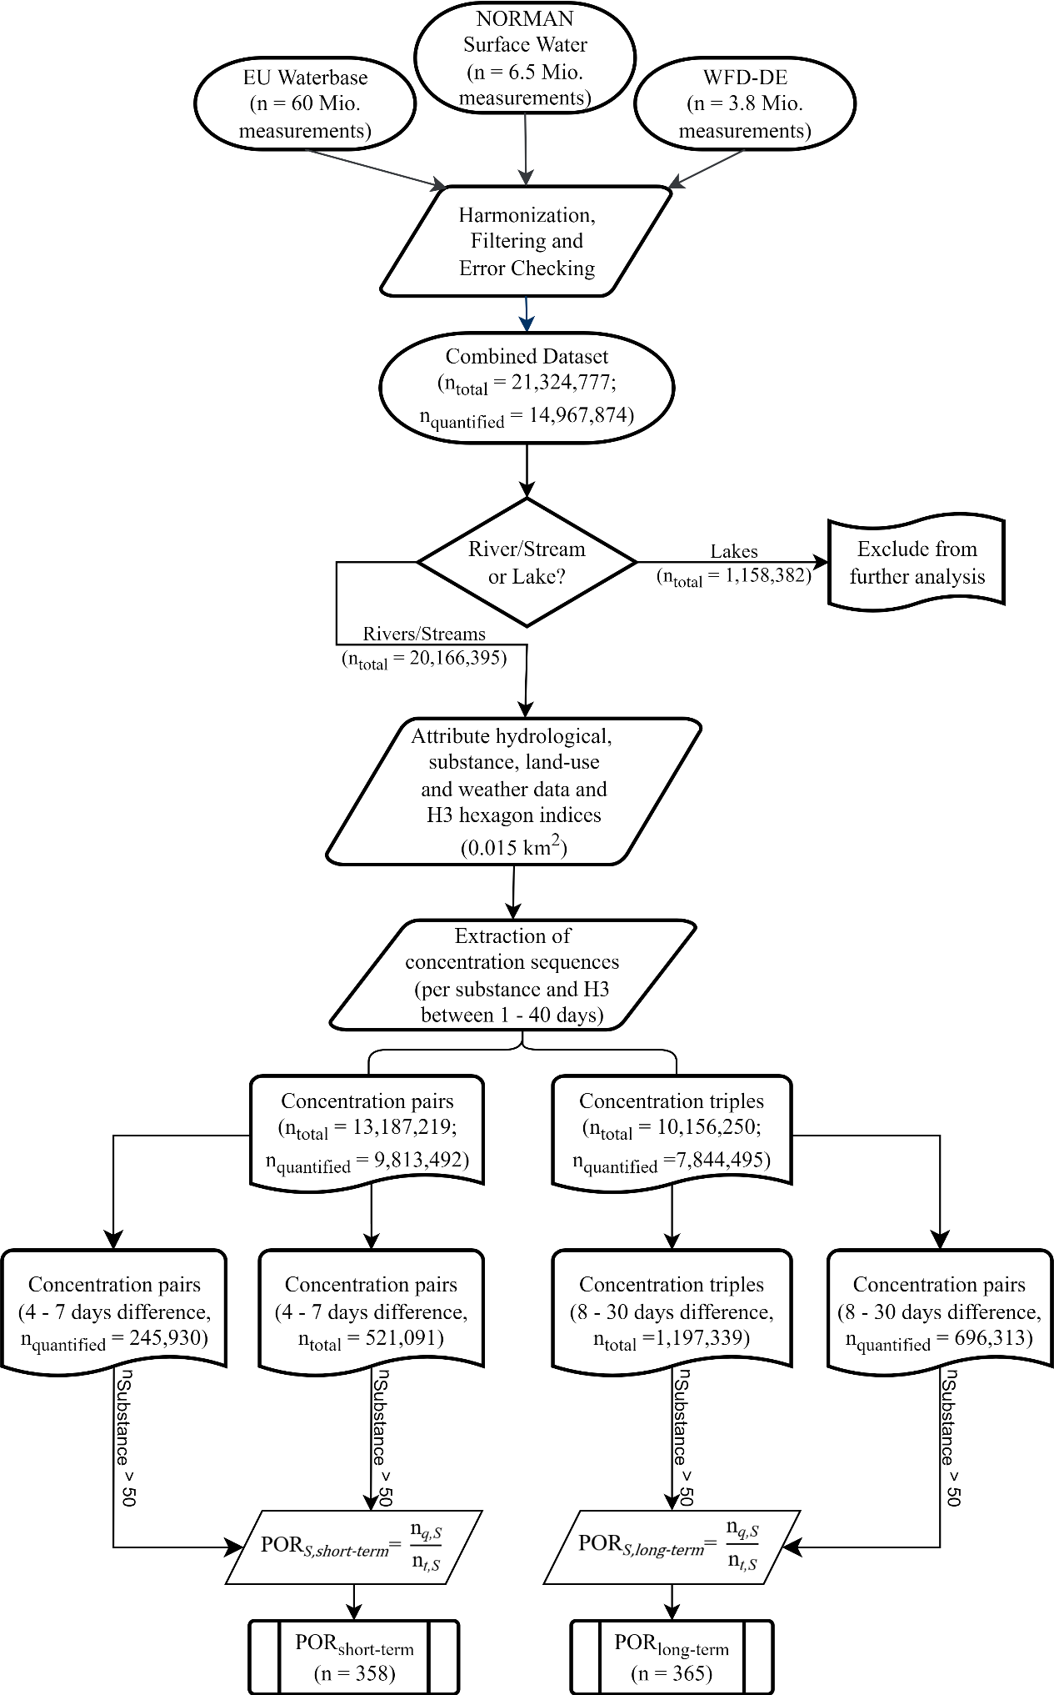
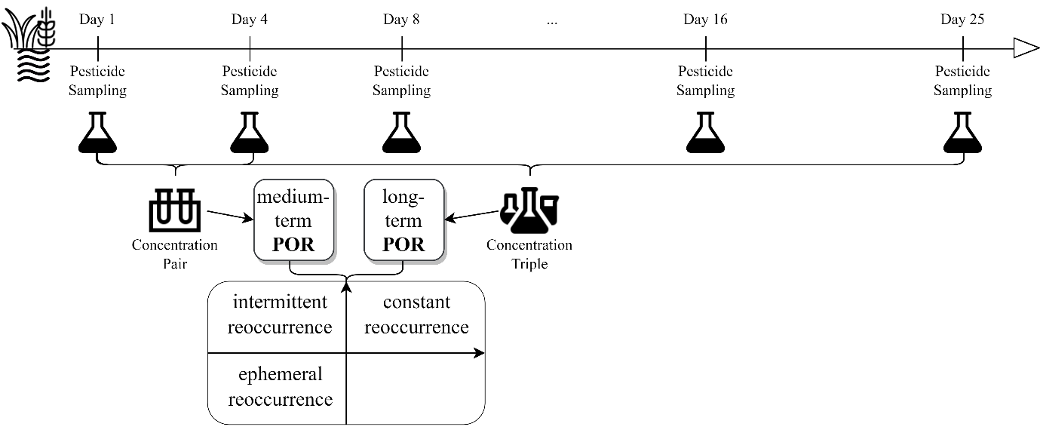
Figure SI-2 – Data processing flowchart illustrating the pipeline of data streamlining and preparation for the derivation of concentration pairs and triples and the subsequent calculation of pesticide PORs.
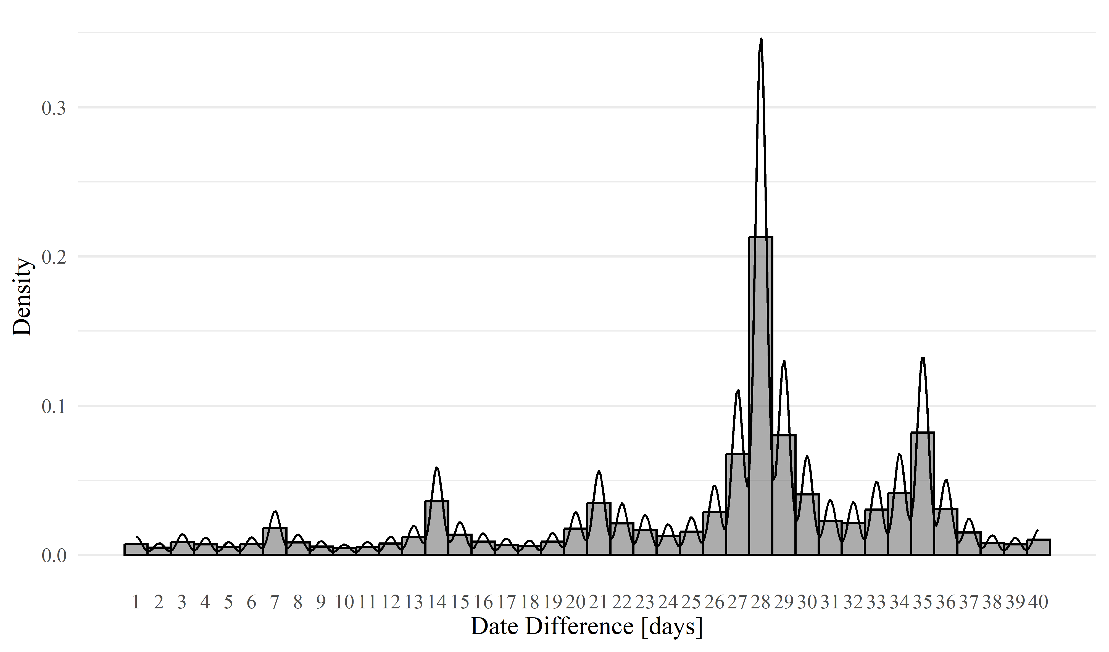
Figure SI-3 – Exemplary visualization of the derivation of concentration sequences for the calculation of pesticides PORs.
Figure SI-4 – Density distribution of sampling intervals discovered in the data used for our analysis of substances with n > 100.
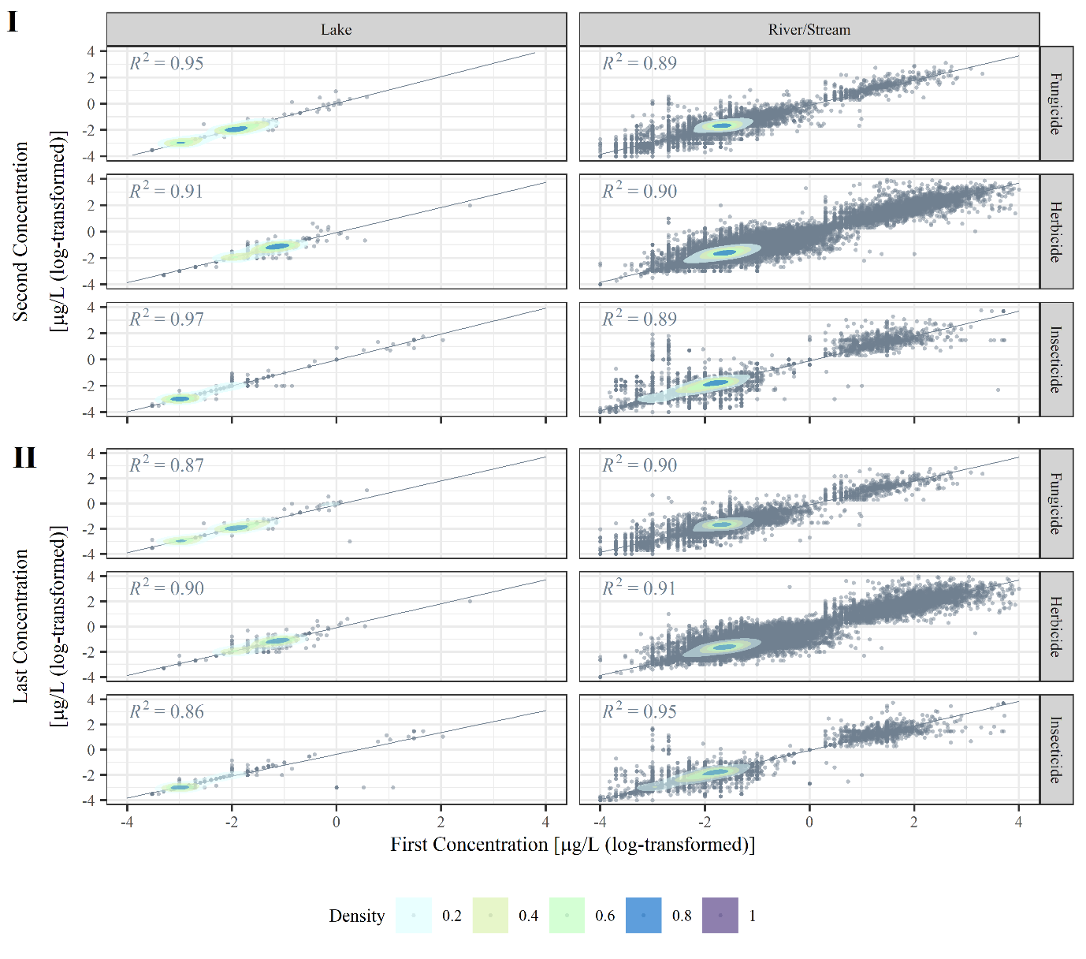
Figure SI-5 – Comparison of subsequent concentrations based on concentration triples (I: 1st and 2nd concentration, II: 1st and 3rd concentration) on log₁₀-transformed axes. Points are overlayed with density clouds demonstrating the concentration of data. Linear regression models were fitted for the relation between 1st and 2nd (I) and 1st and 3rd (II) concentrations with respective R² displayed accordingly.
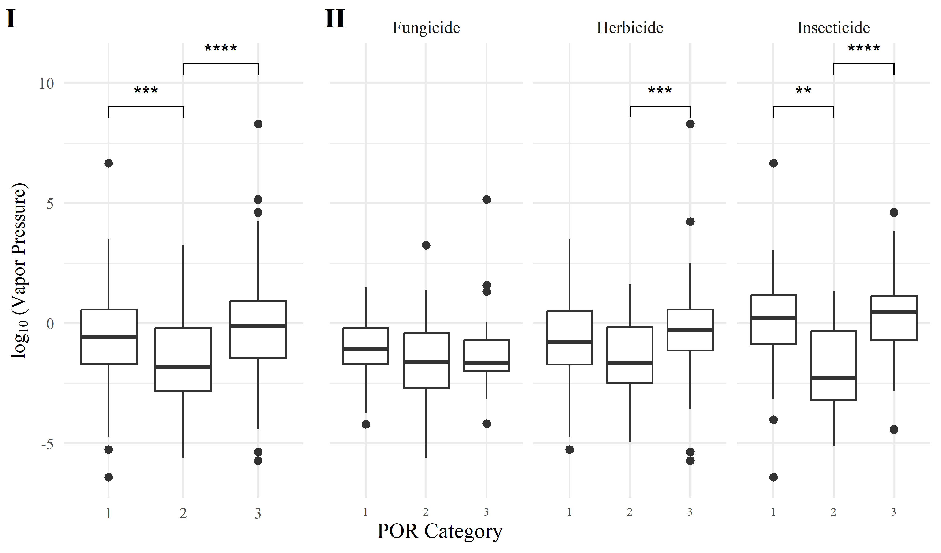
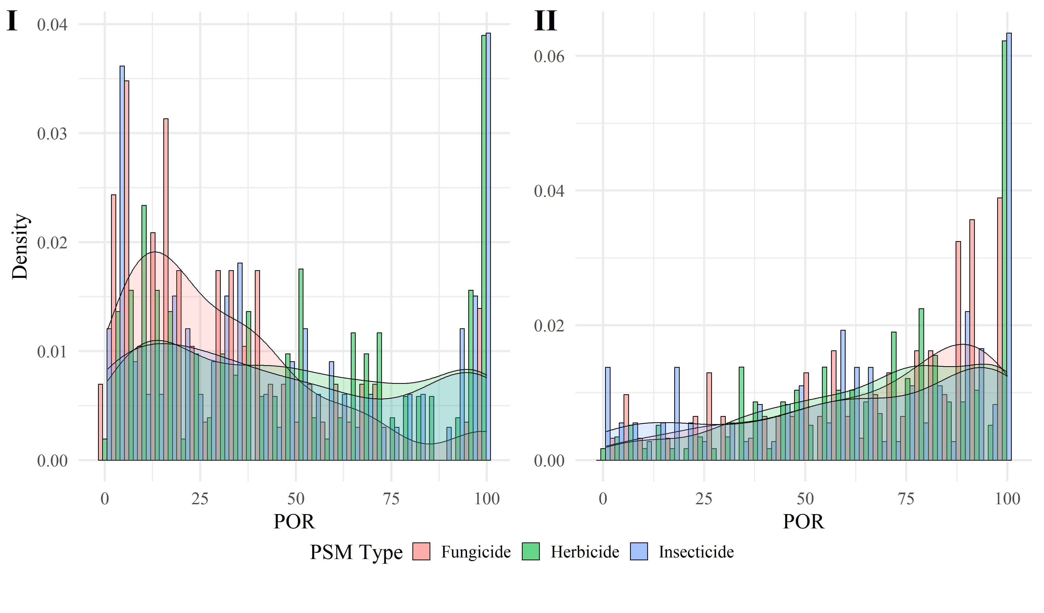
Figure SI-6 – Histograms of POR distribution categorized by pesticide types (red = fungicides, green = herbicides, blue = insecticides) for concentration pairs (A) and triples (B). Concentration pairs (indicating medium-term reoccurrence) exhibit a skewedness towards POR < 50% while POR calculated based on concentration triples (indicating long-term reoccurrence) tend to be more right-skewed.
Figure SI-7 – Boxplots of distributions of (log₁₀-transformed) vapor pressure across POR categories (plot I) assigned in Figure 2 (main text), grouped by pesticide types (II). Levels of significance for differences in mean values are denoted as: *: p < 0.05, **: p < 0.01, ***: p < 0.005.
Supporting Tables
Table SI-1 – Descriptive statistics of databases used and created in the course of this study.
Raw Data*
EU Waterbase | NORMAN Empodat | German WFD
n = 60,011,857 | n = 6,479,007 | n = 3,838,760
817 substances/parameters | 458 substances | 162 substances
n_{pesticides} = 24,930,900 | n_{pesticides} = 6,014,337 | n_{pesticides} = 3,838,760
317 pesticides | 341 pesticides | 162 pesticides
1941 – 2021 | 1998 – 2020 | 1984 – 2015
Pre-processed and Combined Data**
 | total entries | quantified entries
 | n = 21,324,777 | n = 14,967,874
Waterbodies | n_{rivers/streams} = 20,166,395  n_{lakes} = 1,158,382 | n_{rivers/streams} = 14,040,012  n_{lakes} = 927,862
Pesticide Types | n_{herbicides} = 11,321,558  n_{insecticides} = 7,538,874  n_{fungicides} = 2,464,345 | n_{herbicides} = 7,770,444  n_{insecticides} = 5,760,294  n_{fungicides} = 1,437,136
Database Coverage | n_{EU-WB} = 13,108,835  n_{NORMAN} = 4,415,429  n_{WFD} = 3,794,917  n_{NORMAN, EU-WB} = 5,596 | n_{EU-WB} = 12,776,594  n_{NORMAN} = 287,908  n_{WFD} = 1,897,776  n_{NORMAN, EU-WB} = 5,596
Concentration Sequences***
 | Duplets | Triplets
n_{total}  (only quantified) | n = 13,187,219  (n = 9,813,492) | n = 10,156,250  (n = 7,844,495)
Countries | n = 37 | n = 36
Sites | 11,846 | 9,140
Years | 1978 – 2021
Waterbodies  (only quantified) | n_{rivers/streams} = 12,578,968  (n_{rivers/streams} = 9,332,171)  n_{lakes} = 608,251  (n_{rivers/streams} = 481,321) | n_{rivers/streams} = 9,700,495  (n_{rivers/streams} = 7,458,322)  n_{lakes} = 455,755  (n_{rivers/streams} = 386,173)
Pesticide Types  (only quantified) | n_{herbicides} = 6,843,018  (n_{herbicides} = 4,911,014)  n_{insecticides} = 4,912,023  (n_{insecticides} = 3,986,196)  n_{fungicides} = 1,432,178  (n_{fungicides} = 916,282) | n_{herbicides} = 5,179,257  (n_{herbicides} = 3,870,537)  n_{insecticides} = 3,893,111  (n_{insecticides} = 3,249,745)  n_{fungicides} = 1,083,882  (n_{fungicides} = 724,213)
*The first part of the table described the three databases combined for this study (NORMAN, Jaroslav Slobodnik. NORMAN EMPODAT Database - Chemical Occurrence Data, 2022; EU-WB, Waterbase - Water Quality ICM and German Pesticide Monitoring data collected in the course of the implementation if the water framework directive, European Parliament and Council, 2000)in raw data form.
**The second part of the table describes the pre-processed combined data, subdivided into total data entries and only quantified data entries.
***The third and final part of the table contains descriptive statistics about concentration duplets and triplets.
Table SI-2 – Descriptive statistics of pesticide reoccurrences derived from concentration pairs and triples.
14,967,874 quantified measurements of 474 pesticide compounds at 17,638 sites
 | Medium-term reoccurrence | Longer-term reoccurrence
n | 245,930 | 322,640
% of all measurements | 1.6% | 2.2%
% of respective measurements | 47.2% | 61.7%
n_{sites} | 2,122 | 1,256
% of all sites | 12% | 7.6%
n_{compounds} | 428 | 406
% of all compounds | 90.3% | 85.6%
n_{POR} | 358 | 365
POR distributions | n_{Herbicides} = 165  n_{Insecticides} = 104  n_{Fungicides} = 89 | n_{Herbicides} = 169  n_{Insecticides} = 106  n_{Fungicides} = 90
Table SI-3 – Pesticides with at least one POR (POR_{medium-term} or POR_{long-term}), respective pesticide type and POR category.
Substance | Pesticide Type | Quad-rant | POR_{medium-term} [%] | POR_{long-term} [%]
(Z)-Dichloropropene | Insecticide | I | 5.2 | 12.6
2,4,5-Trichlorophenoxyacetic acid | Herbicide | III | 72.1 | 84.3
2,4-Dichlorophenol | Herbicide | IV | 55.2 | 33.6
2,4-Dichlorophenoxyacetic acid | Herbicide | III | 51.3 | 75.0
2,4-Dichlorophenoxybutyric acid | Herbicide | III | 68.4 | 75.4
2,6-Dichlorobenzamide | Herbicide | III | 69.1 | 72.9
2,6-Dichlorobenzonitrile | Herbicide | IV | 50.6 | 47.3
2-Imidazolidinethione | Fungicide | III | 100.0 | 100.0
3-Hydroxycarbofuran | Insecticide | III | 75.2 | 97.8
4,6-Dinitro-o-cresol | Herbicide | III | 96.1 | 99.3
AMPA | Herbicide | III | 69.7 | 82.1
Acetamiprid | Insecticide | III | 68.1 | 98.0
Acetochlor | Herbicide | III | 77.9 | 73.5
Acibenzolar-S-methyl | Fungicide | II | 16.8 | 92.8
Acifluorfen | Herbicide | III | 100.0 | 90.1
Aclonifen | Herbicide | III | 60.1 | 59.1
Alachlor | Herbicide | III | 95.5 | 68.6
Aldicarb | Insecticide | I | 5.1 | 24.9
Aldrin | Insecticide | III | 90.4 | 55.8
Ametoctradin | Fungicide | NA | NA | 100.0
Ametryn | Herbicide | I | 25.4 | 37.7
Amidosulfuron | Herbicide | II | 24.8 | 62.4
Atrazine | Herbicide | III | 96.6 | 90.8
Azinphos-ethyl | Insecticide | III | 50.6 | 63.8
Azinphos-methyl | Insecticide | III | 61.1 | 90.1
Aziprotryne | Herbicide | NA | NA | 100.0
Azoxystrobin | Fungicide | II | 48.4 | 59.6
Beflubutamid | Herbicide | II | 6.0 | 81.6
Benalaxyl | Fungicide | I | 34.5 | 39.8
Benfluralin | Herbicide | III | 100.0 | 100.0
Bentazone | Herbicide | III | 72.9 | 79.7
Benthiavalicarb-isopropyl | Fungicide | II | 4.1 | 75.6
Bifenox | Herbicide | I | 46.5 | 47.0
Bifenthrin | Insecticide | NA | 1.7 | NA
Bis(dimethylaminothiocarbonyl) disulfide | Fungicide | II | 27.9 | 58.8
Bixafen | Fungicide | I | 7.4 | 7.8
Boscalid | Fungicide | I | 31.8 | 40.5
Bromacil | Herbicide | II | 41.6 | 54.1
Bromoxynil | Herbicide | III | 86.1 | 94.8
Bromoxynil octanoate | Herbicide | I | 31.3 | 36.7
Bromuconazole | Fungicide | II | 16.8 | 92.8
Bupirimate | Fungicide | II | 31.7 | 86.7
Butam | Herbicide | I | 11.3 | 44.5
Buturon | Herbicide | NA | NA | 100.0
Captan | Fungicide | III | 100.0 | 100.0
Carbendazim | Fungicide | III | 66.0 | 53.0
Carbetamide | Herbicide | III | 76.8 | 91.1
Carbofuran | Insecticide | III | 78.3 | 95.0
Carboxin | Fungicide | I | 2.7 | 27.8
Carfentrazone-ethyl | Herbicide | NA | NA | 100.0
Chlorantraniliprole | Insecticide | II | 6.0 | 81.6
Chlordane | Insecticide | I | 11.5 | 18.6
Chlorfenvinphos | Insecticide | III | 95.8 | 75.2
Chlorfluazuron | Insecticide | NA | NA | 100.0
Chloridazon | Herbicide | III | 51.7 | 70.8
Chlorothalonil | Fungicide | I | 6.2 | 2.9
Chlorotoluron | Herbicide | III | 57.0 | 69.0
Chloroxuron | Herbicide | II | 42.1 | 85.5
Chlorpropham | Herbicide | I | 9.6 | 18.1
Chlorpyrifos | Insecticide | III | 95.7 | 88.5
Chlorpyrifos-methyl | Insecticide | III | 59.4 | 59.1
Chlorsulfuron | Herbicide | III | 100.0 | 93.7
Chlorthiamid | Herbicide | III | 100.0 | 100.0
Clethodim | Herbicide | II | 4.8 | 77.9
Clodinafop | Herbicide | NA | NA | 100.0
Clodinafop-propargyl | Herbicide | II | 0.9 | 78.5
Clomazone | Herbicide | I | 13.7 | 8.1
Clopyralid | Herbicide | III | 51.4 | 54.9
Clothianidin | Insecticide | III | 70.6 | 79.3
Coumaphos | Insecticide | I | 19.0 | 9.0
Cyanazine | Herbicide | III | 53.0 | 58.0
Cyazofamid | Fungicide | II | 6.7 | 80.6
Cybutryne | Fungicide | III | 71.6 | 74.0
Cycloxydim | Herbicide | I | 6.7 | 35.9
Cyflufenamid | Fungicide | II | 22.8 | 87.9
Cyfluthrin | Insecticide | I | 3.6 | 3.9
Cypermethrin | Insecticide | III | 94.6 | 91.6
Cyproconazole | Fungicide | I | 20.1 | 30.2
Cyproconazole | Fungicide | I | 20.1 | 30.2
Cyprodinil | Fungicide | I | 9.3 | 24.4
Cyromazine | Insecticide | II | 12.6 | 57.5
DDT | Insecticide | IV | 96.9 | 48.1
Dalapon | Herbicide | III | 100.0 | 100.0
Deethylatrazine | Herbicide | III | 51.3 | 73.0
Deisopropylatrazine | Herbicide | III | 64.2 | 60.1
Deltamethrin | Insecticide | I | 2.9 | 8.4
Demeton-S | Insecticide | I | 2.4 | 1.9
Demeton-S-methyl | Insecticide | III | 83.7 | 97.9
Demeton-S-methylsulphon | Insecticide | III | 81.8 | 97.9
Desethylterbutylazine | Herbicide | III | 52.2 | 57.6
Desmedipham | Herbicide | III | 64.1 | 52.1
Desmetryn | Herbicide | III | 72.8 | 73.7
Diazinon | Insecticide | I | 26.3 | 46.3
Dicamba | Herbicide | IV | 66.9 | 48.6
Dichlofluanid | Fungicide | I | 2.7 | 36.3
Dichlorprop | Herbicide | III | 80.6 | 93.3
Dichlorprop-P | Herbicide | II | 17.6 | 78.7
Dichlorvos | Insecticide | III | 64.4 | 70.7
Diclofop | Herbicide | III | 80.0 | 84.3
Dicofol | Insecticide | IV | 51.7 | 45.9
Dieldrin | Insecticide | III | 91.2 | 57.3
Difenoconazole | Fungicide | III | 69.8 | 81.1
Diflubenzuron | Insecticide | II | 23.6 | 81.6
Diflufenican | Herbicide | I | 15.9 | 38.9
Dimefuron | Herbicide | II | 48.3 | 75.9
Dimethachlor | Herbicide | II | 38.4 | 54.0
Dimethenamid | Herbicide | I | 11.1 | 12.6
Dimethenamid-P | Herbicide | NA | NA | 6.1
Dimethoate | Insecticide | II | 48.6 | 66.3
Dimethomorph | Fungicide | III | 56.4 | 91.8
Dimoxystrobin | Fungicide | III | 62.4 | 78.3
Diniconazole | Fungicide | NA | NA | 100.0
Dinoseb | Herbicide | III | 99.4 | 94.1
Dinoterb | Herbicide | IV | 86.7 | 40.9
Disulfoton | Insecticide | II | 3.7 | 54.9
Diuron | Herbicide | III | 91.4 | 80.4
Endosulfan | Insecticide | III | 98.9 | 96.8
Endosulfan I | Insecticide | III | 52.4 | 64.3
Endosulfan II | Insecticide | III | 62.7 | 58.6
Endosulfan sulfate | Insecticide | I | 3.9 | 1.1
Endrin | Insecticide | III | 91.3 | 57.4
Epoxiconazole | Fungicide | III | 53.8 | 52.5
Etaconazole | Fungicide | NA | NA | 100.0
Ethephon | Herbicide | NA | NA | 100.0
Ethidimuron | Herbicide | III | 94.7 | 88.6
Ethofumesate | Herbicide | II | 38.1 | 53.8
Ethyl N-cyclohexyl-N-ethylthiolcarbamate | Herbicide | NA | NA | 100.0
Etofenprox | Insecticide | II | 21.9 | 74.6
Etrimfos | Insecticide | II | 49.2 | 60.6
Famoxadone | Fungicide | II | 15.1 | 68.9
Fenamidone | Fungicide | II | 35.4 | 90.0
Fenarimol | Fungicide | I | 20.1 | 48.7
Fenazaquin | Insecticide | III | 54.6 | 91.3
Fenbuconazole | Fungicide | II | 12.7 | 77.1
Fenbutatin oxide | Insecticide | III | 100.0 | 100.0
Fenhexamid | Fungicide | II | 29.8 | 69.6
Fenitrothion | Insecticide | III | 93.2 | 93.5
Fenoprop | Herbicide | III | 67.1 | 88.2
Fenoxaprop | Herbicide | NA | NA | 71.2
Fenoxaprop-P | Herbicide | IV | 78.3 | 24.0
Fenoxaprop-P-ethyl | Herbicide | I | 12.4 | 5.6
Fenoxycarb | Insecticide | II | 5.8 | 61.8
Fenpropidin | Fungicide | II | 7.9 | 52.2
Fenpropimorph | Fungicide | II | 40.8 | 61.2
Fenpyroximate | Insecticide | II | 18.8 | 89.4
Fenthion | Insecticide | III | 58.1 | 87.9
Fenuron | Herbicide | II | 44.8 | 72.3
Fipronil | Insecticide | I | 2.1 | 15.7
Flamprop | Herbicide | NA | NA | 89.8
Flazasulfuron | Herbicide | II | 25.9 | 97.0
Florasulam | Herbicide | II | 10.6 | 54.2
Fluazifop | Herbicide | II | 21.1 | 63.0
Fluazifop-butyl | Herbicide | NA | NA | 100.0
Fluazinam | Fungicide | II | 18.8 | 89.2
Fluchloralin | Herbicide | NA | 2.5 | NA
Fludioxonil | Fungicide | III | 68.4 | 94.1
Flufenacet | Herbicide | I | 11.2 | 28.7
Flufenoxuron | Insecticide | II | 28.5 | 80.5
Fluometuron | Herbicide | III | 100.0 | 100.0
Fluopicolide | Fungicide | II | 22.5 | 81.3
Fluopyram | Fungicide | III | 58.4 | 87.2
Fluoxastrobin | Fungicide | II | 16.7 | 86.8
Flupyrsulfuron | Herbicide | NA | NA | 100.0
Fluquinconazole | Fungicide | I | 15.3 | 46.2
Flurochloridone | Herbicide | II | 37.8 | 81.3
Fluroxypyr | Herbicide | I | 23.9 | 34.2
Flurtamone | Herbicide | I | 18.4 | 30.4
Flusilazole | Fungicide | I | 8.8 | 18.7
Flutolanil | Fungicide | II | 15.4 | 72.3
Flutriafol | Fungicide | II | 47.3 | 98.2
Folpet | Fungicide | II | 9.9 | 56.5
Foramsulfuron | Herbicide | I | 4.7 | 43.0
Formothion | Insecticide | NA | NA | 100.0
Fuberidazole | Fungicide | II | 16.3 | 87.9
Furalaxyl | Fungicide | NA | 5.8 | NA
Furmecyclox | Fungicide | NA | 1.8 | NA
Glyphosate | Herbicide | III | 72.7 | 71.2
Haloxyfop | Herbicide | II | 28.8 | 60.1
Heptachlor | Insecticide | I | 40.6 | 37.1
Heptachlor epoxide B | Insecticide | I | 34.7 | 31.1
Heptenophos | Insecticide | I | 1.9 | 0.9
Hexachlorobenzene | Fungicide | III | 94.9 | 72.7
Hexachlorocyclohexane | Insecticide | III | 100.0 | 62.6
Hexaconazole | Fungicide | NA | NA | 100.0
Hexaflumuron | Insecticide | II | 43.1 | 92.6
Hexazinone | Herbicide | I | 22.9 | 46.7
Hexythiazox | Insecticide | II | 16.3 | 87.9
Hydroxyatrazine | Herbicide | III | 95.5 | 92.1
Hydroxyterbuthylazine | Herbicide | III | 100.0 | 100.0
Imazalil | Fungicide | I | 5.0 | 6.6
Imazamox | Herbicide | II | 17.4 | 80.2
Imazapic | Herbicide | NA | NA | 100.0
Imazaquin | Herbicide | NA | NA | 100.0
Imazethapyr | Herbicide | NA | NA | 100.0
Imazosulfuron | Herbicide | NA | NA | 100.0
Imidacloprid | Insecticide | I | 32.9 | 36.4
Imidacloprid | Insecticide | I | 32.9 | 36.4
Indoxacarb | Insecticide | II | 17.3 | 88.3
Iodenphos | Insecticide | III | 100.0 | 100.0
Iodosulfuron | Herbicide | II | 6.0 | 81.6
Ioxynil | Herbicide | III | 75.5 | 92.4
Iprodione | Fungicide | II | 35.9 | 65.2
Iprovalicarb | Fungicide | II | 34.0 | 91.0
Isodrin | Insecticide | III | 92.1 | 64.6
Isoproturon | Herbicide | III | 86.9 | 81.2
Isoxaben | Herbicide | III | 65.0 | 99.4
Isoxaflutole | Herbicide | NA | 11.8 | NA
Karbitulate | Herbicide | III | 96.3 | 98.6
Kepone | Insecticide | III | 100.0 | 100.0
Kresoxim-methyl | Fungicide | I | 7.2 | 45.3
Lenacil | Herbicide | I | 3.5 | 14.7
Lindane | Insecticide | III | 77.1 | 83.5
Linuron | Herbicide | III | 83.3 | 65.4
MCPA | Herbicide | III | 66.3 | 82.1
Malathion | Insecticide | II | 42.3 | 59.5
Mandipropamid | Fungicide | II | 34.3 | 87.6
Mecoprop | Herbicide | III | 64.7 | 83.8
Mecoprop | Herbicide | III | 64.7 | 83.8
Mecoprop-P | Herbicide | II | 36.7 | 50.3
Mepanipyrim | Fungicide | II | 7.4 | 79.7
Mepronil | Fungicide | II | 43.1 | 92.0
Meptyldinocap | Fungicide | NA | NA | 100.0
Mesotrione | Herbicide | II | 30.7 | 56.8
Metalaxyl | Fungicide | II | 40.6 | 50.9
Metalaxyl-M | Fungicide | III | 72.9 | 92.2
Metamitron | Herbicide | III | 50.4 | 55.5
Metazachlor | Herbicide | II | 47.0 | 71.8
Metazachlor OXA | Herbicide | III | 93.2 | 99.3
Metconazole | Fungicide | II | 38.3 | 89.4
Methabenzthiazuron | Herbicide | II | 48.5 | 78.9
Methamidophos | Insecticide | III | 100.0 | 100.0
Methidathion | Insecticide | I | 4.8 | 22.2
Methiocarb | Insecticide | I | 20.6 | 21.9
Methomyl | Insecticide | I | 17.6 | 34.0
Methoprotryne | Herbicide | I | 15.3 | 19.8
Methoxychlor | Insecticide | I | 26.8 | 43.4
Methoxyfenozide | Insecticide | II | 35.2 | 91.9
Methyl bromide | Herbicide | III | 100.0 | 100.0
Methyl parathion | Insecticide | II | 32.9 | 57.9
Metobromuron | Herbicide | II | 49.7 | 79.0
Metolachlor | Herbicide | II | 45.5 | 66.1
Metolachlor ESA | Herbicide | III | 98.2 | 99.1
Metolachlor OA | Herbicide | III | 97.0 | 98.2
Metosulam | Herbicide | I | 3.8 | 39.3
Metoxuron | Herbicide | I | 13.9 | 33.8
Metrafenone | Fungicide | II | 38.8 | 90.4
Metribuzin | Herbicide | III | 72.6 | 84.2
Metsulfuron | Herbicide | III | 100.0 | 100.0
Metsulfuron-methyl | Herbicide | III | 72.3 | 86.8
Mevinphos | Insecticide | I | 2.5 | 6.8
Mirex | Insecticide | I | 15.3 | 16.8
Mitotane | Insecticide | III | 100.0 | 100.0
Monolinuron | Herbicide | II | 31.2 | 69.6
Monuron | Herbicide | II | 39.0 | 63.8
Myclobutanil | Fungicide | II | 41.3 | 92.6
N-(3,4-Dichlorophenyl)propanamide | Herbicide | II | 44.8 | 66.3
Napropamide | Herbicide | I | 11.4 | 9.8
Neburon | Herbicide | III | 100.0 | 100.0
Nicosulfuron | Herbicide | I | 24.7 | 32.7
Nitrofen | Herbicide | III | 100.0 | 100.0
Norflurazon | Herbicide | III | 98.7 | 98.7
Omethoate | Insecticide | III | 67.0 | 65.1
Orbencarb | Herbicide | I | 9.5 | 4.3
Oxadiazon | Herbicide | I | 49.2 | 43.4
Oxadixyl | Fungicide | I | 3.8 | 25.8
Oxamyl | Herbicide | III | 100.0 | 100.0
Parathion | Insecticide | II | 35.8 | 60.4
Penconazole | Fungicide | II | 36.4 | 81.1
Pencycuron | Fungicide | II | 44.7 | 91.1
Pendimethalin | Herbicide | II | 34.1 | 50.2
Pentachloronitrobenzene | Fungicide | III | 100.0 | 100.0
Permethrin | Insecticide | III | 95.6 | 87.0
Pethoxamid | Herbicide | II | 12.3 | 54.3
Phenmedipham | Herbicide | I | 12.0 | 36.3
Phosalone | Insecticide | III | 100.0 | 100.0
Picloram | Herbicide | NA | NA | 57.9
Picolinafen | Herbicide | I | 14.7 | 32.8
Picoxystrobin | Fungicide | III | 61.1 | 92.3
Pirimicarb | Insecticide | III | 52.4 | 60.2
Pirimiphos-methyl | Insecticide | I | 0.8 | 0.8
Prochloraz | Fungicide | I | 7.8 | 27.3
Procymidone | Fungicide | NA | NA | 100.0
Profoxydim | Herbicide | NA | NA | 100.0
Prometon | Herbicide | III | 100.0 | 100.0
Prometryn | Herbicide | I | 31.3 | 47.9
Propachlor | Herbicide | I | 1.8 | 14.6
Propamocarb | Fungicide | II | 32.4 | 62.8
Propazine | Herbicide | I | 31.2 | 47.3
Propetamphos | Insecticide | III | 100.0 | 100.0
Propham | Herbicide | I | 38.1 | 24.4
Propiconazole | Fungicide | II | 31.8 | 53.1
Propoxur | Insecticide | I | 4.2 | 29.2
Propoxycarbazone | Herbicide | NA | NA | 100.0
Propyzamide | Herbicide | I | 34.6 | 45.0
Proquinazid | Fungicide | II | 16.7 | 87.9
Prosulfocarb | Herbicide | I | 17.1 | 35.6
Prosulfuron | Herbicide | I | 10.6 | 4.5
Pyraclostrobin | Fungicide | II | 22.1 | 70.9
Pyraflufen-ethyl | Herbicide | NA | NA | 75.6
Pyrazophos | Insecticide | NA | NA | 100.0
Pyridate | Herbicide | III | 100.0 | 100.0
Pyrifenox | Fungicide | NA | NA | 80.0
Pyrimethanil | Fungicide | I | 8.4 | 27.2
Pyroxsulam | Herbicide | I | 5.9 | 45.8
Quinalphos | Insecticide | NA | NA | 100.0
Quinmerac | Herbicide | III | 53.1 | 58.6
Quinoclamine | Herbicide | II | 6.0 | 81.6
Quinoxyfen | Fungicide | III | 50.9 | 53.7
Quizalofop | Herbicide | NA | NA | 100.0
Rimsulfuron | Herbicide | II | 18.3 | 74.3
Secbumeton | Herbicide | III | 100.0 | 100.0
Simazine | Herbicide | III | 97.5 | 78.8
Spirodiclofen | Insecticide | II | 17.6 | 89.4
Spiromesifen | Insecticide | NA | NA | 100.0
Spiroxamine | Fungicide | II | 24.1 | 77.2
Sulcotrione | Herbicide | II | 35.5 | 60.8
Sulfosulfuron | Herbicide | II | 16.9 | 71.7
Tebuconazole | Fungicide | II | 18.0 | 59.3
Tebufenozide | Insecticide | III | 57.5 | 77.1
Tebufenpyrad | Insecticide | II | 16.3 | 87.9
Teflubenzuron | Insecticide | II | 22.8 | 97.0
Tefluthrin | Insecticide | NA | NA | 18.6
Terbufos | Insecticide | III | 100.0 | 100.0
Terbumeton | Herbicide | III | 80.8 | 87.9
Terbutryn | Herbicide | II | 37.4 | 66.5
Terbutylazine | Herbicide | III | 60.0 | 71.4
Tetraconazole | Fungicide | III | 100.0 | 100.0
Tetrasul | Insecticide | NA | NA | 100.0
Thiabendazole | Fungicide | I | 13.1 | 43.4
Thiacloprid | Insecticide | II | 47.6 | 75.5
Thiamethoxam | Insecticide | III | 53.7 | 75.3
Thiencarbazone-methyl | Herbicide | II | 6.5 | 79.7
Thifensulfuron methyl | Herbicide | II | 7.9 | 79.4
Thiometon | Insecticide | NA | NA | 100.0
Thiophanate-methyl | Fungicide | II | 14.1 | 59.1
Thitrol | Herbicide | II | 41.5 | 54.9
Tolclofos-methyl | Fungicide | I | 1.4 | 6.8
Tolylfluanid | Fungicide | I | 1.5 | 9.1
Tralkoxydim | Herbicide | II | 13.4 | 78.0
Tri-allate | Herbicide | I | 33.0 | 35.4
Triadimefon | Fungicide | I | 3.5 | 22.4
Triadimenol | Fungicide | II | 18.1 | 73.0
Triasulfuron | Herbicide | II | 12.0 | 62.5
Triazophos | Insecticide | I | 30.1 | 39.5
Triazoxide | Fungicide | II | 6.0 | 81.6
Tribenuron-methyl | Herbicide | II | 7.0 | 77.9
Trichlorfon | Insecticide | I | 2.5 | 1.0
Triclopyr | Herbicide | I | 8.6 | 29.8
Trietazine | Herbicide | III | 100.0 | 100.0
Trifloxystrobin | Fungicide | II | 19.4 | 90.2
Triflumizole | Fungicide | NA | NA | 100.0
Triflumuron | Insecticide | NA | NA | 100.0
Trifluralin | Herbicide | III | 95.7 | 72.6
Triflusulfuron | Herbicide | NA | NA | 69.1
Triflusulfuron-methyl | Herbicide | II | 8.8 | 75.7
Triticonazole | Fungicide | II | 18.4 | 89.3
Tritosulfuron | Herbicide | I | 4.8 | 1.2
Vinclozolin | Fungicide | II | 42.5 | 68.9
Zoxamide | Fungicide | II | 41.0 | 90.8
alpha-1,2,3,4,5,6-Hexachlorocyclohexane | Insecticide | III | 99.4 | 98.4
alpha-Cypermethrin | Insecticide | I | 0.9 | 12.6
beta-Hexachlorocyclohexane | Insecticide | III | 99.3 | 99.3
delta-Hexachlorocyclohexane | Insecticide | III | 100.0 | 100.0
lambda-Cyhalothrin | Insecticide | II | 32.3 | 70.2
o,p'-DDE | Insecticide | I | 11.9 | 18.3
o,p'-DDT | Insecticide | I | 31.0 | 45.9
p,p'-DDD | Insecticide | I | 32.3 | 47.9
p,p'-DDE | Insecticide | I | 31.7 | 48.1
trans-Chlordane | Insecticide | I | 1.4 | 0.7
trans-Nonachlor | Insecticide | NA | NA | 92.2
Supporting References
Tennekes, Henk A.; Sánchez-Bayo, Francisco. Time-Dependent Toxicity of Neonicotinoids and Other Toxicants:Implications for a New Approach to Risk Assessment. J Environ Anal Toxicol 2011, 01 (S4). DOI: 10.4172/2161-0525.S4-001.
Agri4Cast. Gridded Agro-Meteorological Data in Europe. https://agri4cast.jrc.ec.europa.eu/DataPortal/Resource_Files/PDF_Documents/7.pdf (accessed May 17, 2023).
Angiulli, F.; Basta, S.; Pizzuti, C. Distance-based detection and prediction of outliers. IEEE Trans. Knowl. Data Eng. 2006, 18 (2), 145–160. DOI: 10.1109/TKDE.2006.29.
Beulke, S.; Brown, C. Evaluation of methods to derive pesticide degradation parameters for regulatory modelling. Biology and Fertility of Soils 2001, 33 (6), 558–564. DOI: 10.1007/s003740100364.
Blackwood, L. G. The lognormal distribution, environmental data, and radiological monitoring. Environmental monitoring and assessment 1992, 21 (3), 193–210. DOI: 10.1007/BF00399687.
Blöschl, G.; Bierkens, M. F.; Chambel, A.; Cudennec, C.; Destouni, G.; Fiori, A.; Kirchner, J. W.; McDonnell, J. J.; Savenije, H. H.; Sivapalan, M.; Stumpp, C.; Toth, E.; Volpi, E.; Carr, G.; Lupton, C.; Salinas, J.; Széles, B.; Viglione, A.; Aksoy, H.; Allen, S. T.; Amin, A.; Andréassian, V.; Arheimer, B.; Aryal, S. K.; Baker, V.; Bardsley, E.; Barendrecht, M. H.; Bartosova, A.; Batelaan, O.; Berghuijs, W. R.; Beven, K.; Blume, T.; Bogaard, T.; Borges de Amorim, P.; Böttcher, M. E.; Boulet, G.; Breinl, K.; Brilly, M.; Brocca, L.; Buytaert, W.; Castellarin, A.; Castelletti, A.; Chen, X.; Chen, Y.; Chen, Y.; Chifflard, P.; Claps, P.; Clark, M. P.; Collins, A. L.; Croke, B.; Dathe, A.; David, P. C.; Barros, F. P. J. de; Rooij, G. de; Di Baldassarre, G.; Driscoll, J. M.; Duethmann, D.; Dwivedi, R.; Eris, E.; Farmer, W. H.; Feiccabrino, J.; Ferguson, G.; Ferrari, E.; Ferraris, S.; Fersch, B.; Finger, D.; Foglia, L.; Fowler, K.; Gartsman, B.; Gascoin, S.; Gaume, E.; Gelfan, A.; Geris, J.; Gharari, S.; Gleeson, T.; Glendell, M.; Gonzalez Bevacqua, A.; González-Dugo, M. P.; Grimaldi, S.; Gupta, A. B.; Guse, B.; Han, D.; Hannah, D.; Harpold, A.; Haun, S.; Heal, K.; Helfricht, K.; Herrnegger, M.; Hipsey, M.; Hlaváčiková, H.; Hohmann, C.; Holko, L.; Hopkinson, C.; Hrachowitz, M.; Illangasekare, T. H.; Inam, A.; Innocente, C.; Istanbulluoglu, E.; Jarihani, B.; Kalantari, Z.; Kalvans, A.; Khanal, S.; Khatami, S.; Kiesel, J.; Kirkby, M.; Knoben, W.; Kochanek, K.; Kohnová, S.; Kolechkina, A.; Krause, S.; Kreamer, D.; Kreibich, H.; Kunstmann, H.; Lange, H.; Liberato, M. L. R.; Lindquist, E.; Link, T.; Liu, J.; Loucks, D. P.; Luce, C.; Mahé, G.; Makarieva, O.; Malard, J.; Mashtayeva, S.; Maskey, S.; Mas-Pla, J.; Mavrova-Guirguinova, M.; Mazzoleni, M.; Mernild, S.; Misstear, B. D.; Montanari, A.; Müller-Thomy, H.; Nabizadeh, A.; Nardi, F.; Neale, C.; Nesterova, N.; Nurtaev, B.; Odongo, V. O.; Panda, S.; Pande, S.; Pang, Z.; Papacharalampous, G.; Perrin, C.; Pfister, L.; Pimentel, R.; Polo, M. J.; Post, D.; Prieto Sierra, C.; Ramos, M.-H.; Renner, M.; Reynolds, J. E.; Ridolfi, E.; Rigon, R.; Riva, M.; Robertson, D. E.; Rosso, R.; Roy, T.; Sá, J. H.; Salvadori, G.; Sandells, M.; Schaefli, B.; Schumann, A.; Scolobig, A.; Seibert, J.; Servat, E.; Shafiei, M.; Sharma, A.; Sidibe, M.; Sidle, R. C.; Skaugen, T.; Smith, H.; Spiessl, S. M.; Stein, L.; Steinsland, I.; Strasser, U.; Su, B.; Szolgay, J.; Tarboton, D.; Tauro, F.; Thirel, G.; Tian, F.; Tong, R.; Tussupova, K.; Tyralis, H.; Uijlenhoet, R.; van Beek, R.; van der Ent, R. J.; van der Ploeg, M.; van Loon, A. F.; van Meerveld, I.; van Nooijen, R.; van Oel, P. R.; Vidal, J.-P.; Freyberg, J. von; Vorogushyn, S.; Wachniew, P.; Wade, A. J.; Ward, P.; Westerberg, I. K.; White, C.; Wood, E. F.; Woods, R.; Xu, Z.; Yilmaz, K. K.; Zhang, Y. Twenty-three unsolved problems in hydrology (UPH) – a community perspective. Hydrological Sciences Journal 2019, 64 (10), 1141–1158. DOI: 10.1080/02626667.2019.1620507.
Brodsky, I. H3: Uber’s Hexagonal Hierarchical Spatial Index. Uber Technologies, Inc [Online], Jun 27, 2018. https://eng.uber.com/h3/ (accessed March 1, 2022).
Bundesamt für Verbraucherschutz und Lebensmittelsicherheit (BVL). Verzeichnis zugelassener Pflanzenschutzmittel. https://apps2.bvl.bund.de/psm/jsp/index.jsp (accessed May 17, 2023).
Cousins, I. T.; Ng, C. A.; Wang, Z.; Scheringer, M. Why is high persistence alone a major cause of concern? Environmental Science: Processes & Impacts 2019, 21 (5), 781–792. DOI: 10.1039/c8em00515j.
Directive 2000/60/EC of the European Parliament and of the Council of 23 October 2000 establishing a framework for Community action in the field of water policy. WFD, 2000.
EFSA Journal; European Food Safety Authority (EFSA), Ed., 11th ed.
European Environment Agency. EEA Catchments and Rivers Network System. ECRINS v1.1 No. 7, 2012. DOI: 10.2800/51667.
European Environment Agency. Waterbase - Water Quality ICM. https://www.eea.europa.eu/data-and-maps/data/waterbase-water-quality-icm-2 (accessed May 17, 2023).
Gudivada, V. N.; Apon, A.; Ding, J. Data quality considerations for big data and machine learning: Going beyond data cleaning and transformations. International Journal on Advances in Software [Online] 2017, 10 (1&2), 1–20. http://personales.upv.es/thinkmind/dl/journals/soft/soft_v10_n12_2017/soft_v10_n12_2017_1.pdf (accessed May 17, 2023).
Heymann, Y. CORINE land cover. Guide technique; Environnement, sécurité nucléaire et protection civile 12585; Office des publ. officiellles des Communautés Européennes: Luxembourg, 1993.
Hutton, C.; Wagener, T.; Freer, J.; Han, D.; Duffy, C.; Arheimer, B. Most computational hydrology is not reproducible, so is it really science? Water Resour. Res. 2016, 52 (10), 7548–7555. DOI: 10.1002/2016WR019285.
Jaroslav Slobodnik. NORMAN EMPODAT Database - Chemical Occurrence Data; NORMAN Network, 2022.
Mishra, P.; Pandey, C. M.; Singh, U.; Gupta, A.; Sahu, C.; Keshri, A. Descriptive statistics and normality tests for statistical data. Annals of cardiac anaesthesia 2019, 22 (1), 67–72. DOI: 10.4103/aca.ACA_157_18.
Plana, Q.; Alferes, J.; Fuks, K.; Kraft, T.; Maruéjouls, T.; Torfs, E.; Vanrolleghem, P. A. Towards a water quality database for raw and validated data with emphasis on structured metadata. Water Quality Research Journal 2019, 54 (1), 1–9. DOI: 10.2166/wqrj.2018.013.
Primost, J. E.; Marino, D. J. G.; Aparicio, V. C.; Costa, J. L.; Carriquiriborde, P. Glyphosate and AMPA, “pseudo-persistent” pollutants under real-world agricultural management practices in the Mesopotamic Pampas agroecosystem, Argentina. Environmental Pollution 2017, 229, 771–779. DOI: 10.1016/j.envpol.2017.06.006.
Redman, A. D.; Bietz, J.; Davis, J. W.; Lyon, D.; Maloney, E.; Ott, A.; Otte, J. C.; Palais, F.; Parsons, J. R.; Wang, N. Moving persistence assessments into the 21st century: A role for weight-of-evidence and overall persistence. Integr Environ Assess Manag 2022, 18 (4), 868–887. DOI: 10.1002/ieam.4548.
Smiti, A. A critical overview of outlier detection methods. Computer Science Review 2020, 38, 100306. DOI: 10.1016/j.cosrev.2020.100306.
Sprague, L. A.; Oelsner, G. P.; Argue, D. M. Challenges with secondary use of multi-source water-quality data in the United States. Water Res [Online] 2017, 110, 252–261. https://www.sciencedirect.com/science/article/pii/S0043135416309642.
Stagge, J. H.; Rosenberg, D. E.; Abdallah, A. M.; Akbar, H.; Attallah, N. A.; James, R. Assessing data availability and research reproducibility in hydrology and water resources. Scientific data 2019, 6, 190030. DOI: 10.1038/sdata.2019.30.
Tang, T.; Strokal, M.; van Vliet, M. T.; Seuntjens, P.; Burek, P.; Kroeze, C.; Langan, S.; Wada, Y. Bridging global, basin and local-scale water quality modeling towards enhancing water quality management worldwide. Current Opinion in Environmental Sustainability [Online] 2019, 36, 39–48. https://www.sciencedirect.com/science/article/pii/S1877343518300319.
Uber Technologies, Inc. H3: Hexagonal hierarchical geospatial indexing system. https://h3geo.org/ (accessed May 17, 2023).
University of Hertfordshire. PPDB: Pesticide Properties DataBase (accessed September 22, 2022).
Waterbase - Water Quality ICM [Online]. https://www.eea.europa.eu/data-and-maps/data/waterbase-water-quality-icm-1 (accessed March 2, 2022).

