Non-Target Screening of Surface Water Samples to Identify Exposome-Related Pollutants: A Case Study from Luxembourg
Dagny Aurich¹ * , Philippe Diderich², Rick Helmus³, Emma L. Schymanski¹ *
¹ Luxembourg Centre for Systems Biomedicine (LCSB), University of Luxembourg, 6 avenue du Swing, 4367 Belvaux, Luxembourg.
² Administration de la gestion de l’eau (AGE), Avenue du Rock’n’Roll 1, 4361 Esch-sur-Alzette, Luxembourg
³ Institute for Biodiversity and Ecosystem Dynamics (IBED), University of Amsterdam, Science Park 904, 1098 XH Amsterdam, The Netherlands.
ORCIDs: DA 0000-0001-8823-0596, PD 0000-0001-6969-2162, RH 0000-0001-9401-3133, ELS 0000-0001-6868-8145.
* Correspondence: DA: dagny.aurich@uni.lu and ES: emma.schymanski@uni.lu

Additional file
This document contains supplementary figures (Figures S1 and S2). A separate excel file contains supplementary tables (Tables S1 to S12).

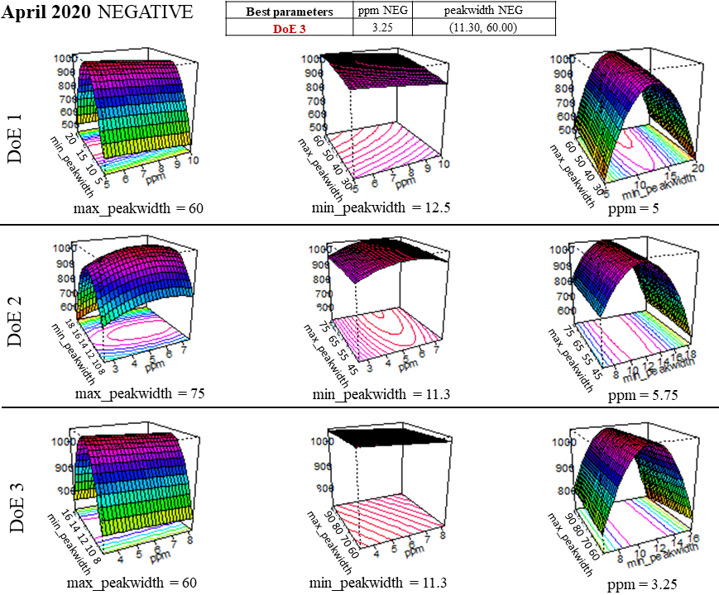
Figure S1: Design of Experiments (DoEs) of feature optimization workflow, with DoE3 giving best results for the April 2020 analyses. The iterative process involved the testing of parameters in three DoEs; the best slices for each DoE were visualized using perspective plots.

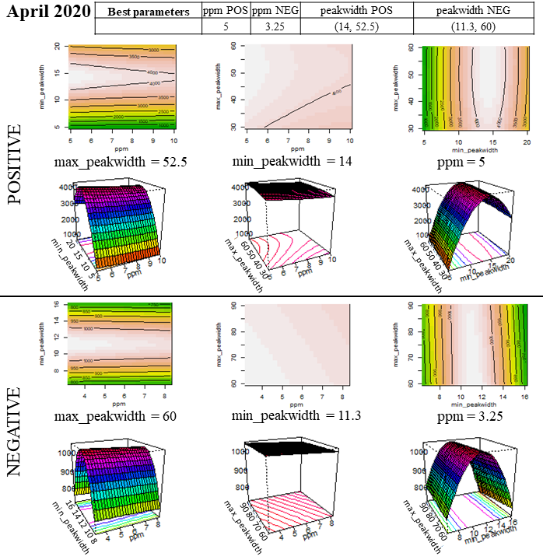
Figure S2: Results of feature optimization workflow, with the best results in positive and negative mode for the April 2020 analyses.

