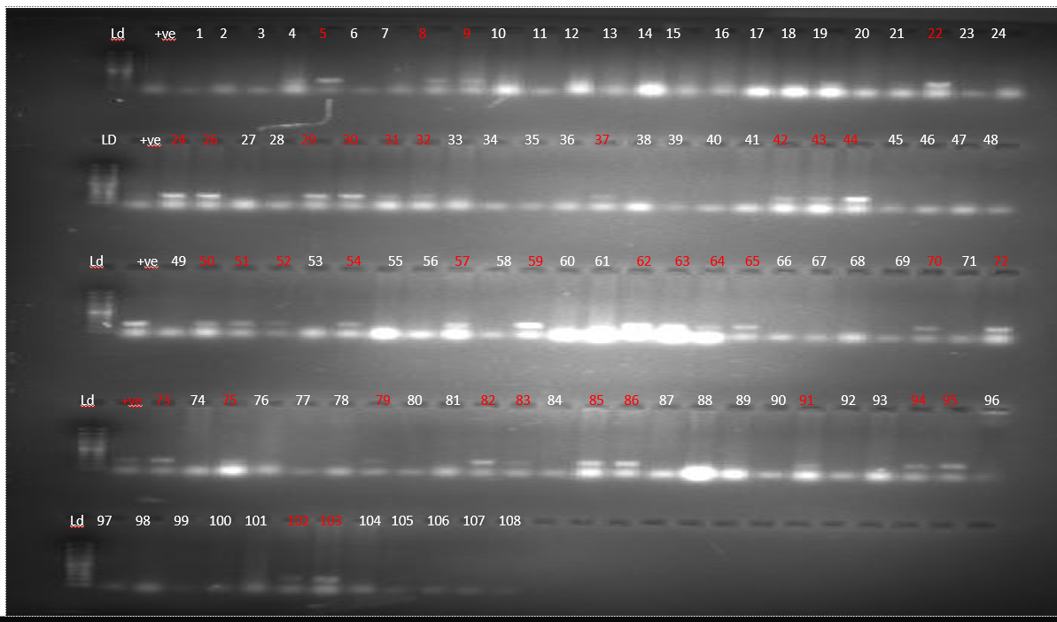
Additional file 1
Fig S1: Gel image of the PCR results of the miracidia host seeking assay for imidacloprid. The image shows the results for controls (well 1-12= controls in substrate for 2 hours, 13-24= controls in substrate for 4 hours and 24-36= controls in substrate for 6 hours) versus those exposed to imidacloprid at 2% the average EC50 for miracidia at 6 hrs (37-72, arranged for time as controls) and those exposed to imidacloprid at 40% the average EC50 for miracidia at 6 hrs (73-108). Each row starts with a DNA ladder and a positive control (250 bps) except the bottom row which does not have the positive control.

Table S2: Results of the miracidia host seeking assay in raw format.
Pesticide | Treatment | Concentration | Infected | Not infected | Percentage infected
Control | Control | 0 | 3 | 9 | 25.86
Control | Control | 0 | 2 | 10 | 25.86
Control | Control | 0 | 5 | 8 | 25.86
Control | Control | 0 | 5 | 7 | 25.86
Control | Control | 0 | 4 | 8 | 25.86
Control | Control | 0 | 0 | 13 | 25.86
Imidacloprid | Low | 4.88 | 4 | 8 | 44.44
Imidacloprid | Low | 4.88 | 6 | 6 | 44.44
Imidacloprid | Low | 4.88 | 6 | 6 | 44.44
Imidacloprid | High | 48.8 | 0 | 12 | 2.78
Imidacloprid | High | 48.8 | 0 | 12 | 2.78
Imidacloprid | High | 48.8 | 1 | 11 | 2.78
Diazinon | Low | 1.05 | 1 | 11 | 11.11
Diazinon | Low | 1.05 | 0 | 12 | 11.11
Diazinon | Low | 1.05 | 3 | 9 | 11.11
Diazinon | High | 10.5 | 0 | 12 | 2.78
Diazinon | High | 10.5 | 0 | 12 | 2.78
Diazinon | High | 10.5 | 1 | 11 | 2.78

Table S3: Results of the sporocyst development assay in raw format.
Pesticide | Treatment | Concentration | Shedding | Not shedding | Percentage shedding | Percentage shedding on week 1
Control | Control | 0 | 1 | 7 | 21.03 | 8.46
Control | Control | 0 | 1 | 5 | 21.03 | 8.46
Control | Control | 0 | 1 | 5 | 21.03 | 8.46
Control | Control | 0 | 1 | 6 | 21.03 | 8.46
Control | Control | 0 | 2 | 5 | 21.03 | 8.46
Control | Control | 0 | 3 | 5 | 21.03 | 8.46
Imidacloprid | Low | 4.88 | 3 | 5 | 23.61 | 8.33
Imidacloprid | Low | 4.88 | 0 | 8 | 23.61 | 8.33
Imidacloprid | Low | 4.88 | 2 | 4 | 23.61 | 8.33
Imidacloprid | High | 48.8 | 2 | 2 | 33.33 | 11.11
Imidacloprid | High | 48.8 | 0 | 3 | 33.33 | 11.11
Imidacloprid | High | 48.8 | 3 | 3 | 33.33 | 11.11
Diazinon | Low | 1.05 | 0 | 3 | 26.67 | 12.5
Diazinon | Low | 1.05 | 4 | 1 | 26.67 | 12.5
Diazinon | Low | 1.05 | 0 | 4 | 26.67 | 12.5
Diazinon | High | 10.5 | 2 | 2 | 27.78 | 11.11
Diazinon | High | 10.5 | 2 | 4 | 27.78 | 11.11
Diazinon | High | 10.5 | 0 | 7 | 27.78 | 11.11

