Additional file 1
Additional Tables
Table S1 The top 10 countries for the number of papers published.
Ranking | Country | Publications | Centrality | Year (first)
1 | China | 1446 | 0. 12 | 2011
2 | India | 290 | 0. 07 | 2012
3 | USA | 286 | 0. 01 | 2011
4 | South Korea | 209 | 0. 28 | 2011
5 | Australia | 125 | 0. 27 | 2011
6 | Brazil | 98 | 0. 12 | 2013
7 | Saudi Arabia | 96 | 0. 08 | 2014
8 | Malaysia | 85 | 0. 01 | 2012
9 | Pakistan | 81 | 0. 06 | 2013
10 | Canada | 72 | 0. 02 | 2014

Table S2 The top 10 institutions in the field for the number of papers published.
Ranking | Institution | Publications | Centrality | Year (first) | Half-Value Period
1 | Chinese Acad Sci | 130 | 0. 20 | 2011 | 8. 5
2 | Hunan Univ | 76 | 0. 02 | 2015 | 4. 5
3 | Korea Univ | 59 | 0. 08 | 2014 | 5. 5
4 | King Saud Univ | 51 | 0. 08 | 2014 | 3. 5
5 | Univ Florida | 46 | 0. 06 | 2011 | 6. 5
6 | Hong Kong Polytech Univ | 41 | 0. 09 | 2015 | 4. 5
7 | China Agr Univ | 37 | 0. 12 | 2015 | 9. 5
8 | Tsinghua Univ | 36 | 0. 03 | 2015 | 5. 5
9 | Harbin Inst Technol | 34 | 0. 01 | 2019 | 1. 5
10 | Northwest A&F Univ | 33 | 0. 04 | 2018 | 2. 5

Table S3 The top 10 authors in the field for the number of papers published.
Ranking | Publications | Author | Year (first) | Half-Value Period
1 | 75 | Ok, Yong Sik | 2012 | 6. 5
2 | 41 | Tsang, Daniel C W | 2015 | 4. 5
3 | 39 | Gao, Bin | 2011 | 7. 5
4 | 36 | Vithanage, Meththika | 2013 | 5. 5
5 | 30 | Zeng, Guangming | 2015 | 3. 5
6 | 22 | Tan, Xiaofei | 2016 | 2. 5
7 | 21 | Mohan, Dinesh | 2012 | 5. 5
8 | 18 | Pittman, Charles U | 2012 | 7. 5
9 | 17 | Liu, Yunguo | 2015 | 2. 5
10 | 17 | Wang, Bing | 2018 | 2. 5

Table S4 The top 10 journals in the field for the number of papers published.
Ranking | Journal | Publications | Proportion | IF
1 | Science of The Total Environment | 160 | 5. 98% | 10. 754
2 | Chemosphere | 160 | 5. 98% | 8. 943
3 | Environmental Science and Pollution Research | 141 | 5. 27% | 5. 19
4 | Bioresource Technology | 135 | 5. 05% | 11. 889
5 | Journal of Hazardous Materials | 98 | 3. 66% | 14. 224
6 | Journal of Environmental Chemical Engineering | 94 | 3. 51% | 7. 968
7 | Journal of Environmental Management | 92 | 3. 44% | 8. 91
8 | Chemical Engineering Journal | 91 | 3. 4% | 16. 744
9 | Journal of Cleaner Production | 91 | 3. 4% | 11. 072
10 | Biomass Conversion and Biorefinery | 62 | 2. 31% | 4. 05

Table S5 Top 20 keywords with the most publications in biochar adsorption for wastewater treatment.
Ranking | Frequency | Keyword | Year (first) | Centrality
1 | 1167 | wastewater | 2011 | 0. 52
2 | 1157 | adsorption | 2011 | 0. 3
3 | 1100 | aqueous solution | 2011 | 0. 26
4 | 930 | removal | 2011 | 0. 11
5 | 794 | activated carbon | 2011 | 0. 07
6 | 581 | sorption | 2011 | 0. 01
7 | 572 | water | 2011 | 0. 04
8 | 544 | biochar | 2012 | 0
9 | 507 | heavy metal | 2011 | 0. 13
10 | 332 | carbon | 2011 | 0
11 | 322 | waste | 2011 | 0
12 | 309 | mechanism | 2011 | 0
13 | 305 | pyrolysis | 2011 | 0. 02
14 | 303 | adsorbent | 2011 | 0
15 | 289 | methylene blue | 2016 | 0
16 | 289 | kinetics | 2012 | 0. 01
17 | 232 | equilibrium | 2011 | 0. 12
18 | 232 | pyrolysis temperature | 2014 | 0
19 | 222 | magnetic biochar | 2013 | 0
20 | 208 | soil | 2011 | 0

Additional Figures

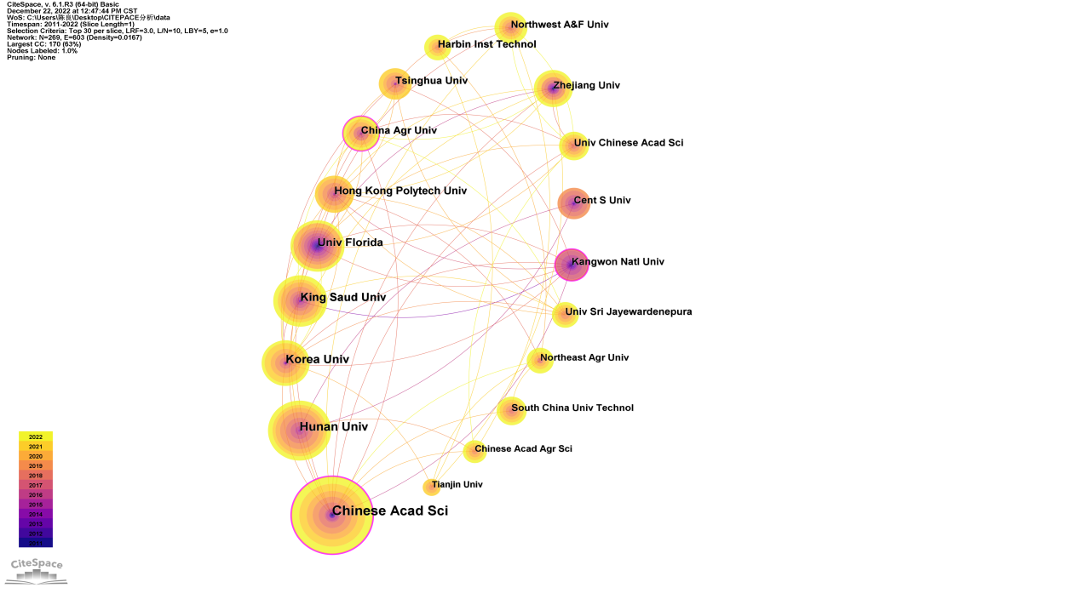
Figure S1 Biochar adsorption for wastewater treatment research institute visualization.

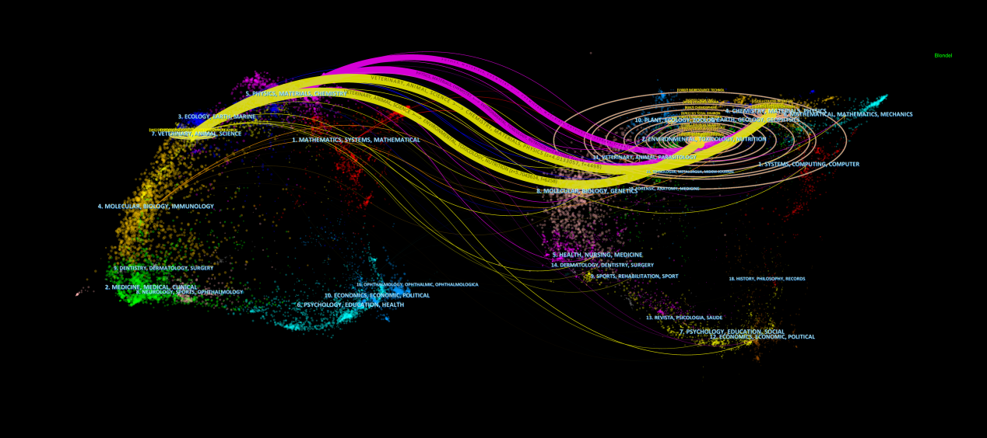
Figure S2 The dual map overlay of biochar adsorption for wastewater treatment.

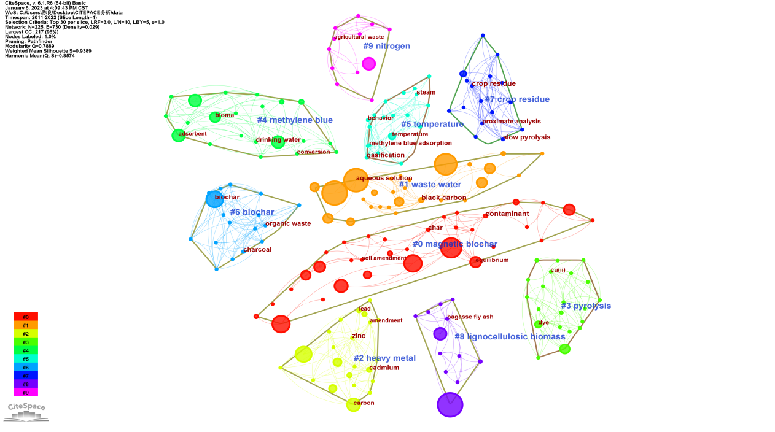
Figure S3 Analysis of biochar adsorption for wastewater treatment keywords co-occurrence clustering.

