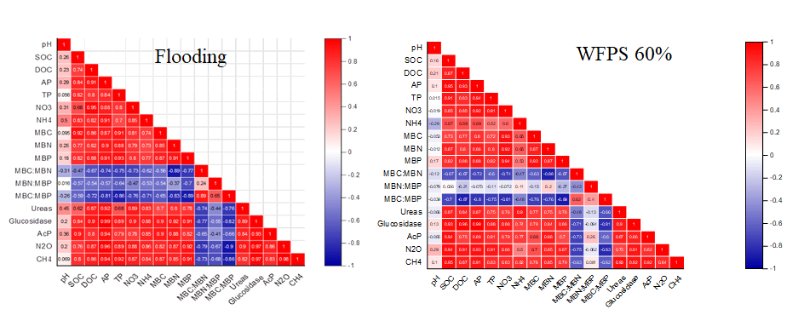
Fig. S1. Analysis of Pearson's correlations for variables in 60% WFPS and flooded soils
Note: SOC: soil organic carbon, DOC: dissolve organic carbon, NO₃: nitrate, NH₄: ammonium, TP: total phosphorus, AP: available phosphorus, Glucosidase: β-glycosidase, MBC: microbial biomass carbon, MBN: microbial biomass nitrogen, MBP: microbial biomass phosphorus, MQ: microbial quotient, AcP: acid phosphatase; N2O: nitrous oxide, CH4: methane.

Fig. S2. Relationships among methane (CH₄) and nitrous oxide (N₂O) and dissolve organic carbon (DOC), microbial biomass carbon (MBC) and soil pH

Fig. S3. Relationships among methane (CH₄) and nitrous oxide (N₂O) and urease, β-glycosidase and acid phosphatese

