Supplementary Materials
S1 Overview of Datasets
The following section gives additional details on our database’s individual datasets. Table S1 provides a general overview.
Table S1: Overview of individual datasets making up the macroinvertebrate assemblage database. The table provides each dataset's start and end year and the number (#) of all sites and least disturbed sites.
Dataset | Start Date | End Date | # Sites | # Least Impaired Sites
Monitoring data, Flanders, Belgium | 2005 | 2019 | 375 | 44
Monitoring data, Croatia | 2017 | 2017 | 25 | 14
Monitoring data, Netherlands | 2005 | 2017 | 246 | 46
Monitoring data, Finland | 2007 | 2017 | 132 | 100
Monitoring data, France | 2005 | 2020 | 4,203 | 1,502
Monitoring data, Germany | 2005 | 2013 | 4,389 | 763
Monitoring data, Greece | 2005 | 2013 | 88 | 14
Ecosurv Project, Hungary | 2005 | 2005 | 241 | 23
Monitoring data, Norway | 2017 | 2018 | 7 | 7
Monitoring data, Poland | 2009 | 2019 | 785 | 344
Monitoring data, Portugal | 2017 | 2019 | 202 | 61
Monitoring, Ebro Catchment, Spain | 2006 | 2020 | 458 | 138
Monitoring data, Spain | 2013 | 2017 | 778 | 258
Monitoring data, Sweden | 2018 | 2021 | 99 | 60
Monitoring data, United Kingdom | 2016 | 2021 | 1,671 | 349
Biodrought Project, Czech Republic | 2012 | 2014 | 5 | 0
Monitoring, Slovakia | 2008 | 2018 | 30 | 0

S2 Lists of taxa used to train the models
The following taxa were used to train the Copper model:
Acroneuria lycorias, Alona affinis, Amnicola sp., Asellus aquaticus, Campeloma decisum, Ceriodaphnia dubia, Ceriodaphnia reticulata, Cherax destructor, Chironomus decorus, Chironomus javanus, Chironomus riparius, Chironomus tentans, Corbicula malinensis, Corbicula australis, Crangonyx pseudogracilis, Cypris subglobosa, Culex sp., Daphnia ambigua, Daphnia carinata, Daphnia magna, Daphnia parvula, Daphnia pulex, Daphnia pulicaria, Daphnia rosea, Ecdyonurus torrentis, Echinogammarus berilloni, Erpobdella testacea, Gammarus pseudolimnaeus, Gammarus pulex, Goniobasis livescens, Juga livescens, Gyraulus circumstriatus, Limnodrilus hoffmeisteri, Lophopodella carteri, Lumbriculus variegatus, Lymnaea stagnalis, Macrobrachium sp., Macrobrachium lanchesteri, Melanoides tuberculata, Moina dubia, Nais sp., Nais elinguis, Orconectes rusticus, Paratya australensis, Pectinatella magnifica, Philodina acuticornis, Physa heterostropha, Physa integra, Plumatella emarginata, Procambarus clarkii, Rhithrogena semicolorata, Sericostoma personatum, Simocephalus serrulatus, Siphlonurus armatus, Stenocypris major, Tropocyclops prasinus mexicanus, Tubifex tubifex, Unio angasi, and Utterbackia imbecilis.
The following taxa were used to train the imidacloprid model:
Asellus aquaticus, Caecidotea sp., Ceriodaphnia dubia, Daphnia magna, Gammarus pulex, Hyalella azteca, Aedes sp., Caenis horaria, Caenis sp., Chaetopteryx villosa, Chaoborus obscuripes, Cheumatopsyche sp., Chironomus dilutus, Chironomus tentans, Cloeon dipterum, Cloeon sp., Coenagrion sp., Deleatidium sp., Epeorus longimanus, Ephemerella sp., Gyrinus sp., Heptageniidae, Hexagenia sp., Isonychia bicolor, Maccaffertium sp., Micrasema sp., Neocloeon triangulifer, Plea minutissima, Simulium vittatum, Stenelmis sp., Trichocorixa sp., Lampsilis fasciola, Lumbriculus variegatus

S3 Predicted EC50 values
The predicted $EC_{50}$ values are available under: https://seafile.rlp.net/d/899eb07c6f8140628fa5/

S4 How many samples/taxa were analyzed for each type?
Tables S2 and S3 show the number of samples and taxa per chemical, respectively.
Table S2: Number of samples from least impacted sites, where at least 75% of taxa had converging Markov chains and that were inside the 95% highest density interval, analyzed for each combination of river type and chemical.
broad river type | copper
RT1 | 63
RT2 | 492
RT3 | 245
RT4 | 397
RT5 | 360
RT6 | 183
RT7 | 111
RT8 | 451
RT9 | 362
RT10 | 342
RT11 | 268
RT12 | 103
Table S3: Number of taxa from least impacted sites, where at least 75% of taxa had converging Markov chains and that were inside the 95% highest density interval, we analyzed for each combination of broad river type and chemical.
broad river type | copper
RT1 | 441
RT2 | 1,073
RT3 | 844
RT4 | 911
RT5 | 783
RT6 | 592
RT7 | 467
RT8 | 739
RT9 | 692
RT10 | 368
RT11 | 358
RT12 | 262

S5 Results for all samples
The following sections show the results for all assemblages, including those from disturbed catchments and those with $HC_{5}$ values outside the 95% HDI. Figure S1 shows the variation between and within broad river types for all available sampling sites. Including these assemblages only minimally alters the distribution of $HC_{5}$ values. Compared to the distribution of $HC_{5}$ values for assemblages from least disturbed catchments the most notable difference is the outliers with high $HC_{5}$ values for imidacloprid.
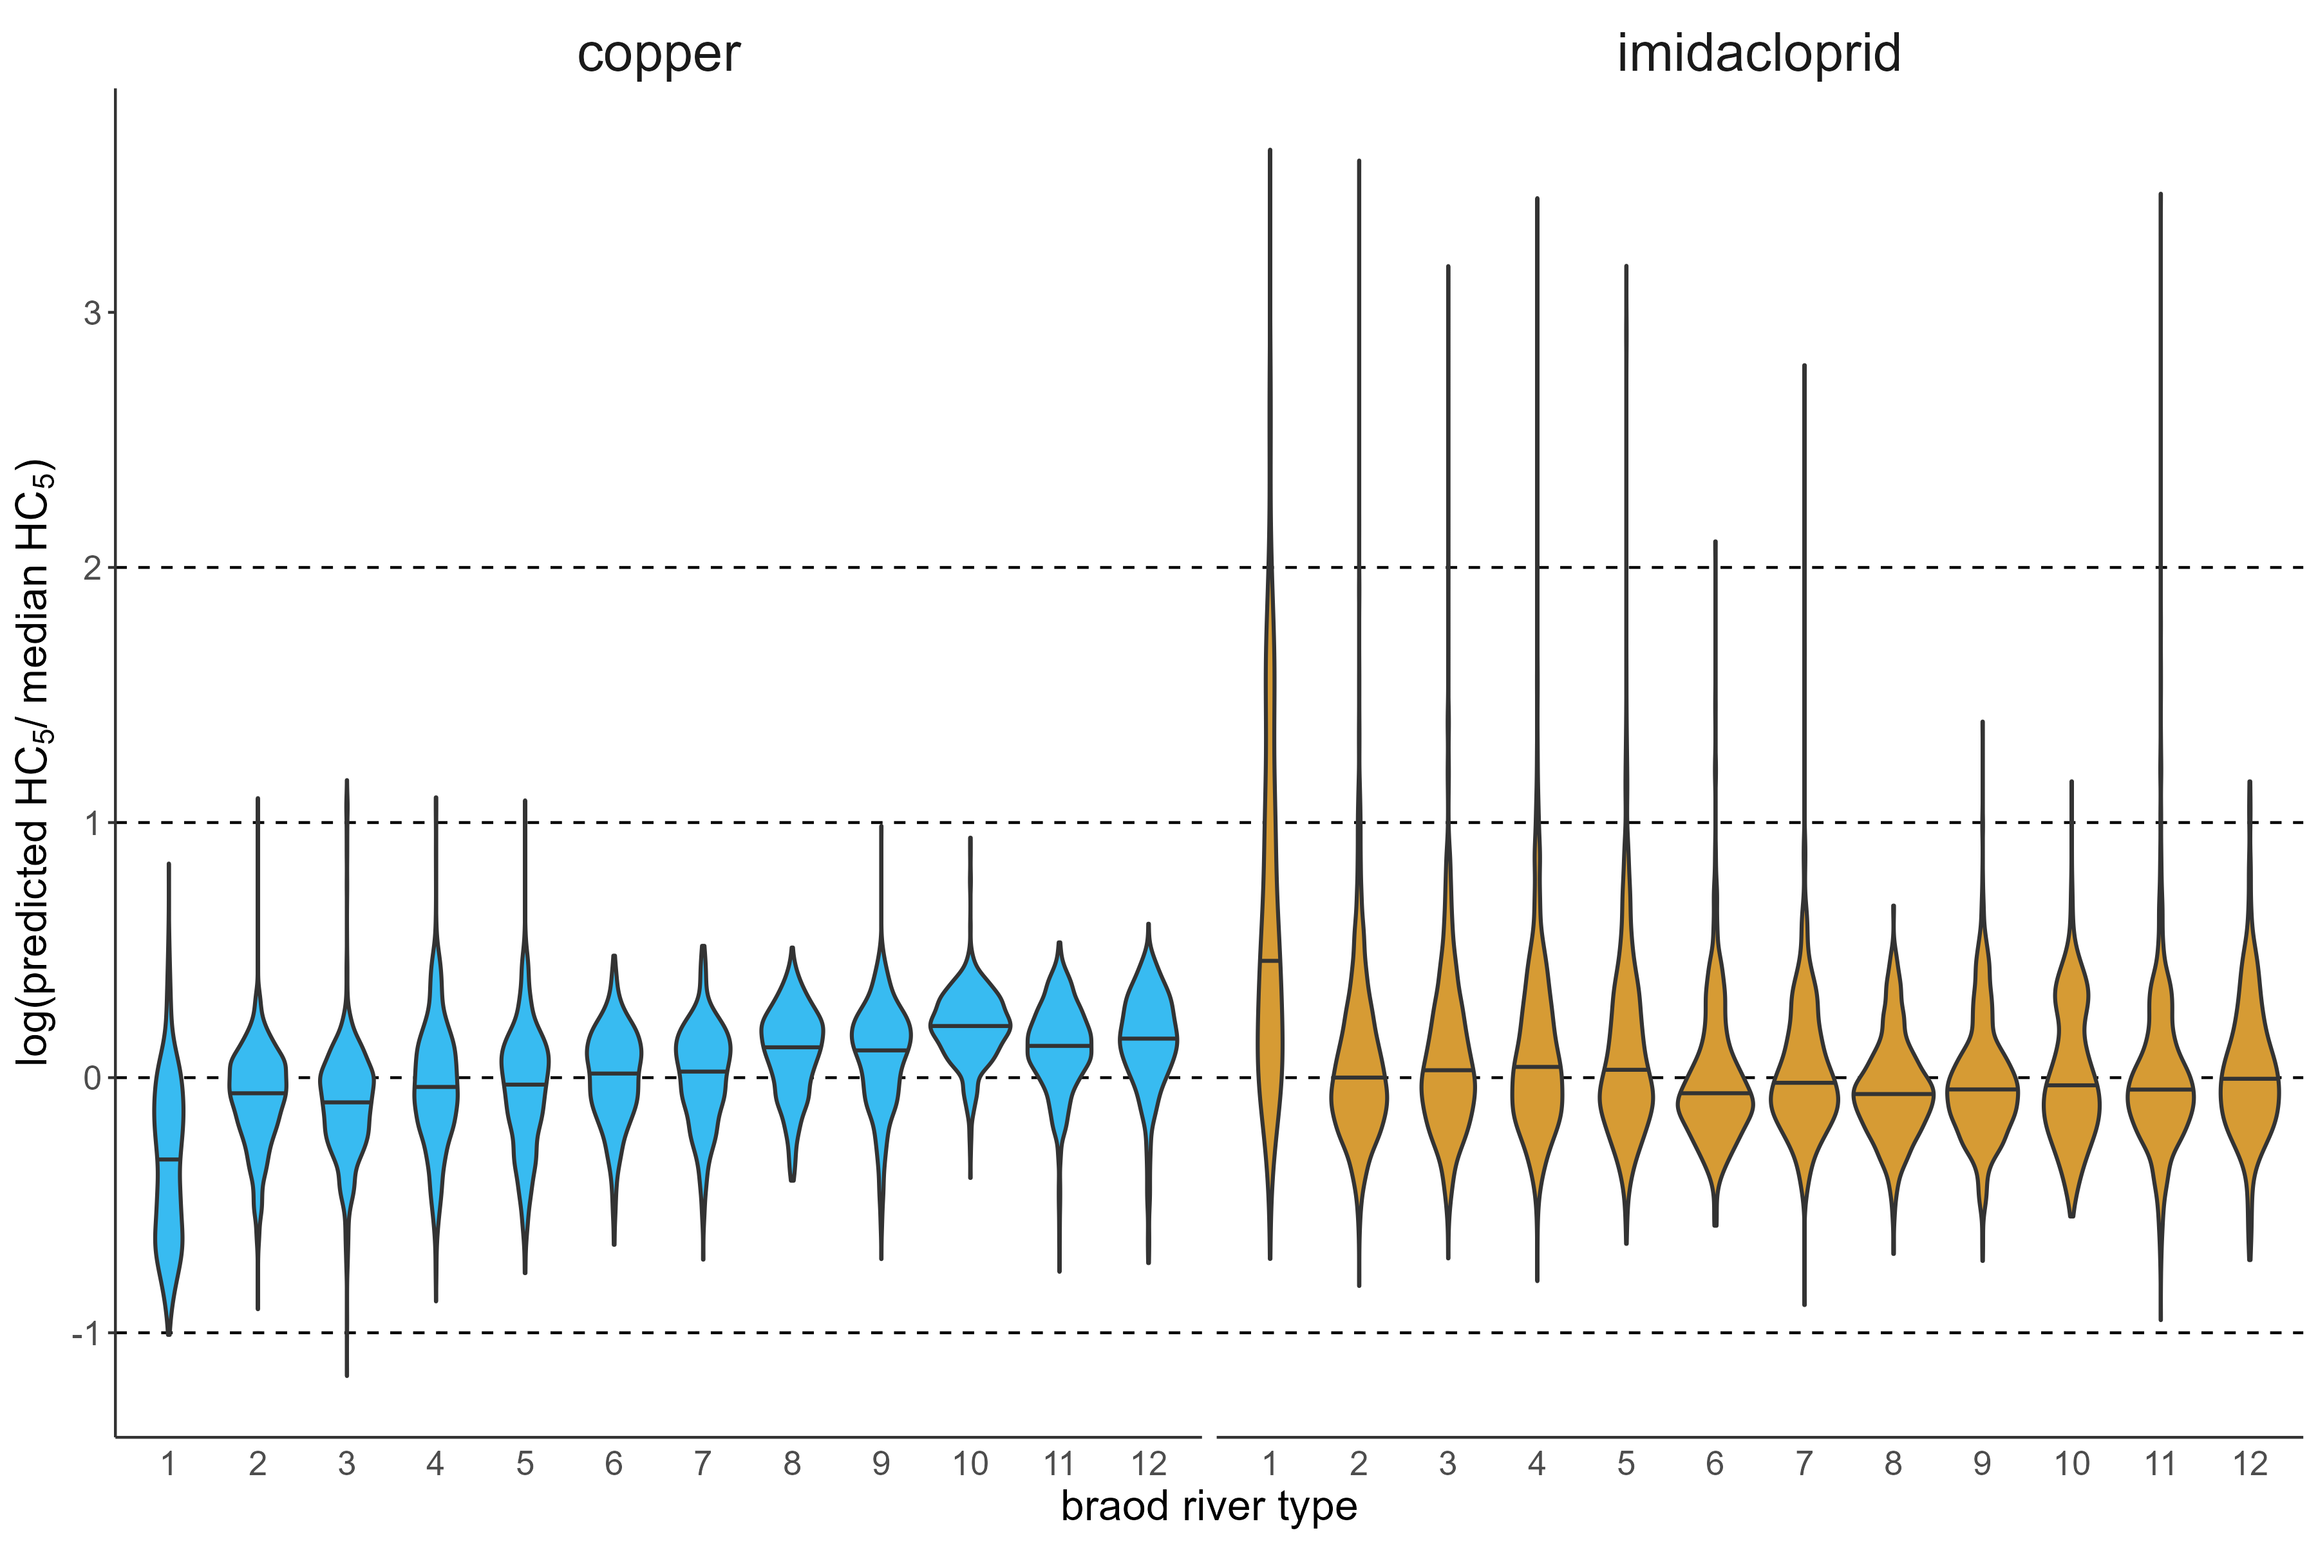
Figure S1: Variation in median hazard concentration 5 ($HC_{5}$) values across river types. This plot shows the density distribution of scaled $HC_{5}$ values for each chemical and river type. Scaling was achieved by dividing $HC_{5}$ values by the median $HC_{5}$ for the chemical across river types and are shown on a log10 scale. Values of zero thus imply that the value is equal to the chemical’s overall median and values of one indicate that the value is an order of magnitude greater than the overall median. For an explanation of river types, see the method section. Horizontal lines within the density curves are medians. This plot shows all available assemblages.
Copper shows the most marked differences, which were lower than in the analysis of assemblages from the least disturbed catchments (Figure S2).
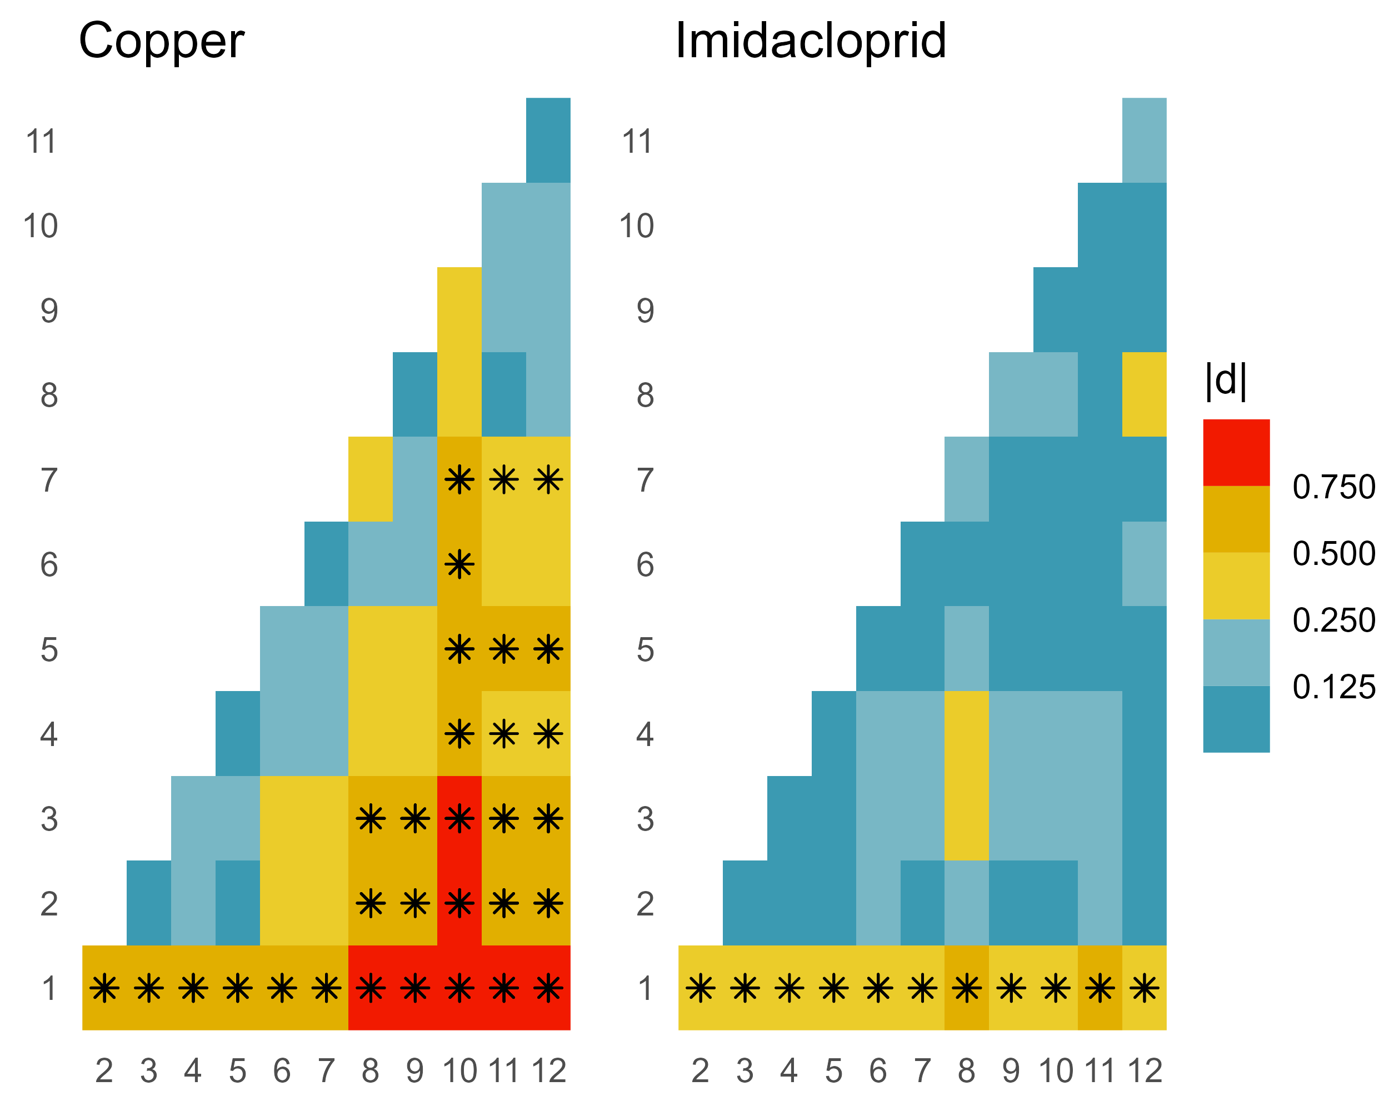
Figure S2: Differences between the assemblage hazard concentration 5 ($HC_{5}$) values of different river types expressed as the absolute value of Cliff’s d. Dark blue cells indicate small differences and dark yellow cells mark the largest observed differences. An asterisk marks Cliff’s d values that exceed the 0.47 threshold. Values are based on all available sampling sites.
The range of quotients between median river type $HC_{5}$ values for all assemblages (Figure S3) is similar, though smaller, to that of assemblages from the least disturbed catchments (cf. Figure 6). The largest observed difference, a factor of 2.8, was between assemblages from very large rivers (RT1) and those from high-altitude rivers (RT10).
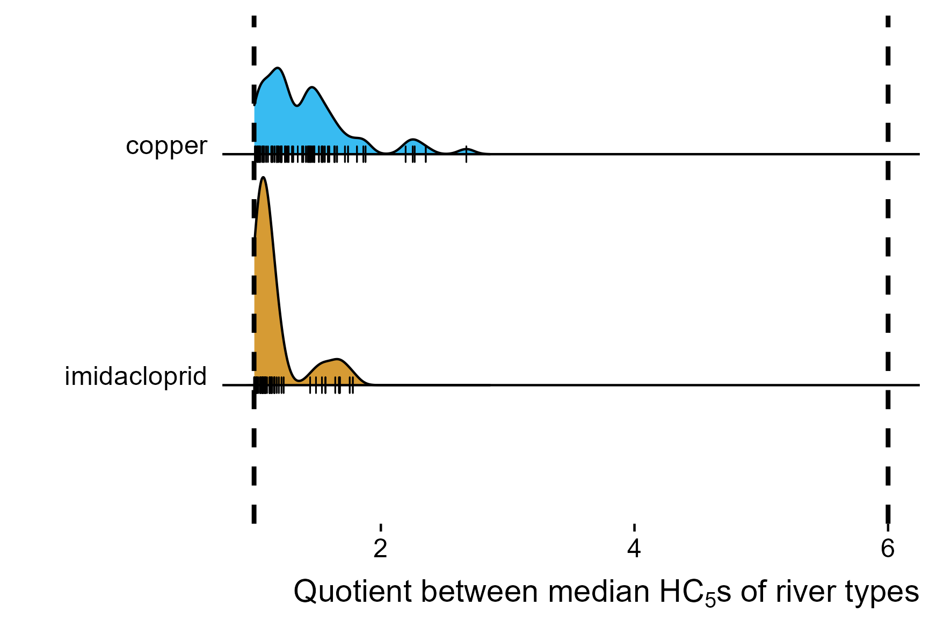
Figure S3: Factor of variation between median hazard concentrations 5 ($HC_{5}$s) for all sites, i.e., including disturbed sites and sites outside the 95% highest density interval. The black dashed vertical lines mark differences of factor one and six. The small vertical lines are the observed quotients.

S6 Is there a systematic difference in the sensitivity of taxa with non-stationary Markov chains?
We excluded taxa for which the Markov chains did not converge to stationarity (henceforth non-stationary taxa), as indicated by the Heidelberg-Welch statistic. This removal can bias the results if these taxa skew toward high or low sensitivities. To evaluate the risk of this bias, we compared the predicted log ($EC_{50}$) values of the non-stationary taxa with those of stationary taxa. While our low confidence in the predicted sensitivity values for non-stationary taxa lead us to remove them from the final analyses, they are the best indicators of their sensitivity available to us. For copper, we observed no systematic differences between the sensitivities we predicted for stationary and non-stationary taxa (Figure S4). For imidacloprid, non-stationary taxa tended to be more sensitive than stationary taxa. The difference in median $EC_{50}$ was a factor of 9. This large difference also resulted from a strongly skewed distribution of log $EC_{50}$ values. The difference in arithmetic means is a factor of 5.7. Nonetheless, these results suggest that the non-stationary taxa might have been more sensitive.
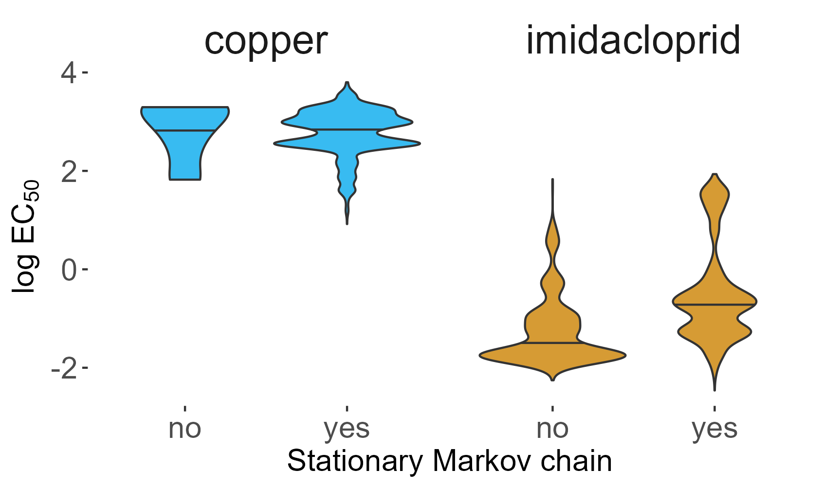
Figure S4: Predicted log (EC₅₀) values for taxa with stationary and non-stationary posterior distributions.
To test how strongly the removal impacted our results, we computed $HC_{5}$ including the non-stationary taxa. The largest difference between river types was still for copper between assemblages of very large and high-altitude rivers. The amount of variation is slightly lower (a factor of 3) compared to the original analysis (results not shown). We therefore conclude, that the removal of non-stationary taxa, even though they might skew more sensitive, has not notably impacted our results.
S7 Effects of quality assurance measures on taxonomic and spatial composition
After fitting the hSSD model, we removed all taxa for which a Heidelberg-Welch test returned a statistically significant result ($α$ = 0.05) thus indicating that the posterior distribution had not reached stationarity. This impacted the different chemicals and taxonomic orders to varying degrees (Figure S5).
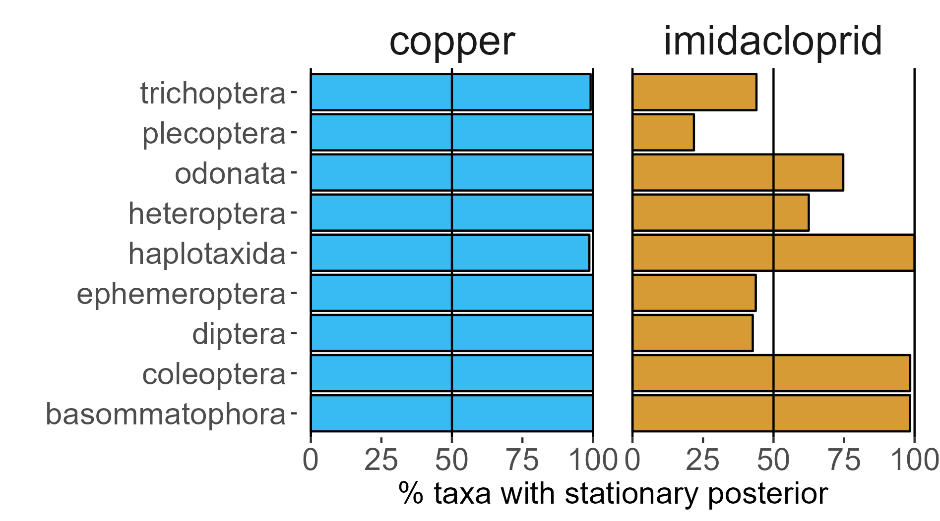
Figure S5: Percentage of taxa in the most common orders for which the hierarchical species distribution model produced stationary posterior distributions. The two black vertical lines indicate 50% and 100%, respectively.
Among the two compounds, the higher fractions of taxa were lost for imidacloprid, where the most highly affected orders were Ephemeroptera, Plecoptera, Trichoptera, and Diptera. For copper, almost no species had to be removed. The changes in the number of sites per river type follow a similar pattern (Figure S6).
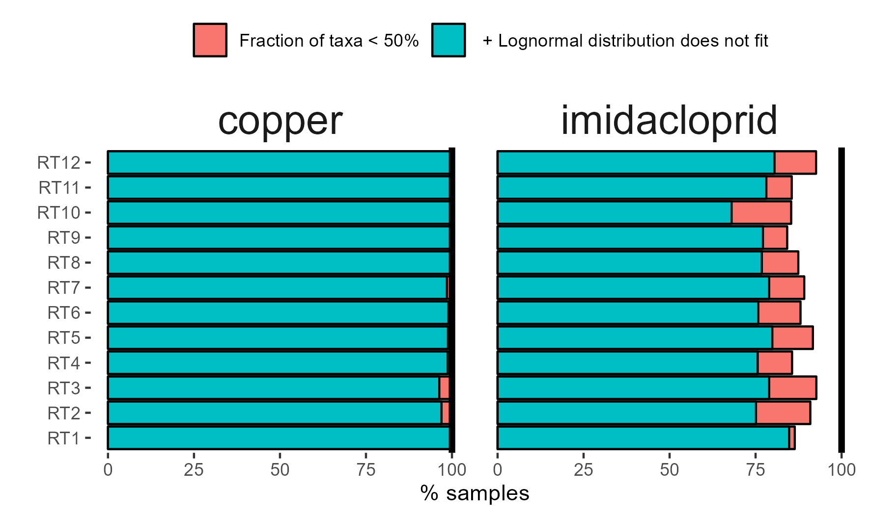
Figure S6: Effect of removing assemblages with less than 50% of taxa left after removing taxa with non-stationarity posteriors (red bar) and of additionally removing assemblages whose species sensitivity distribution was not well approximated by a lognormal distribution (blue bar).
Again, we note the higher losses for imidacloprid and the lower losses for copper.

S8 Alternative version of Figure 4
Figure S7 shows the density distribution of $HC_{5}$ values for each chemical and river type. It is an alternative version of Figure 4. The latter has a scaled Y-axis, which might distort the results but does not.
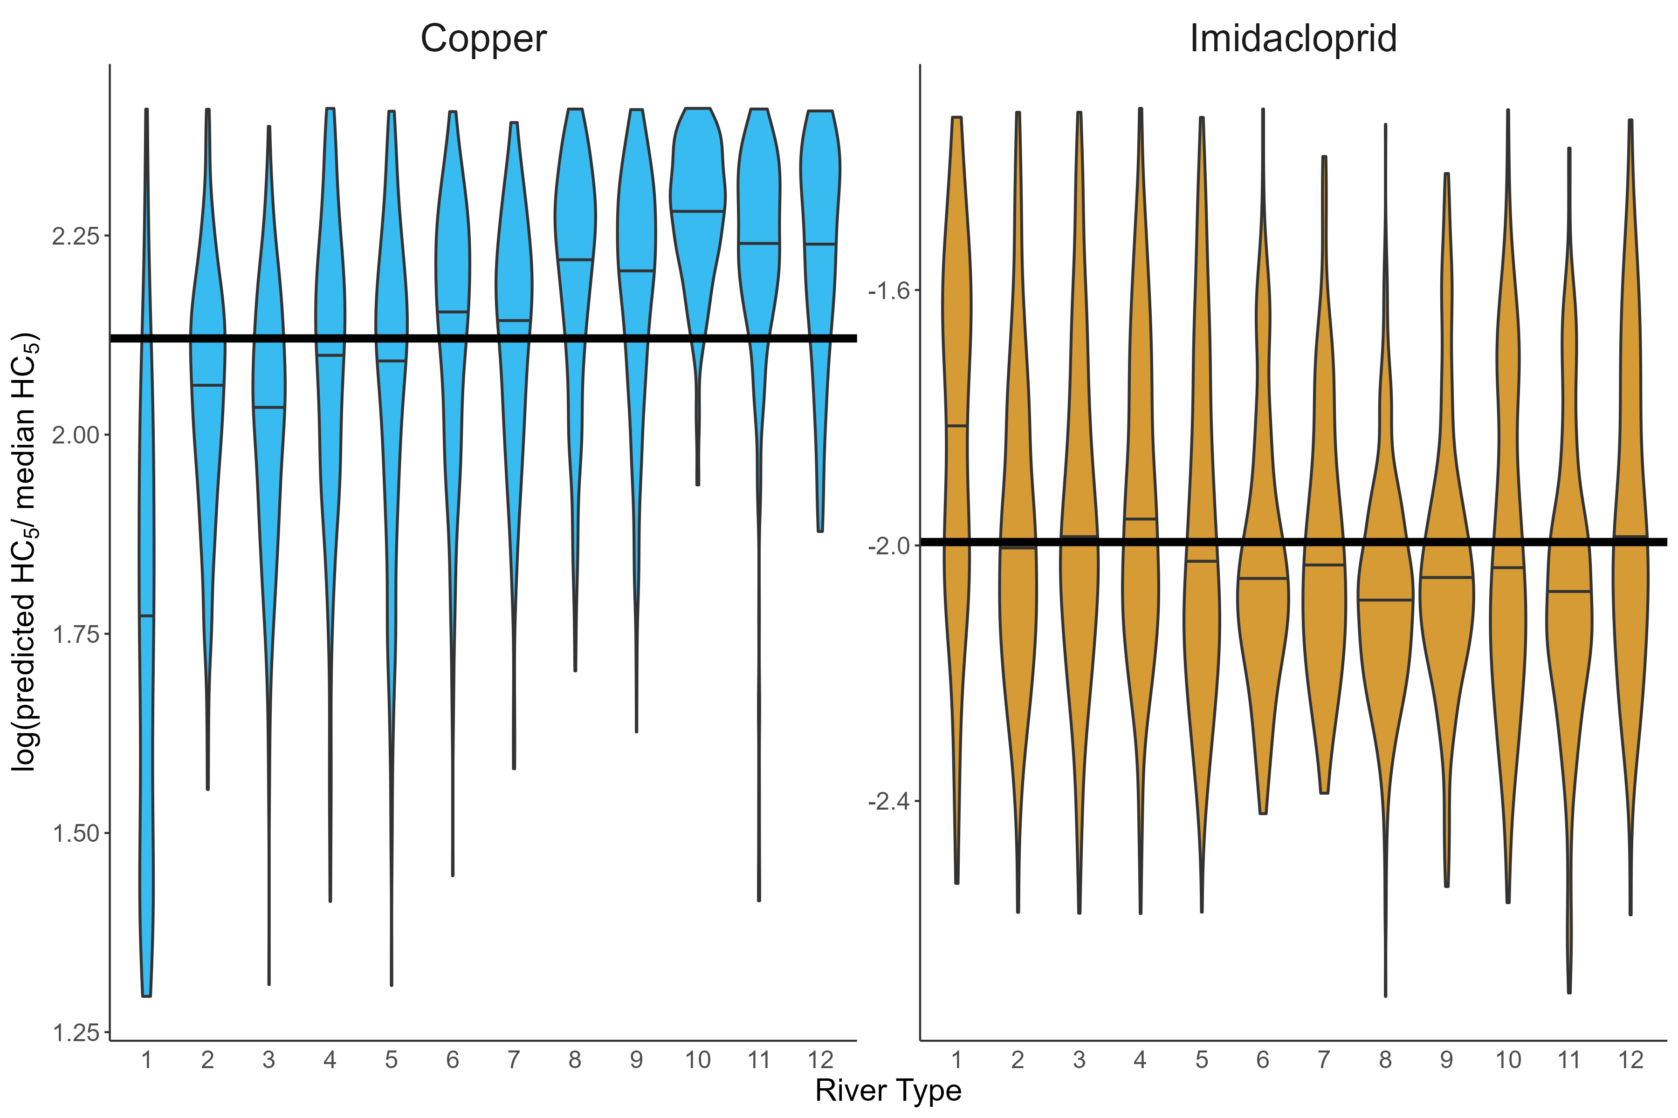
Figure S7: Density distribution of Hazard concentration 5 ($HC_{5}$) values for each chemical and river type. Horizontal lines within the density curves are medians. The gray horizontal line shows the overall median of the respective chemical. The plot shows values from the least disturbed sites within the 95% highest density interval.

S9 Leave-one-out Cross-Validation of the Hierarchical Species Sensitivity Distribution Model
We performed leave-one-out cross-validation to evaluate the accuracy of predictions from the hierarchical Species Sensitivity Distribution model. Iteratively, we removed each taxon individually from the training data set, refit the model, and predicted the LC₅₀ of the removed taxon. We evaluate the model fit using the relative absolute error (RAL).
$$RAL= \frac{|LC_{50, predicted}-LC_{50,measured} |}{LC_{50, measured}}$$
For the model fitting, we used the same hyperparameters as for the main analysis, i.e., a sample size of 30.000 for copper and 50.000 for imidacloprid, a burn-in sample size of 10.000 for copper and 20.000 for imidacloprid, and a thinning of 15. The errors differed strongly among taxa (Figure S8). The median of RALs were 0.87 and 0.99 for copper and imidacloprid, respectively. The maximum relative absolute errors were 141.71 and 2559.147 for copper and imidacloprid, respectively.
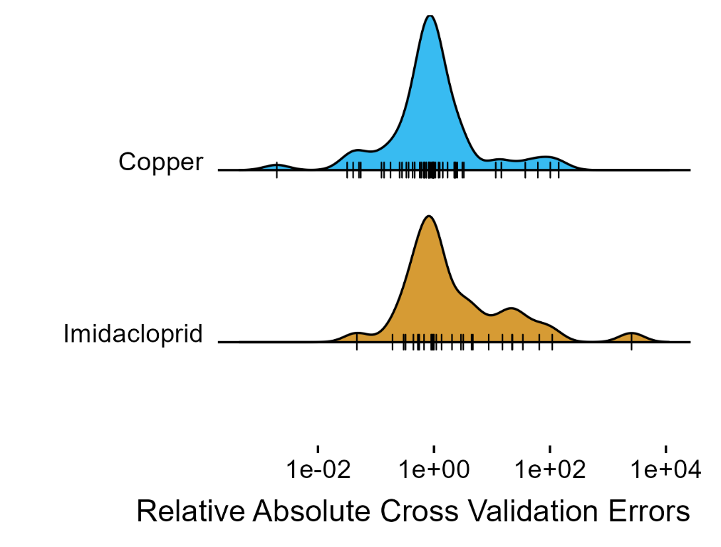
Figure S8: Relative absolute cross-validation error for copper and imidacloprid. The x-axis is log-scaled.

We evaluated how strongly the uncertainty introduced through these predictor errors impacts the comparison between river types. To this end, we empirically derived mixture distributions that fit the distribution of ln(RAL) (Figures S9 and S10). For both compounds, we used the same general form with different parameters.
$$\ln\left(RAL\right)\sim Ν\left(μ_{1}, σ_{1}^{2}\right)+Ber(p_{1})*N(μ_{2}, σ_{2}^{2})+Ber(p_{2})*N(μ_{3},σ_{3}^{2})$$
Here, N(μ, σ²) is a normal distribution with mean μ and variance σ² and Ber(p) is a Bernoulli distribution with probability p. For copper, μ₁ = mean(ln(RAL_{copper})), σ₁² = 1, μ₂ = 3, σ₂² = 0.5, μ₃ = 8, σ₃² = 0.05, p₁ = 0.25, and p₂ = 0.1. For imidacloprid, μ₁ = median(ln(RAL_{imidacloprid})), σ₁² = 1, μ₂ = 3.5, σ₂² = 0.25, μ₃ = 8, σ₃² = 0.05, p₁ = 0.20, and p₂ = 0.05.
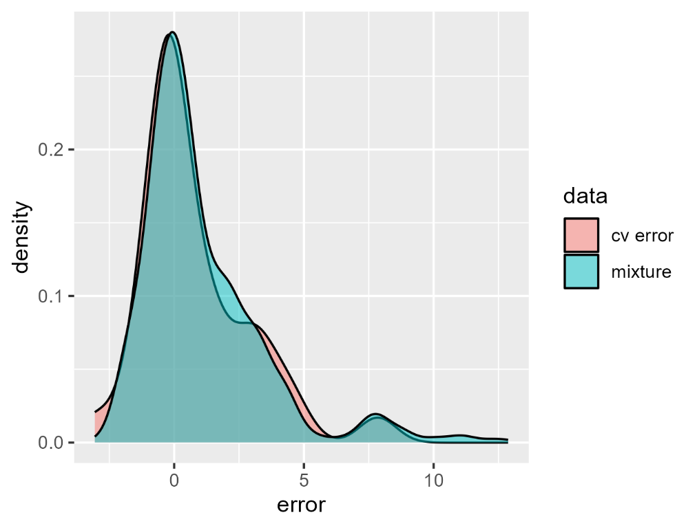
Figure S9: Distribution of natural logarithms of copper cross-validation errors (cv error, red) and values simulated from the mixture distribution (mixture, blue).
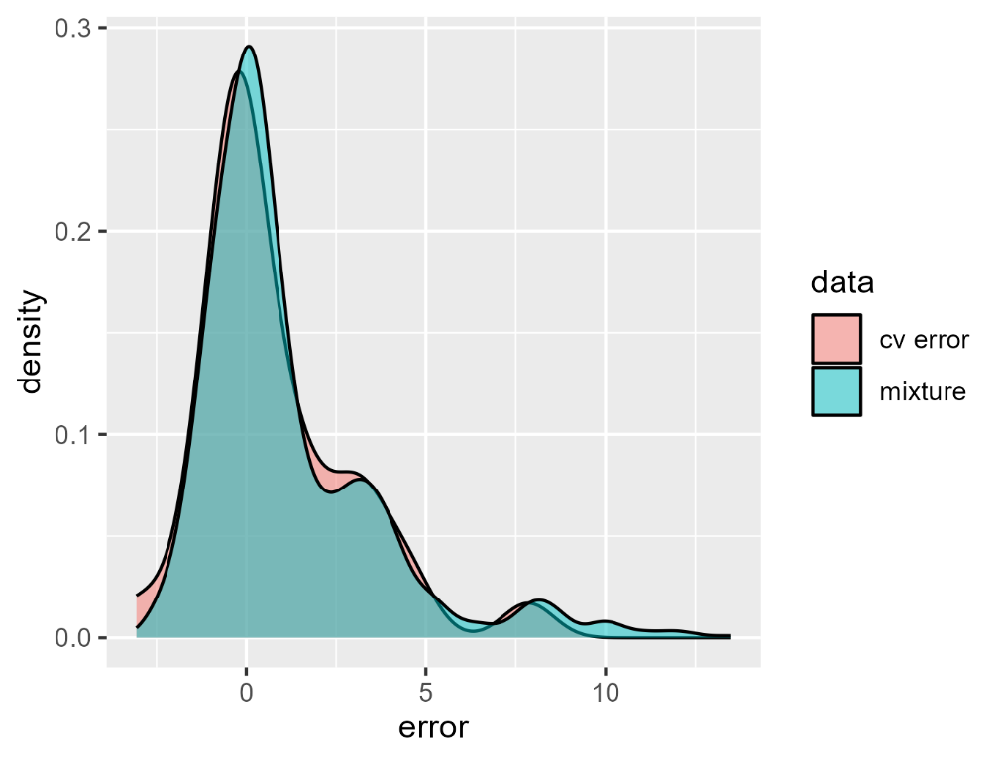
Figure S10: Distribution of natural logarithms of imidacloprid cross-validation errors (cv error, red) and values simulated from the mixture distribution (mixture, blue)

Thus, we could draw random values from an approximate distribution of errors. We used this to simulate errors for all taxa and evaluated the effect on differences between river types. For each taxon, we drew a value from the respective mixture distribution, multiplied the LC₅₀ predicted by the hSSD model with this value, and computed the differences in median HC₅ values between river types. We repeated this procedure 100 times. Median differences between river types were slightly higher but never (copper) or very rarely (imidacloprid) exceeded the predetermined threshold of six (Figure S11). Note that this analysis included 13200 comparisons for imidacloprid and copper. Four exceedances for imidacloprid thus correspond to 0.03% of comparisons.
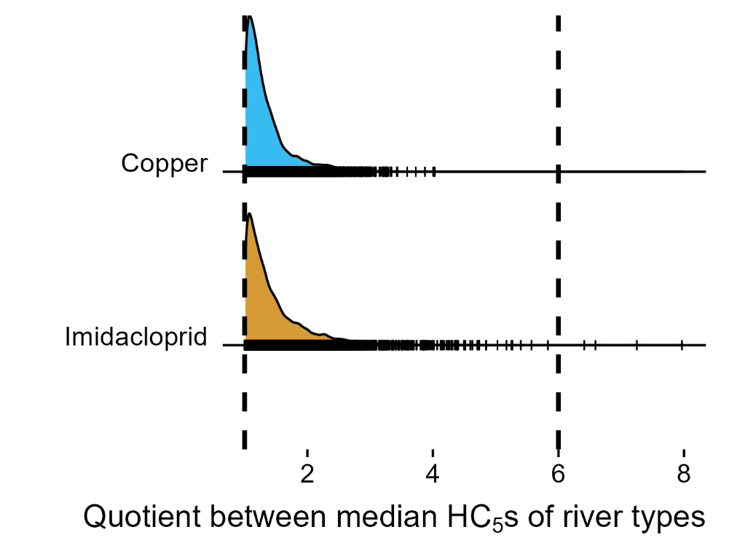
Figure S11: The factor of variation between the median $HC_{5}$s of broad river types after cross-validation error propagation. This figure shows the results for all 100 iterations. The black dashed vertical lines mark factors of one and six, i.e., the lowest possible value and the upper limit for assessment factors suggested by EFSA for deriving regulatory thresholds with macroinvertebrate Species Sensitivity Distributions. Small vertical lines show individual quotients.

