Supporting Information
Characterising Biodegradation of Compostable Bioplastics: Releasing Microplastics or Micro-bioplastics
Cheng Fang^{a, b}∗, Xian Zhang^{c}, Zixing Zhang^{c}, Ravi Naidu^{a, b}
ª Global Centre for Environmental Remediation (GCER), University of Newcastle, School of Environmental & Life Sciences, Callaghan NSW 2308, Australia.
^{b} CRC for Contamination Assessment and Remediation of the Environment (CRC CARE), University of Newcastle, Callaghan NSW 2308, Australia.
^{c} Key Lab of Urban Environment and Health, Institute of Urban Environment, Chinese Academy of Sciences, Xiamen 361021, China.

*Corresponding author: Cheng Fang, Tel: +61 2 4913 8740; Fax: +61 2 4913 8740; E-mail: cheng.fang@newcastle.edu.au. https://orcid.org/0000-0002-3526-6613

Contents
1. Sample preparation 3
1.1. Figures S1-S2/Table S1: Photo images and information of samples 3
1.2. Figures S3-S5: Stability in the absence of microorganisms 7
1.3. Figures S6-S7: Biodegradation in kitchen 10
2. More characterisation 12
2.1. Figure S8: Typical SEM images of the released debris 12
2.2. Figures S9-S10: Possible derivate surface groups and released items 13
3. References 15

Sample preparation

1.1. Figures S1-S2/Table S1: Photo images and information of samples
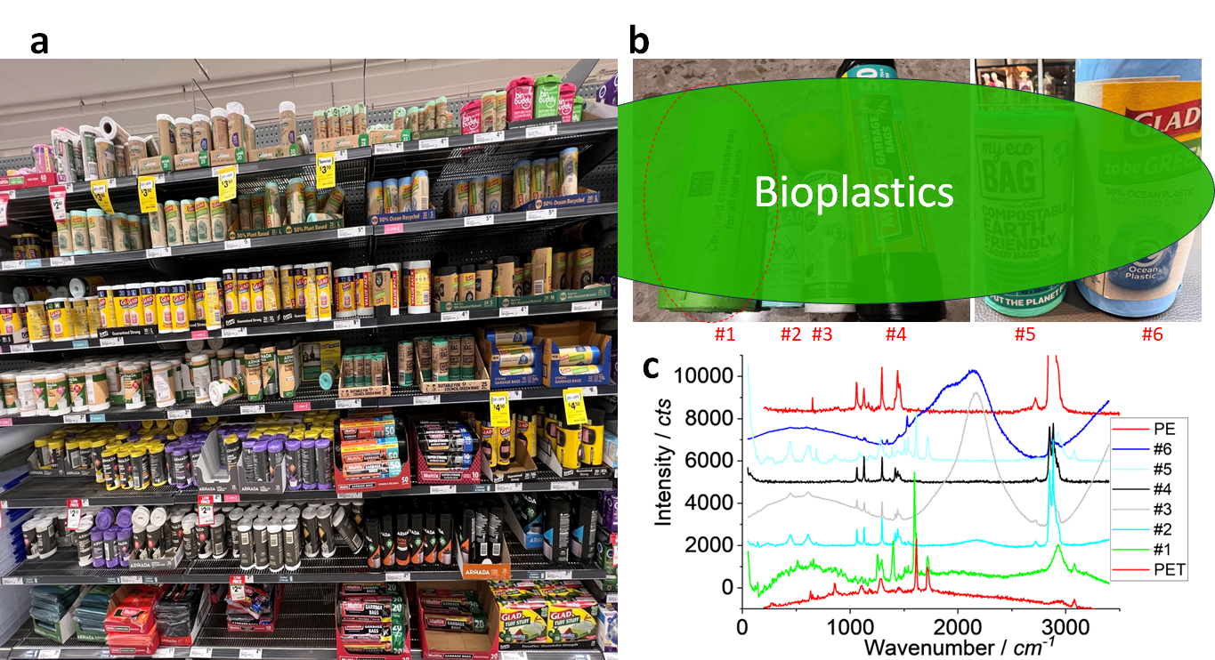 Figure S1. Photo images of bioplastic bags in a local market (a), typical ones tested in this report (b) and their Raman spectra (c). There is an orange in (b) as a size reference.

There are many brands of bioplastic bags on the market, as shown above. We selected several ones, including a compostable bag (#1), a plant-based bag (#2), a sustainable bag (#3), a garbage bag (#4), a compostable earth-friendly bag (#5) and an ocean plastic-recycled bag (#6). The sample #1 was focused in this report (along with another one from China, #7, shown below), both of which are used as table bin bag in kitchen to collect food residues, as presented below.
While the main formulation components might be different and vary, Raman spectra show the possible presence of polymers including PBAT, PET, PE etc. Other polymer and co-components such as starch are identified in the main manuscript and below.
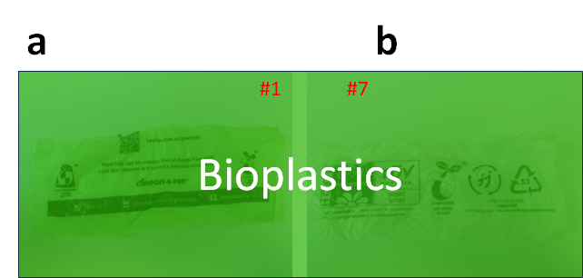
Figure S2. Photo images of two bioplastic bags (#1 and #7) tested in this report.

To identify the main components formulated in the bags, we employed MALDI-MS first, which is presented in the main manuscript. To this end, the bags shown above have been cut using scissors to small pieces for test, as mentioned in the main manuscript. For the cutting, the blank areas are intentionally selected, to avoid the mark/label parts where the prints might have interference for the analysis.

Table S1: detail information about samples.
No/# | Suggestion | Brand information | Label |  | Main Chemical
1 | Certified compostable bag for all food waste | Use to line your food scraps bin, change the bag every 2-3 days or as needed |  | 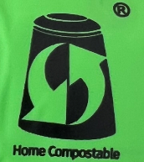 | PBAT, starch
2 | Plant based bag, made from 50% renewably sourced materials |  | 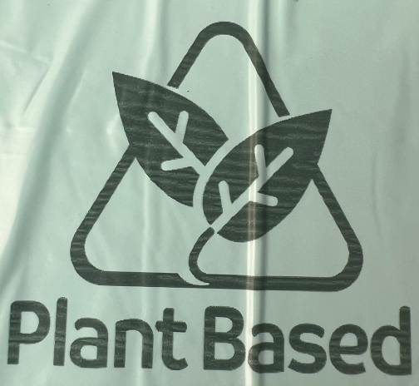 |  | PE
3 | Sustained kitchen bag, 60% plant based plastic | Certified biobased product, 60% | 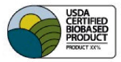 |  | PE
4 | Kitchen bag | Rubbish & garden waste, Home & office, extra wide |  |  | PE
5 | Compostable earth friendly caddy bag | Sustainable alternative to conventional plastic, certified for home, council and industrial |  |  | PBAT
6 | 50% ocean recycled plastic | To be green |  |  | PE, PET
7 | OK compost bag |  |  |  | PBAT, PLA, starch

Some labels might be not the standard ones, more information see (Rosenboom et al., 2022).

1.2. Figures S3-S5: Stability in the absence of microorganisms

1.2.1. Stability under laser
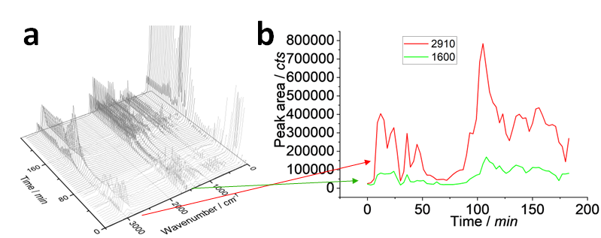
Figure S3. Raman spectra showing the stability of the sample under laser illumination. (a) lists the typical spectra collected at different stages, (b) extract the signal intensities at two characteristic peaks, as arrowed.

Figure S3 shows the stability of the bioplastic sample under the laser illumination. In (a), the spectra are collected at the different stage of the laser illumination. The laser power was set the maximum at ~10 mW and focused via a 100 × objective lens onto the sample surface for ~3 hours. We can see the variation of the spectrum intensity at the different illumination duration. Two typical peaks’ intensities are extracted and presented in (b). Although the variation is observed (due to laser heating, random scattering etc.), there is no signification difference among them, particularly when the collected scattering signal is mapped as image, as shown below. Under the microscope, we also did not see the change on the morphology, which is different from the sample after biodegradation for ~1 week. The biodegraded sample can be easily burned by the laser, even the laser power has been decreased to ~1 mW, which is presented later.
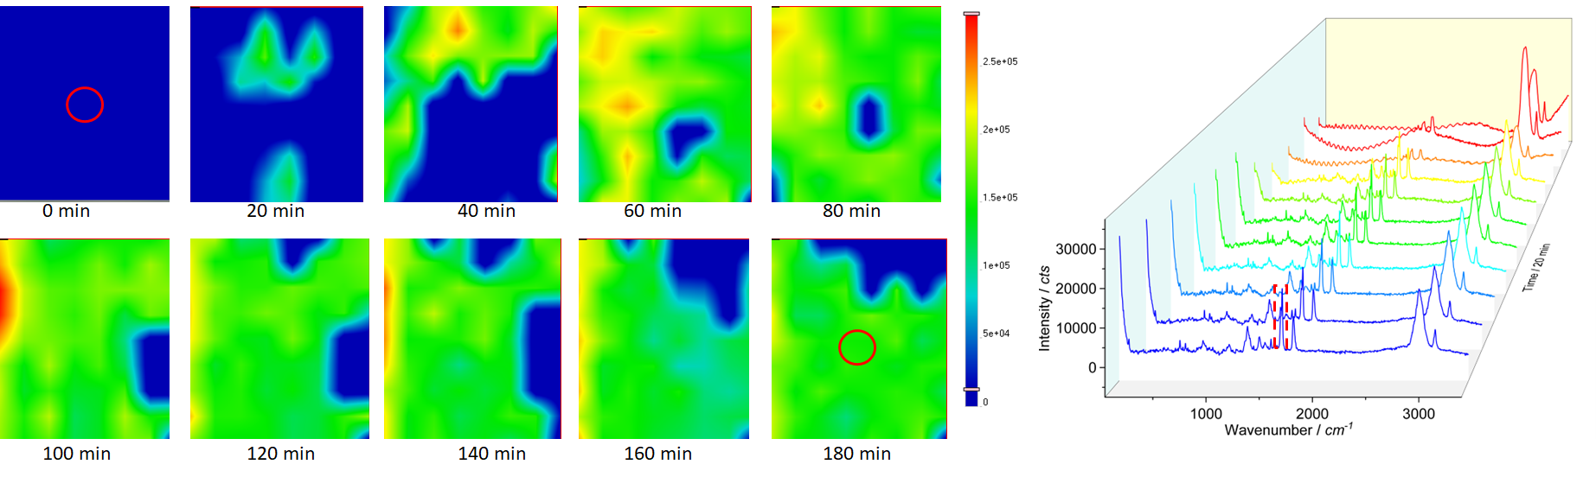
Figure S4. Raman images showing the stability of the sample under laser illumination. The images are mapped via the characteristic peak at ~1600 cm⁻¹ (squared). The colour scale bar is provided, and the average spectra of the scans are extracted, listed and compared as well.

The mapping images are shown here, and the averaged spectra from the scanning matrices are also shown (on the right) for comparison. Basically, the sample is stable and the variation of image/spectrum is normal for Raman scattering signal, although the conditions/parameters changes cannot be ignored. More importantly, the characteristic peaks of the sample (or spectrum profile) have no difference, suggesting that the main components in the sample are stable.

1.2.2. Stability in oven (~60 °C), tap water (~38 °C)
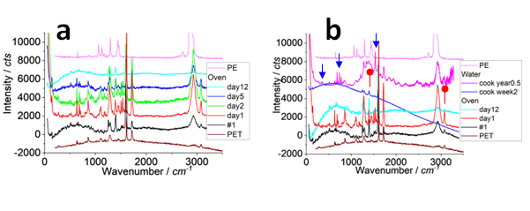
Figure S5. Raman spectra showing the stability of the sample in an oven (a) or in water (b, for comparison). The time durations are labelled in the figures. The newly appeared peaks are arrowed in (b).

In this section, we test the stability in oven and in water. In (a), we see the variation of the spectrum intensity at ~60 °C. Overall, the decrease intends can be observed, but the main characteristic peaks have no position shift and there is no new peak, meaning the sample is relatively stable at ~60 °C.
In (b), we have incubated the samples in the water vapour, akin to “cooking” using tap water, at ~38 °C for ~2 weeks or for half a year. Basically, the main characteristics peaks can be identified without change. Only after half a year, some characteristic peaks disappeared (indicated by red dots), while some new peaks appeared (blue arrows). That means the polymer molecular structure might been changed, such as some derivate groups on the sample surface, as discussed in the main manuscript. However, for naked eyes (shown below) and microscope, there is no observable change on colour and morphology.
This change happens after half a year, suggesting a slow degradation process of in the absence of microorganisms. The biodegradation process can be much faster, which is reported below.

1.3. Figures S6-S7: Biodegradation in kitchen
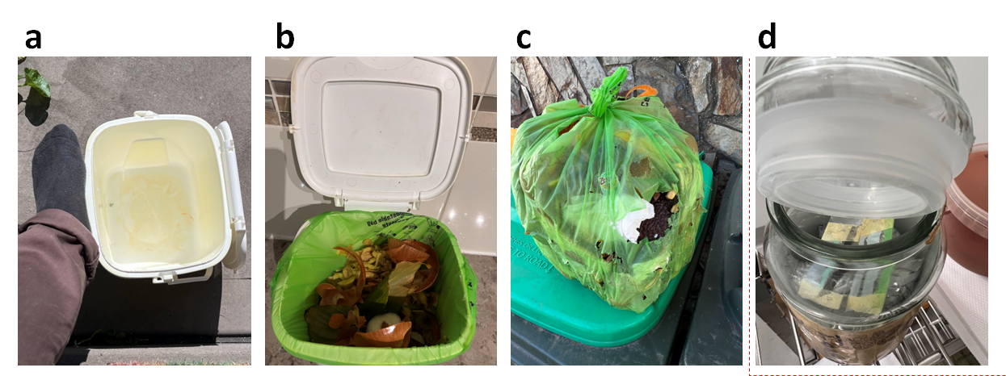
Figure S6. Photo images of the compostable plastic bag sample. (a) is a kitchen table bin with an adult foot as a size background. (b) shows the table bin using the compostable bag to collect the food residues. (c) shows the broken / biodegraded bag after ~1 week serving as the table bin bag in kitchen, the release debris is tested herein. (d) demonstrates the “cooking” process in water for above test (Figure S5), where the bags samples are fixed onto the glass slide surface and left on an aluminium island with tap water on the bottom, all in a glass container stored in a room at ~38 °C.

The compostable bag is tested and the sampling process is demonstrated above. Basically, after ~1 week serving as a table bin bag (10-20 °C), the bag was found broken and release some debris that are tested herein.
On the contrary in (d), if stayed dried in an over at ~60 °C for ~2 weeks, or with water vapor at ~38 °C for half a year, or even directly dipped into a tap water for ~2 weeks, the bag sample is still table and no significant change can be observed by our naked eyes, even by test shown in Figures S4-S5.
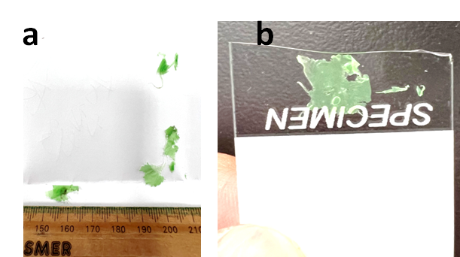
Figure S7. Samples released by biodegradation from the table bag. More see above.

The released debris are shown above. While the big pieces can be easily seen by our naked eyes, there are lots of small ones (<5 mm) that are difficult to be directly seen, which might be categorised as microplastics and are the main testing targets in this report. In (b), the big debris can be peeled off to left behind small debris on the bottom for test, to capture the small microplastics (such as <25 μm).

More characterisation

2.1. Figure S8: Typical SEM images of the released debris
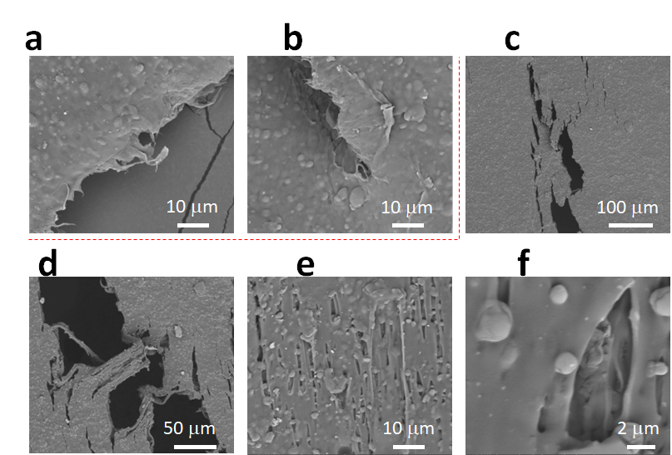
Figure S8. Typical SEM images of the biodegradable plastic. (a, b) are collected before the biodegradation, to compared with those after (rests).

Typical SEM images are provided here. Before the biodegradation, the film of plastic is also shown for comparison in (a, b). After serving as a table bin bag for ~1 week, the morphology changes, including the cracks, fractures, and broken holes developed on the film, due to the biodegradation.

2.2. Figures S9-S10: Possible derivate surface groups and released items
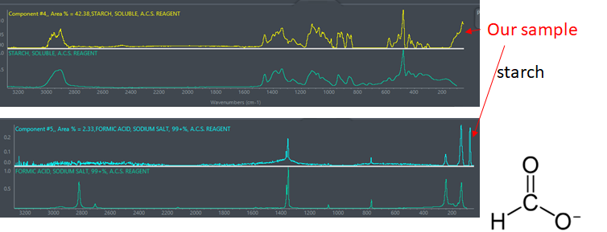
Figure S9. Raman spectrum comparison between the sample spectra and suspects of starch and formic acid, to help the assignments.

As discussed in the main manuscript, we also collect spectra that are assigned to starch or formic acid (Olbert-Majkut et al., 2009; Pinkard et al., 2019). Note some peaks might be not effectively collected either due to the weak intensity (e. g. ~1050 cm⁻¹) or owing to the shielding effect of plastic (e.g. ~2910 cm⁻¹). However, the main characteristic peaks herein can lead to the assignments, as demonstrated above.

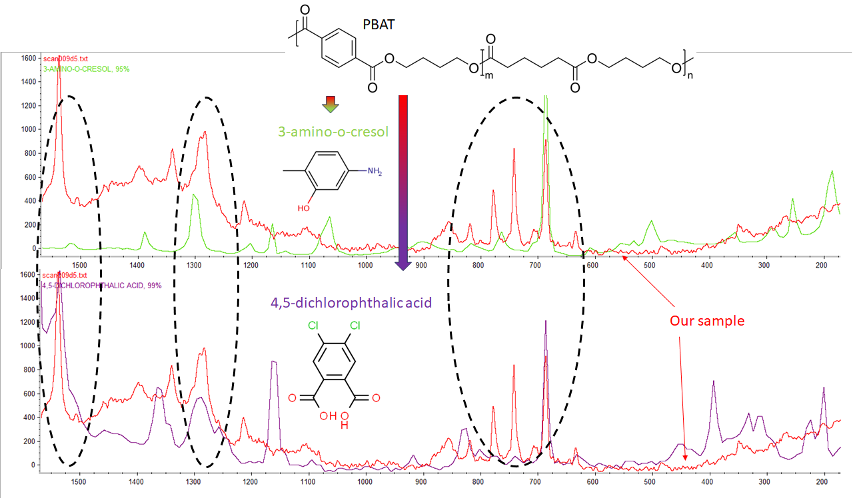
Figure S10. Raman spectrum comparison between the sample spectrum and suspects of a-amino-o-cresol and 4,5-dichlorophthalic acid. The main similar peaks for assignments are circulated.

The surface groups derivate on the film surface due to the biodegradation are identified here, via Raman spectrum (Donelli et al., 2009). The newly appeared peaks are circulated. By indexing in the Raman spectrum library, most likely they are 3-amino-o-cresol or 4,5-dichlorophthalic acid. Their molecular structures are listed and can be the derived group from the PBAT polymer chain. Note the biodegradation process is actually complicated and depends on lots of parameters, the derivate group thus might be different for different plastics, under different parameters. The co-ingredients in the plastics bag also contribute to the variation on the deviated group.

References
Donelli, I., Taddei, P., Smet, P.F., Poelman, D., Nierstrasz, V.A. and Freddi, G. 2009. Enzymatic surface modification and functionalization of PET: A water contact angle, FTIR, and fluorescence spectroscopy study. Biotechnology and Bioengineering 103(5), 845-856.
Olbert-Majkut, A., Ahokas, J., Lundell, J. and Pettersson, M. 2009. Raman spectroscopy of formic acid and its dimers isolated in low temperature argon matrices. Chemical Physics Letters 468(4), 176-183.
Pinkard, B., Gorman, D., Rasmussen, E., Kramlich, J., Reinhall, P. and Novosselov, I. (2019) Kinetics of Formic Acid Decomposition in Subcritical and Supercritical Water - A Raman Spectroscopic Study.
Rosenboom, J.-G., Langer, R. and Traverso, G. 2022. Bioplastics for a circular economy. Nature Reviews Materials 7(2), 117-137.

