Supplementary/Supporting information

A stoichiometric insight into seasonal imbalance of phosphorus and nitrogen in central European fishponds
Running title: Seasonal nutrient ratio in fishponds
Author list:
Lenka Kajgrová¹, Vojtech Kolar^{2,3}, Koushik Roy¹, Zdeněk Adámek¹, Petr Blabolil^{2,3}, Radovan Kopp⁴, Jan Mráz¹, Martin Musil^{5,6}, Oldřich Pecha¹, Libor Pechar^{5,6}, Jan Potužák¹, Jaroslav Vrba^{2,3}
Affiliation:
¹University of South Bohemia, Faculty of Fisheries and Protection of Waters, South Bohemian Research Center of Aquaculture and Biodiversity of Hydrocenoses, Institute of Aquaculture and Protection of Waters, České Budějovice, Czech Republic
²University of South Bohemia, Faculty of Science, České Budějovice, Czech Republic
³Biology Centre CAS, Institute of Hydrobiology, České Budějovice, Czech Republic
⁴Mendel University in Brno, Faculty of AgriSciences, Brno, Czech Republic
⁵ENKI, o.p.s., Třeboň, Czech Republic
⁶University of South Bohemia, Faculty of Agriculture and Technology, České Budějovice, Czech Republic

Address of correspondence:
Lenka Kajgrová
University of South Bohemia in České Budějovice, Faculty of Fisheries and Protection of Waters, South Bohemian Research Center of Aquaculture and Biodiversity of Hydrocenoses, Institute of Aquaculture and Protection of Waters, Na Sádkách 1780, 370 05 České Budějovice, Czech Republic
E-mail: kajgrova@frov.jcu.cz

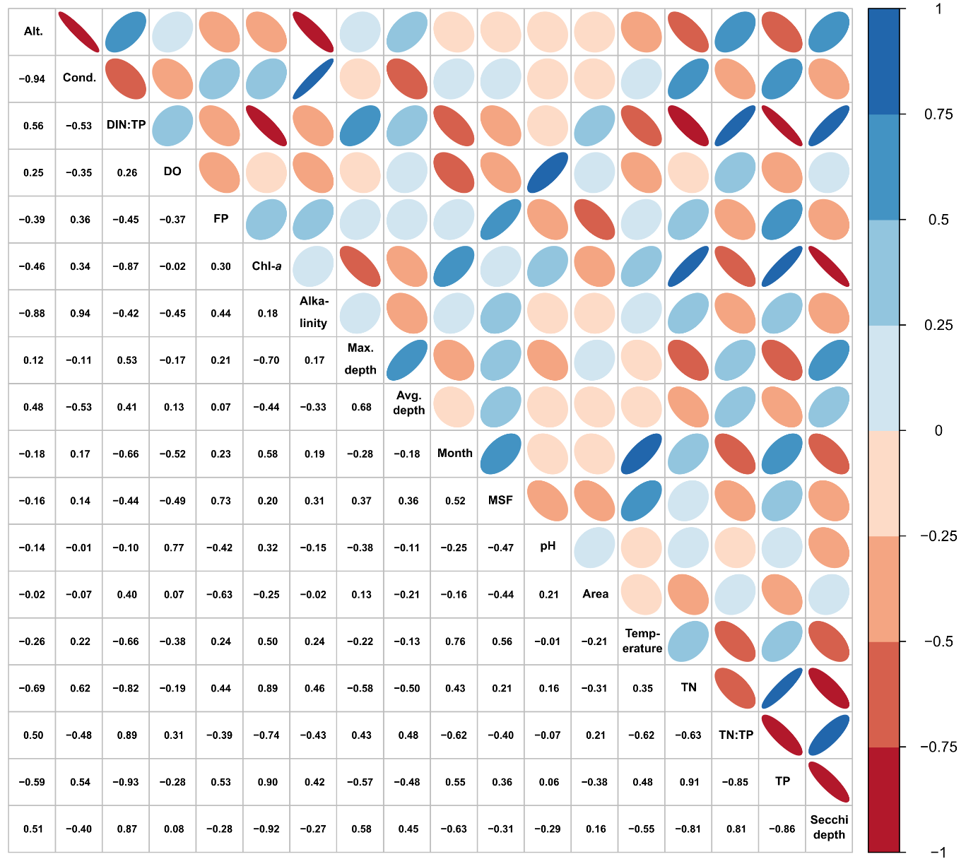
Figure S1. The resulting correlation coefficients are displayed in a correlation matrix, where values below the diagonal represent the Pearson correlation coefficients between each pair of variables. The slope and colour intensity of an ellipse in the matrix illustrates the sign and strength of the correlation between two variables (with a colour code in %). Abbreviations of variables: Alt. = altitude; Cond. = conductivity; DIN:TP = dissolved inorganic nitrogen to total phosphorus ratio; DO = dissolved oxygen; FP = fish production as final fish biomass (kg per ha); Chl-a = chlorophyll-a concentration, Max. depth = maximum depth of ponds; Avg. depth = average depth of ponds; Month = month of the sampling; MSF = dose of supplemental feed applied each month to support fish growth; Area = pond area; TN = total nitrogen; TN:TP = total nitrogen to total phosphorus ratio; TP = total phosphorus; Secchi depth = transparency.

Table S1. Characteristics, environmental variables, and stoichiometric ratio (median and range) of each fishpond under study.
Number in Fig. 1 | Fishpond name | Pond-years | Altitude  (m a.s.l.) | Area (ha) | Mean depth (cm) | DO  (mg L⁻¹) | Secchi depth (cm) | Conductivity  (µS cm⁻¹) | TN  (mg L⁻¹) | TP  (mg L⁻¹) | DIN  (µg L⁻¹) | DRP  (µg L⁻¹) | DIN:TP (molar) | Chlorophyll-a  (µg L⁻¹)
1 | Dehtář | 14 | 406 | 228 | 210 | 9.55  (4.95–15.60) | 54  (25–150) | 322  (127–495) | 2.1  (0.8–4.8) | 0.15  (0.05–0.62) | 180  (0.2–2750) | 15  (1–165) | 1.11  (0.001–93) | 68.75  (2.90–420)
2 | Klec | 4 | 418 | 64 | 200 | 9.35  (5.10–12) | 33  (20–90) | 214  (201–229) | 3.36  (1.57–7.77) | 0.25  (0.13–0.39) | 10  (2–20) | 11  (1–21) | 0.002  (0.001–0.13) | 205.06  (61.04–376.13)
3 | Kvítkovický | 2 | 448 | 24 | 300 | 7.63  (4.63–13.37) | 35  (15–140) | 361  (313–396) | 3.02  (2.03–4.87) | 0.34  (0.2–0.61) | 320  (10–2860) | 125  (14–422) | 0.18  (0.002–3.61) | 97.50  (2–327.73)
4 | Rod | 5 | 415 | 22 | 130 | 9.85  (5.80–18.40) | 30  (15–140) | 191  (131–246) | 2.74  (1.13–8.77) | 0.24  (0.09–0.6) | 20  (1–570) | 12  (3–28) | 0.03  (0.001–5.32) | 144.50  (0.42–696.03)
5 | Novoveský | 1 | 178 | 178 | 100 | 9.01  (6.31–16.13) | 21  (20–30) | 843  (712–983) | 5.78  (5–6.25) | 0.50  (0.30–0.56) | 700  (330–1860) | NA | 2.35  (0.14–8.28) | 447.48  (179.40–541.68)
6 | Jaroslavický | 1 | 190 | 189 | 115 | 8.10  (4.26–11.33) | 22  (15–30) | 352  (184–401) | 2.5  (2.00–2.90) | 0.18  (0.17–0.37 | 410  (110–1000) | NA | 3.80  (1.30–4.81) | 140.31  (53.28–300.44)
7 | Hlohovecký | 1 | 170 | 94 | 115 | 7.51  (3.36–10.96) | 19  (11–33) | 1588  (1498–1600) | 4.80  (3.44–7.67) | 0.41  (0.26–0.59) | 160  (20–380) | 18  (11–28) | 0.03  (0.01–0.15) | 304.84  (66.54–449.72)
8 | Mlýnský | 2 | 170 | 100 | 100 | 4.32  (1.47–10.69) | 116  (14–163) | 1746  (1493–1865) | 4.69  (2.33–6.17) | 0.31  (0.14–0.65) | 1720  (30–2890) | 129  (9–376) | 0.22  (0.03–1.99) | 44.13  (3.28–163.46)
9 | Dobrá Vůle | 3 | 414 | 25.45 | NA | 10.98  (5.60–16.67) | 27  (13–130) | 187  (88–211) | 2.68  (1.39–5.53) | 0.28  (0.1–0.51) | 50  (10–740) | 13  (5–73) | 0.19  (0.01–2.35) | 129.38  (2.48–434.83)
10 | Potěšil | 1 | 419 | 64 | 260 | 6.9  (4.60–10.22) | 17  (10–30) | 160  (125–166) | 3.74  (2.1–6.13) | 0.44  (0.2–0.56) | 20  (10–50) | 14  (8–18) | 0.05  (0.02–0.07) | 330.16  (81.91–514.88)
11 | Služebný | 3 | 422 | 24.2 | 280 | 8.31  (3.37–16.30) | 20  (15–88) | 250  (230–292) | 3.01  (2.28–5.14) | 0.30  (0.19–0.51) | 20  (10–1170) | 12  (3–179) | 0.05  (0.01–0.29) | 145.99  (50.92–396.70)
12 | Prostřední Hoskovský | 1 | 440 | 0.48 | 90 | 7.72  (4.57–10.33) | 110  (30–130) | 322  (292–1640) | 2.25  (1.2–4.7) | 0.24  (0.10–0.63) | 70  (40–4150) | 46  (24–91) | 0.31  (0.06–63) | 15.70  (1.80–140)
13 | Buchhamer | 1 | 440 | 0.66 | 110 | 6.16  (2.25–13.95) | 93  (30–150) | 259  (224–322) | 1.9  (1.20–2.30) | 0.15  (0.07–0.22) | 50  (30–980) | 48  (16–82) | 0.26  (0.16–30) | 25  (0.50–91)
14 | Dolní Samonicky | 1 | 440 | 1 | 90 | 10.53  (3.22–18.20) | 53  (20–120) | 581  (539–606) | 3.7  (2.2–4.7) | 0.25  (0.11–0.46) | 80  (40–2180) | 78  (58–160) | 0.23  (0.07–0.92) | 57  (2.10–260)
15 | Lusk | 1 | 440 | 0.8 | 130 | 10.72  (3–15.91) | 95  (45–140) | 448  (396–555) | 3.05  (1.5–3.5) | 0.30  (0.11–0.612) | 290  (40–2140) | 295  (110–610) | 1.12  (0.06–12) | 18.55  (0.50–230)
16 | Horni Sitotci | 1 | 440 | 0.45 | 90 | 7.96  (5.50–12.95) | 85  (60–150) | 472  (432–556) | 1.25  (1.10–1.60) | 0.22  (0.09–0.45) | 40  (30–440) | 112  (23–250) | 0.27  (0.075–2.21) | 24.50  (3.10–89
17 | Dolní Sirotčí | 1 | 440 | 0.33 | 90 | 10  (7.12–12.53) | 90  (60–170) | 459  (435–559) | 1.35  (1.1–1.8) | 0.22  (0.09–0.48) | 40  (30–310) | 93  (23–250) | 0.3  (0.07–2) | 42  (1.40–200)
18 | Rožmberk | 13 | 430 | 489 | 130 | 9.98  (4.35–19.30) | 35  (10–155) | 199  (124–259) | 2.10  (0.65–8.9) | 0.21  (0.05–0.84) | 140  (90–1670) | 17  (5–126) | 0.87  (0.2–79) | 151.50  (7.40–760)
19 | Horusický | 9 | 416 | 415 | 100 | 7.20  (0.50–12) | 44  (15–250) | 334  (241–439) | 2.02  (0.7–5.9) | 0.21  (0.05–1) | 170  (90–1190) | 14  (5–130) | 0.81  (0.18–14) | 75  (3.20–350)
20 | Bezdrev | 14 | 381 | 520 | 150 | 8.55  (3.00–17) | 45  (5–180) | 393  (198–483) | 2.2  (0.9–3.8) | 0.14  (0.033–0.53) | 190  (70–2100) | 13  (5–52) | 1.29  (0.34–64) | 66  (5.40–260)
21 | Svět | 14 | 436 | 200 | 160 | 9.10  (4.70–18) | 54  (25–300) | 220  (121–279) | 1.65  (0.65–3.9) | 0.09  (0.02–0.32) | 170  (70–1790) | 5  (5–38) | 1.96  (0.79–102) | 20  (3.50–110)
22 | Staňkovský | 14 | 469 | 241 | 260 | 10.10  (5.30–14.75) | 150  (55–300) | 120  (92–148) | 1.15  (0.25–1.15) | 0.03  (0.01–0.08) | 290  (70–1930) | 5  (5–17) | 10.81  (2.73–210) | 37.25  (2.80–290)
23 | Kaclezsky | 8 | 534 | 180 | 150 | 8.90  (6.50–13.20) | 72  (23–250) | 136  (80–164) | 1.7  (0.6–4.2) | 0.08  (0.03–0.33) | 160  (90–2150) | 5  (5–29) | 3.01  (0.51–111) | 37.25  (2.80–290)
24 | Olšina | 6 | 730 | 138 | 150 | 9  (6.70–11.60) | 70  (30–250) | 75  (60–101) | 1.2  (0.25–2.8) | 0.08  (0.04–1.30) | 120  (90–410) | 8  (5–28) | 2.11  (0.27–6.23) | 34  (2.50–240)
25 | Káňov | 8 | 427 | 159 | 180 | 8.90  (5.50–13.10) | 45  (15–175) | 298  (211–425) | 2.5  (1–4.8) | 0.24  (0.09–1.1) | 140  (90–1760) | 13  (5–220) | 0.73  (0.17–15) | 110  (2.20–540)
26 | Ratmirovsky | 5 | 525 | 73 | 170 | 10.40  (3.30–19.10) | 45  (10–100) | 134  (96–237) | 2  (0.8–3.8) | 0.15  (0.04–0.33) | 310  (70–2950) | NA | 1.52  (0.34–139) | 102.50  (7.40–340)
27 | Hejtman | 5 | 490 | 72 | 180 | 11.10  (6.10–22.10) | 45  (25–140) | 202  (155–231) | 1.9  (0.9–4) | 0.15  (0.04–0.42) | 240  (70–3440) | NA | 1.31  (0.27–179) | 96  (12–330)
28 | Labuť | 3 | 453 | 453 | 180 | 8.85  (6.80–12.20) | 45  (35–55) | 314  (259–347) | 1.6  (0.7–3.70) | 0.14  (0.11–0.24) | 150  (100–2100) | 5  (5–30) | 1.28  (0.71–30) | 74.50  (45–137.50)
29 | Buzicky | 4 | 429 | 40.3 | NA | 8.85  (6.05–16) | 33  (25–50) | 395  (296–514) | 3.3  (1.8–4.65) | 0.49  (0.25–0.85) | 430  (90–1620) | 103  (31–315) | 0.44  (0.2–13) | 180  (105–445)
30 | Prostřední | 1 | 170 | 45 | 100 | 7.04  (5.11–11.91) | 63  (22–135) | 1655  (1651–1700) | 3.80  (1.20–5.12) | 0.41  (0.32–0.45) | 430  (60–2670) | 95  (20–316) | 0.60  (0.02–1.90) | 50.23  (1.80–185.64)
31 | Nesyt | 2 | 170 | 250 | 150 | 9.21  (2.92–14.53) | 44  (12–118) | 1405  (1321–1514) | 3.84  (1.88–5.96) | 0.36  (0.10–0.69) | 510  (20–2240) | 76  (19–341) | 0.39  (0.01–3.05) | 61.45  (1.44–413.48)
32 | Ráček I | 1 | 590 | 0.23 | 110 | 8.28  (6.82–13.42) | 300  (200–350) | 210  (196–231) | 0.88  (0.5–2.16) | 0.05  (0.04–0.63) | 110  (90–1860) | NA | 3.5  (1.74–40) | 2.96  (1.48–13.32)

Table S2. The values of ∆AIC_{c}, degrees of freedom (df), Akaike weights of the different GLMMs and the proportion of variance explained by the fixed effects relative to the overall variance (marginal R²) for chlorophyll-a. The most parsimonious and other plausible models (∆AIC_{c} ≤ 2) for each response are in bold. Models are ordered by the degree of parsimony. Explanatory variable: Chl-a = concentrations of chlorophyll-a; Area = total surface area of fishpond; DIN:TP = dissolved inorganic nitrogen to total phosphorus ratio; Alt = altitude; Month = month of the sampling; Year = year of the sampling, Locality = sampled locality; ² = second-order polynomial. See Methods for more details.
Response | Model Structure | ∆AIC_{c} | df | Weight | Marginal R²
log₁₀(Chl-a) | ~ (log₁₀Area + log₁₀Area²) + (DIN:TP + DIN:TP² + Alt + Alt²) * Month + (1|Year) + (1|Locality) | 0 | 15 | 1 | 0.397
 | ~ (log₁₀Area + log₁₀Area²) + (DIN:TP + Alt + Alt²) + (1|Year) + (1|Locality) | 235.2 | 9 | <0.001 | 0.275
 | ~ (log₁₀Area + log₁₀Area²) + (DIN:TP + DIN:TP² + Alt) + (1|Year) + (1|Locality) | 230.3 | 9 | <0.001 | 0.263
 | ~ (log₁₀Area + log₁₀Area²) + DIN:TP + (Alt + Alt²) * Month + (1|Year) + (1|Locality) | 54.1 | 12 | <0.001 | 0.354
 | ~ (log₁₀Area + log₁₀Area²) + DIN:TP + DIN:TP² + Alt * Month + (1|Year) + (1|Locality) | 75.3 | 11 | <0.001 | 0.319
 | ~ (log₁₀Area + log₁₀Area²) + DIN:TP + Alt + (1|Year) + (1|Locality) | 234.8 | 8 | <0.001 | 0.259
 | ~ (log₁₀Area + log₁₀Area²) + Alt + Alt² + (1|Year) + (1|Locality) | 389.6 | 8 | <0.001 | 0.119
 | ~ (log₁₀Area + log₁₀Area²) + DIN:TP + DIN:TP² + (1|Year) + (1|Locality) | 228.3 | 8 | <0.001 | 0.262
 | ~ (log₁₀Area + log₁₀Area²) + (DIN:TP + Alt)*Month + (1|Year) + (1|Locality) | 39.1 | 11 | <0.001 | 0.343
 | ~ (log₁₀Area + log₁₀Area²) + (Alt + Alt²)*Month + (1|Year) + (1|Locality) | 105.9 | 11 | <0.001 | 0.305
 | ~ (log₁₀Area + log₁₀Area²) + (DIN:TP + DIN:TP²)*Month + (1|Year) + (1|Locality) | 16.2 | 11 | <0.001 | 0.360
 | ~ (log₁₀Area + log₁₀Area²) + DIN:TP * Month + (1|Year) + (1|Locality) | 35.7 | 9 | <0.001 | 0.338
 | ~ (log₁₀Area + log₁₀Area²) + Alt * Month + (1|Year) + (1|Locality) | 118.4 | 9 | <0.001 | 0.268
 | ~ (log₁₀Area + log₁₀Area²) + Month + (1|Year) + (1|Locality) | 117.5 | 7 | <0.001 | 0.262
 | ~ (log₁₀Area + log₁₀Area²) + DIN:TP + (1|Year) + (1|Locality) | 232.7 | 7 | <0.001 | 0.259
 | ~ (log₁₀Area + log₁₀Area²) + Alt + (1|Year) + (1|Locality) | 390.8 | 7 | <0.001 | 0.090
 | ~ (log₁₀Area + log₁₀Area²) + 1 + (1|Year) + (1|Locality) | 390.8 | 6 | <0.001 | 0.088

