Supplementary Material

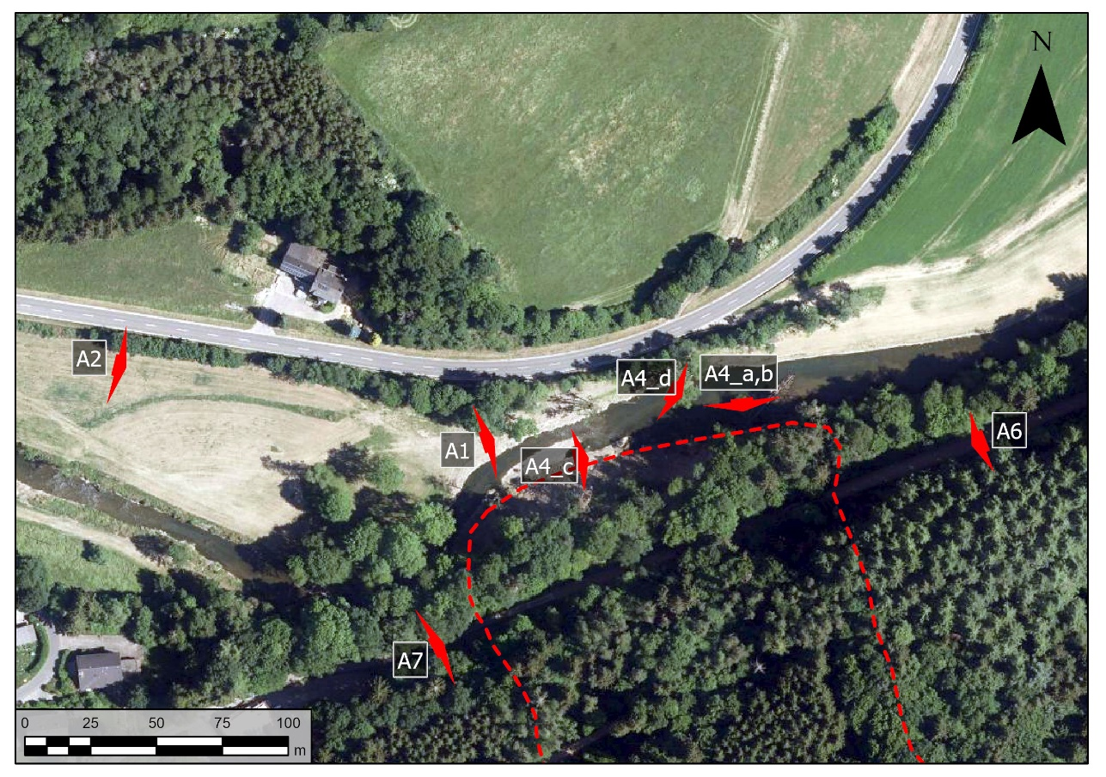
Figure A0 Location of photos in supplementary Material

Figure A1 Peak discharge is marked with red lines. The slide on the right and the street on the left.

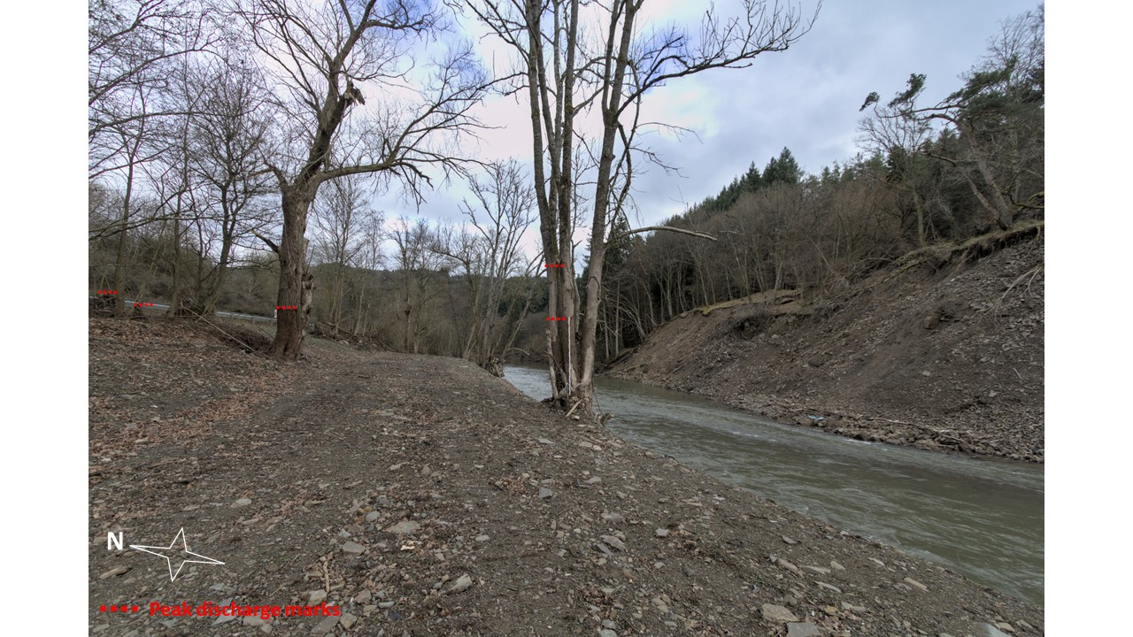

Figure A2: Overview of the complete slide with active area (red) and currently inactive area (light blue)

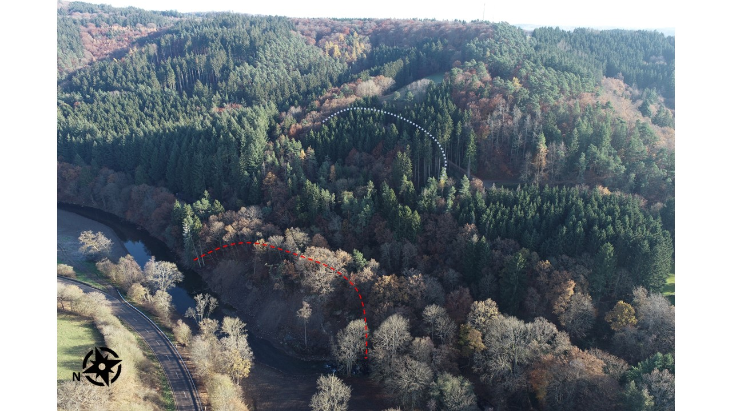

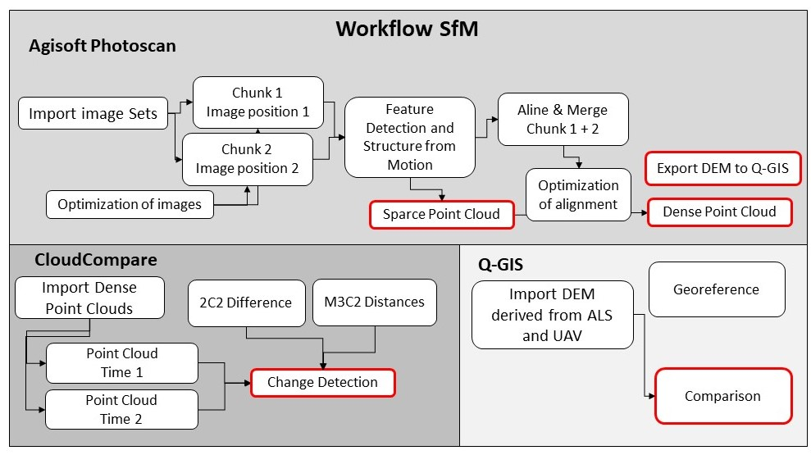
Figure A3: The workflow followed from UAV imagery to point Density Clouds.

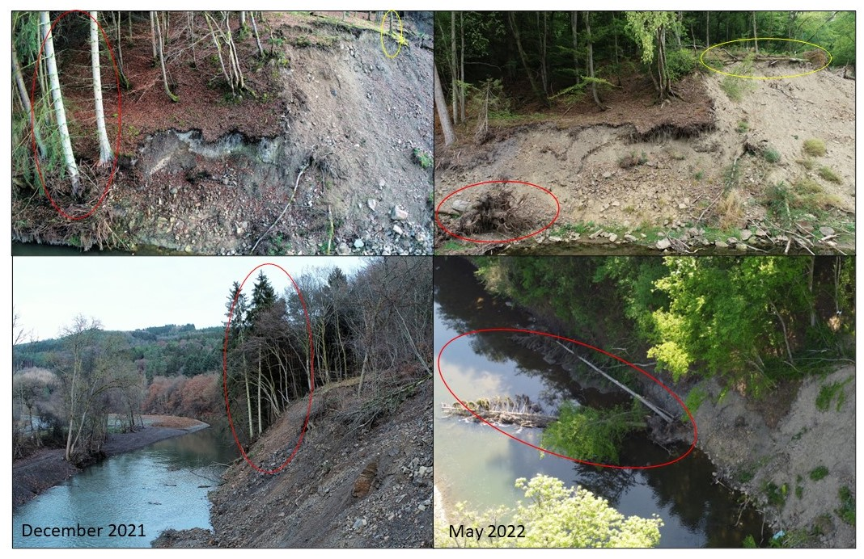
Figure A4: Images from the frontal slope area showing differences in vegetation December 2021 and May 2022.

Figure A5: Additional ERT Profiles showing the subsurface horizontally (P3, P5, P6) and longitudinally (P4)

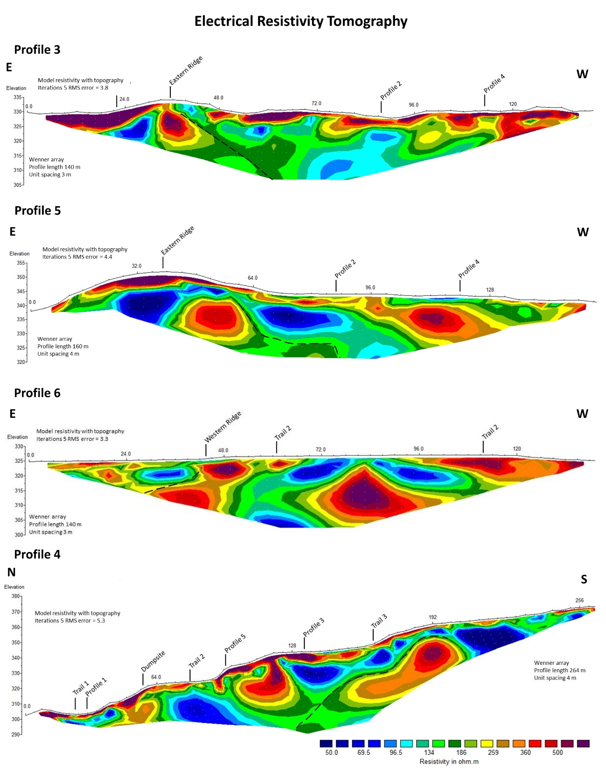

Figure A6: Overview of sliding area towards the west. Retaining wall for a smaller landslide (see Figure 2).
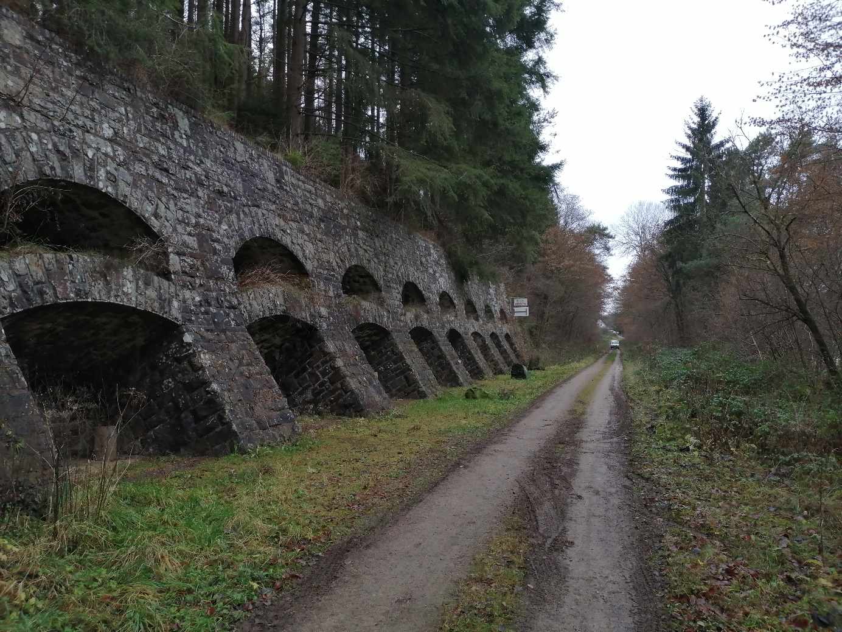

Figure A7: Cracks in the trail that appeared during the flood, view towards the slide.
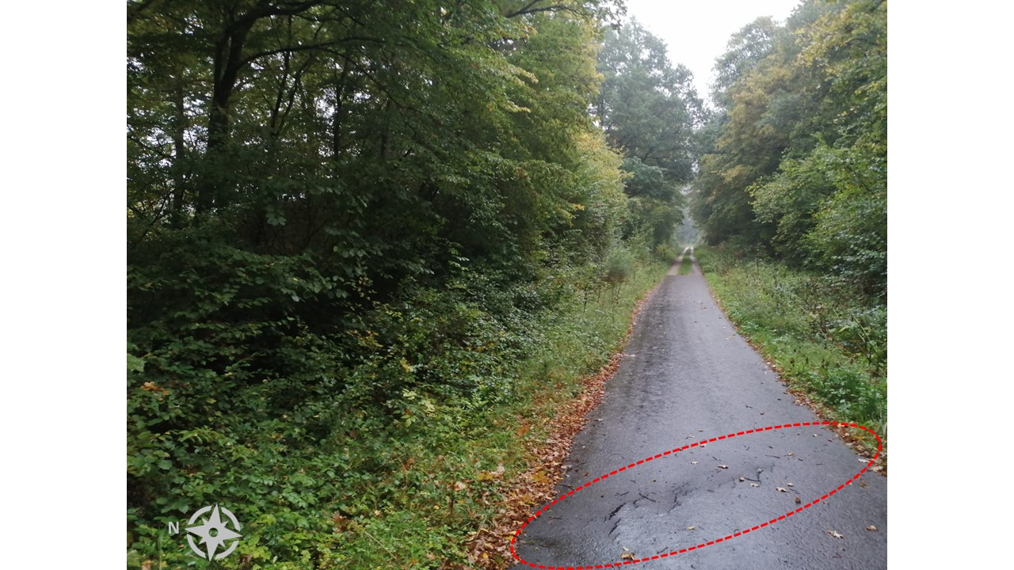

Figure A8: Position of Müsch landslide along the Ahr river,
