Supplements
Supplementary Figure 1. Trends in the reporting of the raw (a) and relative abundances (b) of non-native species over time according to the applied Generalised Additive Model, displaying individual data points contributing to each respective trend.
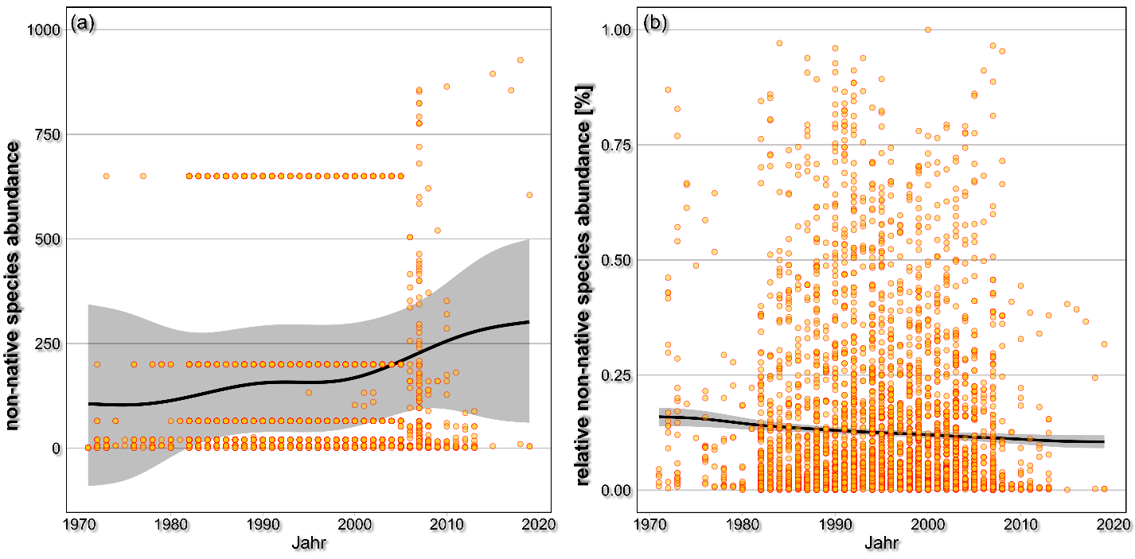
Supplementary Table 1. Number of occurrences (by years) non-native species were reported within the German time series, according to Haase et al. (2023). Note that each time series contains multiple years.
Species | Number of occurrences
Dreissena polymorpha | 1157
Corophium curvispinum | 610
Dugesia tigrina | 515
Dikerogammarus villosus | 439
Gammarus tigrinus | 393
Potamopyrgus antipodarum | 264
Jaera istri | 221
Corbicula fluminea | 217
Echinogammarus ischnus | 165
Physella acuta | 94
Corbicula fluminalis | 88
Proasellus coxalis | 87
Cordylophora caspia | 82
Hypania invalida | 53
Orconectes limosus | 49
Corophium robustum | 40
Orchestia cavimana | 21
Echinogammarus berilloni | 20
Erpobdella testacea | 18
Dendrocoelum romanodanubiale | 17
Eriocheir sinensis | 17
Pontogammarus robustoides | 10
Dikerogammarus haemobaphes | 9
Branchiura sowerbyi | 7
Echinogammarus trichiatus | 6
Potamothrix moldaviensis | 2
Balanus improvisus | 1
Limnomysis benedeni | 1
Lithoglyphus naticoides | 1
Pectinatella magnifica | 1
Proasellus meridianus | 1
Rhithropanopeus harrisii | 1

Supplementary Table 2. Results of the applied generalized additive model for the raw abundance of non-native species.
Parametric coefficients:
 | Estimate | Std. Error | t value | Pr(>|t|)
(Intercept) | -0.0000005096 | 0..000009159 | -0.556 | 0.578
Approximate significance of smooth terms:
 | edf | Ref.df | F | p-value
s(year) | 0.385170651 | 0.668 | 1.351 | 0.3422
s(Longitude,Latitude) | 3.942426047 | 15.000 | 0.502 | 0.0495 | *
s(site_id) | 0.993631329 | 1.000 | 0.202 | <0.001 | ***
n_unique_sites | 0.000003371 | 1.000 | 0.000 | 0.5642
Signif. codes: 0 ‘***’ 0.001 ‘**’ 0.01 ‘*’ 0.05 ‘.’ 0.1 ‘ ’ 1
Rank: 10/61
R-sq.(adj) = 0.00117 Deviance explained = 0.189%
GCV = 6.1573e+06 Scale est. = 6.1515e+06 n = 4607
Supplementary Table 3. Results of the applied generalized additive model for the relative abundance of non-native species.
Parametric coefficients:
 | Estimate | Std. Error | t value | Pr(>|t|)
(Intercept) | -0.00000012347 | 0.00000004586 | -2.692 | 0.00712 | **
Approximate significance of smooth terms:
 | edf | Ref.df | F | p-value
s(year) | 0.929109 | 0.9321 | 12.502 | <0.001 | ***
s(Longitude,Latitude) | 2.765840 | 9.0000 | 1.080 | <0.05 | **
s(site_id) | 0.981498 | 1.0000 | 44.692 | <0.001 | ***
n_unique_sites | 0.003664 | 1.0000 | 0.031 | <0.05 | **
Signif. codes: 0 ‘***’ 0.001 ‘**’ 0.01 ‘*’ 0.05 ‘.’ 0.1 ‘ ’ 1
Rank: 12/61
R-sq.(adj) = 0.00463 Deviance explained = 0.561%
GCV = 0.031484 Scale est. = 0.031443 n = 4607
Supplementary Table 4. Results of the applied generalized additive model for the total number of non-native species.
Parametric coefficients:
 | Estimate | Std. Error | t-value | Pr(>|t|)
(Intercept) | 7.0786 | 0.7089 | 9.985 | < 0.001 | ***
Approximate significance of smooth terms:
 | edf | Ref.df | F | p-value
s(year) | 6.1990 | 7.373 | 37.54 | < 0.001 | ***
s(unique_sites) | 0.9495 | 1.000 | 10.84 | <0.05 | ***
Signif. codes: 0 ‘***’ 0.001 ‘**’ 0.01 ‘*’ 0.05 ‘.’ 0.1 ‘ ’ 1
R-sq.(adj) = 0.906 Deviance explained = 92%
GCV = 3.8959 Scale est. = 3.2345 n = 48

