Supplemental Information

Dioxin-like and estrogenic activity screening in fractionated sediments from a German catchment after the 2021 extreme flood
Sarah Johann ^{1,2*}, Moritz Düster ¹, Piero Bellanova ³, Jan Schwarzbauer ⁴, Alexandra Weber ⁵, Stefanie Wolf ⁶, Holger Schüttrumpf ⁶, Frank Lehmkuhl ⁵, Henner Hollert ^{1,2,7,8}

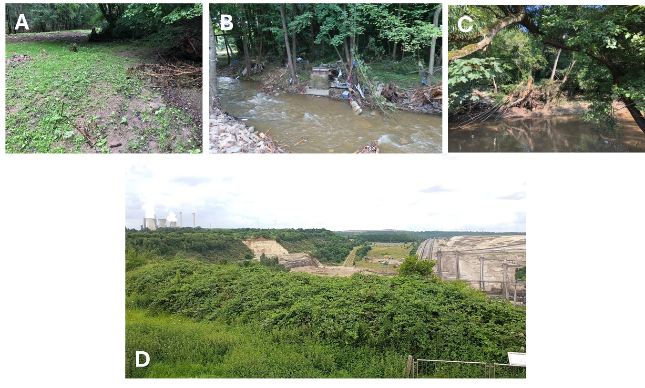
Figure SI1 Exemplary pictures of sampling sites in the Vicht-Inde catchment after flood event in July 2021. (A) V1: floodplain area at the Vicht after flooding, (B) V2: Vicht with washed up household items, (C) I2, (D) I5: flooded open pit close to the Inde River.

Table SI1 20% cytotoxic effect concentration (EC₂₀) (mgSEQ/mL) of H4IIe cells exposed to fractions B1 to B6 of the sediment extracts from the extreme flood event 2021. Two replicates (R1, R2) of NR retention assay were performed in total. – indicates no cytotoxic effect up to 100 mgSEQ/mL. Internal surrogate standard (5.8 ng/µL fluoracteophenone, 6.28 ng/µL d10-benzophenone and 6.03 ng/µL d34-hexadecane) did not alter cell viability.
Sample | B1 |  | B2 |  | B3 |  | B4 |  | B5 |  | B6
 | R1 | R2 | R1 | R2 | R1 | R2 | R1 | R2 | R1 | R2 | R1 | R2
I 1 | - | - | - | - | - | - | - | - | - | - | - | -
V 1 | - | - | - | 23.70 | - | - | - | - | - | - | - | -
V 2 | - | - | - | - | - | - | - | - | - | - | - | -
V 3 | - | - | - | - | - | - | - | - | - | - | - | -
I 2 | - | - | - | - | - | - | - | - | - | - | - | -
I 3 | - | - | - | - | - | - | - | - | - | - | - | -
I 4 | - | - | - | - | - | - | - | - | - | - | - | -
I 5 | - | - | - | - | - | - | - | - | - | - | 19.59 | 20.73
I 6 | - | - | - | - | - | - | - | 18.47 | - | - | - | -
I 7 | - | - | - | - | - | - | - | - | - | - | - | -
Blank | - | - | - | - | - | - | - | - | - | - | - | -

Table SI2 Median grain size of sediments from the Vicht-Inde catchment after the 2021 flood event. Grain size distribution was measured using laser diffraction and calculated following Mie theory.
Sample abbreviation | River | Median grain size / (µm)
V 1 | Vicht | 551.57
V 2 | Vicht | 567.82
V 3 | Vicht | 32.04
I 1 | Inde | 35.69
I 2 | Inde | 142.61
I 3 | Inde | 55.21
I 4 | Inde | 93.12
I 5 | Inde | 67.25
I 6 | Inde | 21.27
I 7 | Inde | 302.28

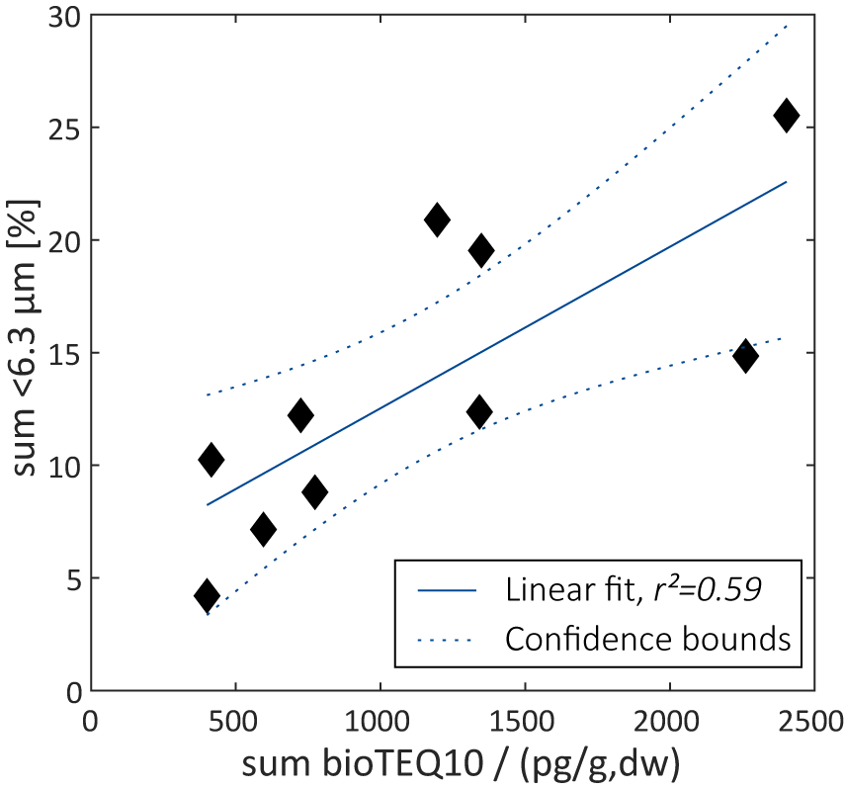
Figure SI 2 Correlation of fine grain size fractions and total organic carbon (TOC) with dioxin-like activity. Dioxin-like activity was measured as µEROD activity in H4IIE cells and expressed as biological equivalent quotient (bio-TEQ₁₀). Bio-TEQs of individual fractions were summed up. Thresholds for fine sediment grain size was set to 6.3 µm.
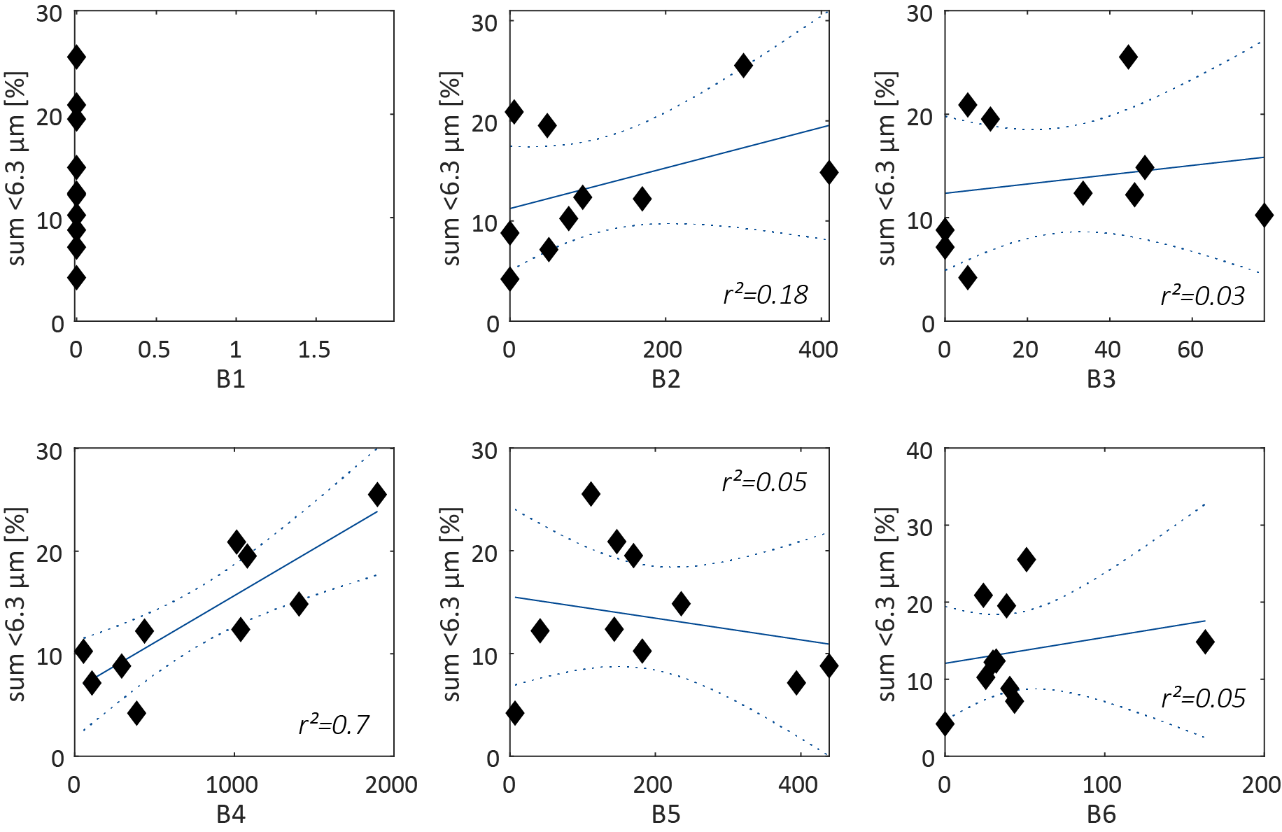
Figure SI3 Correlation of bioassay-derived TCDD equivalents (bio-TEQs) with fine grain size fractions of individual chemical fractions B1 to B6. Threshold of fine sediments was set to 6.3 µm. Bio-TEQs were derived from µEROD activity in H4IIE cells.

