Supplementary data
A- Supplementary Figures

Fig. S1. Standard curve of CAP concentration at 225 nm

Fig. S2. Standard curve of CAP concentration at 243 nm

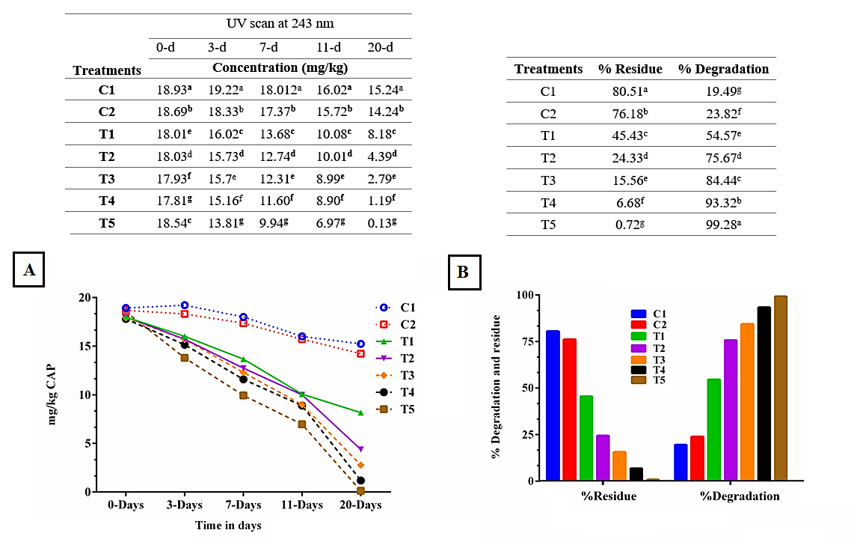
Fig. S3. Biodegradation efficiency of CAP added at 20 mg/kg in sandy loam soil as affected by inoculation with individual and / or mixed bacterial consortia during the incubation periods at 30 °C for 20 days, as determined by UV scan at 243 nm. Different letters represent significant differences (Duncan’s test significant difference test at p < 0.05) among all treatments.C1, Soil polluted with CAP but (No NPK, No inoculum). C2, Soil polluted with CAP, with NPK but (No inoculum). The treatments (T1-T5) were all polluted with CAP, with NPK and treated with bacterial inoculum as follows: T1, Mono-Gram-positive (Bacillus subtilis subsp. subtilis AZFS3). T2, Mono-Gram-negative (Pseudomonas aeruginosa KZFS4). T3, Di-Gram-negative consortium (Pseudomonas aeruginosa KZFS4 & Alcaligenes aquatilis KZFS11). T4, Tetra Gram-positive (Bacillus subtilis subsp. subtilis AZFS3, Bacillus pumilus AZFS5, Bacillus mojavensis AZFS15 & Bacillus paramycoides AZFS18). T5, Hexa-mixed bacteria (T3+T4).

B- Supplementary Tables

Table S1. Biodegradation efficiency of CAP added at 20 mg/kg in sandy loam soil as affected by inoculation with individual and / or mixed bacterial consortia during the incubation periods at 30 °C for 20 days, as determined by UV scan at 225 nm

Treatment | UV scan at 243 nm |  |  |  |  | %Residue | %Degradation
Treatment | 0-d | 3-d | 7-d | 11-d | 20-d | %Residue | %Degradation
Treatment | Concentration (mg/kg) |  |  |  |  | %Residue | %Degradation
C1 | 18.78e | 18.85^{b} | 17.34^{b} | 15.41^{b} | 14.15^{b} | 77.12ª | 22.88^{f}
C2 | 18.86^{b} | 19.12ª | 17.94ª | 15.93ª | 15.12ª | 72.48^{b} | 27.52^{g}
T1 | 18.77^{f} | 16.67^{c} | 13.48^{c} | 10.23^{c} | 8.13^{c} | 43.31^{c} | 56.69e
T2 | 18.76^{g} | 16.15^{d} | 12.56^{d} | 10.13^{d} | 4.38^{d} | 23.37^{d} | 76.63^{d}
T3 | 18.84^{c} | 15.79e | 12.23e | 9.094e | 2.78e | 14.75e | 85.25^{c}
T4 | 18.87ª | 15.41^{f} | 11.85^{f} | 8.95^{f} | 1.18^{f} | 6.26^{f} | 93.74^{b}
T5 | 18.82^{d} | 14.12^{g} | 9.92^{g} | 6.94^{g} | 0.14^{g} | 0.77^{g} | 99.23ª

