Supplemental File A. Glyphosate and Chelation

Calcium (Ca) is a divalent (2+) cation. According to Monsanto scientists [56]:
“EPSP synthase catalyzes the conversion of phosphoenolpyruvic acid (PEP) and 3-phosphoshikimic acid to 5-enolpyruvyl-3-phosphoshikimic acid. Glyphosate blocks this step by competing with PEP for binding to the enzyme’s active site.” (Emphasis added)

The propensity of glyphosate to react with, and bind to other chemicals is foundational to its efficacy as a herbicide. Glyphosate has a weakly negative charge that varies as a function of pH and its specific chemical form (e.g. monoammonium salt, diammonium salt, isopropylamine salt, potassium salt, sodium salt, and trimesium salt) [56].

Glyphosate’s tendency to chelate with other molecules is also important in the distribution of GLY in the body. A team of Monsanto scientists led by Vicini published a paper [56] that includes a section entitled “Chelating Properties of Glyphosate”. It addresses various controversies associated with GLY’s ability to form complexes with minerals and other chemicals and states:

“Glyphosate is a zwitterion with 3 acidic protons that make it a tridentate chelating agent of divalent and trivalent metals, forming either 1:1 or 1:2 complexes…This chemical property is often overstated as a mechanism whereby glyphosate application to plants limits mineral availability either by limiting uptake from the soil or limiting mineral transport in the phloem.” (Emphasis added)

In response to published papers claiming that glyphosate can tie up essential mineral micronutrients in plant phloem, or in the human GI tract, Vicini et al. advance a variety of arguments to the contrary [56]. These include that in plant phloem and the human GI tract there are many other molecules and minerals that are more highly reactive than glyphosate, and that the concentrations of some other chelators are much higher than the concentration of glyphosate.

The strength of metallo-glyphosate bonds remains an important consideration both in the efficacy of GBHs and GLY immobilization, mobilization, and excretion in the human body. There is no discussion of glyphosate’s tendency to bind with calcium in bones in the Vicini et al. paper, although there is discussion of GLY-calcium chelation in soil and plants.

Another team offers a more detailed explanation of glyphosate’s mode of herbicidal activity [44], again noting the competitive binding of glyphosate:
“…the primary effect of glyphosate on plants seems to be inhibition of 5-enolpyruvylshikimate-3-phosphate synthase (EPSPS), an enzyme of the shikimate pathway for biosynthesis of aromatic amino acids. EPSPS catalyzes the transfer of the enolpyruvyl moiety of phosphoenolpyruvate (PEP) to the 5-hydroxyl of shikimate 3-phosphate (S3P) to produce 5-enolpyruvylshikimate3-phosphate (EPSP) and inorganic phosphate…”

“Glyphosate competitively inhibits the EPSPS, because it binds more tightly to the enzyme than one of its substrates, phosphoenolpyruvate (PEP), thereby inhibiting the enzyme’s catalysis.” (Emphasis added)

Cakmak et al. discuss the impacts of metallo-glyphosate complexes in immobilizing mineral nutrients in plants and soil ecosystems [75]. They write:
“Glyphosate has high ability to complex several divalent cationic nutrients such as calcium (Ca), magnesium (Mg), manganese (Mn) and iron (Fe)...These cationic nutrients easily bind to the glyphosate molecule via the carboxyl and phosphonate groups forming poorly soluble or very stable complexes… Calcium has been shown to precipitate glyphosate by forming a 1:1 complex in aqueous solutions...”

Supplemental File B. The Role of Hematopoietic Stem Cells in the Etiology of Blood Cancers

Cells derived from hematopoietic stem cells (HSCs) evolve into various types of blood cells. Lymphoid progenitor cells produce lymphocytes that populate the body’s immune system. Figure 1 maps the types of cells that evolve from hematopoietic stem cells (HSCs) within bone marrow [78].

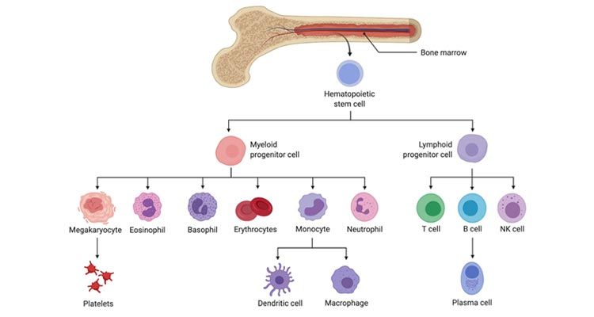
Figure 1. The human immune system and cell types produced in bone marrow.

HSCs have self-renewal capacity. They can be found in several organs and produce blood over the entire human life-span. Bone marrow is a highly vascularized tissue that generates more new cells than any other part of the body [78]. Nombela-Arrieta and Manz point out that: “Remarkably, at any given moment, 90% of total cell numbers of the organism originates from or resides in the BM (bone marrow)”[78].

Bone marrow makes approximately 10 billion white blood cells daily [85]. There are three types of lymphocytes: B cells, T cells and NK cells. These cells differ in their functions, cell surface proteins and receptors (phenotype), and genetic makeup (genotype). B cells make and secrete the antibodies (immunoglobulins) that protect the body against foreign agents such as bacteria and viruses [76]. T cells migrate from the bone marrow to the thymus where they mature, and then migrate again to secondary lymphoid tissues. NK cells also migrate from the bone marrow to various sites such as the spleen, skin, and the gastrointestinal tract.

T cells and NK cells are functionally similar and serve to regulate the immune system and attack foreign agents, such as viruses and abnormal or malignant cells. Lymphocytes are constantly recirculating in the blood and lymphatic fluids. They move between the various lymphoid organs and tissues as part of the body’s dynamic immune-surveillance system.

B cells and T cells are the only cells in the human body that require a change in their original DNA sequences in order to fulfil their normal functions. Accordingly, the body’s ability to respond to potentially deadly microorganisms requires substantial diversification of T-cell receptors and B-cell receptor/antibody repertoires. Such diversity is generated by a series of DNA translocations or rearrangements that require double-strand DNA breaks in the receptor genes, followed by rejoining of the DNA segments into a new functional gene.

A number of NHL subtypes originate in bone marrow. These include chronic lymphocytic leukemia, follicular lymphoma, mantle cell lymphoma, and multiple myeloma [91]. Other blood cancers originate and/or mature in lymphoid tissues, but may have come from, or at some point in their maturation, flowed through bone marrow.

