Supplemental Information

materials availability
This study did not generate new unique materials.

data and code availability
All figures in the text are based on secondary data (Data S1-2)

Supplemental table:

Table S1. Actors of trade and investment agreements between the Mercosur and European trade regions under negotiation
Table 1 describes in the first section (above) the different bodies (EFTA, EU and Mercosur). The two TIAs (EMFTA and AAUEM) are described in the second section with reference to impact assessments which were consulted for this article.

Actors | Abbr. | description
European Free Trade Association | EFTA | The EFTA is an intergovernmental organization established in 1960, comprising Switzerland, Norway, Iceland, and Liechtenstein. Together, they have signed over 29 trade agreements with over 40 countries, including several in Latin America. The EFTA member states, with a collective population of 14.2 million and a combined GDP of US$ 1.1 trillion, represent some of the highest gross domestic product (GDP) per capita globally [1].  The EFTA model chapter on trade and sustainable development was revised in 2019 with provisions on trade and climate change, biodiversity, gender equality and responsible business conduct and institutional monitoring mechanisms with a panel of experts that can effectively exert public pressure on the parties concerned to help them to enforce their rights and obligations, e.g., regarding the implementation of the provisions on trade, sustainable agricultural and food systems, labour and employment [2]. This mechanism supplements the Joint Committee.
Southern Common Market | Mercosur | Formed in 1991 by Argentina, Brazil, Paraguay, and Uruguay, and officially established through the 1994 Protocol of Ouro Preto, the Mercosur operates as an intergovernmental consensus-based structure. Its primary objective is to establish a common market while concurrently advancing 'economic development with social justice' throughout the region [3]. The (full) member states cover an area of over 12 million square kilometers and hosting a population of about 260 million, Mercosur's collective GDP amounts to approximately US$ 2.7 trillion.  The Mercosur Negotiating Group engages in simultaneous negotiations for the AAEUM and the EMFTA [3]. These negotiations cover similar clauses regulating trade in goods, rules of origin, and sustainability [4].  Bolivia, Chile, Colombia, Ecuador, Guyana, Peru, and Suriname are associate states of the Mercosur. Venezuela is a full member and has been suspended since December 2016.
European Union | EU | The European Union (EU) has established a single internal market through a standardized system of laws that apply in all member states.  The EU employs a variety of mechanisms, such as the Trade and Sustainable Development (TSD) chapters in TIAs, to promote labor rights, environmental sustainability, and corporate social responsibility among its trading partners. TSD chapters have a commercial purpose to ensure a level-playing for EU companies and consistency with international environmental and labour standards [5], a high level of environmental protection and labor standards as well as the prohibition to lower the level of protection [6]. On the other hand, TSD chapters have a political purpose to enhance the enforcement of non-trade rules and policy objectives [7, 8].  The European Commission has developed a 15-Point Action Plan proposing a new approach for the TSD chapters. This approach aims to create "more tailored and targeted" country-specific provisions to mitigate both direct and indirect trade impacts on biodiversity [8]. In case of conflicts related to provisions in the TSD chapters in a TIA with the EU, a special dispute settlement procedure is established to enforce the commitments in TSD chapters with the general state-to-state dispute settlement and extending the compliance stage to disputes under TSD chapters with arbitrators in charge of such disputes to have proven expertise in the relevant fields, e.g., the Paris Agreement [8–11] . The Commission sets new policy orientation, based on the comprehensive review of SIAs setting a new benchmark on Trade and Sustainable Development (TSD), ranging from a more results-oriented approach, through increased transparency and a reinforced role for civil society, to targeted support, while also increasing the level of commitment by including the possibility of trade sanctions as a last resort [12]. Furthermore, the European Economic and Social Committee (EESC) sees further opportunities to strengthen the role of civil society and the Domestic Advisory Groups (DAGs), at the level both of the agreement as well as of its implementation. However, the EESC regrets that no action is being taken to involve civil society more thoroughly during the negotiation process [12].
TIAs under negotiation | abbr. | description | assessments
EFTA -Mercosur Free Trade Agreement | EMFTA | The EMFTA is expected to create a market of approximately 280 million consumers with a GDP of over US$ 3.7 trillion [13]. The EMFTA would eliminate import-export tariffs in various sectors, ranging from 8% to 0%, and provide additional protection for foreign direct investment and intellectual property. According to the economic analysis, this agreement is expected to benefit the Swiss export industry the most, potentially leading to a 0.06% increase in Switzerland’s real GDP, compared to a 0.01% increase for overall Mercosur real GDP [13]. | Switzerland-mandated EIA: [13]  Impact on Swiss agriculture: [14]  NGOs’ blueprint human rights impact assessment: [15]
Association Agreement between the European Union and Mercosur | AAEUM | The AAEUM would supplement the 1999 inter-regional Framework Cooperation Agreement. In June 2019, the EU and Mercosur reached a political agreement for an Association Agreement including a trade component. The AAUEM is estimated to increase the GDP of the EU of 10.9 billion Euros in the conservative scenario and of 15 billion Euros in the ambitious scenario. In the Mercosur economies, the increase of GDP would range from less than 360 million Euros in Paraguay in the conservative scenario to 4.6 billion Euros in Argentina in the ambitious scenario [16]. | SIA EU-mandated: [16]  NGOs’ reviews of SIA: [17–19]

Supplemental notes:
Note S1. Experimental Procedures
We conducted an online survey and a one-day hybrid workshop, hosted in November 2021 by the University Research Priority Program on Global Change and Biodiversity of the University of Zurich. Nineteen participants, trained in various scientific disciplines (law, geography, ecology, biology, earth system science, environmental sciences, political ecology, ecological economics, development studies, finance, political economy, spatial statistics, sociology, remote sensing, participatory modeling), gathered with the objective of building an interdisciplinary network to develop more accurate and policy-relevant environmental impact assessments (EIAs) with foci on biodiversity and interrelated human rights.

The sustainability of trade and/or investment agreement (TIA), require multiple fields of knowledge for understanding the problem and addressing it in an iterative process in which early solutions are understood as opportunities to further understand and explore the project [20], taking care of the diversity of knowledge and expertise needed to know how to take care for the ‘wicked problem’ [21]. First, we discussed the state of the art of EIAs in Switzerland and sustainability impact assessments (SIAs) in the European Union. Second, we reviewed the first EIA mandated by the Swiss government on one specific TIA (hereafter Switzerland-mandated EIA) [13] to identify methodological limitations and, in a proof-of-concept approach, make suggestions for EIA methodology to complement established methods and protocols and overcome current limitations. We conducted an interdisciplinary review of Switzerland-mandated EIA [13], and raised numerous challenges that we grouped in 13 guiding themes, clustered on (1) deforestation, (2) chemical pollution, (3) geographical scale and disciplinary scope, and (4) workflow (e.g., inclusivity and enforcement). The themes reflect research participants’ expertise and interests and are not exhaustive of all sustainability challenges of trade and investment agreements neither representative of the state-of-the-art in all SIA, EIA or impact assessment on biodiversity and ecosystem services. We highlighted what Switzerland-mandated EIA covers (state of the report), what it overlooks (limitations) and how we suggest overcoming specific limitations (research outlooks). As the final EMFTA text was not public at the time of writing this manuscript, we based our commentary on the summary of the draft agreement prepared by the European Free Trade Association (EFTA) Secretariat [22].

Note S2. statistical description related to figures
To develop our figures, we compare different available data (Data S1-2).

The description of figure 0 is provided in the figure caption to create transparency on the different methodology to interpret the impact of deforestation. It is interesting that the EU SIA cites the IMAZON report on this term: We did not integrate findings from Arima et al. 2021 who focused on the impacts of the AAEUM on Amazonia [23].

For figure 1, our calculation of the percentage increase in Swiss exports of chemical and pharmaceutical products to Mercosur member states induced by the EMFTA (percentage values highlighted in black) compares the absolute increase estimated by Switzerland-mandated EIA (Table 4 Changes in sectoral exports, p.35),[13] to data from Comtrade for the years 2021. For chemical products, we aggregated Comtrade data for exports of organic chemicals (HS 29) and inorganic chemicals (HS 28) reported by Switzerland. For pharmaceutical products, we compared the values of the Switzerland-mandated EIA on basic pharmaceutical products to the values from Comtrade for pharmaceutical products (HS 30).

In comparison, the Switzerland-mandated EIA reported a 0.5% increase of exports compared to Switzerland total exports to the world. For example, Switzerland-mandated EIA estimates that the EMFTA would increase Swiss exports by US$ 321M, and states that this corresponds to a 0.5% increase in Swiss exports, which indeed matches the value of US$ 63.1B for Switzerland’s total exports to the world in 2014, the reference year of the GTAP model, which was used by Switzerland-mandated EIA ($0.5\%×63.{10}^{9}≈320.{10}^{6}$). We also observed that the ban of exports of five pesticides harmful to humans and the environment, containing the active substances atrazine, diafenthiuron, methidathion, paraquat and profenofos since 2021 from Switzerland did not reduce overall Swiss exports of organic chemical products to Mercosur member states (US$ 716M in 2020 – US$ 823M in 2021). (Data S2)

For Figure 2, our comparison of deforestation is based on different data sets and methodologies. The CGE model in the Switzerland-mandated EIA [13] (in red in Figure 2) used forest area data from the World Development Indicators, UNSD Environmental Indicators, and MAGNET land elasticities[24]. The sections 4.2.2.4.1 Land use risks due to agriculture sector and deforestation (pp.59-62) and 4.2.2.4.2 Biodiversity risks due to agriculture and forest activities (pp.62-64) analyze the results on deforestation risks in more details. The EIA also recognizes the implications of benchmarking with different time periods resulting in a three times higher percentage of projected deforestation (0.25% instead of 0.08%): “This estimate of potential deforestation should be viewed in the context of historical land use patterns. The deforestation rates in Brazil decreased sharply between 2009 and 2014, with a low of 5000 km2 in 2014. Nevertheless, deforestation rates have started increasing again in the last years, with an average deforestation for 2015-2018 of almost 7000 km2 (Butler, 2019). However, these more recent deforestation rates still remain well below the rates observed at the beginning of the 2000s, which consistently surpassed 20000 km2. Therefore, if we use a yearly deforestation rate of 7000 km2 in Brazil (instead of the long term average of more than 30000 km2) the share of the potential deforestation associated with the implementation of the EMFTA will represent around 0.25% (instead of 0.08%) of current yearly deforestation rates.” (p.61)

We aggregate data on agriculture and forestry published in table 4 Changes in sectoral exports of the Switzerland-mandated EIA (p.35) [13]. The data in orange on deforestation risk embodied in production and consumption of agricultural and forestry commodities from Mercosur exported to Switzerland (Figure 3 A) was taken from Pendrill et al. (2020), which relies on a land balance and crop attribution model [25] and remote sensing data [26]. For afforestation in Switzerland (Figure 2 B), our calculation is based on FAO Global Forest Resources Assessment 2020 [27]. We suppose a fix reforestation rate for 2010-2020 to calculate the reforestation rate for the same period (1990-2015) as the benchmark in the Switzerland-mandated EIA (Data S1). The benchmark drafted in an icon combining a box-and-whisker plot and a target with an arrow (Figure 3 C) is based on the Glasgow Leaders’ Declaration on Forests and Land Use.¹⁵¹

Note S3. additional figures

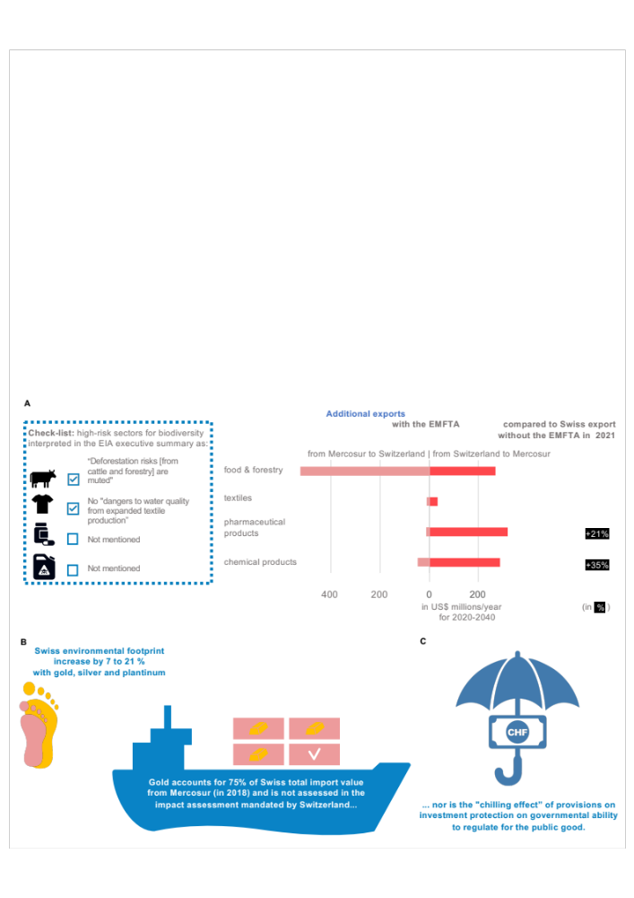

Figure S1. Products and regulations with high risk for biodiversity and out of scope of the EIA mandated by Switzerland
The Switzerland-mandated EIA of Switzerland-Mercosur trade under the EMFTA omits products already exempted from tariffs, e.g. gold, and omits regulatory effects, e.g. investment protection.

Regarding Figure S1, the icon with two feet illustrates that the net import of non-monetary gold, silver, and platinum significantly amplifies Switzerland's total ecological footprint by 7–26% [61] (left Figure 2). Our illustration of the share of gold in total Swiss imports from Mercosur member states comes from information published in the Switzerland-mandated EIA (p.84) [13] (center Figure 2). The regulatory effects of investment protection, illustrated with an umbrella and bank note, is characterized as a potential “regulatory chill” or “chilling effect” in the literature [28–34] (right Figure 2).

References
1. GFB Acordo de livre comércio Mercosul-EFTA: Resumo informativo elaborado pelo governo brasileiro
2. EAER (2021) Switzerland’s Foreign Economic Policy Strategy. Federal Department of Economic Affairs, Education and Research EAER, Bern
3. Bianculli AC (2020) Politicization and Regional Integration in Latin America : Implications for EU – MERCOSUR Negotiations ? 8:254–265. https://doi.org/10.17645/pag.v8i1.2598
4. Bürgi Bonanomi E, Tribaldos T (2020) PPM-Based Trade Measures to Promote Sustainable Farming Systems ? What the EU / EFTA-Mercosur Agreements Can Learn from the EFTA-Indonesian Agreement. Eur Yearb Int Econ Law 10:1–27. https://doi.org/10.1007/8165_2020_64
5. EESC (2016) Communication from the Commission to the European Parliament, the Council, the European Economic and Social Committee and the Committee of the Regions - Trade for all: Towards a more responsible trade and investment policy. European Economic and Social Committee, Brussels
6. Durán GM (2020) Sustainable development chapters in EU free trade agreements: emerging compliance issues. Common Mark Law Rev 57:
7. Borchert I, Conconi P, Ubaldo MD, Herghelegiu C (2021) The Pursuit of Non-Trade Policy Objectives in EU Trade Policy. World Trade Rev 20:623–647. https://doi.org/10.1017/S1474745621000070
8. Muller J (2023) EU Imported Biodiversity Loss: The Gaps and Overlaps Between Trade Impact and Provisions on Biodiversity in EU Free Trade Agreements. In: de Amstalden M, Moran N, Asmelash H (eds) International Economic Law. Springer Nature Switzerland, Cham, pp 303–321
9. Bartels L (2014) A model human rights clause for the EU’s international trade agreements. Deutsches Institut für Menschenrechte, Berlin
10. European Parliament (2022) Outcome of the Commission’s review of the 15-point action plan on trade and sustainable development. European Parliament, Brussel
11. General Secretariat of the Council (2022) Council Conclusions on the Trade and Sustainability Review
12. EESC (2022) Communication from the Commission to the European Parliament, the Council, the European Economic and Social Committee and the Committee of the Regions: The power of trade partnerships: together for green and just economic growth [COM(2022) 409 final]. European Economic and Social Committee, Brussels
13. Francois J, Häberli C, Manchin M, Polanco R, Rojas-Romagosa H, Tomberger P (2020) Assessment of the potential environmental impacts and risks in Switzerland and the MERCOSUR States resulting from a Free Trade Agreement (FTA) between the EFTA States and MERCOSUR. State Secretariat for Economic Affairs (SECO), Federal Department of Economic Affairs, Education and Research, Bern
14. Portmann M, Ritzel C (2020) Ex-ante-Evaluation eines Freihandelsabkommens zwischen der Schweiz und den Mercosur-Staaten: Auswirkungen auf die Landwirtschaft. Agroscope
15. Dommen C (2020) Blueprint for a Human Rights Impact Assessment of the comprehensive free trade agreement between EFTA and Mercosur. Alliance Sud, Bern, Switzerland
16. Mendez-Parra M, Garnizova E, Baeza Breinbauer D, Lovo S, Velut J-B, Narayanan B, Bauer M, Lamprecht P, Shadlen K, Arza V, Obaya M, Calabrese L, Banga K, Balchin N (2020) Sustainability Impact Assessment in Support of the Association Agreement Negotiations between the European Union and Mercosur. Publications Office of the European Union, Luxembourg
17. Dupré M, Dauphin T (2022) The European Commission’s Trade Sustainability Impact Assessments: a critical review. Veblen Institute for Economic Reforms and Greenpeace, Paris and Hamburg
18. Aguiar A, Arima E, Taheripour F, Barreto P (2020) Is the EU-MERCOSUR trade agreement deforestation-proof?, Instituto do Homem e Meio Ambiente da Amazônia. Amazon Institute of People and the Environment (IMAZON), Belém
19. GRAIN (2021) EFTA-Mercosur: another low blow to climate, peoples’ rights and food sovereignty *. https://grain.org/en/article/6662-efta-mercosur-another-low-blow-to-climate-peoples-rights-and-food-sovereignty#sdfootnote29sym,
20. Van der Velden M, Sjåfjell B (2023) Thinking with Care: Exploring Interdisciplinarity in a Global Research Project. In: Sjåfjell B, Russell R, Van der Velden M (eds) Interdisciplinary Research for Sustainable Business. Springer International Publishing, Cham, pp 23–40
21. Rittel HWJ, Webber MM (1973) Dilemmas in a general theory of planning. Policy Sci 4:155–169. https://doi.org/10.1007/BF01405730
22. EFTA (2019) Conclusion in Substance of the EFTA Mercosur free trade negotiations. Note by the EFTA Secretariat
23. Arima E, Barreto P, Taheripour F, Aguiar A (2021) Dynamic Amazonia: The EU–Mercosur Trade Agreement and Deforestation. Land 10:1243. https://doi.org/10.3390/land10111243
24. Tabeau A, Helming J, Philippidis G (2017) Land supply elasticities: overview of available estimates and recommended values for MAGNET. Publications Office of the European Union, Luxembourg
25. Pendrill F, Persson UM, Kastner T (2020) Deforestation risk embodied in production and consumption of agricultural and forestry commodities 2005-2017
26. Hansen MC, Potapov PV, Moore R, Hancher M, Turubanova SA, Tyukavina A, Thau D, Stehman SV, Goetz SJ, Loveland TR, Kommareddy A, Egorov A, Chini L, Justice CO, Townshend JRG (2013) High-Resolution Global Maps of 21st-Century Forest Cover Change. Science 342:850–853. https://doi.org/10.1126/science.1244693
27. FAO (2020) Global Forest Resources Assessment 2020. Food and Agriculture Organization, Rome, Italy
28. Kuik O, Kettunen M, van Vliet J, Colsa A, Illes A (2018) Trade Liberalisation and Biodiversity Scoping Study on Methodologies and Indicators to Assess the Impact of Trade Liberalisation on Biodiversity (Ecosystems and Ecosystem Services). Final report for the European Commission (DG ENV). Institute for Environmental Studies (IVM/Vrije Universiteit), Amsterdam & Institute for European Policy (IEEP), Brussels/ London
29. Donaubauer J (2018) Winning or losing in investor-to-state dispute resolution: The role of arbitrator bias and experience. Rev Int Econ 26:892–916. https://doi.org/10.1111/roie.12347
30. Amos R, Lydgate E (2020) Trade, transboundary impacts and the implementation of SDG 12. Sustain Sci 15:1699–1710. https://doi.org/10.1007/s11625-019-00713-9
31. Coenen J, Bager S, Meyfroidt P, Newig J, Challies E (2021) Environmental Governance of China’s Belt and Road Initiative. Environ Policy Gov 31:3–17. https://doi.org/10.1002/eet.1901
32. Tauli-Corpuz V (2016) Report of the Special Rapporteur on the rights of indigenous peoples. In: General Assembly of the United Nations. pp 1–34
33. Duggal KAN, Diamond NJ (2021) Human Rights and Investor–State Dispute Settlement Reform: Fitting a Square Peg into a Round Hole? J Int Dispute Settl 00:1–31. https://doi.org/10.1093/jnlids/idab006
34. Rarrick LC (2019) Biodiversity Impacts of Investment and Free Trade Agreements. Pace Environ Law Rev 37:67–101

