SUPPLEMENTARY – additional file 2

The following parameters were assessed to characterize the pond samples used for the chironomid in vivo experiment. The values were measured in the glass beakers (for water parameters) and using freeze dried sediment.
Water parameters
Nitrate was underrange in all cases, concentration was therefore below 0.5 mg/L and is not displayed in the following figures.

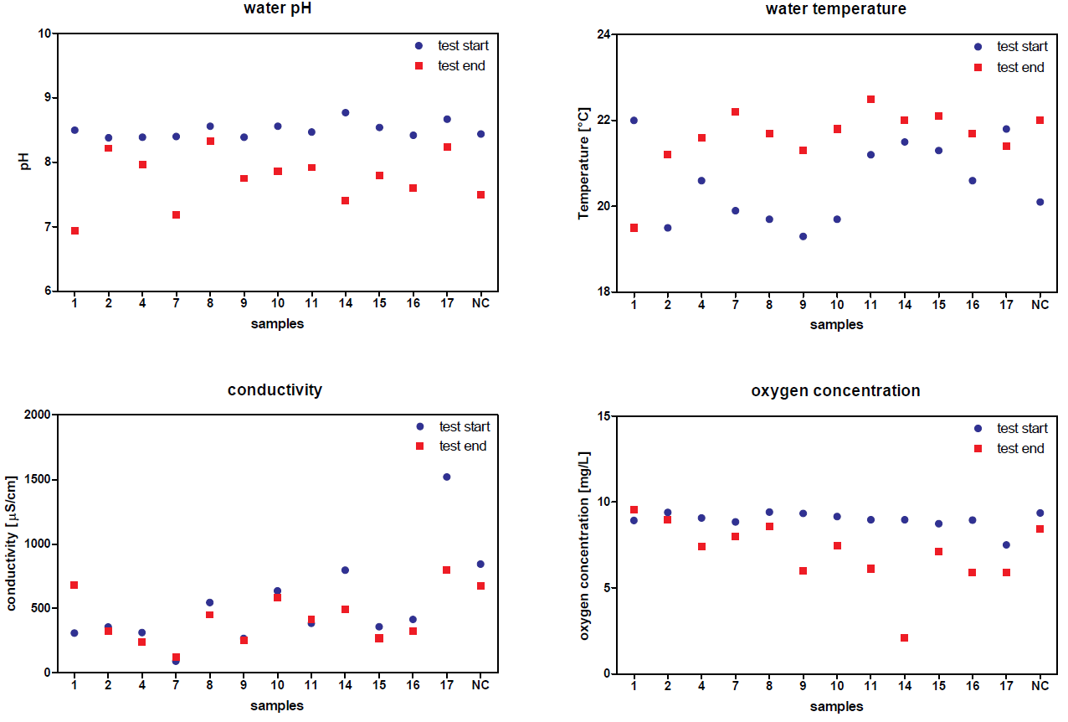

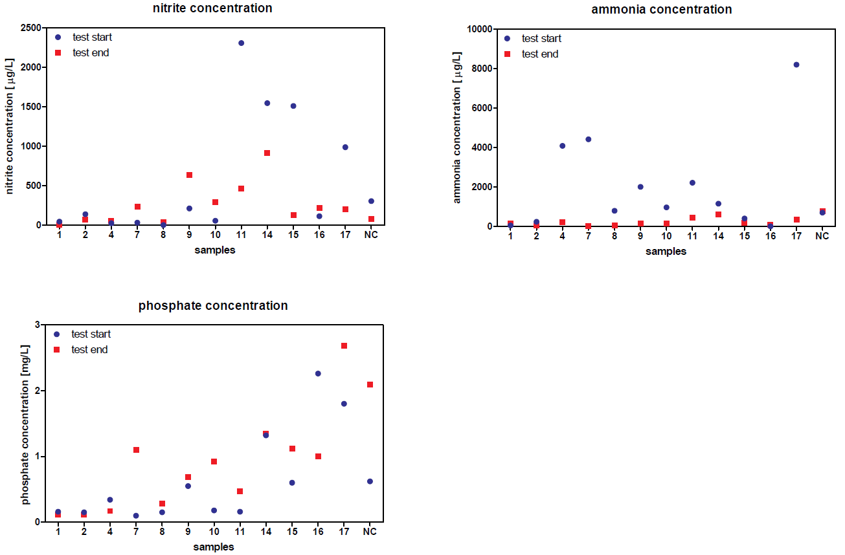

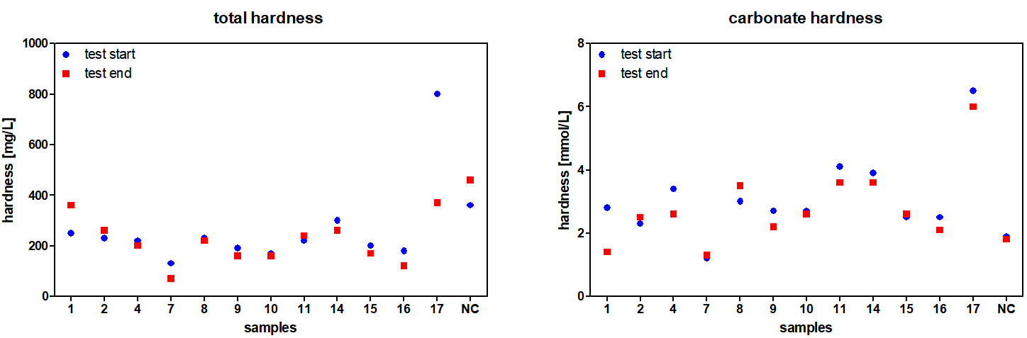

Sediment parameters
